CPSD/RWC/DAR/JFP/vdl Mailed 1/13/06

Decision 06-01-022 January 12, 2006

BEFORE THE PUBLIC UTILITIES COMMISSION OF THE STATE OF CALIFORNIA

Application of the North County Transit District for authority to construct 4 in-station pedestrian at-grade crossings at 3 passenger light-rail stations in connection with the Oceanside to Escondido Sprinter passenger light-rail project in City of San Marcos, County of San Diego, California. | Application 04-08-015  (Filed August 16, 2004)

O P I N I O N

Summary
This decision grants the North County Transit District’s (NCTD) request to construct four in-station pedestrian at-grade crossings (crossings) at three Light Rail Transit (LRT) stations in the City of San Marcos, San Diego County.

Discussion
As part of the project to construct its 22-mile SPRINTER Oceanside-Escondido Rail Project (OERP), NCTD proposes to construct four crossings at three LRT stations in the City of San Marcos, as described in Appendix A and located as shown in a vicinity map in Appendix B attached to this order. Detailed drawings of the proposed four crossings are included in the application.
The four crossings and three LRT stations form part of the existing 22-mile Escondido Branch Line of the San Diego Subdivision formerly owned by the Atchison, Topeka & Santa Fe Railroad, now owned by NCTD. The OERP is a new LRT system consisting of partial track realignment and the construction of three sections of passing track, each 3.5 miles in length. The existing track system accommodates three round trips of freight rail service each week. The new light rail system will share the tracks with the freight rail service. However, freight and light rail service will be completely separate. Freight service will operate only in the evening hours after the completion of light rail service for the day.
NCTD will provide light rail service by means of diesel-multiple-unit (DMU) light rail vehicles. The DMU is a self-propelled diesel-electric or diesel-hydraulic rail vehicle with a maximum speed of 55 miles per hour. NCTD can couple the vehicles together to make trains consisting of two or three vehicles total. However, initial service will consist of trains with a maximum of two vehicles. During peak loading, each train may transport a maximum of 300 passengers. NCTD plans a maximum of sixty-four (64) passenger trains per day, based on a 30-minute operating headway.
North San Diego County Transit Development Board (NSDCTDB) is the lead agency for this project under the California Environmental Quality Act of 1970 (CEQA), as amended in 1982 and as stated in Public Resources (PR) Code Section 21000 et seq. NSDCTDB prepared a Subsequent Final Environmental Impact Report (SEIR) for the project in March 1997. On September 13, 2001, in compliance with PR Code Section 21108 or 21152, NSDCTDB filed a Notice of Determination (NOD) with the San Diego County Clerk. The NOD found that “Implementation of the 100% design plans for the project will not create new significant effects on the environment from those analyzed in the Subsequent Final Environmental Impact Report (SEIR) certified by NSDCTDB in March 1997.” NSDCTDB prepared an Addendum for the project pursuant to the provisions of CEQA. Additional mitigation measures were not made a condition of the approval of the project. A copy of the NOD is included in Appendix C attached to this order.
The Commission is a responsible agency for this project under CEQA. CEQA requires that the Commission consider the environmental consequences of a project subject to its discretionary approval. To comply with CEQA, a responsible agency must consider the lead agency’s Environmental Impact Report or Negative Declaration prior to acting upon or approving the project (CEQA Guideline Section 15050(b)). The specific activities that a responsible agency must conduct are contained in CEQA Guideline Section 15096.
We reviewed and considered the lead agency’s NOD. Safety, transportation, and noise are within the scope of the Commission’s permitting process.
We find that NSDCTDB’s environmental documents are adequate for our decision-making purposes. We find that NSDCTDB reasonably concluded that implementation of 100% design plans for the project will not create new significant effects on the environment from those analyzed in the SEIR certified by NSDCTDB in March 1997. Applicable mitigation measures adopted in the SEIR will be applied as part of this project. Accordingly, we adopt the NOD for purposes of our project approval.
The Commission’s Consumer Protection and Safety Division – Rail Crossings Engineering Section (RCES) staff inspected the site of each of the three proposed LRT stations. After reviewing the need for and the safety of the proposed crossings, RCES recommends that the Commission grant NCTD’s requests.
The application is in compliance with the Commission’s filing requirements, including Rule 38 of Rules of Practice and Procedure, to construct a public highway across a railroad. Notice of the application filing was published in the Commission Daily Calendar on August 17, 2004.
In its application, NCTD states its belief that the requirement of Rule 38a for a legal description is burdensome when applied to a situation where a pedestrian crossing is located within the limits of a transit station. The three proposed stations are owned by NCTD, and there is no easement, license or encroachment of any kind that distinguishes the locations of the proposed crossings from platforms, tracks, and other station facilities.
NCTD believes that the Rule 38a requirement, as written, is burdensome when there is no accompanying easement, license or encroachment to be documented as part of real estate agreements between railroads and local roadway agencies. Generating a unique metes-and-bounds or other similar legal description for the sole purpose of satisfying Rule 38a is costly, as California law requires that only a licensed land surveyor can prepare such descriptions. NCTD believes that the location of pedestrian crossings within transit stations is best determined by their relationship with station design, not by road, street or highway alignment.
RCES staff, after consulting with the Commission’s Legal and Administrative Law Divisions, has worked with NCTD to develop an alternative method of identifying the locations of proposed pedestrian crossings within transit stations. Staff believes that for our locating purposes, a railroad milepost accompanied by transit station plans noting the crossing location with footage distances from observable points within the station, and a description of the crossing warning devices, adequately identifies the proposed pedestrian crossing locations within the boundaries of transit stations. We accept NCTD’s milepost identifier and accompanying plans, included in its application, as satisfying the requirements of Rule 38a.
Categorization and Need for Hearings
In Resolution ALJ 176-3137, dated August 19, 2004, and published in the Commission Daily Calendar on August 20, 2004, the Commission preliminarily categorized this application as ratesetting, and preliminarily determined that hearings were not necessary. Since no protests were filed, this preliminary determination remains correct. It is not necessary to revise the preliminary determinations made in Resolution ALJ 176-3137.
Waiver of Comment Period
This is an uncontested matter in which the decision grants the relief requested. Accordingly, pursuant to Public Utilities Code Section 311(g)(2), we waive the otherwise applicable 30-day period for public review and comment.

Assignment of Proceeding
Richard Clark is the assigned Examiner in this proceeding.
Findings of Fact
- The Commission published Notice of Application 04-08-015 in the Commission Daily Calendar on August 17, 2004. There are no unresolved matters or protests; a public hearing is not necessary.
- NCTD requests authority, under Public Utilities Code Sections 1201-1205, to construct four crossings at three LRT stations in the City of San Marcos, County of San Diego.
- Public convenience, necessity, and safety require construction of the four crossings of NCTD’s proposed Oceanside-Escondido Rail Project.
- NSDCTDB is the lead agency for this project under CEQA, as amended.
- NSDCTDB filed an NOD regarding this project and found that implementation of the 100% design plans for the project will not create significant effects on the environment from those analyzed in the SEIR certified by NSDCTDB in March 1997. NSDCTDB prepared an Addendum for the project pursuant to the provisions of CEQA. Additional mitigation measures were not made a condition of the approval of the project.
- The Commission is a responsible agency for this project and has reviewed and considered the lead agency's NOD.
- Safety, transportation, and noise are within the scope of the Commission’s permitting process.
Conclusions of Law
- The Application is uncontested and a public hearing is not necessary.
- The Application should be granted as set forth in the following order.
ORDER
IT IS ORDERED that:
- North County Transit District (NCTD) is authorized to construct four in-station pedestrian at-grade crossings at three Light Rail Transit stations in the City of San Marcos (City), County of San Diego, at the locations and substantially as described in and as shown by plans attached to Application (A.) 04-08-015; and as described in Appendix A attached to this order.
- NCTD shall comply with all applicable General Orders and the Manual on Uniform Traffic Control Devices, including the California Supplement.
- Construction and maintenance costs shall be borne in accordance with an agreement to be entered into between the City and NCTD (parties). Should the parties fail to agree, the Commission shall apportion the costs of construction and maintenance by further order.
- Within 30 days after completion of the work under this order, NCTD shall notify the Commission’s Consumer Protection and Safety Division, Rail Crossings Engineering Section in writing, by submitting a completed standard Commission Form G (Report of Changes at Highway Grade Crossings and Separations), of the completion of the authorized work.
- This authorization shall expire if not exercised within two years unless the Commission extends the time or if the parties do not comply with the above conditions. The Commission may revoke or modify authorization if public convenience, necessity or safety so require.
- The application is granted as set forth above.
- A.04-08-015 is closed.
This order becomes effective 30 days from today.
Dated January 12, 2006, at San Francisco, California.

MICHAEL R. PEEVEY
President
GEOFFREY F. BROWN
DIAN M. GRUENEICH
JOHN A. BOHN
RACHELLE B. CHONG
Commissioners
North County Transit District (NCTD) proposes to construct four in-station pedestrian at-grade crossings (crossings) at three Light Rail Transit (LRT) stations in the City of San Marcos, San Diego County, in connection with its SPRINTER Oceanside-Escondido Light Rail Project. The Commission’s assigned crossing identification numbers, Federal Department of Transportation (DOT) identification numbers and authorized automatic warning devices are as follows:

Light Rail Transit Station | Assigned PUC  Crossing No. | Assigned  DOT No. | Automatic Warning Device
Palomar College Station northerly pedestrian crossing | 106E-114.49 | 027574T | 2 – 10s
Palomar College Station southerly pedestrian crossing | 106E-115.71 | 922632E | 2 – 10s
San Marcos Station pedestrian crossing | 106E-116.15 | 027577N | 2 – 10s
CSU, San Marcos Station pedestrian crossing | 106E-116.33-A | 922633L | 2 – 10s

NCTD will install two modified Standard No. 10 (Pedestrian and Bicycle Flashing Light Type signal as described in General Order (GO) 75-C) automatic warning devices at each of the four crossings at the three LRT stations. The Standard No. 10s will be modified with two back-to-back pairs of flashing red lights and the addition of a “Look ⬅➔” sign.
In addition, the approaches to the crossings will be of an “S” shape design. Handrails will be used on the approaches to guide pedestrians to look both ways toward the tracks prior to walking across the tracks. The crossings will be eight feet wide with concrete panel crossing surface material with rubber flange way inserts. Yellow tactile tile surface warning strips, conforming to the American Disabilities Act Federal Regulations, will also be installed on platform edges in advance of the crossings.
VICINITY MAP

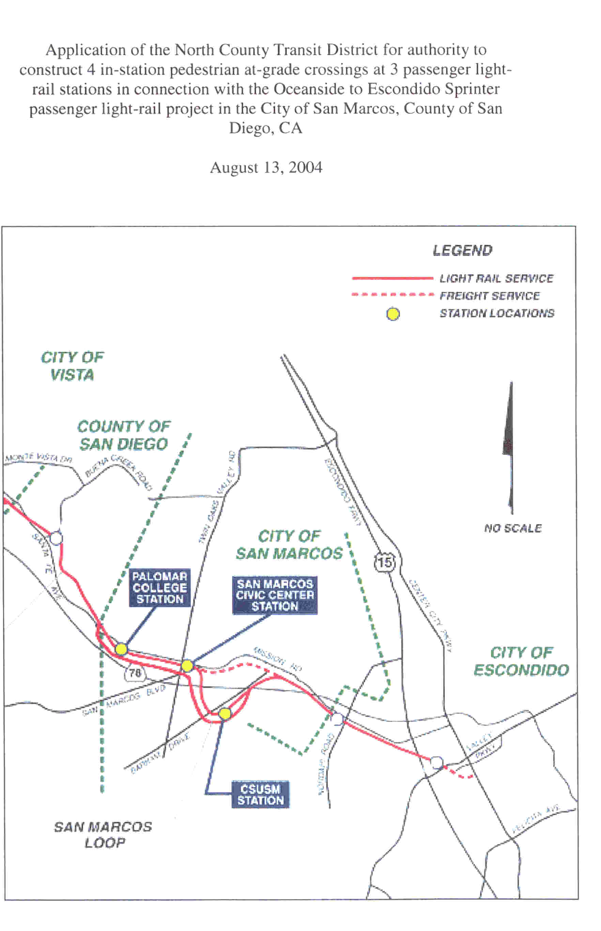

ENVIRONMENTAL DOCUMENT
