CPSD/RWC/DAR/JFP/vdl Mailed 6/16/06

Decision 06-06-024 June 15, 2006

BEFORE THE PUBLIC UTILITIES COMMISSION OF THE STATE OF CALIFORNIA

Application of the City of Santa Fe Springs for authority to construct an underpass grade separation of Valley View Avenue (C.P.U.C. Crossing No. 002-158.40) at the BNSF Railway San Bernardino Subdivision within the Cities of Santa Fe Springs and La Mirada, County of Los Angeles. | Application 05-11-005  (Filed November 8, 2005)

O P I N I O N

Summary
This decision grants the City of Santa Fe Springs’ (City) request for authority to construct a grade-separated crossing (crossing) of Valley View Avenue beneath tracks of the BNSF Railway Company’s (BNSF) San Bernardino Subdivision, replacing the existing at-grade crossing identified as CPUC Crossing No. 002-158.40, in Los Angeles County.

Discussion
Proposed Project
The proposed replacement of the existing Valley View Avenue at-grade crossing with a grade-separated structure beneath the BNSF tracks is part of a larger California Department of Transportation-Division of Rail (Caltrans) program to improve intercity passenger rail service. Caltrans, in cooperation with the Southern California Regional Rail Authority (SCRRA) and BNSF, proposes to increase the rail capacity of the existing BNSF San Bernardino Subdivision main line corridor from the City of Commerce (Mile Post 148.6) for 14.7 miles to the City of Fullerton (Mile Post 163.3).
Caltrans’ Third Track and Grade Separation Project (Project) focuses on increasing the efficiency of this corridor to accommodate the existing number of trains utilizing the corridor and future increases in both speed and volume of planned intercity passenger and commuter rail service. At its current operating level (approximately 100 total trains per day, including both freight and passenger trains), schedule delays occur along this rail corridor, resulting in significant impacts to both freight and passenger service. Currently, BNSF operates approximately 42 freight trains daily on this route at maximum speeds of 50 miles per hour (mph). SCRRA operates approximately 34 Metrolink commuter passenger trains daily, and Amtrak operates approximately 26 intercity passenger trains daily at maximum speeds of 79 mph.
BNSF’s main line corridor currently has two main line tracks. The Project proposes the construction of a third main line track and replacement of up to seven existing at-grade crossings with grade-separation bridge structures. The proposed grade separations will substantially improve overall safety and vehicular traffic flow on surface streets along the rail corridor by completely separating rail traffic from vehicular and pedestrian traffic. The third main line track will enhance efficiency of train movements along this corridor, reduce conflicts between freight and passenger service operations, and ensure passenger train service can operate on a reliable schedule.
The replacement of the existing Valley View Avenue at-grade crossing with a grade-separation bridge structure is a key component of the Project. During construction of the grade separation, vehicular traffic on Valley View Avenue will be detoured to a temporary road and temporary at-grade crossing adjacent to and approximately 100 feet to the west of the existing roadway and crossing. City also requests authority to construct this temporary at-grade crossing on the detour roadway, and proposes to completely remove the detour roadway and temporary crossing once the new grade separation is completed.
The adjacent intersection of Valley View Avenue and Stage Road will be depressed to allow Valley View Avenue to go under the railroad tracks without changing existing vehicular traffic circulation patterns. During construction and operation of the detour roadway and temporary crossing, the intersection of Valley View Avenue and Stage Road will be relocated to the temporary detour roadway. This temporary roadway intersection will be fully signalized and interconnected with the temporary at-grade crossing.
The proposed warning devices for the temporary at-grade crossing consist of two Standard No. 9-As (automatic gate type signal with additional lights on a cantilever, as defined in General Order 75-C) placed on each approach. In addition, advance warning signs (W10 series, per the Manual on Uniform Traffic Control Devices) will be installed, along with railroad pavement markings and raised island medians on approaches to the crossing, and as described in plans attached to the application and in Appendix A attached to this order.
Environmental Review
The California Environmental Quality Act of 1970 (CEQA, as amended, Public Resources Code Section 21000 et seq.) applies to discretionary projects to be carried out or approved by public agencies. A basic purpose of CEQA is to inform governmental decision-makers and the public about potential, significant environmental effects of the proposed activities. Since the project is subject to CEQA and the Commission must issue a discretionary decision in order for the project to proceed (i.e., the Commission must approve the project pursuant to Section 1202 of the Public Utilities Code), the Commission must consider the environmental consequences of the project by acting as either a lead or responsible agency under CEQA.
The lead agency is the public agency with the greatest responsibility for supervising or approving the project as a whole. Here, Caltrans is the lead agency for this project and the Commission is a responsible agency. As a responsible agency under CEQA, the Commission must consider the lead agency’s environmental documents and findings before acting on or approving this project.
The Commission reviewed and considered the lead agency’s Final Environmental Impact Report (FEIR) and Notice of Determination (NOD), and finds them adequate for our decision-making purposes.
The Commission’s Consumer Protection and Safety Division – Rail Crossings Engineering Section (RCES) has inspected the site of the proposed grade-separated crossing. After reviewing the need for and safety of the proposed grade-separated crossing, RCES recommends that the Commission grant City’s request.
The application is in compliance with the Commission's filing requirements, including Rule 38 of Rules of Practice and Procedure, which relates to the construction of a public highway across a railroad. A vicinity map of the existing crossing location and a plan of the proposed grade-separated crossing are shown in Appendix A attached to this order.

Categorization and Need for Hearings
In Resolution ALJ 176-3162, dated November 18, 2005, and published in the Commission Daily Calendar on November 21, 2005, the Commission preliminarily categorized this application as ratesetting, and preliminarily determined that hearings were not necessary. No protests were filed, and it is not necessary to revise the preliminary determinations made in Resolution ALJ 176-3162.

Waiver of Comment Period
This application is an uncontested matter in which the decision grants the relief requested. Accordingly, pursuant to Public Utilities Code Section 311(g)(2), we waive the otherwise applicable 30-day period for public review and comment.
Assignment of Proceeding
Richard Clark is the assigned Examiner in this proceeding.
Findings of Fact
- Notice of the application was published in the Commission’s Daily Calendar on November 14, 2005. There are no unresolved matters or protests; a public hearing is not necessary.
- City requests authority, under Public Utilities Code Sections 1201-1205, to construct a grade-separated crossing of Valley View Avenue beneath tracks of the BNSF’s San Bernardino Subdivision, replacing the existing at-grade crossing identified as CPUC Crossing No. 002-158.40, in Los Angeles County.
- The proposed grade-separated crossing is part of a larger Caltrans project to improve the efficiency of BNSF’s rail corridor to accommodate the existing number of trains utilizing the corridor, and future increases in both speed and volume of planned intercity and commuter rail passenger service, in the approximately 14.7 miles from the City of Commerce (Mile Post 148.6) to the City of Fullerton (Mile Post 163.3).
- During construction, City needs to construct a temporary roadway and temporary at-grade crossing to detour vehicular traffic on Valley View Avenue, which will be removed once construction of the grade separation is completed.
- Public convenience, safety and necessity require the construction of the proposed grade-separated crossing.
- Caltrans is the lead agency for this project under CEQA, as amended.
- Caltrans adopted an FEIR and NOD for this project pursuant to CEQA.
- The Commission is a responsible agency for this project, and has reviewed and considered the lead agency’s FEIR and NOD.
Conclusions of Law
- The FEIR and NOD adopted by Caltrans as the documentation required by CEQA for the Crossing Project is adequate for our decision-making purposes.
- We adopt the Caltrans’ FEIR and NOD for purposes of our approval.
- The application should be granted as set forth in the following order.
ORDER
IT IS ORDERED that:
- City of Santa Fe Springs (City) is authorized to construct a grade-separated crossing (crossing) of Valley View Avenue beneath tracks of the BNSF Railway Company’s (BNSF) San Bernardino Subdivision, replacing the existing at-grade crossing identified as CPUC Crossing No. 002-158.40, in Los Angeles County. The new grade-separated crossing shall be identified as CPUC Crossing No. 002-158.40-B.
- City is also authorized to construct a temporary at-grade crossing, approximately 100 feet to the west of the exiting crossing, on a temporary detour roadway for the purpose of diverting vehicular traffic from Valley View Avenue during construction of the grade-separated crossing. The temporary at-grade crossing shall be eliminated either three years from the date of this Order or the date the grade-separated crossing is opened to vehicular traffic, which ever date occurs first.
- Warning devices at the temporary at-grade crossing shall include two Standard No. 9-As (automatic gate type signal with additional lights on a cantilever, as defined in General Order 75-C) on each approach. The temporary at-grade crossing shall be interconnected with the traffic signals at the temporary vehicular intersection of Valley View Avenue and Stage Road. In all other aspects, the temporary at-grade crossing, detour roadway, and temporary intersection of Valley View Avenue and Stage Road shall be constructed as fully described in plans attached to the application.
- City and BNSF shall comply with all applicable rules, including Commission General Orders and the Manual on Uniform Traffic Control Devices (MUTCD), as amended by the MUTCD California Supplement.
- Construction and maintenance costs shall be borne in accordance with an agreement that has been entered into between City and BNSF (parties). Should the parties fail to agree, the Commission will apportion the costs of construction and maintenance by further order.
- Within 30 days after the temporary at-grade crossing is opened to vehicular traffic, BNSF shall notify the Commission’s Consumer Protection and Safety Division, Rail Crossings Engineering Section (RCES) in writing, by submitting a completed Standard Commission Form G (Report of Changes at Highway Grade Crossings and Separations), that the temporary at-grade crossing is open and that the existing at-grade crossing is removed. Within 30 days after the grade-separated crossing is opened to vehicular traffic, BNSF shall notify RCES in writing, by submitting a completed Standard Commission Form G, that the grade-separated crossing is open and the temporary at-grade crossing is eliminated.
- This authorization shall expire if not exercised within three years unless time is extended or if the above conditions are not complied with. Authorization may be revoked or modified if public convenience, necessity, or safety so require.
- This application is granted as set forth above.
- Application 05-11-005 is closed.
This order becomes effective 30 days from today.
Dated June 15, 2006, at San Francisco, California.

MICHAEL R. PEEVEY
President
GEOFFREY F. BROWN
DIAN M. GRUENEICH
JOHN A. BOHN
RACHELLE B. CHONG
Commissioners

VICINITY MAP
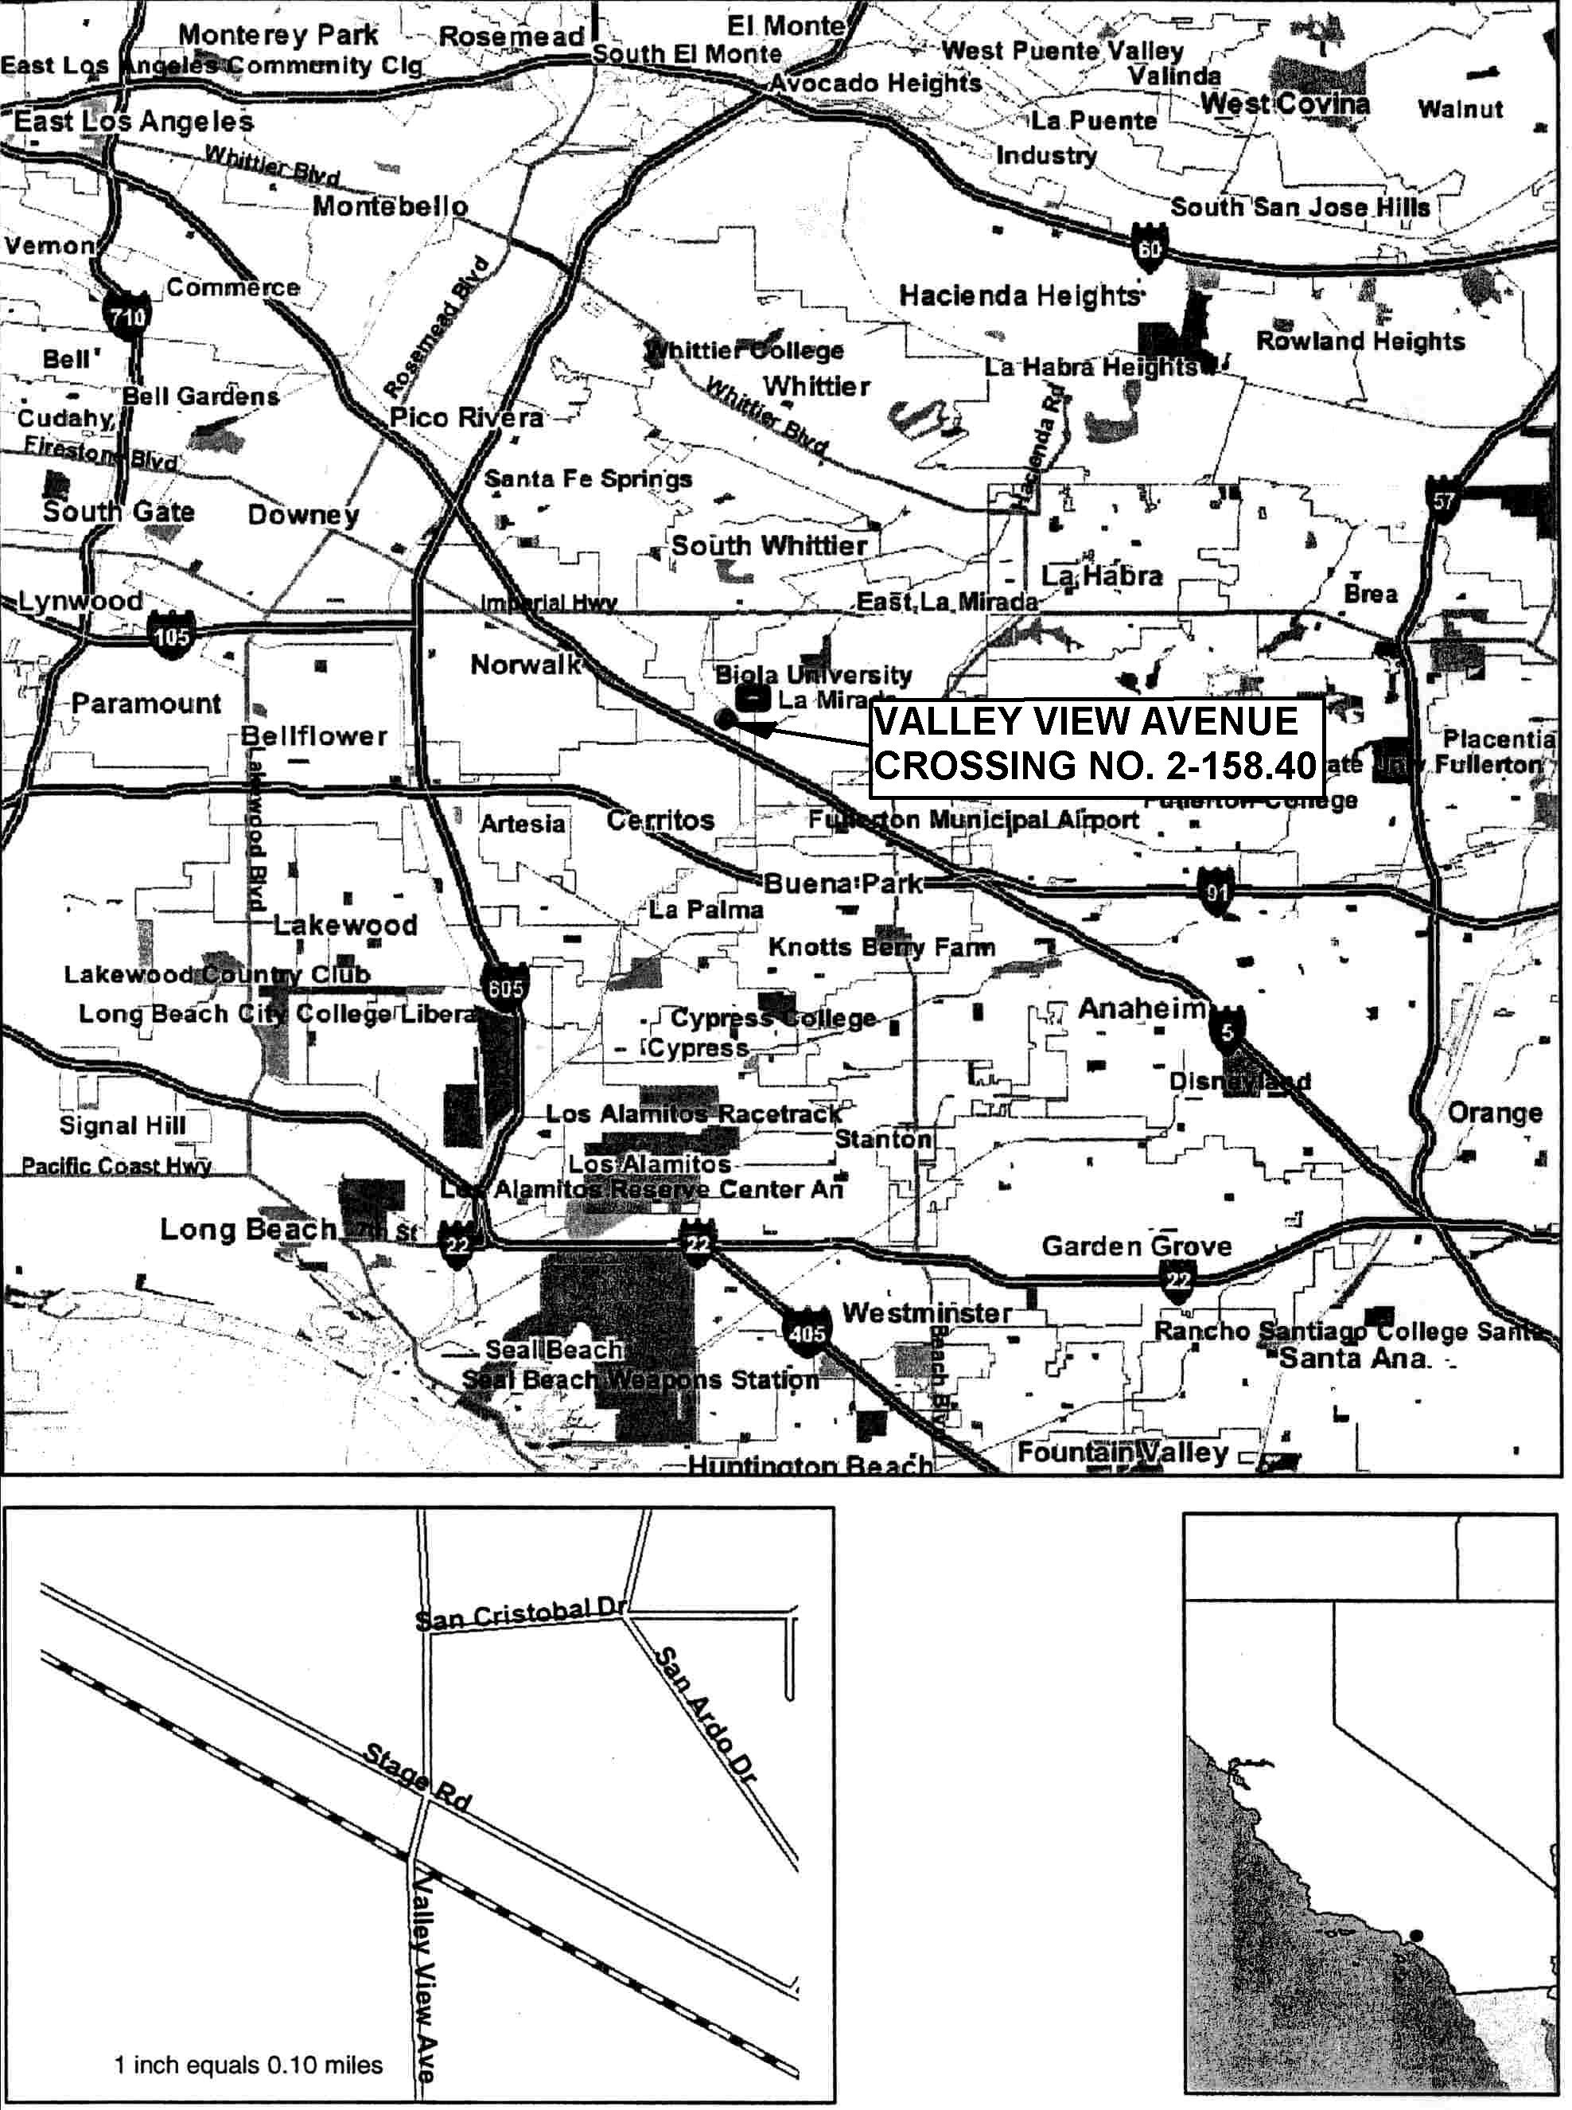
BRIDGE PLAN & ELEVATION
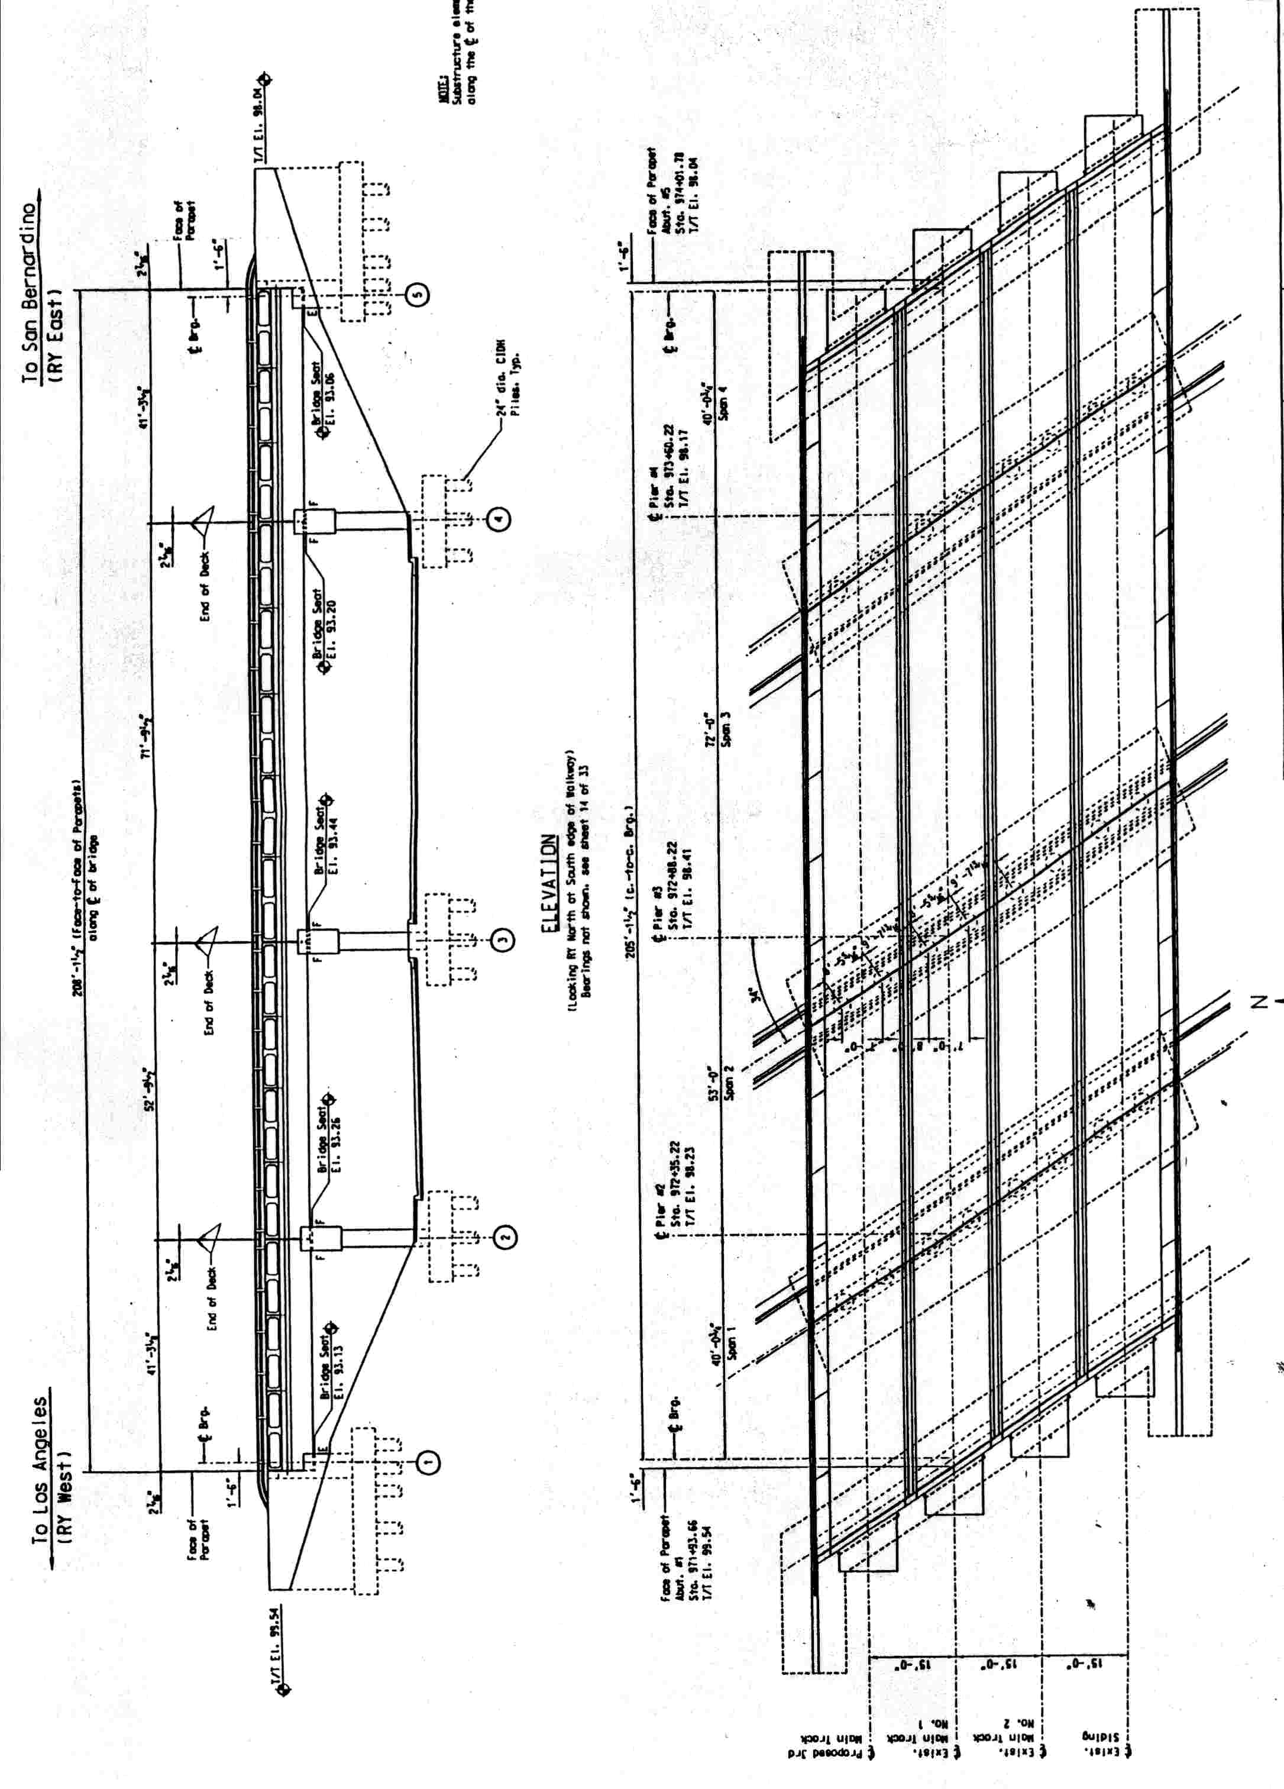
TEMPORARY ROADWAY AND AT-GRADE CROSSING
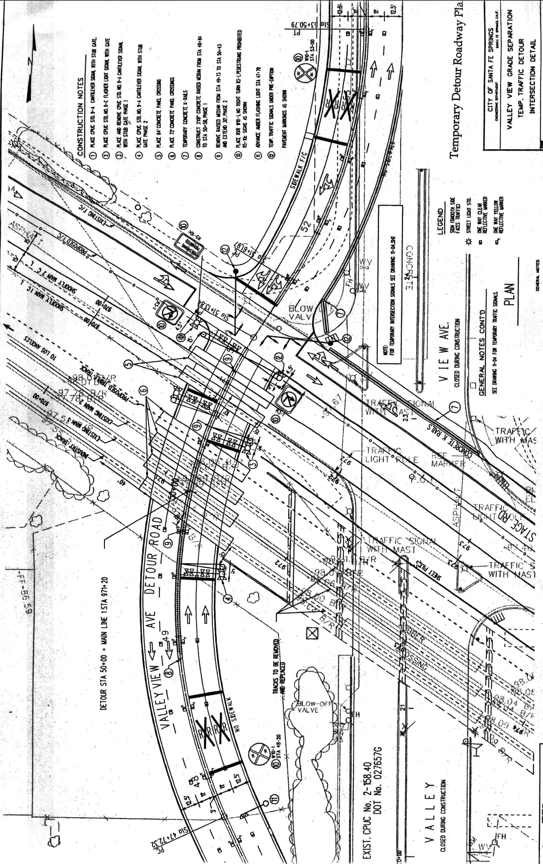

CEQA Guidelines (Title 14 of the California Code of Regulations), Section 15051(b).
CEQA Guidelines, Sections 15050(b) and 15096.

