CPSD/RWC/DAR/JFP/vdl Mailed 9/13/06

Decision 06-09-015 September 7, 2006

BEFORE THE PUBLIC UTILITIES COMMISSION OF THE STATE OF CALIFORNIA

Application of the City of Oxnard to construct a new public at-grade crossing across a lead and siding track of the Union Pacific Railroad Company in the City of Oxnard, County of Ventura. | Application 05-08-005  (Filed August 5, 2005)

O P I N I O N

Summary
This decision grants the City of Oxnard’s (City) request to construct an at-grade highway-rail crossing (crossing), referred to as the Oxnard Transportation Center Parking Lot Crossing, adjacent to the Oxnard Transit Center (OTC) over the tracks and right-of-way of the Union Pacific Railroad Company (UPRR) in the City of Oxnard, Ventura County.

Discussion
Proposed Project
The proposed crossing over UPRR’s junction lead tracks with the Ventura County Railroad (VCRR) at UPRR’s milepost 407.86, adjacent to the OTC, is part of the project that involves the construction of a new long-term parking lot adjacent to the OTC. The purpose of the project is to accommodate more vehicle capacity and continued growth of the OTC. The project includes the elimination of two pre-existing buildings, both of which are owned by UPRR, and construction of a proposed at-grade crossing. The proposed crossing will be a two-lane road 35 feet wide with one sidewalk to the north of the roadway connecting the parking lot with Oxnard Boulevard to the west.
The crossing is over UPRR junction lead tracks that connect UPRR’s mainline to the VCRR mainline near the OTC. The VCRR is a subsidiary shortline railroad within RailAmerica's Sunset Division. The VCRR serves the industrial areas of south Oxnard, the Port of Hueneme and the U.S. Naval Construction Battalion Center. Current freight train traffic on the junction lead tracks consists of approximately 5 trains per day at approximately 20 MPH, with no passenger trains utilizing these tracks.
Grade separation is not practicable due to low train volume (5 trains per day) and projected vehicle traffic of 35-50 vehicles per day using the new parking lot. The proposed warning devices at the crossing for both westbound and eastbound vehicular approaches shall consist of two Standard No. 9s (flashing light signals with gates, as defined in General Order (GO) 75-C), and one Standard No. 8 (flashing light signals as defined in GO 75-C) on the northwest quadrant for pedestrians using the sidewalk. Public safety also requires that the City place on all crossing approaches railroad crossing pavement markings (RXR) with Highway-Rail Grade Crossing Advance Warning (W10-1) signs per the Manual on Uniform Traffic Control Devices. The westbound approach will have a 64-foot long by 3-foot wide raised median. The eastbound approach will have a 100-foot long by 3-foot wide raised median.
Environmental Review
The California Environmental Quality Act of 1970 (CEQA, as amended, Public Resources Code Section 21000 et seq.) applies to discretionary projects to be carried out or approved by public agencies. A basic purpose of CEQA is to inform governmental decision-makers and the public about potential, significant environmental effects of the proposed activities. The Commission must issue a discretionary decision in order for the project to proceed (i.e., the Commission must approve the project pursuant to Section 1202 of the Public Utilities Code) and consider the environmental consequences of the project by acting as either a lead or responsible agency under CEQA.
The lead agency is the public agency with the greatest responsibility for supervising or approving the project as a whole. Here, City is the lead agency for this project and the Commission is a responsible agency. As a responsible agency under CEQA, the Commission must consider the lead agency’s environmental documents and findings before acting on or approving this project.
City asserts that the proposed project is statutorily exempt from CEQA pursuant to CEQA Guideline 15275 for projects that include the institution or increase of passenger or commuter service on rail lines or high-occupancy vehicle lanes already in use, including the modernization of existing stations and parking facilities. The project is exempt from CEQA since the sole purpose of the new crossing is part of a modernization plan of the existing OTC.
The Commission reviewed and considered the City’s Final Project Study Report and finds it adequate for our decision-making purposes.
The Commission’s Consumer Protection and Safety Division – Rail Crossings Engineering Section (RCES) has inspected the site of the proposed crossing. After reviewing the need for and safety of the proposed crossing, RCES recommends that the Commission grant City’s request.
The application complies with the Commission’s filing requirements, including Rule 38 of Rules of Practice and Procedure, which relates to the construction of a public highway across a railroad. A vicinity map of the proposed crossing location and a plan of the proposed at-grade crossing are shown in Appendix A, attached to this order.

Categorization and Need for Hearings
In Resolution ALJ 176-3157, dated August 25, 2005, and published in the Commission Daily Calendar on August 26, 2005, the Commission preliminarily categorized this application as ratesetting, and preliminarily determined that hearings were not necessary. No protests were filed, and it is not necessary to disturb the preliminary determinations made in Resolution ALJ 176-3157.

Waiver of Comment Period
This is an uncontested matter in which the decision grants the relief requested. Accordingly, pursuant to Public Utilities Code Section 311(g)(2), the otherwise applicable 30-day period for public review and comment is being waived.
Assignment of Proceeding
Richard Clark is the assigned Examiner in this proceeding.
Findings of Fact
- Notice of the application was published in the Commission’s Daily Calendar on August 10, 2005. There are no unresolved matters or protests; a public hearing is not necessary.
- City requests authority, under Public Utilities Code Sections 1201-1205, to construct an at-grade crossing over the tracks and right-of-way of UPRR in the City of Oxnard, Ventura County.
- Construction of the proposed crossing is necessary to accommodate the growing number of OTC users.
- A grade separation is not practicable due to low train volumes and projected daily vehicular counts of 35-50.
- Public safety requires that warning devices at the crossing be two Standard No. 9s for both westbound and eastbound traffic on the OTC, one Standard No. 8 mounted on the northwest quadrant to alert pedestrians of an approaching train, as well as raised medians on both eastbound and westbound approaches, as shown on plans in Appendix A, and as attached to the application.
- City is the lead agency for this project under CEQA, as amended.
- The City determined that the proposed project is statutorily exempt from CEQA pursuant to CEQA Guideline 15275.
- The Commission is a responsible agency for this project, and has reviewed and considered the City’s Final Project Study Report.
Conclusions of Law
- The Final Project Study Report adopted by City as the documentation required by CEQA for the crossing project is adequate for our decision-making purposes.
- We adopt the lead agency’s Final Project Study Report for purposes of our approval.
- The application should be granted as set forth in the following order.
ORDER
IT IS ORDERED that:
- City of Oxnard (City) is authorized to construct an at-grade highway-rail crossing (crossing) over the tracks and right-of-way of the Union Pacific Railroad Company (UPRR) in the City of Oxnard, Ventura County. The new crossing will be identified as CPUC Crossing No. 001E-407.90-C, Oxnard Transit Center crossing.
- Public safety requires that warning devices at the crossing be two Standard No. 9s (automatic gate type signal as defined in Commission General Order (GO) 75-C) for both westbound and eastbound traffic on Oxnard Transit Center, one Standard No. 8 (Flashing light signal as defined in GO 75-C) mounted on the northwest quadrant to alert pedestrians of an approaching train, as well as raised medians on both eastbound and westbound approaches as shown on plans in Appendix A, and as attached to the application. Public safety also requires that the City place on all crossing approaches railroad crossing pavement markings (RXR) with Highway-Rail Grade Crossing Advance Warning (W10-1) signs per the Manual on Uniform Traffic Control Devices (MUTCD).
- City shall comply with all applicable rules, including General Orders and MUTCD, as amended by the MUTCD California Supplement.
- Construction and maintenance costs shall be borne in accordance with an agreement that has been entered into between City and UPRR (parties). Should the parties fail to agree, the Commission will apportion the costs of construction and maintenance by further order.
- Within 30 days after completion of the work under this order, UPRR shall notify the Rail Crossings Engineering Section (RCES) in writing, by submitting a completed Standard Commission Form G (Report of Changes at Highway Grade Crossings and Separations), of the completion of the authorized work.
- This authorization shall expire if not exercised within two years unless time is extended or if the above conditions are not complied with. Authorization may be revoked or modified if public convenience, necessity, or safety so require.
- A request for extension of the two-year authorization period must be submitted to RCES at least 30 days before the expiration of that period. A copy of the request must be sent to all interested parties.
- This application is granted as set forth above.
- Application 05-08-005 is closed.
This order becomes effective 30 days from today.
Dated September 7, 2006, at San Francisco, California.

MICHAEL R. PEEVEY
President
GEOFFREY F. BROWN
DIAN M. GRUENEICH
JOHN A. BOHN
RACHELLE B. CHONG
Commissioners
VICINITY MAP
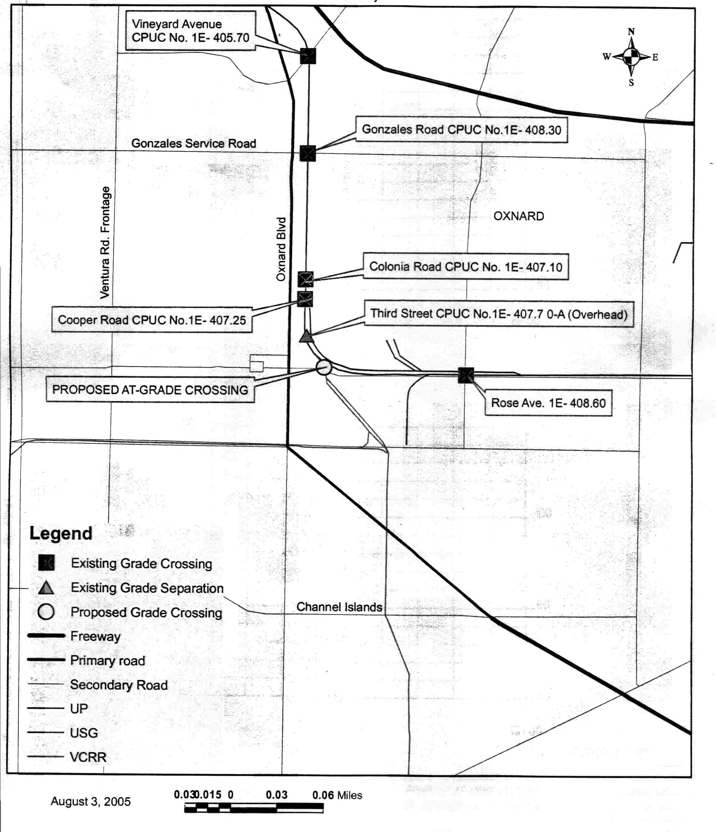

PLAN OF PROPOSED AT-GRADE CROSSING
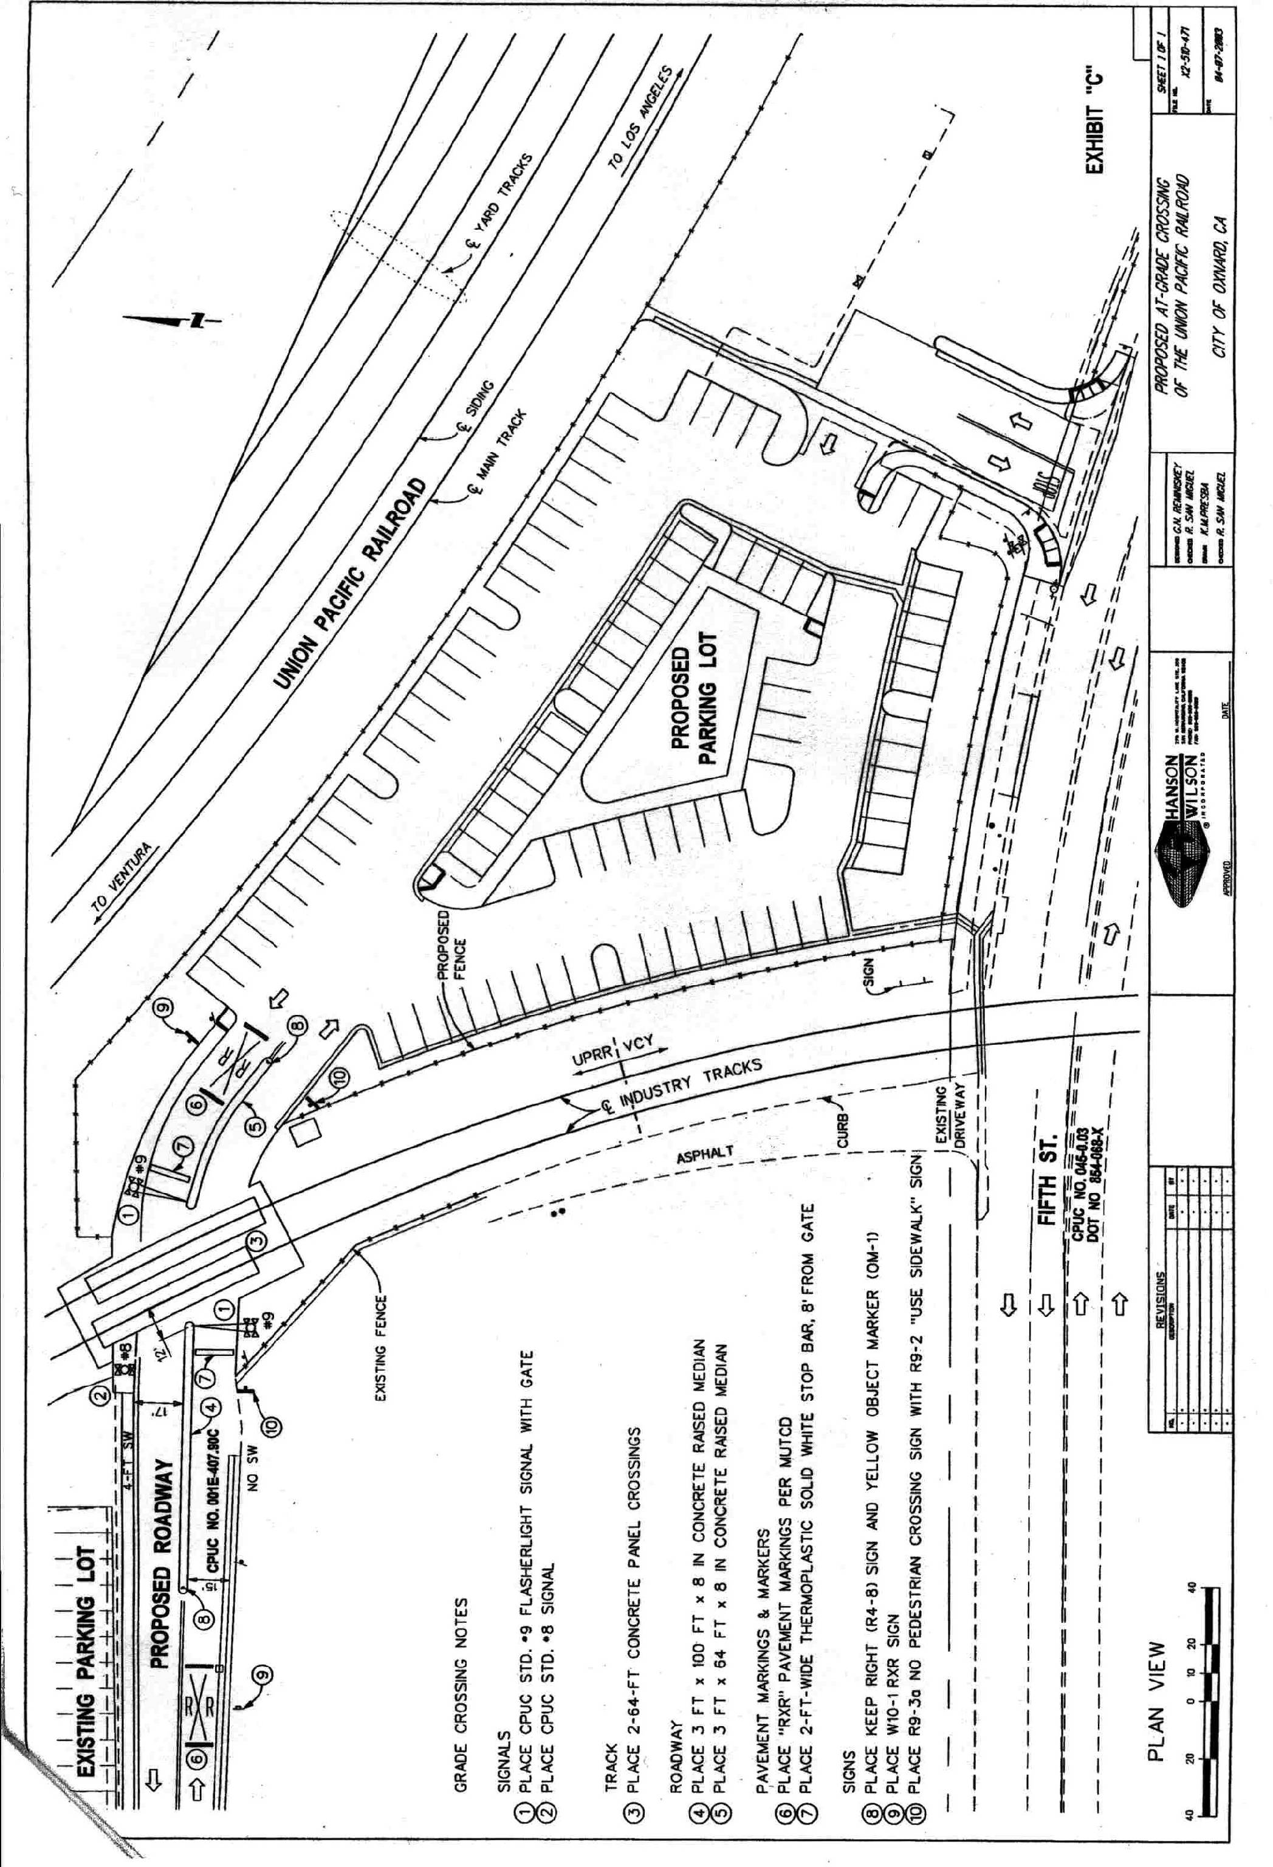

CEQA Guidelines (Title 14 of the California Code of Regulations), Section 15051(b).
CEQA Guidelines, Sections 15050(b) and 15096

