APPENDIX A

California Institute
for Climate Solutions

Table of Contents

1. Executive Summary…………………………………………………………………………. 3
1.a. Introduction……………………………………………………………………………. 3
1.b. Mission of the California Institute for Climate Solutions (CICS)…………………….. 4

2. Organizational Structure and Governance………………………………………………… 5
2.a. Governance and Administration……………………………………………………… 5
2.b. Leadership…………………………………………………………………………….. 6

3. Research and Education Themes…………………………………………………………… 9
3.a. Background……………………………………………………………………………. 9
3.b. Priority Program Areas………………………………………………………………. 11
3.b.i. Buildings and Homes: Energy Efficiency and Conservation…………………… 11
3.b.ii. Energy Supply, Sources, and Technologies…………………………………… 12
3.b.iii. Governance, Policy, and Management……………………………………….. 14
3.b.iv. Climate Forecasts and Analysis……………………………………………….. 15
3.b.v. Quality of Life: Health and the Environment………………………………….. 16
3.b.vi. Measurement, Informatics, and Analytical Infrastructure…………………... 18
3.b.vii. Education, Technology Transfer, and Product Development………………. 19

4. Research and Education Program Budget ………………………………………………. 20

5. The University of California – Overview…………………………………………………... 21

1. Executive Summary

1.a. Introduction
The University of California (UC) proposes to establish the California Institute for Climate Solutions (CICS) to address the impacts of climate change with new and innovative cross-cutting strategies and programs in energy and environmental research, technology development and deployment, climate economics, infrastructure design, socioeconomic impacts and responses, education, public services, and policy action. Research and education are critical components in identifying, developing and implementing solutions to climate change, and the UC can serve as a key partner supporting the efforts of business and government. The UC is prepared to make a major personnel, infrastructure, and public-engagement commitment to this Institute and to the study and design of strategies for addressing climate change as a state, national, and global issue.

In the face of unprecedented social and economic challenges, California has embarked on the most aggressive climate change policy initiatives in the country. The Governor and the Legislature have set forth ambitious greenhouse gas emissions reduction goals for 2020 and 2050 (including AB1493, AB32 SB1368), which will profoundly change the state’s electricity and transportation sectors. Furthermore, the consequences of climate change will force California to adapt its transportation, energy, and water infrastructure, as well as many public services, such as health and disaster relief. With a rapidly growing population — a 75% increase is projected in the next 50 years — California will have to address climate challenges while fostering the economic growth needed to support over 70 million people. The very nature of this economic growth will impact greenhouse gas emissions on a global scale.

While California has set forth bold goals to address both the causes and consequences of climate change, many fundamental challenges remain regarding how to best achieve these goals. The CICS will address these critical challenges by identifying and helping to design a broad set of policies that target critical carbon-intensive sectors of California economy. Policies must be crafted to induce the development and widespread adoption of new climate-friendly systems and the economic, legal, and policy instruments to bring new technologies into the mainstream.. State and local agencies must adapt to the consequences of climate change, especially in the areas of water resources, disaster preparedness (e.g., wildfires), and new threats to human health. One of the major legal issues for the state is whether and how new federal legislation will pre-empt California’s new policies. How should new policies be financed? How should policies be optimally monitored and enforced? In what way and how frequently should energy and climate-related policies be evaluated to ensure they adapt to future environment changes and refinements of scientific knowledge?

Another challenge is to evaluate the cost effectiveness and efficacy of the various strategies necessary to motivate individual people to change their behavior in ways that will lead to lower greenhouse gas emissions. These strategies include regulations, taxes and markets, incentives (for example, time-of-day pricing for electrical use), informing consumer behavior through carbon footprint and carbon content analysis, labeling, or pricing, public education, and access to new technologies. There is a great need to develop ways to evaluate how public choices are made, the degree to which education about energy and climate issues actually influences them, and how they are distributed demographically.

A third challenge is to rapidly conduct research and move into practice sustainable ways for people to live while maintaining quality of life, healthy ecosystems, and preventing disruptive effects of climate change. This requires a focused effort that is unusual for both government and research universities and persuading innovative and productive researchers to alter the direction of their research and contribute to achieving the vision of a sustainable future. A particular challenge will be to develop practices that safeguard and in fact address from the outset issues of social and environmental justice for disadvantaged communities.

A fourth challenge is responding to the need for a changing workforce. Enacting the kinds of technological and societal changes needed to reduce greenhouse gas emissions requires increased training of both students and the public in a range of areas. The UC system has exceptionally strong undergraduate, graduate, and postdoctoral training programs, as well as nationally recognized K-12 science outreach programs. Many campuses also host technology transfer offices and offer extension services that bridge university research and industry,

Each of these challenges requires sustainability as a solution. Sustainability will be the primary criterion for successful climatic and environmental impacts mitigation, and adaptation policies and practices.

1.b. Mission of the California Institute for Climate Solutions (CICS)
To address the consequences of climate changes on infrastructure, public services, and policies that will mitigate the effect of climate change, the CICS will have three missions:

- Identify and support researchers at all of the UC campuses and laboratories who can make a contribution to solving real problems related to energy, climate change, and quality of life
- Establish a system for accelerating research and analysis on specific issues relating to climate change (see Table 1) and its causes and consequences in California
- Educate and train a new generation of researchers and public officials to alter the direction of their research and contribute to achieving a vision of a sustainable future.

The CICS will bring together UC researchers to assist the Public Utility Commission (PUC) and other state agencies in resolving critical problems, conducting research, developing new modeling and planning analysis tools, analyzing and commenting on policy issues, and responding to informational requests from other agencies, municipalities and the general public. It will host active basic and applied research and education programs aimed at advancing the understanding of the relationship between climate, energy, and sustainable quality of life. As designed, the CICS will be responsive to ongoing policy issues and support high-risk, high-benefit efforts, as well as longer-term collaborations, and be a platform to leverage opportunities in federal, state, industrial, and venture capital markets.

Table 1: Mission-Oriented Institute Program Areas
- Buildings and Homes: Energy Efficiency and Conservation
- Energy Supply, Sources, and Technologies
- Governance, Policy, and Management
- Climate Forecasts and Analysis
- Quality of Life: Health and the Environment
- Measurement, Informatics, and Analytical Infrastructure
- Education, Technology Development, and Product Development

The Institute will be an active partner, designing and implementing short-term and long-term solutions to the diverse impacts of global climate change on California rate-payers, businesses, municipalities, and community groups, as well as in assisting the state in meeting regional and global challenges raised by the changing climate. This partnership will serve as a model program for engaging university resources to provide mission-oriented research, education, and policy support to public agencies that bridges the gap between research and application.

2. Organizational Structure and Governance

2.a. Governance and Administration
The CICS will be a dynamic research and educational partnership between the University of California, the PUC, and other stakeholders. Working together, this group will strategically develop and pursue a research and educational agenda that transcends individual interests and priorities. This necessarily requires an organizational structure that is able to (1) seamlessly integrate policy, science, and technology; (2) sustain efforts over an extended period; and (3) maintain a nimbleness that allows it to shift emphasis to immediate or critical problems as they arise.

A master agreement between the UC and PUC will allow for the efficient deployment of both short- and long-term task orders to undertake specific projects or respond to policy analysis requests. Task orders have been used successfully on several campuses and facilitate inter-campus agreements, allow expedited processing of time sensitive topics and provide an on-going mechanism in support of a regular consultative process. In general, task orders will be issued for projects identified and supported through the proposal process and headed by researchers with expertise in the principal area required by the individual task orders; project durations will range from a short period (e.g., a few months for expert reviews or analysis) to as long as several years. The structure of the CICS will also allow for periodic external peer review and reassessment of overall priorities and goals.

The task-order mechanism will also fund, through cost-sharing agreements, the CICS’s engagement with state municipalities, agencies, and the private sector in part through a parallel program of internship opportunities and visiting staff periods. In this way, the mission-oriented efforts of the Institute will support not only industry, government, and university professionals, but also researchers at all levels of the UC, from undergraduate to post-doctoral. These exchanges will serve several goals: (1) provide educational instruction or mentoring in the CICS’s areas of active work; (2) engage professionals from the public or private sector in specific program areas, or in the design or implementation of programmatic aspects of the mission of the Institute; and (3) provide opportunities for officials from agencies or industries outside California to participate in the development of technologies, programs, and policies to address climate change.

The Institute Director, in collaboration with the Steering Committee and Stakeholder Committee (described below), will prepare a 3-5 year strategic plan that establishes broad goals (Figure 1). The strategic plan will guide the development of an annual research and educational agenda, which will be collaboratively prepared with researcher and stakeholder input. The annual research and education agenda will identify short- and long-term priorities and broad research and educational funding topics. Once the research and education agenda is published, there will be an annual call for proposals falling into three categories: i) exploratory grants, which will fund short-term, higher-risk ideas; ii) larger, targeted grants, which will fund longer-term efforts and comprise over 2/3 of the program; and iii) continuing grants, which will be used to extend productive areas of research and education for an additional year or two. Both research and education proposals may be submitted for each of these categories. Partnerships with industry, non-UC research and educational institutions, and other stakeholders (e.g., NGOs) will be sought, where possible, to complement and extend research and educational objectives. Funded efforts in every category must include societal applications such as technology development, insight into policy implementation or analysis, and/or fundamental knowledge. All submitted proposals will undergo external review by a panel made up of both academics and stakeholders.
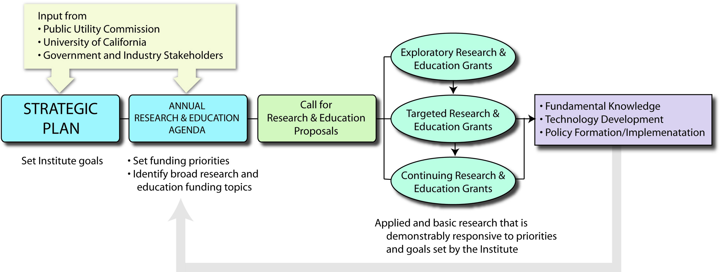

Figure 1. Organizational Process of the California Institute for Climate Solutions
2.b. Leadership
The CICS will be led by the Institute Director, who will report to the Governing Board and receive programmatic guidance and support from several key committees. The Steering Committee and Stakeholder Committee will provide broad programmatic direction to the CICS, and will represent the interests of the UC, PUC, and other stakeholders. The Program Council will assist the Director in ongoing activities regarding the conduct of research and education programs. The organizational structure is outlined in Figure 2.

Governing Board. The Governing Board will be co-chaired by the PUC President and the UC President, and will include additional senior personnel from each institution, and other state organizations and external experts. The Board will reflect shared governance over the strategic mission of the CICS and approve the strategic plan. The Governing Board will establish the Institute’s mission, and appoint the members of the Steering and Stakeholder Committees. It will oversee a regular review of program activities by internationally renowned experts unaffiliated with the Institute.

Institute Director. The Institute Director, a senior UC faculty member, will provide overall scientific leadership for the CICS and serve as the main point of contact between the Governing Board and the Committees that make up the Institute. The Institute Director will create for CICS participants an infrastructure that assures progress and quality are a central goal of the Institute. The Director’s key responsibilities will be to make decisions regarding research direction and financial activities. Among the duties, he or she will help researchers identify potential collaborators, including researchers who are working along similar lines on other campuses or universities, and stakeholder groups, and ensure that effective avenues of communication exist, both within the CICS and between researchers, decision-makers, and other stakeholders. Every year, the Institute Director, as Chair of the Program Council, will be responsible for issuing a call for proposals consistent with the science and education agenda. With advice from the Program Council, the Director will recommend to the Governance Board the set of projects to be funded and will ensure that those proposals are consistent with the mission of the CICS.

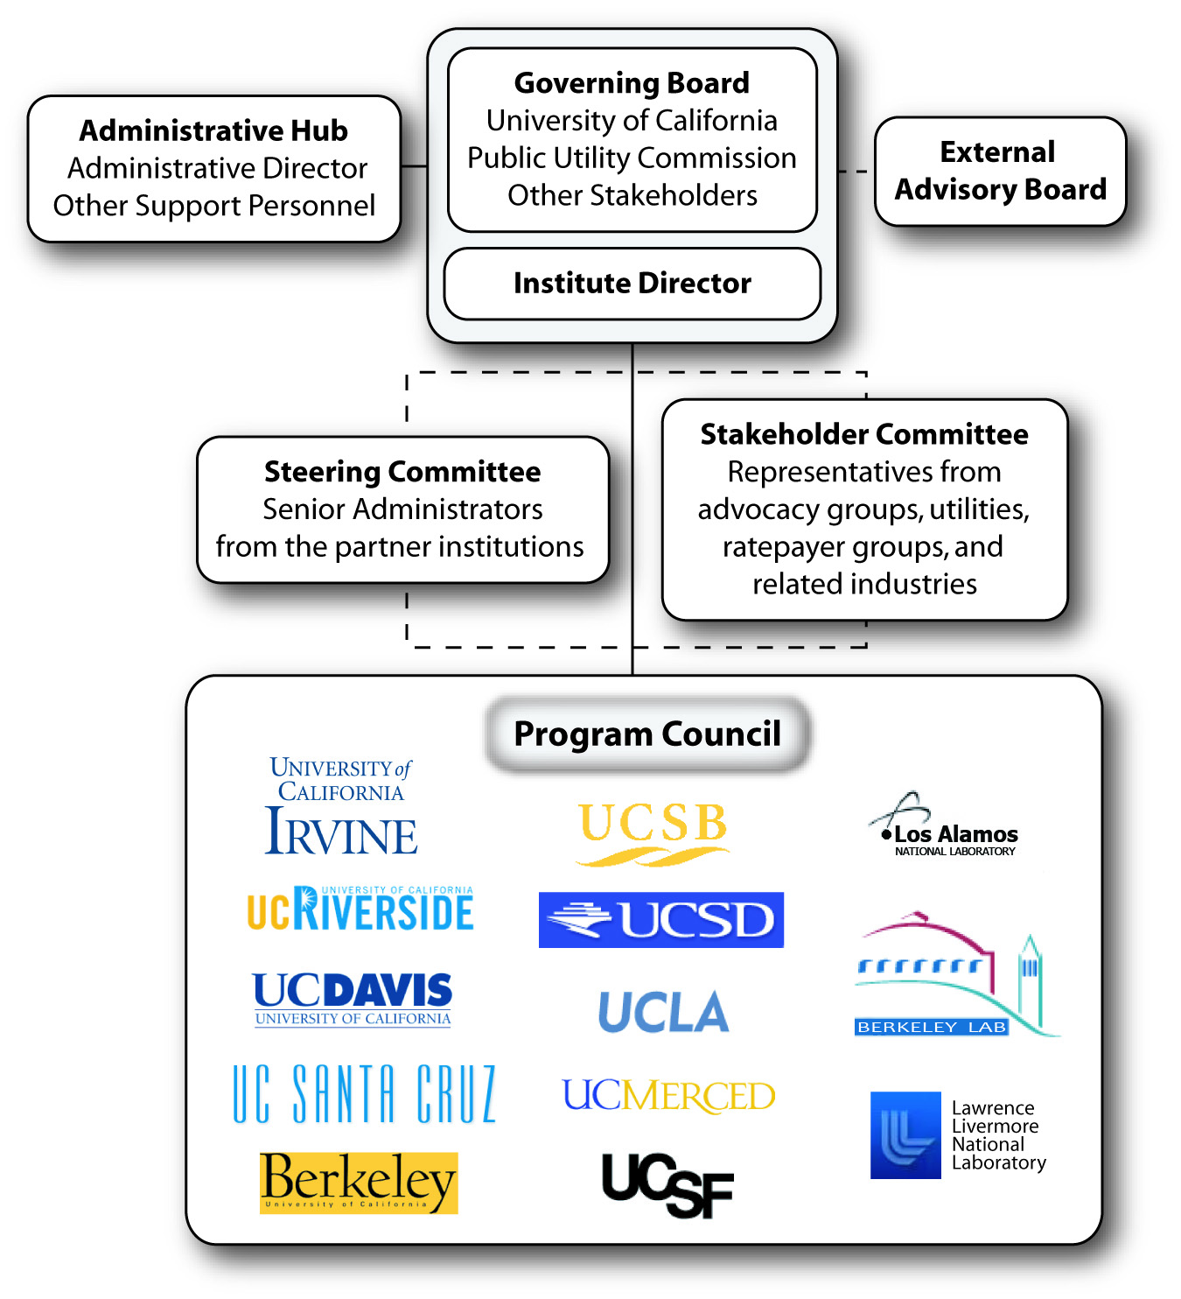

Figure 2. Key components and organizational structure of the California Institute for Climate Solutions

The Steering Committee. The Steering Committee will be made up of representatives from UC, its partner institutions, and renowned external experts. Together with the Stakeholder Committee (described below), the Steering Committee will act as a science advisory group and develop and publish an annual research and education agenda consisting of short-term and long-term topics. It will oversee budget allocations to those research and education areas. The committee will be appointed by the Governing Board and will develop a 3-5-year Strategic Plan, in partnership with the Stakeholder Committee; progress toward strategic goals will be reported annually, and will be accompanied with a 3-5-year content update. The Steering Committee will also serve as an ad hoc review and advisory group that the Institute Director may call upon from time to time to deliberate on policy matters, or to comment on how specific CICS efforts align with strategic priorities.

The Stakeholder Committee. The Stakeholder Committee will be composed of representatives from advocacy groups, ratepayers groups, environmental organizations, utilities, and related industries, and appointed by the Governing Board. The Stakeholder Committee, jointly with the Steering Committee, will serve in the role of key advisors, influencing the shape and content of both the strategic plan and the annual science and education agenda. Members of the Stakeholder Committee will also serve as an ad hoc review and advisory group who may be asked by the Institute Director, from time to time, to deliberate on policy matters.

The Program Council. The Program Council, comprising disciplinary research and campus representatives from the UC academic community, will be responsible for overseeing annual program progress toward the scientific and educational agenda. Several members of the council will be assigned to each of the primary program areas, and they will monitor and assess the success of each of the programmatic areas by reviewing periodic reports and conducting meetings. Periodic meetings of the Program Council will allow the members to discuss the progress made in each area and to identify cross-cutting themes, activities, and results. The Program Council will also ensure that the links between scientists and stakeholders are well established so information flows continuously between the two.

Another major role of the Program Council will be to oversee the proposal funding process. This includes (1) issuing the periodic call for proposals; (2) identifying and enlisting potential reviewers of proposals; (3) convening review panels to rank project proposals; and (4) recommending to the Institute Director the annual list of projects to be funded under each program. The Institute Director will make the final recommendation to the Governance Board.

Finally, the Program Council will include an Education Subcommittee that will be responsible for coordinating the education and outreach program. This will require them to leverage the existing outreach programs on each UC campus, the UCOP, and the PUC.

Administrative Hub. The Administrative Hub will serve as the main focal point for administrative operations, including identifying and resolving system-wide operational issues and coordinating inter-institutional operational solutions. A key member of the Administrative Hub will be the Administrative Director, who will (1) coordinate administrative activities with staff on each UC campus and the PUC; (2) oversee most administrative functions, such as financial management, personnel, purchasing, reporting, and event planning; and (3) act as a point of contact for government offices, other states, and foreign governments interested in partnering with or learning from California’s experience. The Hub will be responsible for the administrative operations associated with the annual call for proposals, and will staff the Program Council.

3. Research and Education Themes
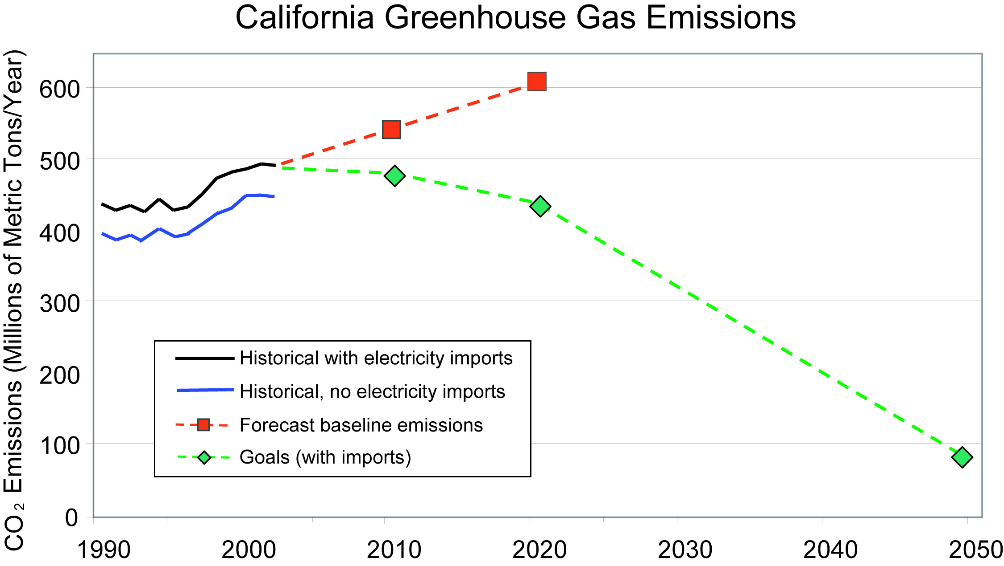
Figure 3. Historical and forecast greenhouse gas emissions, and California’s goals.
Source: Bemis and Allen (2005).
3.a. Background
California is facing the difficult challenge of attempting to meet its long-term energy needs while reducing and stabilizing greenhouse gas emissions to levels far below today’s emissions rate. The Governor and Legislature have adopted goals for 2020 and 2050 commensurate with the future emission pathways considered necessary to avoid dangerous climate change, while still allowing for global economic growth and development (Wigley, Richels et al. 1996; Baer, Harte et al. 2000; Hayhoe, Cayan et al. 2004; Intergovernmental Panel on Climate Change 2007).
Achieving greenhouse gas stabilization by 2050 will not be easy. The 2020 climate-stabilization target requires a reversal of historical trends (Figure 3), while the 2050 target calls for a profound change in energy supply and other parts of the economy. With the 2020 goal only slightly more than a decade away, and because energy technologies tend to be large, complex, and slow to change, to achieve the short-term goal California will need to rely on (1) mature technologies that are already in the market but are under-used; (2) technologies that can be commercialized within the next several years; and (3) a variety of non-technological solutions. The more distant, and far more ambitious, 2050 climate-stabilization goal requires a very different approach. The products needed to achieve the 2050 goal, such as vehicles and fuels, are not available today, so technological innovation will be required. Attaining the 2050 climate-stabilization goal therefore translates to major innovations and investments in new technologies, as well as changes in behavior. Government action is not only appropriate but necessary to bring these changes about because climate change is a market externality and, like most environmental protection, a public good. Without government intervention, markets ignore externalities and provide fewer products and services that cater to public good than is socially and economically optimal. In addition, innovation designed to achieve public good also requires government action (Arrow, Bolin et al. 1995; Norberg-Bohm 1999).

In general, any effort to mitigate greenhouse gas emissions will affect climate and quality of life (health, air and water quality) through a wide range of changes to the atmosphere, as well as to natural and managed (built) systems and how we live in them. An end-to-end analysis of particular strategies, which incorporates the significant predicted growth in California’s population, will need to encompass all of these potential impacts. Some aspects of climate-change mitigation will rely on voluntary choices made by the people of California. In addition to projecting the changes in personal choices required to achieve certain mitigation solutions, there is a need to educate citizens about these choices and evaluate the rate at which they are adopted.

Climate change, whether at the lower or higher end of projected levels, will produce substantial environmental and health impacts, and these impacts are inextricably linked to energy production and demand. In recognition of the interrelationships, we have adopted the following principles in developing the priority program areas for research, innovation, and education:
- Encouraging investment in and improvement of current and near-term knowledge, education, and advanced technologies that will help meet the 2050 goal, while supporting progress toward the 2020 goal.
- Stimulating innovation and development of new knowledge, education, and technologies that can dramatically lower greenhouse gas emissions at minimum cost and be deployed ideally by 2020 or soon thereafter, but clearly get the state on track for meeting the 2050 goal.
- Contributing to the attainment of the state’s objectives while ensuring economic growth, public health protection, air quality and other environmental protection goals, affordable energy prices, environmental justice, and diverse and reliable energy sources.

3.b. Priority Program Areas
The CICS will initially focus on five primary research areas to address the causes and consequences of climate change in California as well as supporting two key cross-cutting themes that clearly underpin efforts in each of the primary research areas: measurement and informatics and education and technology transfer. It is important to note that all of these program areas should not be considered lists of projects, but rather those topics, concepts, and areas in which the greatest intellectual and public/private innovative capacity must be brought to bear. There are numerous situations in which these five areas overlap; cross-cutting impacts are ubiquitous throughout the program areas. This intentional redundancy ensures that the program as a whole will be greater than the sum of its parts, that a multifaceted approach is taken to address each area, and that the entire UC system knowledge base is leveraged. Finally, we have made certain that policy analysis has been built into each focus area so that social scientists will work alongside natural and physical scientists, and together they will partner with policymakers and consumer groups to inform each other and the general public.

3.b.i. Buildings and Homes: Energy Efficiency and Conservation
Buildings and Homes
Opportunities and Impacts
- Improved building codes will reduce energy use and enhance development
- Advanced end-use technologies will improve energy efficiency
- Real-time monitoring will enhance user conservation practices
Buildings currently use approximately 68% of all electricity and 34% of all natural gas consumed in California, thus California cannot succeed in addressing energy challenges without an aggressive program focused on building-energy performance. With a projected state population of 59 million people in 2050, this program area will focus not only on making efficiency and conservation improvements to existing structures, but also planning and designing more-efficient urban and suburban development where new residents will live and work. The location, demography, and forms of urban growth will impact greenhouse gas emissions from virtually all major energy sectors, including transportation, residential, and electrical-energy generation. Plans for new urban growth seldom incorporate measures to assess and reduce greenhouse gas emissions, despite the potential for land use and planning policy to help California meet its regulatory goals.

Energy efficiency innovations, for example, new or improved technologies, residential and commercial practices, pricing strategies, and innovative policies such as the decoupling of electricity sales and revenues, have transformed the California economy. While California is as much as 40% more-efficient per capita than the U.S. as whole, there still exist tremendous opportunities for continuing and even accelerating efficiency gains. Total emissions per capita must decrease if greenhouse gas emissions are to decline in an era with continued rapid population increase. Enhancing building codes; installing cool roofs; benchmarking industrial energy use; integrating new energy and environmental sensing technologies into building and houses; prototyping, developing and applying lower-cost and higher functionality ‘smart’ meters; and advancing battery technology, solid state lighting, power storage, and energy-oriented nano-technology all offer the potential for a ‘second revolution’ of energy efficiency. New approaches to designing the urban and suburban landscapes in ways that minimize transportation-related emissions and take advantage of landscaping to enhance local climate and environmental quality will also be required to extend emission reductions while sustaining growth in new communities.

As reflected in AB32 and SB1493, the regulatory burden of addressing climate change will fall most heavily on the transportation and electric-power sectors. The state currently faces a wide array of policy approaches for mitigating greenhouse gas emissions within these two critical sectors of the California economy. Policymakers will need to analyze the likely impacts of alternative policy approaches; within the electricity-supply sectors, candidate policies include renewable portfolio standards, an emissions cap and trade program, mandated best available technologies, tax breaks and rebates for renewable energy sources, and subsidies for research and development of new technologies through the energy supply chain.

The critical challenge for improving energy efficiency and conservation in buildings is recognizing that knowledge in public, private, and university spheres must be integrated. Energy science and technology research must be coupled with robust policy and economic analysis, ultimately leading to aggressive implementation efforts. Widespread implementation of new technologies and behaviors will depend on the modification of building codes and other regulations, consumer expectations and behaviors, financial incentives, and product availability, among others. UC programs can partner productively with local and regional NGOs in nascent efforts to influence governments, industries, and the public by offering substantive information and credibility. While maintaining academic objectivity, UC faculty, students, and research staff can actively participate on the advisory and governing boards that are responsible for developing and implementing programs to increase energy efficiency and conservation.

3.b.ii. Energy Supply, Sources, and Technologies
As described in the previous section, increased population and changes in climate will clearly impact energy demand. Meeting those increased demands without increasing greenhouse gas emissions will require not only energy efficiency and conservation but also the development of new energy sources and technologies. UC researchers are currently participating in the development and innovation of numerous low-carbon renewable-energy technologies that are the subject of increasing state and national interest, including wind energy, solar photovoltaics, solar thermal energy, ocean energy, geothermal energy, and interactions of biology and nanotechnology with energy systems design.
Energy Supply, Sources, and Technologies
Opportunities and Impacts
- Deploy next-generation solar, wind, biofuel, geothermal, and environmentally sensitive hydro power to achieve California’s emission targets
- Reduce costs of carbon capture and sequestration and ensure permanence of storage
- Next-generation biofuels and distribution networks will expand energy sources

In this program area, research and education will focus on developing new and innovative approaches to standard and renewable energy sources and technology. More research is needed to identify sustainable resources suitable for providing fuel and energy, for making those resources cost-effective and competitive, and for assuring that they do not bring unintended consequences that create new problems or exacerbate old ones (e.g., air pollution).

Climate warming is expected to shift the state’s hydroclimate toward a more flood-prone regime. This, coupled with the risk of catastrophic fire, has serious implications on a reliable supply of hydropower, which currently provides more than 15% of California’s energy, and is especially important during periods of peak demand. There is great potential to develop new solar energy sources, which fall into three categories according to their primary energy product: solar electricity, solar fuels, and solar thermal systems. Each of the three generic approaches to exploiting the solar resource has untapped capability well beyond its present usage. All three categories can benefit by the development of new materials to efficiently absorb sunlight, new techniques to harness the full spectrum of wavelengths in solar radiation, and new approaches, based on nanostructured architectures, that can revolutionize the technology used to produce solar electricity. Basic research is needed to develop approaches and systems to bridge the gap between the scientific frontier and practical technology. Across all solar technologies, the current rate of scientific discovery is simply too slow to match the rate at which technological advances are needed to bring new products to bear on the state’s urgent energy needs.

As wind and solar power become more cost-effective, issues of intermittency and energy storage must be addressed. We must advance the capabilities to efficiently produce and store energy during peak production times so it can be used during peak consumption periods. Electromechanical and electrochemical technologies for energy storage must be advanced for use in large-scale renewable energy systems; they are also required for large-scale deployment of hybrids and plug-in hybrids, as well as a huge market in consumer goods. Furthermore, integrating all energy production and storage systems requires a reliable and secure transmission grid system. California needs to begin to strategically invest in an intelligent grid-system that spans all regions of the state.

Finally, the technologies for removing greenhouse gases (especially CO₂) from the atmosphere require careful consideration. A number of potentially promising technologies (e.g., biosequestration, gas and liquid trapping, sorption to mineral phases) will require careful cost-analysis in the short and long term. California has an enormous sequestration resource, estimated between 180 and more than 800 Gt CO₂. This resource can hold emissions from large point sources, including natural gas power plants, refineries, ethanol plants, and cement manufacturing plants. In short, carbon capture and sequestration (CCS) has the potential to dramatically reduce net carbon dioxide emissions within and outside the state. The principal issues surrounding CCS are the stability and accessibility of geologic storage sites, investment in the needed infrastructure, cost, and risk. There is a need to sustain biosequestration by better understanding the carbon dynamics of forests, agricultural sources and sinks, and wildland accumulation. For example, many current agricultural and production forestry practices actually reduce carbon storage in comparison to wildland preservation and minimum tillage approaches. If found to be a cost-effective method for providing stable, long-term storage, sequestration could permit fossil-fuel baseload power plants to operate while still achieving the state emission-reduction targets outlined in AB32 and SB1368. Research and development is needed to both reduce costs for these CCS technologies and to develop new technologies beyond these options.

Large-scale state-wide application of CCS to reduce CO₂ emissions will depend on demonstration projects at a scale that tests our knowledge of site characterization, capture and sequestration processes, and operations. California is a centerpiece of large-scale demonstration projects, such as the WestCarb activities and the large, industrially-based project at Carson, CA. Through demonstrations like these, the CICS partners will develop protocols for risk assessments and regulations, as well as monitoring plans, that will allow safe and efficient operation of large-scale CCS projects. These protocols and regulatory frameworks need to be developed and, when completed, could serve as national standards.

3.b.iii. Governance, Policy, and Management
Governance, Policy, and Management
Opportunities and Impacts
- Project California’s energy future to identify technology, resource, and policy needs; integrate risk assessment methods
- Conduct short- and long-term regulatory and economic analysis toward efficient energy and other resource markets
- Use new life-cycle methods for greenhouse gas, water, and consumer product assessments, and product accounting and labeling
Effective mitigation policy in support of AB32 and SB 1368 must be based on current scientific knowledge of the full range of activities that alter climate. Transforming the economies of California, the U.S., and the world to operate under climate-change constraints, all while ensuring economic growth, will necessarily involve a number of interrelated policies. This transformation must be based on knowledge of the efficacy and reliability of various energy sources, as well as address the economic and security risks inherent in the energy sector. Success in mitigating climate change will require the harmonization of efforts among several regulatory agencies, as well as private and public sectors, and the combining of innovative governance approaches, attention to environmental justice concerns, and sophisticated legal crafting with a systemic view. The primary mission of this program area is to translate science into policy recommendations and to harness ongoing social science research to support policy analysis.

Efforts in this program area will focus on short-term and long-term regulatory policy analysis of market options, the ways in which environmental governance can be implemented, and the efficacy of mitigation strategies. Studies of innovative environmental governance will assist policymakers and regulators in developing and testing new and innovative alternatives for the variety of sector-based concerns raised by the economy-wide climate challenge. These activities are also intended to support the development and implement of new approaches being developed by business, and government.

Over the past 15 years, the United States has invested heavily in scientific research, monitoring, data management, and assessment for climate-change analyses to build a foundation of knowledge for decision-making. Formal assessments, that involve exploring the uses and identifying the limits of evolving knowledge to manage risks and opportunities, are a key component of both policy-making and decision-making. The CICS will sponsor an ongoing synthesis and assessment program, with key products timed to support a range of actions in support of AB32.

The Institute will also explore the use of advanced modeling in decision support for adaptive management and a range of options that go well beyond what is currently in place in applications. Analyses will be built around projections of future California energy requirements, consumer behavior, energy production technologies, and projections of the costs, availability, and environmental impact of resources. The future system structure depends on technology developments, the cost and availability of resources in California, and the required level of greenhouse gas reductions. The CICS will identify practical options for the future California system, identify the key decision points and alternatives along the way, and identify the key information about technologies and resources that are needed to make those decisions.

3.b.iv. Climate Forecasts and Analysis
Climate Forecasts and Analysis
Opportunities and Impacts
- Produce predictions of climate-change impacts to California’s water system, air quality, and ecosystems
- Deploy intensive monitoring system to examine state climate and climate-change indicators
- Develop regional/local analysis and modeling system
With the passage of AB32 and SB 1368, California has taken decisive steps to moderate global warming through reductions in greenhouse gas emissions. Observations demonstrate that climate is already changing and projections indicate that climate in California will change substantially, despite having in place the most-aggressive greenhouse gas mitigation policies in the country. Thus, progress in meeting California’s emission targets will be affected by the continual evolution of the water, transportation, and energy sectors in response to the changing environment. We know that climate change will produce a cascade of effects: warming will alter the hydrologic cycle in the form of more rain and less snow, increased evaporation, and likely acceleration in the rise of sea level. This, in turn, will change energy demands for transporting water around the state, influence people’s choices about where to live and work, and potentially affect food security, due to impacts on the agricultural sector. It is crucial for California to have the capacity to understand these cascading effects in regional and local detail, because these changes will likely have profound impacts on not only the supply and demand of energy in the state, but also water supply, water and air quality, agriculture productivity, human health, ecosystems, and many other vital resources.

In this program area, the CICS will provide detailed and robust forecasts of climate change to help safeguard the state’s social and natural infrastructure and its vital economic sectors, and provide a better understanding of the conditions that drive energy supply and demand in California. Research in this program area will generate state-of-the-art regional and local predictions of climate changes and their downstream impacts on energy, water, and other sectors so that California can continuously update its approach for managing supplies of water and energy, and adapt its infrastructure for transportation and industry. This program area will develop an interactive analysis and modeling system that links global climate, regional climate and weather, and local impacts, such as those described by hydrology, airsheds, coastal zones, and other applications models. California’s location on the border of the Pacific basin, which modulates current climate and will certainly affect climate change in the state, requires that regional modeling will need to include an interactive coastal ocean component. Thus, the modeling system will be designed to encompass a hierarchy of models that simulate and predict climate and its impacts.

The modeling system developed in this program area will be tailored to address public policy needs in conducting risk assessment, and exploring options for adaptation/mitigation at the state and local levels. Models forecasting climate change at the level of the State of California are rapidly improving; an aspect of producing better climate forecasts must involve a high-level analysis capacity to test and improve models in the context of a range of historical and real-time observations. To be most effective, this effort will be carried out in concert with intensive monitoring of state climate and climate indicators. Because climate forecasts will always carry substantial uncertainty, a crucial element of the modeling and analysis effort will consist of developing an ensemble of possible climate-change scenarios that can be used to assess climate and climate impacts probabilistically, and to provide this in sufficient detail that decision makers can evaluate possible outcomes. This interlinked climate modeling and analysis system will also allow an assessment of vulnerabilities, extreme events, and possible tipping points. In particular, the modeling and analysis conducted in this program area would aim to understand and predict heat waves, floods, drought, and hazardous-air-quality episodes.

3.b.v. Quality of Life: Health and the Environment
This program area will conduct research and education that focuses on determining the direction, magnitude, and frequency of health and environmental change in California. Efforts will focus on characterizing and understanding the effects of climate change on our natural and human surroundings, and will bring forward new and innovative methods to minimize or eliminate these effects in conjunction with state and local agencies. Understanding who and what is at greatest risk from current patterns, and how impacted segments will be affected by different policy choices are critical to targeting resources and building consensus.
Quality of Life: Health and the Environment
Opportunities and Impacts
- Identify potential health issues from climate change (e.g. heat waves, droughts, changes in disease vectors)
- Improve air quality through monitoring, modeling, and reductions in particulate- and ozone-causing emissions
- Deploy observational network for ecosystem impacts and monitor feedback from climate change

The vitality of California’s society and economy are inextricably linked to the health of its population and its environment. Health is affected by a variety of exposures that occur indoors and outdoors (e.g., to pollutants and extreme temperatures) and many of these exposures will be modified by climate change, by adaptations to climate change (e.g., more air conditioning), and by efforts to mitigate climate change.

One focus of this program area is the impact of climate change and energy policy on (1) exposure and health effects in marginalized communities, and (2) the environment. This includes heat-related exposures, air quality changes, water quality, and indirect effects, e.g. soil moisture effects on disease vectors. It is expected that this research will make use of existing health data, direct measurements of air and water, modeling, and social science data. Climate change, and the climatic and environmental impacts of changes in energy use strategies, will impact California’s diverse communities and natural resources to different degrees. Aspects of mitigation that rely on voluntary choices need to be enhanced through education and outreach to all communities, and impacts on natural resources must be minimized. Equally important will be to project the change in personal choices needed to achieve certain mitigation levels, and then evaluate the rate at which California is moving toward those choices.

This program area will combine research and education on issues related to environmental justice and equity with a unique new social extension and partnership program. In this program, we will provide energy and society extension services; offer short courses and yearlong fellowships to underserved communities, labor, and communities involved in environmental justice issues; and create convening mechanisms to bring together key stakeholders in business, government, and environmental justice communities to discuss issues and policies.

Another focus of this program area is to sustain California’s environmental quality and ecological diversity despite the challenges posed by climate change. The health of the state's environment is directly linked to the availability and quality of California's water, air, land, and ecological resources. Through careful management of its natural environment, the state has ensured reliable supplies of water; however, the provision of adequate water could be seriously affected by the environmental impacts of climate change. These impacts include significant reductions in snowpack in a warmer California climate; a loss of forest vitality, which mitigates the effects of flooding and erosion; reductions in commercial and sport fishing industries; and rising sea level changes coupled with biological disturbances, such as harmful algal blooms and waste-disposal conditions. Researchers at the CICS will actively partner with state agencies to monitor, predict, and mitigate the impacts of climate change on these vital ecosystem services.

California has some of the worst air quality regions in the country in terms of ozone and particulate matter concentrations. The local, state, and federal governments and agencies are concerned that climate change will exacerbate California’s already severe air quality problems. Particulates and ozone formed by photochemical smog contribute directly to climate change regionally and globally, and indirect effects of pollution include changes in the lifetimes of greenhouse gases. Air quality is important to climatic, human, and ecosystem sustainability.

Finally, with climate and hydrologic modeling, and the new measurements needed to drive these models, CICS researchers will provide needed understanding of forest management and climate-change effects on mountain precipitation and runoff, help to identify sustainable watershed and forest management practices, investigate impacts of changes in land cover and land use in source-water areas, and explore the effects of increased demand to optimize production for agriculture and urban needs. In short, research conducted in this program area will help us better understand watershed management practices (to increase the efficiency of water use and harness for energy generation), the tradeoffs of transporting water versus desalinization, the effect of climate change on air quality, and how actions taken to mitigate greenhouse gas increases will impact air quality at a range of spatial scales.

3.b.vi. Measurement, Informatics, and Analytical Infrastructure
Measurement, Informatics and
Analytical Infrastructure
Opportunities and Impacts
- Monitor greenhouse gas inventories and emissions target verification
- Develop real-time data flow of energy demand and use across industrial, commercial, and residential energy use
- Ecological monitoring of marine and freshwater fish populations
The CICS will construct and maintain a multifaceted, longitudinal, and shared database to be used by all CICS participants. This database will be in the form of an internet server — easily accessible to all participants — that has the computing power to run the kinds of complex analyses required to understand the intricacies of climate change. It will leverage the vast computing power of existing data centers at the UC campuses and our partners (e.g., LLNL). The information and analysis system will harvest multi-source data, multi-scale data, and generating data products to address key policy issues using the best available observations and model results. The scope of information sources will encompass observing networks and existing local, state, and federal sources, and will allow for the integration of future sources through an open standards approach. Data libraries will be routinely updated to document the expected changes in future climate and their associated uncertainties. This digital library will be available to all impact planners, giving them a quantitative description of the expected future changes upon which to build policy directions.

The first step to building the kind of databases necessary for both short-term progress and long-term sustainability is identifying the range and scope of climate-change effects, and the types of informed decisions that must be made about mitigation activities. These questions drive the need for continuous, current information, ranging from observations of climate, air quality, and energy use to health-related factors. These data allow us to build and test better predictive models and to better understand the interrelationships between climate and its impacts (e.g., forecasting the relationship of energy demand to temperature, the relationship of snowpack to water and hydroelectric energy supply, or the impact of locally-sourced goods versus those transported over long distances on air quality and health).

Among the types of measurements that will be made and existing data that will be captured for portal availability are: temporally disaggregated electricity demand information for representative classes of consumers across the state; spatially, temporally and functionally resolved energy use information from sensors placed in representative buildings; energy use patterns across a range of consumer categories; energy supply characteristics at sufficient detail to resolve patterns and provide a basis for optimal use; environmental data, such as precipitation, snowpack, soil moisture, evapotranspiration, and runoff measurements from source-water catchments in support of hydropower and watershed management research; information on the demand for and use of energy and climate information by various categories of stakeholders; and water use patterns in relation to pumping and other power uses.
Reliable data from a variety of user groups, from research to mitigation to adaptation, is a vital resource that California and its partners need in order to deal with the energy-related impacts of climate change. This program area will collect and verify both real-time and snapshot data, and act as a clearinghouse and data verification resource for the UC, the state, its partners, cities, utilities, and other businesses and communities involved in climate-change mitigation and adaptation.

3.b.vii. Education, Technology Development, and Product Development
Education, Technology Development, and Product Development
Opportunities and Impacts
- Develop and distribute educational and outreach materials
- Engage stakeholders and user groups to ensure high-priority goals are being achieved
Translating new knowledge into forms useful for energy producers, energy consumers, and decision makers across multiple sectors requires credible institutions, sustained efforts, and flexible approaches that recognize a range of needs and capacities to use that information. The CICS will leverage the existing outreach capacity on all UC campuses and the UC Office of the President, spanning K-12 teacher education to programs that encourage “the average citizen” to serve the regions in which they are located. In addition, as a unique provider of California’s future workforce participants, the UC must begin to train the type of workforce that the state will need to meet future challenges.

This program area will focus on UC based efforts related to developing a strong and trained future workforce, including such elements such as adding new minors to current UC majors, developing new majors, offering unique opportunities for internships with industry and policymakers.

In addition, this program area will focus on integrating and distributing information conducted in each of the other priority areas, moving that knowledge to campus outreach and extension personnel, and assessing and improving the effectiveness of CICS programs through bidirectional communication with stakeholders. The types of activities that will be part of this effort include focused interviews and surveys designed to better identify and document the need and demand for energy and climate information in the state across multiple sectors; monthly energy and climate newsletter(s) that translate timely forecasts and other information into forms usable for stakeholders; regional, topical workshops involving program results and related information; attendance of stakeholders at key meetings of outreach and science program participants; and follow-up, valuational assessments of stakeholder demand for and use of energy and climate forecasts, and other information. Communicating new knowledge effectively throughout the UC will be the primary aim of this program area and, because it is of critical importance, will also be the focus of the Educational Subcommittee of the Program Council.

The transfer of technology from research to end-users will be one of the missions of the Institute. The CICS will bridge the gap between researchers and end-users by developing business models that translate research results into viable business structures — by creating initial demonstrations of those business solutions, bringing stakeholders together, and conducting other programs that publicize climate-change solutions.

Because the CICS will present and advocate solutions in several widely varying program areas, its technology transfer activities will vary depending on the application and end-user. On one level, research and business consulting represents a lower amount of involvement from the CICS; this type of activity would encompass public-private workshops that the CICS would host to help outside partners interact and discuss market ideas. On a second level, licensing university research solutions to private-sector partners would represent a higher level of involvement of the CICS. The most complex involvement between the CICS and outside partners would be in evaluating new business ventures, where detailed market analysis is required. Regardless of the level of technology transfer, one common theme cuts across all applications: business planning needs to begin during the research phase and carry all the way through to market introduction. If research plans do not consider market forces, their solutions may never be competitive.

The University of California already has a resources network that can serve as a model for information and technology transfer from the research programs to policy makers and the public, and has begun initiating new efforts to develop information networks. For example, the UC has hosted workshops on developing carbon-emission measurements and credits for wildlands, agriculture, and urban areas. Enacting the kinds of technological and societal changes needed to reduce greenhouse gas emissions requires increased training of the workforce and citizens in a range of areas. The UC provides the means to develop the educational resources needed to meet these needs. Technology transfer activities at the CICS will leverage existing technology transfer programs at all UC campuses and the UCOP. The CICS funding will be instrumental in expanding these capabilities at all campuses to optimize technology transfer activities for technologies that assess and mitigate climate change.

Private-sector partners will benefit from participating in EEC technology transfer activities through opportunities to: (1) review ideas with business and research experts; (2) expand the mindset of each participant through constructive interactions between industry and academia; (3) provide visibility for industry products and solutions; and (4) recruit students for future internships and employment.

4. Research and Education Program Budget

The UC has developed an approximate budget for the stated research and education program. We have not allocated funds to specific research and education themes because this would be the mission of the Steering/Stakeholder groups with final approval by the Governance Committee.

Research and Education Programs | 353,000,000
Symposiums, Conferences | 5,200,000
Education, Outreach, Communications | 5,000,000
Fellows Program | 9,500,000
Internship Programs | 5,800,000
Strategic Opportunities | 35,000,000
Indirect Costs (26%) | 107,510,000
Equipment Costs | 78,990,000
PROPOSED RESEARCH PROGRAM COSTS | 600,000,000

The cost estimate for the civic/governmental fellows program assumes a budget of about $200K/yr per position (and escalated as noted above). This provides salary and supplies budget for fellows visiting the institute on a sabbatical leave from public sector positions. Support for two positions is anticipated for the first three years, four positions for the second three years, and six positions for the final four years. We envision a parallel program for visiting industry fellows, but anticipate that this might be part of an industry consortium arrangement and would not be funded through the budget provided by the PUC. A contingency of about 5% is provided for opportunity funds that will allow institute leadership some flexibility to take advantage of strategic opportunities. Equipment costs are estimated to total approximately $79 million over 10 years. This is a preliminary estimate based on the cross-cutting area needs for the measurement and informatics area and supports equipment purchase ranging from basic computing equipment to complex monitoring systems for remote sensor systems.

5. UC Resources

The University of California has ten campuses – Berkeley, Davis, Irvine, Los Angeles, Merced, Riverside, San Diego, San Francisco, Santa Barbara, and Santa Cruz – but UC’s presence extends far beyond these. UC campuses and programs are integral contributors to the health and prosperity of California communities across the state. The size and breadth of the University’s intellectual and scientific resources give UC a unique ability to tackle many of the challenges facing California, the nation, and the world on the scale that modern challenges require.
The University's fundamental missions are teaching, research and public service. The ten campuses of the University of California provide exciting environments that foster world-class educational and research opportunities and generate a wide range of benefits and services that touch the lives of Californians throughout the state. The UC family includes more than 209,000 students, more than 170,000 faculty and staff, 45,000 retirees and more than 1.4 million living alumni. UC’s academic offerings span more than 150 disciplines, with more departments ranked in the top 10 nationally than at any other university.
Instructional programs at the undergraduate level transmit knowledge and skills to students. At the graduate level, students experience with their instructors the processes of developing and testing new hypotheses and fresh interpretations of knowledge. Education for professional careers, grounded in understanding of relevant sciences, literature and research methods, provides individuals with the tools to continue intellectual development over a lifetime and to contribute to the needs of a changing society. Through our academic programs, UC helps create an educated workforce that keeps the California economy competitive. And, through University Extension, with a half-million enrollments annually, UC provides continuing education for Californians to improve their job skills and enhance the quality of their lives.
Its basic research programs yield a multitude of benefits for California: billions of tax dollars, economic growth through the creation of new products, technologies, jobs, companies and even new industries, agricultural productivity, advances in health care, improvements in the quality of life. Finally, through its public service programs and industry partnerships, UC disseminates research results and translates scientific discoveries into practical knowledge and technological innovations that benefit California and the nation.
In addition, UC is involved in the management of three U.S. Department of Energy laboratories – Lawrence Berkeley and Lawrence Livermore in California, and Los Alamos in New Mexico. These laboratories are performing cutting-edge research in fields ranging from national security to energy efficiency. With nearly 19,000 employees, the three laboratories have become unparalleled research and development centers. The laboratories also contribute to the nation's economic competitiveness through partnerships with industry, and all are leaders in math and science education, helping to enlighten, educate, and train students and teachers at all levels.
The University of California has always played a key role as a center of innovation and technology development. By attracting research funds, enhancing employment and productivity, and producing business spinoffs, UC has been instrumental in the success of some of the world’s most dynamic regional economies in the world. UC contributes to innovation through two primary pathways: research-and-development activities that enhance both labor and capital productivity; and technology transfers and business spinoffs that carry UC discoveries into the marketplace. Both impacts have proven very beneficial to California.

(END OF APPENDIX A)

