WATER/RSK/FLC/PTL/MCV/MDC/jlj

PUBLIC UTILITIES COMMISSION OF THE STATE OF CALIFORNIA

DIVISION OF WATER AND AUDITS RESOLUTION NO. W-4780
Water and Sewer Advisory Branch August 20, 2009

RESOLUTION

(RES. W-4780), SERENO DEL MAR WATER COMPANY (Sereno). ORDER AUTHORIZING A GENERAL RATE INCREASE PRODUCING ADDITIONAL ANNUAL REVENUE OF $7,366 OR 7.30% IN TEST YEAR (TY) 2009 AND $10,732 OR 9.90% FOR ESCALATION YEAR 2010.
__________________________________________________________

Summary
By Draft Advice Letter filed on December 31, 2008, Sereno, a Class D water utility, seeks to increase its rates for water service to recover increased operating expenses and earn an adequate return on its plant investment. The Division of Water and Audits (DWA) accepted this draft advice letter as complete for filing on February 19, 2009.

For Test Year 2009, this resolution grants an increase in gross annual revenues of $7,366 or 7.30% for TY 2009 and additional annual revenue of $10,732 or 9.90% for the escalation year 2010. The gross annual revenues were estimated to provide an Operational Rate of Margin (ROM) of 24%.

Background
Sereno is a wholly-owned subsidiary of Russian River Utilities and it serves 126 metered rate residential customers in its service area which is adjacent to Highway 1, approximately 3 ½ miles north of Bodega Bay in Sonoma County.

Sereno has requested authority under General Order 96-B, Water Industry Rule 7.3.3(5), and Section 454 of the Public Utilities Code to increase its revenues by phasing increased revenues over three years as follows: $8,100 or 8.73% in 2009; $4,400 or 4.36% in 2010; and $7,400 or 7.03% in 2011. Sereno’s request is based on its estimated ROM of 19.85%.

The present rates were established on March 14, 2008, by approval of Advice Letter 42, which authorized a 4.1% Consumer Price Index for 2007.

The DWA recommends the phased-in increase in revenues over a two-year period instead of Sereno’s three-year period increase in its rates.

DWA’s estimated present-rate gross revenues for 2008 are $101,094. DWA’s estimated revenues for TY 2009 are $108,460 and $119,192 for 2010 at DWA’s recommended rates.

The last general rate increase was granted on February 11, 2004, pursuant to Res.
W-4459, which authorized a rate increase of $1,633 or 2.17%, resulting in a rate of margin of 20%.

Notice AND PUBLIC MEETING
A notice of the proposed rate increase was mailed to each customer on March 9, 2009. The DWA received three letters in opposition to the rate increase. Sereno responded promptly to the letters and shared its response with the DWA. The Commission’s Consumers Affairs Branch has not received any complaints in the last twelve months.

A public meeting was held on April 13, 2009, at the Bodega Bay Fire Protection District located at 510 Highway One in Bodega Bay, and was attended by twelve customers. The Commission Staff explained the process of the rate increase for Class D water utilities and Sereno’s representatives explained the reasons for the rate increase, and their proposed conservation or tier rate structure. The rest of the meeting consisted of comments and questions by the customers.

DISCUSSION

The DWA made an independent analysis of Sereno’s operations. Appendix A shows Sereno’s and DWA’s estimated summary of earnings at present, requested, and recommended rates for TY 2009 and escalation year 2010. Sereno is in agreement with DWA’s recommended revenue requirement and rates shown in Appendix A.

The DWA’s general approach for estimating Sereno’s operating expenses, excluding purchased power and water, insurance, taxes other than income, uncollectibles, and salaries, is based on taking the average of the past three years’ (2006 – 2008) recorded expenses and applying the most current monthly escalation factor from the Global Insight U.S. Economic Outlook. The monthly escalation factor for labor and non-labor is provided by the Division of Ratepayer Advocates from the Global Insight U.S. Economic Outlook for 2008 through 2012. DWA used the escalation factor published for the month of April, 2009 which was estimated at -0.80% for non-labor expenses and 3.8% for labor expenses.

The DWA reviewed operating revenues and expenses including purchased power and water, materials, contract work, laboratory services (water testing), other plant maintenance, management salaries, office service and rentals, office supplies and expenses, professional services, insurance, regulatory commission expenses, depreciation, and taxes other than income. The major differences between DWA’s and Sereno’s expense figures were the following: (1) Materials, (2) Contract Work, (3) Insurance, and (4) Regulatory Commission Expense accounts. Sereno has accepted DWA’s figures. Staff verified the operating expenses by reviewing supporting documents for substantiation and accuracy, and included the amounts that were deemed reasonable and prudent.

In Decision (D.) 92-03-093 the Commission adopted the ROM for ratemaking as an alternative to the Rate of Return (ROR) method for Class C and Class D utilities. Therefore, to determine the authorized rate of return and revenues for Sereno, DWA calculated Sereno’s revenues using both the ROR and ROM methods. Under most situations for Class D water utilities with relatively low rate base, the Commission’s policy is to recommend the method that produces the higher revenues.

The DWA annually updates the recommended rates for the ROR and ROM methods for Class D water utilities and for 2009 the recommended rates are as follows:

 | Rates of Return (ROR) | Rates of Margin
Class D | 12.75% to 13.75% | 24%

DWA computed Sereno’s revenues using both methods and the ROM at the recommended rate of 24% produced the higher revenues. The revenues using the ROM at 24% resulted in $119,192 compared to $111,267 using the ROR method with a rate of 13.25%. Appendix A provides a complete breakdown of revenues by category.

Sereno’s current rate structure consists of two schedules: 1, Metered Service; and 3, Construction Service. Given Sereno’s water supply conditions, Sereno proposes to modify its current Metered Service Schedule 1 to a 3-tier water conservation rate structure (also known as block rates) for the quantity charge. Sereno also requests to have their Schedule No. 3 cancelled since they do not anticipate having any further use for this schedule. DWA recommends granting Sereno’s request to cancel Schedule No. 3 and to implement water conservation rates as discussed below.

In 2008, the Commission approved several water conservation rate design programs with tier rates for several Class A and B water utilities. In adopting the water conservation rates, the Commission did not prescribe specific tier levels or price differentials for the rates; instead it allowed parties in the OII to negotiate the tier levels and rate differentials. The structure of adopted rates, however, in general provide a lower rate for water (per unit cost) in the first tier and/or lower fixed charge and an increased price in the upper tiers. Sereno’s proposed tier rates follow a similar rate structure as those adopted by the Commission for Class A water companies.

Based on DWA’s analysis of Sereno customers’ 2007 water consumption patterns, approximately 82% of customers have water consumption levels within the first tier 0 to 6.7 Ccf (One Ccf is equal to one hundred cubic feet) and approximately 13% within the 2nd tier 6.71 to 10.7 Ccf and 5% within the 3rd tier more than 10.7 Ccf. Given that the majority of Sereno’s customers’ consumption will fall within the first tier, DWA’s concern about having significant rate impacts for its customers is minimized.

Furthermore, DWA’s concern about the complexity of a 3-tier structure for a Class D water utility is offset by the reduction in the overall rate impact for the majority of the customers, since a portion of the commodity revenue is shifted to the upper tiers. DWA therefore supports the adoption of Sereno’s proposed rate structure with the following conditions:

- Sereno shall maintain annual customer water consumption data from 2008 through 2011, or through its next General Rate Case (GRC), in order to assess the level of water conservation achieved with implementation of the new rate structure;

- Sereno shall file Tier 1 Advice Letters on or before August 1, 2010 to implement the escalation rates for 2010, and these rates shall become effective on August 1, 2010;

- Sereno shall provide customer education on the new water conservation rates and information on ways customers can reduce their water usage; the customer education information shall be submitted to DWA for review and approval by DWA before it is sent to the customers.

- Sereno’s 3-tier rate structure should be re-evaluated in its next GRC filing;
Given that Sereno will assume additional risk in its recovery of the authorized revenues and additional costs for the water conservation customer education, it will be granted authority to establish a water conservation memorandum account to track revenue under or over collections associated with implementation of the conservation rates and any incremental costs associated with its water conservation educational effort, costs not include in the rates being authorized in this Resolution, for future rate recovery. Sereno shall file Tier 1 Advice Letters to establish its water conservation memorandum account and to implement its new tariffs.

At the DWA’s recommended rates, shown in Appendix B, the monthly bill for a residential customer with a ¾-inch meter that uses 6.7 Ccf (One Ccf is equal to 100 cubic feet) will increase by $26.91 from $64.84 to $91.75 or 41.5% in 2009 and by $10.02 from $91.75 to $101.77 or 10.9% in 2010. The 2009 increase is due to implementation of the Commission’s prescribed meter size ratios for the rate design, which had not been applied to Sereno’s existing rate structure. A more detailed bill comparison for the present and recommended rates is shown in Appendix C. The adopted quantities and tax calculations are shown in Appendix D.

compliance
There are no outstanding Commission orders requiring system improvements.

Sereno has been filing annual reports as required. However, DWA recommends that Sereno separate out, in its annual reports, the cost information associated with plant contribution and the Small Drinking Water Bond Act (SDWBA) loan. Sereno should subtract out from the company’s water plant in service (Schedule B ) $190,000 for plant contribution for the well collector and 200,000 gallon storage tank, and $250,000 for the SDWBA loan for improvement of its water treatment plant. The subtracted amounts for contribution and SDWBA amounts should be reduced for the amortized or depreciated amounts from the time periods when the contribution and loans were executed.

According to the Department of Public Health, the utility currently meets all applicable water quality standards.

The DWA found that Sereno also needs to update Rule 3, Application for Service, to add a “Service to Tenant” provision required by Public Utilities Code Section 2714, and Schedule UF, Surcharge to Fund Public Utilities Commission Reimbursement Fee, to update the surcharge to 1.5% in compliance with Resolution M-4819.

COMMENTS
Public Utilities Code Section 311(g) (1) provides that resolutions generally must be served on all parties and subject to at least 30 days public review and comment prior to a vote of the Commission.

Accordingly, this draft Resolution was mailed to the utility and protestants and made available for public comment on July 21, 2009. Comments were received from Gayle Goldstone and Robert Keranen, customers of Sereno Water Company. Mrs. Goldstone and Mr. Keranen, in their comments, question the cost information used by DWA Staff in determining Sereno’s recommended operating expenses.

DWA’s recommended expenses are based on an audit of Sereno’s invoices, its 2006 through 2008 recorded expenses reported in its annual reports, and additional cost information provided by the utility to support its expense request.

Mrs. Goldstone and Mr. Keranen, in their comments, also raised concerns with the magnitude of the rate increase. As indicated in the discussion section of this resolution, the reason for the significant rate increase in 2009 is due to DWA implementation of the Commission’s prescribed meter size ratios in computing the customers’ service charge, which had not previously been applied to Sereno’s existing rate structure. Under the current rate structure the service charge was the same amount ($42.26 per month) for a 5/8-inch and a ¾-inch size meter because the Commission’s prescribed ratios for the different meter sizes had not been applied. So, by applying the prescribed meter size ratio of 1.5 to compute the customer service charge for a ¾-inch meter the service charge increased by 50%. Customers have the option of requesting a smaller size meter.

Findings
- Sereno should separate out, in its annual reports, the cost information associated with plant contribution and the Small Drinking Water Bond Act (SDWBA) loan.

- Sereno should subtract out from the company’s water plant in service (Schedule B ) $190,000 for plant contribution for the well collector and 200,000 gallon storage tank, and $250,000 for the SDWBA loan for improvement of its water treatment plant. The subtracted amounts for contribution and SDWBA amounts should be reduced for the amortized or depreciated amounts from the time periods when the contribution and loans were executed.

- Sereno’s proposed water conservation 3-tier rate structure should be allowed, and should be re-evaluated in Sereno’s next General Rate Case filing.

- Sereno should maintain annual customer water consumption data from 2008 through 2011, or through its next General Rate Case (GRC), to assess the level of water conservation achieved with implementation of the new rate structure.

- Sereno should file a Tier 1 Advice Letter on or before August 1, 2010 to implement the escalation rates for 2010, and these rates shall become effective August 1, 2010.

- Sereno should provide customer education on the new water conservation rates and information on ways customers can reduce their water usage. The customer education information should be submitted to DWA for review and approval before it is sent out to Sereno’s customers.

- Sereno should be granted authority to establish a memorandum account to track revenue under or over collections associated with implementation of the conservation rates and incremental costs associated with its water conservation education effort.

- Sereno should delete Schedule No. 3, Construction Service.

- Sereno agrees with the DWA’s inflation rates of 3.8% and -0.8% for labor and non labor expenses.

- DWA used annual reports for expenses, where actual bills were not available.

- Except for the costs associated with materials, contract work, insurance, and regulatory expenses we find the company’s estimates to be reasonable.

- DWA’s recommended summary of earnings (Appendix A) is reasonable and should be adopted.

- The rates recommended by DWA (Appendix B) are reasonable and should be adopted.

- The quantities (Appendix D) used to develop the DWA’s recommendations are reasonable and should be adopted.

- Sereno should update Rule 3, Application for Service, to add the “Service to Tenant” provision required by Public Utilities Code Section 2714, and Schedule UF, Surcharge to Fund Public Utilities Commission Reimbursement Fee, to update the surcharge to 1.5% in compliance with Resolution M-4819.
.

Therefore it is ordered that:
- Authority is granted under Public Utilities Code Section 454 to Sereno Del Mar Water Company to file an advice letter incorporating the summary of earnings and the revised rate schedules attached to this resolution as Appendices A and B, and concurrently cancel its presently effective rate Schedule 1, General Metered Service; and Schedule 3, Construction Service. The effective date of the revised schedules shall be five days after the date of filing.

- Sereno Del Mar Water Company is authorized to increase its annual revenues by $7,366 or 7.30% for Test Year 2009 and $10,732 or 9.9% for escalation year 2010.

- Sereno shall file a Tier 1 Advice Letter on or before August 1, 2010 to implement the escalation rates for 2010, and these rates shall become effective August 1, 2010.

- Sereno Del Mar Water Company’s water conservation rates are reasonable and are adopted.

- Sereno shall provide customer education on the new water conservation rates and information on ways customers can reduce their water usage. The customer education information shall be submitted to DWA for review and approval before it is sent to Sereno’s customers.

- Sereno shall maintain annual customer water consumption data from the time the new conservation rates are implemented through 2011, or through its next General Rate Case (GRC), to assess the level of water conservation achieved with the new rate structure.

- Sereno Del Mar Water Company is authorized to establish a memorandum account to track revenue under and over collections associated with the implementation of the conservation rates and incremental costs associated with its water conservation education efforts. Sereno shall file a Tier 1 Advice Letter to establish this water conservation memorandum account.

- Sereno shall separate out, in its annual reports, the cost information associated with plant contribution and the Small Drinking Water Bond Act (SDWBA) loan from the actual company plant investments, as specified Finding No. 2, above.

- The quantities (Appendix D) used to develop the Division of Water and Audits’ recommendations are adopted.

- Sereno shall update Rule 3, Application for Service, to add the “Service to Tenant” provision required by Public Utilities Code Section 2714, and Schedule UF, Surcharge to Fund Public Utilities Commission Reimbursement Fee, to update the surcharge to 1.5% in compliance with Resolution M-4819.

- This resolution is effective today.

I certify that the foregoing resolution was duly introduced, passed, and adopted at a conference of the Public Utilities Commission of the State of California held on August 20, 2009; the following Commissioners voting favorably thereon:

/s/ PAUL CLANON
Paul Clanon
Executive Director

MICHAEL R. PEEVEY
President
DIAN M. GRUENEICH
JOHN A. BOHN
RACHELLE B. CHONG
TIMOTHY ALAN SIMON
Commissioners
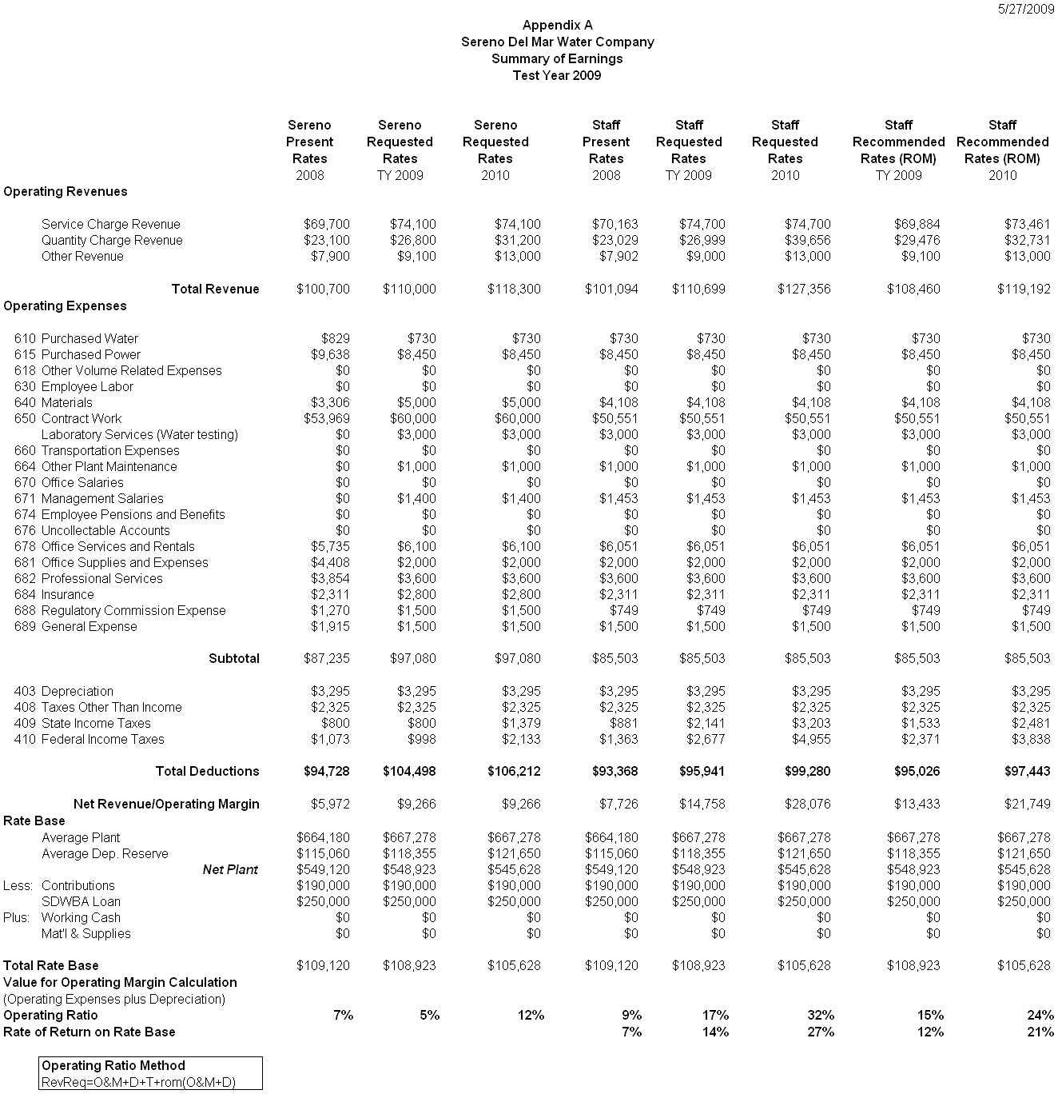

APPENDIX B
Page 1 of 2

Sereno Del Mar Water Company

Schedule No. 1

METERED SERVICE
Test Year 2009

APPLICABILITY

Applicable to all metered water service.

TERRITORY

The subdivision known as Sereno Del Mar and vicinity located 3.5 miles north of Bodega Bay, Sonoma County.

RATES

Quantity Rate |  | 2009
 |  | Per Month
0 to 6.7 | For all water deliver per 100 cu. ft. | $4.00
6.71 to 10.7 | For all water deliver per 100 cu. ft. | $4.50
over 10.7 | For all water deliver per 100 cu. ft. | $5.50

Service Charge |  | 2009
 |  | Per Month
 | Charge per meter size
 | 3/4-inch | $64.95
 | 1-inch | $108.25
 | 1- 1/2 inch | $216.49
 | 2-inch | $346.39

The Service Charge is a readiness-to serve charge which is applicable to all metered service and to which is added the water used computed at the Quantity Rate.

SPECIAL CONDITIONS

  - Any customer prior to resuming service within 12 months after such service was discontinued will be required to pay all service charges which would have been billed if service had not been discontinued.

  - A surcharge of $6.75 in addition to the regular monthly service charge shall be charged to all meter service. The surcharge is specifically for the repayment of the Safe Drinking State Revolving Fund loan as approved by Resolution W-4234. The monthly surcharge rate is subject to periodic adjustment.

  - All bills are subject to the reimbursement fee set forth in Schedule No. UF.
APPENDIX B
Page 2 of 2
Sereno Del Mar Water Company
Schedule No. 1
METERED SERVICE
Escalation Year 2010

APPLICABILITY

Applicable to all metered water service.

TERRITORY

The subdivision known as Sereno Del Mar and vicinity located 3.5 miles north of Bodega Bay, Sonoma County.

RATES
Quantity Rate |  | 2010
 |  | Per Month
0 to 6.7 | For all water deliver per 100 cu. ft. | $4.50
6.7 to 10.7 | For all water deliver per 100 cu. ft. | $5.00
over 10.7 | For all water deliver per 100 cu. ft. | $6.25

Service Charge |  | 2010
 |  | Per Month
 | Charge per meter size
 | 3/4-inch | $68.27
 | 1-inch | $113.79
 | 1- 1/2 inch | $227.57
 | 2-inch | $364.12

The Service Charge is a readiness-to serve charge which is applicable to all metered service and to which is added the water used computed at the Quantity Rate.

SPECIAL CONDITIONS

- Any customer prior to resuming service within 12 months after such service was discontinued will be required to pay all service charges which would have been billed if service had not been discontinued.

- A surcharge of $6.75 in addition to the regular monthly service charge shall be charged to all meter service. The surcharge is specifically for the repayment of the Safe Drinking State Revolving Fund loan as approved by Resolution W-4234. The monthly surcharge rate is subject to periodic adjustment.

- All bills are subject to the reimbursement fee set forth in Schedule No. UF.

(END OF APPENDIX B)

APPENDIX C
Sereno Del Mar Water Company
COMPARISON OF RATES

Test Year 2009
Sereno
 |  |  |  | Per Service Connection Per Month
 |  |  |  | Present | Recommended | Percent
 |  |  |  | Rates | Rates | Increase
Service Charge:
 |  | For 5/8”-inch meters |  | $42.26 | $43.30 | 2.5%
 |  | For 3/4-inch meters |  | $42.26 | $64.95 | 53.7%
 |  | For 1-inch meters |  | $70.49 | $108.25 | 53.6%
 |  | For 1-1/2-inch meters |  | $141.10 | $216.49 | 53.4%
 |  | For 2-inch meters |  |  | $346.39
Quantity Charge:
Metered Water Usage |  | 0 to 6.7 |  | $3.37 | $4.00 | 18.7%
(100 cubic feet) |  | 6.71 to 10.7 |  | $3.37 | $4.50 | 33.5%
 |  | over 10.7 |  | $3.37 | $5.50 | 63.2%

A monthly bill comparison for a customer with a 3/4-inch meter is shown below:
Usage | Present |  | Recommended | Amount | Percent
100 cu. ft. | Rates |  | Rates | Increase | Increase
0 | $42.26 |  | $64.95 | $23 | 53.7%
5 | $59.11 |  | $84.95 | $26 | 43.7%
6.7 | $64.84 |  | $91.75 | $27 | 41.5%
10.7 | $78.32 |  | $109.75 | $31 | 40.1%
17 | $99.55 |  | $144.40 | $45 | 45.1%
20 | $119.77 |  | $160.90 | $41 | 34.3%

APPENDIX C

COMPARISON OF RATES

Sereno Del Mar Water Company

Escalation Year 2010

Sereno
 |  |  | Per Service Connection Per Month
 |  |  | 2009 | Recommended | Percent
 |  |  | Rates | Rates | Increase
Service Charge:
 | For 3/4-inch meters |  | $64.95 | $68.27 | 5.1%
 | For 1-inch meters |  | $108.25 | $113.79 | 5.1%
 | For 1-1/2-inch meters |  | $216.49 | $227.57 | 5.1%
 | For 2-inch meters |  | $346.39 | $364.12 | 5.1%
Quantity Charge:
Metered Water usage | 0 to 6.7 |  | $4.00 | $4.50 | 12.5%
(100 cubic feet) | 6.71 to 10.7 |  | $4.50 | $5.00 | 11.1%
 | over 10.7 |  | $5.50 | $6.25 | 13.6%

A monthly bill comparison for a customer with a 3/4-inch meter is shown below:

Usage | 2009 |  | Recommended | Amount | Percent
100 cu. ft. | Rates |  | Rates | Increase | Increase
0 | $64.95 |  | $68.27 | $3.32 | 5.1%
5 | $84.95 |  | $90.77 | $5.82 | 6.9%
6.7 | $91.75 |  | $101.77 | $10.02 | 10.9%
10.7 | $109.75 |  | $121.77 | $12.02 | 11.0%
17 | $144.40 |  | $161.65 | $17.25 | 11.9%
20 | $160.90 |  | $176.55 | $15.65 | 9.7%

(END OF APPENDIX C)
APPENDIX D
Sereno Del Mar Water Company
ADOPTED QUANTITIES
Test Year 2009

Purchased Power
Pacific Gas and Electric Company
Effective Date May 1, 2006
Schedule A-6 Small General Time-of-Use Service – Polyphase

Total Customer/Meter Charge Rates
Meter Charge (A-6) ($ per meter per day) $0.20107

Total Energy Rates ($ per kWh)
Peak summer $0.41487
Part-Peak summer $0.18872
Off-Peak summer $0.11732
Part-Peak winter $0.14196
Off-Peak winter $0.11603

Total kWh 45,773
Total Cost $8,450

Property Taxes $2,325

Service Connections
¾ - inch 109
1 – inch 17
Total 126

Consumption 6,833 Ccf

Tax Calculations
 |  |  | 2009 | 2010
Operating Revenues |  |  | $108,460 | $119,192
Expenses |  |  | $85,503 | $85,503
Depreciation |  |  | $3,295 | $3,295
Taxes other than Income |  |  | $2,325 | $2,325
Taxable Income for State |  |  | $17,337 | $28,069
State tax |  |  | $1,533 | $2,481
Taxable Income for Federal |  |  | $15,804 | $25,587
Federal tax |  |  | $2,371 | $3,838

(END OF APPENDIX D)

In the Rate of Margin Method, the utility’s revenue requirement is defined as the sum of its operating and maintenance expenses, depreciation, income and other taxes, multiplied by the rate of margin (D.92-03-093, pg. 11.)
Order Instituting Investigation (OII) 07-01-022.
Sereno’s billing system has the capability of tracking water consumption information on a monthly basis by customer.
Per the Commission’s Standard Practice U-7-W.

