FINAL REPORT ON THE AUDIT OF THE DELTA ENERGY CENTER POWER PLANT

CONDUCTED UNDER GENERAL ORDER 167
TO DETERMINE COMPLIANCE WITH
OPERATION, MAINTENANCE, AND LOGBOOK STANDARDS

ELECTRIC GENERATION PERFORMANCE BRANCH
CONSUMER PROTECTION AND SAFETY DIVISION
CALIFORNIA PUBLIC UTILITIES COMMISSION
505 VAN NESS AVENUE

SAN FRANCISCO, CA 94102

May 29, 2009

Richard W. Clark, Director
Consumer Protection and Safety Division
Table of Contents

Introduction 6
Plant Description 6
Plant Operations 8
AUDIT SCOPE 8
SECTION 1—Safety Hazards Requiring Immediate Corrective Action 9
SECTION 2 - Other Findings of Standards Requiring Corrective Action 9
FINDING 2.1 – HRSG Hot Spots Could Burn Workers 9
FINDING 2.2 –Blowdown Tank Hotspots Could Burn Workers 17
FINDING 2.3 – Chemical Fumes Exhaust into Work Areas 19
FINDING 2.4 – Poorly Secured High Pressure Gas Cylinders Could Tip Over 20
FINDING 2.5 – A Wrench Makes a Poor Valve Handle 24
FINDING 2.6 - The Manual for Cycle Chemistry is Out of Date 25
FINDING 2.7 - New Sections of Cooling Towers are Missing on Plant Drawings 26
FINDING 2.8 – Drawings of the Chemical Injection System Lists Disused Chemicals 27
FINDING 2.9 – Wind, Vehicles, Or Hand Carts Could Damage Tarps Used for Control of Chemical Spills 28
FINDING 2.10 – Plant Drawings Contain Conflicting Identification Numbers on Safety Valves 30
FINDING 2.11 – Inadequate Drawings of Water Sampling Systems Could Endanger Workers 30
FINDING 2.12 – Plant Documents Conflict on the Size of a Safety Valve 31
FINDING 2.13 – The Plant Failed to Hold Annual Emergency Evacuation Drills 32
FINDING 2.14 – The Plant Lacks Signs Indicating Evacuation Routes and Assembly Areas 33
FINDING 2.15 – The Plant’s Air Quality Permit Was Not Available On-Site 33
FINDING 2.16 Pools Around Clogged Storm Drains Are Hazardous 33
FINDING 2.17 – The Plant Lacks a List of Hazardous Waste Handlers 34
FINDING 2.18 – The Plant Fails To Verify the Qualifications of Contractors 34
FINDING 2.19 – The Plant Fails to Assign Responsibility for the Safety of Contractors 35
FINDING 2.20 – A Locker Containing Flammable Materials Lacks an Automatic Door Closer 36
FINDING 2.21 – Missing Entries on Safety Forms Make It Unclear Whether Maintenance Tasks Are Hazardous 38
SECTION 3 –Other Audit Observations 39
OBSERVATION 3.1 - Plant’s Chemistry Program 39
OBSERVATION 3.2 - Boiler (HRSG) Inspection Program 40
OBSERVATION 3.3 – Flow Accelerated Corrosion 41
OBSERVATION 3.4 – Work Management System 41
OBSERVATION 3.5 – Balance of Maintenance Approach 42
OBSERVATION 3.6 – Training 42
OBSERVATION 3.7 – Training Support 42
OBSERVATION 3.8 – Stopping Unsafe Work 43
OBSERVATION 3.9 – Two Calpine Regional Managers are Housed On-Site 43
OBSERVATION 3.10 – Lock-Out/Tag –Out/Try Procedure 43
OBSERVATION 3.11 – Chemistry Laboratory Housekeeping and Equipment 44
OBSERVATION 3.12 – Chemistry Laboratory Equipment 46
OBSERVATION 3.13 – General House Keeping 47
OBSERVATION 3.14 – Operator Conduct 50
OBSERVATION 3.15 – Job Training 50
OBSERVATION 3.16 –Routine Walk Downs 50
OBSERVATION 3.17 – Data Collection 51
OBSERVATION 3.18 – Plant Communications 52
OBSERVATION 3.19 – Fire Protection Devices 52
OBSERVATION 3.20 – Air Emissions Compliance 56

TABLE OF PHOTOS AND FIGURES

Photo 1: Thermal image of Unit 1’s expansion joint. 10
Photo 2: Thermal image of Unit 1’s bottom reheater inlets. 11
Photo 3: Thermal image of Unit 1’s man-way in the transition duct “B”. 12
Photo 4: The plant installed new signage and a barrier near the expansion joint vicinity to mitigate burn hazards. 13
Photo 5: The plant kept a minimum 2-inch gap between the stainless steel bellow and the existing insulation, as the manufacturer recommended. 14
Photo 6: The plant added new piping insulation throughout the HRSG where it previously detected excessive heat leakage. 15
Photo 7: The plant added new piping insulation throughout the HRSG where it previously detected excessive heat leakage. 16
Photo 8: The plant added new piping insulation throughout the HRSG where it previously detected excessive heat leakage. 17
Photo 9: Blowdown tank’s lower portion lacks protective barrier. 18
Photo 10: The plant extended the protective barrier to prevent access to the lower portion of the blow-down tanks. 19
Photo 11: High pressure hydrogen cylinders are not properly secured. 21
Photo 12: High pressure hydrogen cylinders are not properly secured. 21
Photo 13: Improved storage of high pressure cylinders. 22
Photo 14: Improved storage of high pressure cylinders. (Photo redacted.) 23
Photo 15: Improved storage of high pressure cylinders. (Photo redacted.) 24
Photo 16: A vise grip is used as handle to operate the sample valve. 24
Photo 17: A new valve handle has been installed. 25
Photo 18: Cooling Tower drawings do not reflect the addition of two new cells to the cooling tower. 27
Photo 19: Temporary sodium bromide chemical injection system. 29
Photo 20: Removed temporary sodium bromide chemical injection system from access road. 29
Photo 21: Clogged debris screen in storm drain. 34
Photo 22: The flammable liquid storage locker does not have an automatic door closer. 37
Photo 23: The chemistry analysis table holds multiple water analysis devices and is well organized. 44
Photo 24: Reagents and corrosive chemicals are properly stored and bench tops are free of clutter. 45
Photo 25: The flammable storage cabinet below the fume hood has self closers. 45
Photo 26: Emergency shower and personal protective equipment and spill containment materials are readily available. 46
Photo 27: Multiple water analysis devices can be seen on a clean, well organized lab table. 47
Photo 28: Excellent general housekeeping practices were evident. Here the water treatment area is free of debris. 48
Photo 29: Hoisting cables and a motor are neatly stacked on pallets awaiting removal to storage and repairs. 48
Photo 30: Improperly stored ladders were removed within hours of notification during the Audit. 49
Photo 31: The plant stores ladders on hangers, leaving walkways clear. 49
Photo 32: A roving operator seen with the digital personal assistant used for gathering plant information during routine walk downs. 51
Photo 33: Inspection tags are visible on the boiler feedwater pump 53
Photo 34: Close-up of the fire suppression system inspection tags show 54
Photo 35: The main diesel powered fire pump 55
Photo 36: Locks are installed to prevent accidental closure of valves as recommended in the May 2006 inspection. 56

Executive Summary
This is the Final Report from the audit of the Delta Energy Center prepared by the Consumer Protection and Safety Division (CPSD) of the California Public Utilities Commission (CPUC). The Delta Energy Center is a nominal 880 Megawatt (MW) combined-cycle power plant located in Pittsburg, California. CPSD audited the plant for compliance with the Commission’s General Order 167, which includes Operation, Maintenance, and Logbook Standards for power plants.

CPSD visited the plant site from March 26-30, 2007, examining documents, interviewing staff, inspecting equipment, and observing operations, and on April 15, 2008 CPSD sent Delta a Preliminary Audit Report. The report identified 21 violations including burn and other hazards, out-of-date procedures and plant drawings, and overdue safety drills. Delta responded with a Corrective Action Plan (CAP) on July 15, 2008. On September 11, 2008 and January 28, 2009, CPSD and Delta met at the plant site to resolve outstanding issues. Delta cooperated fully throughout the entire audit process, making some repairs during the staff’s March visit. CPSD now issues this Final Report.

Introduction
On January 4, 2007, a team from the Commission’s Consumer Protection and Safety Division (CPSD) initiated an audit of the Delta Energy Center Generating Station (“Delta” or “the plant”) to determine whether the plant was in compliance with General Order (GO) 167. GO 167 includes maintenance, operation, and logbook standards for power plants. The audit team included Ron Lok, Chuck Magee, Jim Cheng, and Rick Tse.

CPSD conducted the audit through an examination of plant performance, data requests and a visit to the plant site. First, the team examined outage reports by CPSD staff, as well as databases maintained by the California Independent System Operator (ISO). On January 4, 2007, the team notified the plant of the audit. The team visited the plant site from March 26- 30, 2007.

Plant Description
The Delta Energy Center is a nominal 880 Megawatt (MW) combined-cycle power plant located in Pittsburg, California. Calpine owns and manages Delta and several other power plants in or near Pittsburg California, including the 64 MW Pittsburg Power plant, the 512 MW Los Medanos Energy Center and the 47 MW Riverview Peaking plant. Delta began commercial operations in June, 2002. The plant uses both treated wastewater and municipal water. Like all combined cycle plants, the plant produces power using two cycles: a gas turbine and a heat recovery steam generator. The gas turbine cycle is equipped with a fogging system for intake air and steam injection (PAG-Power Augmentation) to achieve peak output from the combustion turbine and the generator attached to it. In the second cycle, which is primarily fired by the waste heat from the turbine, duct burners can further supplement peak output. Finally, the plant uses two kinds of technologies to minimize emission of nitrogen oxides, low-NOx burners and Selective Catalytic Reduction with ammonia injection (SCR).

The plant uses treated wastewater in its cooling towers and treated municipal water in its boilers. The plant sits next to the Delta Diablo Sanitary Department’s (DDSD) waste water treatment plant, which pumps reclaimed municipal wastewater to the plant’s cooling tower to replace water that evaporates or is lost when contaminants are flushed out of the cooling system (this flushing process is also known as “blow down”). The plant’s cooling water blowdown requires no additional filtering or purification prior to returning it to the DDSD, which further treats the water before releasing it into the delta. Contra Costa Water District supplies water via a canal to the plant’s raw water treatment facility, which purifies the water for use in the plant’s heat recovery steam generator.

Delta produces power in two successive power cycles, minimizing fuel use. The fuel efficiency of plants like Delta is roughly fifty percent, compared to 33 percent for conventional steam plants. The plant incorporates three Siemens Westinghouse Model W501FD2 gas turbines and one Toshiba steam turbine. Delta requires external power to start-up (in other words, it lacks “black-start capability”).

The first cycle depends on the gas turbines which combust natural gas. The first part of each turbine compresses intake air from the atmosphere. Burners ignite natural gas which flows into the compressed air stream. The resulting hot, pressurized gas mixture drives the second part of the turbine. Because turbines produce less power when intake air is hot, the plant’s designers added a fogging system to cool the intake air. Further, they added a steam injection system, which increases the mass flow through the turbine and therefore the plant’s capacity. Each of the three gas turbines drives a 215 megawatt generator. The combustion turbine converts to electricity only a third of the energy contained in the fuel; the rest is expelled as hot exhaust gas.

In the second cycle, the hot exhaust from the gas turbines flows through a Heat Recovery Steam Generator (HRSG). Manufactured by Deltek, the HRSG produces steam for the steam turbine, which drives a 297 megawatt generator. After passing through the HRSG, the turbine exhaust enters the atmosphere through the plant’s stacks.

The plant can maximize its output by firing natural gas in “duct burners” located in the HRSG. Duct burners are low in fuel efficiency but inexpensive to build. The plant operates the duct burners during peak periods, when demand and prices for electricity are high.

The plant uses two kinds of technology to reduce emissions of nitrogen oxides (NOx); nitrogen oxides combine with sunlight and volatile organic compounds (VOCs) in the atmosphere produce smog. First, the burners in the gas turbine are designed to operate below the temperatures at which thermal NOx forms. Second, the plant installed a Selective Catalytic Reduction System for the HRSG’s exhaust. The system injects ammonia into the HRSG’s exhaust, which passes over a chemical catalyst. Under stable operating conditions, the plant emits as little as 2.5 ppm NOx (compared to uncontrolled emissions of 50 ppm from a conventional power plant).

Plant Operations

The plant’s current capacity factor is 70%. Generally speaking, the plant operates at full capacity during peak hours, but reduces its output at other times. During the peak generating seasons, the plant operates at 100% load during the day but only at 50% load at night. During the Spring, the plant cycles down or off when cheaper hydro power is available. The plant operated under a Reliability Must Run (RMR) agreement with the California Independent System Operator (CAISO) through the years 2004 to 2006; the ISO terminated the agreement in 2007.

AUDIT SCOPE
The team looked broadly at the plant’s compliance with standards, especially on problems identified from the plant’s operating history based largely on reports from CPSD inspections of outages at the plant. Major past incidents and problems include:

- A Superheater header failed during full load operation. In December of 2004, an end-cap on the header of Unit 3’s super-heater ruptured, releasing high pressure (2,000 psig) steam and propelling the end-cap against and damaging the boiler casing. While the failure injured no one, it shut down Unit 3 for two weeks. The plant’s root-cause analysis was inconclusive because the event destroyed crucial evidence.

- The XXXXX on gas turbine compressor diaphragms failed prematurely. Caused by a design defect on all XXXXX model 501FD2 gas turbines, this failure shut Unit 2 down for three weeks in February, 2006. In response, the plant repaired Unit 1 & 3’sXXXXX, which have since operated without failures. The _____ on the _____ experienced higher than expected wear. In addition to repairing Unit 2, the plant also repaired _________ for Units 1 and 3.

- An expansion joint on an exhaust casing failed prematurely. These casings carry hot exhaust gases from the turbine in the HRSG. The expansion joints help the casings adjust to changes in temperature. The plant installed an expansion joint on Unit 3 produced by a company different from the plant’s principal manufacturer. That joint failed prematurely, forcing Unit 3 out of service for two days in December, 2006.

Because the plant followed-up appropriately, this audit report will not discuss these past incidents further.

The audit focused on the plant’s compliance with specific standards, including those covering:

Logbooks, training, and human resources
- Equipment, parts, and tools
- Flow Accelerated Corrosion program
- Water treatment and chemistry
- Regulatory compliance, engineering support, and safety including hazardous material handling, and fire and spill prevention and response
- Contractor training
- Operator training
- Lock-out Tag-out program
- Equipment drawings update
- Maintenance planning, performance, and documentation specifically related to:
  - Boiler tube leaks.
  - Boiler safety valves
  - Gas Turbine blades
  - Circulating water system
  - Steam turbine
  - Chemical injection systems

In the Preliminary Audit Report, CPSD identified 21 Findings including burn and other hazards, out-of-date procedures and plant drawings, and overdue safety drills. Auditors found no safety hazards requiring immediate action. Upon review of the preliminary Audit Report, Delta submitted a Corrective Action Plan (CAP) which agreed with many of staff’s recommendations. The plant addressed all issues (some immediately). The plant needs to complete corrective actions for Findings 2.13, 2.14 and 2.18.

SECTION 1—Safety Hazards Requiring Immediate Corrective Action
Auditors found no safety hazards requiring immediate correction.

SECTION 2 - Other Findings of Standards Requiring Corrective Action

FINDING 2.1 – HRSG Hot Spots Could Burn Workers
The plant deferred repairs of hot spots in the HRSG, a violation of Operation and Maintenance Standards. Hotspots on the HRSG expose plant staff to burn hazards, reduce thermal efficiency and may lead to equipment damage that affects reliability.

Thermal images from an infrared scan show that part of the HRSG registered above 600°F during operation. These areas include the expansion joints, bottom reheater inlets, and man-ways in transition duct “B” (See Photos 1 to 3). The hotspots are near ground level and catwalks where plant staff frequently walk.

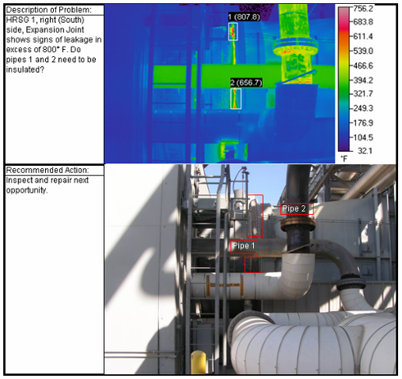
Photo 1: Thermal image of Unit 1’s expansion joint.
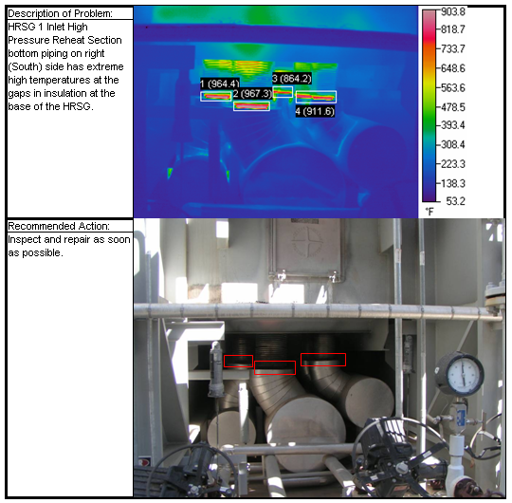
Photo 2: Thermal image of Unit 1’s bottom reheater inlets.

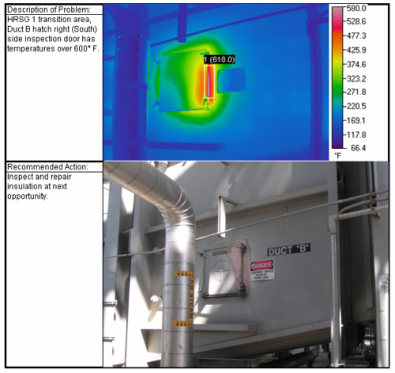
Photo 3: Thermal image of Unit 1’s man-way in the transition duct “B”.

In addition to posing safety hazards, hotspots reduce thermal efficiency and may lead to equipment damage that affects reliability. In this case, the insulation is beneath the HRSG’s external casing. If allowed to continue, hotspots can cause thermal buckling of the HRSG’s external casing and may lead to cracks. This risk is exacerbated because the HRSG’s duct burners increase exhaust temperature and subject the HRSG to additional thermal stress.

Further, plant staff identified several severe hotspots during an infrared scan in September 2006. Staff recommended repair in the next immediate outage. However at the time of the audit, which was six months after the recommendation, the plant still had not repaired the hotspots.

Final Outcome and Follow-up
The plant repaired most of the hotspots, but left two hotspots untouched because insulation could cause overheating and failure of fasteners. The manufacturer of the expansion joint (Photo 1), KE-Burgman, recommended against insulating that joint, saying that it functions at high temperature by design. Insulating the joint would raise temperatures and cause the joint’s fasteners to fail. To mitigate burn risks, the plant installed caution signs in the area (Photo 4). The HRSG’s manufacturer, Deltek, similarly recommended that the plant maintain at least a 2-inch gap between the stainless steel bellow and the existing pipe insulation (Photo 5). The plant therefore left the gap in place, but did not post signs because the area is difficult to access. The plant did, however, install new piping insulation at other hotspots in the HRSG (Photo 6). Finally, the plant replaced gaskets and insulation to repair a hotspot at the manway door for Duct B (Photo 3).

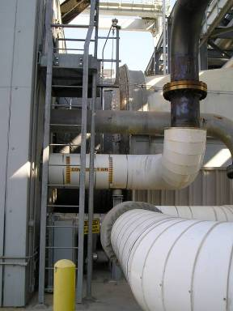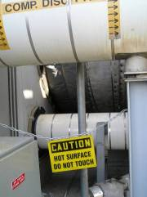
Expansion Joint
Photo 4: The plant installed new signage and a barrier near the expansion joint vicinity to mitigate burn hazards.

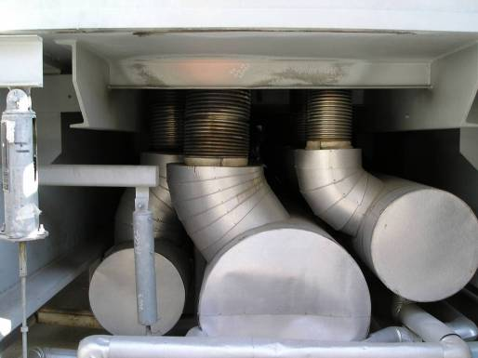
Stainless steel bellow
Existing pipe insulation
Min. 2” gap
Photo 5: The plant kept a minimum 2-inch gap between the stainless steel bellow and the existing insulation, as the manufacturer recommended.

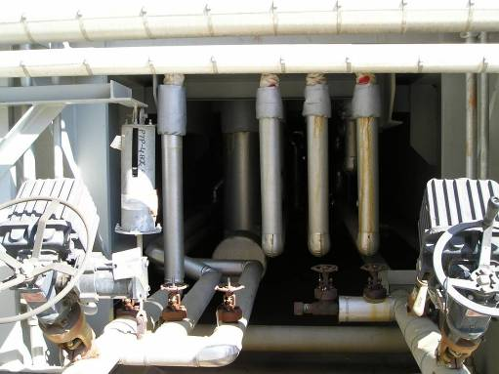
Photo 6: The plant added new piping insulation throughout the HRSG where it previously detected excessive heat leakage.

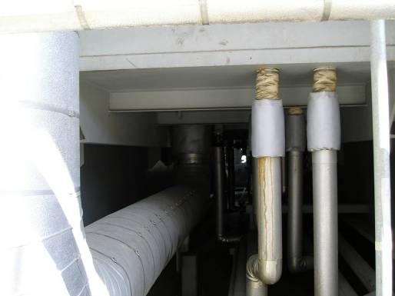
Photo 7: The plant added new piping insulation throughout the HRSG where it previously detected excessive heat leakage.
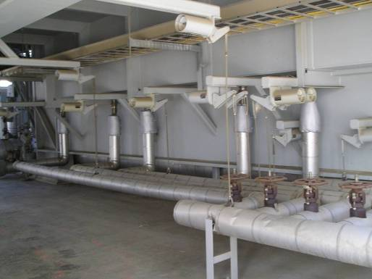
Photo 8: The plant added new piping insulation throughout the HRSG where it previously detected excessive heat leakage.

FINDING 2.2 –Blowdown Tank Hotspots Could Burn Workers
Inadequate barriers on the blow-down tanks expose plant staff to burn hazards, a violation of the Operation and Maintenance Standards. While a mesh wire surrounds the midsection of the tank, the tank’s lower portion lacks a protective barrier and exposes plant staff to burn risks. Further, the tanks are near areas where plant staff walk frequently (See Photo 9).

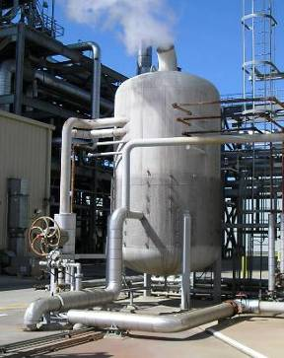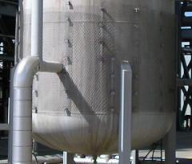
Photo 9: Blowdown tank’s lower portion lacks protective barrier.

Final Outcome and Follow-up
The plant added an expanded metal shield to the lower portion of the blowdown tanks to guard against burns (Photo 10).

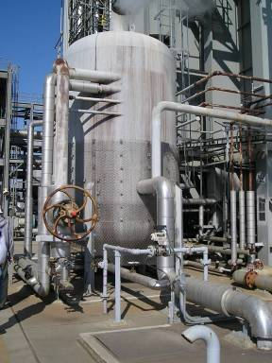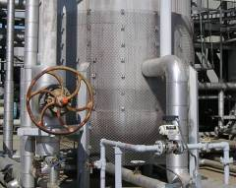
Photo 10: The plant extended the protective barrier to prevent access to the lower portion of the blow-down tanks.

FINDING 2.3 – Chemical Fumes Exhaust into Work Areas
The Steam Jet Air Ejector (SJAE) exhausts gases into the work area, exposing plant personnel to hazardous fumes; a violation of Operation and Maintenance Standards.

The plant uses hazardous chemicals in the feedwater for pH adjustment and to control corrosion (particularly of iron and copper alloys) in the Heat Recovery Steam Generator (HRSG). The feedwater converts to steam in the HRSG and condenses back to feedwater in the condenser. During normal operation of a plant the SJAE exhausts non-condensable gases and water vapor from the condenser cavity into the atmosphere. The exhaust from the SJAE contains hazardous chemicals that are near walkways where plant personnel can inhale them

The three chemicals injected into the HRSG feedwater include Cyclohexylamine, Morpholine (Nalco 356 Corrosion Inhibitor) and liquid phosphate (Nalco BT-3000). In addition, the plant injects Carbohydrazide (Elimin-Ox by Nalco) to further reduce corrosion. The manufacturer’s safety data sheets (MSDS) state that the vapors from these chemicals can irritate the eyes, nose, throat and lungs.

During the audit plant tour, when one unit was already operating and the other starting up, the auditor noticed a strong chemical smell in the vicinity of the condenser air ejectors, and asked the Plant Manager what the smell was. The Plant Manager said staff had noticed the smell before and believes it to be amines from chemicals that the plant injects into the feedwater. The Plant Manager acknowledged that he had not tested the gas in the vicinity of the air ejector, and was not sure which chemicals were being exhausted into the work area.

Final Outcome and Follow-up
Although tests showed that fumes presented minimal hazard to workers, the plant installed piping to vent the material away from work areas. A contractor, Trident Environmental and Testing, Inc, was hired to test both condensate and non-condensable gases. The tests showed that the amine odor was Nalco 356. The tests also showed that the discharge was well below regulatory limits and posed no hazard. In any event, in August 2008, the plant re-routed the discharge away from areas used by personnel.

FINDING 2.4 – Poorly Secured High Pressure Gas Cylinders Could Tip Over
High pressure storage cylinders for hydrogen gas (Photos 11 & 12) are not securely fastened and could be easily tipped over accidentally or during an earthquake, a violation of the Operation Standards.
Earthquakes or collisions could knock over unsecured cylinders and cause serious injuries and/or damage to equipment. Such impacts can shear the regulator valve from an uncapped cylinder, especially if a regulator is attached and unguarded, causing rocking or rapid spinning. Under certain conditions, damaged hydrogen cylinders can become missile-like projectiles.

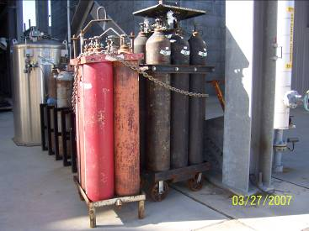
Photo 11: High pressure hydrogen cylinders are not properly secured.

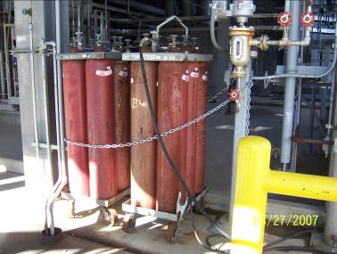
Photo 12: High pressure hydrogen cylinders are not properly secured.

Final Outcome and Follow-up
The plant has replaced cylinder racks and repositioned safety chains (Photos 13, 14 & 15). The plant also reduced its inventory of empty cylinders.

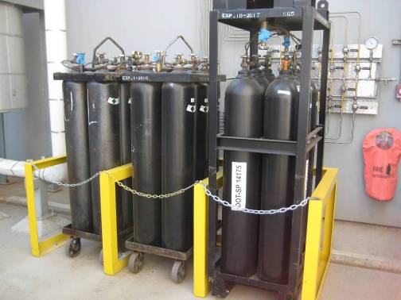
Photo 13: Improved storage of high pressure cylinders.

Photo 14: Improved storage of high pressure cylinders. (Photo redacted.)

Photo 15: Improved storage of high pressure cylinders. (Photo redacted.)

FINDING 2.5 – A Wrench Makes a Poor Valve Handle
The plant replaced a valve handle (Photo 16) with a vise grip wrench, an awkward arrangement which violates Operation and Maintenance Standards. Located on the chemical sampling panel, the valves isolate and control small streams taken for sampling from the plant's main water and/or steam streams Use of the vise grip could damage (that is over-torque) the valve, making sampling difficult or impossible, and/or causing leakage of water or steam and thus endangering plant personnel.
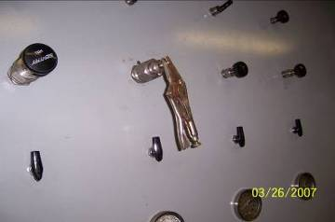
Photo 16: A vise grip is used as handle to operate the sample valve.

Final Outcome and Follow-up
The plant replaced the valve and wrench with a new valve and handle.

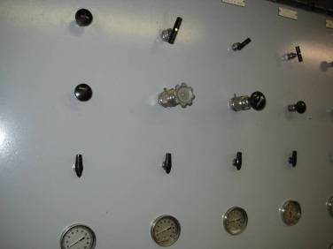
Photo 17: A new valve handle has been installed.

FINDING 2.6 - The Manual for Cycle Chemistry is Out of Date

The plant has not reviewed nor updated its Chemistry Manual for over two years, a violation of Operation and Maintenance Standards. Although the manual itself calls for an annual content update, the plant has not revised the manual since April 2005 (See Figures 1 and 2). If information or procedures have changed since the last revision, staff or contractors relying on the manual might make operational errors.
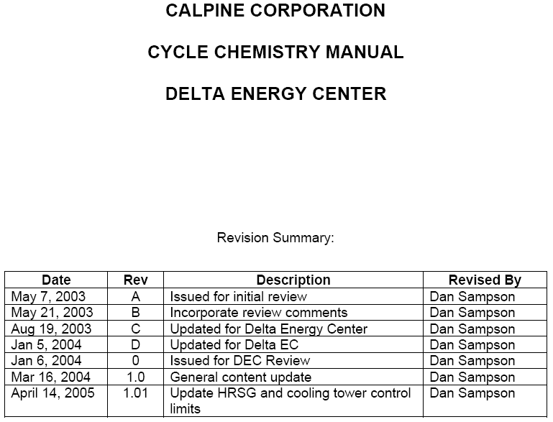

Figure 1: Chemistry manual needs updating
XXXXX, who was their regional water specialist, is no longer there
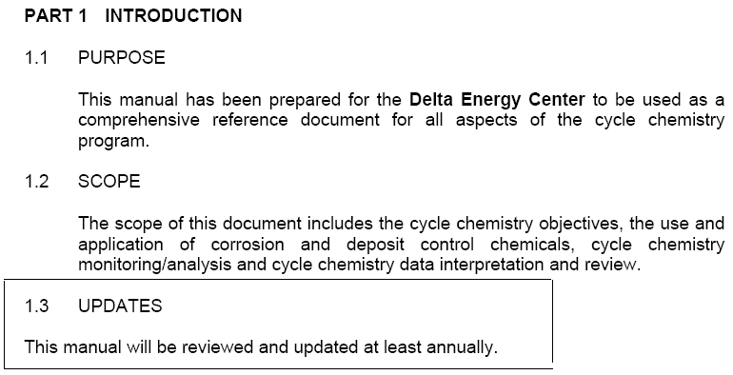
Figure 2: Chemistry manual needs updating

Final Outcome and Follow-up

Immediately after the audit visit, the plant updated the Cycle Chemistry Manual, and entered a recurring Maximo work order for future reviews. The plant subsequently reviewed the manual in March 2007 and March 2008.

FINDING 2.7 - New Sections of Cooling Towers are Missing on Plant Drawings

The plant’s design drawings for cooling towers fail to show two recently-added cells (Figure 18), a violation of Operation and Maintenance Standards. The plant added two new cells because the original 12 provided insufficient cooling, but never added the new cells to plant drawings. In particular, one design drawing and two of the plant’s Piping and Instrumentation Drawings (P&IDs) lack tower numbers 13 and 14, specifically

- GEA Dwg. No. 100, Rev. E
- P&ID Dwg. No. 24473-0-M6-00002, Rev. 4
- P&ID Dwg. No. 24473-0-M6-00003, Rev.3

There are many consequences of inadequate plant drawings. First, staff may order the wrong parts or make inappropriate repairs, causing outages or temporarily reducing the plant’s capacity. Second, staff may be unable to determine how to isolate equipment for repair (through the lock-out, tag-out process), posing safety hazards for repair personnel. Finally, inaccurate drawings may mislead firemen or other emergency responders.

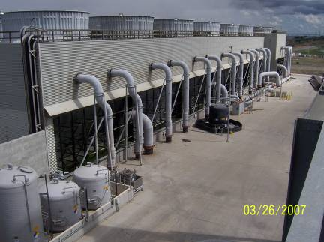
New cells not reflected on plant P&ID
Photo 18: Cooling Tower drawings do not reflect the addition of two new cells to the cooling tower.

Final Outcome and Follow-up
The plant added the two new cells to drawings of the cooling tower, in particular:

- P&ID Dwg. No. 24473-0-M6-WL-00002, Rev. 5; Circulating Water System
- P&ID Dwg. No. 24473-0-M6-WL-00003, Rev. 5; Circulating Water System

FINDING 2.8 – Drawings of the Chemical Injection System Lists Disused Chemicals
After changing the chemicals added to the plant’s feedwater, the plant failed to update the piping and instrumentation diagrams (P&ID) of the chemical injection system for circulating water, a violation of Operation and Maintenance Standards.

All chemicals that support the operation of the plant must be properly identified on all drawings and documents to assure that replacement equipment, piping, and control instruments are compatible with the chemical being used. The plant operator stated that one of the circulating water chemical feed/storage systems was changed to feed a different chemical, Hypochlorite, instead of the original Bromide, and then a new Sodium Bromide feed system (Photo 19) was added to stabilize the water chemistry. The plant must update the following Piping and Instrument Diagrams (P&ID) to indicate these changes:
- Bechtel P&ID No. 24473-0-M6-00002, rev. 4
- Bechtel P&ID No. 24473-0-M6-00003, rev.3

Final Outcome and Follow-up

The plant revised drawings of the chemical injection system, in particular:
P&ID Dwg. No. 24473-0-M6-TL-00001, Rev. 4, “Circulating Water Chemical Feed Injection System.”

FINDING 2.9 – Wind, Vehicles, Or Hand Carts Could Damage Tarps Used for Control of Chemical Spills
The plant relies on a flimsy plastic tarp, supported by steel mesh, to control spills of sodium bromide, a violation of Operating and Maintenance Standards. The plant adds sodium bromide to cooling water in order to control the growth of bacteria. If touched, ingested, or inhaled, sodium bromide irritates the skin, eyes, and respiratory system; in large quantities it damages the eyes and nervous system. While experimenting with different chemicals and chemical injection systems, the plant installed the tarp (Photo 19) to provide temporary secondary containment, that is, to control spills from the bromide storage tank. The plant permanently adopted the bromide injection system, but never replaced the tarp. The tarp is not acceptable for permanent use because it is located in an open area where passing vehicles, hand carts, or heavy winds can damage it.

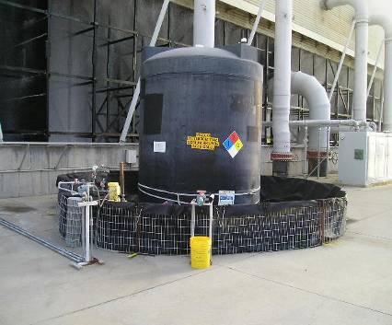
Temporary tarp used for secondary containment structure
Photo 19: Temporary sodium bromide chemical injection system.

Final Outcome and Follow-up
The plant decided to discontinue use of sodium bromide and to remove the associated chemical injection tank and system. An auditor verified the removal of the tank piping and pumps on Sept. 11, 2008 (Figure 20).

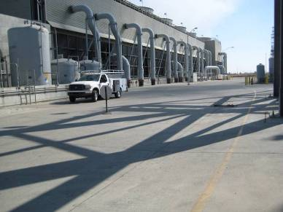
Photo 20: Removed temporary sodium bromide chemical injection system from access road.

FINDING 2.10 – Plant Drawings Contain Conflicting Identification Numbers on Safety Valves
Two different plant drawings list different tag identification numbers for the same safety valves on the HRSG’s steam drums, a violation of Operation and Safety Standards. Safety valves are designed to release pressure and prevent explosions in the case of a very serious malfunction. Because of their importance, safety valves are subject to extensive regulations and documentation. Plants use tag numbers to guide replacement, repair, and settings of safety valves. Incorrect tag numbers therefore pose serious safety hazards.

The plant should revise the P&ID and/or the vendor print for the drum safety valves so the tag numbers consistently match up on the drawings and P&ID’s. The auditor reviewed and noted that the Vendor print from Anderson Greenwood Crosby, drawing No. DS-100-001 indicates a safety valve tag No. TB1A-1, while P&ID 04044385, sheet 1 shows this same safety valve with a tag number of PSV-1A.

Final Outcome and Follow-up

The plant re-issued drawings with corrected tag identification numbers for the safety valves. In particular, the plant revised:

- Deltak P&ID Dwg. No. 04044385, sheet 1 of 10, Rev. L,
- Deltak P&ID Dwg. No. 04044385, sheet 2 of 10, Rev. L,
- Deltak P&ID Dwg. No. 04044385, sheet 3 of 10, Rev. L,
- Deltak P&ID Dwg. No. 04044385, sheet 4 of 10, Rev. L, and
- Deltak P&ID Dwg. No. 04044385, sheet 5 of 10, Rev. L.

FINDING 2.11 – Inadequate Drawings of Water Sampling Systems Could Endanger Workers

The plant cannot safely isolate sample streams of boiler steam and feedwater, a violation of Operation and Maintenance Standards. Plant drawings currently do not assign corresponding tag numbers to the valves controlling each stream, making isolation difficult.

To allow continuous, automatic monitoring of water and steam in various systems, the plant’s piping carries sample flows from various system (for example, boiler feedwater) to a sampling cabinet in the chemistry laboratory. Many of these systems operate at very high temperatures and pressures.

To isolate each sampling stream completely, staff must close two valves located in different parts of the plant; however, these valves are not clearly marked on plant drawings. Generally, one valve is located at the system itself, while the other valve is located in the chemistry laboratory. Because of the physical separation between the valves, staff cannot easily trace which valves close off each system. Staff must depend on plant drawings to identify the valves to close. Improper isolation could expose workers to high pressure water and steam, posing a risk of serious injury.

The plant should revise the vendor drawing and Plant P&IDs to show matching valve tag numbers for each sample point. The auditor reviewed and verified the mis-matched tag numbers on vendor drawing by Johnson March P&ID D-252861-M01, Rev. B & Delta P&ID 04044385 Sheet 1, Rev. K

Final Outcome and Follow-up
The plant revised the drawing to show clearly which pairs of valves to close in order to isolate different parts of the sampling system. In particular, the plant revised Deltak P&ID Dwg. No. 04044385, sheet 1 of 10, Rev. L

FINDING 2.12 – Plant Documents Conflict on the Size of a Safety Valve
Plant documents show different sizes for the same safety valve on a boiler drum, a violation of Operation Standards. The original design drawings indicate that a 2-1/2 inch safety valve should be installed; however, recent calibration test data indicates this valve to be 2 inches. If the 2 inch valve is actually installed on the boiler, the boiler could over-pressurize, exceeding design limits of the boiler and its tubes, resulting in extensive damage and personal injury.

The affected safety valve (tag. No. HP PSV) is located on Unit 1’s HP drum. The following documents conflict regarding the size of the valve:

- Data sheet no. DS-100-003, sheet 1 of 1, rev. 0. This document specifies the type and size of the safety valve that the plant purchased and installed on the boiler. Specifically, the drawing shows the tag number, size, capacity, pressure rating, temperature rating, and materials of construction. This document indicates a size of 2.5 inches, because the document indicates the identification code 2.5-K2-6 (2 ½” inlet with a 6”outlet).

- Unit 1 HP drum PSV calibration data sheet dated 07/12/06; a record of the recent calibration test performed on this safety valve, shows the wrong size. The calibration test measures the safety valve’s set pressure, as well as the tag number, size, and the relief setting. The size indicated on this document is 2 inches, rather than 2.5 inches, because it uses the identification code 2- K2-6 (2” inlet with a 6”outlet).

The plant should verify the size of the safety valve installed on the Unit 1 high pressure drum because the boiler could over-pressurize due to an undersized pressure safety valve; resulting in extensive damage and personal injury.

Final Outcome and Follow-up
The plant determined that the calibration sheet had identified the valve as a 2" valve, rather than the 2 ½” valve actually installed per design. The plant corrected the calibration sheet in March 2007. The valve met requirements; the plant did not change it.

FINDING 2.13 – The Plant Failed to Hold Annual Emergency Evacuation Drills
Delta Energy Center (DEC) has not held an Emergency Response Evacuation Drill and Evaluation since November 2005, a violation of Operation and Maintenance Standards. The plant is out of compliance with the plant’s own Emergency Response Plan which requires such a drill annually. Further confusing matters, plant management issued a memo requiring drills quarterly; further, at every other drill the memo stated that plant is supposed to invite the participation of external agencies such as the Fire Department and the CAISO. The memorandum therefore conflicts with the Emergency Response Plan as well as the plant’s Safety and Health Plan. Without clear plans for training, and without conducting that training, plant staff may be unprepared to react in emergencies.

Final Outcome and Follow-up
As of July 2008, the plant is now scheduling annual emergency evacuation drills using the Maximo Preventative Maintenance scheduler. The scheduler issues work orders for the drills and alerts plant staff to notify all appropriate outside agencies. Plant management rescinded the conflicting memo referencing quarterly drills.

The plant conducted a full evacuation drill on July 17, 2008. As a result, the plant identified several “action items” that the plant plans to resolve:

- Assessment of the plant’s PA system
- Relocating red beacon and warning sign at the front gate
- Installing additional wind socks
- Post evacuation dialogue
- Adding more evacuation signage

An auditor revisited the facility on January 28, 2009 and confirmed that the plant had moved the red beacon and installed additional wind socks. The plant has yet to install the new PA system that will include a pre-recorded emergency announcement directing workers to appropriate evacuation areas. The plant also has yet to post signs at emergency assembly areas, as well as signs pointing to those areas. The Plant Manager gave February 28, 2009 as the completion date for these activities. CPSD requests that the plant report every three months after the issuance of this report until the work is complete.

FINDING 2.14 – The Plant Lacks Signs Indicating Evacuation Routes and Assembly Areas
The plant lacks signage and documentation of Emergency Assembly Areas, a violation of Operation and Maintenance Standards. First, the plant yard lacks signs directing staff to either of the plant’s two assembly areas. Second, the plant lacks signs at the assembly areas themselves. Third, the plant’s orientation video instructs visitors to go to the assembly area if an alarm sounds but fails to state where that assembly area is located.
Final Outcome and Follow-up
The plant agreed to correct the problems, by posting signs at assembly areas, as well as signs pointing to those areas; posting evacuation maps throughout the plant; and updating information for contractors. Further, the plant will revamp its public address system (see Finding 2.13); pre-recorded announcements will tell workers which evacuation areas to use during each emergency. CPSD requests that the plant report every three months after the issuance of this report until the work is complete.

FINDING 2.15 – The Plant’s Air Quality Permit Was Not Available On-Site
The plant did not have a current permit to operate from the Bay Area Air Quality Management District available on site, a violation of Operation and Maintenance Standards. Plant staff stated that the plant had applied for such a permit but had not yet received it.

Final Outcome and Follow-up
In September 2008, the plant showed auditors the approved air permit.

FINDING 2.16 Pools Around Clogged Storm Drains Are Hazardous
Debris clogged the screens of several storm drains, a violation of operation and maintenance standards. The Auditor found pools of standing water below several storm grates (Photo 21). If the plant fails to clear these drains, slip and fall hazards and other safety issues can occur as the area floods.
Photo 21: Clogged debris screen in storm drain.

Final Outcome and Follow-up
The plant replaced silt bags in the drain and, in Sept. 2007, created a recurring Maximo PM work order to do so before each rainy season.

FINDING 2.17 – The Plant Lacks a List of Hazardous Waste Handlers
The plant lacks a current list of hazardous waste handlers, a violation of Operation and Maintenance Standards. The plant’s Emergency Action and Spill Prevention and Countermeasure Plans fail to list the plant’s current hazardous waste handler and transporter, TTS Inc.

Final Outcome and Follow-up
In March 2007, the plant updated the list of hazardous waste handlers in the Emergency Action Plan and the Plant Spill Prevention Control and Countermeasure Procedure. The plant also created a recurring Maximo work order to schedule future updates.

FINDING 2.18 – The Plant Fails To Verify the Qualifications of Contractors
The plant asks that visitors and contractors sign a “Liability Release Form” and a “Proof of Training Form.” Plant staff fails to keep copies of contractor certification or proof of insurance on file. Plant staff failed to produce any evidence that contractor qualifications or training is verified and recorded. It appears that staff can sign-off contractors and give them work without proper review, a violation of Operation and Maintenance Standards.
Final Outcome and Follow-up
The plant showed the CPSD Auditor Safety Prequalification Forms and Insurance Certification forms signed by contractors employed at Delta. Plant Staff also showed the CPSD Auditor a Safety and Health procedure (SHP-13), titled "Contractor Safety,” that requires Contractors to meet Safety Pre-qualifications and Continuing Service Agreement (CSA) criteria in order to work at the facility. The Plant Manager stated that copies of CSAs, proof of insurance, and completed Safety Prequalification forms are not kept onsite but are available on Calpine’s intranet, and contractor qualifications are checked intermittently. The Plant Manager stated that for many trades, it would be difficult to check all contractors’ training materials, licenses and certifications, since many of the trades do not issue proof such as pocket certificates or cards.
The CPSD Auditor revisited the facility on January 28, 2009 to discuss this matter in more detail with the Plant Manager. The Plant Manager assured the CPSD Auditor that the review of contractor licenses, insurance and safety training is tracked at the Corporate Level. The Plant Manager said that only qualified contractors have an active CSA as required of all contractors working at the facility. The Plant Manager also demonstrated a very comprehensive program of contractor management and quality control (CQC). Plant staff familiar with the contractor’s trade becomes the Authorized Individual (AI) charged with all aspects of contractor management (i.e. overseeing contract employee safety and assessing work quality).
The CPSD acknowledges that a contractor’s employee training and certification in some trades cannot be easily assessed in the field, but certain trades do certify workers. CPSD is concerned that a contractor using a large labor pool could hire an unqualified worker under a blanket or umbrella CSA.
Therefore, for trades that require certification for critical code work, the Plant should check to assure that workers have that certification. Such trades may include welding on boilers or high energy pipe, and electrical work that involves the potential of arch flash. CPSD requests that the plant report every three months until the plant establishes a program to perform such checks.

FINDING 2.19 – The Plant Fails to Assign Responsibility for the Safety of Contractors
The plant’s Safety and Health Procedure Manual (SHP) fails to define who is in charge of the management of contractor personnel, a violation of Operation and Maintenance Standards. Among other things, it is unclear whom plant or contract staff should contact if an injury or accident occurs. Without proper notification, there could be delays in providing emergency first aid, administering CPR, and/or admitting ambulances or other emergency response vehicles into the plant. Additionally, the SHP lacks an “Incident and Accident Reporting” procedure.

Final Outcome and Follow-up
In response, the plant submitted documents demonstrating compliance. The Safety and Health Procedure section 9 “Injury Management” provides instructions on whom to contact in an emergency. Procedure 13, “Contractor Safety” also specifies who is responsible for contract personnel and under what circumstances. The plant noted that this procedure was in place at the time of the initial audit.

FINDING 2.20 – A Locker Containing Flammable Materials Lacks an Automatic Door Closer
A locker for flammable liquids lacks an automatic door closer, a violation of the Operation and Maintenance Standards. The cabinet (Photo 22) is adjacent to the reverse osmosis water treatment area. Without such a closer, fires can spread to or from materials in the lockers.

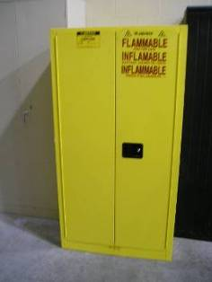
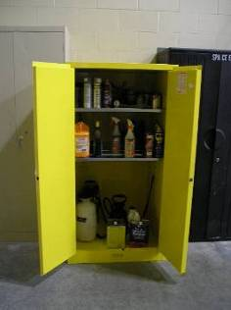
Photo 22: The flammable liquid storage locker does not have an automatic door closer.

Final Outcome and Follow-up
In March 2007, Delta equipped the locker with an automatic closing device.

FINDING 2.21 – Missing Entries on Safety Forms Make It Unclear Whether Maintenance Tasks Are Hazardous

The plant failed to detect and act upon incomplete lockout/tagout/try (LOTOT) forms, a violation of Operation and Maintenance Standards. In particular, auditors found that plant staff failed to complete Section 3 of the standard form, which identifies any special permits necessary to safely perform maintenance work. Failure to fill out the form is also a violation of the plant’s procedures.

Before performing maintenance on equipment, plant staff must de-energize and neutralize the equipment so that maintenance personnel are safe from electrical shock, accidental equipment activation and other dangers. Known as “clearing” the equipment, this process requires that plant personnel physically lock equipment in a safe condition and tag it so that all personnel are aware that the equipment is cleared. The plant’s LOTOT Procedure, SHP-7, controls this process, and requires that employees fill out all three sections of a “LOTOT” form.

The auditor reviewed LOTOT forms that plant staff prepared for maintenance tasks. Of the 118 forms reviewed, 10 had no entries for Section 3, "Additional Permits Required". The Issuing Operator of the clearance is supposed to use this section to flag any hazardous conditions requiring special work permits. Hazardous conditions include confined spaces, electrical work, and work which could expose the worker to high fluid pressure or steam hazards. Blank forms fail to make clear whether there is 1) no hazard or 2) whether there is a hazard that the Operator has failed to note.

The faulty LOTOT forms were 06-71, 06-81, 06-86, 06-95, 06-97, 06-114, 06-126, 06-149, 06-150, and 06-157.

Final Outcome and Follow-up
The plant believes that worker safety was not compromised, despite the uncompleted forms. In every case where LOTOT forms were incomplete, the plant had issued a Safe Work Permit that notified workers of all hazardous conditions. Nonetheless, the plant re-trained all personnel in clearance and work safety, and initiated regular audits of LOTOT forms, scheduled through Maximo work orders.

SECTION 3 –Other Audit Observations

OBSERVATION 3.1 - Plant’s Chemistry Program
Through continuous monitoring of Heat Recovery Steam Generator (HRSG) water chemistry, the plant prevents corrosion and scaling in the HRSGs, which in turn prevents tube leaks and other damage. Chemistry control includes feedwater pretreatment, injecting chemicals, blow-down of HRSG water, collecting grab-samples, using on-line analyzers, and tracking feedwater chemistry at different stages of the water cycle.

The plant pretreats feedwater to prevent scale deposit in the HRSGs. The plant uses reverse osmosis and ion-exchange to reduce the hardness of the water, that is, to remove ions and dissolved minerals. Such ions and minerals can form scale deposits in HRSGs. The auditor visited the water treatment building and saw the equipment in operation.

In addition to physically removing air from the feedwater, the plant injects several chemicals to maintain pH and oxygen levels. The first, liquid phosphate, is injected into the High Pressure drum to buffer against upset conditions and maintain pH level. The second, Eliminox, is injected into the feedwater to remove dissolved oxygen, which is highly corrosive. Eliminox is called an “oxygen scavenger.” The plant further reduces oxygen levels by passing condenser makeup water through a mechanical deaerator. Finally, the plant injects Nalco 356, a corrosion inhibitor. Nalco 356 is a blend of amines that neutralizes acidic gases which can also corrode HRSG tubes.

To remove sludge which precipitates from HRSG feed water, the plant blows down the HRSG continuously. Sludge is an accumulation of calcium carbonate and other impurities that precipitate from the feed water. If not removed, sludge can adhere to boiler tube surfaces and bake into a hard scale. The scale inhibits heat transfer from the HRSG tubes causing them to overheat and fail. Operators monitor sludge formation using the Distributed Control System and by manual feedwater sampling. Operators also continuously monitor specific conductivity, a general indication of the overall condition of the feedwater. Once per shift, operators test for iron, copper, silica, and phosphate which can also form scale. If these levels are high, the operators open the blowdown valve to purge these impurities from the HRSG.

The plant monitors HRSG feedwater continuously, and confirms those readings by manual tests every four hours. As described in Finding 2.11, the plant continuously pipes feedwater to a sampling cabinet in the chemistry laboratory. In the cabinet, automatic analyzers measure pH, conductivity, and dissolved oxygen, and send the data to a computerized database. To assure that those results are accurate, every four hours, the chemistry technician manually collects “grab samples” of water and tests them for the same parameters. The technician alerts operators if he observes a substantial difference between the manual and automated tests. In the chemistry lab, the auditor watched the technician test a grab-sample, as well as a demonstration of the database, which records and trends chemistry parameters.

Finally, the plant tracks feedwater chemistry at different stages of the water cycle to look for precursory problems. Using resulting data, the chemist differentiates between normal upset conditions (which occur routinely when power plant load changes) and abnormal states such as high pH. High pH may indicate contamination, for example, from a condenser tube leak. If the plant detects abnormalities in feedwater, it restores the feedwater to an acceptable state by following the relevant protocol in the plant’s chemistry manual.

OBSERVATION 3.2 - Boiler (HRSG) Inspection Program
The plant inspects the HRSGs regularly and follows up with maintenance as necessary to keep them in good repair. Inspections include infrared scanning for hotspots.

As part of the plant’s predictive maintenance program, staff last inspected the HRSGs in May 2006. They inspected the HRSGs from the inlet through the exhaust stack. That inspection also included a boiler tube analysis by the plant’s chemical supplier, Nalco. The report said that all the HRSGs are in serviceable condition. However, the report also noted deficiencies. The most severe was in Unit 3’s transition section where a HRSG roof plate and some insulation were missing. The damage created a localized hotspot and a 10-foot crack. Plant staff has since repaired the crack. The plant will continue to monitor the other deficiencies.

The plant hires Hartford Insurance Company to inspect its HRSGs once a year. The inspection satisfies Cal-OSHA’s requirements for boiler operating permits. Hartford’s last inspection, in May 2006, included visual examinations of the watertubes, internal welds, safety valves, steam line hangers, boiler casings, supports and foundations. The inspection report said that all the components were adequately maintained and properly operated. An Auditor also verified that all the HRSG’s operating permits are current.

The plant hires Crane Valve Service to test the HRSG safety valves annually. The company tests each valve in accordance with ASME B&PV Code Section I. Each unit has 12 safety valves and Crane last tested them in July 2006. The test records revealed that all 36 valves were in good condition. All, except one valve which was 30 psi low, were within their set-point tolerances. Crane re-adjusted that one valve to be within allowable tolerances.

Finally, the plant scans its HRSGs with infrared devices once a year to look for hotspots and buckled and cracked liner plates. These deficiencies allow heat to escape from the HRSG which reduces the efficiency of the unit. Eliminating hotspots therefore improves thermal efficiency and prevents further damage to the liner plates. The plant last scanned its HRSGs in September 2006. The inspection identified several severe hotspots and recommended repair in the next outage. The plant addressed the report’s recommendations in Finding 2.1.

OBSERVATION 3.3 – Flow Accelerated Corrosion
The plant’s high-energy piping program identifies and addresses flow-accelerated corrosion to prevent critical pipe failures. Once a year, the plant performs ultrasonic testing on all its high-energy pipes. The plant tracks corrosion rates and thicknesses in order to determine when piping or fittings need replacement or repair.

High-energy pipes are prone to erosion-corrosion, also known as flow-accelerated corrosion. Periodic monitoring is crucial to prevent catastrophic pipe ruptures and to ensure safe and reliable operation. Once a year, the plant tests high-energy pipes ultrasonically to ensure that pipe walls exceed minimum thicknesses recommended by ASME. The plant last inspected its high-energy pipes in June 2006. Plant staff took measurements on the High Pressure, Intermediate Pressure and Low Pressure drums as well as on the Main Steam, Condensate, and Feedwater lines. The inspection report showed three-dimensional diagrams showing where staff took the measurements. The report said that all measurements met minimum requirements and that staff will perform ultrasonic testing again in April 2007.

The plant also tracks all measurements in a database called Maximo. Plant staff uses the measurements to project when piping or fitting needs replacement or repair. Staff also uses the measurements to determine if they need to adjust their inspection frequency.
.

OBSERVATION 3.4 – Work Management System
The plant uses Maximo software in its computerized maintenance management system (CMMS) for scheduling and tracking work orders. The auditor reviewed the plant’s work management procedures to verify how work orders are created, listed, and tracked in the Maximo software program.

The auditor examined procedures for the following:

- How a work order is initialized and tracked,
- How to list work orders as preventive, predictive, or outage type work,
- How work orders are automatically prioritized,
- How backlogs are generated and handled,
- Who has the responsibility for tracking the work order schedule,
- How often are meetings conducted for tracking work orders, and
- Who is responsible for assuring communications between the operations, maintenance, and crafts groups,

In addition to the Maximo-generated work orders that are accessible from the plant’s computers, the plant’s “maintenance planning/scheduling board,” located in the control room, tracks current work orders on a weekly basis. This visual management tool identifies and shows the current status of work the maintenance department has planned or assigned. The plant updates the board daily as work order status changes. The auditor reviewed a list of work orders generated from Maximo to verify that the report format contains the information described in the plant’s work management procedures.

OBSERVATION 3.5 – Balance of Maintenance Approach
The plant’s preventive and predictive maintenance programs are wide ranging. The auditor verified that, to support a balanced maintenance approach, the plant has:

    - Implemented the Maximo program to create and track work orders,
    - Performed vibration analysis, motor current analysis, infrared thermographic imaging, and oil analysis,
    - Taken recent thermographic images of the HRSGs,
    - Performed major inspections and tests on HRSGs and the steam turbine,
    - Scheduled long-term major outages for maintenance on major equipment,
    - Recorded equipment performance data and down-loaded data into the plant’s computer to track performance trends during daily operator rounds, and
    - Analyzed deposits on HRSG tubes to determine the need for chemical cleaning.

OBSERVATION 3.6 – Training
The plant effectively tracks employee training records. Plant Staff uses a computer-based training (CBT) program with many program modules and levels. In addition to the CBT, Plant Staff uses on-the-job training, simulators, and classroom seminars that round out the training curriculum.
    - Supervisors use computer software to track individual employee training progress. For example, software automatically sends computer messages to managers/supervisors altering them to an employee’s need for training, review and re-certification.
    - Plant Staff and supervisors use computer and hand-written quizzes to evaluate the effectiveness of training.
Supervisors use questionnaires that require their employees to give them feedback and instructor training evaluations.

OBSERVATION 3.7 – Training Support
Plant Staff manage and retain training records in a computer-based program for at least five years as specified in maintenance and operation standards.

    - The Operations Manager demonstrated a computer database called “The Delta Energy Center (DEC) Training System” that contains training records for the plant’s staff. All Plant Supervisors use the DEC Training system to keep track of their employees. Supervisors enter the names of their employees and the employee's required certifications, dates for recertification, recent recertification and training records are displayed.
    - When supervisors log on, the computer software alerts them to an employee’s need for recertification or to a training deficiency.

OBSERVATION 3.8 – Stopping Unsafe Work
The Plant’s Safety and Hazard Procedure No. SHP 13-7.7 allows any Calpine employee to stop work and to cite contractors for safety violations.
- The Plant’s Safety and Health Procedure (SHP) requires any Calpine Employee to stop contractor work if there is an imminent hazard.
- When a contractor’s actions are in violation of plant safety protocol, Calpine Management can also use a “Contractor Notice of Safety Violations” ticket which carries fines and the penalty of contract termination

OBSERVATION 3.9 – Two Calpine Regional Managers are Housed On-Site
Calpine’s maintains corporate health, safety and environmental offices at the plant, enabling prompt response to emergencies.

The Delta Energy Center (DEC) Facility provides office space and clerical support for Calpine’s Regional Safety and Health Manager and the Regional Environmental Safety Director. Both managers can observe plant activities first hand and can express corporate expectations for safety and environmental compliance directly to Plant Staff.
According to the Director of Safety and Health, injuries and lost time are falling for Calpine’s fleet of power plants. Between 2004 and 2007, instances of Medical Restricted Duty dropped from thirteen to two, and Lost Time Accidents dropped from seven to one.

OBSERVATION 3.10 – Lock-Out/Tag –Out/Try Procedure
The Auditor verified that:
- Control Operators keep log entries of all equipment, confined spaces and special entry procedures undertaken during an outage.
- Plant Staff use physical tags (labels), locks and chains on switches, equipment and access ports to eliminate improper equipment start-up and access to confined spaces. Lead control operators hold the keys to these locks in a lock box that itself is double locked. Control Operators will release keys and clear tags only after responsible staff verify the completion and clearance of work.
- Plant procedures have a complete list of confined spaces requiring LOTOT procedures.

There was one finding on the Lock-Out/Tag-Out program however, it is described in Finding 2.21.

OBSERVATION 3.11 – Chemistry Laboratory Housekeeping and Equipment

The CPSD Auditor found the water chemistry laboratory to be very well-organized and clean (Photos 23 thru 25).
- Plant Staff keep reagents and corrosive liquids properly stored.
- Table tops were free of clutter.
- Plant Staff minimize storage of reagents on desktops; reagents kept on desktops are in appropriate secondary containment.
- The flammable liquid storage locker under the fume hood has self-closers (Photo 25).
- Plant Staff keep access to the emergency shower clear and personal protective equipment readily available. (Photo 26).
- Plant Staff ensure the fume hood is operational and clear of debris and excess equipment.
- The chemistry analysis table holds multiple water analysis devices (Photos 27). Plant Staff use these devices for calibration and cross referencing, ensuring precise and accurate water analysis. Specifically, these devices measure water pH, ion concentration, silica, oxygen and chlorine/bromine among other things.

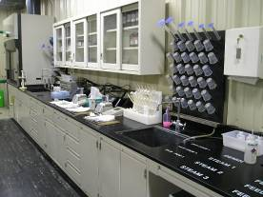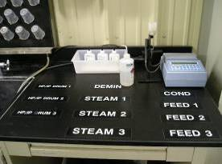
Photo 23: The chemistry analysis table holds multiple water analysis devices and is well organized.
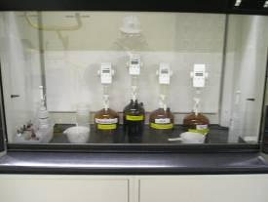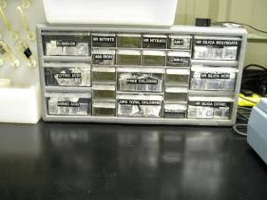
Photo 24: Reagents and corrosive chemicals are properly stored and bench tops are free of clutter.

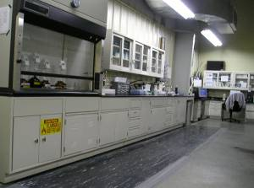
Photo 25: The flammable storage cabinet below the fume hood has self closers.

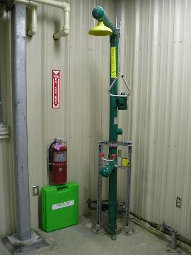
Photo 26: Emergency shower and personal protective equipment and spill containment materials are readily available.

OBSERVATION 3.12 – Chemistry Laboratory Equipment
The chemistry lab contains multiples of various kinds of water analysis equipment (Photo 27) which allows staff to double-check measurements and to calibrate one device against another. These pieces of equipment measure water pH, silica, chlorine and iron, among other things.

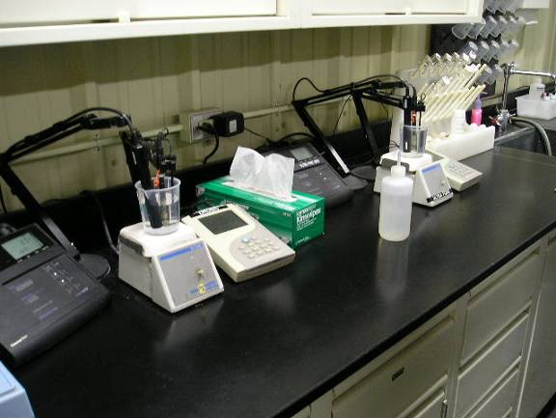
Photo 27: Multiple water analysis devices can be seen on a clean, well organized lab table.

OBSERVATION 3.13 – General House Keeping
The plant demonstrates good housekeeping practices..
- Plant Staff contribute to overall safety by properly storing equipment (Photos 30 thru 34), regularly sweeping areas and removing debris.
- Plant Staff are responsive and keen to improve general plant safety. The Auditor pointed out ladders that were improperly stored. Plant staff picked up and properly stored the ladders within hours (Photos 28 and 31).

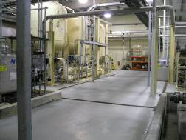
Photo 28: Excellent general housekeeping practices were evident. Here the water treatment area is free of debris.

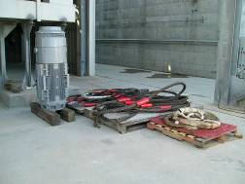
Photo 29: Hoisting cables and a motor are neatly stacked on pallets awaiting removal to storage and repairs.

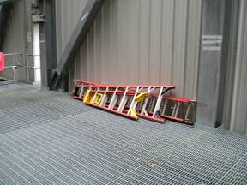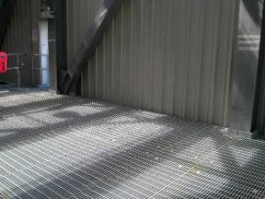
Photo 30: Improperly stored ladders were removed within hours of notification during the Audit.

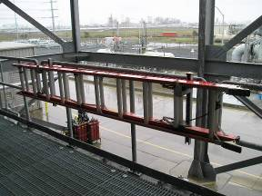
Photo 31: The plant stores ladders on hangers, leaving walkways clear.

OBSERVATION 3.14 – Operator Conduct
The control room operators and personnel exhibit professional behavior and excellent knowledge of plant operations.
- On March 27th the Auditor observed control room activities during a morning start-up. Control room personnel acknowledged system and equipment alarms and annunciators. Roving operators (rovers) went out to check equipment without delay and reported back to the control room via two-way radios.
- Operators received an alarm during the start-up, Unit 3. A faulty temperature sensor called a “blade path thermocouple” spiked in temperature causing the CTG to auto unload due to a suspected high temperature spread. A high combustion spread can be an indication of a combustion issue or anomaly. This event caused an “auto-unload”, and the Unit “rolled back” from 145 Mw to 52% load, or about 92 MWs. During this time the operators worked calmly and methodically. A temperature sensor called a “blade path thermocouple” caused a spike in the Combustion Dynamics Monitoring System (CDMS). A spike indicates a high combustion spread and leads to excess vibration, and what operators call an “event”. The Unit was brought on line within the hour. Operators wrote a work order instructing a technician to check the system for leaks.
- The Auditor observed team members during a shift change. Key personnel held short informal meetings. Shift members discussed and resolved problems, and notified each other of any other operating considerations relevant during their shifts.

OBSERVATION 3.15 – Job Training
Supervisors train new staff using on-the-job training, and monitor their progress.
- The Auditor observed a “C” operator trainee during his on-the-job training period. The supervising trainer quizzed the trainee several times throughout the day on the trainee’s observations and activities.
- The roving operators took the trainee on every walk down. En route, the rovers instructed the Trainee, discussed procedures with him, showed him how to use the data recording device, and explained what to look for and how to test equipment.
- Training Supervisors allowed the trainee to perform various tasks, but only under their direct supervision.
- The supervising trainer required the trainee to spend two to three hours per shift on the computer-based training provided by General Physics.

OBSERVATION 3.16 –Routine Walk Downs
Rovers carry out routine walk downs a minimum of twice daily. The CPSD Auditor accompanied a rover on several routine and informal walk downs. The rover followed a predetermined route to ensure key components and systems were functioning properly.

OBSERVATION 3.17 – Data Collection
The plant uses effective systems to record and track information collected during daily walk-downs. The plant collects data (Figure 32) in Personal Digital Assistants (PDAs) for analysis and trending in a centralized data storage and analysis system.

- Plant staff uses a Dell Personal Digital Assist (PDA) to take notes and collect information during walk-downs (i.e. oil pressure, pump status) on the operations of plant equipment. Plant staff then “docks” the PDA into its “cradle” which immediately downloads the information into a desk top computer. The desk top computer uploads the PDA information into software called the Delta Energy Center (DEC) PI System.
- Operators use the DEC PI System daily to look for trends and to analyze equipment operation. By comparison, most plants use handwritten notes and checklists, which are inherently less reliable and more inconsistent.

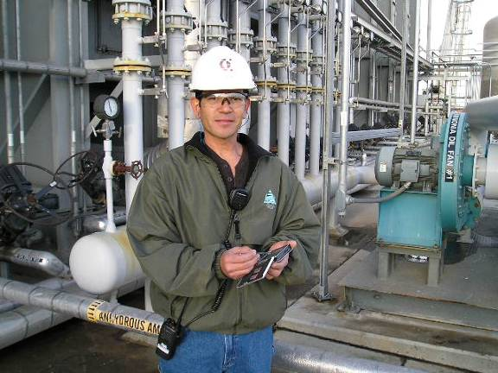
Photo 32: A roving operator seen with the digital personal assistant used for gathering plant information during routine walk downs.

OBSERVATION 3.18 – Plant Communications
The plant provides adequate communications devices for supervisors and roaming plant staff. All plant personnel and visitors are required to carry a walkie-talkie during plant inspections and other roving activities. Plant staff can promptly make both routine and emergency communications.

OBSERVATION 3.19 – Fire Protection Devices
Plant Management has a contract with Tyco Fire Systems Inc. for the inspection and maintenance of their Fire Protection equipment.
- All extinguishers and remote equipment have current inspection tags (Photos 33 & 34)
- Plant operators test run the main diesel powered fire pump weekly (Photo 35).
- The contractor inspected the fire protection system on May 11, 2006. The contractor wrote a report and plant staff implemented all of the suggested changes and upgrades from the report (i.e. valve locks; see Photo 36).

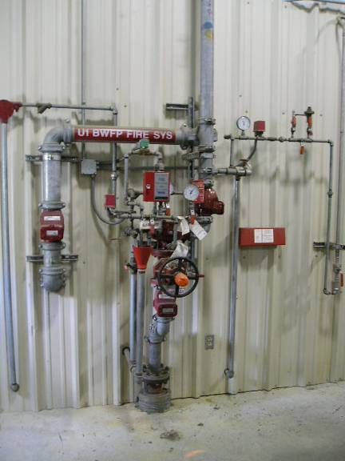
Photo 33: Inspection tags are visible on the boiler feedwater pump
fire suppression system.
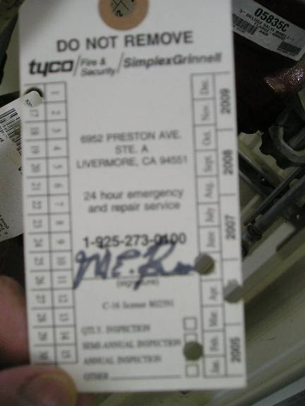
Photo 34: Close-up of the fire suppression system inspection tags show
an inspection date of May 2006.

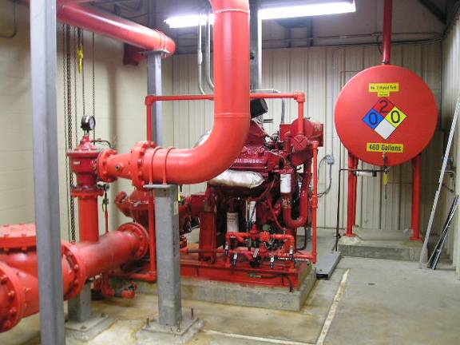
Photo 35: The main diesel powered fire pump

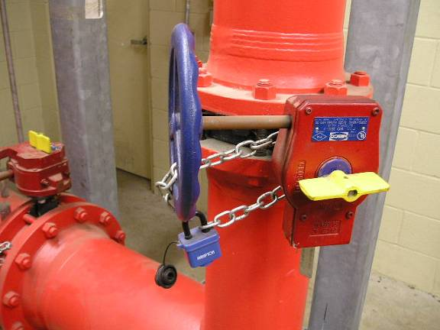
Photo 36: Locks are installed to prevent accidental closure of valves as recommended in the May 2006 inspection.

OBSERVATION 3.20 – Air Emissions Compliance
An outside contractor, Avogadro Group LLC annually tests the plant’s compliance with air emissions regulations.

- Plant staff makes every effort to implement all recommendations and corrections by the Contractor, Avogrado to meet Air Emissions requirements and regulations.
- Plant Staff hired the Avogadro to perform emissions testing beginning on October 13, 2006.
- Avogadro performed a “Relative Accuracy Test Audit” (RATA) of the “Continuous Emission Monitoring Systems” (CEMS). Avogadro concluded that all units are in compliance.
- Plant Staff keeps all RATA and CEMS test results and records on file dating back five years.

Further information on the Commission’s Power Plant Performance program may be found at the Commission’s Web Site at http://www.cpuc.ca.gov/PowerPlantStandards.
This plant is distinct from the 1311 megawatt Pittsburg Power Plant owned by Mirant Corporation.
CPSD inspects a power plant when outages or curtailments reduce the plant’s output by 50 MW or more.
Operation Standard 1, Assessment Guideline A and C.
Delta Energy Center Infrared Thermography Report dated September 20, 2006
Delta Energy Center Infrared Thermography Report dated September 20, 2006
Operation Standard 1, Assessment Guideline A and C.
OSHA – Code of Federal Regulation Title 29 Part 1910 requires hot surfaces within 7 feet of the ground be covered with insulating materials or guarded in manners as to prevent contact.
Operation Standard 1, Assessment Guideline A and C.
OSHA 29 CFR 1910.101 Compressed gas guidelines provide accepted storage, handling and use practices for users of compressed gas.
Operation Standard 1, Assessment Guideline A and C.
Operation Standard 1, Assessment Guideline A and C.
Operation Standard 7, Assessment Guideline A, G, & I
Operations Standard 8, Assessment Guideline No. B5,B7, B10, & B12
Operations Standard 8, Assessment Guideline No. B5,B7, B10, & B12
Operations Standard 8, Assessment Guideline No. B5,B7, B10, & B12
Federal regulations require secondary containment. See 40 CFR 264.175(b)(1), “A base must underlie the containers which is free of cracks or gaps and must be sufficiently impervious to contain leaks, spills, and accumulated precipitation until the collected material is detected and removed.”
Operations Standard 8, Assessment Guideline No. B5,B7, B10, & B12
Operations Standard 8, Assessment Guideline No. B5,B7, B10, & B12
Operations Standard 8, Assessment Guideline No. B5,B7, B10, & B12
Operations Standard 8, Assessment Guideline No. B5,B7, B10, & B12
The practice also conflicts with the plant’s Safety and Health Plan (SHP) and the National Fire Protection Association (NFPA) Code 4.5.6.2
Operations Standard 8, Assessment Guideline No. B5,B7, B10, & B12
Operation Standard 10, Assessment Guideline A
Operations Standard 10, Assessment Guideline A
Operation Standard 1, Assessment Guideline 4; operation standard 6, Assessment Guideline 6
No. 13-5.6
Operation Standard 1, Assessment Guideline 4; operation standard 6, Assessment Guideline 6
Operation Standard 1, Assessment Guideline 4; operation standard 6, Assessment Guideline 6
The lack of a self-closer also violates OSHA standards.
Operation Standard 14, Assessment Guideline a and B
Procedure SHP-7, Revision 3, Titled, “Lockout/Tagout/Try”, Paragraph 7.1.1.6 states, “Based on the information gathered during the work scope review, the Issuing Operator shall complete sections 1, 2, and 3 of the LOTOT Clearance Form.” The clearance form is Enclosure 7.2a of Procedure SHP-7.
Delta Energy Center May 2006 HRSG Inspection Report
Loss Prevention Report by Hartford Steam Boiler Inspection and Insurance Company dated May 22, 2006
Crane Valve Service Safety Valve Test Records dated July 12, 2006
Delta Energy Center Infrared Thermography Report dated September 20, 2006
Delta Energy Center PAP-11 Rev00 dated 2/13/07
See ASME B31 Pressure Piping Code
Delta Energy Center Ultrasonic Testing Measurements Rev060606
OSHA standard 1926.152(b) (4) (ii) requires self-closers.

