PUBLIC UTILITIES COMMISSION OF THE STATE OF CALIFORNIA

ENERGY DIVISION RESOLUTION E-4253
September 24, 2009
Redacted

RESOLUTION

Resolution E-4253. Southern California Edison (SCE) Company. PROPOSED OUTCOME: This Resolution approves three renewable portfolio standard power purchase agreements (PPAs) with wholly- and directly-owned subsidiaries of Caithness Shepherds Flat, LLC (CSF): North Hurlburt Wind, LLC, South Hurlburt Wind, LLC and Horseshoe Bend Wind, LLC.

ESTIMATED COST: This Resolution approves cost recovery for three renewable energy PPAs. Actual costs are confidential at this time.

By Advice Letter 2275-E filed on October 10, 2008 and Advice Letter 2275-E-A filed on February 23, 2009.

__________________________________________________________

Summary
Southern California Edison’s three Caithness Shepherds Flat (CSF) contracts comply with the Renewable Portfolio Standard (RPS) procurement guidelines and are approved
Southern California Edison (SCE) filed advice letter (AL) 2275-E on October 10, 2008 requesting Commission review and approval of three renewable energy power purchase agreements (PPAs) executed with wholly- and directly-owned subsidiaries of CSF. SCE filed supplemental AL 2275-E-A on February 23, 2009 to include the Independent Evaluator Report for SCE’s 2007 renewable energy solicitation.

Generating facilities | Type | Term  (Years) | Capacity  (MW) | Energy  (GWh) | Expected Online  Date | Location
North Hurlburt, | Wind, new | 20 | 140-350 | 662 | June 2011 | Oregon
South Hurlburt, | Wind, new | 20 | 140-350 | 662 | Jan 2012 | Oregon
Horseshoe | Wind, new | 20 | 140-350 | 662 | Jan 2012 | Oregon

SCE procured the proposed contracts consistent with SCE’s 2007 RPS Procurement Plan, which was approved by the Commission in D.07-02-011. Pursuant to the PPAs, SCE will buy as-available renewable energy from the CSF facilities in Oregon. SCE will manage the intermittent energy by either selling it and replacing it at a later date with an equivalent amount of energy for import to California, or firming and shaping the energy for import into California upon receipt. In either event, SCE’s imports into California under the PPA shall be consistent with the delivery rules in the California Energy Commission’s RPS Eligibility Guidebook. . While the contract prices may be at or below the applicable 2007 market price referents (MPR), the total cost of the contract with firming and shaping will require above-MPR funds. Approval of this contract will exhaust SCE’s above-MPR funds. Deliveries from this PPA are reasonably priced and fully recoverable in rates over the life of the contract, subject to Commission review of SCE’s administration of the contract.

The Division of Ratepayer Advocates’ protests are denied.

AL 2275-E and 2275-E-A are approved without modification.

Confidential information about the contract should remain confidential
This resolution finds that certain material filed under seal pursuant to Public Utilities (Pub. Util.) Code Section 583, General Order (G.O.) 66-C, and D.06-06-066 should be kept confidential to ensure that market sensitive data does not influence the behavior of bidders in future RPS solicitations.

Pursuant to D.06-06-066 and the decision’s Appendix I “IOU Matrix”, this Commission adopted a “window of confidentiality” for individual contracts for RPS energy or capacity. Specifically, this Commission determined that RPS contracts should be confidential for three years from the date the contract states that energy deliveries begin, except contracts between investor-owned utilities (IOUs) and their own affiliates, which should be public.

Background
The RPS Program requires each utility to increase the amount of renewable energy in its portfolio
The California RPS Program was established by Senate Bill (SB) 1078 and has been subsequently modified by SB 107 and SB 1036. The RPS program is set out at Public Utilities (PU) Code Section 399.11, et seq. An RPS policy generally requires that a retail seller of electricity, such as SCE, increase the amount electricity generated by Eligible Renewable Energy Resources (ERR) as a percentage of its retail sales. Under the California RPS, each utility is required to increase its total procurement of ERRs by at least 1% of retail sales per year so that 20% of its retail sales are supplied by ERRs by 2010. Also, on November 17, 2008, Governor Schwarzenegger issued Executive Order S-14-08, setting a goal for energy retailers to deliver 33 percent of electrical energy from renewable resources by 2020.

In response to SB 1078, SB 107, and SB 1036, the Commission has issued a series of decisions and resolutions that establish the regulatory and transactional parameters of the utility renewables procurement program.
- On June 19, 2003, the Commission issued its “Order Initiating Implementation of the Senate Bill 1078 Renewable Portfolio Standard Program,” D.03-06-071.
- Instructions for utility evaluation of each offer to sell ERRs requested in an RPS solicitation were provided in D.04-07-029, as required by PU Code Section 399.14(a)(2)(B). The bid evaluation methodology is known as ‘least-cost, best-fit’.
- The Commission adopted standard terms and conditions (STCs) for RPS power purchase agreements in D.04-06-014, as required by PU Code Section 399.14(a)(2)(D). These STCs are compiled in D.08-04-009, as modified by D.08-08-028, and as a result, there are now thirteen STCs of which four are non-modifiable.
- D.06-10-050, as modified by D.07-03-046, compiled the RPS reporting and compliance methodologies. In this decision, the Commission established methodologies to calculate a retail seller’s initial baseline procurement amount, annual procurement target (APT) and incremental procurement amount (IPT).
- The Commission adopted its market price referent (MPR) methodology in D.04-06-015 for determining the market price of energy, as defined in PU Code Sections 399.14(a)(2)(A) and 399.15(c); the MPR serves as a cost containment tool because the above-MPR contract costs of RPS contracts are limited (PU Code Section 399.15[d]). The Commission refined the MPR methodology for the 2005 RPS Solicitation in D.05-12-042. Subsequent resolutions adopted MPR values for the 2005, 2006, 2007, and 2008 RPS solicitations.
- In D.06-10-019, the Commission adopted rules for the eligibility and approval of RPS short-term contracts (procurement contracts that are less than 10 years in duration) and bilateral contracts (procurement contracts that are negotiated outside of a competitive RPS solicitation). Further rules regarding the review and approval of short-term and bilateral contracts were adopted in D.09-06-050.

Pursuant to SB 1036, above-MPR costs can now be recovered in rates
Resolutions E-4160 and E-4199 implemented SB 1036, which modified the RPS cost containment mechanism. In Resolution E-4199, the Commission established cost limitations for each IOU and set forth guidelines for approving above-MPR RPS contracts negotiated through a competitive solicitation. SCE was allocated $322,107,744 in AMFs.

PU Code § 399.15(d)(2) provides that “The above-market costs of a contract selected by an electrical corporation may be counted toward the cost limitation if all of the following conditions are satisfied:
(A) The contract has been approved by the commission and was selected through a competitive solicitation pursuant to the requirements of subdivision(d) of Section 399.14.
(B) The contract covers a duration of no less than 10 years.
(C) The contracted project is a new or repowered facility commencing commercial operations on or after January 1, 2005.
(D) No purchases of renewable energy credits may be eligible for consideration as an above-market cost.
(E) The above-market costs of a contract do not include any indirect expenses including imbalance energy charges, sale of excess energy, decreased generation from existing resources, or transmission upgrades.
Once a utility’s AMFs are insufficient to support the costs of above-MPR RPS contracts, the commission must allow the utility to “limit its procurement to the quantity of eligible renewable energy resources that can be procured at or below the MPR”. However, a utility can voluntarily decide to procure above-MPR RPS contracts once the cost limitation has been exhausted.

Energy from RPS facilities located out-of-state must be delivered to California
The California Energy Commission (CEC) is responsible for certifying the eligibility of renewable energy facilities for the RPS program, as well as verifying and tracking the generation and delivery of renewable energy claimed for compliance with the RPS program. If a renewable energy facility has its first point of interconnection to the transmission network outside of California, it must satisfy all of the following additional requirements:
- It is connected to the transmission network within the Western Electricity Coordinating Council (WECC) service territory.
- It commences initial commercial operation after January 1, 2005.
- Electricity produced by the facility is delivered to an in-state location.
- It will not cause or contribute to any violation of a California environmental quality standard or requirement.
- If the facility is outside of the United States, it is developed and operated in a manner that is as protective of the environment as a similar facility located in the state.
- It participates in the Western Renewable Energy Generation Information System (WREGIS), the accounting system to verify compliance with the renewables portfolio standard by retail sellers
While facilities located in California or with their first point of interconnection in the state are automatically deemed “delivered”, eligible renewable energy from out-of-state facilities must be “scheduled for consumption by California end-use retail customers” to be counted for compliance with the RPS program. The RPS statute also allows “electricity generated by an eligible renewable energy resource [to] be considered ‘delivered’ regardless of whether the electricity is generated at a different time from consumption by a California end-use customer.” The CEC’s RPS Eligibility Guidebook says that in practical terms, this means that out-of-state energy may be “firmed” and “shaped”, or backed up or supplemented with delivery from another source, before it is delivered to California. The CEC’s Guidebook provides three examples of eligible delivery structures, and essentially allows a generator, third party, or the IOU to firm and shape RPS contracts.

For each advice letter requesting CPUC approval of a PPA with an out-of-state RPS facility, the CEC provides written documentation to the CPUC addressing whether a proposed RPS contract’s delivery structure would be eligible pursuant to the guidelines in the CEC’s Guidebook.
Interim Greenhouse Gas Emissions Performance Standard (EPS) established emission rate limitations for long-term electricity procurement
A greenhouse gas emissions performance standard (EPS) was established by Senate Bill 1368, which requires that the Commission consider emissions costs associated with new long-term (five years or greater) power contracts procured on behalf of California ratepayers.

On January 25, 2007, the Commission approved D.07-01-039 which adopted an interim EPS that establishes an emission rate quota for obligated facilities to levels no greater than the greenhouse gas (GHG) emissions of a combined-cycle gas turbine powerplant. The EPS applies to all energy contracts for baseload generation that are at least five years in duration. Renewable energy contracts are deemed EPS compliant from the EPS except in cases where intermittent renewable energy is firmed and shaped with generation from non-renewable resources. If the renewable energy contract is firmed and shaped with a specified energy source that is considered baseload generation, then the energy source must individually meet the EPS. If, however, the intermittent energy is firmed and shaped with an unspecified energy source (e.g. system power), then D.07-01-039 specifically defines the following eligibility condition:
For specified contracts with intermittent renewable resources (defined as solar, wind and run-of-river hydroelectricity), the amount of substitute energy purchases from unspecified resources is limited such that total purchases under the contract (whether from the intermittent renewable resource or from substitute unspecified sources) do not exceed the total expected output of the specified renewable powerplant over the term of the contract.

SCE requests Commission approval of a renewable energy contract
On October 10, 2008, SCE filed AL 2275-E seeking approval of three power purchase agreements (PPA) between SCE and Caithness Shepherds Flat. The PPA results from SCE’s 2007 RPS solicitation. The PPA will contribute energy deliveries towards SCE’s renewable procurement goal required by California’s RPS statute.

SCE requests that the Commission issue a resolution containing the following findings:

- Approval of the CSF Contracts in their entirety
- A finding that any electric energy sold or dedicated to SCE pursuant to the CSF Contracts constitutes procurement by SCE from an eligible renewable energy resource (ERR) for the purpose of determining SCE’s compliance with any obligation that it may have to procure from ERRs pursuant to the RPS Legislation or other applicable law concerning the procurement of electric energy from renewable energy resources
- A finding that all procurement under the CSF Contracts that complies with the CEC’s delivery requirements counts, in full and without condition, towards any annual procurement target established by the RPS Legislation or the Commission which is applicable to SCE
- A finding that all procurement under the CSF Contracts that complies with the CEC’s delivery requirements counts, in full and without condition, towards any incremental procurement target established by the RPS Legislation or the Commission which is applicable to SCE
- A finding that all procurement under the CSF Contracts that complies with the CEC’s delivery requirements counts, in full and without condition, towards the requirement in the RPS Legislation that SCE procure 20% (or such other percentage as may be established by law) of its retail sales from ERRs by 2010 (or such other date as may be established by law)
- A finding that the CSF Contracts, and SCE’s entry into the CSF Contracts, is reasonable and prudent for all purposes, including, but not limited to, recovery in rates of payments made pursuant to the CSF Contracts, subject only to further review with respect to the reasonableness of SCE’s administration of the CSF Contracts
- Any other and further relief as the Commission finds just and reasonable.

SCE’s Procurement Review Group participated in review of the contracts
In D. 02-08-071, the Commission required each utility to establish a “Procurement Review Group” (PRG) whose members, subject to an appropriate non-disclosure agreement, would have the right to consult with the utilities and review the details of:
- Overall transitional procurement strategy;
- Proposed procurement processes including, but not limited to, RFO; and
- Proposed procurement contracts before any of the contracts are submitted to the Commission for expedited review.

SCE’s PRG was formed on or around September 10, 2002. Participants include representatives from the Commission’s Energy and Legal Divisions, the Division of Ratepayer Advocates (DRA), The Utility Reform Network (TURN), the Natural Resources Defense Council, California Utility Employees, the Union of Concerned Scientists, Aglet Consumer Alliance and the California Department of Water Resources.
SCE asserts that its PRG was consulted during each step of the 2007 renewable procurement process. On June 27, 2007, SCE presented its proposed 2007 RPS short list to the PRG and on August 6, 2008, SCE briefed the PRG concerning the conclusion of discussions with Caithness.

Although Energy Division is a member of the PRG, it reserved its judgment on the contracts until the resolution process. Energy Division reviewed the transactions independent of the PRG, and allowed for a full protest period before concluding its analysis.

Notice
Notice of AL 2275-E and AL 2275-E-A was made by publication in the Commission’s Daily Calendar. SCE states that a copy of the Advice Letter was mailed and distributed in accordance with Section 3.14 of General Order 96-B.

Protests
Advice Letter 2275-E was protested by the DRA on October 30, 2008. DRA requests that AL 2275-E be denied based on a few grounds:

- The PPAs should not be purchased at above-MPR prices because they “do not provide any direct renewable resource benefits to California ratepayers” and because the non-transparent firmed and shaped transaction does not have value for ratepayers.
- The PPAs disregard the least-cost best-fit (LCBF) methodology in the 2007 RPS bid evaluation process.
- The advice letter fails to state what non-modifiable terms the PPAs modified given that the transaction involves the Bonneville Power Authority, a Federal Agency.

SCE responded to DRA’s protest, arguing that the protest is without merit because:
- The PPA prices are reasonable and a below-MPR contract price is not a limitation on RPS contract approval. Also, the contracts do not include firming and shaping arrangements. Rather, the delivery transaction will be included in SCE’s annual Energy Resource Recovery Account (ERRA) for reasonableness review.
- SCE properly assessed both quantitative (e.g. price) and qualitative (e.g. project viability) factors in its evaluation of the 2007 solicitation bids.
- The advice letter specifically says that the PPAs include the four non-modifiable standard terms and conditions.

Discussion
Description of the project
The following table summarizes the substantive features of the PPA. See confidential Appendices A and B for detailed discussion of contract price, terms, and conditions:

Generating facilities | Type | Term  (Years) | Capacity  (MW) | Energy  (GWh) | Expected Online  Date | Location
North Hurlburt, | Wind, new | 20 | 140-350 | 662 | June 2011 | Oregon
South Hurlburt, | Wind, new | 20 | 140-350 | 662 | Jan 2012 | Oregon
Horseshoe | Wind, new | 20 | 140-350 | 662 | Jan 2012 | Oregon

The proposed long-term contract for new wind generation was negotiated as part of SCE’s 2007 renewable solicitation and was executed in August 2008. The CSF facilities will be located in Gilliam and Morrow counties in north-central Oregon, and will deliver the as-available energy to SCE at the Slatt substation within the Bonneville Power Administration control area. SCE will manage the intermittent energy by either selling it and replacing it at a later date with an equivalent amount of energy for import to California, or firming and shaping the energy for import into California upon receipt. In either event, SCE’s imports into California under the PPA shall be consistent with the delivery rules in the California Energy Commission’s RPS Eligibility Guidebook. SCE asserts that all required permits to install, operate, and connect the wind turbines to the transmission system have been procured. While the contract prices may be at or below the applicable 2007 market price referents (MPR), the total cost of the contract with firming and shaping will require above-MPR funds.

Energy Division examined the contract on multiple grounds:
- PPA is consistent with SCE’s CPUC-adopted 2007 RPS Plan
- SCE’s bid evaluation process is consistent with CPUC’s LCBF decision
- PPA conforms to CPUC-adopted standard terms and conditions
- CEC confirms that the proposed delivery structure complies with the RPS Eligibility Guidebook
- SCE will comply with Emissions Performance Standard for firming and shaping transactions
- SCE sufficiently demonstrates that the projects are viable relative to the offers in its 2007 solicitation
- The contract prices are reasonable

The PPA is consistent with SCE’s CPUC-adopted 2007 RPS Plan
California’s RPS statute requires the Commission to review the results of a renewable energy resource solicitation submitted for approval by a utility. The Commission will then accept or reject proposed PPAs based on their consistency with the utility’s approved renewable procurement plan (Plan). SCE’s 2007 Plan includes an assessment of supply and demand for renewable energy and bid solicitation materials, including a pro-forma agreement and bid evaluation methodology documents. The Commission conditionally approved SCE’s 2007 RPS procurement plan, including its bid solicitation materials, in D.07-02-011.

As ordered by D.07-02-011, on March 2, 2007 SCE filed and served its amended 2007 Plan. The proposed PPA is consistent with SCE’s Commission-approved RPS Plan.

PPA fits with identified renewable resource needs
SCE’s 2007 RPS Plan called for SCE to issue a competitive solicitation for electric energy generated by eligible renewable resources from either existing or new generating facilities that would deliver in the near term or long term. SCE also considered any new or repowered facilities that operate on co-fired fuels or a mix of fuels that include fossil fuel hybrid. SCE’s 2007 request for proposals (RFP) solicited proposals for projects that would supply electric energy, environmental attributes, capacity attributes and resource adequacy benefits from eligible renewable energy resources. SCE requested proposals based upon standard term lengths of 10, 15 or 20 years with a minimum capacity of one MW. SCE indicated a preference to take delivery of the electric energy at SP-15, but considered proposals based upon any designated delivery point within California. Additionally, SCE solicited for contracts that were located either within California, or if outside California, have the first point of interconnection in the WECC transmission system and have access to a transmission pathway capable of delivering the energy to a location within California.

The proposed CSF projects fit SCE’s identified renewable resource needs. SCE will procure the electric energy, green attributes, capacity attributes and resource adequacy benefits from the new renewable energy facilities. They are expected to deliver in the near-term, with commercial online dates in 2011 and 2012. While not located in California, the facilities are located in WECC and SCE will firm and shape the energy consistent with the CEC’s RPS delivery rules.
PPA selection consistent with RPS Solicitation Protocol
SCE distributed an RFP package that included a procurement protocol, which set forth the terms and conditions of the RFP, requirements for proposals, selection procedures, approval procedures and the RFP schedule. As part of the bid submission, SCE required bidders to submit comments on SCE’s pro forma agreement, to execute non-disclosure agreements and to send a letter stating that the bidder agrees to be bound by the terms and conditions of the protocol. The protocol also requested that proposals contain complete, accurate, and timely information about the project’s supplier, generating facility, and commercial terms and the pricing details of the proposal.

Consistent with D.07-02-011, SCE retained an independent evaluator (IE) to report to SCE’s procurement review group about the 2007 RPS solicitation and to ensure that the solicitation was conducted fairly and that the best resources were acquired. According to the IE Report submitted in supplemental AL 2275-E-A, the IE performed his duties overseeing the 2007 solicitation and has provided assessment reports to the PRG and the CPUC. See Appendix D for a detailed discussion of the IE’s review of these projects.
SCE says that all 2007 bids, including the CSF projects, were solicited, negotiated and executed in a manner consistent with SCE’s 2007 RFP Protocol. All 2007 bids offered power from eligible renewable energy resources, submitted the standard forms, agreed to be bound by the protocol and signed a non-disclosure agreement.

Bid evaluation process consistent with least-cost best fit (LCBF) decision
The CPUC’s LCBF decision directs the utilities to use certain criteria in their bid ranking. It offers guidance regarding the process by which the utility ranks bids in order to select or “shortlist” the bids with which it will commence serious negotiations.

SCE’s LCBF bid review process used for its 2007 solicitation is in compliance with the applicable Commission decisions. SCE’s LCBF analysis evaluates both quantitative and qualitative aspects of each proposal to estimate its value to SCE’s customers and relative value in comparison to other proposals.
Quantitative Assessment
SCE quantitatively evaluates bids based on individual benefit-to-cost (B-C) ratios. It is this B-C ratio that is used to rank and compare each project. The B-C ratios measure total benefits divided by total costs according to the following equation:

B-C Ratio = Capacity Benefit + Energy Benefit
Payments + Integration Cost + Transmission Cost + Debt Equivalence

The capacity benefits are assigned based on SCE’s forecast of capacity value and a technology-specific effective load carrying capability (ELCC). SCE evaluates the project energy benefits using a production simulation model that compares the total production costs of SCE’s base resource portfolio with the total production costs of the portfolio including the proposed RPS project. This calculation takes into account forecasted congestion charges, dispatchability and curtailability. This modeling methodology evaluates the impact of portfolio fit for all projects.

The market valuation of each project includes an assessment of the payments, an all-in price for delivered energy adjusted in each time-of-delivery period, and integration costs. Pursuant to Commission policy (D.04-07-029 and clarified by D.07-02-011), integration cost adders for all proposals must be zero. Further, the transmission upgrade costs are estimated using SCE’s transmission ranking cost report for resources that do not have an existing interconnection to the electric system or a completed Facilities Study.
Qualitative Assessment
SCE also assesses qualitative attributes of RPS bids and considers the inclusion of additional sellers on the shortlist if a bid’s qualitative attributes are particularly strong. The attributes that SCE considers include, but are not limited to: (a) extent of Seller’s mark-up of SCE’s pro forma agreement; (b) project viability; (c) status of project development efforts; (d) timing and progress towards gaining access to transmission; (e) technology viability; (f) technology and economic viability; and (g) seller’s capability to perform all of its financial and other obligations under the pro forma agreement.

Other non-quantitative attributes are used to determine tie-breakers, such as (a) environmental impacts of seller’s proposed project on California’s water quality and use; (b) resource diversity; (c) benefits to minority and low income communities; (d) local reliability; and (e) environmental stewardship.
Evaluation of CSF bid
The evaluation of the CSF bid was favorable in comparison to the bids in SCE’s 2007 solicitation. See confidential Appendix B for more detailed bid comparisons.

Independent evaluator (IE) oversaw SCE’s RPS procurement process
Consistent with D.07-02-011, SCE retained an IE, Sedway Consulting, to report to SCE’s procurement review group about the 2007 RPS solicitation and to ensure that the solicitation was conducted fairly and that the best resources were acquired. According to the IE Report submitted in AL 2275-E-A, Sedway Consulting performed its duties overseeing the 2007 solicitation and has provided assessment reports to the PRG and the CPUC.

In its Independent Evaluator Report, Sedway Consulting concluded that SCE “conducted a fair and effective evaluation of the proposals that it received in response to its 2007 RPS RFP and made the correct selection decisions in its short list.” Sedway Consulting performed its own evaluation of all 2007 proposals using its own proprietary model developed to simulate SCE’s LCBF ranking results. The IE ranked all proposals using its model and compared the results to SCE’s bid ranking results. The IE’s ranking results were similar to SCE’s, and as a result, Sedway Consulting agreed with SCE’s short-listing decisions. In addition, the IE monitored SCE’s short-listing discussions, contract negotiations and meetings with management where SCE made decisions, for example, regarding bid prioritizations and negotiation positions. Overall, the IE concludes that SCE conducted a fair and effective evaluation of its 2007 renewable energy proposals.
For the IE’s contract-specific evaluation about the CSF projects, see confidential Appendix D.

Consistency with adopted standard terms and conditions
STCs for the CSF contracts are in compliance with D.08-04-009.

Proposed delivery structure complies with CEC’s RPS Eligibility Guidebook
On April 13, 2009, the CEC provided the CPUC with a letter declaring that the proposed CSF delivery structure satisfies the RPS delivery requirements. This letter, which also includes a brief overview of the CSF delivery structure, can be found in Appendix C.

SCE will firm and shape the CSF energy consistent with the EPS
The CSF contracts are for intermittent renewable energy that will be firmed and shaped with generation from non-renewable resources. SCE will be firming and shaping the energy from the CSF facilities, and thus will be responsible for ensuring that the substitute energy is compliant with the EPS. SCE’s proposed delivery mechanism does not specify the energy that it will use to firm and shape these CSF contracts and could potentially firm and shape with either specified or unspecified power. In the advice letter, SCE asserts that it will firm and shape the CSF contracts consistent with the EPS rules because:
- SCE adheres to the EPS requirements for all of its imports of specified baseload energy; and
- SCE will comply with CEC requirements for firming and shaping intermittent out-of-state RPS energy.
Based on SCE’s representation of how the CSF contract will be firmed and shaped, the Commission finds this contract is compliant with the EPS, subject to SCE’s administration of the contract.

SCE demonstrates that the project is viable relative to other offers
In AL 2275-E, SCE says that “Caithness has either addressed, or is in the advanced stages of resolving, the major risk factors of constructing” the CSF facilities. Relative to other projects bid into the 2007 solicitation, CSF is further ahead in the project development process and is relatively more viable than the majority of SCE’s other offers.
Project Milestones
The PPAs identify the agreed upon project milestones, including, interconnection agreement, permits, financing, construction start and commercial operation deadlines.
Financeability of Resource

Caithness Energy has significant financing experience. For the CSF projects, they are engaging with Citigroup Inc to advise on financial options.

Investment Tax Credit (ITC)
The CSF projects are contingent upon the federal production tax credit (PTC), which was recently extended until the end of 2012. Given the expected 2011 and 2012 online dates, these projects should be eligible for the PTC. This extension provides important certainty for the wind market and adds to the viability of this project. However, there is always a risk that project development is delayed and projects come online after 2012.

Sponsor’s Creditworthiness and Experience
Caithness Energy has significant experience financing, owning and operating power plants utilizing geothermal, wind, solar and natural gas. CSF and its affiliates have developed, operated and owned interests in over 2,500 MW of wind projects.
Transmission Upgrades
SCE says that no upgrades are needed to BPA’s transmission system for this project. The Slatt substation will be expanded to accommodate the CSF facilities. All permits have been obtained for this expansion, and Caithness has placed orders for the major equipment.
Permitting
CSF has obtained all permits needed to construct and operate the CSF facilities.

Contract prices are reasonable
Based on certain contract terms and conditions, the contract prices may be either below or above the applicable 2007 market price referents (MPR). Using the AMFs rules set forth in Resolution E-4199, however, the total cost of each contract with firming and shaping will require above-MPR funds.

The CSF project has high viability relative to the other bids in SCE’s 2007 solicitation and can contribute to RPS goals in the near-term. On balance, the project has value to ratepayers given the contract price and the qualitative attributes of the project. See below for more details about the contract’s viability and confidential Appendix A for more detailed discussion of the contract prices.

Approval of these contracts will exhaust SCE’s cost limitation
The contracts are eligible for above-MPR funds (AMFs) because:
- The contracts were selected through a competitive solicitation
- The contracts cover a duration of no less than 10 years
- The contracts are for new facilities commencing commercial operations after January 1, 2005
- The contracts are not for renewable energy credits
- Indirect expenses are not included in the above-market funds request

The Energy Division Director’s letter (May 28, 2009) regarding SCE’s AMF balance said that SCE has $221,874,570 in AMFs remaining. Pursuant to the methodology adopted in Resolution E-4199, SCE calculated the maximum amount of AMFs that the projects could use given the contract terms and conditions. The aggregate cost of the contracts plus firming and shaping to deliver the energy to California will exhaust SCE’s AMFs. SCE has voluntarily agreed to incur the above-MPR costs of the CSF contracts that exceed their cost limitation.

Commission denies DRA’s protests
DRA protests the CSF projects because they are above the MPR
DRA objects to the CSF projects because they are above the MPR and because DRA doesn’t believe that firmed and shaped projects have value for ratepayers. For those reasons, DRA asserts that the contracts “should come at a discount rather than a premium to California ratepayers.” SCE replies that the CSF contract prices are reasonable because they are consistent with the RPS program goals, and the projects will provide near-term deliveries at a reasonable cost.

The Commission finds that the contract price is reasonable and that the CSF projects have value to ratepayers. The CSF contract price, benefit-to-cost ratio, and viability are reasonable as compared to SCE’s 2007 solicitation bids. Further, the contract is compliant with CPUC decisions and will additionally serve SCE’s need for near-term RPS-eligible energy deliveries.

DRA also argues that the firming and shaping transaction for the CSF contracts are not transparent and the cost is uncertain. SCE responds that the contracts do not actually include firming and shaping arrangements. Rather, the delivery transaction, including its costs, will be included in SCE’s annual Energy Resource Recovery Account (ERRA) for DRA review.

The Commission acknowledges that the CSF PPAs do not include a firming and shaping transaction because SCE, not CSF, will be handling the delivery of the CSF energy into California. However, SCE included a detailed description of the delivery structure in confidential Appendix C of AL 2275-E. SCE also publicly provided this information to the CEC for the CEC staff to assess whether the proposed firming and shaping structure would meet the RPS delivery requirements according to the RPS Eligibility Guidebook. In addition to describing the firming and shaping transaction, SCE disclosed the firming and shaping costs in AL 2275-E, in its confidential discussion of the project’s benefit to cost ratio. SCE also estimated the costs in its filing responding to Resolution E-4199.

Accordingly, DRA’s protest is denied. Also, we clarify that the firming and shaping structure has been vetted with the CEC and the review in ERRA will be limited to adherence to the structure proposed in the advice letter, rather than a complete review of the legitimacy of the structure.

DRA asserts that SCE disregarded the LCBF methodology in the 2007 RPS bid evaluation process
DRA’s protest includes several confidential arguments related to SCE’s application of the LCBF methodology to the selection of the CSF bid. SCE replies that DRA’s claim is based on an emphasis of the quantitative factors “without giving proper weight to qualitative factors, including the CSF Project’s multitude of strong viability attributes such as no required transmission upgrades, 100% site control, full attainment of all required permits and Caithness’ proven track record with respect to project development and equipment procurement.”

The Commission finds that the LCBF methodology was properly applied to the CSF contract. Specifically, we agree with SCE that a bid’s qualitative attributes, such as project viability, are important in the LCBF bid evaluation process. There are many RPS program priorities, including attaining the RPS at least cost and reaching the RPS goals in a timely manner. Both priorities must be assessed in a utility’s bid evaluation methodology. Accordingly, DRA’s protest is denied.

See confidential Appendix B for further discussion on SCE’s application of the LCBF methodology to the CSF bid.

DRA asserts that SCE did not identify what non-modifiable terms are in the CSF PPAs
DRA protests AL 2275-E, asserting that it does not say whether SCE and CSF modified any of the non-modifiable terms. DRA is concerned because they say “the PPA transaction involves the Bonneville Power Authority (BPA), which is a Federal Agency that usually requires contracts subject to federal law” and one of Pacific Gas and Electric’s RPS PPAs was rejected for having modified the required Applicable Law standard term and condition.

The Commission rejects DRA’s protests. As SCE notes in its reply, page 9 AL 2275-E states, “The CSF Contracts include the four ‘non-modifiable’ terms identified above without change”.

Comments
Public Utilities Code section 311(g)(1) provides that this resolution must be served on all parties and subject to at least 30 days public review and comment prior to a vote of the Commission. Section 311(g)(2) provides that this 30-day period may be reduced or waived upon the stipulation of all parties in the proceeding. The 30-day comment period for the draft of this resolution was neither waived nor reduced.

No comments were received.

Findings
- The RPS Program requires each utility, including SCE, to increase the amount of renewable energy in its portfolio to 20 percent by 2010, increasing by a minimum of one percent per year.
- D.08-04-009 sets forth four non-modifiable and nine modifiable standard terms and conditions to be incorporated into RPS power purchase agreements.
- D.07-02-011 directed the utilities to issue their 2007 renewable RFOs, consistent with their renewable procurement plans.
- The Commission required each utility to establish a Procurement Review Group (PRG) to review the utilities’ interim procurement needs and strategy, proposed procurement process, and selected contracts.
- Levelized contract prices below the 2007 MPR are considered per se reasonable as measured according to the net present value calculations explained in D.04-06-015, D.04-07-029, and D.05-12-042.
- SB 1036 modified the process for recovering above-MPR costs of RPS contracts. As a result, each utility can request rate recovery for above-MPR contract costs from the CPUC, and these costs will apply to a utility’s cost limitation if certain conditions are satisfied.
- SCE filed Advice Letter (AL) 2275-E on October 10, 2008, requesting Commission review and approval of three new renewable energy contracts with Caithness Shepherds Flat (CSF).
- DRA protested AL 2275-E on October 30, 2009. SCE filed a reply on November 6, 2008.
- SCE filed supplemental Advice Letter 2275-E-A on February 23, 2009 to include the Independent Evaluator report for SCE’s 2007 RPS solicitation.
- SCE briefed its PRG on its proposed shortlist and status of negotiations for the 2007 RPS solicitation. SCE also briefed the PRG concerning the successful conclusion of discussions with CSF.
- The Commission has reviewed the proposed contracts and finds them to be consistent with SCE’s approved 2007 renewable procurement plan.
- The CSF contract terms and conditions are consistent with D.08-04-009.
- The costs of the CSF contracts, estimated pursuant to the rules set forth in Resolution E-4199, exceed the 2007 MPR released in Resolution E-4118.
- The CSF contracts meets the requirements of PU Code §399.15(d)(2) for contracts to be counted toward SCE’s cost limitation. These contracts will exhaust SCE’s cost limitation.
- Although the CSF contracts are eligible for AMFs, this Resolution does not prejudge the Commission’s decision on the characterization or eligibility of renewable energy credit transactions.
- SCE has voluntarily agreed to incur the above-MPR costs of the CSF contracts that exceed their cost limitation.
- The CEC wrote a letter to the CPUC determining that the delivery structure to delivery the energy from the CSF contracts to California is consistent with the RPS Eligibility Guidebook.
- SCE states in AL 2275-E that the firming and shaping transactions will comply with the EPS requirements.
- SCE sufficiently demonstrates that the projects are viable relative to the offers in its 2007 solicitation.
- The Commission denies DRA’s protests to AL 2275-E because the contract prices are reasonable, SCE complied with their approved LCBF methodology in their evaluation of the CSF bid, and the CSF contracts contain all four non-modifiable terms and conditions.
- The CSF contracts are reasonable and should be approved in its entirety.
- The costs of the contracts between SCE and Seller are reasonable and in the public interest; accordingly, the payments to be made by SCE are fully recoverable in rates over the life of the projects, subject to CPUC review of SCE’s administration of the PPAs.
- Certain material filed under seal pursuant to Public Utilities (Pub. Util.) Code Section 583 and General Order (G.O.) 66-C, and considered for possible disclosure, should not be disclosed. Accordingly, the confidential appendices, marked "[REDACTED]" in the redacted copy, should not be made public upon Commission approval of this resolution.
- Procurement pursuant to these Agreements is procurement from an eligible renewable energy resource for purposes of determining Buyer's compliance with any obligation that it may have to procure eligible renewable energy resources pursuant to the California Renewables Portfolio Standard (Public Utilities Code Section 399.11 et seq.), Decision 03-06-071, or other applicable law.
- Procurement pursuant to these Agreements constitutes incremental procurement or procurement for baseline replenishment by Buyer from an eligible renewable energy resource for purposes of determining Buyer's compliance with any obligation to increase its total procurement of eligible renewable energy resources that it may have pursuant to the California Renewables Portfolio Standard, CPUC Decision 03-06-071, or other applicable law.
- The CSF contracts proposed in AL 2275-E and AL 2275-E-A should be approved without modifications.

Therefore it is ordered that:
- The proposed renewable energy contracts between Southern California Edison (SCE) and Caithness Shepherds Flat in Advice Letter 2275-E and 2275-E-A are approved without modification.
- The costs of the contracts between SCE and Caithness Shepherds Flat are reasonable and in the public interest; accordingly, the payments to be made by SCE are fully recoverable in rates over the life of the projects, subject to Commission review of SCE’s administration of the contracts.
- The protests from the Division of Ratepayer Advocates are denied.
- This Resolution is effective today.

I certify that the foregoing resolution was duly introduced, passed and adopted at a conference of the Public Utilities Commission of the State of California held on September 24, 2009; the following Commissioners voting favorably thereon:

/s/ PAUL CLANON
PAUL CLANON
Executive Director

MICHAEL R. PEEVEY
PRESIDENT
DIAN M. GRUENEICH
JOHN A. BOHN
RACHELLE B. CHONG
TIMOTHY ALAN SIMON
Commissioners

Confidential Appendix A:
Contract Price
[REDACTED]

Confidential Appendix B:
Confidential bid data and contract terms and conditions
[REDACTED]

Confidential Appendix C:
CEC Letter Regarding Eligibility of Puget’s Proposed Delivery Structure

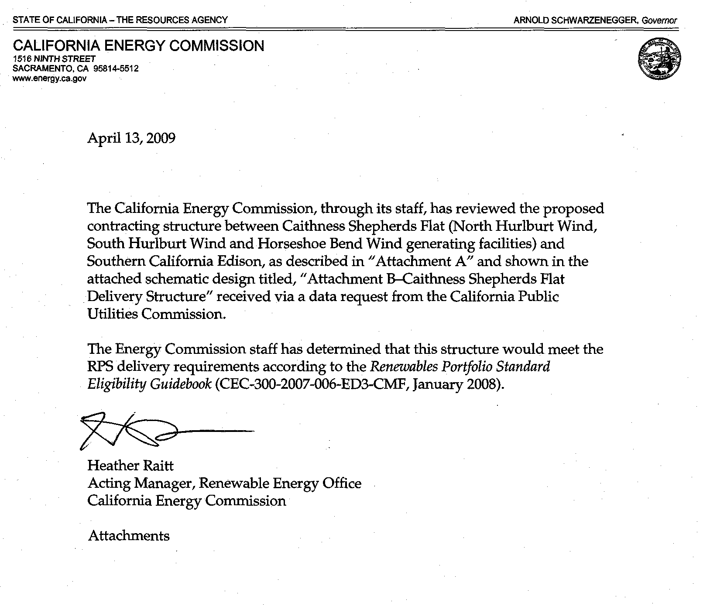
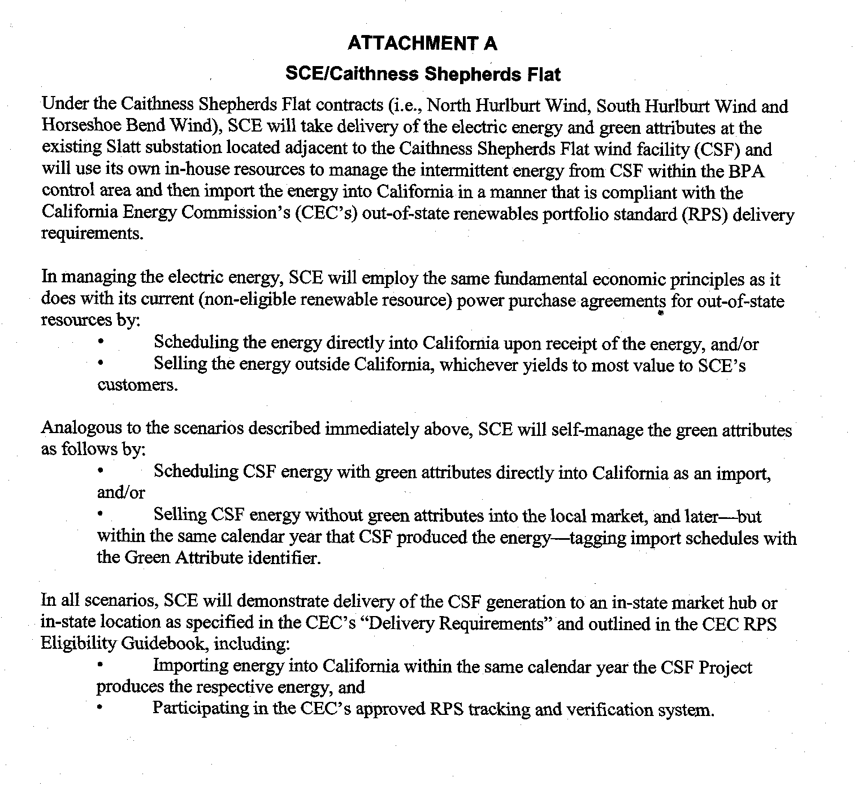

Confidential Appendix D:
Independent Evaluator Report for CSF projects
[REDACTED]

Each facility can have a maximum capacity of 350 MW, but the total capacity of the three projects can not exceed 909 MW. CSF expects the total capacity to be around 800 MW.
SB 1078 (Sher, Chapter 516, Statutes of 2002)
SB 107 (Simitian, Chapter 464, Statutes of 2006)
SB 1036 (Perata, Chapter 685, Statutes of 2007)
http://gov.ca.gov/executive-order/11072/
http://docs.cpuc.ca.gov/word_pdf/FINAL_DECISION/27360.PDF
http://docs.cpuc.ca.gov/WORD_PDF/FINAL_DECISION/38287.PDF
http://docs.cpuc.ca.gov/WORD_PDF/FINAL_DECISION/81269.PDF
http://docs.cpuc.ca.gov/word_pdf/FINAL_DECISION/86954.pdf
D.06-10-050, Attachment A, (http://www.cpuc.ca.gov/WORD_PDF/FINAL_DECISION/61025.PDF) as modified by D.07-03-046 (http://www.cpuc.ca.gov/WORD_PDF/FINAL_DECISION/65833.PDF)
The IPT represents the amount of RPS-eligible procurement that the LSE must purchase, in a given year, over and above the total amount the LSE was required to procure in the prior year. An LSE’s IPT equals at least 1% of the previous year’s total retail electrical sales, including power sold to a utility’s customers from its DWR contracts.
http://docs.cpuc.ca.gov/word_pdf/FINAL_DECISION/37383.pdf
http://www.cpuc.ca.gov/word_pdf/FINAL_DECISION/52178.pdf
Respectively, Resolution E-3980: http://www.cpuc.ca.gov/WORD_PDF/FINAL_RESOLUTION/55465.DOC, Resolution E-4049: http://www.cpuc.ca.gov/word_pdf/FINAL_RESOLUTION/63132.doc, Resolution E-4118: http://www.cpuc.ca.gov/word_pdf/FINAL_RESOLUTION/73594.pdf Resolution E-4214: http://docs.cpuc.ca.gov/Published/Final_resolution/95553.htm
http://docs.cpuc.ca.gov/word_pdf/FINAL_DECISION/60585.PDF
http://docs.cpuc.ca.gov/WORD_PDF/FINAL_RESOLUTION/81476.PDF
http://docs.cpuc.ca.gov/WORD_PDF/FINAL_RESOLUTION/98603.PDF
For a link to Resolution E-4199 and other documents related to the AMFs program, see: http://www.cpuc.ca.gov/PUC/energy/Renewables/hot/SB1036implementation.htm
PU Code §399.15(d)(3)
PU Code §399.15(d)(4)
Public Resources (PR) Code 25741(b)(2)(B)
PR Code Section 25741(a)
Id
http://energy.ca.gov/2007publications/CEC-300-2007-006/CEC-300-2007-006-ED3-CMF.PDF
pg 23-24
Chapter 464, Statutes of 2006 (SB 1368)
D.07-01-039 adopted an emission rate of 1,100 pounds of carbon dioxide per megawatt-hour for the proxy CCGT (section 1.2, page 8) http://www.cpuc.ca.gov/WORD_PDF/FINAL_DECISION/64072.PDF
“Baseload generation” is electricity generation at a power plant “designed and intended to provide electricity at an annualized plant capacity factor of at least 60%.” § 8340 (a)
D.07-01-039, Conclusion of Law 40. Note: These compliance rules specifically apply to IOUs, additional compliance rules may apply to other RPS-obligated load serving entities.
The California Energy Commission is responsible for determining the RPS-eligibility of a renewable generator. See PU Code Section 399.12 and D.08-04-009, as modified by D.08-08-028.
As defined by SCE, “’RPS Legislation’ refers to the State of California Renewable Portfolio Standard Program, as codified at California Public Utilities Code Section 399.11 et seq.”
The entire text of this portion of the protest is redacted.
CSF expects the total capacity to be 800 MW. Also, each facility can have a maximum capacity of 350 MW, but the total capacity of the three projects can not exceed 909 MW.
PU Code §399.14
AL 2275-E, page 13
Page 10
The CPUC has not authorized the use of unbundled or tradable renewable energy credit transactions. A thorough examination of the issues related to the use of unbundled and tradable RECs for RPS compliance is taking place in R.06-02-012 and we do not wish to prejudge the outcome of that proceeding.
On April 13, 2009, Energy Division staff received a letter from the CEC the delivery structure of SCE’s PPAs with CSF are consistent with the CEC’s RPS deliverability rules

