Date of Issuance: 2/26/2010

PUBLIC UTILITIES COMMISSION OF THE STATE OF CALIFORNIA

Communications Division | RESOLUTION T- 17230
Carrier Oversight and Programs Branch | February 25, 2010

R E S O L U T I O N

Resolution T-17230. Funding Approval for the Plumas-Sierra Telecommunications Middle-Mile Project, from the California Advanced Services Fund (CASF), Amounting to $1,721,280.
__________________________________________________________________

Summary

This Resolution adopts funding for the Plumas-Sierra Telecommunications (PST) middle-mile project, amounting to $1,721,280 from the California Advanced Services Fund (CASF), contingent upon receiving American Recovery and Reinvestment Act (ARRA) funding, posting of a performance bond, and compliance with Commission Resolutions T-17143 and T-17233. The amount granted represents 10% of the total estimated project costs to provide broadband service to underserved census block groups (CBGs) in accordance with Resolutions T-17143 and T-17233, and Decision (D.) 09-07-020.

Background

On December 20, 2007, the Commission approved D.07-12-054 which established the two-year CASF program to provide matching funds of up to 40% of the total project costs for the deployment of broadband infrastructure in unserved and underserved areas in California. Resolution T-17143, approved on June 12, 2008, adopted application requirements, scoring criteria for the award of funds, and a prescribed timeline for other filings and notifications including a projected Commission Meeting date for final approval of award(s). This same Resolution directed interested applicants seeking funding for unserved and underserved projects to file their project proposals and funding requests beginning July 24, 2008 and August 25, 2008, respectively.
D.07-12-054 limited the extension of CASF funding to:
- Entities with a Certificate of Public Convenience and Necessity (CPCN) that qualify as “telephone corporations” as defined in § 234 of the Public Utilities Code (PU Code);
- Wireless carriers registered with the Commission that have been granted a Wireless Identification Number (WIR);
- Entities who have pending applications for a CPCN; and
- A consortium with a member holding a CPCN or a WIR who will serve as the fiscal agent of the consortium (D.07-12-054 at pgs. 33-35, mimeo).

On July 9, 2009, the Commission issued D.09-07-020 establishing new schedules and plans for the filing, review and approval of an additional round of broadband project requests. This decision also provides the potential for the applicants to seek CASF program funding while pursuing funding for broadband deployment grants issued under the ARRA. Also, because federal grants under ARRA can fund up to 80% of the project cost, D.09-07-020 allowed applicants to seek an additional 10% funding coverage from the CASF, leaving only 10% of the project cost for the applicant to provide.

On July 29, 2009, Governor Schwarzenegger signed Assembly Bill (AB) 1555 (Chapter 24, Statutes of 2009), amending Section 281 of the PU Code to expand CASF eligibility to any entity applying for CASF funding in conjunction with their ARRA funding request, provided that entity satisfies the eligibility requirement for CASF funding. AB 1555 also provides that the Commission establish requirements and guidelines for non-certificated applicants.

On October 29, 2009, the Commission approved Resolution T-17233 establishing application requirements and guidelines for non-CPUC certificated applicants and broadband providers applying for CASF grant money, in conjunction with an application for ARRA funding, to develop and deploy broadband infrastructure.

As of December 17, 2009, the Commission has granted applicants $57.61 million in CASF funds for 38 projects covering 11,045 square miles, benefiting an estimated 115,706 potential households, as follows:

- Unserved area projects- $12.04 million, 17 projects, 4,303 square miles, and 33,327 households;
- Underserved area projects- $45.57 million, 21 projects, 6,742 square miles, 82,375 households.

Notice/Protests

The Commission posted, by county, a list of Census Block Groups (CBGs) for PST’s project on its CASF website page under “(1) UNSERVED areas proposed to be served as of July 17, 2009: Census Block Groups (CBGs),” and (2) UNDERSERVED areas proposed to be served as of July 17, 2009: Census Block Groups (CBGs)”. Challenges were filed against the list of CBGs posted as of that date. The Communications Division (CD) proceeded to review and analyze the proposed project areas to verify that they were indeed unserved and/or underserved as of the applicant’s filing date.

Discussion

This Resolution adopts contingent funding of $1,721,280 for the proposed PST middle- mile project in Plumas, Lassen, and Sierra Counties. This project is described in detail in Appendix A. Maps of the proposed project are located on pages A-3 and A-4 of Appendix A. The total project cost is estimated at $17,212,799. PST requests 10% of total estimated project costs, or $1,721,280, from the CASF as a match to PST’s 80% ARRA fund request.

PST’s Background

PST is a wholly-owned non-profit subsidiary of Plumas-Sierra Rural Electric Cooperative (PSREC), which was founded in 1937. PSREC is a member-owned electric distribution utility providing electricity and related services to over 6,500 member/owners in Plumas, Lassen, and Sierra counties in California, and portions of Washoe County in Nevada. Their headquarters are in Portola, CA, with a second office in Susanville (Lassen County).

PST is an experienced wireless Internet service provider that currently operates six
wireless networks in Plumas and Eastern Sierra counties, using a combination of spectrums, and both licensed and unlicensed frequencies. PST determines which frequency and technology to use based on the terrain and density of foliage in the area to be served. Since the mid 1990s, PST has offered satellite television, dial-up Internet access, and more recently, satellite high-speed broadband, Wi-Fi Internet access and wireless cellular telephone services in several areas within Plumas, Lassen, and Sierra Counties.
Plumas-Sierra Rural Electric Cooperative (PSREC) describes itself as “a true cooperative, controlled by the membership through an elected seven-person board of directors.” Their stated goal is to “provide utility services with a high level of reliability for fair and reasonable costs. We are also dedicated to improving the quality of life of our member-owners and our local communities.”

PST is proposing a middle-mile backhaul network equipped with Packet Optical Network Platform (PONP) terminal equipment. The proposed network will serve anchor institutions and wholesale service providers via a point-to-point configuration with logical ring service architecture and an OC-48 core network at four core node sites. For the wholesale customers’ subscribers, the nodes will be equipped with a variety of standard interfaces to accept traffic from DS1 to OC-3 circuits. Hence, in utilizing PONP equipment, PST’s open network architecture allows existing rural service providers that have significant investment in legacy TDM network equipment to realize the benefits of a lower-cost per bit middle-mile connectivity that packet optical transport supports. This network would also give service providers access to greater backhaul bandwidth capacity so that they may offer emerging services that retail customers are likely to demand, while fostering service area economic development.

PST’s Application

In its application, PST submitted the following table which proposes a variety of delivery speed and delivery type service offerings intended specifically and exclusively for anchor institutions and wholesale service providers. Delivery speeds (third column below) are expressed in megabits per second (mbps).

Plumas-Sierra Telecommunications anchor institution and wholesaler proposed service offering:
Row # | Service Offering | Delivery Speeds | Delivery Type
1 | Dark Fiber | Unlimited | n/a
2 | T1 point-to-point | 1.544 mbps | Symmetric
3 | DS-3 point-to-point | 44.376 mbps | Symmetric
4 | OC-3 | 155.52 mbps | Symmetric
5 | OC-12 | 622 mbps | Symmetric
6 | OC-48 | 2,488 mbps | Symmetric
7 | Ethernet Private Line | 10 mbps | Non-shared
8 | Ethernet Private Line | 100 mbps | Non-shared
9 | Ethernet Virtual Private Line | 10 mbps | Shared
10 | Ethernet Virtual Private Line | 100 mbps | Shared
Row # | Service Offering | Delivery Speeds | Delivery Type
11 | Public Internet | 10 mbps | Shared
12 | Public Internet | 100 mbps | Shared

PST states that the symmetric and non-shared delivery types (rows 1 through 8) will require dedicated bandwidth between nodes for correct operation. These services are most commonly used by large anchor tenants, large businesses, wholesale customers and Internet Service Providers (ISPs). Anchor tenants such as hospitals and schools move large amounts of data and function within a private network or environment for security. Wholesalers and ISPs resell the bandwidth to residential subscribers and provide a portal to the internet; customers then share the bandwidth distributed by the wholesaler or ISP. Shared services (rows 9 through 12) will burst up to the wholesaler or ISPs advertised speed (e.g. up to 3 mbps download and up to 1 mbps upload). Shared services use an allocation of bandwidth across the network making this service the most economic if bandwidth needs are not substantial. Shared services are used by smaller anchor tenants and business that do not require large amounts of bandwidth.

The PST middle-mile project is designed to support the northeastern Sierra region of California, including portions of Plumas, Lassen, and Sierra Counties. The proposed fiber route follows the U.S. Route 395 corridor from Sparks, Nevada into California heading north to Susanville, with a second fiber path “branching off” after entering California to take a westerly route along California State Route 70 to Quincy, and another branch off of the second fiber path heading south along State Route 49 in Sierra County to Loyalton and Sierraville.

In its middle-mile proposal, PST states that as a service provider, it is intimately familiar with the demography, terrain, topology, assets and limitations associated with the proposed project area. The proposal acknowledges that the project area has "pockets" of broadband available, limited to very small areas which do not provide the opportunity for most households and businesses to access broadband service. The proposal states that portions of Lassen County along the Hwy 395 corridor only have access to dial-up and satellite-delivered internet access and are unserved. PST further states that there are pockets within Plumas, Lassen and Sierra Counties that remain underserved due to extreme terrain challenges which could be effectively mitigated with the approval of grant funds to help offset the cost of adding more access points than would be typically necessary for less challenged areas with higher household density and fewer terrain limitations, so that a higher percentage of households and businesses within the proposed project area may be served.

For qualification purposes under the CASF program, unserved areas are defined as areas not served by any form of facilities-based broadband, or where internet connectivity is available only through dial-up service or satellite. Likewise, underserved areas are defined as areas where broadband service is available but no facilities-based provider offers service at speeds of at least 3 mbps download and 1 mbps upload.

Under initial CASF guidelines set forth by D.07-12-054 and Resolution T-17143, only service providers that hold a CPCN or those having submitted a pending CPCN application qualified for CASF funding. This CASF application was originally submitted by Inyo Networks, Inc. (Inyo) on July 17, 2009. At that time, Inyo was collaborating on two projects with PST and filed two applications on their behalf, serving as fiscal agent. Inyo submitted the original application in collaboration with PST as Inyo had already submitted a pending CPCN application and PST had not applied for a CPCN.

After Inyo submitted the initial middle-mile application, the Legislature passed AB 1555, which enabled organizations without a CPCN to apply for CASF funds in conjunction with an ARRA grant filing. With this change in carrier certification requirements, Inyo, with PST’s knowledge, notified the Commission on August 27, 2009 that responsibility and administration for this mid-mile application would be best met by PST assuming direct responsibility for the application. In a written response dated August 28, 2009, and in recognition of the fact that PST planned to submit an application for an 80% ARRA grant to match its 10% CASF application for this same project, the Commission acknowledged this transfer of responsibilities to both parties.

Challenges to Census Block Groups

The initial July 17, 2009 application that Inyo Networks submitted in collaboration with PST proposed to offer middle-mile broadband service to wholesale customers, who in turn could provide retail service to over 13,000 households within 45 Census Block Groups (CBGs) in underserved areas of Plumas, Lassen and Sierra counties. The original estimated project cost was $17,212,799. Forty (40) of the forty-five (45) CBGs included in the original application were formally challenged.

PST issued separate written “blanket” rebuttals to the CBG challenges on September 17, 2009 to address (1) all CBG challenges within Plumas and Sierra Counties, and (2) all CBG challenges within Lassen County. PST then met with CD staff on September 24, 2009 to further discuss the rebuttals and answer questions about the challenged CBGs. The blanket rebuttal for challenged CBGs in (1) Plumas and Sierra Counties cited (a) limited service brought to these areas via microwave technology which is vulnerable to weather conditions and lacks redundancy, resulting in more local outages for customers, and (b) the prohibitive cost of backhaul services in these areas (at High-Capacity T-1 service rates of $600 to $3,500 per month, or $400 to $2,400 per megabyte), due to lack of competition. The blanket rebuttal for Lassen County cited more of the same conditions, and demonstrated the lack of broadband service availability by adding specific reference to PST’s contract with Frontier Communications to purchase 40 megabits (MB) of bandwidth, of which Frontier can provide only 22 MB of bandwidth due to a lack of facilities in this area.

PST claims that no “open access” fiber facilities currently exist—that is, fiber optic service available for wholesale purchase to in turn facilitate retail sale—within the proposed project area. For the entire project, PST’s blanket rebuttals stated:

“Plumas-Sierra's Mid-Mile project will bring an OC-48 core network that will offer economical bandwidth to last mile providers as well as businesses and anchor institutions. The Mid-Mile system we are proposing will be scalable, open access, redundant, secure, and be sold at fair and reasonable rates. This service is currently not available in Plumas, Sierra County, and the proposed portion of Lassen County. In an effort to ensure our rebuttal reflects the intention of this project we felt it important to mention that it appears the comments…apply to Last Mile service rather than wholesale backhaul service. The Plumas-Sierra Mid-Mile Fiber project will ensure that facilities (bandwidth) are available for future growth and economic development of the region. Last Mile providers need Mid-Mile facilities to meet the goal of providing useable broadband to end-users.”

PST had previously responded to CBG challenges in a separate last-mile project application which the Commission addressed by Resolution T-17246 dated December 17, 2009. The CBG “footprint” of PST’s Last Mile project application overlaps certain CBGs within Lassen County that PST applied for in this middle-mile project application. In that separate Last Mile application, PST provided results from a market research survey they conducted, along with other documents describing why it believes portions of the broadband map showing 5–10 mbps broadband in Lassen County are not accurate representations of the actual download speeds in the areas where PST proposes to provide broadband service.

Communications Division (CD) initially reviewed PST’s project eligibility through analysis of the required submitted data. These data include, but are not limited to: descriptions of current and proposed broadband infrastructure; Geographic Information System (GIS) formatted Shapefiles mapping the subject areas; assertion that the area is unserved and/or underserved; potential subscriber size and household incomes; project construction schedule; project budget; proposed pricing and commitment period for new subscribers; and, financial qualifications of the applicant. In addition, CD reviewed the submitted Shapefiles, which mapped the broadband deployment proposed using United States 2000 Census data, the January, 2008, Broadband Task Force Report (BBTF) including its on-line maps, and the revised August 10, 2009, California Broadband Task Force (CBTF) maps, among others.

After independent evaluation and review by CD staff, Resolution T-17246 determined that PST successfully defended several challenged CBGs within Lassen County in its last-mile proposal, and therefore approved last-mile funding for twelve (12) CBGs within Lassen County. This Resolution also approves middle-mile funding for those same 12 CBGs in this middle-mile project. The middle-mile costs within these 12 CBGs are separate from costs associated with placement of last-mile facilities in the same 12 CBGs approved in PST’s last-mile application. These CBGs (and associated costs) can be described as being served by the fiber route that follows the U.S. Route 395 corridor after entering California from Sparks, Nevada to Susanville.

CD further reviewed three (3) additional CBGs within in Lassen County which are included in PST’s application. All three of these CBGs appear to be adequately served for retail customers, but PST has demonstrated and documented that the proposed fiber path transits through all three CBGs to serve anchor institutions that are not adequately served by available broadband facilities. As such, this Resolution also approves middle-mile funding for a total fifteen (15) CBGs within Lassen County included in PST’s application.

PST’s middle-mile proposal also includes fifteen (15) CBGs in Plumas and Sierra Counties to be served by (1) the route that is described as the second fiber path “branching off” of the fiber route that follows the U.S. Route 395 corridor, which takes a westerly route along California State Route 70 to Quincy, and (2) another branch off of this second fiber path heading south along State Route 49 in Sierra County to Loyalton and Sierraville. All of these CBGs were challenged. PST’s middle-mile application proposes to provide broadband on a wholesale basis to retail service providers and anchor institutions located within these CBGs.

On December 15, 2009, CD staff met again with PST to discuss amending its application and provide the opportunity for PST to demonstrate that this middle-mile proposal would transit through the 15 challenged CBGs in Plumas and Sierra Counties to ultimately serve anchor institutions, while also facilitating adequate fiber facilities for wholesale use, thereby providing retail service providers access to greater backhaul bandwidth capacity. As demonstrated by PST, the respective fiber paths as described above will transit through challenged CBGs to serve anchor institutions located at the terminus of these fiber paths.

PST submitted its amended application on January 12, 2010 to provide anchor institution and wholesale service within thirty (30) CBGs in Plumas, Lassen, and Sierra Counties. The amended application included numerous testimonials written by potential anchor institutions located in the proposed project area which support PST’s statements and its effort to receive funding approval to place middle-mile facilities. In each case, the testimonial-submitting institution cites (1) its inability to acquire backhaul capacity, (2) the prohibitive distance-related cost of backhaul capacity when available through T-1 circuits when compared to the cost scalability of alternate technologies provided by fiber if and when it becomes available, (3) the resulting lack of facilities available from AT&T in Plumas and Sierra County and Frontier Communications in Lassen County, and (4) existing services inability to meet these institutions’ future needs if limited to service at 3 mbps download and 1 mbps upload. PST’s amended application states that there are 171 anchor institutions located within the proposed project area.

PST forwarded testimonial letters from the City of Loyalton, the Feather River Community College District, the City of Portola, the Plumas County Office of Education, the Plumas District Hospital, the Plumas (County Economic Development) Corporation, the Sierra Institute for Community and Environment, the Plumas Bank, the Plumas-Sierra Rural Electric Cooperative, the Susanville Indian Rancheria, and the United States Department of Agriculture Forest Service (Plumas National Forest).

For further emphasis, PST reports that the Lassen County Prison is currently building an electric cogeneration facility that will require additional bandwidth for its communications circuits. PST proposes to serve the Lassen County Prison as an anchor institution. Additionally, the Plumas Bank submitted that:

“…the existing telecommunication services available will not pragmatically meet the increasingly sophisticated requirements of our industry for data transfer, disaster recovery, and business resumption as mandated by regulatory entities and prudent business practices. As such, speeds of 3 mbps download and 1 mbps upload do not meet our company’s needs.”

Resolution T-17143 allows for the Commission to approve middle-mile applications that—while transiting through or terminating within served or unserved areas—propose to place fiber facilities for the purpose of serving anchor institutions and wholesalers. CD staff notes PST’s assertion and resulting substantiation that no “open access” fiber facilities currently exist—that is, fiber optic service available for wholesale purchase which then facilitate retail sale—within the proposed project area. Resolution T-17143 addresses this issue by stating:

“…we should consider the total network costs of deploying broadband to an area. Verizon specifically pointed out the situation where the transit service between the unserved or underserved community and an internet node does not have enough capacity to allow broadband service in that community. In other words, we may deploy broadband technologies in the community only to have the traffic slow to “dial up” level because the current transit capacity can only provide that “dial-up” speed of service. While it appears these situations are limited, the circumstances where providers have made this claim are notable. We should not allow these inadequate “middle mile” facilities to throttle the delivery of broadband and information services to target communities. Thus, we find it reasonable to consider necessary upgrades to the transit component to reach the desired speed benchmark as part of a CASF grant. The burden is on the applicant to provide sufficient information to show this upgrade is necessary.”

Independent CD staff evaluation and review of further substantiation and documentation indicates that PST has met this burden of proof. PST’s amended application removed fifteen (15) formally challenged CBGs from the original application, while 30 CBGs remain on the amended application. CD staff has determined that none of the estimated project costs are associated with these withdrawn CBGs. Likewise, middle-mile costs within 12 Lassen County CBGs are separate from costs associated with placement of last-mile facilities for the same 12 CBGs in PST’s last-mile application, as approved by Resolution T-17246. All estimated project costs are associated with the 30 CBGs submitted in the amended application. PST submitted this amended application as a non-CPUC certificated applicant pursuant to AB 1555 and D.09-07-020. Therefore, PST’s amended application is for a network with a total project cost of $17,212,799. Accordingly, PST’s funding request is 10% of that amount, or $1,721,280.

Staff also determined that while all of the 30 CBGs included in the amended application may adequately provide facilities for retail sale of broadband, this middle-mile proposal merits approval, as it will provide fiber optic technology and facilities that transit through or terminate within these CBGs to (1) ultimately serve anchor institutions that have demonstrated that they are not receiving adequate broadband capacity, and (2) in transiting through these CBGs, will provide “open access” fiber facilities to enable wholesale purchase for retail sale.

Compliance Requirements

PST is required to comply with all the guidelines, requirements, and terms and conditions associated with the granting of CASF funds for non-licensed broadband providers as specified in the ordering paragraphs of Res. T-17233, including the requirements to 1) post a performance bond equal to the total amount payable under this CASF award, or 10% of the project costs, 2) submit the performance bond within five business days after completion of the California Environmental Quality Act (CEQA) review; 3) submit the information sheets in Appendices 1 and 2 of Res. T-17233 as part of their application; 4) agree in writing to allow the Commission to inspect the applicant’s accounts, book, papers, and documents related to the application and award of CASF funds; and 5) comply with all the guidelines, requirements and conditions associated with the granting of CASF funds as specified in Res. T-17143, including, but not limited to, the submission of Form 477 annually to the Federal Communications Commission as discussed in Res. T-17143.

As PST’s project is subject to CEQA, the Commission must complete CEQA review prior to disbursing CASF funds to PST for project construction. PST must identify any other special permit requirements and will provide those with a cross-reference to the government agencies from which the permits will be or have been required for this project in compliance with all other guidelines, requirements, and conditions associated with the granting of CASF funds as specified in Resolution T-17143 including the submission of FCC Form 477.

The receipt of the CASF grant is contingent on PST’s 1) compliance with the requirements in Res. T-17233 and Res. T-17143; and 2) receipt of ARRA funding.

If the applicant is not successful in its request for the ARRA grant, and as a result, will not build its project, PST should notify the Directory of the Communications Division within thirty (30) days of receiving notification of the disapproval of their ARRA application, so that CASF funds may be reallocated to other applicants. If the ARRA grant is less than 80% of the total estimated project cost they request, then PST may request additional CASF funds in accordance with Ordering Paragraph (OP) 7 in D.09-07-020. The granting of additional funds will be contingent on the availability of CASF funds.

Payments to CASF Recipients

Submission of invoices from and payments to PST shall be made in accordance with Section IX of Appendix A of Resolution T-17143 and according to the guidelines and supporting documentation required in Resolution T-17143.

Payment to PST shall essentially follow the process adopted for funds created under PU Code §270. The following table describes the timeline for processing CASF payments.

Event | Payment Cycle 1  (Day/Month) | Payment Cycle 2  (Day/Month)
Invoices due from Plumas-Sierra Telecommunications to CD | 5th of Month 1 | 20th of Month 1
Payment letters from CD to Information and Management Services Division (IMSD) | On 19th of Month 1 | On 4th of Month 2
Invoices submitted from IMSD to State Controller’s Office (SCO) for payments | 20th through 26th of Month 1 | 5th through 13th of Month 2

PST may submit its invoices under Payment Cycle 1 or 2.

If any date in this payment schedule falls on a weekend or holiday, that date will be advanced to the next business day, but the remaining dates in the payment schedule will remain unchanged. The SCO requires 14 to 21 days to issue payment from the day that requests are received by SCO. Approval and disbursement of the first 25% CASF payment is contingent upon PST’s (1) compliance with the requirements in Resolutions T-17233 and T-17143; (2) receiving ARRA funding approval, and (3) completion of CEQA review.

Comments on Draft Resolution

In compliance with PU Code § 311(g), a notice letter was emailed on January 26, 2010, informing a) all CASF applicants filing under D.09-07-020, and b) parties on the service list of R.06-06-028 of the availability of the draft of this Resolution for public comments at the Commission's website http://www.cpuc.ca.gov/static/documents/index.htm. This letter also informed parties that the final conformed Resolution adopted by the Commission will be posted and will be available at this same website. No parties submitted comments.

Conclusion

The Commission finds CD’s recommended contingent CASF funds award for 30 underserved areas in the PST middle-mile project as discussed in this resolution and summarized in Appendix A to be reasonable and consistent with Commission orders, and, therefore, adopts such award. PST’s contingent funding is based on 1) compliance with the requirements of Resolutions T-17143 and T-17233; and 2) receiving ARRA funding. If PST is unable to obtain ARRA funding and as a result will not build the Last Mile project, then PST should notify the CD Director that the project will not be built so that CASF funds may be reallocated to other grants. PST is also required to post a performance bond and provide a copy of the bond to CD as directed in this resolution.

Findings

- The California Advanced Services Fund (CASF) was implemented by Decision (D.) 07-12-054.
- The CASF was established as a two-year program that will provide matching funds of up to 40% of the total project costs for the deployment of broadband infrastructure in unserved and underserved areas in California.
- Resolution T-17143, approved on June 12, 2008, adopts the application requirements and scoring criteria for the award of funds, a prescribed timeline for other filings, and notifications including a projected Commission Meeting date for final approval of award(s). T-17143 directed interested applicants seeking funding for unserved and underserved projects to file their project proposals and funding requests beginning July 24, 2008.
- On July 9, 2009, the Commission issued D.09-07-020 approving a new CASF schedule and plan for an additional round of broadband projects that would complement broadband grants awarded under the federal government’s American Recovery and Reinvestment Act (ARRA). While retaining the 40% matching grant process, the Commission in this Decision authorized providers an option of seeking a 10% grant from the CASF concurrent with efforts to seek an 80% grant from the ARRA fund.
- On October 29, 2009, the Commission approved Resolution T-17233, which adopts the application requirements and guidelines for non-licensed broadband providers/applicants applying for CASF grant money in conjunction with an application for ARRA funding to support broadband infrastructure deployment.
- The Commission posted, by county, a list of census block groups (CBGs) on its CASF website page under (1) “UNSERVED areas proposed to be served as of July 17, 2009: Census Block Groups (CBGs)”, and (2) “UNDERSERVED areas proposed to be served as of July 17, 2009: Census Block Groups (CBGs).” Communications Division (CD) proceeded with its independent review and analysis of the project areas to verify that they were unserved and/or underserved as of the applicant’s filing date.
- Plumas-Sierra Telecommunications (PST) proposes a middle-mile backhaul network within portions of Plumas, Lassen, and Sierra Counties. The network would be equipped with Packet Optical Network Platform terminals and an Optical Carrier-48 (fiber network line) to accommodate a variety of standard interfaces for wholesale service to service providers, who in return offer retail service to underserved residents and businesses. The network would also provide broadband capacity to anchor institutions.
- PST submitted a proposed service offering listing delivery speeds and types, intended specifically and exclusively for anchor institutions and wholesale service providers.
- PST states that as a service provider it is intimately familiar with the demographic, terrain, topology, assets and limitations associated with the proposed project area, Further, portions of Lassen County only have access to dial-up and satellite-delivered internet, while pockets within Plumas and Lassen Counties have been left unserved due to extreme terrain challenges, all of which—unserved or underserved—could be effectively mitigated with the approval of grant funds to help offset the cost of adding more access points than would be typically necessary.
- Unserved areas are defined as areas not served by any form of facilities-based broadband, or where internet connectivity is available only through dial-up service or satellite.
- Underserved areas are defined as areas where broadband is available but no facilities–based provider offers services at speeds of at least 3 mbps download and 1 mbps upload.
- Under initial CASF guidelines set forth by D.07-12-054 and Resolution T-17143, only service providers that hold a Certificate of Public Convenience and Necessity (CPCN) or those having submitted a pending CPCN application qualified for CASF funding.
- PST’s initial application was filed in collaboration with Inyo Networks Inc. (Inyo) on July 17, 2009, since it had a pending CPCN application and PST did not. After the initial application filing, the legislature’s ratification of Assembly Bill 1555 enabled applicants without a CPCN to apply for CASF funds in conjunction with an ARRA grant filing. With this change in certification requirements, Inyo notified the Commission—and the Commission recognized—the transfer of responsibility to PST for this middle-mile project.
- Forty (40) off the forty-five (45) CBGs in PST’s original middle-mile proposal were formally challenged.
- PST claims that no “open access” fiber facilities currently exist in the proposed project area, so that service providers may purchase on a wholesale basis to then facilitate retail service.
- CD reviewed PST’s middle-mile project eligibility through the analysis of required data submitted. These data include, but are not limited to: descriptions of current and proposed broadband infrastructure; market research studies of broadband currently provided to prospective customers, geographic information system (GIS) formatted Shapefiles mapping the subject areas; assertion that the area is underserved; potential subscriber size and household incomes; project construction schedule; project budget; proposed pricing and commitment period for new subscribers; and, financial qualifications of the applicant.
- CD reviewed the Shapefiles, which mapped the broadband deployment, using sources including, but not limited to, the United States 2000 Census data, the January, 2008, Broadband Task Force Report, and the revised August 10, 2009, California Broadband Task Force map, among others. These maps helped to verify the existence or non-existence of broadband service areas and broadband speeds, where available.
- Resolution T-17246 approved PST’s last-mile application for twelve (12) CBGs in Lassen County that are within the same “footprint” as this middle-mile application. Since these CBGs have been previously challenged and successfully defended by PST in Resolution T-17246, this Resolution will approve the separate cost of middle-mile funding for the same 12 CBGs.
- Three (3) additional Lassen County CBGs within which PST proposes service will facilitate fiber which “transits” through these areas to serve anchor institutions that currently do not receive adequate broadband capacity.
- PST’s proposal also includes fifteen (15) CBGs in Plumas and Sierra Counties.
- PST amended its proposal and resubmitted it on January 12, 2010, to provide anchor institution and wholesale service within thirty (30) CBGs in Plumas, Lassen, and Sierra Counties.
- PST’s amended application states that there are 171 anchor institutions located within the proposed project area.
- Numerous anchor institutions submitted testimonial letters citing their respective difficulties in fulfilling backhaul needs, while also supporting PST’s statements and its effort to receive funding approval to place middle-mile facilities.
- Resolution T-17143 allows for consideration of approving middle-mile application when the applicant has met the burden of demonstrating that middle-mile facilities in the proposed project area are inadequate.
- All estimated project costs are associated with the 30 CBGs submitted in the amended application.
- The PST middle-mile project application for funding to place middle-mile fiber facilities transiting through or terminating within thirty (30) underserved CBGs to (1) provide service to anchor institutions, and /or (2) provide open access to facilitate wholesale purchase, is eligible to receive funding under CASF.
- PST should comply with all guidelines, requirements, and conditions associated with the granting of CASF funds as specified in the ordering paragraphs of Resolutions T-17233 and T-17143 including the submission of FCC Form 477 and compliance with the California Environmental Quality Act (CEQA), among others.
- PST should post a performance bond equal to the total amount payable under this CASF award, or 10% of the project cost, and provide a copy of the bond to CD within five business days after the completion of CEQA review, in accordance with the existing CASF funding rules.
- This project is subject to CEQA. Approval and disbursement of the first 25% CASF payment is contingent upon 1) PST’s compliance with the requirements of Res. T-17233 and T-17143; 2) PST receiving ARRA funding approval; and 3) completion of the Commission’s CEQA review.
- A notice letter was emailed on January 26, 2010, informing a) all CASF applicants filing under D.09-07-020 and, b) parties on the service list of R.06-06-028 of the availability of the draft of this Resolution for public comments at the Commission's website http://www.cpuc.ca.gov/static/documents/index.htm. This letter also informed parties that the final conformed Resolution adopted by the Commission will be posted and available at this same website.
- The Commission finds CD’s recommended contingent CASF award to PST, for underserved areas in the PST middle-mile project and as discussed in this Resolution and summarized in Appendix A, to be reasonable and consistent with Commission orders and should be adopted.

- If PST is unable to obtain ARRA funding and will not build the middle-mile project, then PST should notify the CD Director that the project will not be built so that CASF funds may be reallocated to other grants.

THEREFORE, IT IS ORDERED that:

- The California Advanced Services Fund (CASF) shall award contingent funding of $1,721,280 from the CASF to Plumas-Sierra Telecommunications (PST) for the middle-mile project to provide service in underserved areas as described in the Discussion section and summarized in Appendix A of this Resolution. The award is contingent on PST receiving (1) an ARRA grant for 80% of the total estimated project cost, and (2) compliance with the ordering paragraphs of Res. T-17233.
- PST shall post a performance bond equal to the total amount payable under this CASF award, or 10% of the project cost, and provide a copy of the bond to Communications Division (CD) within five business days after completion of the CEQA review in accordance with the existing CASF funding rules. Failure to demonstrate posting of the performance bond may void contingent approval.
- PST shall comply with all guidelines, requirements, and conditions associated with the CASF funds award as specified in Resolutions T-17233, T-17143 and D.09-07-020 and the CEQA. Failure to comply with this Ordering Paragraph may void contingent approval.
- PST shall notify the CD Director of the disposition of its ARRA application for the middle-mile project.
- PST shall submit a Proponent’s Environmental Assessment (PEA) to Commission staff as instructed in Resolution T-17143, as soon as project-level details become known and, prior to the submission of request for program payments.
- If the PST middle-mile project will not be completed, then PST shall notify the CD Director so that the committed CASF funds may be reallocated for other grants.
- The program fund payment of $1,721,280 for this contingently-approved underserved project shall be paid out of the CASF fund in accordance with the guidelines adopted in Resolutions T-17233, T-17143 and D.09-07-020.
- Payments to PST shall be in accordance with Section IX of Appendix A of Resolution T-17143 and in accordance with the process defined in the “Payments to CASF Recipients” section of this resolution.

This Resolution is effective today.

I hereby certify that this Resolution was adopted by the Public Utilities Commission at its regular meeting on February 25, 2010. The following Commissioners approved it:

/s/ Paul Clanon

PAUL CLANON

Executive Director

MICHAEL R. PEEVEY
President
DIAN M. GRUENEICH
JOHN A. BOHN
TIMOTHY ALAN SIMON
NANCY E. RYAN
Commissioners

APPENDIX A
Plumas-Sierra Last Mile Project
Key Information
1 | Project ID | 307
2 | Project Name | Plumas-Sierra Last Mile
3 | Project Plan | Place a middle-mile backhaul network utilizing Packet Optical Network Platform (PONP) terminal equipment to support California's northeastern Sierra region within Plumas, Lassen, and Sierra Counties along the U.S. Route 395 and California State Routes 49 and 70 corridors.
4 | Project Size (in square miles) | 2,524 square miles
5 | Download speed | This middle-mile network will serve wholesale customers via point-to-point network with logical ring service architecture and OC 48 core network at four core node sites. For the wholesale customers' subscribers, the nodes will be equipped with a variety of standard interfaces to accept traffic from DS1 to OC3. Download speeds range from 1.544 mbps for DS 1 or T1 to 100 mbps for anchor institution Ethernet private and virtual private line.
6 | Upload speed | As stated above
7 | Location | Eastern Sierra in Plumas, Lassen, and Sierra Counties.
a) | Community Name(s) | Plumas County (Blairsden-Graeagle, Chilcoot, Clio); Lassen County (Doyle, Herlong, Litchfield, Janesville, Milford, Standish, Susanville); Sierra County (Calpine, Loyalton, Sierraville).
 | CBGs /Household Income | CBG | Income
1 |  | 60350403011 | $41,801
2 |  | 60350403012 | $33,287
3 |  | 60350403013 | $41,927
4 |  | 60350403014 | $27,964
5 |  | 60350403015 | $34,107
6 |  | 60350403016 | $21,492
7 |  | 60350403021 | $51,678
8 |  | 60350403022 | $42,596
9 |  | 60350404001 | $41,200
10 |  | 60350404002 | $58,750
11 |  | 60350405001 | $62,046
12 |  | 60350405002 | $47,157
13 |  | 60350406001 | $37,550
14 |  | 60350406002 | $33,571
15 |  | 60350406003 | $26,328
16 |  | 60630001002 | $40,417
17 |  | 60630001003 | $17,629
18 |  | 60630001004 | $48,250
19 |  | 60630001005 | $62,500
20 |  | 60630001006 | $41,653
21 |  | 60630002011 | $50,040
22 |  | 60630002021 | $51,346
23 |  | 60630003001 | $26,563
24 |  | 60630003002 | $27,177
25 |  | 60630003003 | $33,438
26 |  | 60630003004 | $42,411
27 |  | 60910100001 | $38,333
28 |  | 60910100002 | $32,198
29 |  | 60910100003 | $41,964
30 |  | 60910100004 | $33,750
c) | ZIP Codes | 95956
 |  | 95971
 |  | 96103
 |  | 96105
 |  | 96106
 |  | 96109
 |  | 96113
 |  | 96114
 |  | 96117
 |  | 96118
 |  | 96121
 |  | 96122
 |  | 96124
 |  | 96126
 |  | 96128
 |  | 96135
8 | Estimated Potential Subscriber Size | N/A
a) | Customers (wholesale) | 3 wholesalers; 171 anchor institutions
9 | Deployment Schedule (from Commission approval) | Completion within 18 months of resolution approval.
10 | Proposed Project Budget | $1,7,212,799
a) | CASF (10%) | $1,721,280
b) | CIAC | N/A
c) | Amount of CASF Funds Requested | $1,721,280

APPENDIX A
Resolution T-17230
Plumas-Sierra Middle-Mile Shapefile

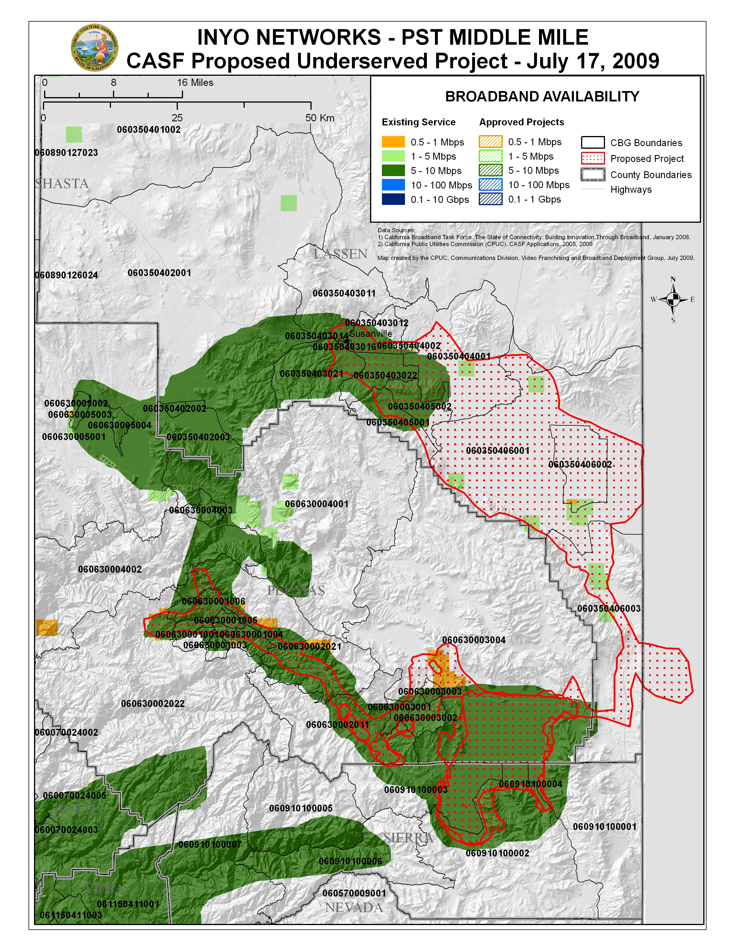

APPENDIX A
Resolution T-17230
Statewide Map
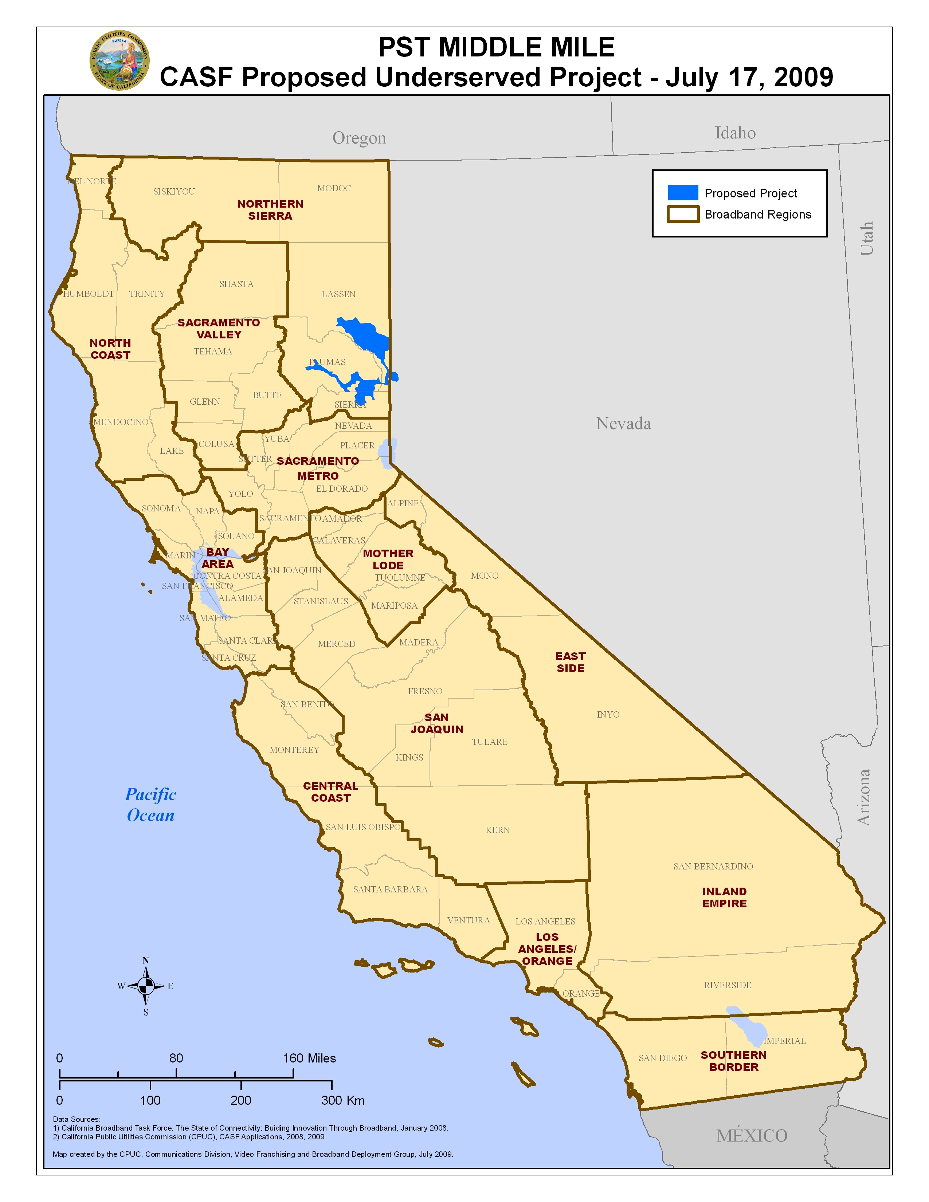
(End of Appendix A)

SB 1193 (Chapter 393, Stats. of 2008) established the California Advanced Services Fund as a new public purpose program.
The American Recovery and Reinvestment Act (ARRA) appropriates $7.2 billion for grants and loans to support national broadband deployment. ARRA offers a unique and ground breaking opportunity for California to partner with the federal government and other state agencies in advancing the goal of bridging the digital divide.
Optical Carrier-48 is a fiber-optic network line that facilitates data delivery at a transmission speed of up to approximately 2,488 megabits per second (mbps).
Digital Signal 1 is a telecommunications standard which transmits voice and data between devices. A DS1 circuit consists of twenty-four (24) channels which transmit at 64 kilobytes per second (kbps), or at a total 1.536 mbps for a DS1 circuit.
Optical Carrier-3 is a fiber-optic network line that facilitates data delivery at a transmission speed of up to approximately 156 mbps.
Time-division multiplexing is an older telecommunications technology used to transfer data in which two or more signals or bit streams are transferred apparently simultaneously as sub-channels within one communication channel, but are in fact physically taking turns on the channel, with the time domain being divided into several recurring timeslots of fixed length, one for each sub-channel.
Rebuttals to CBG challenges for PST’s Mid-Mile application, submitted by PST on September 17, 2009.
Resolution T-17143, p.8
The above schedule is contingent on the CASF recipient submitting clear, complete, and error-free invoices to CD. Additional time to process payments may be necessary if CD finds problems with the submitted invoices.

