FINAL REPORT ON THE AUDIT OF THE LA PALOMA POWER PLANT

CONDUCTED UNDER GENERAL ORDER 167
TO DETERMINE COMPLIANCE WITH
OPERATION, MAINTENANCE, AND LOGBOOK STANDARDS

ELECTRIC GENERATION PERFORMANCE BRANCH
CONSUMER PROTECTION AND SAFETY DIVISION

CALIFORNIA PUBLIC UTILITIES COMMISSION
505 VAN NESS AVENUE
SAN FRANCISCO, CA 94102


January 22, 2010

Richard W. Clark, Director
Consumer Protection and Safety Division

I. Executive Summary 4
II. Background and Audit Process 5
III. Audit Scope 6
A. Plant Description 6
B. Plant Performance Before La Paloma Implemented Corrective Actions (2005 to 2008) 8
C. Plant Performance After La Paloma Implemented Corrective Actions (2009) 11
IV. Corrective Action 13
V. Safety Hazards Requiring Immediate Corrective Action 13
VI. Violations Requiring Corrective Action 13
Finding 1. The plant delegates most major maintenance and repair to the plant manufacturer. 13
Finding 2. There are no formal root-cause analysis reports for the variable guide vane (VGV), burner overfiring or failed pressure sensor problems. 16
Finding 3. The plant lacks a systematic approach to verify all the major work that is performed by Alstom or other contractors. 19
Finding 4. The plant lacks a detailed emergency procedure. 20
Finding 5 - The plant lacks a routine inspection procedure for the fire protection system. 22
Finding 6 – The plant failed to maintain a fire extinguisher in a 24
fire extinguisher cabinet. 24
Finding 7. At night, the plant lacks sufficient back-up for illness or absence in the control room. 25
Finding 8. The plant lacks a program to revise and update its procedures and to compare them to actual practices. 25
Finding 9. The plant fails to track all staff training. 28
Finding 10. The plant’s computerized maintenance management system (CMMS) prevents staff from closing or changing the status on some work records. 28
Finding 11. Plant structures lack appropriate labeling. 29
VII. Audit Observations 30
Observation 1. Plant’s policies encourage safety alertness 30
Observation 2. The plant maintains record of clearances, plant manuals and inventory. 30
Observation 3. Plant has evacuation maps placed at every exit. 31
Observation 4. Continuous Emissions Monitoring (CEMS) System 31
Observation 6. Plant Chemistry 32
Observation 7. Flow Assisted Corrosion (FAC) Program and HRSG Chemical Cleaning 35
Observation 8. Critical Piping Inspections 36
Observation 9. Daily Rounds and Plant Information (PI) Trends 37
Observation 10. Cooling Tower Preventive Maintenance 37
Observation 11. Plant Efforts to Add Capacity and Mitigate Problems Caused by Cycling 38
Observation 12. Management of Change Process 40
Observation 13. Plant Safety and Security Signs 41
Observation 14. The GAO manages predictive, preventive, and corrective maintenance activities acceptably. 41
Observation 15. The GAO periodically refreshes the business plan for this plant. 42
Observation 16. GAO is aware of important plant systems that need additional monitoring. 42
Observation 17. The plant has a training program for new operations personnel. 42
Observation 18. The plant hires skilled maintenance personnel. 43

TABLE OF FIGURES
Figure 1. La Paloma Power Plant. 7
Figure 2. Gas turbine failure drives Unit 1’s EFORd to nearly 20%. 9
Figure 3. Unit 2’s EFORD hits 12% due to multiple gas turbine malfunctions. 10
Figure 4. Turbine bearing problems push Unit 4 EFORd over 13%. 10
Figure 5. Unit 3 experienced fewer problems than other units at the plant. 11
Figure 6. La Paloma's reliability improved in 2009. 12
Figure 7. Fire protection systems records show inconsistent dates. 23
Figure 8. Cabinet is missing a fire extinguisher. 24
Figure 9. Handwritten direction arrows on piping indicate the need for better labeling. 30
Figure 10. These anodes for the impressed current cathodic protection system corrode as they deliver a current to protect piping. 32
Figure 11. The plant finished its inspections of fume hoods just before the audit, and did not maintain annual inspections per the manufacture’s posted recommendations. 33
Figure 12. The water plant chemistry lab contains a DCS system and chemistry manuals. 34
Figure 13. The Units 1 and 2 boiler chemistry lab contains a fume hood. 34
Figure 14. The water plant chemistry lab test bench appears uncluttered. 35
Figure 15. Enlarged holes indicate some FAC on steam separator cans. 36
Figure 16. [FIGURE REDACTED] 39
Figure 17. [FIGURE REDACTED] 39
Figure 18. A warehouse sign reminds employees to follow MOC procedures. 40
Figure 19. La Paloma posts bilingual signs. 41

I. Executive Summary

This is the Final Report from the audit of the La Paloma Power Plant prepared by the Consumer Protection and Safety Division (CPSD) of the California Public Utilities Commission (CPUC). CPSD audited the plant for compliance with the Commission’s General Order (GO) 167, which includes Operation, Maintenance, and Logbook Standards for power plants.

CPSD auditors found eleven violations of GO 167 maintenance and operations standards. Most important, auditors found delays, problems and inefficiencies in maintenance performed by the plant’s main contractor, which also constructed most of the plant’s original equipment. CPSD also found, among other things, that the plant failed to prepare adequate root-cause analyses, lacked adequate quality-control procedures, lacked an automatic reminder for regular fire inspections in its computerized maintenance management system, lacked adequate staff, and failed to correct errors and inconsistencies in some procedures. Additionally, CPSD found that the plant lacked labels for some equipment and utilized an inflexible computerized maintenance management system.

To bring the plant into compliance, La Paloma has taken several corrective actions, and is xxxxxxxxxxxxxxx[REDACTED]xxxxxxxxxxxxxxxxxxxxxxxxxx. The corrective actions include, but are not limited to, hiring additional staff, updating procedures and drawings, adding items to the computerized maintenance management system and working toward quality improvements and better root-cause analysis. With respect to any maintenance problems, the plant must comply with GO 167, xxxxxxxxxxxxx[REDACTED]xxxxxxxxxxx or through other means. La Paloma recognizes the need for improvement, and agrees to brief staff periodically regarding progress in these areas.

In light of problems identified in the audit, the plant should continue to improve its:

- Original Equipment Manufacturer (OEM) maintenance response time,
- Root cause analysis,
- Inventory and parts storage for critical equipment,
- Procedures and processes to insure that plant documents are kept up-to-date,
- Staffing knowledge base in order to reduce the need for offsite specialists to resolve equipment issues.

CPSD notes that La Paloma utilizes an advanced and unusual gas turbine technology, intended to achieve greater efficiency than other combined cycle power plants. This may contribute to maintenance problems. Additionally, construction and start-up issues plagued the plant for several years. La Paloma’s corrective actions and performance improvements led to significantly improved reliability in 2009.

II. Background and Audit Process

Beginning in November 2007, CPSD audited the La Paloma Generating Station to determine whether the plant was in compliance with General Order (GO) 167. GO 167 includes maintenance, operation, and logbook standards for power plants. The audit team included Zam Zam Musse, Ben Brinkman, and Alan Shinkman.

CPSD conducted the audit through an examination of plant performance, data requests and a visit to the plant site. First, the team examined outage reports by CPSD staff, as well as databases maintained by California Independent System Operator (ISO). On September 20, 2007, the team notified the plant of the audit. The team visited the plant site from November 5, 2007 to November 9, 2007, examining documents, interviewing staff, inspecting equipment, and observing operations. At the conclusion of the site visit, the team gave the plant a data request.

On June 30, 2008, CPSD sent the plant the Preliminary Audit Report, which included eleven violations of Maintenance and Operations Standards. CPSD directed the plant to respond within 30 days with a Corrective Action Plan (CAP) for the violations. The plant requested an extension, and submitted its CAP on August 29, 2008. To resolve outstanding issues, CPSD and La Paloma held conference calls on September 15, 2008 and April 28, 2009. In addition, La Paloma submitted additional information in response to CPSD data requests on January 30, 2008, August 29, 2008, October 24, 2008, December 17, 2008, January 5, 2009 and May 5, 2009. CPSD visited the plant in September 2009 to verify corrective actions.

CPSD looked broadly at the plant’s compliance with standards, especially on problems identified from the plant’s operating history. Major incidents and problems are described in findings below, including a misassembled generator whose loose parts destroyed copper windings, an overfire which severely damaged a gas turbine, and numerous failures of variable inlet guide vanes and sensors. Each of these incidents put the plant out of service, sometimes as long as 65 days.

The audit also examined the plant’s compliance with specific Operations and Maintenance standards, including those covering:

- Logbooks, training, and human resources,
- Equipment, parts, and tools,
- Water chemistry,
- Heat Recovery Steam Generator (HRSG) maintenance and operation,
- Regulatory compliance,
- Engineering support,
- Safety, including hazardous material handling, fire and spill prevention and response, and,
- Maintenance and operations planning, performance, and documentation.

During the visit to the plant site from November 5, 2007 to November 9, 2007, team members toured the plant, including the generating units, the control room, the warehouse, chemistry lab, mechanical shop and electrical shop. An auditor attended a plant staff meeting and observed the start-up of a unit. Plant staff demonstrated the plant’s maintenance management software. CPSD reviewed numerous documents and interviewed plant staff. CPSD requested and reviewed additional documents after the site visit.

The audit findings and observations are described below, along with relevant standards and guidelines. Section V of the CPUC audit reports contains findings of violations that pose safety hazards that required immediate corrective action. Auditors found no Section 1 violations at La Paloma. Section VI includes findings of violations that required corrective action as soon as reasonably possible, most of which have since been corrected. Section VII contains observations of plant activities where auditors found no apparent violations.

To prepare this report, CPSD identifies violations of G.O. 167 based on the site visit and document review. CPSD lists these violations under the “Findings” section of Section V and Section VI. Upon receipt of the plant’s corrective action plan, and further investigation, CPSD notes any updates or corrections in each Finding’s “Outcome and Follow-up” section. CPSD does not typically modify or re-write the original Finding text.

III. Audit Scope

A. Plant Description
La Paloma Generating Company, LLC’s, La Paloma Generating Station (see Figure 1) is located in McKittrick, California, on the western outskirts of Bakersfield. The plant consists of four 250 megawatt combined-cycle units, and went into commercial service in March 2003. The plant’s configuration and design distinguish it from most other combined-cycle plants. Each unit consists of an Alstom gas and a Siemens-Westinghouse steam turbine on a single shaft connected with a clutch. Most combined cycle plants consist of multiple gas turbines and a single steam turbine, each with a separate shaft.

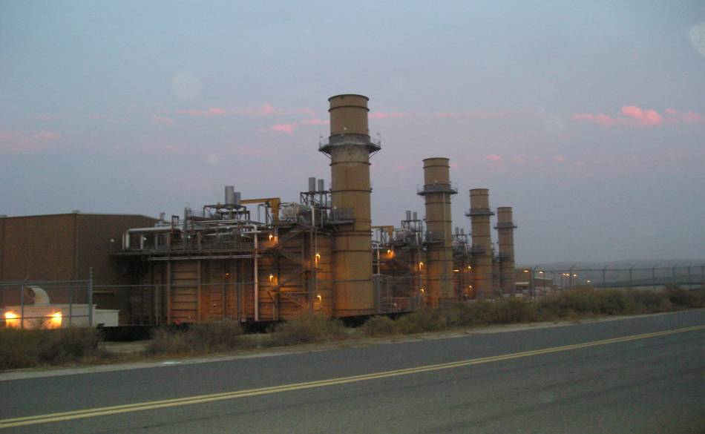
Figure 1. La Paloma Power Plant.

The gas turbine exhausts waste heat into a dual-pressure heat-recovery steam generator (HRSG) which heats feedwater through two different processes, one which produces low-pressure steam (LP), and another which produces high-pressure (HP) steam. The low-pressure section of the HRSG uses a storage vessel (steam drum) which holds a steam and water mixture. This LP system continually circulates water from the steam drum through the HRSG’s heating tubes, and also separates pure steam from the water, which it feeds into the LP section of the steam turbine. The “once-through” high pressure section lacks a steam drum, and operates at higher than normal steam pressure. It draws water from the LP section, heats it only once, and passes it through steam separators directly into the HP section of the steam turbine.

Because of the partial once-through configuration of the HRSG, the plant’s chemical control varies from that of most other steam and combined cycle facilities as well. While most power plants control boiler corrosion by removing oxygen from feedwater, La Paloma carefully injects oxygen into its feedwater to build a protective “magnetite” layer on its HRSG tubes.

The generating units are fired by natural gas, which is supplied to the site from the existing interstate natural gas pipeline jointly owned by the Kern River Gas Transmission Company and the Mojave Pipeline Company. In order to avoid discharging wastewater to the environment, the plant originally recycled all wastewater through an on-site water plant. More recently, the plant replaced the water plant with an injection well. The plant shares a switchyard with the nearby Sunrise Power Plant.

B. Plant Performance Before La Paloma Implemented Corrective Actions (2005 to 2008)

Between 2005 and 2008, La Paloma performed worse than the typical jurisdictional combined cycle plant in California. In some instances the plant displayed particularly substandard statistics. CPSD attributes these below average values to the plant’s difficulties maintaining and operating Alstom’s gas turbine systems. These problems led Moody’s to downgrade La Paloma’s debt rating in 2008. According to Moody’s, “higher than expected forced outages in the 2008 summer period combined with historical operating problems since commercial operation creates uncertainty in Moody's view as to if and when the Project will be able to achieve operating performance commensurate with original expectations.”

CPSD bases its La Paloma performance analysis on the North American Electric Reliability Corporation’s (NERC) Generator Availability Data System (GADS). CPSD requires most jurisdictional power plants to report availability to the GADS database. The GADS database calculates many performance metrics, including the four most significant, for our purposes, namely the Equivalent Availability Factor (EAF), the Equivalent Forced Outage Rate During Times of Demand (EFORd), the Net Capacity Factor (NCF) and the Start Reliability (SR).

NERC allows combined cycle plants to report their outage statistics either separately for each gas turbine or steam turbine, or as a composite value for each power block of gas and steam turbines. Because NERC allows combined cycle plants to report reliability and availability in two distinct manners, CPSD cannot compile a precise assessment of overall jurisdictional plant performance. Despite this difficulty, a review of GADS data for typical jurisdictional combined cycle plants shows estimated composite EAFs in the mid-to-upper 80 percent range, and EFORds between two and four percent, with many units under two percent.

Units 1, 2, and 4 at La Paloma suffered lengthy outages over the past several years. In 2007, Unit 1’s EFORd rose to over 18 percent, mainly because of a catastrophic gas turbine failure (Figure 2). During 2006, Unit 2’s EFORd spiked to over 12 percent, due to multiple problems with sensors, guide vanes, and controls on the gas turbine (Figure 3). Finally, in 2008, multiple steam turbine bearing failures pushed Unit 4’s EFORd over 13 percent (Figure 4). CPSD investigated the plants analysis and response to these equipment problems (see Findings 1 and 2). Unit 3 had relatively few problems (Figure 5).

Several times over the past four years, the plant’s EAF dropped below 70%, but generally this was either due to lengthy required planned inspections, or the forced outages listed above. Like most combined cycle plants, CAISO dispatches these fuel sparing units frequently. Therefore, the Net Capacity Factors for these units generally exceeds 50%.

Figure 2. Gas turbine failure drives Unit 1’s EFORd to nearly 20%.

Figure 3. Unit 2’s EFORD hits 12% due to multiple gas turbine malfunctions.

Figure 4. Turbine bearing problems push Unit 4 EFORd over 13%.
Figure 5. Unit 3 experienced fewer problems than other units at the plant.

C. Plant Performance After La Paloma Implemented Corrective Actions (2009)

La Paloma’s reliability improved significantly in 2009, in the period after it implemented the corrective action plan (CAP) for this audit. Among other things, the plant resolved recurring problems with variable guide vanes and steam turbine bearings. The plant stated that its overall forced outage rate (FOR) for 2009 was 2.1%, which is consistent with available GADS data for EFORd (see Figure 6). In 2009, the plant’s overall EAF rose above 90%. Because of this improved performance, EGPB inspected only one significant forced outage at the plant in 2009; down from five in 2008, 10 in 2007 and 13 in 2006.

Figure 6. La Paloma's reliability improved in 2009.

IV. Corrective Action

To bring the plant into compliance, La Paloma has taken several corrective actions, and is xxxxxxxxxxxxxxxxxxxxxx[REDACTED]xxxxxxxxxxxxxxxxxxxxxxxxxxxxxxxxxxxxxxxxxxxxxxxxxxxxxxxxxxxxxxxxxxxxxxxxxxxxxxxxxxxxxxxxxxxxxxxxxxxxxxxxx. The corrective actions include, but are not limited to, hiring additional staff, updating procedures and drawings, adding items to the computerized maintenance management system and working toward quality improvements and better root-cause analysis. The corrective actions for each finding are listed in Outcome and Follow-up in Section VI.

With respect to Finding 1 (see Section VI), the plant must come comply with G.O. 167, either through xx[REDACTED]xxxx or through other means. In particular, the plant must improve response times to equipment failure or other problems that affect safety and performance. This may involve obtaining more timely access to technical advisors on-site, and maintaining up-to-date drawings and procedures necessary to operate and maintain the plant. xxxxxxxxxxxxxxxxxxxxxxxxxxxxxxxxxxxxxxxxxxxxxxxxxxxxxxx xxxxxxxxxxxxxxxxxxxxxxx[REDACTED]xxxxxxxxxxxxxxxxxxxxxxxxxxxxxxxxxxxxxxxxxxxxxxxxxxxxxxxxxxxxxxxxxxxxxxxxxxxxxxxxxxxxxxxxxxxxxxxxxxxxx.

V. Safety Hazards Requiring Immediate Corrective Action

Auditors found no safety problems requiring immediate correction.

VI. Violations Requiring Corrective Action

Auditors found eleven violations which the plant should correct as soon as reasonably possible.

Finding 1. The plant delegates most major maintenance and repair to the plant manufacturer.

The plant delegates most major maintenance and repairs to the plant manufacturer, Alstom, which causes delays, problems and inefficiencies and violates maintenance and operations standards. In addition, the plant hesitates to take action which might damage its relationship with Alstom. First, Alstom troubleshoots most major equipment failures at the plant, often from remote locations, which leads to delays and miscommunication. Second, the plant lacks as-built drawings, because Alstom withholds plant specifications, such as the shape and composition of turbine blades. Third, Alstom insists that the plant maintain redundant turbine sensors, which the plant believes cause unnecessary trips. Finally, Alstom’s service is sometimes sub-par, as highlighted by a 2003 report by another contractor.

Under its agreement with the plant, Alstom:

- Monitors unit status and operations data remotely to anticipate and prevent potential problems.
- Responds by email to requests for help from the plant (these emails are called Technical Alstom Support Center Input (TASCI) forms).
- Sends to the plant’s engineer Customer Information Bulletins (CIB) on common problems throughout the Alstom fleet.
- Sends engineers and contractors to perform major work, much of which requires very specialized knowledge.
- Provides parts not easily available through other sources.
- Warrantees the “hot gas path” of the gas turbine, including all parts from the combustor to the exhaust of the gas turbine. To maintain the warranty, Alstom inspects and repairs the turbine periodically, depending in part on the number of hours that the turbine operates.

To build in-house expertise and reduce dependence on Alstom, the plant recently hired two ex-Alstom engineers to oversee plant operations and manage the Distributed Control System (DCS), respectively. Nevertheless, the plant continues to rely on Alstom for major maintenance and operations.

First, because Alstom troubleshoots plant failures remotely, and replies to plant requests only by email, plant outages are longer than necessary. During the site visit, a unit tripped offline (see Finding 2). The plant requested assistance from Alstom, which initially assigned the request secondary priority. Alstom replied only several hours later, recommending that the plant check various sensors. The plant remained off-line for three days while the plant and Alstom exchanged emails. These emails make it clear that plant staff became increasingly concerned over the plant’s inability to generate power. At one point, Alstom recommended that the plant adjust the fifth potentiometer on a circuit
board; in fact, the plant found only four potentiometers on that board. Alstom was unaware of the actual configuration at La Paloma.

If the plant requires Alstom technical personnel on site, it takes at least a full day.

In at least one instance of extended downtime, the plant acted without full knowledge and expertise, damaging equipment. In July 2007, the plant tripped due a faulty pressure sensor (see Finding 2). Alstom’s engineer was unable to arrive until three days later. In the meantime, La Paloma bypassed an overfire protection device, causing catastrophic failure of the gas turbine and an extended outage during peak season.

Second, Alstom withholds plant specifications, such as the shape and composition of turbine blades, making it impossible for the plant engineer to update plant drawings “as-built.” For example, in 2004 Alstom rebladed all four units’ turbine compressors but withheld some metallurgical information as proprietary. xxxxxxxxxxxxxxxxxxxxxxxxxx xxxx[REDACTED]xxxxxxxxxxxxxxxxxxxxxxxxxxxxxxxxxxxx.

Third, Alstom insists that the plant maintain redundant turbine sensors, which the plant believes cause unnecessary trips. To protect the costly, state-of-the-art gas turbine, Alstom installed multiple protective sensors, any of which can trip the unit. In order reduce trips, the plant would like to set the control system to trip only when two out of three sensors activate. Alstom resists such changes, though it did approve the plant’s proposal to eliminate some of the 60 redundant sensors in the combustion chamber.

Finally, Alstom’s service is sometimes sub-par. In 2003, the plant hired a third-party contractor to oversee and report on Alstom repairs to one of the plant’s generators. According to the contractor’s report: Alstom lacked “work procedures or plans to clean, inspect, repair, and test the generator rotor.” More remarkably, when the contractor asked Alstom about a rattling sound in the generator, Alstom responded that “any loose part would be held in place by centrifugal force at speed and would not be of concern relevant to running the generator ‘as is’.” Recently, the plant began to check workers in and out of the generator area during inspection and maintenance.

Outcome and Follow-up

In response, the plant took several steps to assume greater responsibility for equipment reliability and to improve its response to problems. xxxxxxxxxxxx[REDACTED]xxxxx xxxxxxxxxxxxxxxxxxxxxxxxxxxxxxxxx. Second, to better direct and monitor the performance of Alstom and other contractors, as well as build its own in-house expertise, the plant hired a “Reliability Engineer” and “Maintenance Supervisor”. Third, the plant updated its essential drawings to match the current configuration at the plant, and implemented a program to ensure these drawings remain correct. Finally, the plant implemented several upgrades and improvements as a result of collaboration with Alstom and other contractors using the plant’s “Major Issues Matrix."

xxxxxxxxxxxxxxxxxx[REDACTED]xxxxxxxxxxxxxxxxxxxxxxxxxxxxxxxxxxxxxxxxxxxxxxxxxxxxxxxxxxxxxxxxxxxxxxxxxxxxxxxxxxxxxxxxxxxxxxxxxxxxxxxxxxxxxx xxxxxxxxxxxxxxxxxxxxxxxxxxxxxxxxxxxxxxxxxxxxxxxxxxxxxxxxxxxxxxxxxxxxxxxxxxxxxxxxxxxxxxxxxxxxxx

The plant must comply with G.O. 167, xxxxxxxxx[REDACTED]xxxxxxxxxxxxxxxxx or through other means. The plant must therefore improve response times to plant requests for assistance, obtain easier access to technical advisors on-site, and maintain up-to-date drawings and procedures necessary to operate and maintain the plant. xxxxxxxxxxxxxx xxxxxxxxxxxxxxxxxxxxxx[REDACTED]xxxxxxxxxxxxxxxxxxxxxxxxxxxxxxxxxxxxxxxxxxxxxxxxxxxxxxxxxxxxxxxxxxxxxxxxxxxxxxxxxxxxxxxxxxxxxxxxxxxxxxxxxxxxxxxxxxxxxxxxxxxxxxxxxxxxxx.

To reduce its reliance on Alstom, the plant hired, and currently employs a Reliability Engineer and a Maintenance Supervisor. According to plant job descriptions, the Reliability Engineer assists with root-cause analysis, oversees quality control at the plant, and prepares reliability reports using the “Plant Information” (PI) database. The Maintenance Supervisor monitors and supervises plant technicians and contractors, including Alstom, to ensure that these workers perform quality work and follow procedures.

To address major equipment problems, such as the unnecessary trips caused by excessively redundant thermal sensors, the plant works with Alstom and other contractors to address issues listed on a “Major Issues Matrix.” In particular, the plant and Alstom upgraded the thermocouples that were causing excessive plant trips.

While the plant lacks detailed metallurgical information on turbine blades, the plant has improved its drawings, and now has the necessary as-built drawings to operate and maintain the plant. To ensure that drawings remain up-to-date, the plant has developed a new procedure for annual assessment of plant operations, which includes review of procedures, drawings, and other documentation. The plant began such a facility review in July 2009, and plans to complete this assessment in December 2009. In September 2009 CPSD verified that the plant had updated its drawings to include the recently installed gas compressor bypass system and injection well.

Finding 2. There are no formal root-cause analysis reports for the variable guide vane (VGV), burner overfiring or failed pressure sensor problems.

The plant fails to analyze the root-causes of equipment problems that caused outages, a violation of the plant’s own procedures, and a violation of operation and maintenance standards. The plant’s units have shut down repeatedly due to failures of instrumentation and control systems, in particular, due to faulty sensors and controller boards. The plant has failed to investigate these repeated control failures. We discuss three examples below. For each of three problems, the plant requested an analysis from Alstom, which submitted responses that specified the immediate failure, but failed to identify the root-cause of that failure. Under operation and maintenance standards, the plant must take responsibility for performing full analysis of failures.

Most importantly, the plant failed to analyze an overfire which severely damaged a gas turbine, and put Unit 1 out of commission from July 15 through August 30, the heart of the summer 2007 peak season. The plant had just installed a new system that would shut down the unit when too much gas entered the turbine, thus protecting the unit from overfiring. This system depended in part on a differential pressure sensor, which was supposed to control the amount of fuel entering the turbine. But on or before July 15, the sensor malfunctioned, sending a false signal that the turbine lacked enough fuel. The overfire protection system therefore shut down the unit. La Paloma staff concluded that the overfire system itself was malfunctioning, and disabled that system. Excess gas entered the turbine combustor, raising temperatures sharply and burning hotspots into turbine blades, destroying the turbine.

Rather than conducting a root-cause analysis, the plant asked Alstom to diagnose the failure; however, Alstom’s report failed to uncover root causes. While Alstom identified the immediate causes of the problem, neither Alstom nor La Paloma went further. In particular, La Paloma failed to investigate why the sensor failed in the first place, or why no one detected that failure. Further, La Paloma failed to analyze the staff’s decision to disable overfiring protection. Root-cause analysis specifically targets such underlying causes.

Second, the plant failed to analyze repeated failures of the control systems for the plant’s variable guide vanes. Such vanes control the entry of air into the compressor. The control system relies on circuit boards, which burned out multiple times. Again, La Paloma asked Alstom to diagnose the failure, and again, Alstom identified only the immediate cause: the burned-out circuit boards. In one case, Alstom found that staff misinstalled twisted-pair wire connections to the circuit boards. However, neither Alstom nor La Paloma analyzed the staff’s failure to install the wires properly, nor the cause of the circuit board failures.

Finally, the plant failed to analyze repeated failures of a gas sensor. During the audit visit, the plant aborted a start-up when a gas sensor failed. The plant replaced the sensor, which immediately failed again. Later, the plant explained that it had failed to “burn-in” (that is, to pretest) the sensor, as required by the sensor manual, because three pages were missing from the manual (see Finding 2.1). Moreover, the plant failed to investigate why the sensors failed repeatedly.

The plant’s failure to analyze the root causes of failures also violates extensive plant procedures requiring such analysis. Further, plant staff has attended week-long training from an expert in the field, Reliability Inc., but fail to use the company’s recommended processes.

Outcome and Follow-up

In response to the preliminary audit report, the plant improved its root-cause analyses as well as quality control throughout the plant. First, the plant updated its procedure for root-cause analysis. Second, the plant created a new form, the Root-Cause Analysis Executive Outage Report containing a one-page discussion of the problem or issue, diagnosis, corrective action taken and follow-up required. Finally, the plant created a six-page Tracking Form (procedure 7.05b) which is attached as a cover memo to all material saved from the investigation. The form designates the manager and team members for the root-cause analysis, lists the data required, describes physical testing of the equipment, compares physical data and symptoms to historical data and lists communication with OEMs. The form records the staff’s discussions of failure hypotheses, their conclusions, and shows the corrective actions the staff decided to take. Those actions include all necessary repairs, restart of the affected units, and any necessary follow up and performance tracking. The form shows any changes made to the plant’s major issues matrix. Finally, the form lists any important lessons learned during the analysis. The plan followed its new procedures to analyze problems with variable guide vanes and the overheating of steam turbine bearings.

The plant also instituted a program to rotate spare parts with limited shelf-lives. Under this program the plant tracks and monitors parts with limited shelf lives, including the gas sensor mentioned in this finding, and replaces them as the shelf life expires. When such parts arrive at the plant, the plant’s warehouse manager records the parts and their expiration dates in an electronic and hardcopy log. The manager then checks this log daily, and orders replacement parts before the shelf life on inventory expires.

Finding 3. The plant lacks a systematic approach to verify all the major work that is performed by Alstom or other contractors.

The plant fails to perform quality assurance on equipment installed by Alstom, or to check all units for similar problems after a failure in one unit, violating operation and maintenance standards. The plant relies on Alstom to ensure the quality of its own work. See Finding 1. Under GO 167’s operation and maintenance standards, the plant must take responsibility for the quality of all work performed.

In 2002, when Alstom installed Unit 2’s generator, La Paloma failed to inspect it and hence failed to notice that the generator arrived misassembled by Alstom. In particular, Alstom had installed Belleville washers backwards. On May 18, 2003, the washers came loose, damaging the generator’s copper windings, and causing a 65-day outage. Initially, Alstom refused to correct the problem under the warranty. La Paloma was forced to hire a third party consultant to investigate the failure of the generator. The contractor’s report concluded that Alstom failed to assemble the generator according to design specifications. Furthermore, the plant’s predictive maintenance procedure requires that the plant check other units for similar problems after a failure in any unit. In this case, the plant failed to check the other three generating units for misinstalled Belleville washers.

Outcome and Follow-up
The plant has addressed both issues raised in Finding 3. Among other things, the plant’s root-cause analysis procedures have always required that the plant check all units when it discovers a major problem on any unit. Since the Preliminary Report, the plant has followed this aspect of the procedures on several occasions. Second, the plant has improved its quality control procedures.

As for the 2003 incident discussed above, the plant insists it checked all four generators but is unable to locate complete documentation, partially due to ownership changes. Since this event is over five years old, CPSD accepts this explanation, provided the plant follow its root-cause policies as described below.

In 2008, after turbine bearing failures shut down Unit 1 multiple times, the plant began a root-cause analysis lasting many months. In September 2008, as part of the root-cause analysis, La Paloma met repeatedly with the steam turbine manufacturer (Siemens) and Alstom. The plant dismantled the failed unit, and determined one root cause was poor quality lube oil.

The plant determined that it could detect similar problems at other units by monitoring bearing temperatures. The plant monitored and trended the bearing temperature data at each unit, and found no indication of problems. Therefore the plant was able to avoid the lengthy outages otherwise required to disassemble each turbine.

As a result of the root-cause analysis, at each unit, the plant drained and replaced lube oil and added electrostatic precipitators to remove oxidized contaminants (called “varnish” by power plants). Because these actions improve the quality of hydraulic control oil, the plant believes this will have an added benefit of resolving recurring problems with the variable inlet guide vane’s hydraulic control.

The plant also realigned and machined the Unit 1’s steam turbine, adding an oil pocket and increasing the nozzle orifice size. These improvements increased oil flow and improved bearing lubrication. The plant did not believe these improvements were necessary at the other turbines, where bearing temperatures remained in the normal range.

The plant made several other repairs and improvements at all units after it discovered a problem at one unit. The plant replaced temperature control thermocouples with upgraded models, redesigned gas turbine and HRSG piping, replaced gaskets and installed new alarms on the gas turbines, re-routed some sensing lines to the HRSG flow transmitters, and negotiated with a contractor for replacement trim parts for the gas turbines. Further, the plant made improvements to the intake air cooling system for the gas turbines, upgraded circuit boards and associated maintenance for the gas detection systems at the plant, and changed brush designs on the generator.

The plant also improved its quality control procedures. In particular, the plant adopted detailed maintenance and inspection checklists for the HRSG and the gas turbine. Finally, as discussed in Finding 1, the plant hired additional personnel to improve quality control.

Finding 4. The plant lacks a detailed emergency procedure.

The plant’s emergency procedure lacks detail for different types of fires and emergencies, a violation of operation and maintenance standards. Emergency procedures should distinguish between types of fires (e.g. in the generator, in the turbine, or a chemical fire), each of which requires a distinct response. By contrast, La Paloma’s procedure for fires reads, in its entirety:

If you see fire or smoke and the alarm has not sounded.
- Activate the fire alarm upon exit of the area.
- Shift Supervisor call 911
If the alarm has sounded
- Leave the area and go to the designated briefing area.
Use portable fire extinguishers only if trained to do so. As soon as safely possible, account for all occupants in your area.

Although the plant runs detailed drills for its staff, the procedure itself lacks step-by-step instructions for both plant staff and emergency responders, a map of the fire suppression system, or a list of hazardous chemicals at the plant, among other things. Finally, the plant’s procedure fails to require the plant to report emergencies to the CPUC under Operating Standard 20.

Outcome and Follow-up

In response, the plant updated its Emergency Plan (Plant Manual Volume 9, Procedure 3.4), including detailed procedures and checklists for each kind of emergency referred to above. The plant added instructions on how to report safety incidents to the CPUC.

Finding 5 - The plant lacks a routine inspection procedure for the fire protection system.

The plant fails to inspect fire protection systems annually, a violation of operation and maintenance standards, and a violation of the plant’s own procedures.
Plant procedures require annual maintenance inspections for the fire protection system.
The auditor checked every fire inspection tag at the plant, and found many violations. For example, the plant last inspected the fire protection system for the water plant’s instrument air compressors on December 2, 2003, almost four years before the audit visit. Second, the plant allowed a 15-month gap between inspections of the fire protection system for the step-up transformer, inspecting it on March 11, 2006 and again the following June. Third, although La Paloma first went on-line in 2003, the plant waited until 2005 to inspect the fire protection system for the first time. Some of the fire protection system lacked any inspection tags. See Figure 7.

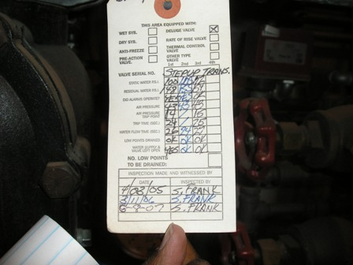
Figure 7. Fire protection systems records show inconsistent dates.

Outcome and Follow-up

In response, the plant added an electronic reminder for fire system inspections to its computerized maintenance management system, as plant procedures have always required. The plant also sent CPSD several reports on fire system inspections performed before and after the audit. Fire inspectors failed to note these inspections on the paper tags. To avoid confusion, the plant removed paper tags. The plant maintains required fire inspection records in computerized files.

CPSD verified that the latest fire suppression system inspection reports show up-to-date inspections on the main step-up transformers on all four units, as well as the turbine bearings, electrical subfloor, and lube oil systems. All of these inspections are less than one year old and therefore on schedule. Although the plant provided no specific inspection report for the Water Plant Instrument Air Compressors, the report for the Zero Discharge Building covers these compressors and is up-to-date.

According to the Los Angeles OSHA office, the plant should have a program in place to inspect the deluge system at least every twelve months, but is allowed some lee-way. OSHA stated that the 15-month interval shown in Figure 7 is a bit excessive, and should not be regular practice. CPSD staff recommends that the average time between inspections not exceed twelve months.

Finding 6 – The plant failed to maintain a fire extinguisher in a

fire extinguisher cabinet.

The plant failed to maintain a fire extinguisher in one extinguisher cabinet, a violation of operating and maintenance standards. Although the plant is supposed to check each cabinet during the daily plant walkdown, auditors found one empty cabinet. The plant immediately placed a fire extinguisher in the cabinet. See Figure 8.

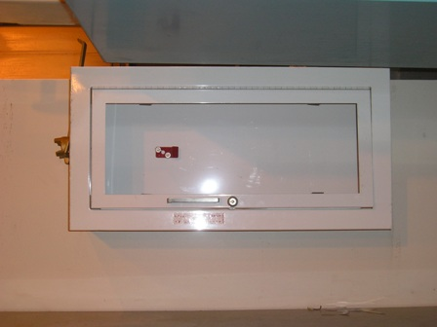
Figure 8. Cabinet is missing a fire extinguisher.

Outcome and Follow-up
In response, the plant argued that even though one cabinet was empty, extinguishers were available nearby. CPSD reviewed the plant’s extinguisher inspection procedures and records, and found that the plant generally follows its procedures. According to the plant, this one extinguisher was out for service. As stated in the finding above, the plant replaced the extinguisher immediately.

Finding 7. At night, the plant lacks sufficient back-up for illness or absence in the control room.

At night, the plant lacks sufficient back-up for illness or absence in the control room, a violation of operation and maintenance standards. Presently, for each night shift the staff includes only one shift supervisor in the control room and three operators (one for Units 1 and 2, one for Units 3 and 4, and one for the water treatment plant – sometimes called “Water World”). Only the shift supervisor is qualified to run the control room.

Indicative of the plant’s own concern about staffing levels, the plant’s 2007 business plan states “as a key component of the plant staffing strategy we will have an O & M tech that is control room qualified on each shift.”

Outcome and Follow-up

The plant responded that the Operations and Plant Managers can operate the plant if absolutely necessary; further, the plant will train additional operators:

The goal to have at least two control room trained personnel on each crew has not changed, and La Paloma has ongoing efforts to train and retain qualified staff. Irrespective of this staffing increase, in the event of an illness or absence, there are other personnel trained as control room operators available within the facility, including the Operations Manager and Plant Manager. The increase in staffing is a direct result of Complete Energy’s commitment to ensure top level operations and maintenance with the best trained personnel. The staffing additions were underway prior to receipt of the preliminary findings, and Complete Energy is working to secure and retain staff in light of an extremely competitive market for such skilled personnel. Estimated completion (dependent on turnover) 7/1/2009

Training is in progress, as can be noted in memos from the Operations Manager.

Finding 8. The plant lacks a program to revise and update its procedures and to compare them to actual practices.

The plant lacks a program to revise and update its procedures and to compare them to actual practices, a violation of operating and maintenance standards. Auditors checked approximately 40 plant procedures and found problems with nine. In some cases, procedures in the plant manuals conflict with other manuals, and/or with the computerized maintenance management system. In other cases, the plant fails to consistently follow procedures. Finally, some procedures are incomplete or unclear.

La Paloma uses extensive procedures, contained in plant manuals, workorders on the computer, and original equipment manufacturer (OEM) manuals. The plant manuals consist of eight volumes, each containing multiple procedures, such as:
  - Safety
  - Environmental
  - Engineering
  - Maintenance procedures
  - Operations Procedures
  - Training and Personnel.

Specific programmatic procedures in the manuals include:
  - Root-cause analysis
  - Flow assisted corrosion
  - Boiler chemical cleaning
  - Management of Change
  - Chemistry procedures

In addition to the procedures contained in the manuals, most plant workorders contain their own procedure and checklist. Upon review of various plant procedures, CPSD auditors found the following deficiencies.

First, there are no records that the plant regularly reviews and updates its procedures. Many of the plant procedures reviewed by CPSD auditors contained revisions dates of October 2007, immediately prior to the audit. While CPSD commends La Paloma for the comprehensive nature of their procedures, and the apparent pre-audit review, CPSD requests that the plant establish a schedule for regular, periodic review.

Second, the plant’s “Management of Change” (MOC) procedure fails to explain when the plant must follow the procedure. As noted in Finding 2.2, the plant sometimes bypasses sensors or changes limits temporarily, without following a formal, documented process. Confusion about when to follow this procedure may explain some of the inconsistencies noted below.

Third, procedures in the plant manuals conflict with other procedures in the manuals, and with procedures in the computerized maintenance management system. Specifically:

- For corrosion control, one plant manual correctly prescribes “oxygen-dosing” in which the plant adds oxygen to feedwater to produce a protective coating on the boiler tubes. Another manual mistakenly directs the plant to add oxygen scavenging chemicals to the feedwater.

- One plant manual directs the plant to change the oil on the Cooling Tower Gearbox Fan twice annually. In reality, the plant follows a procedure and checklist attached to the computer workorder, which requires oil sampling twice annually, and oil replacement as required. The OEM manual for the gearbox fan states that either method is acceptable. However, the procedures, checklists, and actual practices should match.

- The plant manual for Cooling Tower maintenance directs the plant to replace parts on the Sulphuric Acid Pump two times a year. In fact, the plant follows the procedure and checklist on the computerized workorder, which requires that the plant inspect the pump twice annually, and replaces parts only as required. Again, according to the OEM manual, either method is acceptable, but the procedures should match.

Fourth, in at least one case, the plant fails to follow either of two contradictory procedures. Plant manuals contain contradictory and imprecise “Daily Routines” procedures. One manual directs the shift supervisor to walkdown the plant once per shift. Another document calls for the shift supervisor to walkdown the plant only if possible. In reality, the shift supervisor does not make these rounds; rather, once per shift, each outside operator walks down his or her section of the plant.

Fifth, as a consequence of three missing pages in a procedure, the plant neglected to burn-in test a pressure sensor control card (See Finding 2.2), contributing to a unit trip during the audit site visit. The plant added the missing pages during the audit visit.

Sixth, the “Daily Routine” procedure and “Logbook Compliance Document” fail to state that the plant records quantities of consumable chemicals in the plant’s PI database, rather than in the logbook itself. Logbook standards require the compliance document to show the location of all required information not entered in the logbook.

Seventh, the manual for gas turbine operations is inconsistent. Some sections contain checklists and some do not. Volume 6, Section 6.18 (A-D), contains four sections for the four different operations stages – (1) startup, (2) minimum to base load operations, (3) shutdown (normal), and (4) pls/plst/trip (protective load shedding/ protective load shedding with a trip. Only the “shutdown (normal)” section has a space for checkmarks or initials. CPSD is unclear whether the plant actually uses written checklists for any or all of these operations.

Eighth, sections of the Table of Contents of the Volume 6 Plant Manual show the word “RESERVERED”(sic) several times, which, according to the GAO, refers to an OEM manual for a specific maintenance or operations activity. To avoid confusion and be more specific, the words “See appropriate OEM manual” should replace the word “Reservered”.

Outcome and Follow-up
In response the plant corrected the above procedures, and developed an additional process for periodic review of all procedures at the plant. In July 2009, the plant began reviewing all plant procedures during its annual operations assessment, which the plant plans to complete in December 2009. CPSD staff recommends that the plant continue to check its procedures on a regular basis.

Finding 9. The plant fails to track all staff training.

The plant fails to track all staff training, a violation of operating and maintenance standards. The plant tracks safety training, but not other operator training. In addition, the plant duplicates text for Level Two operator training in the material for Level One operator training. The plant kept no checklist to show who had taken this training and who had not.

Outcome and Follow-up

After receiving the Preliminary Report, the plant conferred with CPSD staff and supplied the missing training records.

Finding 10. The plant’s computerized maintenance management system (CMMS) prevents staff from closing or changing the status on some work records.

The plant’s computerized maintenance management system (CMMS) prevents staff from closing or changing the status on some work records, leading to errors or delays in updating equipment maintenance status, and potentially violating maintenance and operations standards.

The plant uses 4SITE for computerized maintenance management. Plant staff enters workorders into the 4SITE System to initiate pending work, classifying the work as corrective, preventive, or predictive, and specifying who should perform the task, either by skill group or by naming certain individuals. The staff prioritizes each workorder as safety, environmental, equipment protection, or economic, and assigns a trigger for the workorder, which indicates when the appropriate person or persons should perform the task.

The workorders contain great detail, often including associated procedures, checklists, or references to checklists. As the plant performs work, staff changes the workorder status from “new”, to “scheduled”, to “for completion by”, to “closed to maintenance”, to “closed to accounts.”

However, excessive rigidity and inaccessibility in the design and implementation of the CMMS interfere with efficient maintenance management. Staff cannot change the status of workorders from “for completion by”, to “closed to maintenance” until the contractor performing the work submits invoices. Only the person assigned a particular task or step can sign off to change the status, and only the person who entered the workorder can change or remove the workorder. In particular, if a scheduler assigns a worker to a task, only that worker can authorize the assignment of another worker to that task. If that worker is unavailable, only the software vendor can change the assignment. Further, the only way to print work orders in progress is to use “Print Screen.”

Outcome and Follow-up
Concluding that the 4SITE system lacks adequate flexibility for its purposes, the plant changed to Mainsaver, a software package specifically designed to manage and track maintenance work.

Finding 11. Plant structures lack appropriate labeling.

Plant staff failed to label some plant structures, a violation of operating and maintenance standards. For instance, a tank containing aqueous ammonia was not labeled. Management stated that labels are forthcoming (see Figure 9).

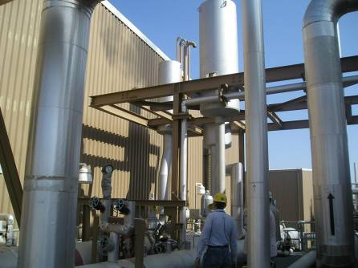
Figure 9. Handwritten direction arrows on piping indicate the need for better labeling.

Outcome and Follow-up

La Paloma responded that more labeling would be appropriate to avoid confusion and accidents. Since the audit visit, the plant has purchased stencils and other labeling equipment, and has applied labels throughout the plant.

VII. Audit Observations

Observation 1. Plant’s policies encourage safety alertness

The plant maintains a safety orientations program for plant visitors, new hires, and current employees. First, the plant’s program for visitors covers plant safety and the surrounding environment. In particular, the orientation encourages all visitors to be aware of endangered species in the habitat. Second, the orientation program for new hires covers health, safety, and other categories. Third, tailboard meetings include a session on safety, and the plant encourages employees to practice safety skills.

Observation 2. The plant maintains record of clearances, plant manuals and inventory.
Except as noted in Findings 1, 2, and 8, the plant tracks clearances, plant manuals, and inventory.

The plant’s Lock Out Tag Out (LOTO) system controls access to equipment that is under repair. Staff documents all clearances and repairs in a physical and electronic logbook. The plant’s control room supervisor cross-checks the two logbooks periodically.

The plant maintains a library that centralizes plant manuals and other documents. The library houses the master copy of all plant procedures. However, as noted in Findings 1 and 8, the plant lacked some updated procedures and drawings of plant systems.

The plant has a comprehensive inventory management system. The plant locks all inventory in the plant’s warehouse, and assigns each part an MM number. The plant assigns two employees to manage the inventory to insure all required plant components are available. However, as noted in Finding 2, the plan failed to track the age of some time-sensitive inventory.

Observation 3. Plant has evacuation maps placed at every exit.

The plants posts evacuation maps at every exit throughout the plant. These maps show employees how to proceed to emergency assembly points.

Observation 4. Continuous Emissions Monitoring (CEMS) System

The plant follows its procedures for maintenance of the continuous emissions monitoring system (CEMS). The plant uses two CEMS shacks, one for Units 1 and 2, one for Units 3 and 4. CPSD auditors entered the Units1&2 CEMS shack, and read the NOX analyzers, which showed that emissions were within limits at the time:

  - Raw NOX (before SCR) = 9.62 ppm
  - Output NOX (after SCR) = 2.24 ppm
  - Output NOX limit = 2.5 ppm hourly rolling average

The plant maintains the CEMS system per plant procedures (Manual 3, Section 3.17) which require monthly, quarterly, and annual PMs. The CPSD auditor verified that the CMMS system contained these PMs, and checked the September 2007 Quarterly PM (PM 0035, Workorder 12394) for completion. The PM included a checklist, which directed the technician to change the CEMS filter, exercise the flow meter, and inspect the pump, performing maintenance and repairs as necessary.

Observation 5. Cathodic Protection System Maintenance

The plant maintains its cathodic protection system. The plant uses impressed current cathodic protection, which prevents corrosion of piping by forcing electrons to flow from buried anodes to plant piping. This setup causes the anodes to corrode, rather than the pipes. Rectifiers (which change alternating current to direct current) provide the electrons. Under its procedure, the plant inspects the cathodic protection system, including the voltages on the rectifiers, every 90 days. The electronic PM contains information on procedures, locations, and limits for acceptable current levels, as well as references to related manuals.

A technician performs the tests, and records results, including rectifier readings, in a standard logsheet. The logsheet stores a running record so the plant can look for trends. The CPSD auditor reviewed the current logsheet to confirm that the plant checked trends every 90 days. In addition to plant staff, an external contractor inspects the cathodic protection system annually. See Figure 10.

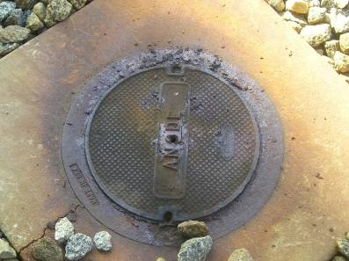
Figure 10. These anodes for the impressed current cathodic protection system corrode as they deliver a current to protect piping.

Observation 6. Plant Chemistry

The plant uses detailed procedures and processes to control plant water chemistry.
The plant first treats raw water in a dedicated system, which the plant calls the “water plant” or “water world”; this treated water enters the demineralizer tank so it can be used as boiler feedwater, among other things.

The water plant processes incoming water from the California Aqueduct, as well as water blowndown from the cooling tower. The plant removes suspended and dissolved solids to make “filtered water” which is then processed further to make “demineralized water”. The plant then processes this demineralized water for use in the Heat Recovery Steam Generator (HRSG). Rather than removing oxygen for the HRSG, the plant “doses” the demineralized HRSG water with oxygen to produce a protective magnetite film in the HRSG tubes. Currently, La Paloma recycles all wastewater. In 2008 the plant plans to drill an injection well for cooling tower blowdown water.

The plant maintains three chemical testing labs – one for Unit 1 & 2, one for Unit 3 & 4, and one for the water plant. Auditors found the labs neat and organized, with extensive procedures available. Although all labs contained fume hoods with recent inspections, the water plant fume hood appeared to be missing some prior inspection stickers (see Figure 11). CPSD reminds the plant to follow manufacturer’s recommendations where possible, to make sure the air flow is adequate to remove harmful fumes, and to stay aware of any changes in OSHA regulations for laboratory fume hoods. The plant employs a dedicated chemist, although at the time of the audit, a shift supervisor performed this duty while the plant sought a new chemist.
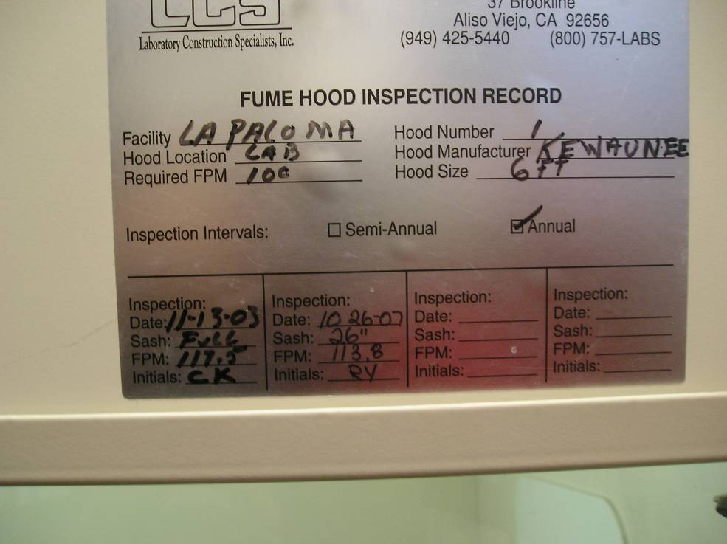
Figure 11. The plant finished its inspections of fume hoods just before the audit, and did not maintain annual inspections per the manufacture’s posted recommendations.

The plant follows its own procedures for maintenance of the “Turbidimeter”, which checks for turbidity, or suspended solids in the water. Plant procedure, Manual 8, Section 29, requires annual preventive maintenance (PM) of the Turbidimeter in chemistry lab. The auditor verified that this PM exists. Plant general chemistry procedure, Manual 7, Section 6, prescribes twice daily sampling of chemical measurements in addition to automated measurements. The CPSD auditor checked logs of these measurements, and randomly verified records for March 2007. The chemistry labs retain completed logs in the lab for one year, and the plant retains completed logs for at least three years. See Figures 12, 13, and 14.

The plant monitors conductivity and chlorine of water entering the evaporative cooler. ALSTOM TASCI folders mention the importance of measuring these parameters.
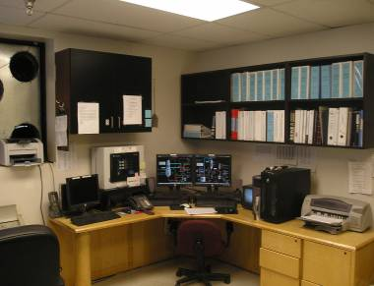
Figure 12. The water plant chemistry lab contains a DCS system and chemistry manuals.

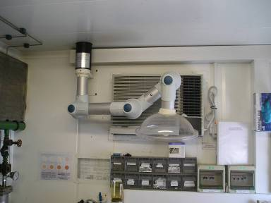
Figure 13. The Units 1 and 2 boiler chemistry lab contains a fume hood.
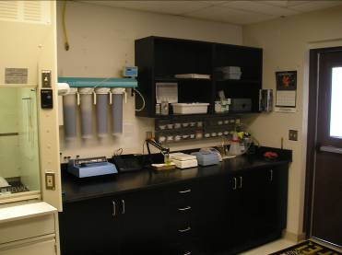
Figure 14. The water plant chemistry lab test bench appears uncluttered.

Observation 7. Flow Assisted Corrosion (FAC) Program and HRSG Chemical Cleaning

The plant engineer developed an extensive Flow Assisted Corrosion (FAC) program, as well as a program to evaluate the HRSG for chemical cleaning. To develop the FAC program, the engineer used ASME Boiler Codes, investigated historical information from other identical units with longer operating time, and hired a consultant, Tigress Engineering. Tigress calculated minimum wall thicknesses:
- For 2.5 inches diameter pipe, a minimum thickness limit of .013”.
- For 3.0 inches diameter pipe, a minimum thickness limit of .112”.

The program identifies approximately 20 HRSG sections to monitor for corrosion vulnerable areas, that is, those where flow, speed, or direction changes, such as bends, welds, and nozzles. The plant engineer measures wall thickness using ultrasound and penetrating dyes.

The plant measured baseline thickness in March 2006, and will remeasure that thickness during each 24,000 hour turbine inspections (which occur approximately every year and a half). The plant remeasured Unit 1’s tube wall thickness in May 2007, and the wall thicknesses of the other three units in 2008.

With these measurements, the plant engineer trends wall thicknesses, to determine whether walls are thinning dangerously. The CPSD auditor reviewed these trends and associated calculations. From these measurement trends, the engineer calculated that the HRSG tubes have an estimated life of 6 to 7 years. At five years he will begin carefully evaluating whether to replace tubes.

The engineer has already identified flow-assisted corrosion on certain parts of the HRSG. In May 2007, an inspection of Unit 1’s HRSG found such corrosion on low-pressure steam-separator cans, which separate high quality steam from water in the low pressure steam drum. As a result, the plant replaced those cans, checks for erosion during each outage, and maintains spares. See Figure 15.

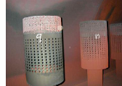
Figure 15. Enlarged holes indicate some FAC on steam separator cans.

The plant uses multiple methods to detect deposit buildups on the HRSG. First, as recommended by the May 2007 inspection report, the plant engineer evaluates the HRSG for chemical cleaning. Although these HRSGs are only approximately four years old, the engineer checks deposit buildup in the low pressure drum, and on the surfaces of boiler tubes and fins. Based on experience at similar plants, the engineer plans to clean or replace tubes after five years, depending on the condition of the tubes at that time. Second, the engineer tests HRSG performance (as well as the performance of other plant components) using software and a system developed with McHale Software. This performance testing indicates when the HRSG is losing heat transfer capability due to deposit buildup in tubes and on tube fins.

Observation 8. Critical Piping Inspections

The plant inspects critical pipes and hangers regularly. The plant contracts with ALSTOM to perform extensive critical piping inspections at the same time as the 24,000 -hour gas turbine inspections (about every year and a half).

The CPSD auditor reviewed the critical piping inspection report for Unit 3 which included piping, hangers, and casing. Specific areas the plant inspected include:

- Reheat Outlet and Inlet Header Tubes for weld toe cracking,
- Reheat outlet header bottom header and cap welds,
- Superheater and reheater desuperheaters (attemperators),
- Upper and lower headers of the Low Pressure (LP) Evaporator Assembly,
- Once Through Cooler Line Nozzle to Pipe Welds,
- Hot Reheat Line Elbows,
- High pressure (HP) Superheater and Reheat Hanger Supports,
- HP and LP Once through cooler line elbows,
- LP Steam Line Elbows, and
- Hot Reheat Line on the Reheat Desuperheater area.

The plant repaired all major problems found in the report, which contains photos of the repairs.

Observation 9. Daily Rounds and Plant Information (PI) Trends

Using detailed checklists, and a handheld electronic data logger, the plant operators inspect, or “walkdown” the plant once per shift. As the operators walk down separate areas of the plant with detailed checklists, they enter inspection measurements into a data logger which resembles a large PDA. On returning to the control room after the walkdown, the operators download the data into the PI database, where staff, engineering, and management can use it for trending and research.

The plant regularly trends this data. The CPSD auditor selected a measurement from the walkdown checklists, the Unit 3 Raw Water Turbidity, and requested to see a trend for November 1, 2007 to November 5, 2007. The operations manager immediately displayed the PI trend, which contained all required data points.

Observation 10. Cooling Tower Preventive Maintenance

The plant uses detailed procedures for cooling tower maintenance. The CPSD auditor checked four procedures for cooling tower maintenance:

- Procedure 8.07A Six month cooling tower Circulation Pump Oil Change
- Procedure 8.07B Six month cooling tower Fan Gearbox Oil Change
- Procedure 8.07C Six month cooling tower Fan Motor Lubrication
- Procedure 8.07D Six month cooling tower Sulphuric Acid Pump Maintenance

The work orders in the plant’s computerized CMMS system matched the procedures in detail, except as discussed in Finding 2.10.

Observation 11. Plant Efforts to Add Capacity and Mitigate Problems Caused by Cycling

The plant has made or will make changes xxxxxxx[REDACTED]xxxxxxxxxxxxxx to xx xxxxxxxxxxxxxxxxxxxxxxxxx[REDACTED]xxxxxxxxxxxxxxxxxxxxxxxxxxxxxxxxxxxxxx xxxxxxxxxxxxxxxxxxxxxxxxxx, 2) to mitigate the problems caused by cycling the plant, xxx[REDACTED]xxxxxxxx The plant stated that numerous outages and problems at the plant can be traced to cycling, xxxxxxxxxxxxx[REDACTED]xxxxxxxxxxxxxxxxxxxxxxxxxxxxxxxxx xxxxxxxxxxxxxxxxxxxxxxxxxxxxxxxxxxxxxxxxxxxxxxxx.

Although Pacific Gas and Electric Generation built the plant to run baseload, in practice the plant’s schedulers often shut it down at night, causing thermal stress on plant components. As a result, the manufacturer considers every start equivalent to a certain number of operating hours when determining the need for inspections under the plant’s warranty.

Cycling may also trip ALSTOM’s sensitive protection systems. ALSTOM requires multiple levels of sensors and protection, many of which are configured to trip on a single bad reading, as opposed to a 2 out of 3 voting scheme. Rapid changes in conditions such as temperature could possibly cause Total Air Temperature (TAT) sensors to trip the unit.

xxxxxxxxxxxxxxxxxxxxx[REDACTED]xxxxxxxxxxxxxxxxxxxxxxxxxxxxxxxxxxxxxxxxxxxxxxxxxxxxxxxxxxxxxxxxxxxxxxxxxxxxxxxxxxxxxxxxxxxxxxxxxxxx The turbine’s carbon monoxide emissions increase at low loads. Under the original design, the plant could not operate at less than 75% of capacity without exceeding emission limits for carbon monoxide. xxxxxxxxxxxxxxxxxxxxxxxxxxxxxxxxxxxxxxxxxxxxxxxxxxxxxx xxxxxxxxxxxxxxxxxxxxxxx[REDACTED]xxxxxxxxxxxxxxxxxxxxxxxxxxxxxxxxxxxxxxxxxxxxxxx xxxxxxxxxxxxxxxxxxxxxxxxxxxxxxxxxxxxxxxxxxx.

xxxxxxxxxxxxxxxxxxxxxxx[REDACTED]xxxxxxxxxxxxxxxxxxxxxxxxxxxxxxxxxxxxxxxxxxxxxxxxxxxxxxxxxxxxxxxxxxxxxxxxxxxxxxxxxxxxxxxxxxxxxxxxxxxxxxxxxxxxxxx.
First, at two of the plant’s units, repeated heating and cooling (and the resulting expansion and contraction) broke a weld between a reheater tube and a header. xxxxxxxxxxxxxxxxxxxxxxx[REDACTED]xxxxxxxxxxxxxxxxxxxxxxxxxxxxxxxxxxxxxxxxxxxxxxxxxxxxxxxxxxxxxxxxxxxxxxxx

Figure 16. [FIGURE REDACTED]

Figure 17. [FIGURE REDACTED]

xxxxxxxxxxxxxxxxxxxxx[REDACTED]xxxxxxxxxxxxxxxxxxxxxxxxxxxxxx ALSTOM designed the combustor with approximately 60 annular temperature sensors, any of which could trip the unit. xxxxxxxxxxxxxxxx[REDACTED]xxxxxxxxxxxxxxxxxxxxxxxx xxxxxxxxxxxxxxxxxxxxxxxxxxxxxxxxxxxxxx.

xxxxxxxxxxxxxxxxxxxxxxxxxxxxxxxxxxxxxxxxxxxxxxxxxxxxxxxxxxxxxxxxxxxxx xxxxxxxxxxxxxxxxxxxxxxxxxxxxxxxxxxxxxxxxxxxxxxxxxxxxxxxxxxxxxxxxxxxxxx xxxxxxxxxxxxxxxxxxxxxxx[REDACTED]xxxxxxxxxxxxxxxxxxxxxxxxxxxxxxxxxx xxxxxxxxxxxxxxxxxxxxxxxxxxxxxxxxxxxxxxxxxxxxxxxxxxxxxxxxxxxxxxxxxxxxxxxxxxxxxxxxxxxxxxxxxxxxxxxxxxxxxxxxxxxxxxxxxxxxxxxxxxxxxxxxxxxxxxxxxxxxxxx xxxxxxxxxxxxxxxxxxxxxxxxx[REDACTED]xxxxxxxxxxxxxxxxxxxxxxxxxxxxxxx xxxxxxxxxxxxxxxxxxxxxxxxxxxxxxxxxxxxxxxxxxxxxxxxxxxxxxxxxxxxxxxxxxxxxxxxxxxxxxxxxxxxxxxx

Observation 12. Management of Change Process

The plant’s Management of Change (MOC) procedure controls changes to the plant’s configuration. Before such changes, the plant must form a committee headed by the plant’s engineer, and including the operations manager, and possibly the environmental, general plant and financial managers, as well as a system expert. The committee must investigate, approve, and document the changes. A subsection of the procedure requires the plant to continuously evaluate Alarms, Sensors, and Limits for possible changes. As reported in Finding 2.8, the procedure fails to specify which changes require this process and which do not. Figure 18 shows a sign in the warehouse which reminds employees to use the process.

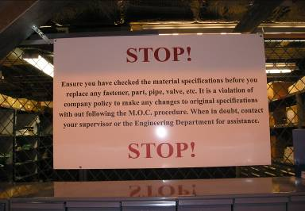
Figure 18. A warehouse sign reminds employees to follow MOC procedures.

The CPSD auditor requested a sample MOC form. The plant engineer supplied a form which evaluates the substitution of high pressure sodium lighting for mercury vapor lighting over the steam turbine hydraulic skid. The form proposed the change to eliminate mercury hazards and to reduce energy consumption. However, the maintenance manager tested the bulbs and discovered they contained not mercury vapor, but rather metal halide, which posed no safety or efficiency problems. After deciding not to proceed with the changes, the committee closed this MOC process on October 31, 2003.

Observation 13. Plant Safety and Security Signs

The plant displays signs in English and Spanish on exterior fences and at the entrances. Some signs states that workers must use personal protective equipment. Other signs advise that all visitors must check in at the plant’s headquarters. These signs are particularly important because many nearby residents and workers speak Spanish. See Figure 19.

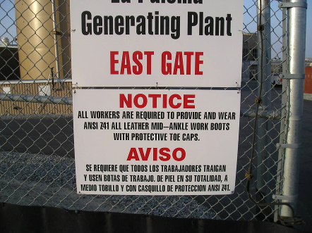
Figure 19. La Paloma posts bilingual signs.

Observation 14. The GAO manages predictive, preventive, and corrective maintenance activities acceptably.

To manage predictive, preventive, and corrective maintenance activities, the plant installed a 4SITE software package in April 2005. Previously, the plant used another software package, but found it not user friendly. In addition, the plant uses KKS, a part-naming scheme. Plant management told the auditor that, ultimately, staff will assign a KKS number to all parts, down to the smallest item (e.g., a computer control card).

The plant prioritizes work orders by topic rather than by number. That is, management assigns the highest priority to safety work orders, then environment, then operations, and finally economics.

Observation 15. The GAO periodically refreshes the business plan for this plant.

The GAO refreshes the business plan at least quarterly to provide new direction and refocus efforts on current issues, or plan and strategize regarding recent opportunities and threats. The Policies and Procedure Manual, Section 4, Business, page 4-5, section 4.2, paragraph 2 contains the business plan.

Observation 16. GAO is aware of important plant systems that need additional monitoring.

The plant manual shows that the GAO recognizes important plant systems that need additional monitoring. This text in Volume 1 contains the following:

Some areas of importance which are often overlooked include
- cathodic protection,
- protective coating systems,
- DC/UPS systems,
- safety and relief valves including BOP valves,
- storage tanks and pressure vessels,
- electrical protection, and
- preventive maintenance of inventory materials and or equipment.

Observation 17. The plant has a training program for new operations personnel.

Newly hired operations employees go through an orientation, training, and qualification program. The program consists of three levels:

- Level One consists of training to become a “Water World” operator. Water World is the water treatment part of the plant. Management allows each new hire one year to complete Level One training.

- Level Two consists of training to become a power block operator. A power block consists of a combustion turbine, a steam turbine and all related equipment to produce electricity. There are four power blocks at the plant, one for each unit. Management allows each new hire one additional year to complete Level Two training.

- Level Three consists of training to become a control room operator. There is no time limit for completing Level Three training.

Observation 18. The plant hires skilled maintenance personnel.

No formal training program exists for maintenance personnel. Plant management hires maintenance personnel with expertise in their respective specialization. In other words, there are no entry level positions in the maintenance department. The plant is working on a program that will allow maintenance personnel to earn certificates from the Society for Instrumentation, Systems, and Automation, whose program includes training on automation.

The term “violation” as used in EGPB’s Final Report refers to conditions or events where the auditors determined that the facility failed to meet G.O. 167 standards. Identification of conditions or events as “violations” in this Final Report does not constitute a formal determination by the California Public Utilities Commission of a G.O. 167 violation. A definitive finding of a G.O. 167 violation requires a formal Commission enforcement proceeding.
Further information on the Commission’s Power Plant Performance program may be found at the Commission’s Web Site at http://www.cpuc.ca.gov/PowerPlantStandards.
A HRSG performs the same function as a boiler at a conventional steam plant. In a standard steam plant, dedicated burners heat the water in the boiler. In a combined cycle plant, exhaust heat from the gas turbine heats the water in a HRSG.
Moody’s on La Paloma Generating Company. November 2008. http://in.reuters.com/article/oilRpt/idINWNA904620081111
EAF represents the percentage of time a plant is available to produce power. The EFORd represents the amount of power the plant cannot produce when required, due to forced outages. The NCF represents what percentage of its total capacity a plant generates over a given period of time. Starting Reliability (SR) is the percentage of time the plant starts successfully. For EFORd a lower number is better, for EAF and SR higher numbers are better.
Forced outage rate (FOR) measures the overall percentage of MW the plant was unable to generate due to forced outages, regardless of whether CAISO required the power.
Q1 2009 FOR = 2.3%, Q2 2009 FOR = 2.6%, Q3 2009 FOR = 1.6%.
Operations Standard 3, Operations Standard 4, Operations Standard 7, Operations Standard 9, Maintenance Standard 8, Maintenance Standard 13, Maintenance Standard 14.
ALSTOM Memorandum “La Paloma Unit 11 Overfiring Incident.” September 13, 2007. PSC Item PE-2007-1223.
Ronald Nelson. N & T Consulting Services. Inspection Report Section 1. Unit 2 Generator. June 7, 2003 to August 22, 2003. p. 2.
Ibid., p. 9.
xxxxxxxxxxxxxxxxxxxxxxxxxx[REDACTED]xxxxxxxxxxxxxxxxxxxxxxxxxxxxxxxxxxxxxxxxxxxxxx.
La Paloma Corrective Action Plan, October 24, 2008.
“As-built” means that the drawings match the actual current configuration of the equipment.
La Paloma Policies and Procedures Manual. Section 13. Facility Management Review and Assessments Policy.
MS 3 - Maintenance Management and Leadership, MS 4 - Problem Resolution and Continuing Improvement, MS 8 – Maintenance Procedures and Documentation. MS 14 - Engineering and Technical Support
From “LA PALOMA GENERATING PLANT PROCEDURE 7.05 PLANT MANUAL VOLUME 7, REV.0 ROOT CAUSE ANALYSIS : “When trouble-shooting or diagnosing the cause of any failure or adverse event, the key to preventing future failures is to understand its underlying causes, and to address those in responding to the immediate problem. The immediate and direct cause of a failure is often itself a symptom of other less obvious problems, and if those are not addressed, the problem is bound to recur....Emergency shutdowns and trips, equipment failures, protective load-shedding events, accidents involving injury or material damage, near-misses, all are occasions which will benefit from diagnosis and analysis of root causes.”
The plant replaced version 7.05 revision 0, dated June 20, 2005 with version 7.05 revision 3, dated September 15, 2008, containing a new Revision/Review History section as a cover page, as well as references to NERC Reliability Standards EOP-004 and PRC-004 requiring the reporting and analysis of power system events.
Procedure 7.05a
Maintenance Standard 1, Operations Standard 1.
PG&E National Energy Group prepared a report titled “Unit 2 Alstom 290,000 KVA generator”
Maintenance Standard 1- Safety, Operations Standard 1 - Safety, Operations Standard 13 – Routine Inspections.
La Paloma Fire Emergency La Paloma Plant Manuals Volume 9 procedure 3.4; Fire Emergency
Health and Safety Reporting Procedures (Plant Manual Volume 9, Procedure 3.0).
Maintenance Standard 1 – Safety, Operations Standard 1 – Safety, Operations Standard 13 – Routine Inspections.
Plant Manual Volume 8, section 8.00C. states, “Mandatory Maintenance is defined as task that must be performed to comply with federal, state, local agencies and/or company policies. These tasks are managed under preventative module of the CMMS. Mandatory Maintenance activities are thoroughly documented for agency audits. Examples of some of the requirements are…: Safety/OSHA requirements. OSHA requires annual safety inspections.
Maintenance Standard 1 – Safety, Operations Standard 1 – Safety.
La Paloma portable fire extinguisher records and inspection procedures from September 2007 to October 2008.
OS 1 - Safety, OS 3 - Operations Management and Leadership, OS 12 - Operations Conduct
Operations manager memos from November 9, 13, 28, 2007
Maintenance Standard 8 – Maintenance Procedures and Documentation, Operations Standard 7 – Operations Procedures and Documentation, GO167, Appendix B: “Generator Logbook Standards (Thermal Energy)”, Section II, Item 9.
Manual 5, Section 5.8
Plant Manual, Volume I, Section XII
Plant Manual, Volume 7
Volume 8, Procedure 8.06B
Plant Manual, Volume 8, Procedure 8.07D
Plant Manual, Volume 5, Section 5.7
Logbook Compliance Document
MS 6 - Training Support, OS 5 - Operations Personnel Knowledge and Skills, OS 6 - Training Support.
Maintenance Standard 10 – Work Management.
MS 1 - Safety , MS 3 - Maintenance Management and Leadership; Cal OHSA Title 8, Section 3321 states that pipelines and above ground piping systems “shall be identified at points where confusion would introduce hazards to employees.” Identification can be by color painting or color bands with associated posting of color codes, names and abbreviations lettered or stenciled, and/or metal tags. MS 11 - Plant Status and Configuration
OS 1 - Safety
MS 8 – Maintenance Procedures and Documentation
OS 20 – Standard 20: Preparedness for On-Site and Off-Site Emergencies.
MS 16 – Regulatory Requirements MS 9 – Conduct of Maintenance
MS 9 – Conduct of Maintenance
Plant Manual, Volume 8, Section 8.39A
MS 15 – Chemistry Control
OS 18 - Unit Performance Testing, OS 27 - Flow Assisted Corrosion
ASME Boiler Code Section 1, 2001 ed 03 addendum.
Alstom. “LPGC Unit 1 HRSG Inspection Report, May 2007.
HRSG tubes use external fins to aid in heat transfer.
MS 13 - Equipment Performance and Materiel Condition, OS 28 - Equipment and Systems
OS 13 - Routine Inspections.
MS 7 – Balance of Maintenance Approach, MS 8 – Maintenance Procedures and Documentation, MS 9 – Conduct of Maintenance.
OS 28 - Equipment and Systems, OS 4 - Problem Resolution and Continuing Improvement, MS 14 – Engineering and Technical Support
Tetra Engineering. “La Paloma Generating Company Unit 3 HRSG Failure Analysis of Reheater Tubes”.
Alstom. “LPGC Unit 1 HRSG Inspection Report, May 2007.
MS 11 – Plant Status and Configuration, OS 8 - Plant Status and Configuration
Request #03.0023, dated 9/26/03
OS 1 - Safety
MS 8 – Maintenance Procedures and Documentation.
KKS Power Plant Classification System is a standardized system for the classification of power stations. It is used during engineering, construction, operation and maintenance of power stations for identification and classification of the equipment. KKS is the abbreviation of the German term Kraftwerk-Kennzeichensystem.
OS 3 - Operations Management and Leadership
Volume 1, Section XI, paragraph 11.3, routine maintenance section (page 9 at the bottom of the page)
OS 5: Operations Personnel Knowledge and Skills, Plant Manual, Volume 4.
MS 5 - Maintenance Personnel Knowledge and Skills.
ISA (Instrumentation, Systems, and Automation Society) includes three certification programs, Certified Automation Professional (CAP), Certified Control Systems Technician (CCST), and Certified Industrial Maintenance Mechanic (CIMM).

