PUBLIC UTILITIES COMMISSION OF THE STATE OF CALIFORNIA

Communications Division | RESOLUTION T-17245A
Carrier Oversight and Programs Branch | May 6, 2010

R E S O L U T I O N

Resolution T-17245A Modifies Resolution T-17245 Reducing California Advanced Services Fund Funding the California Valley Broadband Project, from $7,893,700, to $7,878,386 and Modifying the Project’s Coverage Area.
__________________________________________________________________

Summary

This Resolution modifies Resolution T-17245, by reducing contingent funding from the California Advanced Services Fund (CASF) for the California Valley Broadband (CVB) project from $7,893,700 to $ 7,878,386, and by adjusting the approved area the grant will cover. The amount granted represents 10% of the project costs to provide broadband service to unserved and underserved areas in accordance with Commission Resolution (Res.) T-17143 and Decision (D.) 09-07-020.

Background

On May 6, 2010, the Commission in Decision 10-05-003 approved Application (A.) 10-02-013 by Audeamus, LLC (Audeamus) to modify Resolution (Res.) T-17245 by removing census block groups (CBGs) 060190039004, 060190039005 and 060190041001 from California Valley Broadband’s (CVB’s) approved Unserved area, and by removing CBG 060190082002 from CVB’s approved Underserved area and then transferring these CBGs to Audeamus’ California Advanced Services Fund (CASF) application.

Discussion

Pursuant to D.10-05-003, this Resolution modifies Res. T-17245 and reduces the previously approved grant funding of $7,878,386 and reduces the CVB project’s coverage area for the CVB project in the Central Valley and associated Delta communities. The revised key project information is described in Appendix A, pages A-1 to A-18. Revised maps of the project can be found in Appendix A, pages A-19 and A-20.

This resolution only modifies the following from Res. T-17245:

- Reduces the CASF award to $7,878,386 from $7,893,700 which represents 10% of the revised total project costs.
- Reduces CVB’s total project size to 8,799 square miles from 8,804 square miles.
- Reduces the estimated potential subscriber size from 40,905 unserved households to 40,802 unserved households, and from 36,290 underserved households to 36,024 underserved households.

CVB’s project cost breakdown is revised to the following:

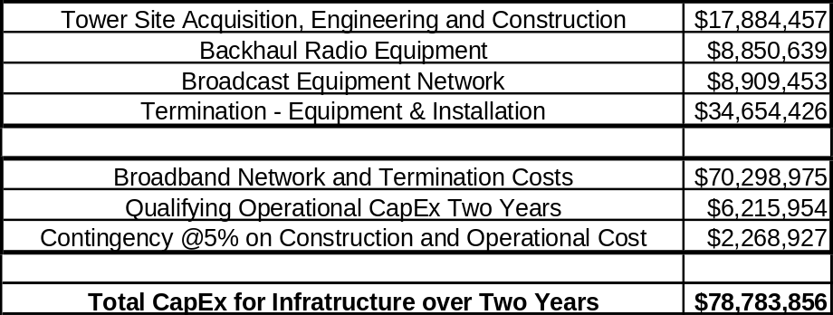

This resolution does not affect other provisions or other CBGs in CVB’s Res. T-17245.

The CVB project is still subject to California Environmental Quality Act (CEQA) review. CVB cannot conduct ground breaking activities until the CEQA review process is completed.

Award of the CASF grant is contingent on CVB’s compliance with the requirements in Resolutions T-17243 and T-17233. specifically, the CVB must post a performance bond equal to the total amount payable under this CASF award, or 10% of the total project costs within five business days after completion of the CEQA review and receipt of funding obtained pursuant to the American Recovery and Reinvestment Act (Recovery Act), whichever dates occurs later.

Comments on Draft Resolution

This is an uncontested matter in which Decision 10-05-03 grants the relief requested. Accordingly, pursuant to Section 311(g)(2) of the Public Utilities Code, the otherwise applicable 30-day period for public comment is waived.

Conclusion

The Commission finds CD’s recommended modification to Res. T-17245 as discussed in this resolution and summarized in Appendix A to be reasonable and consistent with Commission orders, and, therefore, we approve this award.

Findings

- On April 22, 2010, the Commission approved Decision 10-05-003 which modifies Res. T-17245 and approves contingent funding of $7,878,386 for the CVB project in the Central Valley and associated Delta communities. The revised project detail is described in Appendix A, pages A-1 to A-19. Revised maps of the project can be found in Appendix A, pages A-20 and A-21.
- CD determined that 216 unserved CBGs and 295 underserved CBGSs are eligible for CASF funding.
- This resolution does not affect provisions and other CBGs in CVB’s Res. T-17245, including but not limited to the posting a performance bond equal to the total amount payable within five business days after the completion of the CEQA review. Failure to comply with this requirement may result in voiding of the grant.
- CVB’s project is still subject to the California Environmental Quality Act (CEQA) review. CVB cannot conduct ground breaking activities until the CEQA review is completed.
- CVB shall comply will all guidelines, requirements, and conditions associated with the granting of CASF funds as specified in the ordering paragraphs of Resolutions T-17233 and T-17143.

THEREFORE, IT IS ORDERED that:

- The Commission shall award contingent funding of $7,878,386 from the California Advanced Services Fund (CASF) to California Valley Broadband (CVB) for its project to provide service in unserved and underserved areas as described in the Discussion section and as summarized in Appendix A of this Resolution. The award is contingent on CVB’s (1) receiving a Recovery Act grant funding for 80% of the total estimated project cost, and (2) compliance with the Ordering Paragraphs of Res. T-17233 and Res. T-17143.
- CVB shall post a performance bond equal to the total amount payable under this CASF award and provide a copy of the bond to Communications Division within five business days after completion of the California Environment Quality Act Review. Failure to comply with this requirement may result in voiding of the grant.
- CVB shall comply with all guidelines, requirements, and conditions associated with the granting of CASF funds as specified in the ordering paragraphs of Resolutions T-17233 and T-17143.

This Resolution is effective today.

I hereby certify that this Resolution was adopted by the Public Utilities Commission at its regular meeting on April 22, 2010. The following Commissioners approved it:

/s/ Paul Clanon

PAUL CLANON

Executive Director

MICHAEL R. PEEVEY
President
DIAN M. GRUENEICH
JOHN A. BOHN
NANCY E. RYAN
TIMOTHY ALAN SIMON
Commissioners

APPENDIX A
California Valley Broadband, LLC
California Valley Broadband – Revised Project Key Information

1 | Project ID
2 | Project Name | California Valley Broadband
3 | Project Plan | California Valley Broadband (CVB) is a superior fixed wireless network. CVB anticipates utilizing a ‘tri-band” deployment of two unregulated (WiFi) frequencies and one licensed (WiMAX) frequency to accommodate range, terrain, tree and other interference issues.
4 | Project Size (in square miles) | 6,616 Unserved
 |  | 2,182 Underserved
5 | Download speed | Up to 20 mbps
6 | Upload speed | Up to 6 mbps
7 | Location | Sacramento, Solano, San Joaquin, Stanislaus, Merced, Madera and Fresno Counties
a) | Community Name | Avocado, Bretz Mill, Broadview Farms, Burrel, Calflax, Cantua Creek, Cedar Grove, Cedarbrook, Cella, Chaney Ranch, Clint, Conejo , Crabtree, Deer Crossing , Dunlap, Elk, Etheda Springs, Five Points , Giffen Cantua Ranch, Goodmill, Gravesboro , Hoffman Point, Hume, Hume Station
 |  | Kanawyers , Levis, Mercey Hot Springs, Minkler, Miramonte, Monmouth, Mono Hot Springs, Navelencia , Oro Loma , Oxalis, Panoche Junction, Parkfield Junction, Piedra , Piedra Post Office, Pilibos Ranch, Pinehurst, Rodgers Crossing, Schilling, Squaw Valley, Three Rocks, Vanguard
 |  | Westhaven , Westside, Wildflower, Wood Ranch , Berenda , Bonita, Central Camp, Daulton, Italian Swiss Colony, Kismet, La Vina, Trigo, Whisky Falls, Athlone, Ballico, Brito, Cortez, Cortez, Cressey, Dos Palos Y, Hamburg Farms, Hopeton, Ingomar, Merced Falls, Santa Rita Park, Snelling
 |  | South Dos Palos, Stevinson, Bruceville, Clay, Emmaton, Herald, Point Pleasant, Burnham, Cometa, Dogtown, Gillis, Holt, Mokelumne City, Mossdale, New Hope, San Joaquin River Club, Thornton, Trull, Van Allen, Vernalis, Allendale, Birds Landing, Bucktown, Bunker, Chipps, Collinsville, Creed
 |  | Cygnus, Denverton, Dozier, Dutton, Jacksnipe, Maine Prairie, Meins Landing, Montezuma, Olcott, Oxford, Pierce, Rio Vista Junction, Spoonbill, Toland Landing, Vale, Woodward, Yolano, Cooperstown, Eugene, Hatch, Jet, Knights Ferry, La Grange
 |  | Montpelier, Ohm, Paulsell, Solyo, Stomar, Valley Home, Warnerville, Westley
b) | CBGs /Household Income | UNSERVED
 |  | 060190015002 | $37,007
 |  | 060190016001 | $43,026
 |  | 060190016002 | $35,972
 |  | 060190017004 | $39,063
 |  | 060190018003 | $42,500
 |  | 060190019001 | $41,667
 |  | 060190019003 | $30,385
 |  | 060190038033 | $50,833
 |  | 060190039002 | $28,594
 |  | 060190039003 | $23,262
 |  | 060190055152 | $77,073
 |  | 060190059021 | $54,567
 |  | 060190059022 | $70,000
 |  | 060190059024 | $36,250
 |  | 060190059025 | $21,932
 |  | 060190059042 | $45,250
 |  | 060190063001 | $60,331
 |  | 060190063002 | $52,188
 |  | 060190064012 | $69,375
 |  | 060190064014 | $44,700
 |  | 060190064015 | $55,682
 |  | 060190064016 | $30,000
 |  | 060190064021 | $61,563
 |  | 060190064022 | $53,224
 |  | 060190064025 | $20,417
 |  | 060190064031 | $25,455
 |  | 060190064032 | $32,368
 |  | 060190064033 | $29,850
 |  | 060190064034 | $43,884
 |  | 060190064035 | $33,785
 |  | 060190065001 | $23,912
 |  | 060190069003 | $35,000
 |  | 060190073001 | $37,404
 |  | 060190073003 | $42,813
 |  | 060190073005 | $48,030
 |  | 060190074001 | $25,982
 |  | 060190074002 | $34,250
 |  | 060190075001 | $29,821
 |  | 060190075003 | $29,821
 |  | 060190076001 | $33,043
 |  | 060190076002 | $31,538
 |  | 060190076003 | $40,938
 |  | 060190077001 | $35,391
 |  | 060190077004 | $25,455
 |  | 060190078001 | $31,399
 |  | 060190078002 | $21,250
 |  | 060190079001 | $31,771
 |  | 060190079002 | $47,159
 |  | 060190080001 | $43,929
 |  | 060190080003 | $58,203
 |  | 060190082001 | $28,269
 |  | 060190082003 | $30,250
 |  | 060190082006 | $27,467
 |  | 060190083022 | $24,766
 |  | 060190083023 | $27,969
 |  | 060190084015 | $29,875
 |  | 060190084021 | $25,769
 |  | 060190084022 | $27,981
 |  | 060390001021 | $28,281
 |  | 060390001023 | $35,304
 |  | 060390001031 | $37,831
 |  | 060390001051 | $37,039
 |  | 060390001052 | $47,500
 |  | 060390001053 | $36,190
 |  | 060390001055 | $38,913
 |  | 060390002002 | $26,719
 |  | 060390002003 | $31,111
 |  | 060390002004 | $32,841
 |  | 060390004001 | $33,750
 |  | 060390004002 | $29,875
 |  | 060390005031 | $30,750
 |  | 060390005032 | $39,265
 |  | 060390005033 | $49,468
 |  | 060390005061 | $45,729
 |  | 060390005072 | $43,375
 |  | 060390005073 | $31,319
 |  | 060390005081 | $43,281
 |  | 060390005091 | $60,139
 |  | 060390010001 | $47,188
 |  | 060390010002 | $66,599
 |  | 060390010003 | $29,432
 |  | 060390010004 | $26,750
 |  | 060470001001 | $32,065
 |  | 060470001002 | $26,964
 |  | 060470002001 | $34,625
 |  | 060470002002 | $43,468
 |  | 060470002006 | $24,412
 |  | 060470003013 | $36,016
 |  | 060470003031 | $35,644
 |  | 060470003032 | $39,500
 |  | 060470004002 | $50,183
 |  | 060470004003 | $52,778
 |  | 060470004004 | $35,000
 |  | 060470004005 | $50,341
 |  | 060470004006 | $36,129
 |  | 060470005032 | $36,375
 |  | 060470005051 | $35,769
 |  | 060470009011 | $31,328
 |  | 060470009012 | $25,739
 |  | 060470009013 | $35,583
 |  | 060470009031 | $71,923
 |  | 060470019011 | $36,458
 |  | 060470019022 | $41,641
 |  | 060470020005 | $39,028
 |  | 060470020006 | $40,427
 |  | 060470021001 | $34,145
 |  | 060470021002 | $30,481
 |  | 060470021003 | $44,018
 |  | 060470024001 | $30,227
 |  | 060470024002 | $32,991
 |  | 060470024003 | $17,650
 |  | 060470024004 | $28,073
 |  | 060670094031 | $68,438
 |  | 060670094032 | $40,987
 |  | 060670094041 | $71,250
 |  | 060670094042 | $69,444
 |  | 060670094053 | $30,761
 |  | 060670094061 | $73,125
 |  | 060670094062 | $62,679
 |  | 060670095011 | $33,214
 |  | 060670096041 | $39,464
 |  | 060670096042 | $77,059
 |  | 060670096051 | $35,313
 |  | 060670096182 | $65,938
 |  | 060670097001 | $34,625
 |  | 060670097002 | $43,750
 |  | 060670097004 | $44,063
 |  | 060670098001 | $34,970
 |  | 060770031061 | $60,804
 |  | 060770031081 | $64,833
 |  | 060770031141 | $66,354
 |  | 060770032151 | $65,580
 |  | 060770038032 | $28,906
 |  | 060770038034 | $33,125
 |  | 060770039001 | $31,944
 |  | 060770039002 | $51,750
 |  | 060770040011 | $32,500
 |  | 060770040012 | $27,404
 |  | 060770040021 | $85,000
 |  | 060770041031 | $43,984
 |  | 060770041033 | $55,089
 |  | 060770041041 | $76,504
 |  | 060770046001 | $55,179
 |  | 060770046002 | $45,427
 |  | 060770046004 | $57,794
 |  | 060770047011 | $40,179
 |  | 060770047021 | $46,053
 |  | 060770047022 | $52,466
 |  | 060770047023 | $65,000
 |  | 060770047024 | $68,000
 |  | 060770048001 | $46,786
 |  | 060770048002 | $49,688
 |  | 060770048003 | $39,911
 |  | 060770049021 | $52,727
 |  | 060770049023 | $42,095
 |  | 060770049024 | $34,167
 |  | 060770050031 | $42,143
 |  | 060770051061 | $40,625
 |  | 060770051062 | $55,474
 |  | 060770051111 | $31,875
 |  | 060770051191 | $38,958
 |  | 060770052021 | $44,519
 |  | 060770052032 | $73,194
 |  | 060770052033 | $62,321
 |  | 060770055001 | $26,500
 |  | 060770055002 | $60,114
 |  | 060770055003 | $81,027
 |  | 060952508001 | $17,188
 |  | 060952518043 | $71,635
 |  | 060952521021 | $49,020
 |  | 060952521022 | $65,855
 |  | 060952522021 | $75,375
 |  | 060952522022 | $70,982
 |  | 060952523073 | $99,442
 |  | 060952527025 | $78,548
 |  | 060952529031 | $76,725
 |  | 060952529032 | $69,514
 |  | 060952529033 | $93,371
 |  | 060952529034 | $54,167
 |  | 060952533001 | $45,333
 |  | 060952533002 | $57,656
 |  | 060952535001 | $43,527
 |  | 060952535004 | $51,473
 |  | 060990001011 | $46,964
 |  | 060990001012 | $65,972
 |  | 060990001013 | $51,875
 |  | 060990001014 | $43,913
 |  | 060990001023 | $77,514
 |  | 060990005081 | $65,795
 |  | 060990005082 | $41,902
 |  | 060990005083 | $35,875
 |  | 060990005084 | $ 43,750
 |  | 060990015005 | $43,375
 |  | 060990028011 | $33,971
 |  | 060990028013 | $45,642
 |  | 060990028024 | $57,778
 |  | 060990029011 | $50,083
 |  | 060990031001 | $27,468
 |  | 060990031003 | $31,118
 |  | 060990031004 | $125,143
 |  | 060990031005 | $30,357
 |  | 060990032022 | $69,327
 |  | 060990032023 | $50,357
 |  | 060990033001 | $48,065
 |  | 060990033002 | $25,547
 |  | 060990033003 | $43,952
 |  | 060990033004 | $29,868
 |  | 060990034001 | $38,750
 |  | 060990034002 | $28,333
 |  | 060990035004 | $46,471
 |  | 060990036031 | $34,375
 |  | 060990036032 | $31,188
 |  | 060990036034 | $46,625
 |  | 060990036035 | $31,786
 |  | 060990036044 | $44,107
 |  | 060990037003 | $41,731
 | CBGs /Household Income | UNDERSERVED
 |  | 060190008009 | $24,167
 |  | 060190015002 | $37,007
 |  | 060190016001 | $43,026
 |  | 060190016002 | $35,972
 |  | 060190017004 | $39,063
 |  | 060190018001 | $25,741
 |  | 060190018003 | $42,500
 |  | 060190019001 | $41,667
 |  | 060190019002 | $31,932
 |  | 060190019003 | $30,385
 |  | 060190038031 | $28,261
 |  | 060190038033 | $50,833
 |  | 060190039002 | $28,594
 |  | 060190039003 | $23,262
 |  | 060190039004 | $29,583
 |  | 060190039005 | $27,895
 |  | 060190041001 | $46,429
 |  | 060190042071 | $60,521
 |  | 060190043011 | $120,268
 |  | 060190055032 | $29,375
 |  | 060190055111 | $71,767
 |  | 060190055112 | $59,167
 |  | 060190055151 | $30,507
 |  | 060190055152 | $77,073
 |  | 060190059022 | $70,000
 |  | 060190059024 | $36,250
 |  | 060190059042 | $45,250
 |  | 060190061005 | $31,250
 |  | 060190063001 | $60,331
 |  | 060190064011 | $32,985
 |  | 060190064012 | $69,375
 |  | 060190064013 | $47,727
 |  | 060190064014 | $44,700
 |  | 060190064015 | $55,682
 |  | 060190064016 | $30,000
 |  | 060190064021 | $61,563
 |  | 060190064022 | $53,224
 |  | 060190064023 | $48,472
 |  | 060190064024 | $50,417
 |  | 060190064025 | $20,417
 |  | 060190064026 | $49,750
 |  | 060190064033 | $29,850
 |  | 060190064034 | $43,884
 |  | 060190065001 | $23,912
 |  | 060190065002 | $22,404
 |  | 060190065003 | $21,691
 |  | 060190065004 | $22,426
 |  | 060190065005 | $32,045
 |  | 060190068011 | $25,101
 |  | 060190068021 | $32,679
 |  | 060190068022 | $31,250
 |  | 060190069001 | $26,458
 |  | 060190069002 | $39,625
 |  | 060190069003 | $35,000
 |  | 060190070041 | $37,361
 |  | 060190071003 | $26,250
 |  | 060190072011 | $40,625
 |  | 060190072015 | $37,462
 |  | 060190072022 | $40,175
 |  | 060190073001 | $37,404
 |  | 060190073002 | $37,273
 |  | 060190073003 | $42,813
 |  | 060190073004 | $33,000
 |  | 060190073005 | $48,030
 |  | 060190074001 | $25,982
 |  | 060190074002 | $34,250
 |  | 060190074003 | $35,091
 |  | 060190075001 | $29,821
 |  | 060190075002 | $32,292
 |  | 060190075003 | $29,821
 |  | 060190075004 | $46,944
 |  | 060190075005 | $37,361
 |  | 060190076001 | $33,043
 |  | 060190076002 | $31,538
 |  | 060190076003 | $40,938
 |  | 060190076004 | $38,264
 |  | 060190077001 | $35,391
 |  | 060190077002 | $28,472
 |  | 060190078002 | $21,250
 |  | 060190078003 | $18,836
 |  | 060190078004 | $29,167
 |  | 060190079001 | $31,771
 |  | 060190079002 | $47,159
 |  | 060190080001 | $43,929
 |  | 060190080003 | $58,203
 |  | 060190080004 | $24,783
 |  | 060190082001 | $28,269
 |  | 060190082003 | $30,250
 |  | 060190082006 | $27,467
 |  | 060190083013 | $23,864
 |  | 060190083021 | $17,348
 |  | 060190083022 | $24,766
 |  | 060190083023 | $27,969
 |  | 060190084013 | $41,761
 |  | 060190084015 | $29,875
 |  | 060190084016 | $25,938
 |  | 060390001021 | $28,281
 |  | 060390001022 | $41,283
 |  | 060390001023 | $35,304
 |  | 060390001024 | $39,444
 |  | 060390001031 | $37,831
 |  | 060390001051 | $37,039
 |  | 060390001052 | $47,500
 |  | 060390001053 | $36,190
 |  | 060390001055 | $38,913
 |  | 060390002001 | $41,339
 |  | 060390002002 | $26,719
 |  | 060390002003 | $31,111
 |  | 060390002004 | $32,841
 |  | 060390004001 | $33,750
 |  | 060390004002 | $29,875
 |  | 060390005031 | $30,750
 |  | 060390005032 | $39,265
 |  | 060390005033 | $49,468
 |  | 060390005061 | $45,729
 |  | 060390005072 | $43,375
 |  | 060390005073 | $31,319
 |  | 060390005081 | $43,281
 |  | 060390005083 | $57,670
 |  | 060390005091 | $60,139
 |  | 060390007003 | $62,269
 |  | 060390010001 | $47,188
 |  | 060390010002 | $66,599
 |  | 060390010003 | $29,432
 |  | 060390010004 | $26,750
 |  | 060470001001 | $32,065
 |  | 060470002002 | $43,468
 |  | 060470002003 | $43,068
 |  | 060470002005 | $43,963
 |  | 060470002006 | $24,412
 |  | 060470003012 | $28,750
 |  | 060470003013 | $36,016
 |  | 060470003031 | $35,644
 |  | 060470003032 | $39,500
 |  | 060470003041 | $24,828
 |  | 060470004002 | $50,183
 |  | 060470004003 | $52,778
 |  | 060470004004 | $35,000
 |  | 060470004005 | $50,341
 |  | 060470004006 | $36,129
 |  | 060470005031 | $24,306
 |  | 060470005032 | $36,375
 |  | 060470005051 | $35,769
 |  | 060470007021 | $30,125
 |  | 060470009011 | $31,328
 |  | 060470009012 | $25,739
 |  | 060470009013 | $35,583
 |  | 060470018021 | $29,100
 |  | 060470019011 | $36,458
 |  | 060470019012 | $21,786
 |  | 060470019013 | $25,795
 |  | 060470019014 | $25,750
 |  | 060470019021 | $28,413
 |  | 060470019022 | $41,641
 |  | 060470020005 | $39,028
 |  | 060470020006 | $40,427
 |  | 060470021001 | $34,145
 |  | 060470021002 | $30,481
 |  | 060470021003 | $44,018
 |  | 060470022014 | $35,260
 |  | 060470022021 | $49,198
 |  | 060470022023 | $49,286
 |  | 060470023011 | $52,209
 |  | 060470023021 | $51,993
 |  | 060670086001 | $92,213
 |  | 060670086002 | $83,979
 |  | 060670086003 | $39,615
 |  | 060670087012 | $49,125
 |  | 060670090053 | $46,705
 |  | 060670092001 | $54,861
 |  | 060670093151 | $91,122
 |  | 060670093152 | $84,076
 |  | 060670094031 | $68,438
 |  | 060670094032 | $40,987
 |  | 060670094041 | $71,250
 |  | 060670094042 | $69,444
 |  | 060670094043 | $70,104
 |  | 060670094044 | $65,938
 |  | 060670094053 | $30,761
 |  | 060670094061 | $73,125
 |  | 060670094062 | $62,679
 |  | 060670095011 | $33,214
 |  | 060670096041 | $39,464
 |  | 060670096042 | $77,059
 |  | 060670096051 | $35,313
 |  | 060670097001 | $34,625
 |  | 060670097002 | $43,750
 |  | 060670097003 | $40,179
 |  | 060670097004 | $44,063
 |  | 060670098001 | $34,970
 |  | 060770037002 | $38,611
 |  | 060770038034 | $33,125
 |  | 060770039001 | $31,944
 |  | 060770039002 | $51,750
 |  | 060770040011 | $32,500
 |  | 060770040012 | $27,404
 |  | 060770041023 | $34,861
 |  | 060770041031 | $43,984
 |  | 060770041032 | $68,913
 |  | 060770041033 | $55,089
 |  | 060770041041 | $76,504
 |  | 060770046001 | $55,179
 |  | 060770046002 | $45,427
 |  | 060770046003 | $33,558
 |  | 060770046004 | $57,794
 |  | 060770047011 | $40,179
 |  | 060770047021 | $46,053
 |  | 060770047022 | $52,466
 |  | 060770047023 | $65,000
 |  | 060770047024 | $68,000
 |  | 060770047026 | $43,958
 |  | 060770048001 | $46,786
 |  | 060770048002 | $49,688
 |  | 060770048003 | $39,911
 |  | 060770048005 | $63,750
 |  | 060770049012 | $53,107
 |  | 060770049021 | $52,727
 |  | 060770049022 | $50,272
 |  | 060770049023 | $42,095
 |  | 060770049024 | $34,167
 |  | 060770050031 | $42,143
 |  | 060770050032 | $71,523
 |  | 060770050041 | $55,208
 |  | 060770051061 | $40,625
 |  | 060770051062 | $55,474
 |  | 060770051111 | $31,875
 |  | 060770051191 | $38,958
 |  | 060770051192 | $29,219
 |  | 060770052021 | $44,519
 |  | 060770052031 | $62,500
 |  | 060770052032 | $73,194
 |  | 060770052033 | $62,321
 |  | 060770055001 | $26,500
 |  | 060770055002 | $60,114
 |  | 060770055003 | $81,027
 |  | 060952508001 | $17,188
 |  | 060952517012 | $36,659
 |  | 060952517021 | $46,875
 |  | 060952518031 | $56,932
 |  | 060952521021 | $49,020
 |  | 060952521022 | $65,855
 |  | 060952522022 | $70,982
 |  | 060952523051 | $56,111
 |  | 060952523092 | $83,381
 |  | 060952527025 | $78,548
 |  | 060952529031 | $76,725
 |  | 060952529033 | $93,371
 |  | 060952529034 | $54,167
 |  | 060952531016 | $63,214
 |  | 060952532011 | $80,815
 |  | 060952532014 | $90,973
 |  | 060952533001 | $45,333
 |  | 060952533002 | $57,656
 |  | 060952534015 | $67,155
 |  | 060952534024 | $36,202
 |  | 060952534025 | $54,563
 |  | 060952535001 | $43,527
 |  | 060952535004 | $51,473
 |  | 060990001011 | $46,964
 |  | 060990001012 | $65,972
 |  | 060990001013 | $51,875
 |  | 060990001014 | $43,913
 |  | 060990001021 | $57,857
 |  | 060990001023 | $77,514
 |  | 060990002011 | $46,607
 |  | 060990002012 | $56,827
 |  | 060990002022 | $36,750
 |  | 060990005012 | $49,250
 |  | 060990005081 | $65,795
 |  | 060990005082 | $41,902
 |  | 060990028011 | $33,971
 |  | 060990028013 | $45,642
 |  | 060990028023 | $37,333
 |  | 060990028024 | $57,778
 |  | 060990029011 | $50,083
 |  | 060990029012 | $31,339
 |  | 060990029013 | $47,917
 |  | 060990029014 | $37,208
 |  | 060990029015 | $46,528
 |  | 060990029024 | $38,750
 |  | 060990030021 | $48,092
 |  | 060990031001 | $27,468
 |  | 060990031005 | $30,357
 |  | 060990033004 | $29,868
 |  | 060990034001 | $38,750
 |  | 060990034002 | $28,333
 |  | 060990035002 | $40,833
 |  | 060990035004 | $46,471
 |  | 060990036031 | $34,375
 |  | 060990036033 | $34,650
 |  | 060990036034 | $46,625
 |  | 060990036035 | $31,786
 |  | 060990036041 | $45,000
 |  | 060990036043 | $33,603
 |  | 060990036044 | $44,107
c) | ZIP Codes | Unserved
 |  | 95230
 |  | 95307
 |  | 95313
 |  | 95316
 |  | 95323
 |  | 95326
 |  | 95329
 |  | 95355
 |  | 95356
 |  | 95357
 |  | 95358
 |  | 95360
 |  | 95361
 |  | 95363
 |  | 95367
 |  | 95368
 |  | 95376
 |  | 95380
 |  | 95385
 |  | 95386
 |  | 95387
 |  | 93210
 |  | 93234
 |  | 93242
 |  | 93602
 |  | 93608
 |  | 93609
 |  | 93611
 |  | 93616
 |  | 93618
 |  | 93620
 |  | 93621
 |  | 93622
 |  | 93624
 |  | 93625
 |  | 93626
 |  | 93627
 |  | 93628
 |  | 93630
 |  | 93631
 |  | 93634
 |  | 93640
 |  | 93641
 |  | 93646
 |  | 93648
 |  | 93651
 |  | 93654
 |  | 93656
 |  | 93657
 |  | 93660
 |  | 93662
 |  | 93664
 |  | 93667
 |  | 93668
 |  | 93675
 |  | 93701
 |  | 93702
 |  | 93706
 |  | 93711
 |  | 93720
 |  | 93722
 |  | 93725
 |  | 93601
 |  | 93604
 |  | 93610
 |  | 93614
 |  | 93622
 |  | 93626
 |  | 93637
 |  | 93638
 |  | 93643
 |  | 93644
 |  | 93645
 |  | 93653
 |  | 93669
 |  | 93720
 |  | 93610
 |  | 93620
 |  | 93622
 |  | 93635
 |  | 93665
 |  | 95301
 |  | 95303
 |  | 95312
 |  | 95315
 |  | 95316
 |  | 95317
 |  | 95322
 |  | 95324
 |  | 95333
 |  | 95334
 |  | 95340
 |  | 95348
 |  | 95360
 |  | 95365
 |  | 95369
 |  | 95374
 |  | 95380
 |  | 95388
 |  | 94571
 |  | 95615
 |  | 95624
 |  | 95632
 |  | 95638
 |  | 95639
 |  | 95641
 |  | 95655
 |  | 95683
 |  | 95690
 |  | 95693
 |  | 95742
 |  | 95758
 |  | 95817
 |  | 95818
 |  | 95820
 |  | 95822
 |  | 95823
 |  | 95824
 |  | 95826
 |  | 95827
 |  | 95828
 |  | 95829
 |  | 95830
 |  | 95831
 |  | 95832
 |  | 95203
 |  | 95204
 |  | 95206
 |  | 95207
 |  | 95209
 |  | 95212
 |  | 95215
 |  | 95219
 |  | 95220
 |  | 95227
 |  | 95230
 |  | 95231
 |  | 95236
 |  | 95237
 |  | 95240
 |  | 95242
 |  | 95258
 |  | 95320
 |  | 95330
 |  | 95336
 |  | 95337
 |  | 95361
 |  | 95366
 |  | 95376
 |  | 95385
 |  | 95632
 |  | 95686
 |  | 95690
 |  | 94510
 |  | 94512
 |  | 94533
 |  | 94535
 |  | 94571
 |  | 94585
 |  | 94589
 |  | 94590
 |  | 94591
 |  | 94592
 |  | 95612
 |  | 95616
 |  | 95620
 |  | 95687
 |  | 95688
 |  | 95690
 |  | 95694
 | ZIP Codes | Underserved
 |  | 95230
 |  | 95307
 |  | 95313
 |  | 95316
 |  | 95323
 |  | 95326
 |  | 95329
 |  | 95356
 |  | 95357
 |  | 95358
 |  | 95360
 |  | 95361
 |  | 95363
 |  | 95368
 |  | 95380
 |  | 95386
 |  | 93210
 |  | 93234
 |  | 93242
 |  | 93602
 |  | 93605
 |  | 93606
 |  | 93608
 |  | 93609
 |  | 93611
 |  | 93616
 |  | 93618
 |  | 93621
 |  | 93622
 |  | 93625
 |  | 93626
 |  | 93627
 |  | 93630
 |  | 93631
 |  | 93634
 |  | 93640
 |  | 93646
 |  | 93648
 |  | 93651
 |  | 93654
 |  | 93656
 |  | 93657
 |  | 93660
 |  | 93662
 |  | 93664
 |  | 93667
 |  | 93668
 |  | 93675
 |  | 93706
 |  | 93711
 |  | 93720
 |  | 93722
 |  | 93725
 |  | 93727
 |  | 93601
 |  | 93604
 |  | 93610
 |  | 93614
 |  | 93622
 |  | 93626
 |  | 93637
 |  | 93638
 |  | 93643
 |  | 93644
 |  | 93645
 |  | 93653
 |  | 93669
 |  | 93610
 |  | 93620
 |  | 93635
 |  | 95301
 |  | 95315
 |  | 95317
 |  | 95322
 |  | 95324
 |  | 95333
 |  | 95334
 |  | 95340
 |  | 95348
 |  | 95360
 |  | 95365
 |  | 95369
 |  | 95374
 |  | 95380
 |  | 95388
 |  | 95615
 |  | 95624
 |  | 95632
 |  | 95638
 |  | 95639
 |  | 95641
 |  | 95683
 |  | 95690
 |  | 95693
 |  | 95742
 |  | 95758
 |  | 95827
 |  | 95829
 |  | 95830
 |  | 95832
 |  | 95206
 |  | 95212
 |  | 95215
 |  | 95219
 |  | 95220
 |  | 95227
 |  | 95230
 |  | 95231
 |  | 95236
 |  | 95237
 |  | 95240
 |  | 95242
 |  | 95258
 |  | 95320
 |  | 95330
 |  | 95336
 |  | 95337
 |  | 95361
 |  | 95366
 |  | 95376
 |  | 95632
 |  | 95686
 |  | 95690
 |  | 94510
 |  | 94512
 |  | 94533
 |  | 94571
 |  | 94585
 |  | 94589
 |  | 94592
 |  | 95612
 |  | 95616
 |  | 95620
 |  | 95687
 |  | 95688
 |  | 95690
 |  | 95694
8 | Estimated Potential Subscriber Size
a) | Households | 40,802 Unserved
 |  | 36,024Underserved
9 | Deployment Schedule (from Commission approval) | 24 months
10 | Proposed Project Budget | $78,783,856
 | CASF (10%) | $7,878,386
 | CIAC
 | Amount of CASF Funds Requested | $7,878,386
APPENDIX A
Resolution T-17245-A
California Valley Broadband, LLC
Revised California Valley Broadband Shapefile

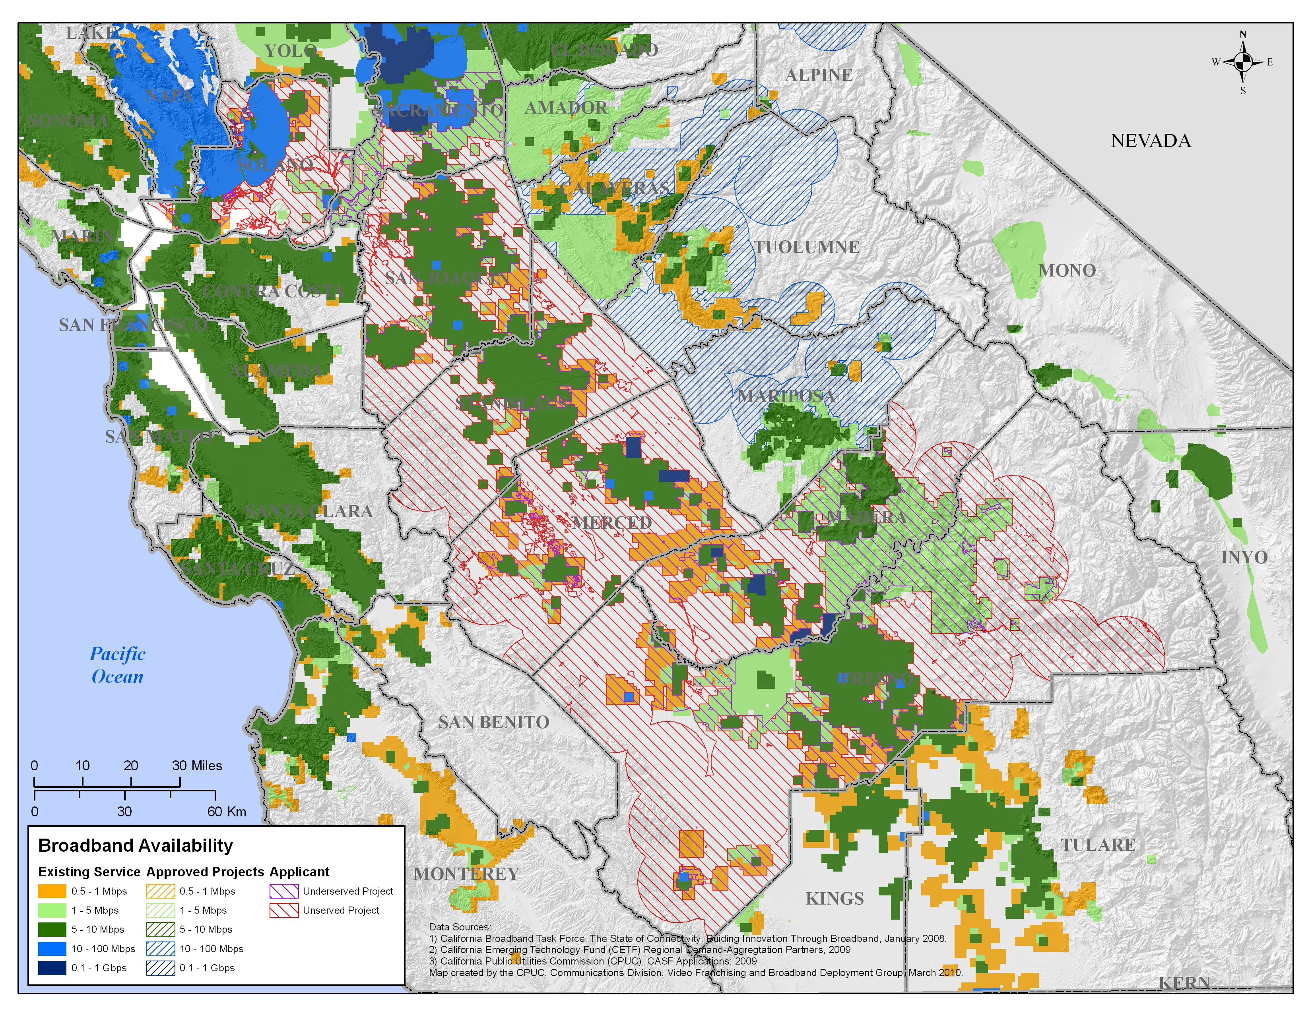

APPENDIX A
Resolution T-17245-A
California Valley Broadband, LLC
California Valley Broadband
Revised Statewide Map

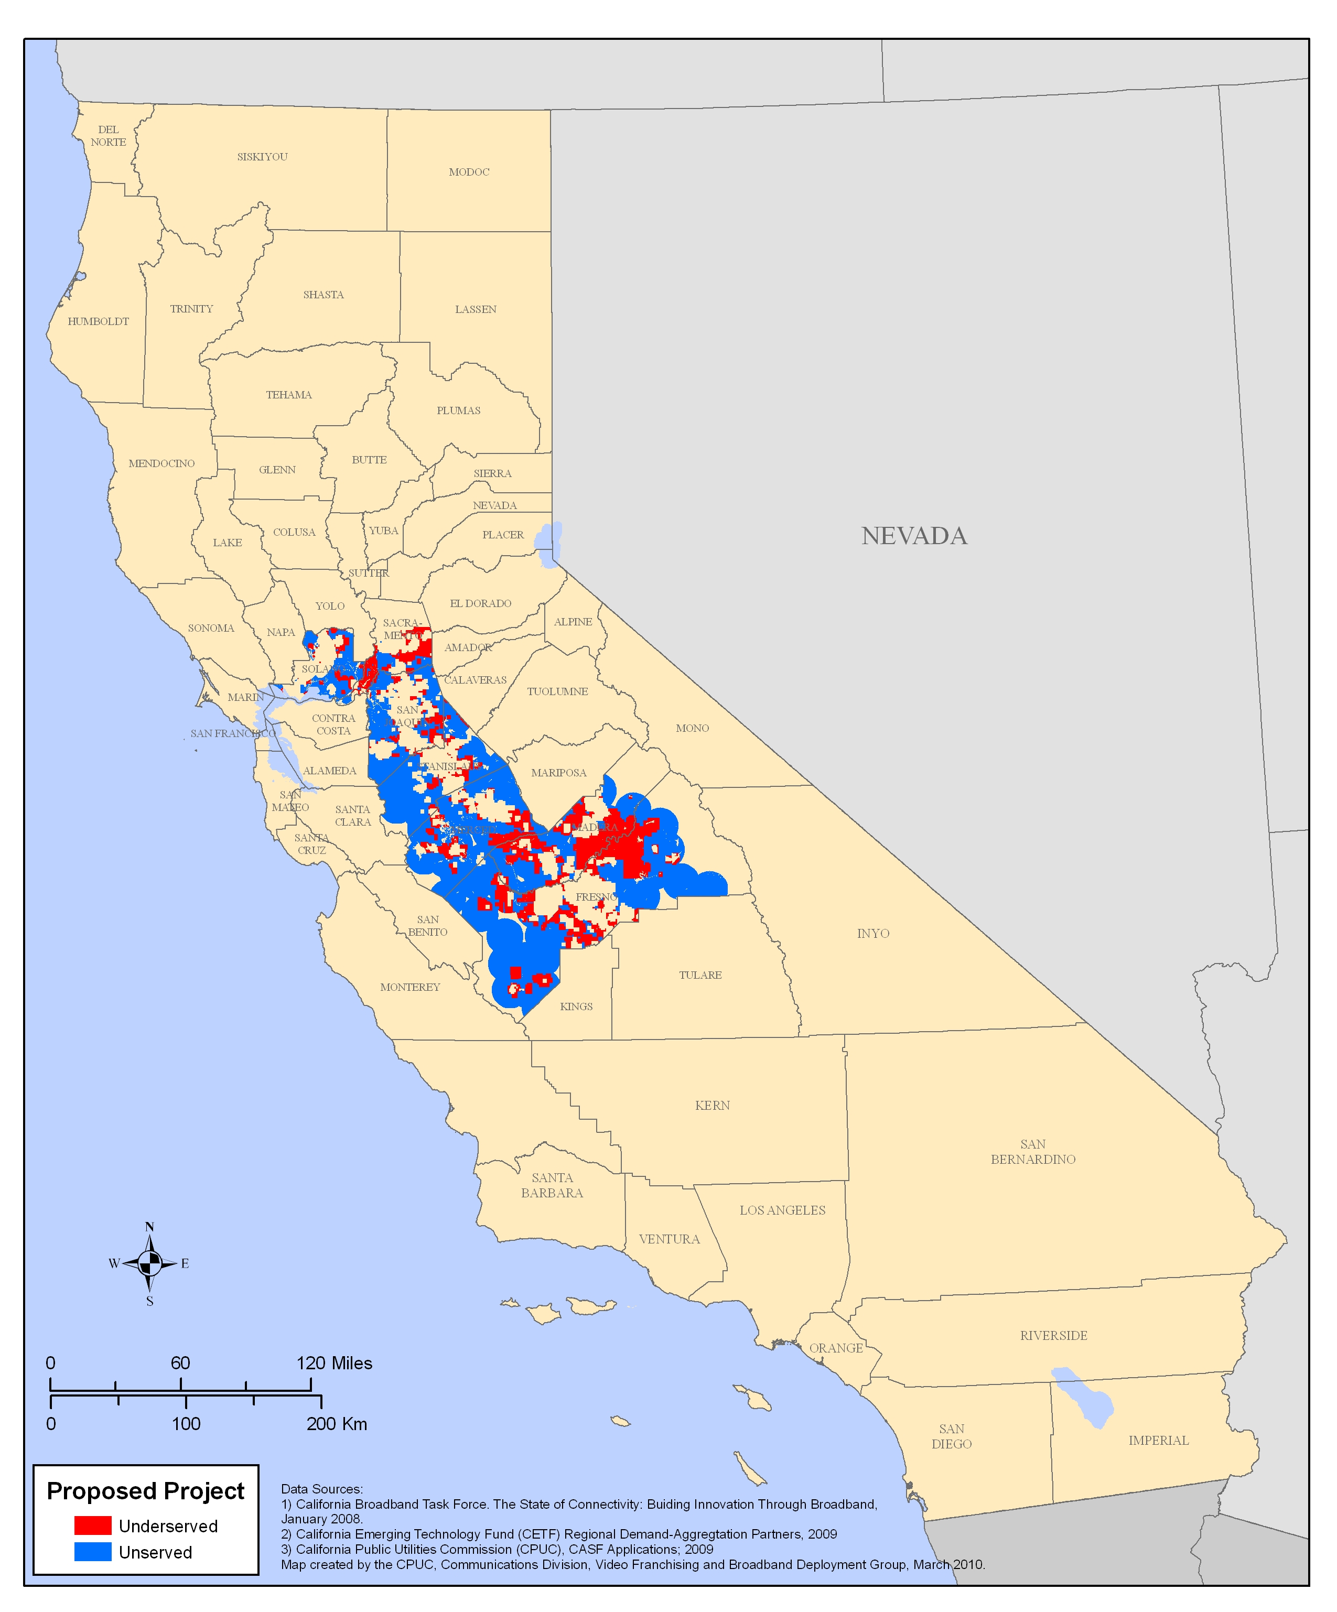

(End of Appendix A)

The Recovery Act appropriates $7.2 billion for grants and loans to support broadband deployment on a national level. The Recovery Act offers a unique and ground breaking opportunity for California to partner with the federal government and other state agencies in advancing the goal of bridging the digital divide.

