FINAL REPORT ON THE AUDIT OF THE ENCINA POWER PLANT

CONDUCTED UNDER GENERAL ORDER 167
TO DETERMINE COMPLIANCE WITH
OPERATION, MAINTENANCE, AND LOGBOOK STANDARDS

ELECTRIC GENERATION PERFORMANCE BRANCH
CONSUMER PROTECTION AND SAFETY DIVISION
CALIFORNIA PUBLIC UTILITIES COMMISSION
505 VAN NESS AVENUE

SAN FRANCISCO, CA 94102

December 10, 2010

Richard W. Clark, Director
Consumer Protection and Safety Division

Table of Contents

Executive Summary 4
Introduction 5
Power Plant Description 10
Power Plant Performance 12
Section 1 – Safety Hazards Requiring Immediate Correction 14
Section 2 – Violations Requiring Correction 15
Finding 2.1 – The plant failed to regularly inspect and monitor flow-assisted corrosion in high-energy pipes and components. 15
Finding 2.2 – The plant delayed repairs on Unit 4’s high pressure steam turbine. 16
Finding 2.3 – The plant failed to evaluate or establish a schedule to complete safety improvements to reduce fire risks. 17
Finding 2.4 – The plant’s Emergency Response Plan needs improvement. 20
Finding 2.5 – The plant lacks a procedure for its computerized work management database. 21
Finding 2.6 – The plant failed to follow its root-cause procedure when it investigated a November 2006 incident. 21
Finding 2.7 – The lead operator could not explain a digital display’s function and could not explain why the display was tagged out. 22
Finding 2.8 – The plant has two black-start test procedures that conflict with each other. 23
Finding 2.9 – The plant delayed repairs on its circulating water tunnel. 24
Finding 2.10 – The plant delayed repairs on a recirculation fan bearing. 26
Finding 2.11 – The plant delayed repairs on asbestos-laden insulation. 26
Finding 2.12 – The plant delayed high-priority corrective repairs. 27
Finding 2.13 – The plant lacks a knowledge retention program. 29
Finding 2.14 – The plant failed to post evacuation maps and signs throughout the facility. 30
Finding 2.15 – The plant failed to maintain an attendance list at one of the assembly areas. 31
Finding 2.16 – The plant failed to label critical system components. 32
Section 3 – Observations 35
Observation 3.1 – The plant follows a strict process to select and qualify contractors. 35
Observation 3.2 – The plant requires contractors to complete a contractor safety notice before they can start work. 35
Observation 3.3 – The plant uses checklists for routine inspection. 35
Observation 3.4 – The plant maintains a logbook compliance document onsite. 36
Observation 3.5 – The plant implements a lock-out tag-out program. 36
Observation 3.6 – The plant conducts evacuation drills regularly. 37
Observation 3.7 – The plant keeps its facility orderly and clean. 37
Observation 3.8 – The plant maintains its cathodic protection system. 38
Observation 3.9 – The plant is well-staffed in a number of areas. 39
Observation 3.10 – The plant verifies contract employees’ qualifications. 39
Observation 3.11 – The plant inspects its cranes and forklifts regularly. 39
Observation 3.12 – The plant controls and updates its equipment diagrams. 39

List of Photos

Photo 1. Encina Power Plant as seen from Carlsbad Boulevard. 10
Photo 2. Fire extinguishers are readily available on the turbine deck. 19
Photo 3. Fire blankets are available near the control room. 19
Photo 4. Deficiency tag on a digital display in the control room. 23
Photo 5. Sinking concrete atop the circulating water tunnel. 24
Photo 6. The plant repaired areas of surface delamination. 25
Photo 7. The plant blows air to the bearing to keep it from overheating. 26
Photo 8. Asbestos insulation exposed at a valve on Unit 4. 27
Photo 9. The plant temporarily installed metal sheeting which redirects oil drips away from hot surfaces. 28
Photo 10 and 11. A defective chamber valve causes large water puddle to form on the ground near Site Column 20A. 29
Photo 12. The plant marked this exit stairwell with luminescent tape. 31
Photo 13. A metal valve tag on an attemperator. 32
Photo 14. The plant labeled Unit 1’s feedwater heater. 33
Photo 15. The plant labeled Unit 2’s induced draft fan motor. 33
Photo 16. Unit 1’s condensate storage tank to be labeled. 34
Photo 17 and 18. On the turbine deck, the plant has a shack where it keeps its locks and binders that track all active clearances. 37
Photo 19. The plant keeps the turbine deck clean and orderly. 38

List of Tables

Table 1. Encina Power Plant has five steam units and one gas turbine unit. 10
Table 2. Encina’s NCF in the last 14 years. 12
Table 3. Encina’s EAF in the last 14 years. 13
Table 4. Encina’s SR in the last 5 years. 13
Table 5. Encina’s FOF in the last 5 years. 14

Executive Summary

This is the Final Report on the August 2008 audit of the Encina Power Plant (“Encina” or “the plant”) prepared by the Commission’s Consumer Protection and Safety Division (CPSD). CPSD audited the plant for compliance with the California Public Utilities Commission’s (“CPUC’s” or “Commission’s”) General Order 167, which includes Operation, Maintenance, and Logbook Standards for power plants.

In June 2008, CPSD notified Encina of the audit and requested pertinent documents. CPSD visited the plant site in August 2008 in order to observe plant operations, inspect equipment, review documents, and interview plant staff. From these activities, CPSD evaluated whether the plant needed improvements in operation or maintenance policies and whether the plant’s programs and procedures met various Operation, Maintenance, and Logbook Standards.

CPSD found 16 violations of Operation and Maintenance Standards. In September 2009, CPSD sent Encina a Preliminary Audit Report which discussed all 16 violations and requested the plant to submit a Corrective Action Plan (CAP). In October 2009, the plant submitted a CAP to address CPSD’s concerns on the violations. In March 2010, CPSD held a teleconference with Encina to discuss the plant’s CAP and requested the plant to submit more supporting documents. In April 2010, the plant submitted supplemental data to address CPSD’s outstanding concerns on the violations. CPSD held a meet-and-confer meeting with Encina on June 22, 2010 to resolve five remaining violations. CPSD now issues this Final Audit Report.

Introduction

In August 2008, a team from the Consumer Protection and Safety Division (CPSD) of the California Public Utilities Commission (“CPUC” or “Commission”) audited the Encina Power Plant (“Encina” or “the plant”) to determine whether the plant was in compliance with General Order (GO) 167, which includes Operation, Maintenance, and Logbook Standards for power plants.

The team first notified Encina of the audit on June 24, 2008 and requested pertinent documents. The team consisted of Ben Brinkman, Alan Shinkman, and Rick Tse. During the site visit from August 18 to 22, 2008, the team observed plant operations, inspected equipment, reviewed documents, and interviewed plant staff. The team found 16 violations of Operation and Maintenance Standards.

In September 2009, CPSD sent Encina a Preliminary Audit Report which identified the 16 violations and asked the plant to submit a Corrective Action Plan (CAP). In October 2009, the plant submitted a CAP to address CPSD’s concerns on the violations. In March 2010, CPSD held a teleconference with Encina to discuss the plant’s CAP and asked the plant to submit more supporting documents. In April 2010, the plant submitted additional documents to address CPSD’s outstanding concerns. CPSD subsequently held a meet-and-confer meeting with Encina on June 22, 2010 to resolve five remaining violations. The violations and their final outcome and follow-up are detailed in Section 2 and summarized below:

Finding 2.1 Encina failed to inspect and monitor flow-assisted corrosion in high-energy pipes and components. Over time, corrosion wears down pipe walls, particularly at elbows, bends and flow restrictions. If high-energy pipes rupture, they will release high pressure steam and potentially damage equipment, and injure or kill workers. In response, the plant stated that it has conducted periodic spot inspections on both Units 4 and 5 to monitor flow-assisted corrosion. Spot inspections, however, do not qualify as full inspections. The plant cannot fully address the risks of corrosion without a full inspection. Although the plant has conducted more spot inspections in April 2010, the plant should do a full inspection as soon as possible and to develop a formal inspection program. The plant stated that it has allocated more funds toward FAC inspection in next year’s budget. The plant will also develop a Piping Assessment Program pursuant to NRG’s corporate directive. The program will identify and establish inspection method, location, and frequency. CPSD will inspect Encina and request additional data to determine if the program addresses the risks of high-energy pipe corrosion.

Finding 2.2 Encina delayed repairs on Unit 4’s high pressure steam turbine, through which high pressure and temperature steam flows. This steam inflicts serious wear and tear on components along its path, particularly on stator vanes and rotating blades. Over time, its components corrode, erode, and undergo metal fatigue and creep. If turbine blades crack, fail, and fly through the turbine, they can cause serious damage and shut down the plant for many months. In response, the plant explained that it deferred the repairs because the recommendation to do so was based on old operating characteristics. Since the recommendation, the number of operating hours and starts has decreased significantly. The steam turbine also runs mostly at low loads and subject to lower pressure and temperature steam. The plant, therefore, extended the repair interval. Nonetheless in February 2010, the plant overhauled Unit 4's HP steam turbine. No further corrective action is required.

Finding 2.3 The plant failed to evaluate or establish a schedule to complete safety improvements that would reduce the plant’s exposure to fires. A fire can injure or kill workers and damage equipment that may shut down the plant for many months. In response, the plant completed several safety recommendations to reduce fire risks. The plant also declined several other recommendations, but provided reasonable justification for its decision. See Finding 2.3 in Section 2 for details.

Finding 2.4 The plant’s Emergency Response Plan (ERP) lacks information on how to respond to earthquakes and wildfires, lacks information on what steps the plant should take after an emergency, and failed to assign certain emergency duties in case of a fire. Emergencies occur without warning. Without proper planning and procedures, the plant cannot effectively respond to emergencies. In response, the plant updated is ERP accordingly. No further corrective action is required.

Finding 2.5 Encina lacks a procedure for processing work orders in its new work management database. Encina still uses the procedure prepared for a database it no longer uses. An updated procedure would explain how the plant initiates, tracks, plans, and schedules work orders, and draw a clear line of responsibility for staff. In response, the plant explained it was transitioning to a new work management database during the audit. And that the new and old databases share similar workflow process. The lack of a procedure for the new database would not have impeded work order planning. The plant explained that it has since completed the transition and fully trained its staff on the new system; therefore CPSD requires no further corrective action.

Finding 2.6 The plant failed to follow its root-cause procedure when it investigated a November 2006 outage when an expansion joint failed. A root-cause analysis (RCA) is a systematic way to identify the ultimate causes of failures to prevent recurrence. Failure to conduct systematic investigations can lead to misdiagnosis and improper correction. In response, the plant explained that the RCA for the November 2006 incident was done per the old procedure. Since July 7, 2008, the plant has adopted a newer and more detailed procedure that governs how staff conducts RCA. In April 2010, the plant submitted a RCA investigation which conformed to the new procedure. No further corrective action is required.

Finding 2.7 The lead operator could not explain the function of a digital display, or why the display was tagged out. The lead operator takes charge in the control room and therefore should know the function and status of controls at all times. This lack of awareness compromises operational reliability and workers’ safety. In response, the plant explained that the lead operator at the time did not understand the auditor’s question. The auditor’s intent, however, was to test how well a lead operator knows his or her controls. Nonetheless, in October 2009, the plant had retrained its operators on this system, which is used to control Unit 4’s SCR. No further corrective action is required.

Finding 2.8 The plant has two conflicting black-start test procedures. The plant uses the procedures to test whether the gas turbine can black-start the steam units. The conflicts may confuse staff and cause test errors or inconsistent test results. In response, the plant explained that one of the procedures is a corporate-wide procedure and the other is a plant-specific standard operating procedure. The two procedures work in conjunction with each other. However, the fact that two procedures exist for the same thing may confuse staff. CPSD asked and the plant added a note to cross-reference the two procedures. No further corrective action is required.

Finding 2.9 The plant delayed repairs on its circulating water tunnel. The deteriorating tunnel poses safety risks for workers, and could shut the plant down. Falling concrete can injure or kill workers who go inside to clean and inspect the tunnel. While walking atop the tunnel, operators on routine inspections can trip and fall over deteriorating concrete and uneven walk surfaces. In response, the plant provided pull-test records on Unit 4’s tunnel that were conducted in 2006. The records indicated that the tunnel is structurally sound and in good condition. The plant also provided documents to show that it cleaned and inspected all four tunnels in 2009. In regards to surface de-lamination atop the tunnel, the plant made multiple repairs, and erected orange cones and barrier tapes as mitigating measures, where necessary. The plant also agreed to add inspection requirements to its tunnel cleaning procedures and checklists. No further corrective action is required.

Finding 2.10 The plant delayed repairs on a recirculation fan bearing. The defective bearing registered higher than normal operating temperature and could fail. If the bearing fails, it will take the recirculation fan out-of-service and limit the unit’s power output. In response, the plant explained that the outboard seal on the re-circ fan failed and not the bearing. On October 29, 2008, the plant repaired the outboard fan seal via Work Order #08-282124. No further corrective action is required.

Finding 2.11 The plant delayed repairs on asbestos-laden insulation. Inhaled asbestos can cause cancer. Also, damaged insulation exposes hot pipes, which can burn workers. In response, the plant analyzed the insulation to confirm it did not contain asbestos. To mitigate burn risk hazards, the plant repaired the broken insulation. No further corrective action is required.

Finding 2.12 The plant delayed high-priority repairs to an oil leak onto hot piping, moisture removal equipment for instrument air, and a defective flood-chamber valve. In response, the plant explained that those repairs are not high-priority repairs because the deficiencies posed no imminent safety hazards. However, operators apparently designated the work orders a priority five, the highest priority in the work order system. At CPSD's request, the plant retrained its staff on work order priority in June 2010. All personnel who enters, prioritizes, and approves work orders attended the training. No further corrective action is required.

Finding 2.13 The plant lacks a knowledge retention program. If senior staff retire in the near future, they will take away with them detailed and valuable knowledge about operation and maintenance. Without a program to retain and transfer institutional knowledge to other staff, upcoming retirements may affect the plant’s operation. In response, the plant stated that in 2007 it filled six “transition positions”, which are positions filled early on to replace outgoing employees. At the meet-and-confer meeting, the plant explained that knowledge retention is only critical for positions in operations and instrumentation and control. In that regards, the plant has an extensive training and certification program for those positions, which includes mentoring, skill assessment, written and hands-on tests. In addition, experienced operators are often involved in many levels of work processes, such as creating checklists and work procedures to capture institutional knowledge. CPSD requires no further corrective action.

Finding 2.14 The plant failed to post evacuation maps and signs throughout the facility. Contractors or new employees who are unfamiliar with the plant’s layout may become disoriented in emergencies and face unnecessary risks; such confusion may slow the plant’s response to the emergency. In response, the plant posted evacuation maps and added more exit signage. The plant marked exit pathways with luminescent tape. The plant also placed warning signs at doors and stairways that are not exit paths. No further corrective action is required.

Finding 2.15 The plant failed to maintain an attendance list at one of the assembly areas. In an evacuation, the safety manager uses the attendance list at the assembly area to take roll call. Without an attendance list, the safety manager cannot accurately account for onsite staff. This may slow the plant’s response to an emergency. In response, the plant updated all attendance lists at each of the assembly areas in July 2009. CPSD asked and the plant created a recurring work order to update the attendance list on a regular basis. No further corrective action is required.

Finding 2.16 The plant failed to label critical system components to identify what equipment belongs to which unit; doing so may help operators orient and familiarize themselves with the equipment which they operate, and prevent operational errors. In response, the plant started labeling critical system components. The plant has already labeled about 84% of all valves in all units. The plant has also labeled about 80% of its feedwater system components, which include feedwater heaters. CPSD asks that by April 13, 2011, the plant reports on the progress of its labeling effort.

Power Plant Description

Encina Power Plant is located next to the Coastal Highway in Carlsbad, California, about 32 miles North of San Diego. San Diego Gas and Electric (SDG&E) built the plant in the 1950s and operated it until 1999. In May 1999, after California restructured the electric industry, SDG&E sold the plant to Cabrillo Power, a joint venture between Dynegy and NRG. In March 2006, NRG acquired Dynegy’s interests in Cabrillo Power and now wholly owns and operates Cabrillo Power.

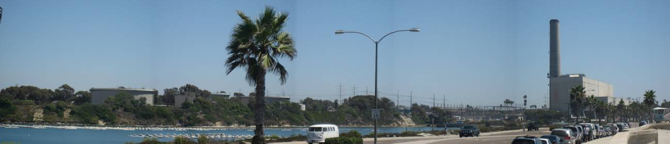
Photo 1. Encina Power Plant as seen from Carlsbad Boulevard.

The 965-megawatt plant has six generation units; all but Unit 6 are conventional steam units. Units 1, 2, and 3, built in the 1950s, generate 106, 104, and 110 megawatts, respectively. Units 4 and 5, built in the 1970s, generate 300 and 330 megawatts, respectively. The plant also has a 15-megawatt gas turbine. All six units can burn either natural gas or fuel oil, though they typically use the former due to air quality regulations. The plant’s 138-kV and 230-kV switchyards deliver the plant’s power to the grid.

Table 1. Encina Power Plant has five steam units and one gas turbine unit.
 | Year Built | Capacity (megawatts) | Primary Fuel | Backup Fuel
Unit 1 | 1954 | 106 | Natural Gas | Number 6 Fuel Oil
Unit 2 | 1956 | 104 | Natural Gas | Number 6 Fuel Oil
Unit 3 | 1958 | 110 | Natural Gas | Number 6 Fuel Oil
Unit 4 | 1973 | 300 | Natural Gas | Number 6 Fuel Oil
Unit 5 | 1978 | 330 | Natural Gas | Number 6 Fuel Oil
Gas Turbine | 1968 | 15 | Natural Gas | Diesel Fuel

Unlike most power plants, Encina houses its steam units inside a building. The building protects the units from corrosive sea air and hides the plant’s industrial-scale equipment, which some find unaesthetic. Flue gas from all five units exhausts through one smoke stack. The units also share one water intake, which channels seawater from the Agua Hedionda Lagoon to the condensers for cooling. Every two years, the plant dredges the Lagoon to prevent sediment from restricting water flow into the intake structure.

The gas turbine unit is located outside the power plant building. It is of an aero-derivative design; in other words, it closely resembles jet engines used on aircrafts. Although the gas turbine is cheaper to construct than the steam units, it is less fuel efficient and was designed to generate power during “peak” days when electricity demand is high. The gas turbine has black-start capability, that is, it can help the grid recover from major blackouts because it can start up without external power.

Encina recently upgraded the plant to reduce nitrogen oxides (NOx) emissions, which contribute to smog and accelerate global warming. In July 2003, the plant replaced the steam units’ burners with “low-NOx” burners, which operate below the temperature at which NOx forms. The plant also installed a Selective Catalytic Reduction (SCR) system on each of the steam units. These systems inject ammonia into the flue gas and pass the mixture over a catalyst to reduce NOx. With these upgrades, Encina meets current State of California air standards.

In November 2008, the plant changed Unit 4’s control system from analog to digital. The plant did the same on Unit 5 in May 2009. Digital controls allow operators to gather operating data more easily, are easier to operate, and less likely to fail. With access to data, operators can generate trends and statistics and run the unit more efficiently and reliably. The plant has no plans to upgrade controls on Units 1, 2 or 3 because the plant wants to retire these units in the near future.

In September 2007, NRG applied for a license with the California Energy Commission (CEC) to build two new combined-cycle units in the area currently occupied by the plant’s fuel tanks. The new units will add 540-megawatts to the plant’s capacity. The increased capacity will allow the plant to retire Units 1, 2, and 3, but the company plans to operate Units 4 and 5 through at least 2017. The license application is still under CEC review. However, with the State’s new once-through cooling (OTC) regulation, it is uncertain whether NRG will move forward with its plan to construct the new combined-cycle units.

Encina no longer has an RMR contract. The manager of the state’s electric grid, the California Independent System Operator (CAISO), ended the plant’s RMR contract in December 2007. However, because the plant can burn dual fuel and black-start on its own, the CAISO awarded the plant a contract to provide those services. Once a year, the CAISO requires the plant to test and re-certify those capabilities in order to maintain its contract. However as of January 2009, CAISO terminated its dual fuel contract with Encina.

Power Plant Performance

CPSD used data collected by NERC GADS and analyzed four performance factors to study Encina’s operating performance in the last five years:

- Net Capacity Factor (NCF),
- Equivalent Availability Factor (EAF),
- Start Reliability (SR), and
- Forced Outage Factor (FOF).

Together, the factors give an insight as to how well the plant has performed in recent years.

NCF measures how close a plant operates to its full capacity. For example, a 50% NCF means a plant generates just half of what it can produce. Table 2 shows Encina’s NCF in the last 14 years.

Table 2. Encina’s NCF in the last 14 years.
Years | NCF (%)
1995 | 23
1996 | 26
1997 | 28
1998 | 35
1999 | No Data Available
2000 | No Data Available
2001 | 47
2002 | No Data Available
2003 | No Data Available
2004 | 37
2005 | 22
2006 | 15
2007 | 8
2008 | 12

In 2007, Encina generated just 8% of the electricity it can produce. That number is about the same as what other California steam plants had produced in that same year. However, it is dwarfed compared to other North America steam plants, which produced 60% of their total megawatt capacity in 2007. Encina’s NCF in 2007 reinforces the fact that California’s aging steam plants are becoming less efficient and competitive, and therefore are less likely called upon to run. These steam plants now generally run only during the summer months when demand for electricity is high. During off-peak seasons, these plants idle while hydro and the more efficient combined-cycle plants supply the needed electricity.

Although Encina now runs less, the plant is still able to upkeep with maintenance and operators’ skill to keep the plant available. EAF measures a plant’s availability to produce power. For example, if a plant breaks down frequently, which makes it unavailable to produce power, then the plant will have a low EAF. Table 3 shows Encina’s EAF in the last 14 years.

Table 3. Encina’s EAF in the last 14 years.
Years | EAF (%)
1995 | 96  Average = 91
1996 | 91
1997 | 93
1998 | 84
1999 | No Data Available
2000 | No Data Available
2001 | 86
2002 | No Data Available
2003 | No Data Available
2004 | 87
2005 | 88  Average = 89
2006 | 90
2007 | 89
2008 | 91

Encina’s average EAF remained much about the same before and after deregulation. A high EAF is always desirable, especially for plants that hardly run. In such a case, a high EAF means that even when the plant has been offline for awhile, it can still startup and produce power if it needs to.

Encina’s ability to startup reliably also attributes to the plant’s high EAFs. SR calculates the ratio of actual starts to attempted starts. It measures how often a plant actually started when it was attempted to start. This index suggests how well a plant is maintained, i.e. a well-maintained plant starts reliably. It also indicates how well operators are trained. Table 4 shows Encina’s SR in the last 5 years.

Table 4. Encina’s SR in the last 5 years.
Years | SR (%)
2004 | 100
2005 | 100
2006 | 100
2007 | 100
2008 | 98

Finally, FOF measures how often a plant is in forced outages. Obviously, a low FOF is desirable. Table 5 shows Encina’s FOF in the last 5 years.

Table 5. Encina’s FOF in the last 5 years.
Years | FOF (%)
2004 | 2
2005 | 3
2006 | 1
2007 | 2
2008 | 1

Encina underwent forced outages infrequently; predictably because it had such high EAFs. In 2008, the plant spent just 1% of the time in forced outages; that’s only 87.6 hours out of 8,760 hours in a year. That number is slightly better than other California steam plants, which were out 1.5% in 2008, and much better than other North America steam plants, which were out 5% in the same year. This suggests that Encina does well in terms of maintenance to avoid forced outages.

Section 1 – Safety Hazards Requiring Immediate Correction

Staff found no safety hazards that require immediate correction.

Section 2 – Violations Requiring Correction

Finding 2.1 – The plant failed to regularly inspect and monitor flow-assisted corrosion in high-energy pipes and components.

The plant failed to regularly inspect for, monitor, trend, and correct flow-assisted corrosion in high-energy pipes and components, violating operation standards. Flow-assisted corrosion is erosion-corrosion caused by a fast moving fluid at high temperature or by a two phase flow (fluid and steam). Over time, it wears down pipe walls, particularly at elbows, bends and flow restrictions. If the plant fails to monitor and correct the corrosion, pipes can rupture and release high pressure steam, which can damage equipment, and injure or kill workers nearby. Plants must therefore monitor and correct corrosion over time.

The plant has never fully inspected Units 1, 2, and 3 for flow-assisted corrosion, and last inspected Units 4 and 5 in 1997 and 1998 respectively. While those inspections found acceptable remaining wall thicknesses, substantial additional corrosion may have occurred because both units have subsequently operated many hours.

Outcome and Follow-up
In response, the plant reiterated that it fully inspected Units 4 and 5 for flow-accelerated corrosion in 1997, and 1998 respectively. CPSD acknowledged the adequacy of those inspections, but those inspections were conducted more than 10 years ago. Substantial corrosion may have occurred because both units have subsequently operated many hours.

The plant stated that since the 1997 and 1998 inspections, it has conducted spot inspections. For example, in December 2001, the plant reexamined the boiler feed pump (BFP) discharge pipe wall, an area where the 1998 inspection revealed possible FAC indications. The 2001 inspection did not detect any wall loss at that location. And then in May 2009, subsequent to the CPUC audit, the plant again reexamined the same location for FAC. Again, the inspection detected no change in wall thickness.

While spot inspections are better than no inspection, CPSD feels that the plant is overdue for a full inspection, particularly on Units 4 and 5, which run more frequently than Units 1, 2, and 3. Flow-assisted corrosion is a complex phenomenon and is affected by multitude of variables. Pipe configuration, design, metallurgy, water chemistry, and operating characteristics are just a few. Consequently, just because the plant reexamined the most prone location and found no corrosion does not mean that there are no corrosion elsewhere in the system. Because of the range of variables involved, one cannot fully address the risks of FAC without a full inspection. Spot inspections do not qualify as full inspections. As such, CPSD expects the plant to do a full inspection as soon as possible and to develop a FAC inspection program going forward.

To the plant’s credit, the plant has already taken the initial steps toward creating a FAC inspection program. For example, in November 2008, plant engineers attended an Aptech seminar to learn to develop and implement a FAC monitoring program. The plant will also develop a Piping Assessment Program to comply with a NRG corporate directive. Plant engineers also attended demonstration of advanced FAC inspection equipment, which enable offline inspection without insulation removal. The plant is also evaluating the need to contract outside experts to identify and select pipe locations for FAC inspection. And finally in the interim, the plant plans to do more spot inspections during overhauls in 2010 and 2011 for Units 4 and 5, respectively.

At the meet-and-confer meeting, the plant provided a report of a FAC inspection conducted in April 2010. A company called Q. PRO Technical Services conducted a Pulse Eddy Current (PEC) inspection. PEC is an inspection technology that can inspect insulated carbon steel piping for internal and external corrosion and erosion through the insulation without disturbing the insulation or coating. Q. PRO inspected some piping and pumps for each of the 5 units and presented the data it collected to the plant. However, the report contains no conclusions or recommendations from the inspection. CPSD asks that the plant’s engineering staff evaluate the results of the PEC examination and to determine whether corrosion or erosion has occurred which warrant repairs.

CPSD will continue to monitor the plant’s progress to meet NRG’s corporate directive, which requires the plant to develop a Piping Assessment Program. The program will identify and establish inspection method, location, and frequency. CPSD will inspect Encina and request additional data to determine if the program addresses the risks of high-energy pipe corrosion.

Finding 2.2 – The plant delayed repairs on Unit 4’s high pressure steam turbine.

The plant delayed repairs on Unit 4’s high pressure steam turbine, which violates maintenance standards. The steam turbine is a critical piece of equipment. High-pressure and temperature steam flows through the turbine. This causes wear and tear on components along the steam path, particularly on stator vanes and rotating blades. Over time, the metal parts corrode, erode, and undergo metal fatigue and creep. If turbine blades crack and fail, they can fly through the turbine, destroy other blades and puncture the turbine casing. Such incidents can injure or kill workers, and can shut down the plant for many months.

The plant last inspected Unit 4’s high pressure steam turbine in 1999. At the time, the 10th stage rotating blades showed initial signs of creep. The contractor who inspected the turbine recommended that the plant replace the blades when the machine reaches 40,000 Equivalent Operating Hours (EOH). At the time of the audit, the machine had already reached 59,000 EOH, but the machine continues to run on its old blades.

Outcome and Follow-up
In response, the plant explained that the contractor’s recommendation to replace the 10th stage rotating blades was based on old operating characteristics. The steam turbine now runs mostly at low loads and subject to lower pressure and temperature steam. Furthermore, the unit now runs less. In 1999, the unit operated over 7,300 hours per year with 27 startups. Between 2006 and 2008, the unit operated less than 5,300 hours per year with just 17 startups. The contractor’s recommendation to replace the blades at 40,000 EOH did not take into account these new operating characteristics, which resulted in a longer service life. In light of this, the plant extended the replacement interval from 40,000 to 60,000 EOH. Nonetheless in February 2010, the plant overhauled Unit 4's HP steam turbine and replaced all 10th stage rotating blades. No further corrective action is required.

Finding 2.3 – The plant failed to evaluate or establish a schedule to complete safety improvements to reduce fire risks.

The plant failed to evaluate or establish a schedule to complete safety improvements to reduce fire risks, violating operation and maintenance standards. The safety improvements reduce the plant’s exposure to fires. A fire can injure or kill workers and destroy plant equipment that may shut down the plant for many months. In particular, fires fueled by high-pressure oil sprays can quickly become conflagrations that threaten the entire plant.

In June 2008, Encina’s insurer assessed the plant for fire risks. The insurer recommended that the plant:

- Install fire sprinklers over the turbine bearings. If bearing seals fail, lube oil under high pressure can spray over a wide area. Hot bearing surfaces can ignite the lube oil.
- Install sprinklers over the lube oil tank. If the tank or its piping ruptures, a large quantity of lube oil can release. If ignited, the lube oil will result in a pool fire. Such a fire can damage the turbine and generator directly above.
- Develop a procedure to safely shut down the lube oil system when it catches on fire. An oil fire will burn as long as the oil continues to flow. Cutting off the oil too early will damage the turbine, and shutting it off too late will fuel the fire. A safe shutdown procedure will ensure that oil flow will stop as soon as practical.
- Install sprinklers over the hydraulic fluid and hydrogen seal oil system. Flange gaskets and fittings may leak and spray a mist of hydraulic and seal oil. Hot surfaces can ignite the oil and result in a spray-fire.
- Install fire sprinklers over the auxiliary transformers. Transformers use oil to insulate its interior. If the oil loses its insulating property, arcing may occur inside the transformer, sparking an explosion.
- Install fire sprinklers in the Administration Building. Sprinklers can control a fire before the fire department arrives, greatly reducing total damage.
- Install a seismic gas shutoff valve for the Storage and Administration Building. The seismic shutoff valve will automatically shut off the gas supply in earthquakes, which are common in Southern California. A strong earthquake can rupture gas lines and release flammable gas that could ignite inside buildings.
- Perform a periodic leak test of its boiler gas safety shutoff valves.
- Test the heat sensors and smoke detectors.

At the time of the audit, the plant has not yet evaluated, nor established a schedule to complete these recommendations. While CPSD does not specifically require plants to follow contractor recommendations, it does expect plants to evaluate those recommendations and to provide justifications when the plant declines them.

Outcome and Follow-up
In response, the plant directly complied with the requirements of Items 3, 8, and 9 listed above, and provided explanations and documentation to address the other items in the list. First, in response to Items 3, 8, and 9 above, the plant developed lube-oil shut-off procedures (Item 3), installed a gas seismic shutoff valve, and provided documentation showing regular contractor inspections of smoke detectors and gas safety shutoff valves (Items 8 and 9).

Second, in response to the portion of Item 4 relating to electro-hydraulic oil, the plant explained that it uses fire resistant and self extinguishing Fyrquel® Electro-Hydraulic oil.

Third, in response to Item 6, lack of automatic sprinklers in the administration building, the plant stated that although its original intention was to install these sprinklers, the administration building is very small, and with multiple exits, making these sprinklers unnecessary. The plant also believes installing water sprinklers in the building could damage critical computer systems, and plans to install an Argonite extinguisher system in the administration building’s server rooms later this year. CPSD asks that by April 13, 2011, the plant reports on the installation of this system.

In response to the remaining items, which recommend automatic sprinklers for the turbine bearings (Item 1), lube oil tanks (Item 2), hydrogen seal oil system (Item 4), and auxiliary transformers (Item 5), the plant stated that it relies on portable CO₂ fire extinguishers, staff monitoring for potential fire hazards, and the local fire department, which is only three minutes away. At the meet-and-confer meeting, CPSD verified multiple fire extinguisher systems near the steam turbines (See Photos 2 and 3).

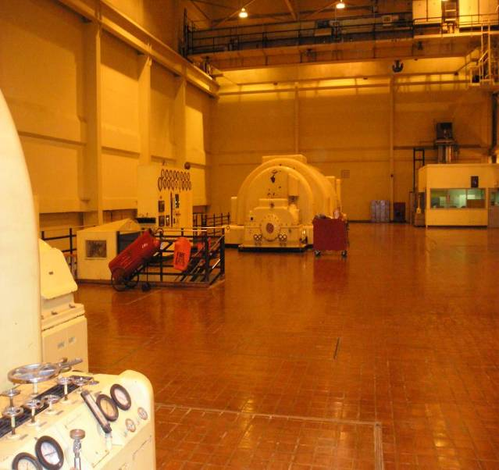
Photo 2. Fire extinguishers are readily available on the turbine deck.

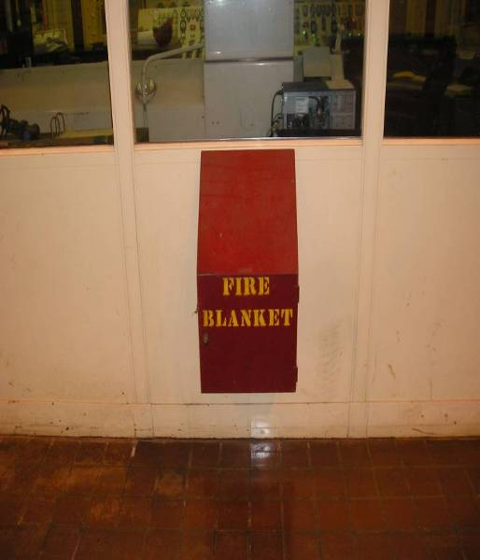
Photo 3. Fire blankets are available near the control room.

Additionally, the plant originally claimed that the use of automatic sprinklers for this equipment was not recommended industry standard, and could cause worse equipment damage. CPSD researched NFPA Codes and FM Global data sheets and found that this claim is not fully supported by current industry practice. In fact, several jurisdictional plants, particularly newer combine-cycle plants, utilize this fire protection technology. CPSD discussed this with the plant in a teleconference, and asked the plant to provide further data and justification for its claims, along with a cost-benefit analysis.

The plant provided a cost-benefit analysis, based on EPRI report NP-4144, which indicated only minor financial risk and little cost benefit to a fully engineered automated fire system. The plant found that only 10% of NRG plants nationwide utilize such systems. Additionally, the plant correctly maintains that FM Global, an insurer known for strict standards, still chose to insure the plant.

CPSD notes that Encina completed several other risk mitigation measures that FM Global recommended, which includes:

- Sealing the cable penetrations in Unit 3-4 Control Room,
- Installing locks on sprinkler position control valves,
- Improving the existing sprinkler control valve inspection procedure,
- Developing a Fire Protection System valve list with system designators keyed to the plant fire system site map, and
- Providing exposure protection for control room windows.

Finding 2.4 – The plant’s Emergency Response Plan needs improvement.

The plant’s Emergency Response Plan (ERP) violates operation standards because it fails to specify: 1) the steps the plant should take after an emergency, 2) how to respond to earthquakes and wildfires, and 3) who should assume certain emergency duties in case of a fire. Emergencies occur without warning and without proper planning and procedure, the plant cannot effectively respond to emergencies. As a result, emergencies may unnecessarily delay the plant’s return-to-service.

First, the ERP lacks response information for earthquake or wildfires, events which have recently occurred in Southern California. The plant’s insurer recommends that the plant include specific earthquake response measures in its ERP.

Second, the plant’s ERP failed to include information on what steps the plant should take following an emergency, such as which authorities to notify. Although the plant includes some of this information in its Injury and Illness Prevention Plan, the information is lacking in its ERP. Information on how to report safety incidents to the CPUC does not appear in either plan.

Finally, the plant’s ERP failed to assign certain emergency duties in the event of a fire. The plant’s insurer recommends that the ERP assign someone to monitor fire pumps and sprinkler valves during a fire.

Outcome and Follow-up
In response, the plant updated its ERP to include: 1) a new procedure for wildfires, 2) instructions for reporting safety incidents to CPSD, and 3) descriptions of staff responsibilities during an emergency. At CPSD’s request, the plant also corrected an inaccurate telephone number and added the CPUC safety reporting website information to its ERP.

In addition, the plant updated its Standard Operating Procedures which describe staff duties during an earthquake. These duties include monitoring lagoon level and boiler drafts. The instructions emphasize safety, and require staff to evacuate and congregate in the Emergency Assembly Area until it is safe to return. No further corrective action is required.

Finding 2.5 – The plant lacks a procedure for its computerized work management database.

The plant lacks a procedure for processing work orders (WO) entered into Maximo (a software program), violating maintenance standards. A procedure would explain how the plant initiates, tracks, plans, and schedules WOs, which draw a clear line of responsibility for staff. The plant replaced MainSaver with Maximo in May 2008, but did not update the relevant procedure. Without such a procedure, staff may process WOs inconsistently and fail to make timely repairs.

Outcome and Follow-up
In response, the plant explained that it was transitioning from one WO database to another during the audit. At the time, the plant did not have a WO procedure for the new system. Auditors felt that a new procedure should have been in place to avoid workflow confusion. The plant contests that the two systems are very similar and that both systems share a similar process to initiate, plan, schedule, and track WOs. Therefore, the lack of a new procedure would not have caused workflow confusion. Auditors did not investigate in-depth enough to decide whether differences between the two systems may have impeded WO planning. However, since Encina completed the transition and fully trained its staff on the new system, CPSD requires no further corrective action.

Finding 2.6 – The plant failed to follow its root-cause procedure when it investigated a November 2006 incident.

The plant failed to follow its root-cause procedure when it investigated a November 2006 outage when an expansion joint failed, violating operation standards. A root-cause investigation is a systematic way to identify the ultimate causes of failures to prevent recurrence. Failing to follow the procedure to investigate systematically may lead to misdiagnosis and improper correction.

An auditor reviewed three root-cause analyses that the plant conducted in recent years. The auditor also reviewed the plant’s procedure for root-cause investigations. The auditor noticed that at least one analysis did not conform to the procedure. In November 2006, a failed expansion joint took Unit 4 out-of-service. The plant investigated and attributed the failure to improper operating procedures. While the plant has identified the root cause and has since revised that procedure to prevent recurrence, the plant failed to follow its root-cause procedure when it conducted the analysis. According to the root-cause procedure, each person who is involved in an incident must fill out an interview form. The plant uses the form to collect factual information so that the plant can investigate a failure thoroughly. The analysis for the expansion joint incident lacks those interview forms.

Outcome and Follow-up
In response, the plant explained that the root-cause analysis for the November 2006 incident was conducted per the old procedure. Since July 7, 2008, the plant has adopted a newer and more detailed procedure that governs how staff conducts RCA. The old procedure was more general and did not prescribe the forms that were required under the new procedure.

In December 2008, since the plant adopted the new procedure, twenty plant staff attended a problem-solving class to learn how to properly investigate and conduct RCA. The plant also designated its Technical Service Group to oversee all root-cause investigations. In January 2009, the plant fully implemented the newly RCA process. NRG is also currently developing a company-wide RCA database to keep record of RCA investigations which would enable staff to offload lessons learned from incidents across NRG’s fleet of power plants.

CPSD asked that the plant provide a copy of RCA done per the new procedure, if any. In April 2010, the plant submitted a RCA investigation conducted under the new procedure. The investigation used the Kepner-Tregoe RCA technique to investigate a discharge pipe failure on Unit 5’s electro-hydraulic pump. The failure, which took place in January 2009, was the second failure in recent history. The RCA identified the root cause to be improper weld preparation during the initial repair. The RCA conformed to the plant’s new procedure. No further corrective action is required.

Finding 2.7 – The lead operator could not explain a digital display’s function and could not explain why the display was tagged out.

The lead operator could not explain the function of a digital display, or why the display was tagged out, which violates operation standards. The lead operator takes charge in the control room and therefore should know the function and status of controls at all times. This lack of awareness compromises operational reliability and workers’ safety.

An auditor toured the control room and saw a deficiency tag on a digital display. He then asked the lead operator at the time to explain the display’s function and the reason for the tag. The lead operator was unable to explain the display’s function or why it was tagged.

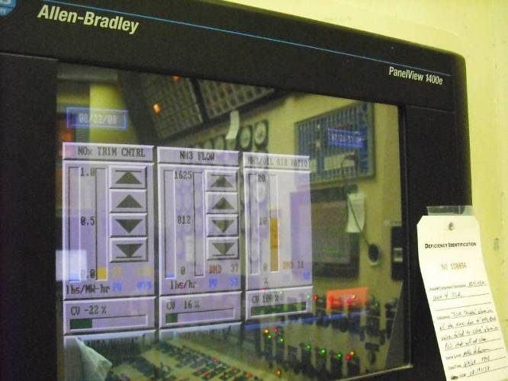
Photo 4. Deficiency tag on a digital display in the control room.

Outcome and Follow-up
In response, the plant explained that the digital display is used to control Unit 4’s SCR system. The plant tagged the display because the display annunciated a false alarm. The plant explained that the lead operator at the time did not understand the auditor’s question or the implication of the auditor’s question. However, the auditor’s question was simple and direct, and the implication is to test how well a lead operator knows his or her controls.

In light of this finding, the plant has traced the deficiency to a faulty solenoid valve. The plant has since replaced the valve, cleared all alarms, and restored the system to service. In October 2009, the plant had also retrained its operators on this system. No further corrective action is required.

Finding 2.8 – The plant has two black-start test procedures that conflict with each other.

The plant has two black-start test procedures that conflict with each other, violating operation standards. The plant has a two-page, informal, procedure and as well as a more detailed and formalized procedure that was a part of the plant’s operator manual. The plant uses the procedure to test whether the gas turbine can black-start the steam units. The conflict may confuse staff and cause test errors or inconsistent test results.

Outcome and Follow-up
In response, the plant explained that the two black-start procedures work in conjunction with each other. The two-page informal procedure is a corporate-wide black-start procedure for all NRG facilities. The detailed procedure is a plant-specific standard operating procedure. The plant reviewed the two procedures and confirmed that following each procedure correctly will not yield test errors or inconsistent test results. However, the fact that two procedures exist for the same thing may confuse staff. CPSD asked and the plant added a note on its standard operating procedure to refer to the corporate-wide procedure. No further corrective action is required.

Finding 2.9 – The plant delayed repairs on its circulating water tunnel.

The plant delayed repairs on its circulating water tunnel, violating maintenance standards. The circulating water tunnel channels seawater from the lagoon to each unit’s condenser for cooling. The deteriorating tunnel poses safety risks for workers and threatens the plant’s reliability.

The deteriorating tunnel poses safety risks for workers. On several occasions, concrete actually fell from the tunnel’s ceiling. Falling concrete can injure or kill workers who go inside to clean and inspect the tunnel. Operators who walk atop the tunnel to routinely inspect the units can trip and fall over deteriorating concrete and uneven walk surfaces.

In addition, because the deteriorating tunnel might collapse, the repair delays threaten the plant’s reliability. Even a partial collapse would restrict water flow to the condensers. This would reduce a condenser’s cooling capacity and limit a unit’s power output.

As a precaution, the plant erected a warning sign at the tunnel’s entry. The plant also said it will hire a contractor to use a special epoxy to repair the tunnel. At the time of the audit, the plant has not yet repaired the deteriorating tunnel.

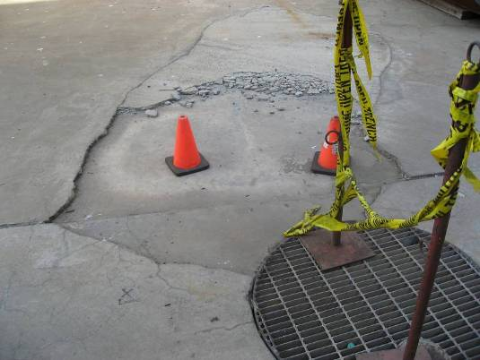
Photo 5. Sinking concrete atop the circulating water tunnel.

Outcome and Follow-up
In response, the plant acknowledged that the circulating water (CW) tunnel is a critical plant asset, of which if not properly maintained, may threaten the plant’s reliability. In 2006, the plant evaluated bio-fouling coatings on the tunnel. At the time, the plant pull tested random areas of Unit 4’s tunnel per ASTM D4541 standards. The test results indicated that the tunnel is structurally sound and in good condition. The plant also stated that it regularly cleans and maintains its tunnel. The plant provided documents that showed it cleaned all four tunnels in 2009.

However, the plant did not provide “pull-test” records for other tunnels. The plant must maintain the integrity of its circulating water tunnels. If it chooses not to conduct more extensive testing, at a minimum it must conduct regular and frequent visual inspections, and insure that the tunnels experience no instances of falling concrete or debris. The plant also admits that the CW deck does have areas of de-lamination, which the plant had repaired before, but which delaminated again. The plant further states that:

“The concrete in the picture is not in danger of breaking or falling into the circulating water tunnel, but it can present a tripping hazard to employees; the bright orange cones and barrier tape are mitigating actions. Any areas on the CW deck providing critical access have been promptly repaired; areas that are not providing critical access are isolated and marked, and will be repaired in normal course.”

The plant made multiple repairs (See Photo 6), and allocated funds in the budget for future repairs. The plant also agreed to add inspection requirements to its tunnel cleaning procedures and checklists. No further corrective action is required.

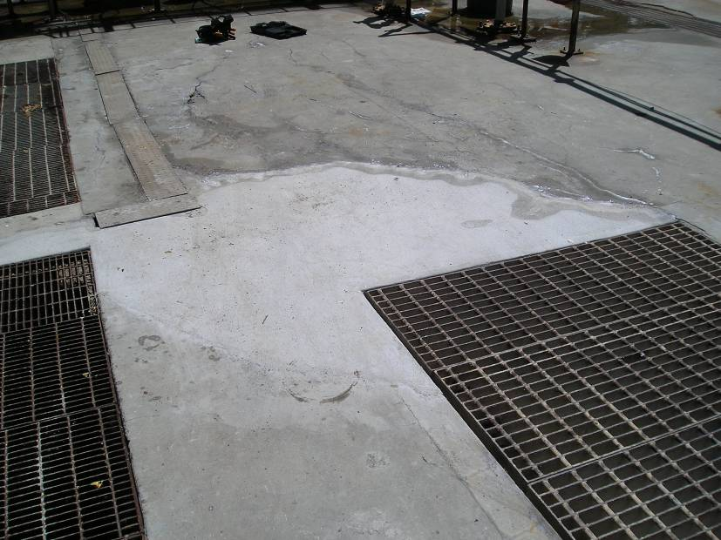
Photo 6. The plant repaired areas of surface delamination.

Finding 2.10 – The plant delayed repairs on a recirculation fan bearing.

The plant delayed repairs on a recirculation fan bearing, violating maintenance standards. The recirculation fan recycles flue gas into the furnace for re-burn. The defective bearing has registered higher than normal operating temperature. At the time of the audit, the plant used an air blower to blow ambient air to the bearing to keep it from overheating. The bearing can fail if operators continue to operate it above its normal temperature. If the bearing fails, it will take the recirculation fan out-of-service and limit the unit’s power output.

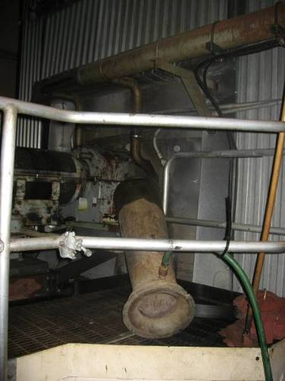
Photo 7. The plant blows air to the bearing to keep it from overheating.

Outcome and Follow-up
In response, the plant clarified that the outboard seal on the re-circ fan failed and not the bearing. The defective seal allowed hot flue gas to leak out. The plant, therefore, placed an air blower to disperse the heat to mitigate burn risks hazards. Subsequently on October 29, 2008, the plant repaired the outboard fan seal via Work Order #08-282124. No further corrective action is required.

Finding 2.11 – The plant delayed repairs on asbestos-laden insulation.

The plant delayed repairs on asbestos-laden insulation, which violates operation and maintenance standards. Asbestos is resistant to heat and is often used in pipe insulation. Asbestos insulation was exposed at a valve on Unit 4. Workers who inhale asbestos face an increased risk of cancer. Also, broken insulation poses burn-risk hazards to operators who walk the area routinely to inspect the unit.

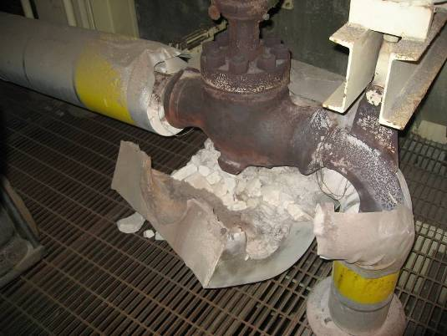
Photo 8. Asbestos insulation exposed at a valve on Unit 4.

Outcome and Follow-up
In response, the plant hired an insulation contractor to analyze the insulation for asbestos. The result was negative and the plant provided a copy of the analysis. To mitigate burn risk hazards, the plant repaired the broken insulation. No further corrective action is required.

(Before) (After)
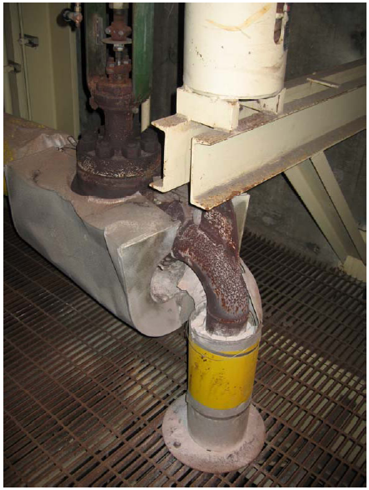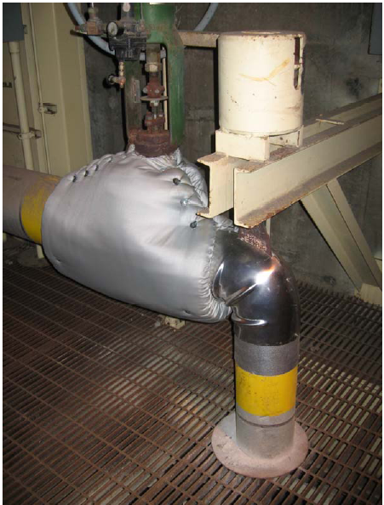

Finding 2.12 – The plant delayed high-priority corrective repairs.

The plant delayed high-priority corrective repairs, violating operation and maintenance standards. Corrective repairs are repairs ordered after something has already failed. Delaying corrective repairs, especially those of high-priority, can inflict more damage and result in longer outages. At the time of the audit, the plant had 266 pending corrective repairs. Three of them were of highest priority and were three months overdue at the time:

- Work Order # CB1C119045 reported an oil leak from a boiler-feed-pump throttle valve. Although the work order stated that “oil was dripping onto hot piping causing an extremely high risk of fire”, the leakage posed no immediate fire hazard because the oil leak is slow (about one drop per second) and that the plant has temporarily installed metal sheeting which redirects the oil away from hot surfaces. Nevertheless, the plant has delayed this repair and the plant must repair the leak before it gets worse.

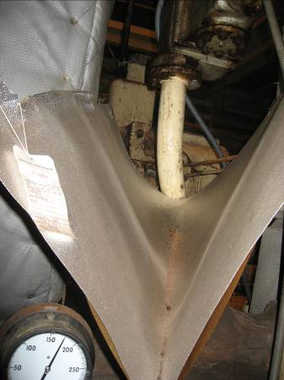
Photo 9. The plant temporarily installed metal sheeting which redirects oil drips away from hot surfaces.

- Work Order # CB1C119011 reported a broken Hankison RefrigiFilter. This equipment removes moisture from the air that the plant uses to control pneumatic instruments. Moist air can cause instruments to malfunction and affect the plant’s operation.
- Work Order # CB1C117554 reported a defective flood-chamber valve. The defective valve has caused large water puddle to form on the ground near Site Column 20A. Water puddle is a breeding ground for algae and poses slip-and-fall hazards for workers who walk the area to routinely inspect equipment.

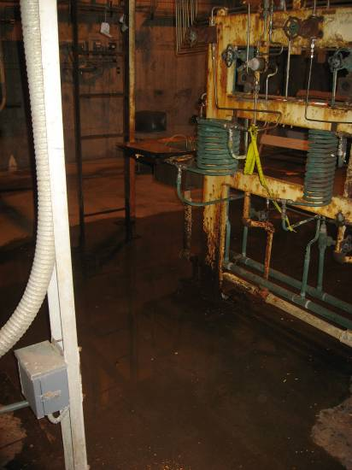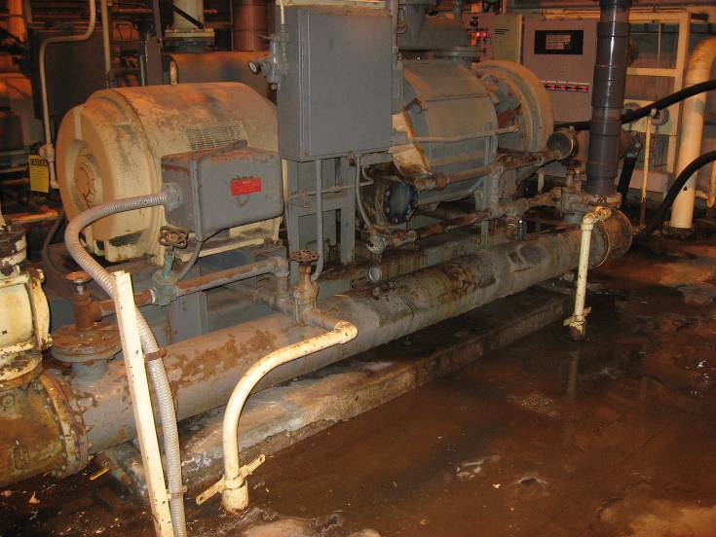
Photo 10 and 11. A defective chamber valve causes large water puddle to form on the ground near Site Column 20A.

Outcome and Follow-up
In response, the plant explained that the three work orders cited were not fix-it-now (FIN) repairs because the deficiencies posed no imminent safety hazards. To the contrary, operators entered the work orders and designated them a priority five, the highest priority in the work order system. If the repairs were not urgent, as the plant explained, then the plant needs to retrain its operators to distinguish FIN repairs from non-urgent repairs so that they will correctly prioritize work orders in the system. Proper work order priorities enable the plant to allocate resources in the most effective manner.

At CPSD's request, the plant retrained its staff on work order priority. The plant conducted training in June 2010. All personnel who enters, prioritizes, and approves work orders attended the training. The plant provided a presentation and an attendance report for the training. CPSD requires no further corrective action.

Finding 2.13 – The plant lacks a knowledge retention program.

The plant lacks a knowledge retention program, which violates operation and maintenance standards. Such a program would collect what is sometimes called “Tribal knowledge”, undocumented processes, procedures, and expertise that an organization develops over time. Many of Encina’s senior staff worked for SDG&E and will retire in the near future. Unless Encina develops a program to retain and transfer tribal knowledge to other staff, upcoming retirements may affect the plant’s operation.

Outcome and Follow-up
In response, the plant submitted a spreadsheet that projects Encina’s staffing needs through 2011. The spreadsheet shows that in 2007 the plant filled six “transition positions”. Transition positions are positions filled early on so new employees can transition into their new roles as they replace outgoing employees. While the plant anticipates retirements and actively fills transition positions, auditors found no evidence that the plant has a knowledge retention program or strategy, such as mentorship, knowledge transfer training, or exit interviews. CPSD believes the plant benefits if it develops a program to retain critical and undocumented knowledge before an exodus of veteran employees.

At the meet-and-confer meeting, the plant explained that knowledge retention is only critical for positions in operations and instrumentation and control. In that regards, the plant has an extensive training and certification program for those positions. Operators are classified into one of four different skill levels (OMT-1 to OMT-4). At each level, an operator attends training classes, mentors with an experienced operator, takes written and hands-on performance tests. Upon successful completion, the O&M Manager has to approve before an operator progresses to the next skill level. At the top level, OMT-4 operators are often involved in many levels of work processes, such as creating checklists and work procedures to capture institutional knowledge. The plant briefed auditors on its operator training and certification process and provided a current training status of its operators. CPSD requires no further corrective action.

Finding 2.14 – The plant failed to post evacuation maps and signs throughout the facility.

The plant failed to post adequate maps and signs, a violation of operation standards. Although the plant maintains a thorough evacuation procedure and identifies its assembly areas clearly, the plant failed to post maps of evacuation routes and assembly areas. Contractors or new employees who are unfamiliar with the plant’s layout may become disoriented in emergencies and face unnecessary safety risks. Assembling such workers may slow the plant’s response to the emergency.

Outcome and Follow-up
In response, the plant posted evacuation maps and added additional exit signage. Additionally, the plant marked exit pathways with luminescent tape (See Photo 12). The plant also placed warning signs at doors and stairways that are not exit paths. The plant notes that it already discusses emergency exit procedures with contractors during its pre-outage safety orientation. No further corrective action is required.

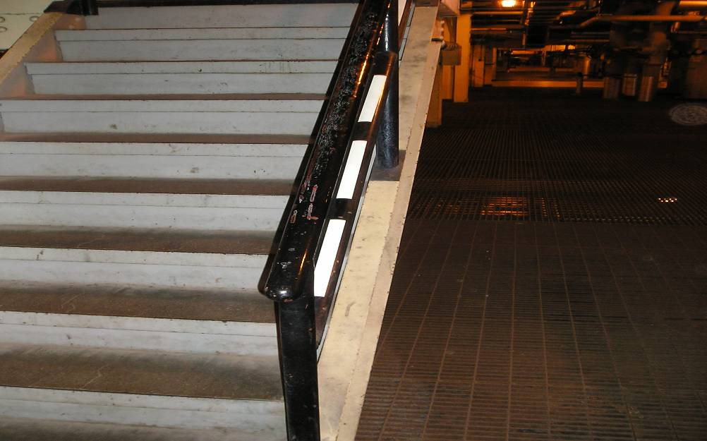
Photo 12. The plant marked this exit stairwell with luminescent tape.

Finding 2.15 – The plant failed to maintain an attendance list at one of the assembly areas.

The plant failed to maintain an attendance list at one of the assembly areas, a violation of operation standards. In an evacuation, plant staff gathers at one of three assembly areas. The safety manager uses the attendance list at the assembly area to take roll call. Without an attendance list, the safety manager cannot accurately account for onsite staff. This slows the plant’s response to the emergency.

Outcome and Follow-up
In response, the plant stated that on September 25, 2008 it held an evacuation drill, at which time it verified that each assembly areas had attendance sheets in place. In addition, the plant grouped these attendance sheets based on job classification in order to facilitate checking attendance during an evacuation. The plant explained that the security guard keeps a real-time list of all staff and visitors on site. During an evacuation, the safety manager at each assembly areas takes roll call on an attendance sheet, and then brings these sheets to the guard’s station to reconcile with the real-time list. In July 2009, the plant updated all attendance lists at each of the assembly areas. CPSD asked and the plant created a recurring work order to update the attendance list on a regular basis. No further corrective action is required.

Finding 2.16 – The plant failed to label critical system components.

The plant failed to label critical system components, a violation of operation standards. In particular, the plant did not label feed-water heaters for Units 1 and 2 that are near each other. Without clear signage, operators can mistake one unit’s heater for another’s, leading to maintenance or operational errors, reducing the plant’s reliability and safety.

Outcome and Follow-up
In response, the plant stated that it has started labeling critical system components. The plant has already labeled about 72% of all valves in all units. The plant’s goal is label all critical control, isolation, and pressure relief valves. The plant has also labeled about 50% of its feedwater system components, which include feedwater heaters.

At the meet-and-confer meeting, the plant stated that it has labeled about 84% of all valves in all units. For its feedwater system, labeling is about 80% complete. The plant has committed to complete all labeling by December 2010. CPSD asks that by April 13, 2011, the plant reports on the progress of its labeling effort.

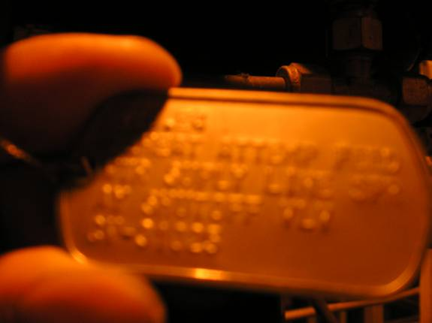
Photo 13. A metal valve tag on an attemperator.

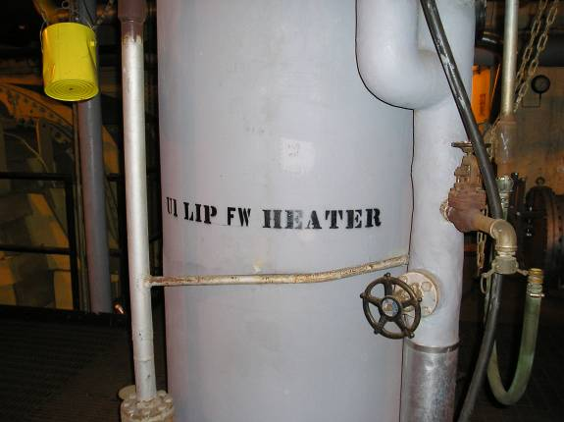
Photo 14. The plant labeled Unit 1’s feedwater heater.

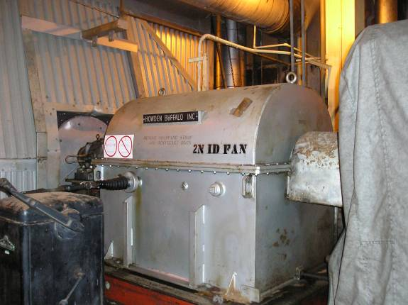
Photo 15. The plant labeled Unit 2’s induced draft fan motor.

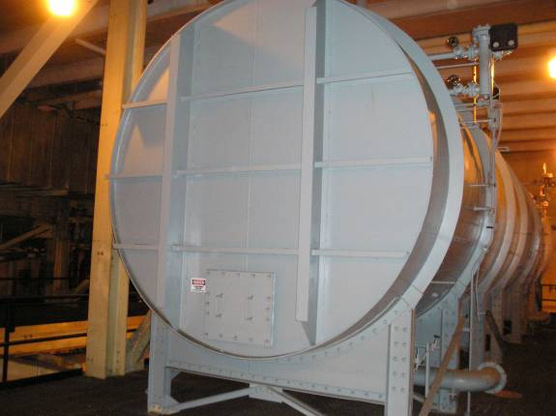
Photo 16. Unit 1’s condensate storage tank to be labeled.
Section 3 – Observations

Observation 3.1 – The plant follows a strict process to select and qualify contractors.

The plant maintains a list of qualified suppliers and contractors. The plant contracts only with firms on this list. The plant adds new suppliers to the list only after a strict qualification process.

The plant uses a web-based program called “Ariba” to pre-qualify suppliers. Potential suppliers answer an extensive list of questions, concerning the company’s experience, qualification and employees’ certification. The plant also looks at the company’s Experience Modification Rating (EMR) to determine the company’s safety history. EMR measures how many claims a company has filed for workers’ compensation, and compares that number to those of similar companies. A lower EMR means a company has had fewer accidents.

Once a potential supplier completes the questionnaire, the plant’s safety manager must review and approve it before the plant can award the supplier a contract. An auditor reviewed the completed questionnaire of Total Western, a company contracted to provide repair service to Encina. The questionnaire conformed to the plant’s qualification process.

Observation 3.2 – The plant requires contractors to complete a contractor safety notice before they can start work.

Before contractors can start work, the plant requires them to fill out a 31-page contractor safety notice. The plant issues contractors this notice at the pre-job briefing, held before the contractor commences work on the first day. The contractor must read the notice and initial each section to acknowledge that he or she understands it. At this time, the plant also discusses with the contractor any specific safety issues that relates to the job at hand. The contractor receives a copy of the notice while the plant keeps the original on-file. An auditor reviewed the contractor safety notices of three companies and found them consistent with the process.

Observation 3.3 – The plant uses checklists for routine inspection.

The plant uses checklists for routine inspection. An auditor walked-down Unit 4 alongside an operator. While the operator did not carry a checklist with him, he did have a note pad to write down any deficiencies he observed. After the walk-down, the operator returned to the control room where he filled out a checklist and filed it away in the shift supervisor’s office. The auditor reviewed several completed checklists, which conformed to the routine inspection. However during the walk-down, the auditor saw several equipment defects. See Findings 2.9, 2.10, and 2.11.

Observation 3.4 – The plant maintains a logbook compliance document onsite.

General Order 167 Section 5.6 requires plants to maintain onsite a logbook compliance document. This document explains how and where plants record their logbook data. An auditor reviewed Encina’s operators’ log manual, which met the requirement of GO 167. The auditor also reviewed a copy of an actual log which conformed to the plant’s log manual.

Observation 3.5 – The plant implements a lock-out tag-out program.

The plant uses a lock-out tag-out program and follows a strict clearance procedure. If a piece of equipment needs repair, the plant not only tags and de-energizes it, but it also locks it such that the equipment stays electrically isolated. This prevents someone from accidentally turning the equipment on while a worker repairs it. Under this program, only the technician in charge of the repair can take the equipment out-of-service, and only the person who placed the lock can remove it. If the person who placed the lock is absent, only the shift supervisor can override his or her authority and remove the lock. The plant has a shack where it keeps all the locks and binders that track all active clearances. The plant also trains its staff on the clearance procedure regularly.

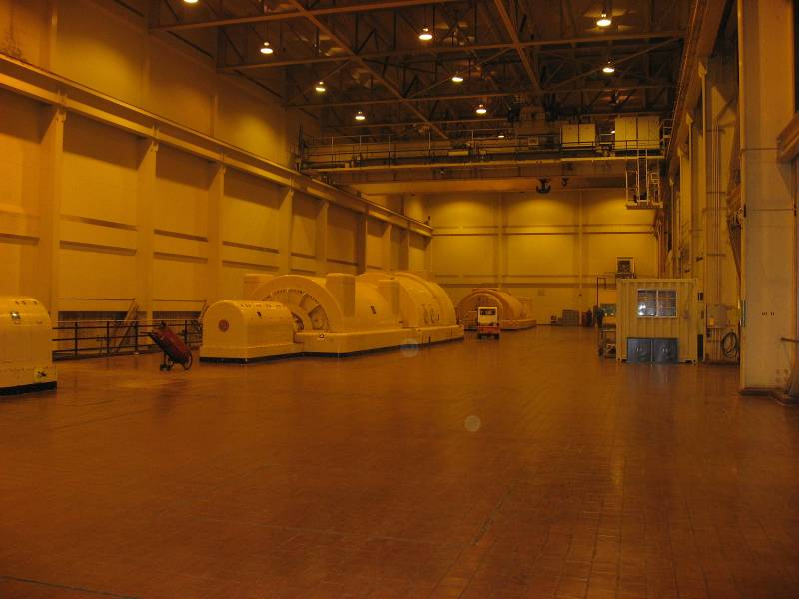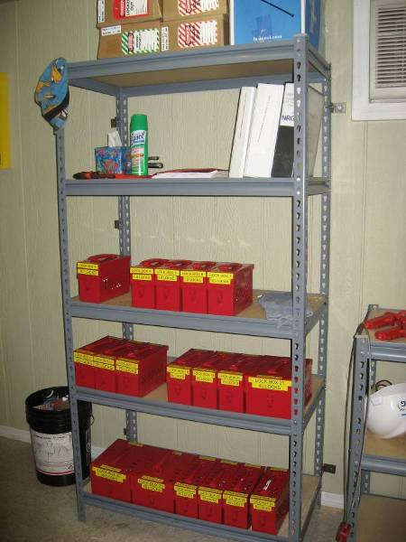
Photo 17 and 18. On the turbine deck, the plant has a shack where it keeps its locks and binders that track all active clearances.

Observation 3.6 – The plant conducts evacuation drills regularly.

The plant conducts evacuation drills regularly. The plant conducts two evacuation drills annually. The plant seeks continuous improvements by evaluating every drill. An auditor reviewed drill evaluations and verified that the plant conducted at least two drills in each of the last two years. The evaluations stated that all staff was accounted for in each of the drills and did not note any deficiencies.

Observation 3.7 – The plant keeps its facility orderly and clean.

The plant keeps its facility orderly and clean. The plant is clean, particularly inside the power plant building. The plant stores unused equipment properly; secured and away from walk-aisles. During the plant tour, an auditor saw the shift supervisor repeatedly picking up and properly disposing trash and debris.

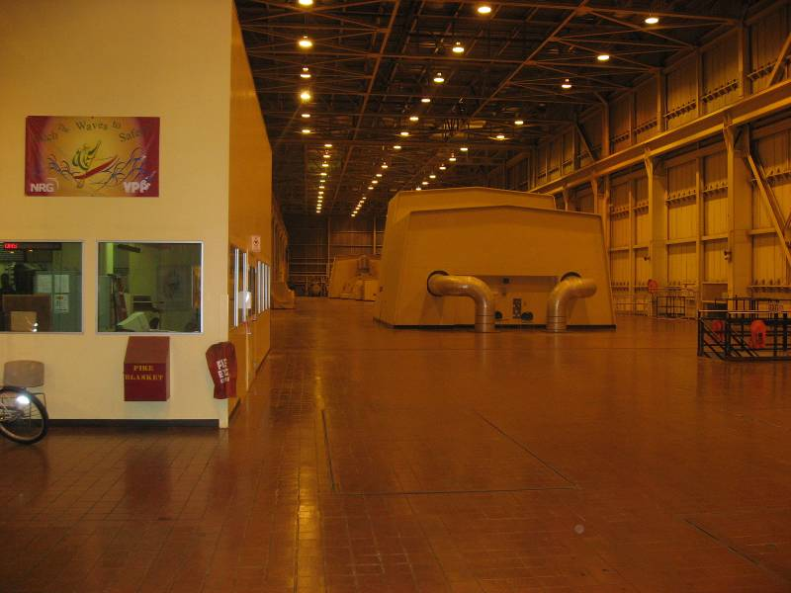
Photo 19. The plant keeps the turbine deck clean and orderly.

Observation 3.8 – The plant maintains its cathodic protection system.

The plant inspects and maintains its cathodic protection system regularly. A cathodic protection system prevents underground pipes from corrosion, particularly cooling water pipes. It works by applying an electric current to an anode on the pipe. This forces the anode to corrode rather than the pipe. As such, the anode is called a “sacrificial” anode. Once the anode corrodes completely, the plant must replace it with a new anode in order to continue to protect the pipe. If the plant does not upkeep its cathodic protection equipment, underground pipes will corrode rapidly and will eventually fail.

An auditor reviewed the cathodic protection report for 2003, and for 2005 through 2008. In each of these years, the plant hired a specialist (Norton Corrosion) to inspect its cathodic protection systems on all five units. The specialist inspected the rectifiers, anodes and reference cells on the traveling screens, condenser waterboxes, and cooling water pipes.

The plant repaired all defects found by the inspections. For example, the 2003 inspection report lists several defective anodes and reference cells. The 2005 report indicates that the plant had replaced these items. The most recent report, completed in June 2008, lists several defective parts. The plant has created work orders to repair them.
Observation 3.9 – The plant is well-staffed in a number of areas.

The plant has staff in the operational, maintenance, and technical area. The plant employs six engineers, five planners, and has dedicated trainers, environmental and safety specialists. Twenty-five Total Western maintenance staff, including a foreman, work full-time at the plant. The plant employs a full-time chemist and a document-control clerk. During each shift, a supervisor directs the work of a staff of three for each pair of units: a control operator, assistant control operator, and an auxiliary operator.

Observation 3.10 – The plant verifies contract employees’ qualifications.

The plant verifies contract employees’ qualifications. The plant employs 25 contract employees who work for Total Western. These employees work full time onsite. The plant relies on them for many of its maintenance and repairs. While contract employees get their training from Total Western, the plant does due-diligence to verify whether the training actually took place. For example, contract employees clean the traveling screens regularly. The plant keeps a record that shows who received the proper training and, therefore, can do the job. Additionally, the plant checks to ensure contract employees are competent to do their jobs. For example, Total Western has welders whose welding skills meet American Society of Mechanical Engineers (ASME) specifications. The plant verifies the welders’ certification before it allows the welders to weld.

Observation 3.11 – The plant inspects its cranes and forklifts regularly.

The plant inspects its cranes and forklifts and maintains records of those inspections. An auditor selected two records at random and verified that the plant has inspected its cranes and forklifts within the last year.

Observation 3.12 – The plant controls and updates its equipment diagrams.

The plant manages its equipment diagrams and has a well-defined process to update them. The plant stores its drawings and schematics at one central location and assigns a clerk to manage them. The room has copiers and plotters so staff can make copies of drawings and not take the originals away. The plant keeps those drawings electronically, but also maintains a set of hardcopies. The plant keeps its drawings organized and maintains a catalog of those drawings.

The plant has a well-defined process to update its drawings. If the plant upgrades or replaces a piece of equipment, it also updates its drawing to reflect the changes. The plant maintains two sets of drawings. It keeps a set of “as-built” master drawings and a set of “working” drawings. If new equipment or an upgrade changes the plant’s configuration, technicians make the necessary changes on the “working” drawings. Engineers must review and approve the changes before the technician can replace the “as-built” masters with the new drawings.

The plant keeps its drawings organized and maintains a catalog of those drawings. The plant catalogs its “as-built” drawings both electronically and on paper. The drawings themselves are also available electronically and on paper. An auditor asked to see the drawing of Unit 4’s cathodic protection system. The clerk and the engineer searched the two cataloging systems at the same time, and within seconds they both located the electronic and hard-copy drawing.

The term “violation” as used in CPSD’s Final Audit Report refers to conditions or events where auditors determined that the facility failed to meet G.O. 167 standards. Identification of conditions or events as “violations” in this Final Audit Report does not constitute a formal determination of a G.O. 167 violation by the CPUC. A definitive finding of a G.O. 167 violation requires a formal Commission enforcement proceeding.
Unless specified otherwise, CPSD auditors made these findings based on plant conditions at the time of the site visit, and information obtained pursuant to data requests. Actual plant conditions may have changed since the time of the site visit.
CAISO SLIC Database pMAX values
Analog systems use hydraulic or compressed air controls. Digital systems are electronic.
Docket Number 07-AFC-06 (Application for Certification)
RMR stands for Reliability-Must-Run. Where demand within a local area exceeds the transmission capacity into that area, the CAISO signs RMR contracts with one or more generators in the area to assure that power is available at reasonable prices.
NERC is a self-regulatory agency which develops and enforces standards to ensure that the North America power system remains reliable. The agency also maintains the GADS database which it developed in 1982. The GADS database stores operating data that participating power plants submit voluntarily. However, the CPUC’s GO 167 makes GADS participation mandatory for California power plants.
Operation Standard 27: Flow Assisted Corrosion; Guidelines A, B, C & D
Erosion-corrosion occurs when a metal surface erodes and corrodes at the same time. First, a pipe surface’s protective oxide layer (called “magnetite”) breaks down. This allows the pipe surface to corrode. As it corrodes, a fast-moving fluid carries away rusts and erodes the pipe. This exposes the pipe surface and allows it to corrode further. And the self-sustaining process continues.
Per ASME Power Piping Code B31.1
PEC Examination for FAC at the NRG Cabrillo Power Plant, Carlsbad, CA dated April 24, 2010
Maintenance Standard 7: Balance of Maintenance Approach; Guidelines A & L Maintenance Standard 9: Conduct of Maintenance; Guideline H
APTECH report dated June 2008
Creep occurs when a metal slowly deforms when exposed to prolong periods of stress and heat.
Equivalent operating hours differ from actual operating hours because it takes into account how many start/stop cycle a unit goes through, the amount of time a unit spends over-firing, and other factors which shorten a unit’s service life.
Operation & Maintenance Standard 1: Safety; Guideline C3.
Work Order 09-21031, Purchase Requisition MX140118, PO # 66405, and Vendor Invoice #161709.
Fyrquel® Electro-Hydraulic Control Fluids are phosphate ester based fire-resistant fluids formulated with trixylenyl and or butylated phenyl phosphates. The fluids are in the class of “non aqueous hydraulic fluids” sometimes referred to as “synthetic fire resistant fluids”.
National Fire Protection Association (NFPA) 850. Recommended Practice for Fire Protection for Electric Generating Plants and High Voltage Direct Current Converter Stations.
Operation Standard 20: Preparedness for On-Site and Off-Site Emergencies; Guidelines A-E
Operator Instruction Manual, Instruction 820.10.1.5, dated September 29, 2009.
Maintenance Standard 8: Maintenance Procedures and Documentation; Guideline H
Directive No. – OPO – 207 dated July 7, 2008
Operation Standard 4: Problem Resolution and Continuing Improvement; Guideline B
Operation Standard 8: Plant Status and Configuration; Guideline A1
The SCR system injects ammonia into the flue gas stream. The mixture passes through and reacts with catalysts to reduce Nitrogen Oxide. The plant relies on this system to comply with air emission limits.
Operation Standard 12: Operations Conduct; Guidelines A-E
NRG Cabrillo Power Operations Inc, Operator Instruction Manual, Gas Turbine – Test of Black Start Capabilities
Maintenance Standard 7: Balance of Maintenance Approach; Guidelines A & L Maintenance Standard 9: Conduct of Maintenance; Guideline H
ASTM (American Society for Testing and Materials) D4541 - 09 Standard Test Method for Pull-Off Strength of Coatings Using Portable Adhesion Testers. According to their website, “ASTM International is one of the largest voluntary standards development organizations in the world-a trusted source for technical standards for materials, products, systems, and services.”
The work order (WO) numbers for the tunnel cleanings are as follows: Units 1-3 WO#09-5790, Unit 4 WO#09-38067 and Unit 5 WO#09-71843
Maintenance Standard 7: Balance of Maintenance Approach; Guidelines A & L Maintenance Standard 9: Conduct of Maintenance; Guideline H
Operation & Maintenance Standard 1: Safety; Guidelines A2 & C3
Operation & Maintenance Standard 1: Safety; Guidelines A1 & C3 Maintenance Standard 7: Balance of Maintenance Approach; Guidelines A & L
Corrective Maintenance (CM) Work Order Backlog Report dated 8/15/08
Operation Standard 3: Operations Management and Leadership; Guideline C1 Operation Standard 4: Problem Resolution and Continuing Improvement; Guideline C Maintenance Standard 3: Maintenance Management and Leadership; Guideline C1
Four auxiliary operators and two shift supervisors
Operation Standard 20: Preparedness for On-Site and Off-Site Emergencies
Operation Standard 20: Preparedness for On-Site and Off-Site Emergencies
Operation Standard 5: Operations Personnel Knowledge and Skills; Guideline D
Contractor safety notice for Preferred Piping, dated 12/19/07, to repair #3 basement air compressor Contractor safety notice for Laser Electric, dated 12/18/07, to maintain office’s air conditioning unit Contractor safety notice for Vortex, dated 12/17/07, to inspect crane at circulating water deck
NRG Cabrillo Basement Log Sheet Units 1, 2, and 3 NRG Cabrillo Sub-basement Log Sheet Units 4 and 5 NRG Cabrillo Unit 1, 2, and 3 Boiler Casing Leak Inspection Log NRG Cabrillo Unit 4 and 5 Boiler Casing Leak Inspection Log
Unit 5’s control operator’s log dated 8/4/08
Norton Corrosion Limited – Cathodic Protection Annual Survey for 2003, 2005, 2006, 2007, and 2008
A rectifier converts AC voltage to DC voltage for the impressed current. Reference cells provide a known voltage level and are used in testing.
Traveling screens filter the intake cooling water for the condensers. The condenser waterbox is where the cooling water enters the condenser to cool the steam from the turbine.
U5 – East Reference Cell #2 South pipe, Reference Cell #4 North pipe, U5 – West Anodes 21, 22, 23 & 24 North pipe
WO# 08-335468, #08-335462, and #08-335472
Project # 13-7972, Drawing E-101, Revision C. “Condenser Cathodic Protection Conduit Run and Wiring Diagram”

