PUBLIC UTILITIES COMMISSION OF THE STATE OF CALIFORNIA

Communications Division RESOLUTION T-17258
Carrier Oversight and Programs Branch May 05, 2011

R E S O L U T I O N

RESOLUTION T-17258. This Resolution grants the request of Nexus Communications, Inc. (U-4387-C) to be designated as an Eligible Telecommunications Carrier providing only Federal LifeLine and Link Up services within the service areas of Verizon California and AT&T California. The request is reasonable because Nexus complied with the requirements of Resolution T-17002, applicable requirements of General Order 153 and applicable requirements for a CPUC registered carrier.

SUMMARY

By this Resolution, the California Public Utilities Commission (CPUC or Commission) grants the request of Nexus Communications, Inc. (U-4387-C) (Nexus) to be designated as an Eligible Telecommunications Carrier (ETC) for the limited purpose of offering Federal LifeLine and Link Up services to qualifying customers in the Verizon California (Verizon) and AT&T California (AT&T) service areas. Nexus’ request is consistent with the Resolution T- 17002, applicable requirements of General Order (G.O.) 153, and applicable requirements for CPUC certificated and registered carrier. We find that the request is reasonable and consistent with the public interest, and should be granted.

BACKGROUND

In Resolution T-17002, the Commission adopted The Comprehensive Procedures and Guidelines for ETC Designation and Requirements for ETCs. This Resolution is consistent with the Federal Communications Commission (FCC) Orders 97-157 and 05-46 regarding designation of a telephone carrier as a qualified ETC. In addition, all carriers seeking ETC designation are required to comply with the applicable requirements for a CPUC certificated or registered carrier.

ETCs are telephone carriers designated by state commissions or the FCC and authorized by the FCC to receive Federal Universal Service Fund (USF) support for providing local telephone service in high cost areas and to low income customers.

The FCC established the ETC program to satisfy this statutory requirement of the Telecommunications Act of 1996. The Federal USF support creates an incentive for the telephone carriers to provide quality residential telephone services at an affordable rate to low income consumers and/or those living in designated high cost areas, e.g., rural areas.

In addition to reviewing ETC designation requests for compliance with the Federal and Commission ETC requirements, the Communications Division (CD) staff reviews the requests for compliance with CPUC LifeLine rules contained in G.O. 153 and Decision (D.) 10-11-033, and other state regulatory requirements for telephone corporations operating in California, including but not limited to paying Public Purpose Program (PPP) surcharges and user fees, and submitting required reports.

G.O. 153 implements the Moore Universal Telephone Service Act, and contains California LifeLine service requirements for wireline carriers offering basic residential telephone service in California, including twenty-two basic elements of LifeLine service that carriers must provide. A list of the LifeLine basic service elements is included in Attachment B of this Resolution. CD staff has applied the provisions of G.O. 153 in its evaluation of Nexus’ ETC designation request. These provisions will have no bearing on California Lifeline offerings. CD recommends that until the Commission adopts California LifeLine rules for wireless service providers in Phase II of Rulemaking (R.) 06-05-028 and/or R.09-06-019. Nexus’ federal LifeLine offerings must comply with G.O. 153. Once the CPUC adopts basic service rules for the offering of wireless LifeLine in California, wireless ETCs, including Nexus, must comply with those rules.

On November 19, 2010, the Commission adopted D. 10-11-033, which made changes to the California LifeLine program. Among other things, the decision allowed California LifeLine customers to choose alternative/non-traditional providers, such as wireless and VoIP, for California LifeLine service and adopted minimum price floors for California LifeLine offerings.

Nexus, a facilities-based wireless service provider, is an Ohio based corporation, with principal offices at 3629 Cleveland Ave., Suite C, Columbus, Ohio, 43223. On March 20, 2009, the Commission issued Nexus its Wireless Registration Identification (WRI) U-4387-C and allowed it to operate as a reseller of Commercial Mobile Radiotelephone Service (CMRS) to the public in California. (See Attachment C of this Resolution for a copy of this authorization.)

On January 25, 2011, the Commission distributed a draft of this Resolution for the required 30-day comment period to the Nexus Service List, utilities and other interested parties. However, on the same day, Nexus filed Advice Letter (AL) supplement 1B and subsequently AL supplement 1C (filed on February 17, 2011). CD withdrew the draft Resolution from the Commission meeting agenda to accommodate these supplemental filings and incorporate the additional information to this Resolution. Comments were received on the first draft Resolution which denied Nexus’ request. The Opening Comments Nexus filed, and the Reply comments filed jointly by the Small LECS and Nexus, also have been integrated in the Discussion section of this Resolution.

In addition, after the release of the first draft Resolution, CD staff discovered that Nexus had not complied with its reporting obligation for PPP surcharges and user fees. CD notified Nexus of this deficiency and requested that Nexus correct this error. Nexus corrected the deficiencies and is now compliant with its reporting obligation for surcharge and user fee remittance. Nexus shall continue to comply with Commission rules, including the payment of PPP surcharges and user fees. Failure to do so may result in revocation of its WRI and ETC designation in California.

SUBJECT OF ADVICE LETTER/FILING

On June 3, 2009, Nexus filed a Tier III AL 1, requesting limited ETC status, for the purpose of offering Federal LifeLine and Link Up services to qualifying California customers in the service areas of Verizon California (Verizon) and AT&T California (AT&T)(see Attachment H of this Resolution for the Service Area Map). Nexus is not seeking Federal High-Cost Fund Support and California State Universal Service Support. In AL 1, Nexus proposed to offer LifeLine customers a free wireless handset, 50 free anytime rollover minutes, with minutes exceeding 50 priced at $0.20 per minute through airtime cards costing $5.00, $10.00, or $20.00. All cards would be depleted at $0.20 per minute. Customers would be also charged a $42.00 activation fee after subtracting the $30.00 Link Up subsidy. This offering would include Caller ID and Call Waiting.

On October 20, 2010, Nexus filed AL supplement 1A to provide information on its modified LifeLine offerings. These new offerings range from 68 free minutes per month to a 500 minute per month for $5.00 offering. Additionally, the revised offerings included text messaging capabilities, voice mail, and refillable airtime cards in $3.00, $5.00, $10.00, $20.00, $30.00 and $50.00 denominations, with calls now priced at $0.10 per minute. The LifeLine activation charge remained at $42.00.

On January 25, 2011, Nexus filed AL supplement 1B to include an additional service plan that will be offered to customers as part of its ETC designation request in California. This plan provides 1000 anytime minutes (or 1000 text messages) for $20.00 and includes the following features: 1) Caller ID, Call Waiting, and free voicemail; 2) a free handset; 3) expanded local calling area; 4) no credit check, deposit, or contract; 5) no customer bills or termination fees; and 6) Taxes are included. Cost per additional minute is $0.10.

On February 9, 2011, Nexus filed its opening comments to the draft Resolution that contained a revision to its proposed Federal LifeLine service offerings. Originally, CD staff concluded that that none of the proposed Federal LifeLine service offerings were comparable to the Incumbent Local Exchange Carriers (ILEC) that is a requirement for ETC designation established in Resolution T-17002. Therefore, the proposed federal LifeLine service offerings that did not meet the requirements for local usage are excluded from the discussion in this Resolution. The newly proposed Federal LifeLine service offerings are analyzed for comparable local usage in the Discussion section of this Resolution. The following summarizes Nexus’ three proposed Federal LifeLine service offerings for California:

(1) 250 minutes for $2.50 per month;
- Free wireless handset;
- Minutes are anytime minutes that can be used for domestic calls including local or intrastate/interstate long distance calls;
- Unused Minutes are not carried over to the following month;
- Text messages are available at the rate of one text per minute of airtime;
- Caller ID, Call Waiting, and voicemail are available;
- Activation charge of $42.00.

(2) 500 minutes for $5.00 per month
- Free wireless handset;
- Minutes are anytime minutes that can be used for domestic calls including local or intrastate/interstate long distance calls;
- Unused minutes are not carried over to the following month;
- Text messages are available at the rate of one text per minute of airtime;
- Caller ID, Call Waiting, and voicemail are available;
- Activation charge of $42.00

(3) 1000 minutes (or 1000 Text Messages) for $20.00
- Free Wireless handset;
- Minutes are anytime minutes that can be used for domestic calls including local or intrastate/interstate long distance calls;
- Unused minutes are not carried over to the following month;
- Text messages are available at the rate of one text per minute of airtime;
- Caller ID, Call Waiting, and voicemail are available;
- Activation Charge of $42.00

The three proposed Federal LifeLine service offerings listed above have the ability to add minutes of airtime by purchasing $3, $5, $10, $20, $30 and $50 denominations with the airtime rate of $0.033 per minute.

On February 17, 2011, Nexus filed AL supplement 1C to provide the Commission with the service area map identifying the areas that Nexus plan to offer services in the Verizon and AT&T service area.

On March 25, 2011, Nexus filed AL supplement 1D to provide the Commission a list of Verizon California exchanges where Nexus would offer service upon approval of its ETC request.

NOTICE/PROTEST

In compliance with G.O. 96-B, Nexus’s AL 1 and supplements 1A, 1B, 1C and 1D were posted on the CPUC Daily Calendar on June 8, 2009, October 27, 2010, January 26, 2011, February 22, 2011, and March 30, 2011, respectively. AL supplements 1B, 1C and 1D were also served via email to the draft Resolution service list.

On June 22, 2009 and November 9, 2010, the Small LECs filed timely protests to Nexus AL 1 and supplement 1A, respectively. The Small LECs argue that Nexus should not be designated as a LifeLine-only ETC, because Nexus does not offer local service comparable to the service offered by incumbent ETCs. The Small LECs also claim that Nexus cannot be granted ETC status until it shows how it will exclude LifeLine subsidies to customers in Small LEC territories.

The Small LECs further state that the Commission should defer consideration of Nexus’ ETC designation, until the pending reforms to the California LifeLine program have been fully considered. Finally, the Small LECs claim that Nexus should be required to comply with the certification and verification requirements of GO 153, as well as with eligibility verification based upon Zip code.

DISCUSSION

In order for the Commission to grant Nexus’ request to be designated as an ETC, Nexus has to satisfy the requirements for designation as an ETC pursuant to Resolution T-17002, The Comprehensive Procedures and Guidelines for ETC Designation. Nexus’ ALs provided information required in Appendix A of Resolution T-17002. Nexus only seeks to participate in the Federal LifeLine and Link Up program and does not intend to draw from the Federal High Cost Fund program and therefore, is not required to meet the requirements contained in Appendix A: Section II-B: Two-Year Service Quality Improvement Plan, and in Appendix B: Comprehensive Reporting Requirements for ETCs to receive Federal High Cost Support to Resolution T-17002.

CD staff has reviewed Nexus’ AL and supplements and had determined that Nexus’ has satisfied the applicable requirements in Resolution T-17002 regarding ETC designation for Federal LifeLine and Link Up support.

Nexus’ offers the services designated by the FCC in the service areas it plans to be eligible to receive Federal LifeLine and Link Up support. Nexus will provide these services using a combination of its facilities and resale of another carrier’s services. These services include:

- Single party service;
- Voice grade access to the public switched network;
- Local usage;
- Dual tone multi-frequency signaling or its functional equivalent;
- Access to emergency services;
- Access to operator services;
- Access to interexchange services;
- Access to directory assistance; and
- Toll limitation for qualifying low-income consumers.

As a designated ETC, Nexus commits to use media of general distribution to comply with Appendix A: Section I –E of Resolution T-17002 and Title 47 C.F.R. Section 54.201, and will advertise the availability of the supported services to the general public within its designated ETC service areas; through the use of print ads, commercial radio, free publications, and point of purchase materials at retail outlets.

Attachment A to this Resolution is an evaluation of Nexus’ compliance with each of the Commission’s ETC and CPCN requirements.

Comparable Local Usage

The Small LECs argue that Nexus should not be designated as an ETC, because it does not offer local service comparable to the incumbent ETCs. They state first that the Nexus plan does not provide sufficient airtime to each household, and as a result the household could be left without services once the free minutes are used and that advanced features are not enough to make Nexus’ offerings comparable. Nexus responded by stating that the Federal rule of comparability is met by a carrier offering a choice of plans, which they provide. Nexus also stated that, since the Commission included advanced features in the Cricket Resolution, it places weight upon inclusion of such features in an ETC proposal.

Neither the CPUC nor the FCC has adopted minimum local usage standards or quantity of minutes to measure comparability. However, the FCC encourages state commissions to consider whether an ETC offers a local usage plan comparable to those offered by the incumbents in examining whether the ETC applicant provides adequate local usage to receive designation as an ETC. The FCC has not prevented states from determining the minimum number of local usage minutes for an applicant to be awarded ETC status.

Consequently, CD used G.O. 153 call allowance rules and D.10-11-033 pricing rules for Measured Rate (MR) LifeLine service as a baseline in evaluating Nexus’ request regarding the comparable local usage requirement. In Resolution T-17266, Ordering Paragraph (O.P.) 3, the Commission approved use of G.O. 153 for evaluating wireless carriers’ requests for ETC designation.

Pursuant to G.O. 153, wireline MR LifeLine customers are given a call allowance of 60 untimed outgoing calls. Calls in excess of the call allowance are priced at $.08 per call. D.10-11-033 adopted a price range for MR LifeLine service with a floor of $2.50 and a cap of $3.66 per month. Nexus proposes to offer three service plans to LifeLine customers, as identified in this Resolution. These plans are similar to wireline MR LifeLine service in that they provide a base level of usage for a set fee with additional charges for usage in excess of the base amount.
In evaluating wireless LifeLine plans that have similar characteristics to wireline MR service, CD deemed it appropriate to determine how many wireless minutes of use (MOU) a wireless MR LifeLine customer should receive using wireless industry average length of call data, and at what cost, based on G.O. 153 MR criteria and LifeLine MR service rates adopted in D.10-11-033.
For its analysis, CD used wireless MOU, average bill, and average revenue per MOU data for the six-month period ending December 31, 2008 from Table 19 of the FCC’s 14th Mobile Wireless Competition Report to Congress (14th Report) and data for the same period from the Cellular Telecommunications Industry Association’s (CTIA) Semi-Annual Wireless Industry Survey. CD used the 2008 data because the FCC data ended then, even though the CTIA data continued through the six-month period ending June 30, 2010. See Attachment D of this Resolution for summaries of the FCC and CTIA data used by CD.
In order to evaluate Nexus’ offerings on a consistent and comparable basis with G.O. 153 MR lifeline service requirements, CD used CTIA average call length data to convert the G.O. 153 MR per call allowance to the MOU unit of measure on which Nexus’ plans are based.
CD estimated the average number of MOU per month that a typical wireless customer would reasonably be expected to use for purposes of estimating what each of Nexus’ plans could cost a LifeLine customer with average call usage. CD estimated that a LifeLine customer with average monthly voice usage would use an average of 769 voice MOU per month for local calls. To arrive at this estimate, CD used data from the 14th Report, dividing the average local monthly bill (excluding data) by the average revenue for voice minute ($38.45/$0.05 = 769 MOU). (See Attachment E of this Resolution for pricing details.)
CD further estimated that a wireless LifeLine customer should get 146 wireless voice MOU’s per month as a basic monthly allowance, and calculated this amount by multiplying the average call length from the CTIA study, by the G.O. 153 call allowance (2.43 minutes*60 untimed calls = 146 MOU). Using these estimates, CD determined that a typical wireless LifeLine customer will use 623 MOU in excess of the estimate of the G.O. 153 MR calculated MOU monthly call allowance (769 average monthly voice MOU – 146 calculated MOU call allowance = 623 excess MOU). CD calculated the cost of each excess MOU to be $.033 ($.08 per call in excess of allowance/2.43 average minutes per call).
CD estimates that a wireless LifeLine plan that is consistent with G.O. 153 MR service requirements and D.10-11-033 MR pricing policies would cost a LifeLine customer between $23.07 [$2.50 allowance + ($.033*623 excess MOU)] and $24.23 [$3.66 allowance + ($.033*623 excess MOU)] per month for 769 local voice only MOU.
To determine if Nexus’ proposed Federal LifeLine service offerings are comparable to wireline MR LifeLine service, CD compared the cost to the customer of each of Nexus’ proposed service offerings priced using 769 monthly average local voice MOUs to the cost of MR LifeLine plans based on G.O. 153 and D.10-11-033 requirements with 769 average monthly MOUs.

Nexus’ proposed service offerings include free nationwide long distance, Caller I.D., Voice Mail, and Call Waiting in addition to local calling, for comparison purposes it is appropriate to consider what a LifeLine customer would pay under G.O. 153 for MR LifeLine service with these additional features. CD used the cost of ILEC packages that include the additional features contained in Nexus’ proposed service offerings to calculate the cost of G.O. 153/D.10-11-033 based MR LifeLine service and compared the results to the calculated cost of Nexus’ proposed service offerings using the 769 average local voice MOU.

CD concluded that the revised Nexus proposed Federal LifeLine service offerings are comparable to the ILECs MR LifeLine service. The table below shows a comparison of each service offering:

Table 1: Estimated Cost of Nexus’ Proposed Federal LifeLine Service Offerings
Compared to G.O. 153 Measured Rate Calculated Costs for 769 MOU****

 | Nexus 250 Minutes for $2.50 | Nexus 500 minutes for $5.00 | Nexus  1000 minute  for $20.00 | AT&T Estimate per G.O. 153 | Verizon Estimate per G.O. 153
LifeLine Plan Cost to Customer with 769** MOU | $19.63 | $13.88 | $20.00 | $23.07 to $24.23 | $23.07 to $24.23
Caller ID, Call Waiting, Long Distance, Voicemail and Tax Cost | $0 | $0 | $0 | $17.06 to $17.09*** | $31.47 to $31.50
Total Cost to LifeLine Customer for 769 MOU with additional features | $ 19.63 | $ 13.88 | $20.00 | $ 40.12 to $41.32* | $ 54.53 to $55.73*

* Price range reflects $2.50 LifeLine floor and $3.66 cap established in D. 10-11-033.
** 769 MOU reflects calculated average local wireless usage based upon FCC and CTIA Data.
*** CD could not find an AT&T package that contained all the elements Nexus has included in its packages. Neither AT&T nor Verizon packages include Call Waiting.
**** See Attachment G of this Resolution for calculation details.

The Small LECs raised their concern that free MOUs can be converted to texts under the Nexus proposals. They believe that a LifeLine plan should offer affordable access to emergency, essential non-emergency and government services. The Small LECs state that text messaging does not necessarily provide this access. Nexus responded to the Small LECs by stating that subscribers have access to emergency 911 services, regardless of the number of minutes they have or their activation status, and this allows them to meet the requirement s of 47 C.F.R. § 101 (a).

Federal rules (47 U.S.C. § 254 and 47 C.F.R. 54.101) identify services designated for LifeLine support, but do not prohibit a customer from choosing to utilize text as a MOU. The Commission does not have such a prohibition either. Because Nexus is offering Federal LifeLine service, CD does not believe that Nexus should be precluded from allowing customers to utilize text messaging as a MOU.

Finally, the Small LECs believe that Nexus’s activation charge is an area of concern, given that it is nearly six times more than Cricket’s activation charge after the Link Up credit has been applied. The Small LECs also believe that free Caller ID and Call Waiting are not sufficient to make Nexus’ offering comparable. They also assert that the poor service quality of wireless signals in rural areas actually undermines claims of comparability. Nexus responded by stating that CD included Caller ID and Call Waiting in the Cricket resolution, and therefore places weight on these custom calling features. Regarding the activation charge, Nexus argues that states are prohibited from regulating the rates of wireless carriers, and that Nexus offers an additional discount to customers in the amount of the remainder of the activation charge after applying Link Up support.

CD agrees that Caller ID and Call Waiting alone are not the measure of comparability; however these features should be considered as an element in the evaluation of the total LifeLine offering. The $42.00 activation charge of Nexus, though high, is not the basis for finding the offering incomparable. CD believes each customer can make a determination as to whether to pay this activation amount or seek a provider with a lower charge.

After reviewing the comments and reply comments of the Small LECs, Nexus, and CD’s analysis, the Commission agrees that all of Nexus’ proposed Federal LifeLine service plans provide comparable local usage to the ILECs. Also, Nexus’ proposed service offerings provide the LifeLine customers significant cost savings over the off-the-shelf retail wireless Nexus plans that are available and should be approved as Nexus’ proposed LifeLine offering in California. (See Attachment F for a comparison of LifeLine plans to the cost of retail wireless plans.)

Public Interest Determination

Before designating a carrier as an ETC, the Commission must determine that it is in the public interest. CD staff believes that Nexus has demonstrated that it would be in the public interest for the company to be designated as an ETC. Nexus has met the requirements in Appendix A: Section II - G: Public Interest Determination of Resolution T-17002 by the following: a) demonstrating the ETC designation will increase consumer choices; b) explaining the advantages and disadvantages of its service offerings; and c) showing the absence of cream skimming.

- The ETC designation will increase consumer choices

Nexus’ ETC designation will increase the available consumer choices for telecommunication services by providing wireless LifeLine service in areas that do not currently have wireless options.

- The advantages and disadvantages of its service offerings

CD staff recognizes that Nexus will gain certain advantages in being designated as an ETC. The designation of Nexus as an ETC allows consumers to receive Federal subsidized wireless service. The advantages of Nexus’ offerings outweigh the disadvantages. The advantages to Nexus’ offerings include the following features: (1) Caller ID, Call Waiting, and Voice mail; (2) receipt of a free handset; (3) expanded local calling area; (4) no credit check, deposit, or contract; (5) no customer bills or termination fees; and (6) telephone mobility.

The disadvantages of the wireless service include the potential that if the handset is removed from the home the customers will have poor mobile reception due to weather conditions, terrain, or gaps in service coverage. CD believes that customers can exercise judgment in determining whether Nexus’ wireless service meets the needs given the customer’s specific circumstances and location. To assist customers in their decision making, CD recommends that Nexus provide adequate information to its customers thru their Federal LifeLine advertising about the potential coverage and service quality issues a customer may encounter if they opt to select a Federal wireless LifeLine plan versus a Federal or State LifeLine wireline plan.

- The absence of creamskimming

Creamskimming is not an issue with Nexus’ request to be designated as an ETC because it is not requesting Federal High Cost support. Nexus’ designation as an ETC will not increase the amount of funds drawn from the Federal Universal Service fund, unless it attracts additional new low-income customers.

In addition to the public interest criteria established by the FCC, CD considered the total cost of each of Nexus’ proposed service offerings to LifeLine customers that have average MOU per month. CD believes that it is not in the public interest to recommend a plan that costs the LifeLine customer more than an off-the-shelf retail priced wireless plan. Attachment F of this Resolution compares the five Nexus proposed LifeLine service offerings to the off-the-shelf wireless offerings of Virgin’s PayLo, metroPCS, Nexus’ ReachOut wireless, AT&T Go phone, Verizon Wireless, and Sprint.

CD concludes that all three Nexus’ proposed Federal LifeLine service offerings are in the public interest because they offers the LifeLine customer significant cost savings over the off-the-shelf retail offerings available. CD finds that Nexus’ proposed service offerings are in the public interest and recommends that the Commission approve them.

G.O. 153 Basic Elements of Service Compliance

CD acknowledges that Nexus’ service offering do not meet six of the twenty-two elements of basic service set forth in G.O. 153 (see Attachment B of this Resolution for a complete list):

- Ability to receive free incoming calls
- Customer choice of flat rate local service or measured rate local service
- Free provision of one directory listing per year
- Free white pages telephone directory
- Free Access to Directory Assistance (DA) calls
- Free access to 800 and 800-like Toll free numbers
While none of Nexus’ plans provide LifeLine customers with free incoming calls as required under the California Service Elements of LifeLine, CD’s method of approximating the number of MOUs that a wireless LifeLine customer should receive does consider that the MOUs reflect outgoing as well as incoming calls. As a result, CD does not believe that the lack of free incoming calls should preclude Nexus’ from receiving ETC status in California, and recommends that the Commission should also authorize a waiver from this G.O. 153 requirement for the three Nexus’ federal LifeLine plans that CD believes is in the public interest to approve.

Nexus only offers its customers a choice of measured rate local service. “Flat rate” local service allows a customer unlimited calling within the customer’s 12-mile local calling area for a fixed price. “Measured rate” local service includes a call allowance and then a per-call charge for calls beyond the allowance but still within the local calling area.

CD believes that Nexus’ lack of a flat rate local calling offering, free access to DA calls and free access to 800/800-like toll free numbers should not be a cause to deny it ETC status. No Federal or California rule mandates that wireless carriers offer free access to DA calls, 800/800-like Toll free numbers and offers both a measured and flat-rate service. Additionally, the CPUC does not regulate commercial mobile radiotelephone services (CMRS/wireless) rates or market entry. Therefore, wireless carriers may choose not to provide free access to DA calls, to free 800/800-like toll-free access or to offer both a measured or flat-rate service. CD believes that Nexus’ LifeLine service offerings are sufficient enough to include usage minutes incurred for DA calls and 800/800-like toll-free calls. Consequently, until the Commission develops wireless LifeLine rules that would apply to all wireless carriers offering LifeLine service, the Commission may authorize Nexus a waiver from this particular G.O. 153 requirement.

The Nexus service offering does not include one free directory listing per year. Presently, no publicly available listing of wireless telephone numbers exists. Therefore, CD does not believe that the directory listing requirement can reasonably be applied to Nexus, and consequently, the Commission should also authorize a waiver from this G.O. 153 requirement for Nexus.

Finally, the Nexus offering does not include provision of a free white-pages telephone directory. Again, given that no publicly available white-pages directory exists for the wireless industry at this time, CD believes that a deviation from this requirement is warranted.

While Nexus does not meet the six G.O. 153 requirements identified above, CD has concluded that Nexus’s offerings overall would provide a public benefit. For the reasons cited above, Nexus’s inability to meet six of the G.O. 153 LifeLine service elements should not be grounds for denying it ETC status for the purpose of offering Federal LifeLine. Through this Resolution, the Commission authorizes Nexus a waiver from the G.O. 153 basic service elements until such time that the Commission has established additional basic service rules for wireless in the current California LifeLine and/or California High Cost Fund B rulemaking proceeding. The authorized waiver will have no bearing on California Lifeline offerings.

Compliance with G.O. 153 Certification and Verification Requirements, and Demonstrating how it will Exclude Federal Wireless LifeLine Subsidies to Small LEC Customers

CD believes that G.O. 153 § 4.2 LifeLine enrollment procedures provide a reasonable means for wireless carriers, including Nexus, to determine if a prospective LifeLine customer is eligible for LifeLine service. Therefore, until the Commission establishes rules for wireless ETC applicants in California, CD recommends that G.O. 153 LifeLine certification and verification rules continue to be used in evaluating wireless carrier ETC designation requests.

The Small LECs state that all carriers whether or not they accept State LifeLine funding should comply with G.O. 153 verification and certification processes. Additionally they state that the Nexus AL supplement 1A should be rejected unless Nexus is required to comply with eligibility certification and verification based on the Zip code+4 verification. Nexus responded by stating it will abide by the certification and verification requirements of GO 153 to the extent the Commission applies these requirements to wireless carriers. Nexus also believes that the Zip +4 Code requirement should not be applied to it, because its database of switch boundaries is more accurate.

In the Joint Reply comments to the draft Resolution, the Small LECs supports Nexus in using its more accurate proprietary database that involves a “systematic verifiable mechanism”.

In addition to using the “systematic verifiable mechanism” as a safeguard against Nexus’ providing LifeLine service to customers in the Small LEC service areas, CD suggests that it is appropriate for the Commission to rely on the Small LECs to monitor for instances where they believe Nexus has offered LifeLine service to a Small LEC customer. Should such instances arise, the Small LECs can raise any related concerns about Nexus’ behavior or practices in the Small LECs’ territories for Commission review. If the matter cannot be resolved informally, the Small LECs can file a complaint with the Commission.

Regarding G.O. 153, it requires that a verification form be sent annually to California LifeLine customers to determine continued program eligibility. In California, certification and verification are accomplished through a third-party administrator or certification agent. CD recommends that Nexus be required to comply with G.O. 153 requirements, including the third-party certification and verification process, and that Nexus not provide the LifeLine service prices until the customer has been prequalified by the third-party certification agent.

Based on CD’s analysis, the Commission should adopt CD’s recommendation that Nexus be required to comply with requirements in G.O. 153 pertaining to the third-party certification agent.

Consideration of Nexus’ ETC Designation should be deferred until the Pending LifeLine Reforms Have Been Fully Considered

The Small LECs argue that the CPUC should not grant Nexus ETC designation, prior to completion of the CPUC’s R. 06-05-028 regarding Universal Service reform. The Small LECs assert that most significantly is the issue of whether and under what terms it would be appropriate to include wireless providers in the California LifeLine program. Nexus replied by stating that the Commission determined 12 years ago that wireless communications carriers should be allowed to provide ULTS if they could comply with ULTS Program rules. Nexus went on to state there is no need to delay action on its request, and that it would abide by whatever the final outcome was in R. 06-05-028.

CD agrees that there is no need to defer consideration of the Nexus ETC designation request. Nexus does not plan to operate in the Small LEC areas. The Commission issued D. 10-11-033 was issued on November 19, 2010 (R.06-05-028), and adopted a policy allowing customers to choose alternative LifeLine providers. Nexus has requested to offer its Federal LifeLine service only in the Verizon and AT&T service areas. Therefore, CD recommends that Nexus be allowed to operate in the service areas it has proposed. Nexus shall file another ETC designation request if it plans to expand its service area designation not covered by this Resolution.

CD recommends that Nexus clearly label its LifeLine offering as Federal LifeLine to minimize customer confusion between State and Federal LifeLine programs. Nexus will also provide adequate information about the potential coverage and service quality issues a customer may encounter if s/he opts to select a federal wireless LifeLine plan versus a State LifeLine wireline plan. And Nexus, prior to publication, must provide to CD staff copies of all marketing materials for review of message clarity.

Universal Service Administrative Company (USAC) Certification Requirements

Upon approval, Nexus shall file information with the USAC, pursuant to 47 Code of Federal Regulation (C.F.R.) Section 54.401 (d), demonstrating that its LifeLine service meets the FCC requirements, and stating the number of qualifying low-income customers and the amount of state assistance. Nexus shall provide the USAC an estimated amount of state assistance (if any) based on current ULTS rates, net of expected amount of Federal support. A copy of Nexus’ certification with the USAC shall be provided to the CD Director within 30 days of receipt from USAC by Nexus.

Summary of CD Recommendations
In this Resolution, the Commission grants Nexus’s limited ETC designation request with the following conditions proposed by CD until such time that the Commission adopts specific California LifeLine or basic service rules for wireless carriers:

- Allow Nexus to offer wireless Federal LifeLine service in the Verizon and AT&T service areas; however, if it decides to expand its service area, it has to file a new request for ETC designation in the new service area(s) not covered in this Resolution.

- Allow Nexus to offer the three proposed Federal LifeLine service offerings for California.

- Authorize Nexus a waiver from the six G.O. 153 LifeLine service elements of LifeLine until such time that the Commission has established additional basic service rules in the current LifeLine and California High Cost Fund B rulemaking proceedings. The authorized waiver will have no bearing on California Lifeline offerings.

- Allow Nexus to implement its “systematic verifiable mechanism” to verify that a prospective LifeLine customer does not reside in the Small LEC service area.

- Nexus shall comply with G.O. 153, including verification and certification processes, and shall not be allowed to begin to offer LifeLine service to customers until the verification and certification process has been put into place with the 3rd party administrator and is operational. Nexus should be required to inform the Communications Division Director within five business-days of when these processes are put into place and are operational.

- Nexus shall clearly label its LifeLine offering as Federal LifeLine to minimize customer confusion between State and Federal LifeLine programs. Nexus shall also provide adequate information about the potential coverage and service quality issues a customer may encounter if s/he opts to select a federal wireless LifeLine plan versus a State LifeLine wireline plan. And Nexus, prior to publication, shall provide to CD staff copies of all marketing materials for review of message clarity.

- Provided to the CD Director within 30 days of receipt from USAC a copy of Nexus’ certification with the USAC.

COMMENTS

Public Utilities Code Section 311(g)(1) requires that the Commission (1) serve a draft resolution on all parties, and (2) make that draft resolution available for public review and comment for a period of 30 days or more, prior to a vote of the Commission on the resolution. Due to the substantive changes to the draft Resolution, Nexus and the Small LECs stipulated to reduce the comment period to 10 days. On April 22, 2011, the Commission distributed a draft of this Resolution for comments to the Nexus Service List, utilities and other interested parties. (See Attachment I of this Resolution for the Service List.)

On April 26, 2011, Opening comments were received from Nexus and the Small LECs. No Reply comments were received. Nexus stated its support for the draft Resolution while the Small LECs provided recommendations to either remove or correct statements made in the draft Resolution to clarify the scope of Nexus’ ETC designation and to avoid confusion between the state LifeLine program and the federal ETC designation process. CD has incorporated the Small LECs’ recommendations in this Resolution.

FINDINGS

- On June 3, 2009, Nexus Communications, Inc. (U-4387-C) filed AL 1 requesting limited ETC designation to offer only Federal LifeLine and Link Up services to qualifying California customers. Nexus is not requesting Federal High Cost Fund support and California State Universal Service Support.

- Nexus Communications, Inc is a facilities-based wireless carrier in California, registered on March 20, 2009 operating as CMRS reseller. Nexus is an Ohio based corporation with principal offices at 3629 Cleveland Ave., Suite C, Columbus, Ohio, 43223.

- On June 22, 2009 the Small LECs, filed Protest against AL 1.

- On October 20, 2010, Nexus filed AL supplement 1A, which proposed to expand the number of its LifeLine offerings.

- On November 9, 2010, the Small LECs Protested AL supplement 1A.

- On January 25, 2011, Nexus filed AL supplement 1B that proposed an additional service plan of 1000 minutes for $20.00.

- On February 17, 2011, Nexus filed AL supplement 1C to provide the Commission with the service area map identifying the areas that Nexus plan to offer services in the service area of Verizon and AT&T.

- On March 25, 2011, Nexus filed AL supplement 1D to provide the Commission a list of Verizon California exchanges where Nexus would offer service upon approval of its ETC request.

- On January 25, 2011, the draft Resolution was released for 30-day public comment. Nexus filed an Opening Comment and a Joint Reply Comment was received from the Small LECs and Nexus.

- On April 22, 2011, due to the substantive changes, the draft Resolution was released for a shortened 10-day public comment. Nexus and the Small LECs stipulated to reduce the 30-day comment period.

- On April 26, 2011, Opening comments were received from Nexus and the Small LECs. No Reply comments were received.

- After the first release of the draft Resolution for 30-day public comment in January 25, 2011, CD staff discovered that Nexus has failed to comply with its obligations to report its surcharges and user fee remittances. Nexus was informed to correct this. Nexus has corrected this and has now complied with its obligations to report its surcharges and user fees.

- It is reasonable to use the Commission rules and policies for California LifeLine service, including D.10-11-033 and G.O. 153 for evaluating ETC designation requests, including certification and verification, until the Commission adopts specific rules for wireless LifeLine offerings.

- Nexus has met all the requirements for Federal LifeLine and Link Up only ETC status established in Resolution T-17002.

- Nexus shall only offer its Federal LifeLine offerings in the service areas of Verizon and AT&T. Nexus shall file another ETC designation request if it plans to expand its service area designation not covered by this Resolution.

- Nexus has provided local usage plans that are comparable to the local usage plans of the ILECs that operated in the areas Nexus’ requested ETC designation in. CD recommends the approval of the three proposed Federal LifeLine service offerings as discussed in this Resolution.

- Nexus shall not operate in the Small LEC territories. To ensure that it will only offer its Federal wireless services outside the Small LEC territories, Nexus shall implement its “systematic verifiable mechanism” that is more accurate than using the Zip+4 code verification process. CD recommends that Nexus implements its systematic verifiable mechanism.

- Nexus did not meet the following G.O. 153 elements of basic telephone services: free incoming calls to customers, customer choice of flat or measured rate service, free access DA calls, free access to 800 and 800-like numbers, one free directory listing per year, and a free white-pages telephone directory. Nexus is authorized a waiver from the G.O. 153 basic service elements of LifeLine until such time that the Commission has establishes additional rules for wireless such as, but not limited to, LifeLine and basic service definition. The authorized waiver will have no bearing on California Lifeline offerings.

- Nexus shall comply with G.O. 153’s certification and verification with Solix to establish customer’s LifeLine eligibility, and not be allowed to begin to offer LifeLine service to customers until the verification and certification process has been put into place with the 3rd party administrator and is operational. Nexus shall be required to inform the Communications Division Director within five business-days of when these processes are put into place and are operational.

- Advertising Nexus’ Federal LifeLine service offerings will create confusion with customers. Nexus shall clearly label its LifeLine offering as Federal LifeLine to minimize customer confusion between State and Federal LifeLine programs. Nexus will also provide adequate information about the potential coverage and service quality issues a customer may encounter if s/he opts to select a federal wireless LifeLine plan versus a State LifeLine wireline plan. And Nexus, prior to publication, must provide to CD staff copies of all marketing materials for review of message clarity.

- Nexus has demonstrated that it is in the public interest to be designated as an ETC for federal LifeLine and Link Up support only in the service areas of Verizon and AT&T.

- Nexus shall continue to comply with Commission rules, including the payment of PPP surcharges and user fees. Failure to do so may result in revocation of WRI and ETC designation in California.

- Nexus shall provide the CD Director within 30 days of receipt from USAC a copy of its certification with the USAC.

- CD recommends granting the request of Nexus to be designated as an ETC for the limited purpose of offering federal Lifeline and Link Up support in the service areas of Verizon and AT&T.

THEREFORE, IT IS ORDERED that:

- Nexus’ request for Eligible Telecommunications Carrier designation for the limited purposes of receiving Federal LifeLine and Link Up service only is granted.

- Nexus shall not be authorized to receive Federal High-Cost Fund Support and California State Universal Service Support.

- Nexus shall offer its wireless Federal LifeLine service in the Verizon and AT&T service areas. Nexus shall file a new request for ETC designation if it wants to expand its service offerings in the service area not covered in this Resolution.

- Nexus shall implement its “systematic verifiable mechanism” to ensure that its Federal LifeLine service offering is extended only to customers in its designated service area.

- Nexus is authorized a waiver from the G.O. 153 basic service elements of LifeLine until such time that the Commission has establishes additional rules for wireless such as, but not limited to, LifeLine and basic service definition. The authorized waiver will have no bearing on California Lifeline.

- Nexus shall comply with G.O. 153’s certification and verification with Solix to establish customer’s LifeLine eligibility, and not be allowed to begin to offer LifeLine service to customers until the verification and certification process has been put into place with the 3rd party administrator and is operational. Nexus shall be required to inform the Communications Division Director within five business-days of when these processes are put into place and are operational.

- Nexus shall clearly label its LifeLine offering as Federal LifeLine to minimize customer confusion between State and Federal LifeLine programs. Nexus shall also provide adequate information about the potential coverage and service quality issues a customer may encounter if s/he opts to select a federal wireless LifeLine plan versus a State LifeLine wireline plan. And Nexus, prior to publication, shall provide to CD staff copies of all marketing materials for review of message clarity.

- Nexus shall continue to comply with Commission rules, including the payment of PPP surcharges and user fees. Failure to do so may result in revocation of WRI and ETC designation in California.

- Nexus shall provide the CD Director within 30 days of receipt from USAC a copy of Nexus’ certification with the USAC.

This resolution is effective today.

I certify that the foregoing resolution was duly introduced, passed, and adopted at a conference of the Public Utilities Commission of the State of California held on May 5, 2011, the following Commissioners voting favorably thereon:

/s/ Paul Clanon
PAUL CLANON
Executive Director

MICHAEL R. PEEVEY
President
TIMOTHY ALAN SIMON
MICHEL PETER FLORIO
CATHERINE J.K. SANDOVAL
MARK J. FERRON
Commissioners

ATTACHMENT A
Summary Evaluation of Nexus’ Compliance
With the ETC and CPCN requirements

Company Name: | Nexus Communications, Inc.
Utility Number: | U-4387-C
Advice Letter # | 1, 1A, 1B, 1C, 1D
Date Filed: | 06/03/2009, 11/10/2010, 01/25/2011, 02/22/2011, 03/25/2011
Item |  | Requirement\Comments
I. CPCN Decision or Wireless Identification Registration (WIR) Letter Compliance
- Date WIR Issued  - Is the carrier currently providing services in CA?  - Local Exchange Tariff filed with the CPUC? (not applicable to Wireless Carriers)  - Current with User Fee Payment?  - Current with Remittance of PPP Surcharges? |  | - 03/20/2009  - No, waiting for ETC designation  - N/A because CMRS are not required to file Tariffs.  - Yes  - Yes
II. ETC Designation: Resolution T-17002
- What is the carrier’s ETC designation request for? |  | Nexus is requesting ETC designation for Lifeline/Link Up support only
- Resolution T-17002, Appendix A
- Section I.A .Service Area Map |  | Nexus plans to provide service in the Verizon California and AT&T California service areas.  Nexus meets all this requirements
- Section I.B. Designated Services  - Single party service  - Voice grade access to the public switched network  - Local usage  - Dual Tone multi-frequency signaling or its functional equivalent  - Access to operator services  - Access to interexchange services  - Access to directory assistance  - Toll limitation for qualifying low-income consumers. |  | Nexus meets all this requirements.
- Section I.C. List of services that they propose not to offer and extension of time. |  | Nexus does not have any services that they propose not to offer. Therefore, there is no need to request an extension of time.
- Section I.D. Waiver of the requirement that an ETC not disconnect lifeline for non-payment of toll. |  | Nexus does not seek a waiver for this requirement.
- Section I.E. Advertising plan |  | Nexus provided a brief description of their advertising plan.
- Section I.F. Implement tariff changes via advice letter filing process. |  | Nexus does not need to implement any tariff changes.
- Section I.G. Request additional time to perform network upgrades. |  | Nexus does not need additional time to perform network upgrades.
- Section II.A. Commitment to Provide service |  | Nexus meets this requirement.
- Section II.B. 2-year service quality improvement plan |  | Nexus is only seeking designation for federal Lifeline and Link Up only. This requirement is applicable only to applicants requesting federal High Cost subsidies.
- Section II.C. Ability to Remain Functional |  | Nexus meets this requirement.
- Section II.D. Consumer Protection |  | Nexus meets this requirement.
- Section II.E. Local Usage |  | Nexus meets this requirement.  (1) 250 minutes for $2.50 per month;  - Free wireless handset;  - Minutes are anytime minutes that can be used for domestic calls including local or intrastate/interstate long distance calls;  - Unused Minutes are not carried over to the following month;  - Text messages are available at the rate of one text per minute of airtime;  - Caller ID, Call Waiting, and voicemail are available;  - Activation charge of $42.00.  (2) 500 minutes for $5.00 per month  - Free wireless handset;  - Minutes are anytime minutes that can be used for domestic calls including local or intrastate/interstate long distance calls;  - Unused minutes are not carried over to the following month;  - Text messages are available at the rate of one text per minute of airtime;  - Caller ID, Call Waiting, and voicemail are available;  - Activation charge of $42.00  (3) 1000 minutes (or 1000 Text Messages) for $20.00  - Free Wireless handset;  - Minutes are anytime minutes that can be used for domestic calls including local or intrastate/interstate long distance calls;  - Unused minutes are not carried over to the following month;  - Text messages are available at the rate of one text messages per minute of air time;  - Activation Charge of $42.00
- Section II.F. Equal Access |  | Nexus meets this requirement.
- Section II.G. Public Interest Determination |  | Nexus meets this requirement.
- Resolution T-17002, Appendix B |  | Nexus is not required to submit a response to this section because they do not plan to receive federal High Cost Fund subsidy.
III. CA LifeLine: GO153 and Resolution T-17202
- For wireless carriers, how many free minutes are they providing to customers with the $10 Federal LifeLine subsidy? What is the per minute rate? |  | See Local Usage section above.  Per minute rate is $0.033.
- Compliance with CA Lifeline certification and verification process? |  | Nexus meets this requirement.

ATTACHMENT B

Nexus’ Compliance with the LifeLine service elements
Source: Nexus’s Advice Letters 1 – 1D

No. | Service Element of LifeLine | Complied? | Comments
1) | Access to single party local exchange service that is substantially equivalent to single party local exchange service. | Yes
2) | Access to all interexchange carriers offering service in the LifeLine customer’s local exchange. | Yes
3) | Ability to place calls | Yes
4) | Ability to receive free incoming calls | No
5) | Free touch-tone dialing | Yes
6) | Free unlimited access to 911/E-911 | Yes
7) | Access to local directory assistance (DA). Each utility shall offer its LifeLine customers the same number of free DA calls that it provides to its non-LifeLine customers. | No | $1.50 per call. Usage minutes are deducted.
8) | Access to foreign Numbering Plan Areas. | Yes
9) | LifeLine rates and charges. | Yes
10) | Customer choice of flat-rate local service or measured-rate local service. The 17 smaller LECs identified in D. 96-10-066 do not have to offer LifeLine customers the choice unless they offer the choice to their non-LifeLine customers. | No | Nexus offers a measured- rate to all customers.
11) | Free provision of one directory listing per year as provided for in D. 96-02-072. | No | No Publicly available wireless listings of telephone numbers are available.
12) | Free white pages telephone directory | No | Wireless carriers do not provide this resource.
13) | Access to operator service. | Yes
14) | Voice grade connection to the public switched telephone network. | Yes
15) | Free Access to 800 or 800-like toll-free services. | No | There is no additional charge for 800 access; however usage minutes are deducted.
16) | Access to telephone relay services as provided for in PU Code § 2881 et seq. | Yes | Hearing impaired service.
17) | Toll free access to customer service for information about LifeLine, service activation, service termination, service repair, and bill inquires. | Yes
18) | Toll free access to customer service representatives fluent in the language (English and non-English) the LifeLine service was originally sold in. | Yes
19) | Free access to toll blocking service. | N/A | Nexus service provides uniform pricing for local and long distance calls.
20) | Free access to toll control service, but only if (i) the utility is capable of offering toll-control service, and (ii) the LifeLine customer has no unpaid bill for toll service. | N/A | Nexus service provides uniform pricing for local and long distance calls.
21) | Access to two residential telephone lines if a low income household with a disabled person requires both lines to access LifeLine | Yes
22) | Free access to the California Relay Service via 711 abbreviated dialing code. | Yes

ATTACHMENT C

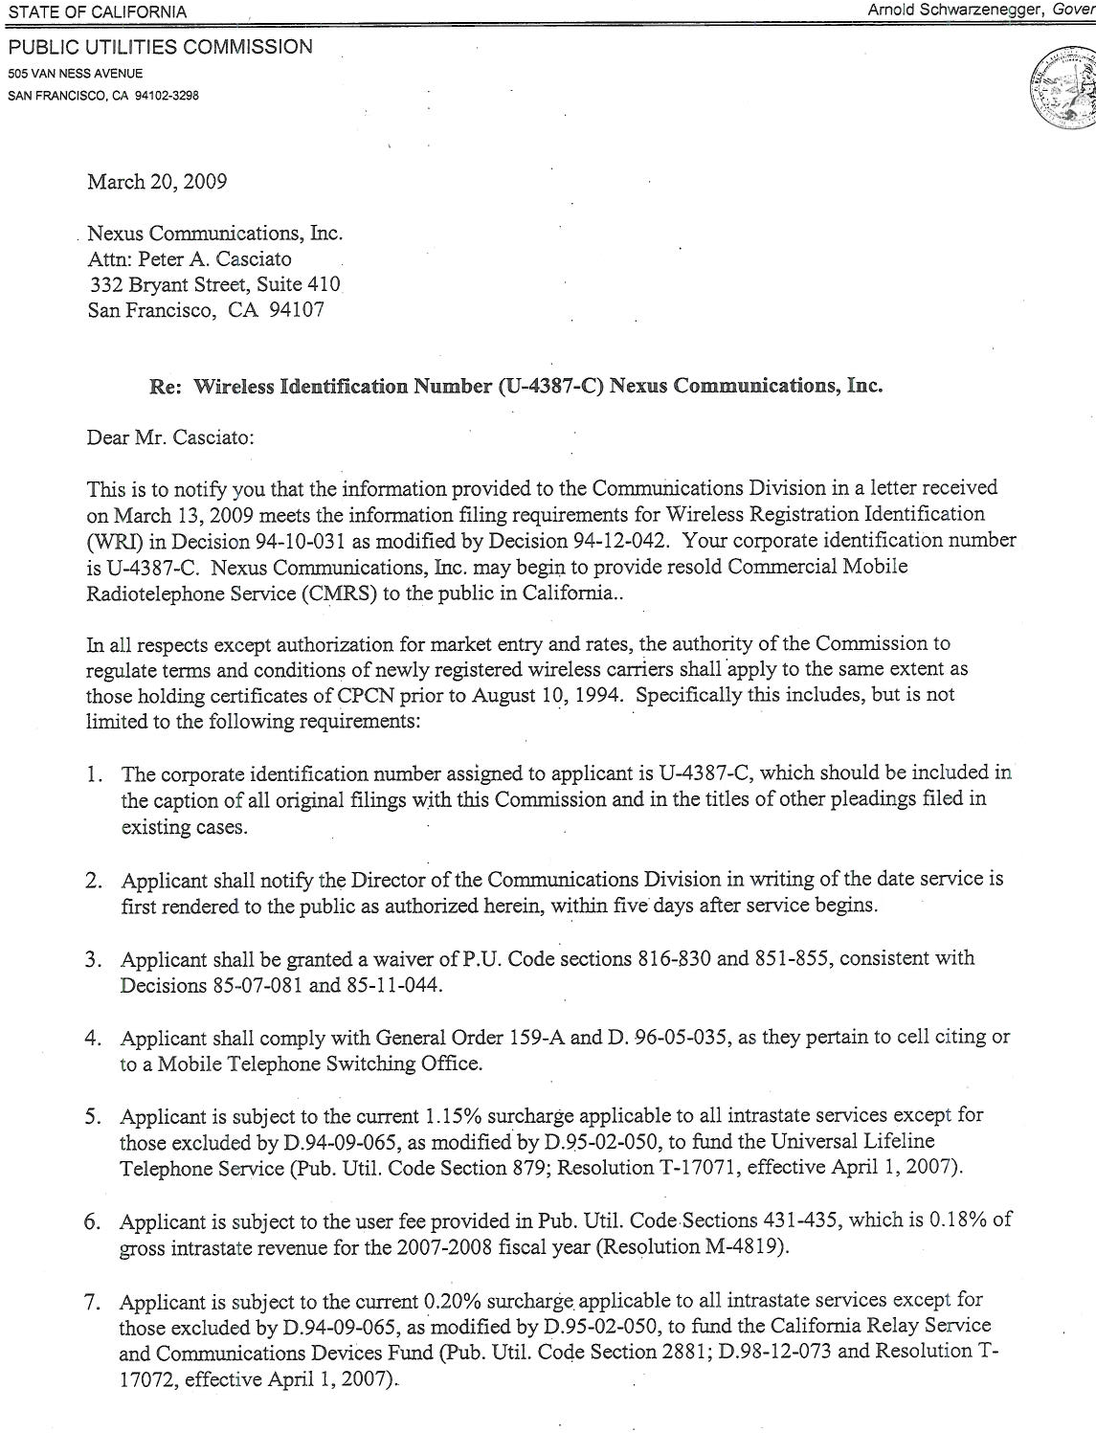

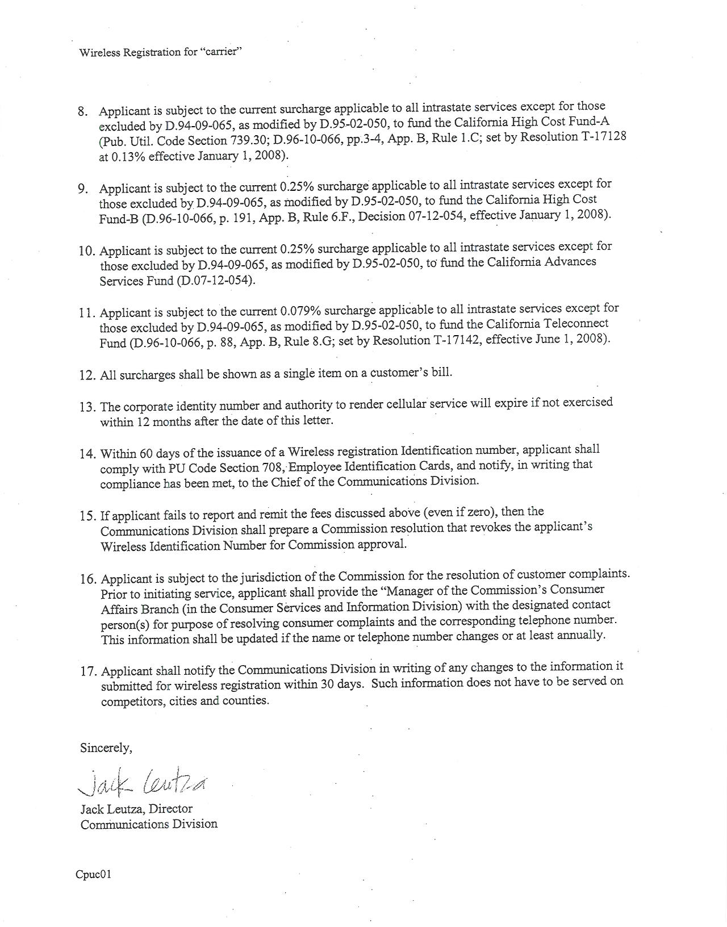

ATTACHMENT D

ATTACHMENT E

Table I: Conversion of Measured Rate Call Allowance to Wireless MOUs
 | CPUC | FCC
FCC Average Local Voice MOU |  | 769
G.O. 153 Call Allowance | 60 untimed calls
CTIA Average Call Duration | X 2.43 Minutes
G.O. 153 Call Allowance in MOU |  | <146>
MOU in Excess of G.O. 153 Allowance |  | 623

Table II: Pricing of Converted MOUs per G.O. 153 & D. 10-11-033

 |  | Minimum | Maximum
D. 10-11-033 Measured Rate Price Call Allowance Range for first 146 MOU (60 calls allowance) |  | $ 2.50 | $ 3.66
Price of 623 MOU in Excess of 146 MOU allowance | $0.033 ($.08 per call/2.43 average call duration) | $20.57 | $20.57
Total G.O. 153/D. 10-11-033 Cost for 769 MOU |  | $ 23.07 | $ 24.23

ATTACHMENT F
Comparison of Nexus’ Lifeline Plans to Off-The-Shelf
Retail Pre-Paid Wireless Plans
 | Nexus Proposed Federal Lifeline Plans |  |  | Retail Pre-Paid Wireless Plans
 | Nexus:  250 | Nexus: 500 | Nexus:  1000 | Virgin Mobile:  Pay Lo  1500 | Nexus dba  Reach Out  Wireless  Simple Plan  1000 | Metro PCS:  unlimited | AT&T:  Go Phone:  unlimited  talk and  text | Sprint  Talk:  450 | Verizon Talk:  450
Avg. MOU* | 769 | 769 | 769 | 769 | 769 | 769 | 769 | 769 | 769
Basic Plan Minutes (allowance) | 250 | 500 | 1000 | 1500 | 1000 | Unlimited | Unlimited | 450 | 450
Avg. Excess MOUs | 519 | 269 | 0 | 0 | 0 | 0 | 0 | 319 | 319
Cost per Min in excess of allowance | $0.033 | $0.033 | $0.033 | $0.10 | $0 | $0 | $0 | $0.45 | $0.45
Cost of excess minutes | $17.13 | $8.88 | $0 | $0 | $0 | $0 | $0 | $143.55 | $143.55
Cost of Additional features:  Caller ID, Voicemail, Call Waiting, Long Distance | $0 | $0 | $0 | $0 | $0 | $0 | $0 | $0 | $0
Cost per Plan | $2.50 | $5.00 | $20.00 | $30.00 | $52.95 | $40.00 | $60.00 | $39.99 | $44.99
Cost to Customer with Average Usage | $19.63 | $13.88 | $20.00 | $30.00 | $52.95 | $40.00 | $60.00 | $183.54 | $188.54

- See Attachment E for Calculation of Average MOUs

ATTACHMENT G
Comparable Local Usage Analysis

Comparison of Nexus Proposed Lifeline Plans to
ILEC Lifeline Measured Rate Plans
(Assuming Average Wireless MOU)

 | Nexus:  250 | Nexus: 500 | Nexus:  1000 | AT&T Lifeline  MR  (minimum) | AT&T Lifeline  MR  (maximum) | Verizon  Lifeline  MR  (minimum) | Verizon  Lifeline  MR  (maximum)
Avg. MOU* | 769 | 769 | 769 | 769 | 769 | 769 | 769
Basic Plan Minutes (allowance) | 250 | 500 | 1000 | 146 | 146 | 146 | 146
Avg. Excess MOUs | 519 | 269 | 0 | 623 | 623 | 623 | 623
Cost per Min in excess of allowance | $0.033 | $0.033 | $0.033 | $0.033 | $0.033 | $0.033 | $0.033
Cost of excess minutes | $17.13 | $8.88 | $0 | $20.57 | $20.57 | $20.57 | $20.57
Min. Lifeline Plan Cost (per D.10-11-033) or Cost per Plan | $2.50 | $5.00 | $20.00 | $2.50 | $3.66 | $2.50 | $3.66
Total G.O.153 Cost to Customers | $0 | $0 | $0 | $23.07 | $24.23 | $23.07 | $24.23
Caller ID | $0 | $0 | $0 | $9.99 | $9.99 | $7.95 | $7.95
Long Distance | $0 | $0 | $0 | $6.99* | $6.99* | $15.99 | $15.99
Voicemail | $0 | $0 | $0 | Not Available | Not Available | $7.45 | $7.45
Federal Excise Tax*** | $0 | $0 | $0 | $0.08 | $0.11 | $0.08 | $0.11
Total Additional Costs | $0 | $0 | $0 | $17.06 | $17.09 | $31.47 | $31.50
Total Cost to Lifeline  Customers | $19.63 | $13.88 | $20.00 | $40.12 | $41.32 | $54.53 | $55.73

* AT&T One Rate Nationwide 5cent Advantage Plan
** Pursuant to GO 153, California LifeLine customers do not pay public purpose surcharges, CPUC User Fee, or the end user common line charge; however, they do pay the Federal Communications Excise Tax of 3%. The charge reflected in this chart line, is 3% of the carrier’s basic LifeLine Flat rate charge. As a note the FCC also exempts Federal Life customers from fees on any services supported by universal service (see www.fcc.gov/cgb/consumerfacts/lllu.html).

ATTACHMENT H

NEXUS SERVICE AREA MAP

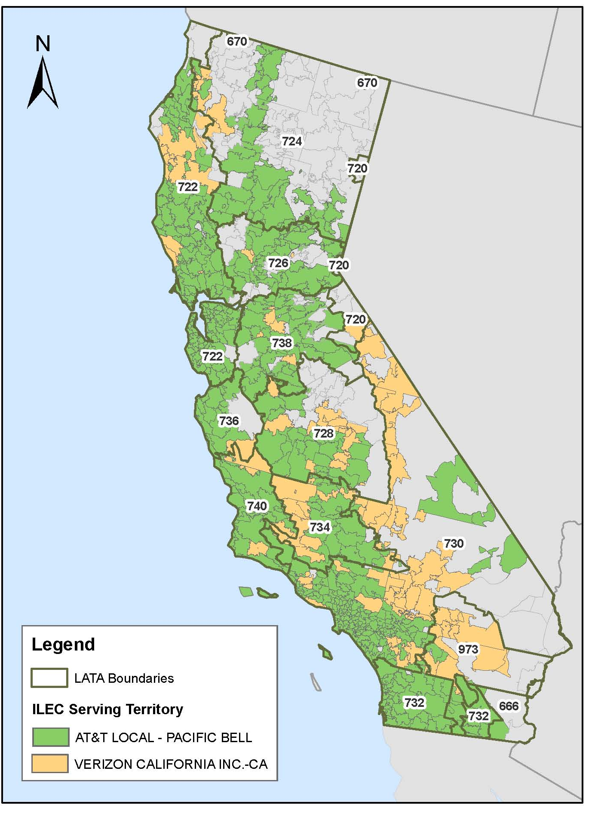

Note: Nexus filed with CD a list of exchanges for AT&T and Verizon. This information is not included in this Resolution but is available by request from the Communications Division with reference to Nexus’ Advice Letter filings.

ATTACHMENT I

Draft Resolution T-17258 Service List (April 22, 2011)
UTILITY NAME | EMAIL
Skadden, Arps, Slate, Meagher & Flom Llp | john.beahn@skadden.com
Citizens Telecommunications Co. Of Ca. | Charlie.Born@FTR.com
Citizens Telecoms. Co. Of Golden State | Charlie.Born@FTR.com
Citizens Telecoms. Co. Of Tuolumne | Charlie.Born@FTR.com
The Siskiyou Telephone Company | jtlowers@sisqtel.net
Happy Valley Telephone Co. | gail.long@tdstelecom.com
Hornitos Telephone Company | gail.long@tdstelecom.com
Winterhaven Telephone Company | gail.long@tdstelecom.com
Verizon West Coast, Inc. | linda.fogg@verizon.com
Sierra Telephone Company, Inc. | lindab@stcg.net
Calaveras Telephone Company | ysmythe@caltel.com
Cal-Ore Telephone Company | waihun@cot.net
Ducor Telephone Company | egwolfe@ducortelco.com
Foresthill Telephone Company, Inc. | dclark@kermantelephone.com
Global Valley Network, Inc. | susan.leclair@pinetreenetworks.com
Kerman Telephone Company | dclark@kermantelephone.com
Pinnacles Telephone Company | lorrie.bernstein@mossadams.com
Volcano Telephone Company | earlb@volcanotel.com
The Ponderosa Telephone Company | dand@ponderosatel.com
WWC License, LLC/Alltel/Western Wireless | nathan.glazier@alltel.com
AT&T California | regtss@att.com
Verizon California, Inc. | margo.ormiston@verizon.com
Frontier Communications Of The Southwest | Charlie.Born@FTR.com
Connectto Communications | ccollier@telecompliance.net
TracFone Wireless, Inc | brecherm@gtlaw.com
Cricket Communications | suzannetoller@dwt.com
I-Wireless | lsteinhart@telecomcounsel.com
Nexus Communications | pacasciato@gmail.com
Virgin Mobile | john.beahn@skadden.com
Llela Tan-Walsh | Llela.Tan-Walsh@cpuc.ca.gov
Charles Christiansen | Charles.Christiansen@cpuc.ca.gov
Michael Evans | Michael.Evans@cpuc.ca.gov
Telco Service Quality | telcoservicequality@cpuc.ca.gov
Chris Witteman | Christopher.Witteman@cpuc.ca.gov
Hien Vo | Hien.Vo@cpuc.ca.gov
Alik Lee | Alik.Lee@cpuc.ca.gov
Xiao Huang | Xiao.Huang@cpuc.ca.gov
Christine Mailloux | cmailloux@turn.org
Davis Wright Tremaine LLP | suzannetoller@dwt.com
Peter A. Casciato | pacasciato@gmail.com
Robby P. Abarca | rpabarca@abarcalawfirm.com
Candice Hyon | candiceh@totalcallusa.com
Patrick Rosvall | prosvall@cwclaw.com
Mondon, Jeffrey A (ATTsi) | jm7626@att.com
YourTel America, Inc. | marg@tobiaslo.com

47 U.S.C. Section 214(e)
D. 10-11-033, mimeo, at 72
Nexus AL1, at 1
The regular activation charge of Nexus is $72.00.
Nexus allows LifeLine customers to defer this remaining $42.00 charge over a twelve-month period, without an interest charge.(AL 1A at 9)
November 8, 2010, Protest and Comments of the Small LECs at 3.
June 22, 2009, Protests and Comments of Small LECs at 3.
June 22, 2009, Protests and Comments of Small LECs at 3.
November 8, 2010, Protest and Comments of the Small LECs at 3.
47 U.S.C. § 214(e)
Resolution T-17266
FCC 05-46, ¶ 34
G.O. 153 §8.5.1
D.10-11-033, pg.56, mimeo
http://files.ctia.org/pdf/CTIA__Survey_Midyear_2010_Graphics.pdf
November 8, 2010, Protest and Comments of the Small LECs at 5.
November 21, 2010, Reply Comments of Nexus Communications at 9.
November 21, 2010, Reply Comments of Nexus Communications at 9.
November 21, 2010, Reply Comments of Nexus Communications at 10.
FCC 05-46, paragraph 40, CPUC Resolution T-17002 Appendix A, Section II-G: Public Interest Determination
Virginia Cellular Order, supra note 18, para. 32 n.102 (citation omitted). See also Highland Cellular Order, supra note 28, para. 26: “Creamskimming’ refers to the practice of targeting only the customers that are the least expensive to serve, thereby undercutting the ILEC’s ability to provide service throughout the area.”
G.O. 153, p.3
G.O. 153, p.5
Nexus charges $1.50 per DA calls.
47 U.S.C. 332 (c)(3)(A) See also D. 95–10-032, mimeo at 17
R.09-06-019
Zip code + 4 is the standard Zip Code with a four digit add-on code. This ad-on code identifies a smaller geographic region within the main code, such as a city block, office building, etc. The link to more Zip Code information is available at http://zip4.usps.com/zip4/welcome.jsp.
November 21, 2010, Reply Comments of Nexus Communications, dated at 3.
The Joint Reply Comments of the Small LECs and Nexus, February 14, 2011 at 1. The systematic verifiable mechanism is Nexus’ proprietary database that “positively validate and serve only proposed subscribers whose address is served by facilities that originate from an AT&T or Verizon or other URF carrier central office switch or wire center, including CLLI, Rate Center, carrier, geographic location and NPA-NXX data along with central office code reports from NANPA (North American Numbering Plan Administration).”
G.O. 153, §§ 4.4, 4.5
G.O. 153, § 4.2.1. The current third-party administrator for California LifeLine is Solix.
Protests and Comments of Small LECs, June 22, 2009 at 3.

