PUBLIC UTILITIES COMMISSION OF THE STATE OF CALIFORNIA

ENERGY DIVISION RESOLUTION E-4472
February 16, 2012

RESOLUTION

Resolution E-4472. Southern California Edison (SCE) Advice Letter (AL) 2655-E, Pacific Gas and Electric (PG&E) Advice Letter 3950-E, and California Center for Sustainable Energy (CCSE) Advice Letter 25, collectively the California Solar Initiative (CSI) Program Administrators, to streamline the CSI application process.

PROPOSED OUTCOME: This Resolution approves the CSI Program Administrators’ (PA) request for the modification of applicant response times for incomplete applications to 14 calendar days, and associated proposals to streamline the application process, as originally proposed in the PAs’ Advice Letters submitted November 2011. All other amendments to the CSI Program Handbook proposed in the above Advice Letters are also approved.

ESTIMATED COST: $0

By SCE Advice Letter 2655-E, filed on November 18, 2011;
By PG&E Advice Letter 3950-E, filed on November 18, 2011;
By CCSE Advice Letter AL 25, filed on November 18, 2011.
__________________________________________________________

Summary
The CSI Program Administrators (PAs) submitted Advice Letters (ALs) in November 2011 requesting modification of applicant response times from 20 to 14 calendar days for incomplete applications, as well as other programmatic modifications to the CSI Program Handbook (Handbook). The Advice Letters were not protested.

In December 2010, Resolution E-4396 had previously denied the PAs’ request for amendments to the CSI Handbook related to a proposed 1-Step Application Process, including decreasing the application review and application fee submission time from 20 days to 14 days.

Upon review of the Advice Letters, Energy Division staff has concluded that these particular amendments are not integral to the 1-Step Application Process, and will help reduce the costs associated with administering and applying for incentives. Accordingly, the proposed Handbook amendments to change the current 20-day application response time for incomplete applications to 14 calendar days, and all other proposed modifications to the CSI Handbook, are approved by this Resolution.

BAckground
- Decisions Governing CSI Program Handbook Process
On January 17, 2006, the Commission issued Decision (D.) 06-01-024, establishing the California Solar Initiative. D.06-08-028, which, among other things, clarified the advice letter process for submitting subsequent revisions to the Handbook, allows the CSI PAs to periodically update the Handbook with revised or new policy changes for the CSI program by submitting proposed amendments via Advice Letter to the Commission for approval. The Commission can also change the Handbook on its own motion, via resolution. If the proposed amendments are not protested by parties, the amendments are approved by the Commission and the PAs implement the changes via the Handbook.

In accordance with the advice letter process, the CSI PAs submitted SCE AL 2655-E, PG&E AL 3950-E, and CCSE AL 25, on November 18, 2011, to modify the Handbook in order to streamline the application process and make other proposed changes.

The CSI PAs have collectively received over 23,725 applications in 2011. Given the volume of applications, even a modest savings in administration processing cost is deemed worthwhile from administrative and ratepayer perspectives. An adoption of cost-saving strategies will reduce costs associated with administering and applying for incentives.

- Summary of Commission Resolution E-4396
In December 2010, the CSI PAs submitted SCE AL 2533-E, PG&E AL 3768-E and CCSE AL 13, which requested a number of amendments to the CSI Handbook. Among them were proposals to establish a mandatory 1-Step application review process for small projects, and to change the applicant reponse time for incomplete applications and the application fee submission time to 14 calendar days.

In September 2011, Resolution E-4396 denied the CSI PAs’ request for a 1-Step application review process and the process-related amendments to change the application time and application fee submission time to 14 calendar days. The request for a 1-Step Application Process was denied on the grounds that it would pose unnecessary risk to contractors and CSI participants by requiring small projects to install and interconnect prior to the issuance of a reserved incentive level.

Further, Resolution E-4396 directed the CSI PAs “to find and implement cost-effective strategies to reduce application paperwork, review current processes, and make reasonable modifications to the existing 2-step application process.” (Resolution E-4396, Ordering Paragraph 3).

- Summary of the Proposed Handbook Revisions in SCE AL 2655-E, PG&E AL 3950-E, and CCSE AL 25
As directed in Resolution E-4396, the proposed CSI Program Handbook revisions in SCE AL 2655-E, PG&E AL 3950-E, and CCSE AL 25 aim to streamline the application process and reduce processing times, as well as allow for greater flexibility when evaluating project extension requests, modify the onsite field inspection requirements for Single-Family Affordable Solar Homes (SASH) Program projects following Commission D.11-07-031, and make other clarifying changes.

The following is a complete list of the proposed amendments:
- Update CSI PA contact information;
- Removal of signed field verification form;
- Modification of applicant response time for incomplete reservation requests from 20 to 14 calander days;
- Require the Proof of Project Milestone package to be submitted via the online application database, Powerclerk;
- Modification of the Extension Request submittal process to allow greater flexibility in determining if an extension will be granted;
- Modification of SASH onsite field inspections following Commision Decision 11-07-031; and,
- Clarification of criteria for complete incentive claim forms.

Notice/Protests
Notices of SCE’s AL 2655-E, PG&E’s AL 3950-E, and CCSE’s AL 25 were made by publication in the Commission’s Daily Calendar. SCE, CCSE and PG&E stated that a copy of the Advice Letter was mailed and distributed in accordance with Section 3.14 of General Order 96-B.

Protests
No protests were filed for SCE AL 2655-E, PG&E AL 3950-E, or CCSE AL 25.

DISCUSSion
The Commission has reviewed the Advice Letters and makes the following observations:

Resolution E-4396 denied the PAs’ request for amendments that changed the application review and application fee submission times from 20 days to 14 days because Energy Division staff interpreted these modifications to be related to the 1-Step Application Process. The resolution denied the 1-Step Application Process, and therefore the application review and application fee submission period modifications - which were assumed to be part of the 1-Step Application Process - were also denied.

The Program Administrators have now re-filed amendments to change the current 20-day application response time for incomplete applications to 14 calendar days. Upon further review, Energy Division staff has concluded that these particular amendments are not integral to the 1-Step Process. In addition, these amendments, as well as the other proposed amendments in the advice letters, will further the Commission’s directive in Ordering Paragraph 3 of Resolution E-4396 to streamline the application process.

Therefore, we approve the amendments that change the current 20-day application response period for incomplete applications to 14 calendar days and all the other amendments included in SCE AL 2655-E, PG&E AL 3950-E, and CCSE AL 25.

Comments
This is an uncontested matter in which the resolution grants the relief requested. Accordingly, pursuant to PU Code 311 (g)(2) and rule 14.6(c)(2) of the Commission’s Rules of Practice and Procedure, the otherwise applicable 30-day period for public review and comment is being waived.

Findings AND CONCLUSIONS
- D.06-08-028 directed the CSI PAs to file an Advice Letter to make changes to the CSI Handbook and clarified the advice letter process for submitting subsequent revisions to the CSI Program Handbook.
- Resolution E-4396 denied the PAs’ request for amendments to the CSI Handbook “related to the 1- Step Process,” and directed the PAs to adopt tighter application processing timelines.
- On November 18, 2011, SCE filed AL 2655-E, PG&E filed AL 3950-E, and CCSE filed AL 25, to make certain modifications to the CSI Handbook.
- No protests were filed to the Advice Letters.
- The proposed amendments that change the current 20-day application response time for incomplete applications to 14 calendar days are not integral to the 1-Step Application Process.
- The proposed amendments in SCE AL 2655-E, PG&E AL 3950-E, and CCSE AL 25 follow the Commission’s directive in Resolution E-4396 to find cost-effective strategies to streamline the CSI application process.

Therefore it is ordered that:
- The CSI Handbook amendments requested by California Solar Initiative Program Administrators, Southern California Edison in Advice Letter 2655-E, Pacific Gas & Electric’s Advice Letter 3950-E, and the California Center for Sustainable Energy’s Advice Letter 25, included herein as Appendix A, are approved.

This Resolution is effective today.

I certify that the foregoing resolution was duly introduced, passed and adopted at a conference of the Public Utilities Commission of the State of California held on February 16, 2012; the following Commissioners voting favorably thereon:

/s/ Paul Clanon Paul Clanon
Executive Director

MICHAEL R. PEEVEY
PRESIDENT
TIMOTHY ALAN SIMON
MICHEL PETER FLORIO
CATHERINE J. K. SANDOVAL
MARK J. FERRON
Commissioners

Appendix A
SCE AL 2655-E, PG&E AL 3950-E, and CCSE AL 25
Proposed CSI Handbook Amendments

Below are the red-lined sections of the CSI Handbook that would be amended per SCE AL 2655-E, PG&E AL 3950-E, and CCSE AL 25:
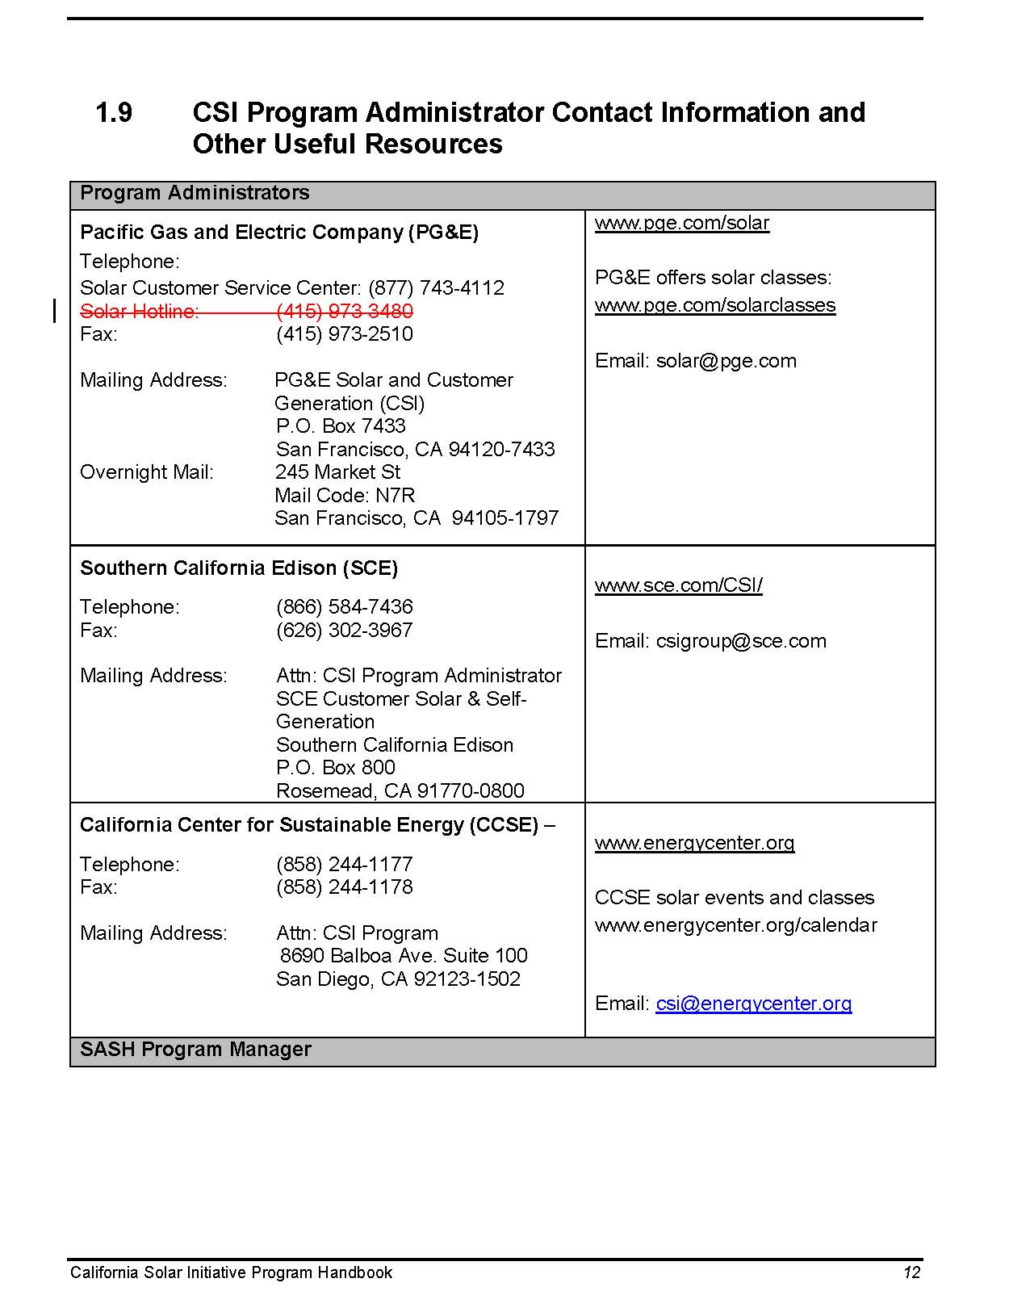
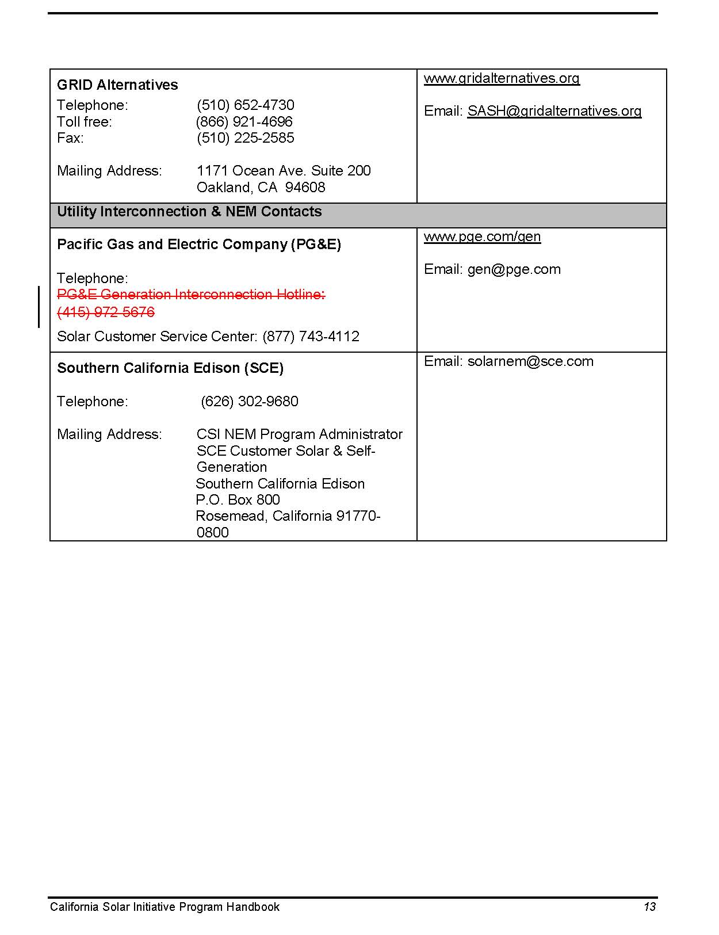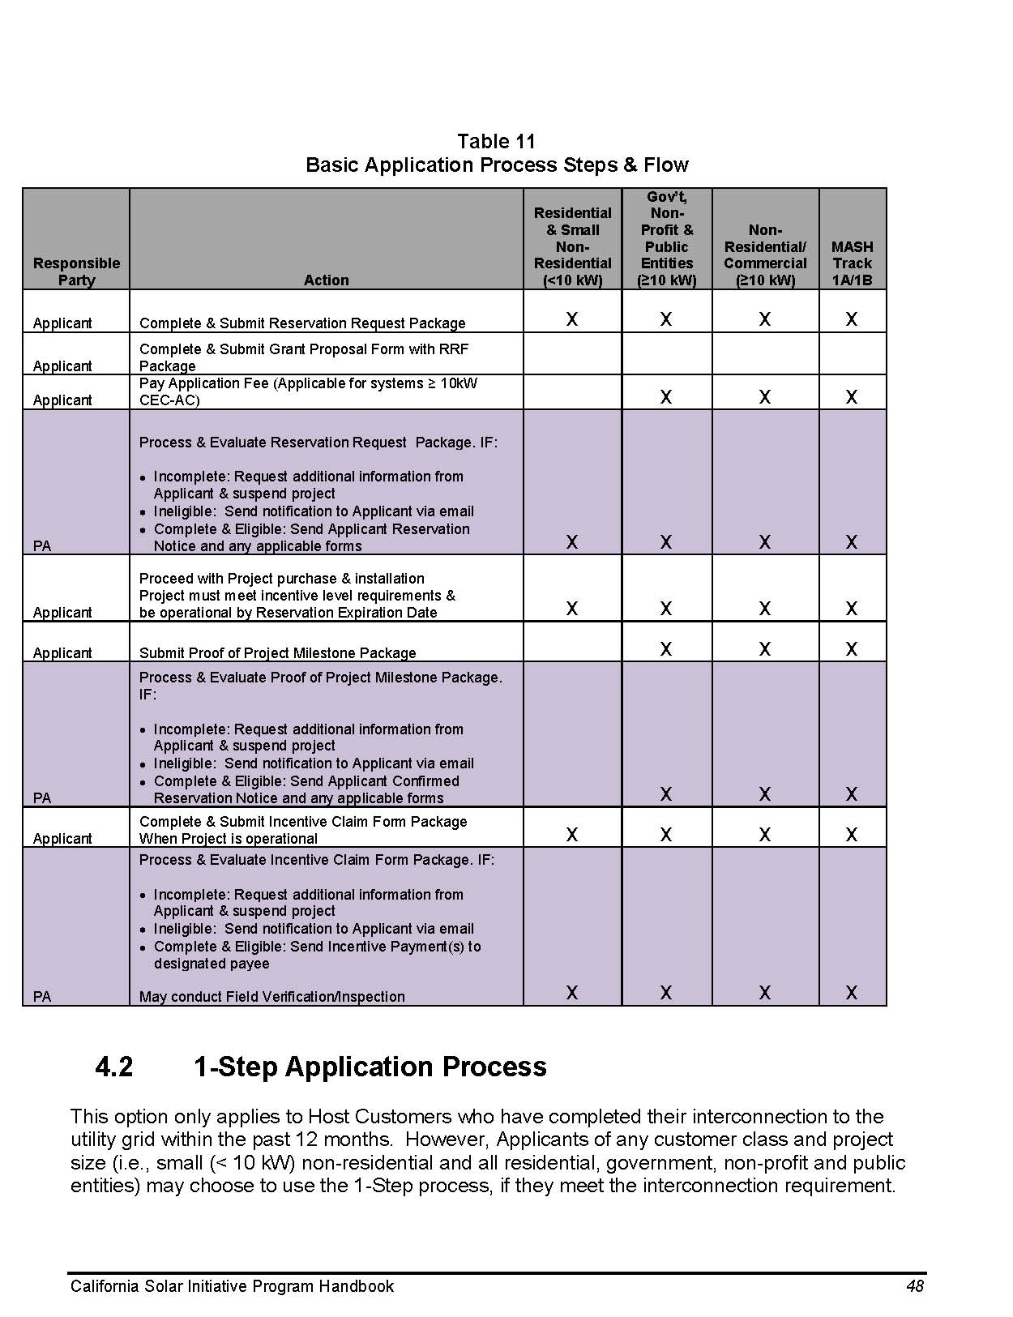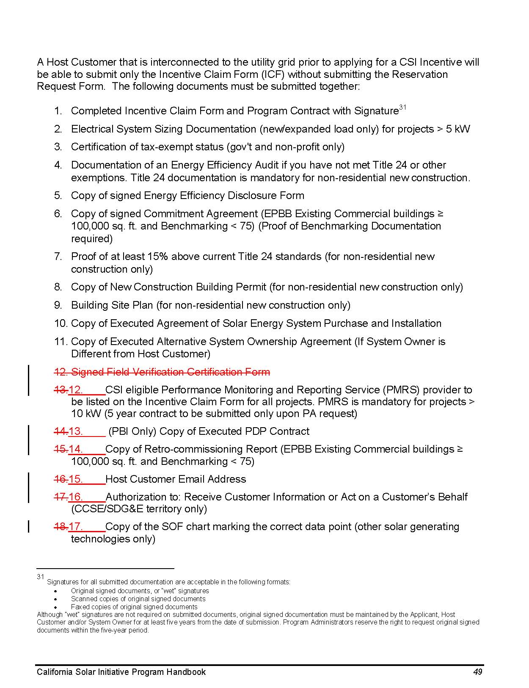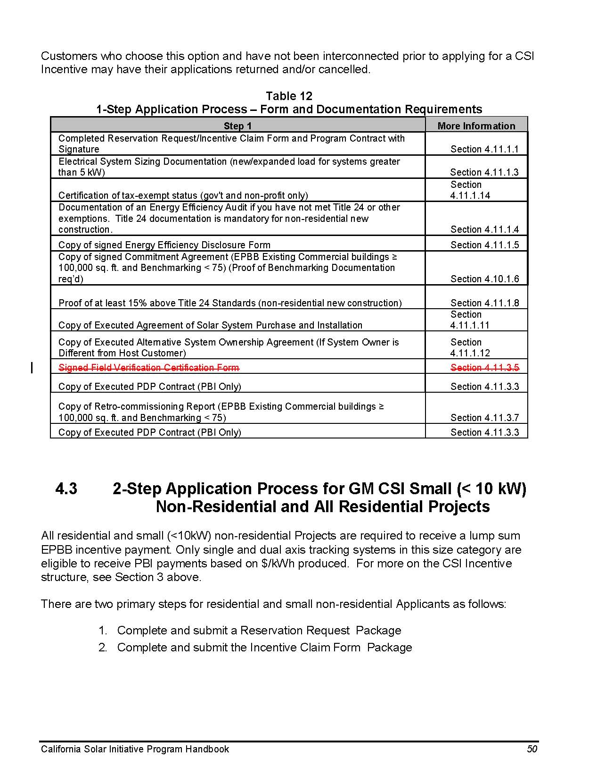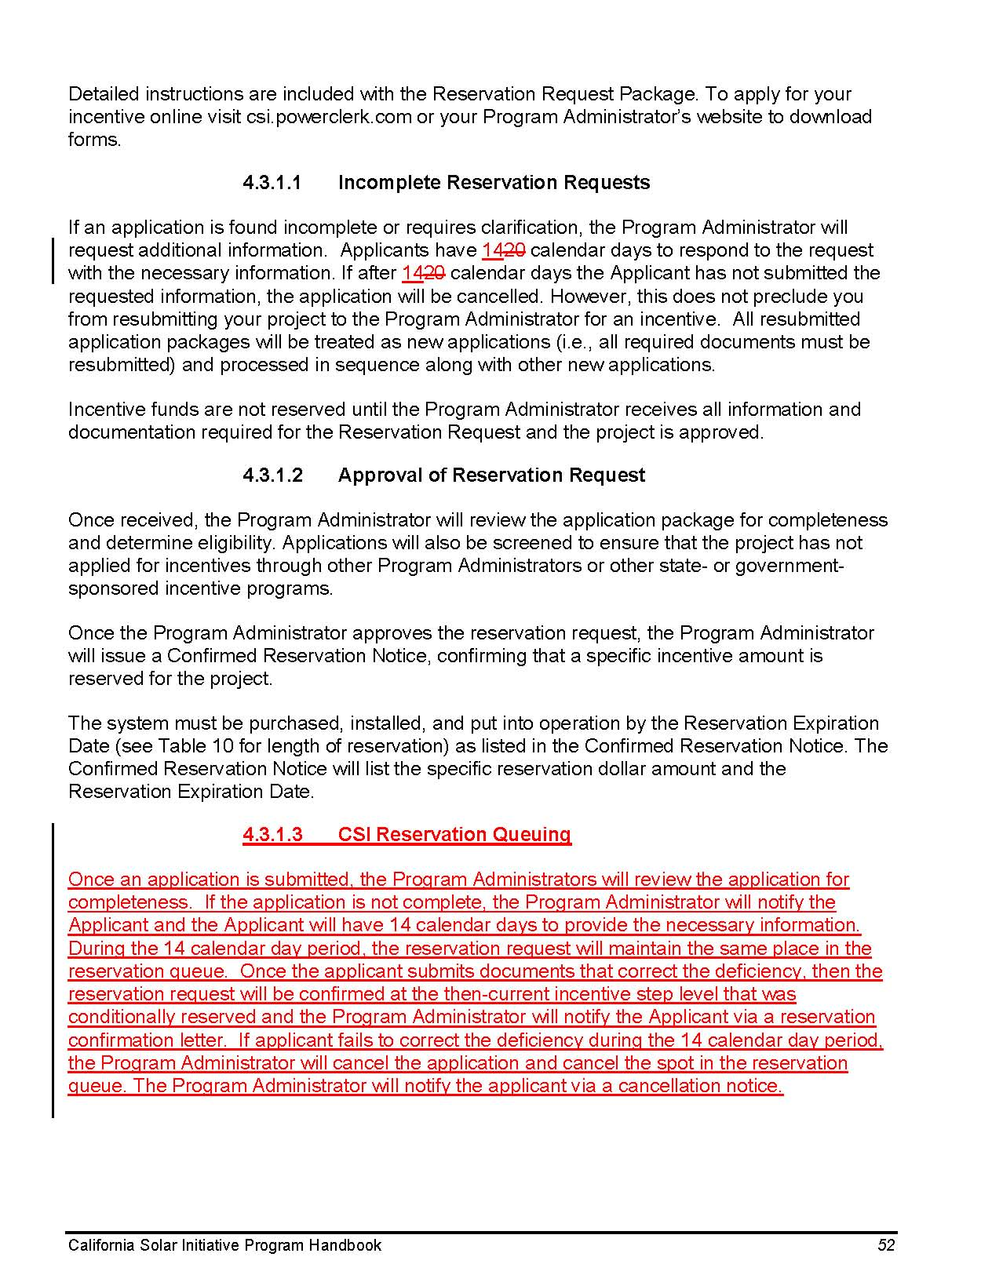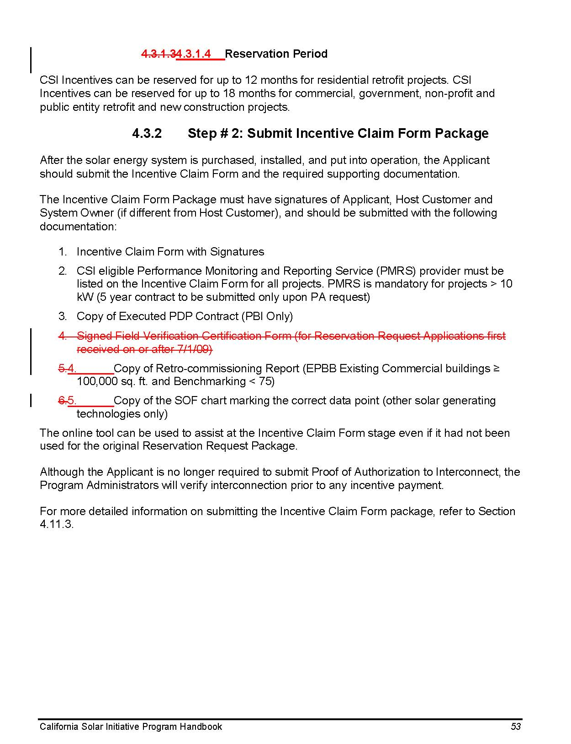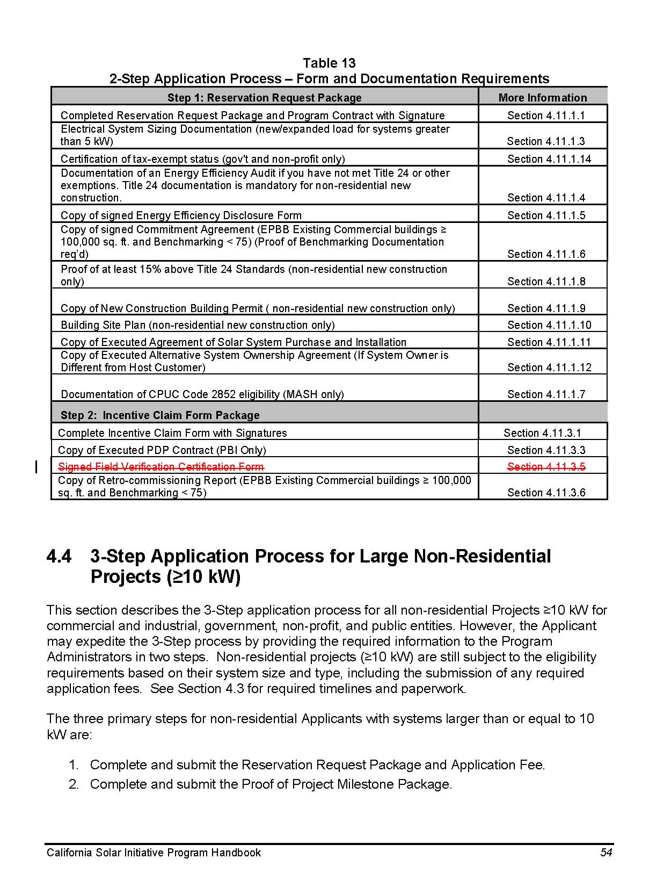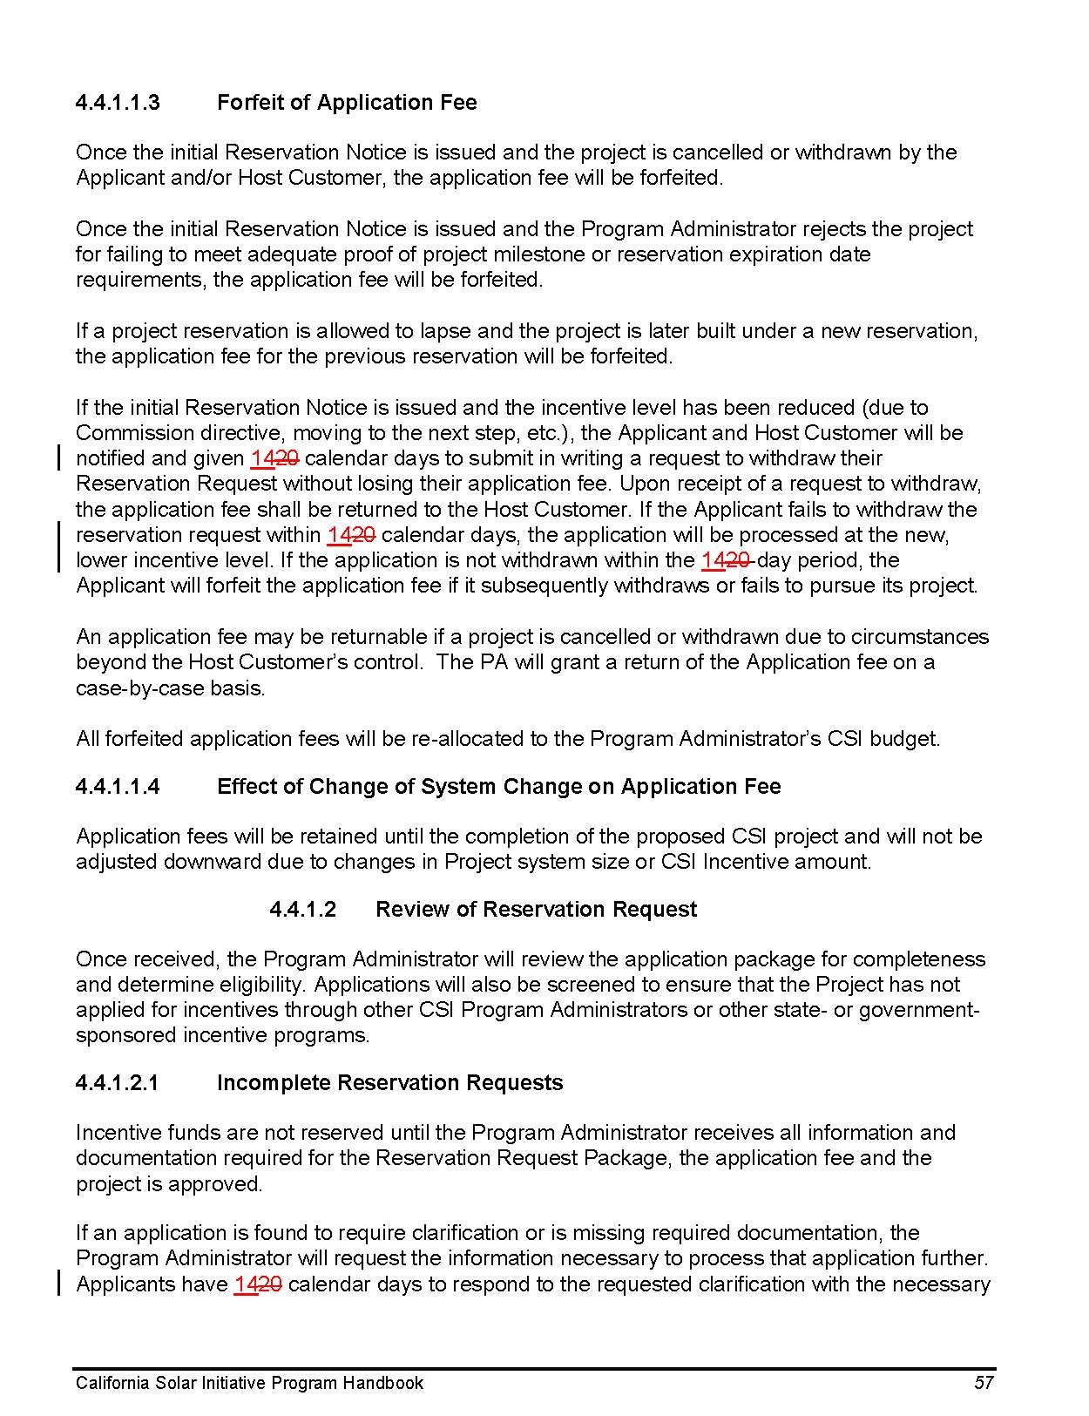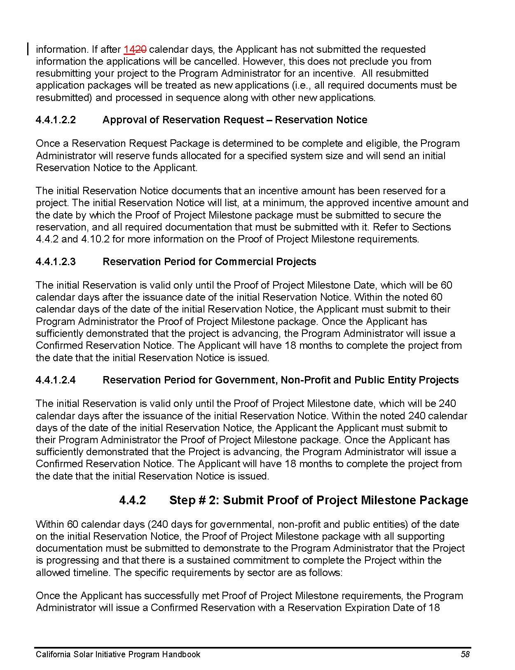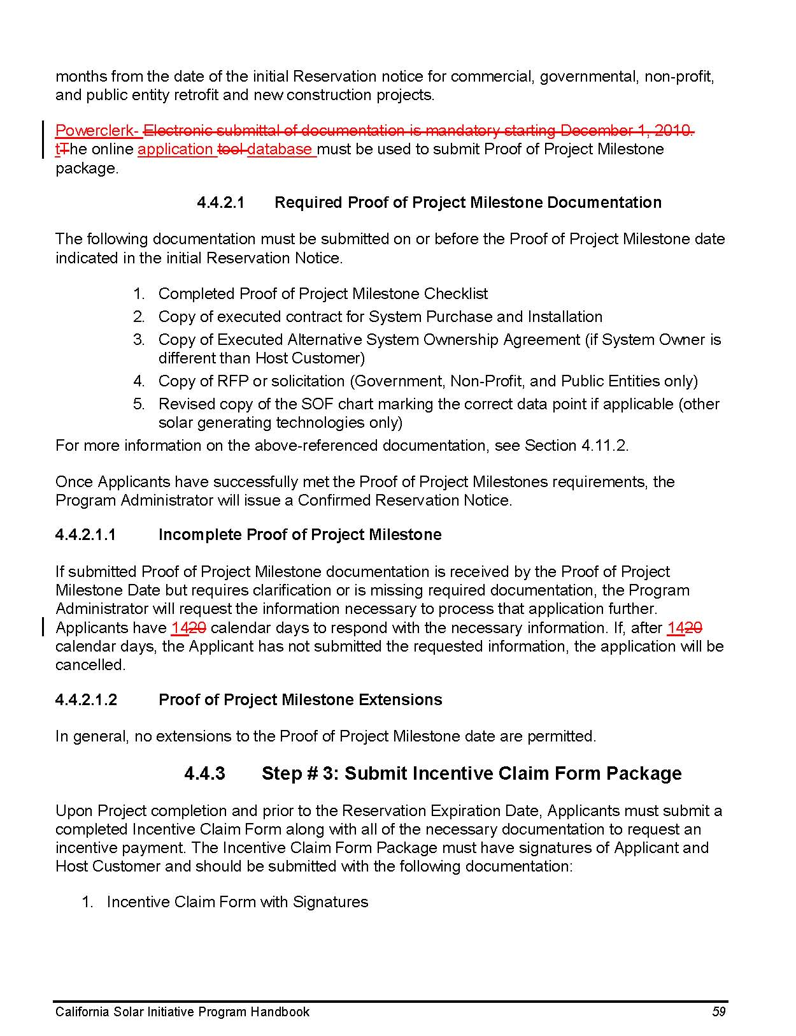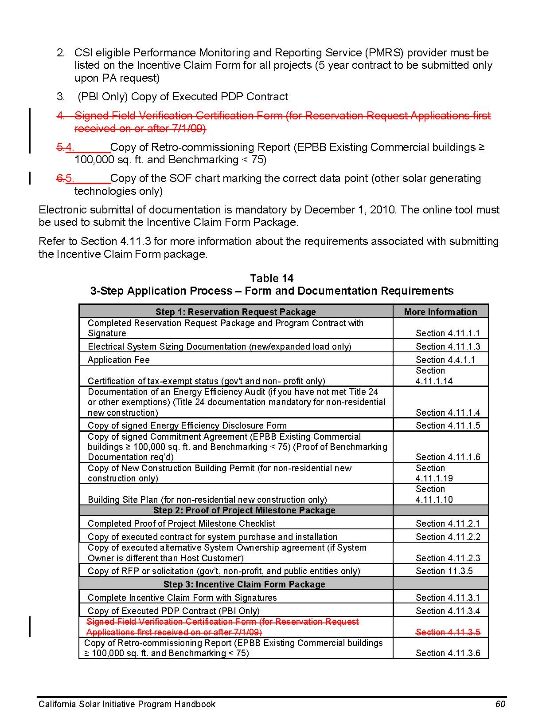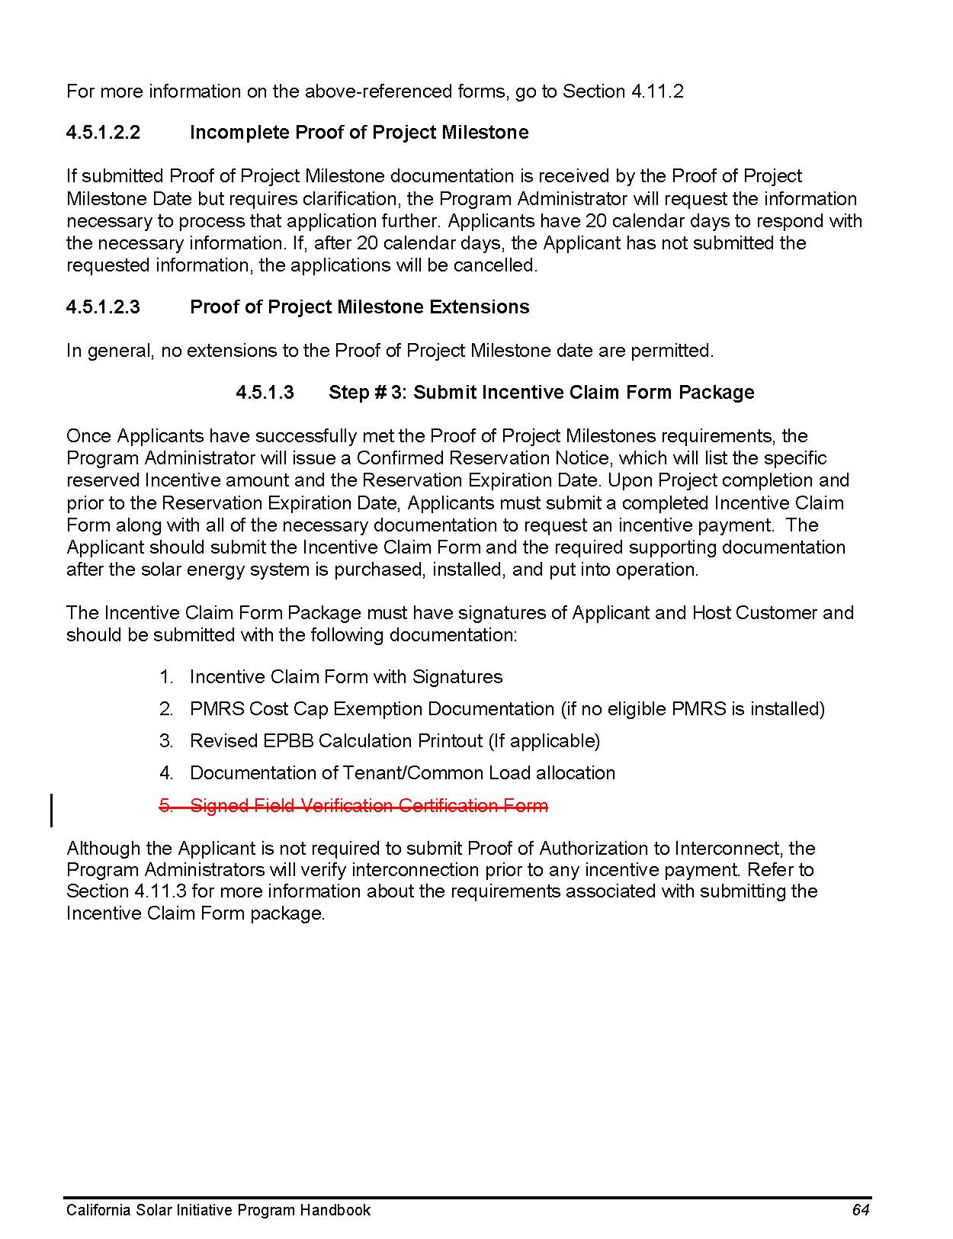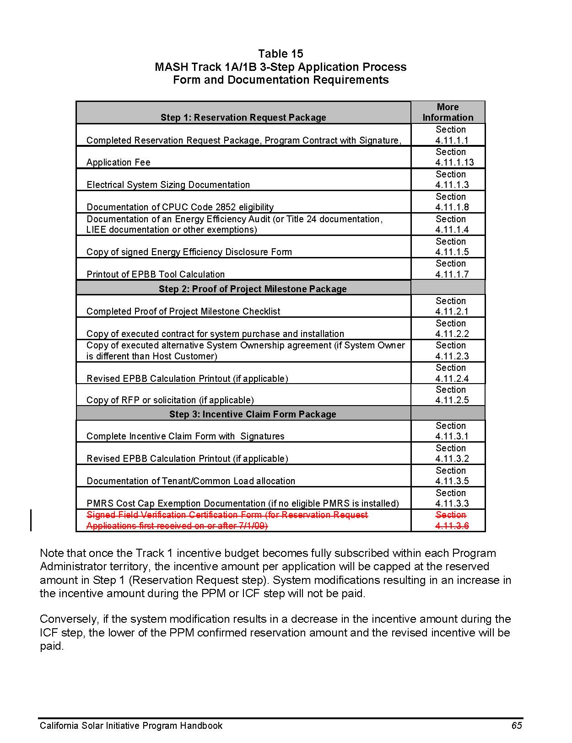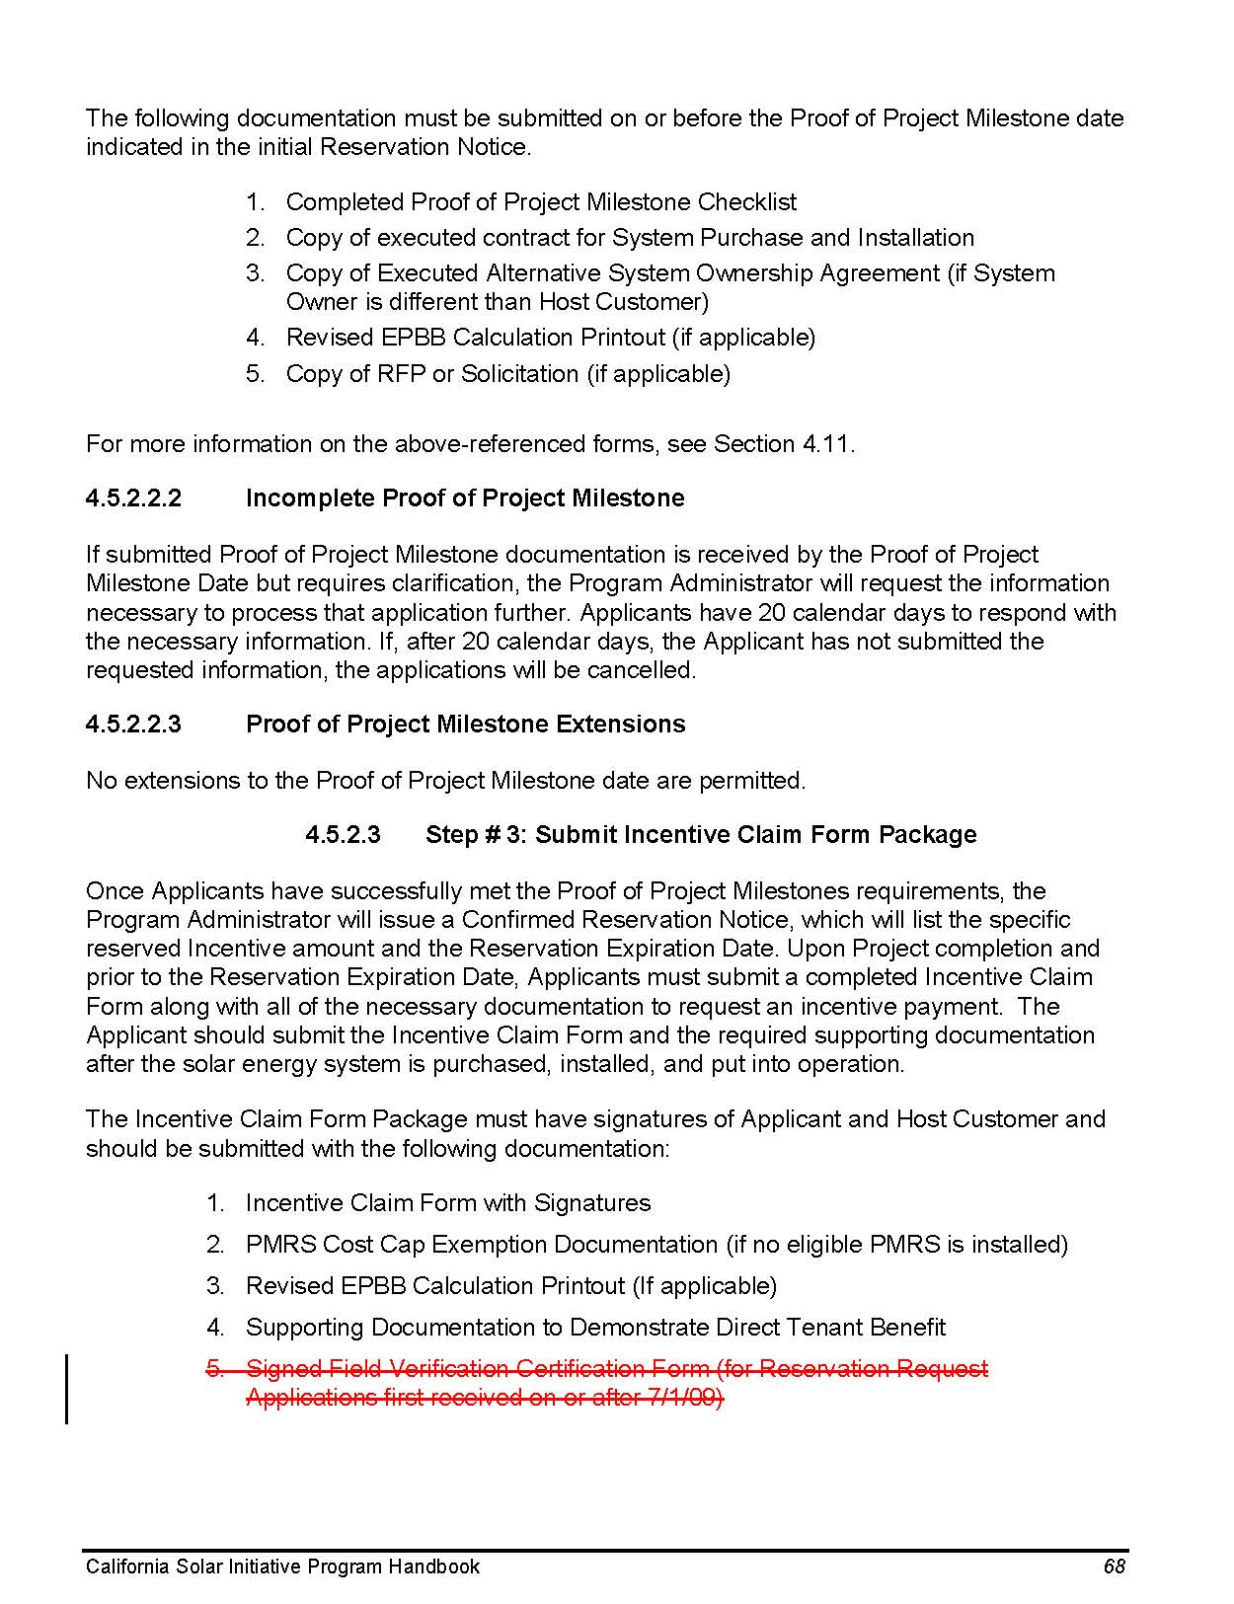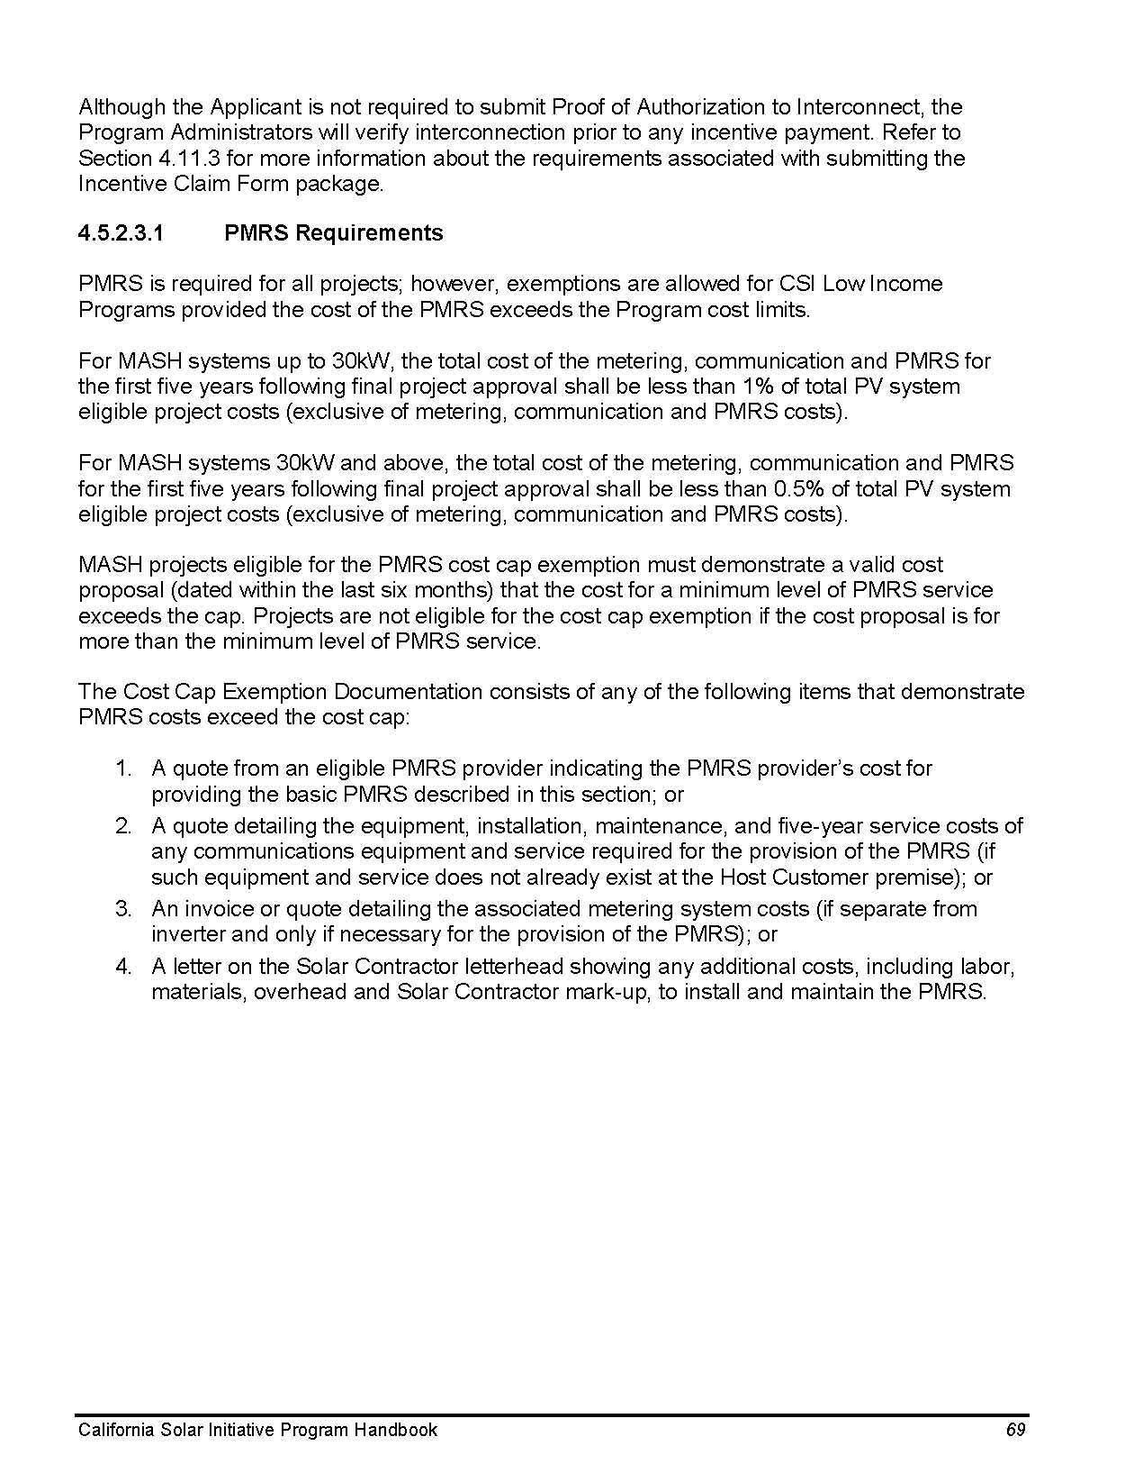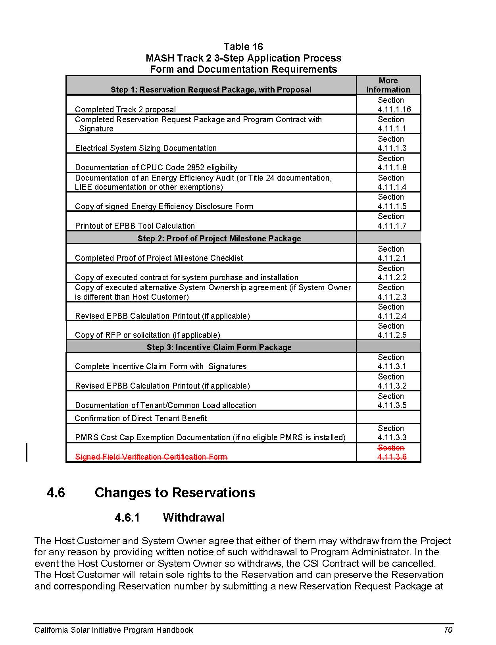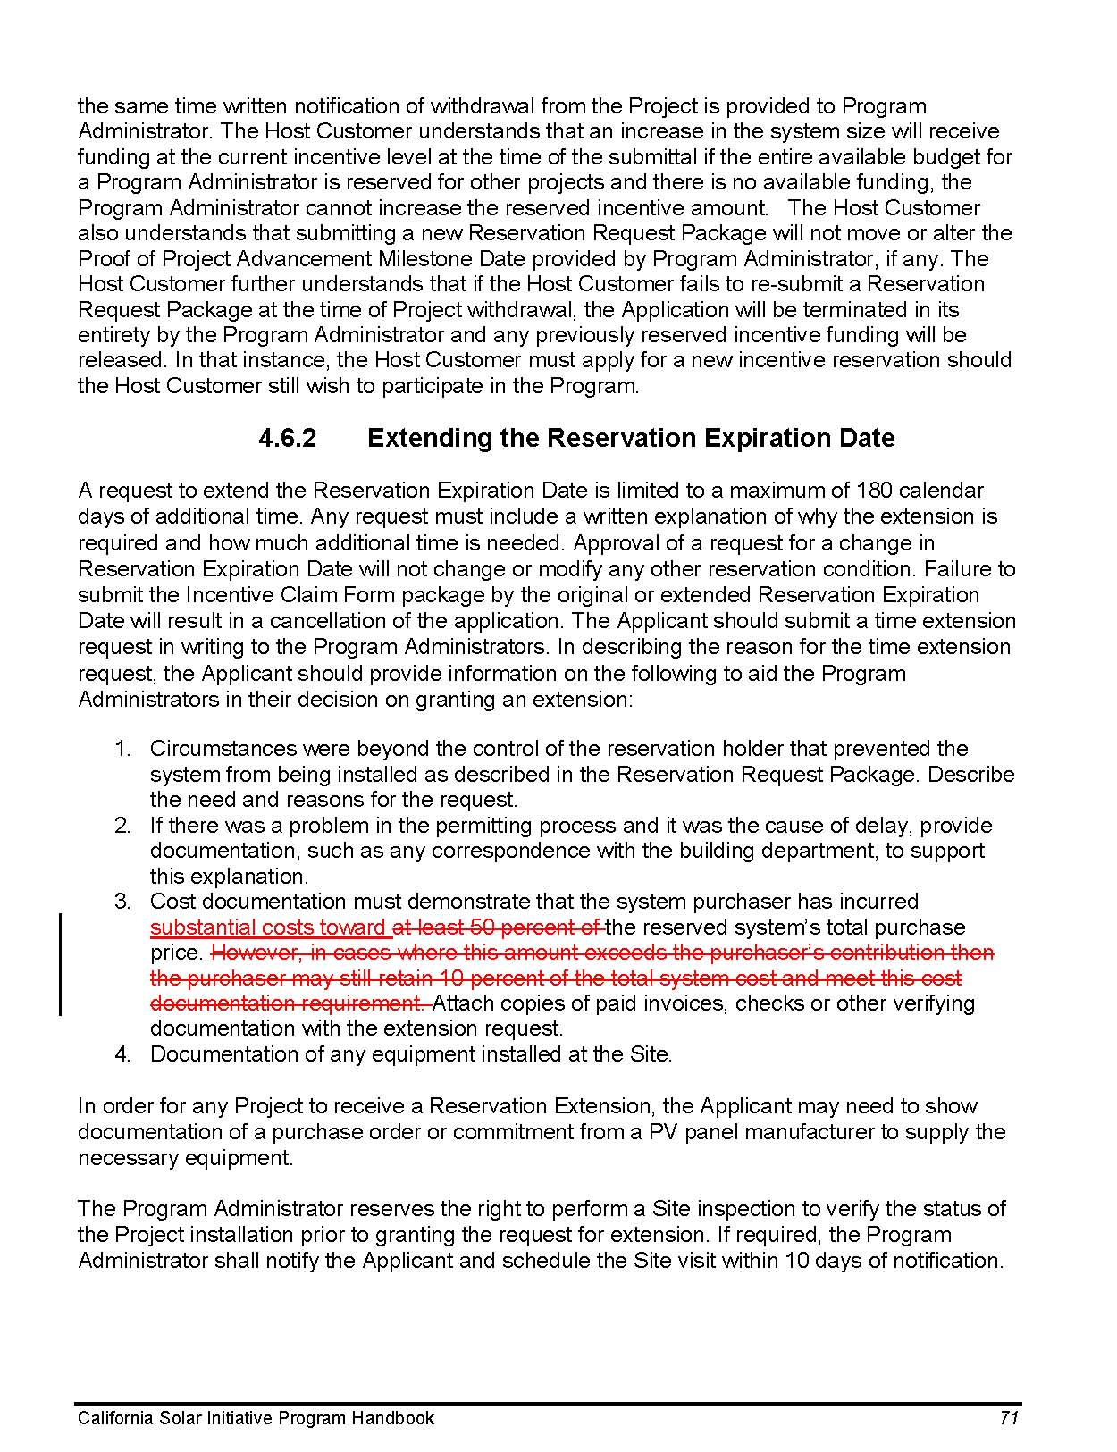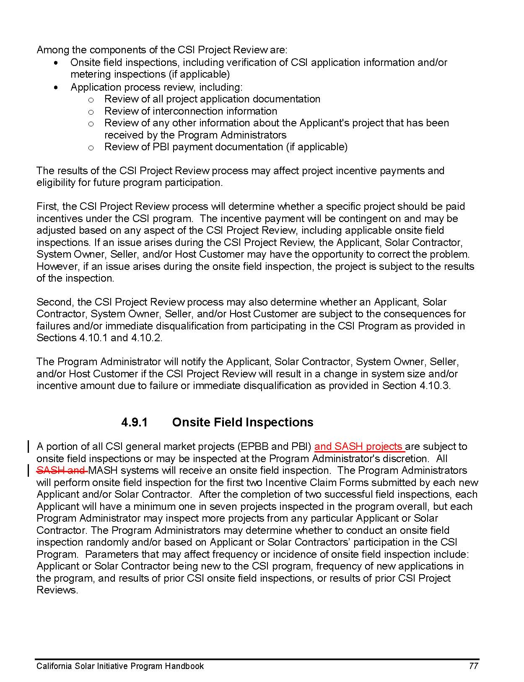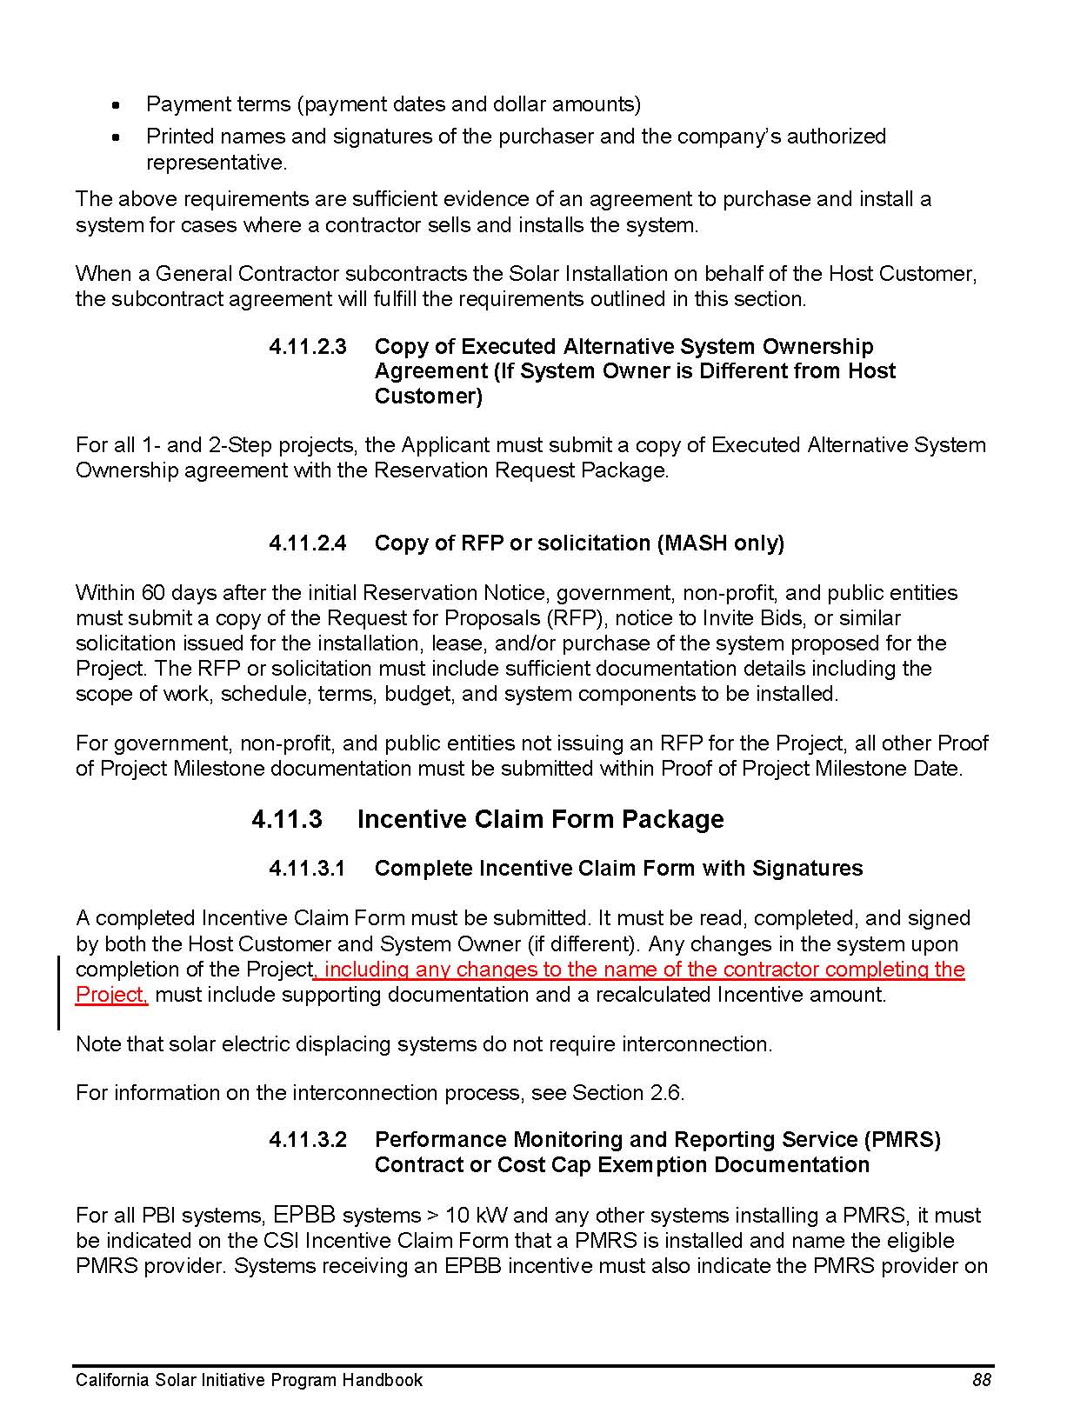

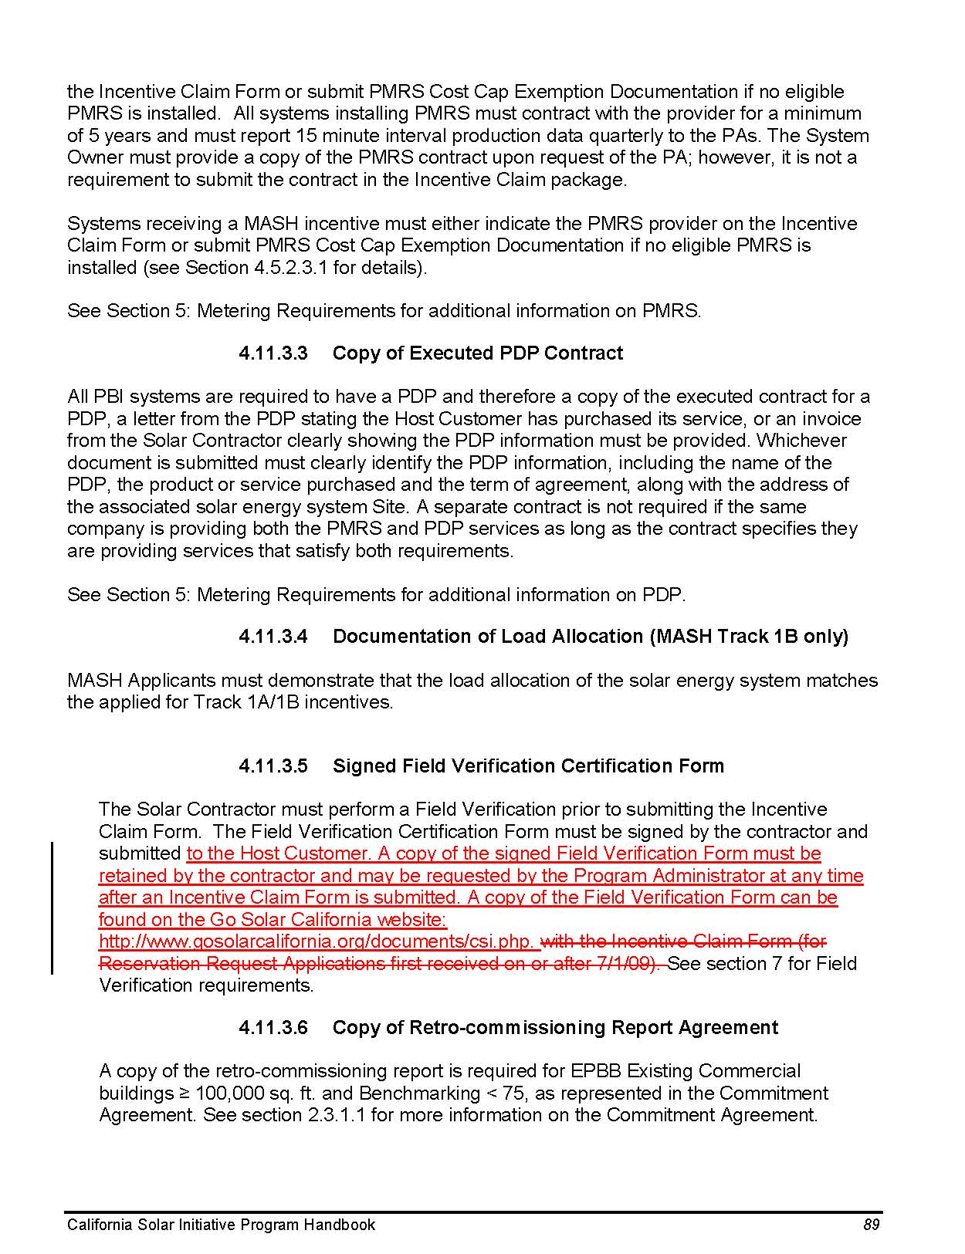

The CSI handbook is available here: http://www.cpuc.ca.gov/PUC/energy/Solar/handbook.htm.
The CSI Program Administrators are Pacific Gas and Electric Company (PG&E), Southern California Edison Company (SCE), and the California Center for Sustainable Energy (CCSE) in San Diego Gas and Electric Company’s territory.
Source: http://www.californiasolarstatistics.ca.gov/reports/monthly_stats/. Data as of December 14, 2011.

