WATER/RSK/JB5/AJT/jlj

PUBLIC UTILITIES COMMISSION OF THE STATE OF CALIFORNIA

DIVISION OF WATER AND AUDITS RESOLUTION NO. W-4913
Water and Sewer Advisory Branch April 19, 2012

RESOLUTION

(RES. W-4913). THIS RESOLUTION AUTHORIZES CALIFORNIA AMERICAN WATER COMPANY TO SPECIFY THE HIGHLAND AVENUE TANK PROJECT IN THE PRESSURE-REDUCING VALVE MODERNIZATION AND ENERGY RECOVERY MEMORANDUM ACCOUNT (PRVMA) AND MAKE THE ACCOUNT APPLICABLE TO ALL DISTRICTS.

Summary
California American Water Company (Cal-Am) filed a Tier-3 Advice Letter (AL) No. 922, on November 4, 2011, seeking authorization from the California Public Utilities Commission (Commission) to designate the Highland Avenue Tank Project to be included in the Pressure Reducing Valve Modernization and Energy Recovery Memorandum Account (PRVMA) authorized by Res. W-4854 on December 2, 2010, and to make the PRVMA applicable to all districts. On December 22, 2012, Cal-Am filed AL-876, in compliance with Res. W-4854, to establish the PRVMA Preliminary Statement in its tariff. This advice letter, AL 922, requests modification of the PRVMA Preliminary Statement to specify the change in location to Highland Tank. This resolution authorizes Cal-Am to specify the Highland Tank project in the PRVMA and to apply the MRVMA to all districts.

BACKGROUND
Res. W-4854, dated December 2, 2010, authorized San Jose Water Company, California Water Service Company, Golden State Water Company, and California American Water Company to establish memorandum accounts to track the costs associated with the research, development, and demonstration of pressure reducing valve modernization projects.

In summary, Res. W-4854 implemented the following:

- Authorized the water utilities noted above to commence implementation of a Research, Development, and Demonstration (RD&D) program to test use of regenerative flow control valves (FCVs).

- Expedited Commission consideration and approval of such projects for ratepayers to benefit from federal tax credits.

- Approved the establishment of a separate memorandum account for each water utility to track the costs associated with the proposed RD&D projects, and

- Directed the water utilities, and encouraged electrical utilities, to work with the Division of Water and Audits (DWA) to finalize project details, select an engineering and design firm, and develop appropriate measurement, verification, and evaluation protocols.

Ordering Paragraph 1 of Res. W-4854 ordered utilities to establish PRVMA for the “projects proposed in the advice letters” resulting in Res. W-4854. In its advice letter, AL 853, Cal-Am proposed “a 13.78 kW [Hydro Turbine Generation] project at the Beyer Blvd. PRV station in the San Diego District”. (Res. W-4854, p. 3.) The project was for the replacement of Pressure Regulating Valves (PRV) with Zeropex’s HTG along with an emergency bypass line for excess flow or for when the HTG is out of service for maintenance.

AL 876-A authorized Cal-Am to establish a new memorandum account, which resulted in the following authorization in its Preliminary Statement:

Pressure-Reducing Valve Modernization and Energy Recovery Memorandum Account (PRVMA)

1. Purpose:

The purpose of the Pressure-Reducing Valve Modernization and Energy Recovery Memorandum Account (PRVMA) is to track all of the costs associated with the Research, Development and Demonstration of electrical regenerative flow control valve project.

2. Applicability:

The Los Angeles, Monterey, and Coronado Districts.

3. Accounting Procedure:

California American Water shall track all PRVMA related costs paid by California American Water including, but not limited to, the costs of engineering and design, equipment, installation, outside contractors, software, measurement, and verification (EM&V).

- A debit entry will be created each month to record costs.

- Interest shall accrue to the PRVMA on a monthly basis by applying a rate equal to one-twelfth of the 3-month Commercial Paper Rate, as reported by the Federal Reserve Statistical Release.

4. Rate Recovery:

California American Water may seek rate recovery of the PRVMA in its next general rate case or through a Tier 3 advice letter filing.

5. Effective Date:

The PRVMA is effective as of December 7, 2010.

Discussion
Cal-Am and its retained consultant, Black and Veatch, have determined that the Beyer Boulevard project site identified in AL 853 is not the preferred project. Cal-Am requests to change the project cite and to have the PRVMA specify the new project cite located at the Highland Tank site.

After the original consideration of the Beyer Boulevard PRV as the preferred project site, additional preliminary project data and pressure recordings were investigated resulting in the determination that the Highland Tank PRV site is now the preferred project. Supervisory Control and Data Acquisition (SCADA) data revealed that the operation of the Highland Tank PRV occurs between eight and 12 hours per day. Field data reveal that a higher pressure differential exists at the Highland Tank PRV compared to the Beyer Boulevard, PRV resulting in higher energy recovery potential. Additionally, flow through the Highland Tank PRV is greater than through the Beyer Boulevard PRV, adding to the recovery potential. Generation potential at Highland Tank PRV exceeds Beyer Boulevard PRV by more than four times. The location of the Beyer Boulevard PRV presented easement constraint issues and would require Cal-Am to acquire additional space in order for the project to be constructed. This included the need to extend construction into the adjoining property for excavation and installation of the necessary equipment. Since the Highland Tank PRV is located entirely on Cal-Am’s property, construction will be much simpler. Additionally, if future expansion of the HTG is recommended, the Highland Tank PRV site would have fewer site constraints. The above-grade design at Highland Tank PRV mitigates the chance for flooding, especially as compared to the flooding potential at the Beyer Boulevard site.

The Highland Tank PRV is located at 2755 Palm Avenue in the City of San Diego at the Highland Tank site. The Highland Tank PRV project includes the installation of Zeropex’s Difgen flow control and pressure management system. The 16-inch PRV is located on the intake line to the Highland tank and serves to reduce system pressure by approximately 85 psi. From the estimate provided by Zeropex, the HTG could produce on average 60.58 kW or more than four times the energy production estimate of the original Beyer Boulevard site.

For the reasons discussed above we find it appropriate to change the project site identified in AL 853 to the Highland Tank PRV and to have this specified in the Preliminary Statement for the PRVMA. In addition, Cal Am corrects the PRVMA Preliminary Statement to indicate that the memorandum account is applicable across all of its districts. This correction is appropriate in that the Highland Tank PRV is a research, development, and demonstration project with potential beneficial uses across all of Cal Am’s districts.

In AL 922, Cal-Am requests modification of the Preliminary Statement in its tariff to specify Highland Tank as follows:

Pressure-Reducing Valve Modernization and Energy Recovery Memorandum Account (PRVMA)

1. Purpose:

The purpose of the Pressure-Reducing Valve Modernization and Energy
Recovery Memorandum Account (PRVMA) is to track all of the costs
associated with the Research, Development and Demonstration of electrical
regenerative flow control valve project at Highland Tank. (C)

2. Applicability: All Districts. (C)

The above tariff changes are reasonable and should be authorized.

NOTICE
Cal-Am provided notice of AL 922 to its service list, in accordance with Section 4.3 of General Order No. 96-B, and to the Commission’s Energy Efficiency proceeding (i.e., A.07-01-024) service list. Also, Section 7.2 of General Order No. 96-B requires the following service with respect to advice letters changing a Commission resolution: service “on anyone who filed a protest or response to the prior advice letter addressed in the resolution, any third party whose name and interest in the relief sought appeared on the face of that prior advice letter…and any other persons who had been served with the resolution”. AL 922 is modifying the project site identified in Res. W-4854. Through the notice Cal-Am’s provided of AL 922, as discussed above, Cal-Am also provided notice to all the persons listed in Section 7.2 of General Order No. 96-B.

COMMENTS

This is an uncontested matter in which the resolution grants the relief requested. Accordingly, pursuant to Public Utilities Code 311(g) (2), the otherwise 30-day period for public review and comment is being waived.

Findings AND CONCLUSIONS
- California American Water Company (Cal-Am) filed a Tier-3 Advice Letter (AL) No. 922 seeking authorization from the California Public Utilities Commission (Commission) to designate the Highland Avenue Tank Project to be included in the Pressure Reducing Valve Modernization and Energy Recovery Memorandum Account (PRVMA) authorized by Resolution W-4854 on December 2, 2010, and to make the PRVMA applicable to all districts.
- On December 22, 2012, Cal-Am filed AL-876, in compliance with Resolution W-4854, to establish the PRVMA Preliminary Statement in its tariff.
- AL 922 requests modification of this tariff to specify the change in location to Highland Tank and to have the PRVMA apply to all districts.
- Resolution W-4854, dated December 2, 2010, authorized San Jose Water Company, California Water Service Company, Golden State Water Company, and Cal-Am to establish memorandum accounts to track the costs associated with research, development, and demonstration pressure reducing valve modernization projects.
- In Resolution W-4854 the Commission ordered the water utilities to establish the PRVMA for the projects proposed in the advice letters resulting in Resolution W-4854 and to track appropriate costs related to these projects in the PRVMA.
- Cal-Am filed AL 853, one of the advice letters resulting in Resolution W-4854. In this advice letter, the utility proposed a pressure reducing valve modernization project at the Beyer Boulevard PRV station in the San Diego District.
- The project at the Beyer Boulevard Station was for the replacement of Pressure Regulating Valves (PRV) with Zeropex’s Hydro Turbine Generator (HTG) along with an emergency bypass line for excess flow or for when the HTG is out of service for maintenance.
- The Beyer Boulevard project site identified in Advice Letter 853 is not the preferred project. Cal-Am requests that the memorandum account be changed to include the now-preferred project, which is located at the Highland Tank site.
- The Highland Tank PRV is located at 2755 Palm Avenue in the City of San Diego at the Highland Tank site.
- From the estimate provided by Zeropex, the Hydro Turbine Generator at the Highland Tank project site could produce on average 60.58 kW or more than four times the estimated energy production of the original Beyer Boulevard site.
- In AL 922, Cal-Am requests modification of the Preliminary Statement in its tariff to specify Highland Tank site and to make the PRVMA apply to all districts.
- The Highland Tank PRV is a research, development, and demonstration project with potential beneficial uses across all of Cal Am’s districts.
- The proposed tariff changes are reasonable and should be authorized.
- Cal-Am provided notice of AL 922 in accordance with General Order No. 96-B.
- Cal-Am provided notice of AL 922 to the service list of A.07-01-024, the Commission’s Energy Efficiency proceeding.

therefore it is ordered that:

- This resolution approves Advice Letter No. 922 and the attached tariff sheets modifying the Preliminary Statement in California American Water Company’s tariff specifying the Highland Avenue Tank Project as the new location in the Pressure Reducing Valve Modernization and Energy Recovery Memorandum Account (PRVMA) authorized by Resolution W-4854 and indicating the PRVMA is applicable across all of California American Water Company’s districts.

- This resolution is effective today.

I certify that the foregoing resolution was duly introduced, passed, and adopted at a conference of the Public Utilities Commission of the State of California held on April 19, 2012; the following Commissioners voting favorably thereon:

/s/ PAUL CLANON
Paul Clanon
Executive Director

MICHAEL R. PEEVEY
President
TIMOTHY ALAN SIMON
MICHEL PETER FLORIO
CATHERINE J.K. SANDOVAL
MARK J. FERRON
Commissioners
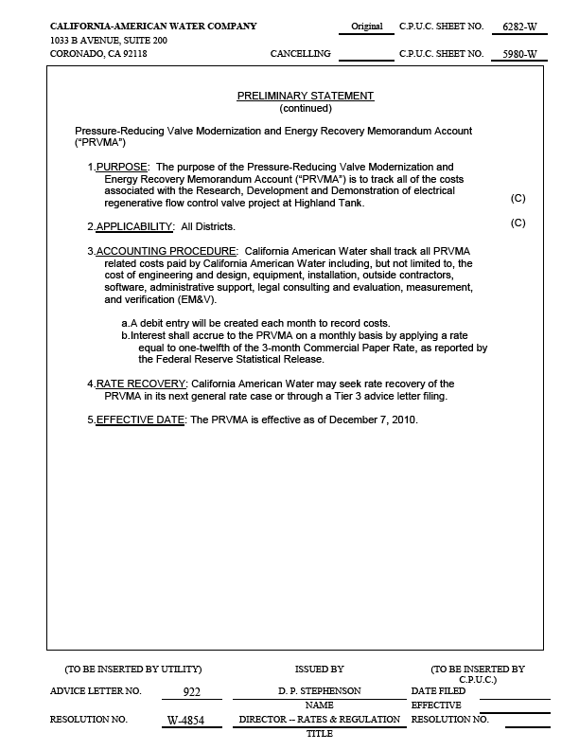

Cal-Am provided notice of AL 853 to its service list and the service list to A.07-01-024. (See the discussion on Res. W-4875, p. 14.) Consistent with that service, Cal-Am provided this same service here with respect to AL 922.

