WATER/SNR/PTL/LEP/TKM:jlj

PUBLIC UTILITIES COMMISSION OF THE STATE OF CALIFORNIA

WATER DIVISION RESOLUTION NO. W-4531
May 26, 2005

RESOLUTION

(RES. W- 4531), MESA CREST WATER COMPANY (MCWC). ORDER AUTHORIZING A GENERAL RATE INCREASE PRODUCING AN ADDITIONAL ANNUAL REVENUE OF $155,672 OR 18.5% IN 2004 AND AN ADDITIONAL $107,696 OR 10.82% IN 2005.

Summary
By Draft Advice Letter, filed on July 1, 2004, MCWC seeks an increase in rates for water service to recover increased expenses of operation and earn an adequate return on its plant investment. For Test Year 2004, this resolution grants an increase in gross annual revenues of $155,672 or 18.5% and an additional annual revenue of $107,696 or 10.82% in Test Year 2005 which is estimated to provide a return on rate base of 18.8% in Test Year 2004 and 23.2% in Test Year 2005.

Background
MCWC, a Class C water utility, has requested authority under Section VI of General Order 96-A and Section 454 of the Public Utilities Code to increase its water rates by $155,671 or 18.53% for test year 2004 and by an additional $107,694 or 10.82% for test year 2005. The purpose of the rate increase is to recover increased operating expenses and to provide an adequate rate of return. MCWC’s request shows 2004 gross revenues of $839,982 at present rates, increasing to $995,654 at proposed rates and to $1,103,350 in 2005. MCWC is requesting a return-on-rate-base of 11.3%.

The last general rate increase (GRC) for MCWC was granted on October 12, 1994, per Res. No. W-3885, which authorized an increase of $75,615 or 13.5% for test year 1994. MCWC was also authorized three Consumer Price Index (CPI) increases since their last GRC. The first CPI increase was for $17,291 or 2.5% authorized in January 1997 followed by a CPI increase of $13,107 or 1.7% in February 1999, and a CPI increase of $13,623 or 1.6% in January 2003. The purpose of the CPI increases is to offset inflation as authorized by Decision (D.) 92-03-093.

MCWC is a California Corporation providing water service to the community of La Canada, Los Angeles County. The service area consists of approximately 600 acres, known as Mesa Crest, located north of and adjacent to the Los Angeles National Forest in or near the City of La Canada Flintridge. MCWC has 707 metered connections in an area that has been fully developed for several decades and does not expect to add any new customers.

The water system includes a Metropolitan Water District (MWD) connection through the Foothill Municipal Water District from which MCWC purchases all of its water supply. MCWC does not have groundwater pumping rights in the Raymond Basin as do the surrounding water utilities, and subsequently, pays more for water supply than the surrounding utilities. MCWC presently has five steel reservoirs in its water system and has identified major upgrades that need to be performed to maintain reliability and safety of the system. The water system has five booster pumps ranging from 15 to 100 horsepower along with five reservoirs with a total capacity of 3.5 million gallons. The system has 55,587 feet of water main.

DISCUSSION
The Water Branch (Branch) made an independent analysis of MCWC’s operations and issued its report in December 2004. Appendix A shows MCWC’s and the Branch’s estimated summary of earnings at present, proposed, and recommended rates for test year 2004 and 2005. Following discussions, MCWC and the Branch agreed to the 2004 and 2005 summary of earnings at the Branch recommended rates shown in Appendix A. The 11.3% rate of return requested by MCWC is within the range authorized by the Commission for a class C utility.

The major differences in expenses were in transportation expenses, employee pension and benefits, office supplies and expenses, insurance, and regulatory commission expenses.

The major differences in MCWC’s rate base were in plant, and accumulated depreciation. A large portion of MCWC’s system is approaching 50 years of age and is in need of replacement or major maintenance in order to avoid unplanned service interruption. MCWC is seeking approval of a 3-year (2004 thru 2006) capital improvement plan for the renovation of four existing steel reservoirs and other water system improvements as stated below. Branch recommends that when the utility completes the plant improvements it should file an Advice Letter to recover costs associated with the plant improvements but such improvements should not exceed $300,000 in any year for the plant approved in this GRC to minimize the impact on ratepayers. Branch agrees with the proposed capital improvement plan but recommends that the reasonableness of costs be reviewed by the Water Division once the advice letter is filed.

Proposed Capital Improvement Plan for
Test Year 2004

Item
No. | Description/Category | Project | BRANCH | MCWC
1 | Reservoirs | Meadows South | Deferred to 2005 Advice Letter | $145,430
2 | Booster Station | Meadowview | Deferred to 2005 | $20,000
3 | Interconnection | La Canada Irrigation District | Deferred to 2007  Advice Letter | $60,000
4 | Main Replacement | Glen Eagle | Deferred to 2005 | $44,000
5 | Main Replacement | Evening Canyon | Deferred to 2005 Advice Letter | $10,000
6 | Meter Replacement | Various | $3000 | $5,000
7 | Other Capital Items | SCADA System | Deferred to 2005 Advice Letter | $25,000

Proposed Capital Improvements for
Test Year 2005

Item
No | Description | Project | BRANCH | MCWC
1 | Reservoirs | Forest Green (2 Mil) | Deferred to 2006 Advice Letter | $295,800
2 | Booster Station | Starlight Crest | Deferred to 2006 Advice Letter | $20,000
3 | Main Replacement | Red Willow | Deferred to 2007 Advice Letter | $20,000
4 | Meter Replacement | Various | $3000 | $5,000
5 | Other Capital Items | Site Improvements | 0 | $10,000

Proposed Capital Improvement Plan for
Year 2006

Item
No | Description | Project | BRANCH | MCWC
1 | Reservoirs | Forest Green (250K) | Deferred to 2007 Advice Letter | $125,000
2 | Booster Station | Hampton | Deferred to 2007 Advice Letter | $20,000
3 | Main Replacement | Hampton Road | Completed in 2004 | $9,000
4 | Meter Replacement | Various | $3000 Advice Letter | $5,000
5 | Other Capital Items | Site Improvements | 0 | $10,000

Two methods are available for Branch to utilize in the rate-making process: (1) Rate of Return and (2) Rate of Margin. Branch calculates the revenue requirement utilizing the rate of return method and then calculates the revenue requirement utilizing the rate of margin method. Policy dictates that Branch recommends the method that produces the higher revenues. This method gives the small water utilities the opportunity to earn a more reasonable and appropriate revenue requirement when the utility has “little rate base”. If only the Rate of Return Method was used, a utility with little or no rate base would earn little or no return. By having the opportunity to use Rate of Margin, these utilities are able to earn a reasonable return.

In Res. W-4524 (March 17, 2005), the CPUC adopted a revised set of standard practices for determining the profit of Class C and D water utilities using the rate of return and rate of margin methods. Based on this revision, the Water Division determines a standard set of rates of return and rates of margin based on current data, to be used by Branch in that year’s Class C and D general rate cases.

In the rate of margin method, the utility’s revenue requirement is defined as the sum of its operating and maintenance expenses, depreciation expenses, income and other taxes, multiplied times the rate of margin. A rate of margin of 24% was used.

Comparison of the revenue requirement indicates that the Rate of Margin method produces a higher revenue requirement but given the fact that MCWC requested and notified its customers of an 18.5% increase for Test Year 2004 and an additional 10.82% in Test Year 2005, the company has indicated that it is satisfied with the increase they have requested which will produce a rate of return of 18.8% in Test Year 2004 and 23.2% in Test Year 2005 and a rate of margin of 16.3% for Test Year 2004 and 21.0% for Test Year 2005.

Based on current rates, MCWC’s annual revenue for Test Year 2004 is $995,654 for Test Year 2004 and $1,103,350 for Test Year 2005. At the recommended rate of margin, the increase in revenue will be $155,672 or 18.5% for Test Year 2004 and $107,696 or 10.82% for Test Year 2005.

D.92-03-093 allows Class C utilities to recover up to 65% of fixed costs in their readiness-to-serve charge. The rates shown in Appendix B recover 65% of the utility’s fixed cost. MCWC’s rate structure consists of two schedules: Nos. 1, Metered Service, and 4, Private Fire Service. The new rate schedules appear in Appendix B.

At the Branch’s recommended rates shown in Appendix B, the bill for a typical residential customer with a 1-inch meter using 3,200 cubic feet of water will increase from $100.32 to $119.50 per month, or 19.1% in test year 2004 and to $132.57 or 10.9% in test year 2005. A comparison of customer bills at present and recommended rates is
shown in Appendix C. The adopted quantities and tax calculations are shown in Appendix D. MCWC has requested that the Safe Drinking Water Bond surcredit be deleted since the company stopped issuing the credit in June 2003.

The Branch staff reviewed operating revenues, and expenses, including salaries and contracting fees, purchased power, insurance expenses, income, and other taxes. Staff verified the operating expenses by reviewing supporting documents for substantiation and accuracy, and included the amounts that were deemed reasonable and prudent.

Notice AND PUBLIC MEETING
A notice of the proposed rate increase was published on the La Canada Valley Sun on August 26, 2004. The Branch and MCWC received one letter from the Mesa Crest Customers Steering Committee, protesting the rate increase. The Consumer Affairs Branch has not received any complaints. A public meeting was held Tuesday, September 21, 2004, at 7 p. m. at the La Crescenta Sheriff Station, 4554 Briggs Avenue, La Crescenta, CA. The meeting began at 7:10 p.m. with about 15 customers present. MCWC is a class C utility with approximately 700 connections in the city of La Canada.

Mr. Peter Liu, Branch Project Manager, explained Commission procedures and the purpose of the meeting. Mr. Christian Aldinger, consultant for MCWC, gave a presentation on the need for the rate increase and stated that the increased water and energy costs and the Department of Health Services-mandated improvements to the system were the main reasons for the rate increase. The customers were satisfied with the increase but felt that MCWS should have anticipated the need for the system improvements before and should have saved money instead of asking the customers to pay for them. Mr. Liu stated that it had been 10 years since the company had requested a rate increase and that the customers may have received lower rates because the company had not asked for a rate increase. Some customers brought up the proposed sale to Cal-Michigan and wanted to postpone the sale. The customers were told that the sale had been approved, and it was beyond the scope of the instant general rate increase advice letter.

COMPLIANCE
MCWC, in Res. W-4381, was authorized to borrow up to $250,000 for re-coating and strengthening of three of MCWC’s wells and was ordered to file with the Water Division a copy of the loan agreement and mortgage note; MCWC complied with the order. MCWC was also ordered to notify the Water Division of the completion of the re-coating project and to submit a summary detailing the amount of loan receipts and disbursements related to this project. The company has not completed the project and estimates the project will not be completed until 2006. The utility has been filing annual reports as required. However, MCWC needs to update their Preliminary Statement, Schedules UF, PUC Reimbursement Fee, and LC, Late Payment Charge; and Tariff Rules 3, Application for Service; 5, Special Information Required on Forms; 7, Deposits; 9, Rendering and Payment of Bills; 10, Disputed Bills; and 11, Discontinuance and Restoration of Service. It also needs to update Forms 2, Customer’s Deposit Receipt; 3, Bill for Service; and the Connection Fee Data Form.

The Branch recommends that the Commission authorize a rate increase of $115,672 or 18.5% for test year 2004 and an additional $107,696 or 10.82% for test year 2005. This will increase estimated annual revenues from $839,982 to $995,654 in test year 2004 and $1,103,350 in Test Year 2005 at recommended rate of return as shown in Appendix A. This increase will produce a rate of margin of 16.3% for Test Year 2004 and 21.0% for Test Year 2005.

Findings
- The Branch’s recommended Summary of Earnings shown in Appendix A is reasonable and should be adopted.

- The rates recommended by the Branch (Appendix B) are reasonable and should be adopted.

- The quantities (Appendix D) used to develop the Branch’s recommendations are reasonable and should be adopted.

- MCWC should notify the Commission upon the completion of the re-coating project and submit a summary detailing the amount of loan receipts and disbursements related to the project.

- MCWC has justified its proposed capital improvement plan that would increase its rate base in 2005, 2006, and 2007 for up to a maximum of $300,000 per year. MCWC should be authorized to file advice letters for the plant additions, but not to exceed $300,000 per year.

- MCWC should update the following rules in its tariff book: Preliminary Statement, Schedules UF, PUC Reimbursement Fee, and LC, Late Payment Charge; and Tariff Rules 3, Application for Service; 5, Special Information Required on Forms; 7, Deposits; 9, Rendering and Payment of Bills; 10, Disputed Bills; and 11, Discontinuance and Restoration of Service. It also needs to update Forms 2, Customer’s Deposit Receipt; 3, Bill for Service; and the Connection Fee Data Form.

- This is an uncontested matter subject to the public notice comment exclusion provided in the PU Code Section 311(g)(3).

Therefore it is ordered that:

- Authority is granted under Public Utilities Code Section 454 to Mesa Crest Water Company, to file an advice letter incorporating the summary of earnings and the revised rate schedules attached to this resolution as Appendices A and B, respectively, and concurrently cancel its presently effective rate Schedules Nos. 1, Metered Service, and 4, Private Fire Service. The effective date of the revised schedules shall be five days after the date of filing.

- Mesa Crest Water Company shall notify the Water Division upon the completion of the re-coating project and submit a summary detailing the amount of loan receipts and disbursements related to the project.

- Mesa Crest Water Company shall update the following rules in its tariff book: Preliminary Statement, Schedule UF, and Schedule LC (Late Payment Charge), and Rule 3, 5, 7, 9, 10, and 11, and Forms 2, Application for Water Service, and 3, Bill for Service, and Connection Fee Data Form.

- Mesa Crest Water Company is authorized to file one advice letter per year in 2005, 2006, and 2007, seeking authorization to include in rate base plant additions set forth in its proposed capital improvement plan as tabulated in this resolution, and receive a corresponding rate adjustment for the additional rate base. However, the plant additions requested for rate base offset shall not exceed $300,000 in one year. Water Division shall verify that the plant additions have been completed and placed in service. To the extent MCWC’s advice letter filings are compliant with this resolution, the rate adjustments shall be effective on regular statutory notice.

- This resolution is effective today.

I certify that the foregoing resolution was duly introduced, passed, and adopted at a conference of the Public Utilities Commission of the State of California held on May 26, 2005; the following Commissioners voting favorably thereon:

STEVE LARSON
Executive Director

MICHEL R. PEEVEY
President
GEOFFREY F. BROWN
SUSAN P. KENNEDY
DIAN M. GRUENEICH
JOHN A. BOHN
Commissioners

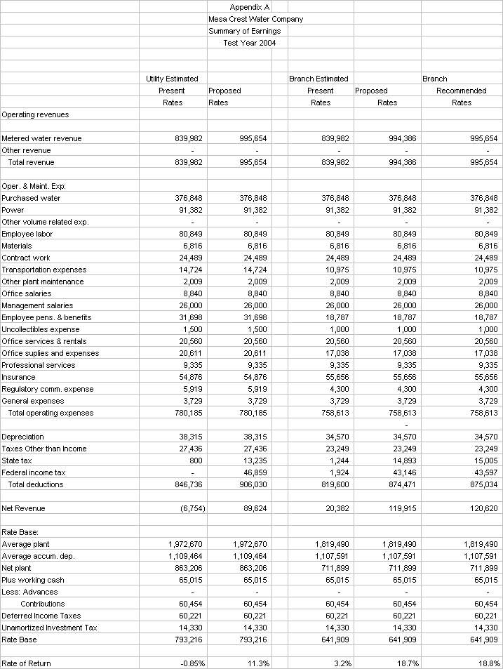
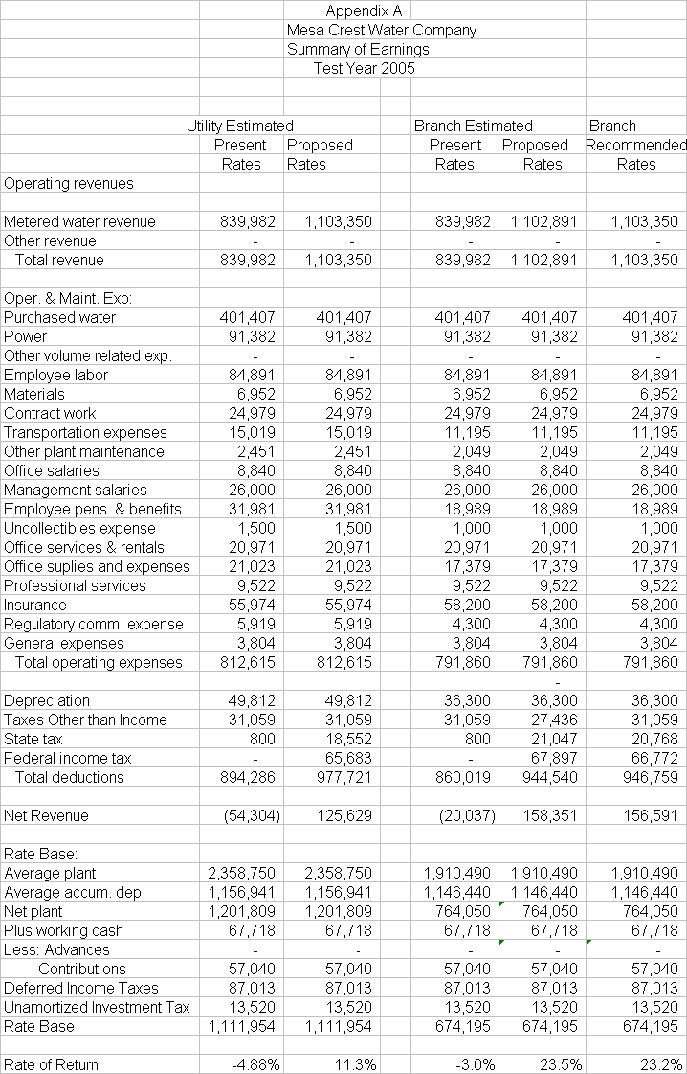

APPENDIX B
Mesa Crest Water Company
Schedule No. 1
METERED SERVICE
Test Year 2004

APPLICABILITY

Applicable to all metered water service.

TERRITORY

The vicinity of La Canada, Los Angeles County.

RATES

Quantity Rates:

All water, per 100 cu. ft. $ 2.56 (I)

Service Charge: Per Meter
Per Month
For 5/8 x ¾-inch meter $ 15.03 (I)
For 3/4-inch meter $ 22.55 |
For 1-inch meter $ 37.58 |
For 1-1/2-inch meter $ 75.15 |
For 2-inch meter $120.24 |
For 3-inch meter $225.45 |
For 4-inch meter $375.75 (I)

The Service Charge is applicable to all metered service. It is a readiness-to-serve charge to which is added the charge, computed at the Quantity Rate, for water used during the month.

SPECIAL CONDITIONS

- All bills are subject to the reimbursement fee set forth in Schedule No. UF.

APPENDIX B
Mesa Crest Water Company
Schedule No. 1
METERED SERVICE
Test Year 2005

APPLICABILITY

Applicable to all metered water service.

TERRITORY

The vicinity of La Canada, Los Angeles County.

RATES

Quantity Rates:

All water, per 100 cu. ft. $ 2.82 (I)

Service Charge: Per Meter
Per Month
For 5/8 x ¾-inch meter $ 16.93 (I)
For 3/4-inch meter $ 25.40 |
For 1-inch meter $ 42.33 |
For 1-1/2-inch meter $ 84.65 |
For 2-inch meter $135.44 |
For 3-inch meter $253.95 |
For 4-inch meter $423.25 (I)

The Service Charge is applicable to all metered service. It is a readiness-to-serve charge to which is added the charge, computed at the Quantity Rate, for water used during the month.

SPECIAL CONDITIONS

- All bills are subject to the reimbursement fee set forth in Schedule No. UF

APPENDIX B
Mesa Crest Water Company
Schedule No. 4
PRIVATE FIRE SERVICE
Test Year 2004

APPLICABILITY

Applicable to all metered water service.

TERRITORY

The vicinity of La Canada, Los Angeles County.

RATES

Service Charge: Per Month

For 4-inch service $ 21.15 (I)
For 6-inch service $ 31.75 (I)

SPECIAL CONDITIONS

- The fire protection connection shall be installed by the utility and the cost paid by the applicant. Such payment shall not be subject to refund.
- The minimum diameter for fire protection service shall be four inches, and the maximum diameter shall be not more than the diameter of the main to which the service is connected.
- If a distribution main of adequate size to serve a private fire protection system in addition to all other normal service does not exist in the street or alley adjacent to the premises to be served, then a service main from the nearest existing main of adequate capacity shall be installed by the utility and the cost paid by the applicant. Such payment shall not be subject to a refund.
- Services hereunder is for private fire protection systems to which no connection for other than fire protection purposes are allowed and which are regularly inspected by the underwriters having jurisdiction, are installed according to specification of the utility, and are maintained.

APPENDIX B
Mesa Crest Water Company
Schedule No. 4
PRIVATE FIRE SERVICE
Test Year 2005

APPLICABILITY

Applicable to all metered water service.

TERRITORY

The vicinity of La Canada, Los Angeles, County.

RATES

Service Charge: Per Month

For 4 inch service $ 23.43 (I)
For 6 inch service $ 35.19 (I)

SPECIAL CONDITIONS

- The fire protection connection shall be installed by the utility and the cost paid by the applicant. Such payment shall not be subject to refund.
- The minimum diameter for fire protection service shall be four inches, and the maximum diameter shall be not more than the diameter of the main to which the service is connected.
- If a distribution main of adequate size to serve a private fire protection system in addition to all other normal service does not exist in the street or alley adjacent to the premises to be served, then a service main from the nearest existing main of adequate capacity shall be installed by the utility and the cost paid by the applicant. Such payment shall not be subject to a refund.
- Services here under is for private fire protection systems to which no connection for other than fire protection purposes are allowed and which are regularly inspected by the underwriters having jurisdiction, are installed according to specification of the utility, and are maintained.

(END OF APPENDIX B)

APPENDIX C
Mesa Crest Water Company
COMPARISON OF RATES
Test Year 2004

Percent
Present Recommended Increase
Rates Rates (Decrease)

Quantity Charge:
For all water, per 100 cu.ft. $2.556 $2.56 1.6%

Monthly Service Charges:

For 5/8 x ¾ - inch meter $ 7.42 $ 15.03 102.6%
For ¾ - inch meter $ 11.12 $ 22.55 102.8%
For 1 - inch meter $ 18.53 $ 37.58 102.8%
For 1½ - inch meter $ 37.07 $ 75.15 102.7%
For 2 - inch meter $ 59.31 $ 120.24 102.7%
For 3 - inch meter $ 111.21 $ 225.45 102.7%
For 4 - inch meter $ 185.35 $ 375.75 102.7%

Private Fire Service:

For 4 - inch service $ 17.84 $ 21.15 18.6%
For 6 - inch service $ 26.79 $ 31.75 18.5%

A monthly bill comparison for a customer with a 1-inch meter is shown below:

Usage Present Recommended Amount Percent
100 cu. ft. Rates Rates Increase Increase

10 $ 44.09 $ 63.18 $19.09 43.3%
20 69.65 88.78 19.13 27.5%
30 95.21 114.38 19.17 20.1%
32 (avg.) 100.32 119.50 19.18 19.1%
40 120.77 139.98 19.21 15.9%

APPENDIX C
Mesa Crest Water Company
COMPARISON OF RATES
Test Year 2005

Percent
Present Recommended Increase
Rates Rates (Decrease)

Quantity Charge:
For all water, per 100 cu.ft. $2.556 $ 2.82 10.3%

Monthly Service Charges:

For 5/8 x ¾ - inch meter $ 7.42 $ 16.93 128.2%
For ¾ - inch meter $ 11.12 $ 25.40 128.4%
For 1 - inch meter $ 18.53 $ 42.33 128.4%
For 1½ - inch meter $ 37.07 $ 84.65 128.4%
For 2 - inch meter $ 59.31 $ 135.44 128.4%
For 3 - inch meter $ 111.21 $ 253.94 128.4%
For 4 - inch meter $ 185.35 $ 423.75 128.4%

Private Fire Service:

For 4 - inch service $ 17.84 $ 23.43 31.3%
For 6 - inch service $ 26.79 $ 35.19 31.4%

A monthly bill comparison for a customer with a 1-inch meter is shown below:

Usage Present Recommended Amount Percent
100 cu. ft. Rates Rates Increase Increase

10 44.09 70.53 26.44 60.0%
20 69.60 98.73 29.08 41.8%
30 95.21 126.93 31.72 33.3%
32 (avg.) 100.32 132.57 32.25 15.0%
40 120.77 155.13 34.36 12.1%

(END OF APPENDIX C)

APPENDIX D
Page 1 of 3
Mesa Crest Water Company
ADOPTED QUANTITIES
Test Year 2004

Purchased Power
Southern California Edison
Schedule PA-1

Total Energy Cost $91,382
Total kWh 811,240
Average Unit Cost $/kWh $0.1126

Purchased Water $376,848
Water Sales Ccf 270,028

Payroll
Employee Labor $80,849
Office Salaries 8,840
Management Salaries 26,000

Payroll Taxes $10,062

Service Connections

Meter Size
5/8 x 3/4" 134
3/4" 1
1” 548
1 1/2" 12
2” 10
3” 2
Total Metered 707
===

APPENDIX D
Page 2 of 3
Mesa Crest Water Company
ADOPTED QUANTITIES
Test Year 2005

Purchased Power
Southern California Edison
Schedule PA-1

Total Energy Cost $91,382
Total kWh 811,240
Average Unit Cost $/kWh $0.1126

Purchased Water $401,407
Water Sales Ccf 270,028

Payroll
Employee Labor $84,891
Office Salaries 8,840
Management Salaries 26,000

Payroll Taxes $10,313

Service Connections

Meter Size
5/8 x 3/4" 134
3/4" 1
1” 548
1 1/2" 12
2” 10
3” 2
Total Metered 707
===

APPENDIX D
Page 3 of 3
Mesa Crest Water Company
ADOPTEDTAX CALCULATIONS
Test Year 2004

State Tax Rate: 8.84%
Federal Tax Rate: 15% for 1st $50,000 taxable income
25% for next $25,000 taxable income
34% for next $25,000 taxable income
39% above

Operating Revenues $ 995,654
Expenses $ 758,613
Depreciation $ 34,570
Taxes other than Income $ 23,249
Interest $ 9,482
Taxable Income for State $ 169,740
State tax $ 15,005
Taxable Income for Federal $ 154,735
Federal tax $ 49,597

ADOPTED TAX CALCULATIONS
Test Year 2005

Operating Revenues $ 1,103,350
Expenses $ 791,860
Depreciation $ 36,300
Taxes other than Income $ 31,059
Interest $ 9,204
Taxable Income for State $ 234,927
State tax $ 20,768
Taxable Income for Federal $ 214,159
Federal tax $ 66,772

(END OF APPENDIX D)

D.92-03-093. March 31, 1992.
ibid, p.37.

