PUBLIC UTILITIES COMMISSION OF THE STATE OF CALIFORNIA

Telecommunications Division | RESOLUTION T-17000
Public Programs Branch | March 15, 2006

R E S O L U T I O N

Resolution T-17000. Budget Phone, Inc. To designate Budget Phone Inc. as an Eligible Telecommunications Carrier (ETC) pursuant to Resolution T-16086.
_____________________________________________________________

Summary

This Resolution addresses the request of Budget Phone Inc. (Budget Phone) for designation as an Eligible Telecommunications Carrier (ETC) in certain exchanges of Verizon and SBC as shown in Appendices A & B of this Resolution.

Although Budget Phone has satisfied most of the requirements for ETC designation as identified in Resolution T-16086, the Commission finds that Budget Phone’s submission lacks adherence to certain requirements. Therefore, this resolution grants conditional approval of Budget Phone’s request subject to submission of a letter to the Director of TD, within 15 days from the adoption of this Resolution, attesting, under penalty of perjury, that it will comply with the following requirements:

- Comply with all of the requirements applicable to competitive local exchange carriers (CLCs) as indicated in Appendix B of Decision (D.) 02-05-031;
- Update its website to include a list of services offered in California;
- Update its website to include a list or a map of areas served in California;
- Revise its tariffs to include toll limitation as an offered service; and
- Expand its advertisement to other media of general circulation such as newspapers of general distribution, radio, website, annual bill inserts, white page directories, and other means in accordance with the Federal Communications Commission’s (FCC) Report and Order (FCC 97-157) in the matter of Federal-State Joint Board on Universal Service (CC Docket No.96-45)

This resolution likewise grants authority to the Director of TD to issue a letter to Budget Phone granting final approval to Budget Phone’s request for designation as an ETC after TD has verified that the aforementioned requirements have been met.

It is stressed that Budget Phone is obligated to provide all the designated services for federal universal service support in the areas for which it is designated an ETC.

Background

Pursuant to FCC 97-157, only ETCs designated by state commissions will be eligible to receive federal high cost, low income, and most rural health care universal service support beginning January 1, 1998. In compliance with this FCC order, the Commission adopted Resolution T-16086 requiring carriers seeking ETC designation to provide the following to comply with ETC eligibility and service requirements:

- self-certification letters indicating their compliance with the ETC eligibility requirements;
  - the service areas for which the carrier is requesting ETC designation;
  - an itemized list of the designated services to be provided;
  - a list of any services which the carrier proposes not to provide and for which the carrier is requesting an extension of time;
  - an indication of whether the carrier plans to apply for a waiver of the requirement that an ETC not disconnect Lifeline service for non-payment of toll charges;
  - a description of the carrier’s advertising plan, indicating the advertising media to be used, and an explanation of how its plan meets the advertising requirement in section 214(e) of the Telecommunications Act.
- advice letters to implement any necessary tariff changes consistent with the ETC service requirements and
- requests for additional time to complete network upgrades needed to provide single-party, E-911, or toll limitation
services.
- a justification for the extension request;
- an indication of the length of time for which the extension is being sought;
- an implementation plan for the network upgrades necessary to provide any of the above services; and
- an estimate of the cost of undertaking the network upgrades.

Furthermore, carriers seeking a waiver of the prohibition to disconnect Lifeline service for non-payment of toll charges were directed to apply such a waiver to the Commission. The waiver application must demonstrate that:

    - the carrier would incur substantial costs in complying with this requirement;
    - the carrier offers toll limitation to qualifying low-income customers without charge;
    - the telephone subscribership among low-income customers in its area is greater than or equal to the national subscribership rate for low-income consumers.

Notice/Protests

Notice of Filing of the petition by Budget Phone, to be designated as an ETC for purposes of federal universal service support was published in the Commission Daily Calendar of January 5, 2006. No protest to this letter request has been received.

Discussion

Budget Phone, a FCC licensed and CPUC certificated CLC, submitted a letter to TD on December 30, 2005 requesting for ETC designation. This Resolution addresses Budget Phone’s request for its compliance with Resolution T-16086.

Compliance with ETC Eligibility and Service Requirements

Budget Phone states that it will provide all of the following designated services:

- Voice-grade access to the public switched network;
- Local Usage;
- Dual tone multi-frequency (DMTF) signaling or its functional equivalent;
- Single-party service or its functional equivalent;
- Access to emergency services;
- Access to operator services;
- Access to interexchange service;
- Access to directory assistance; and
- Toll limitation.

Budget Phone likewise states that upon designation as an ETC, Budget Phone will participate in, and offer, LifeLine and Link-Up programs to qualifying low-income customers and publicize the availability of Lifeline and Link-Up services in a manner reasonably designed to reach those likely to qualify for those services, as required by FCC Rules. Budget phone likewise states that it will advertise the availability of these services in the Designated Areas using media of general distribution, as required by FCC Rules, including but not limited to, point of sale marketing materials at targeted retail locations, television and print ads.

Although a Certificate of Public Convenience and Necessity (CPCN) was granted to Budget Phone in Decision (D) 02-05-021, Budget Phone has not strictly and consistently complied with the terms and conditions set forth in Appendix B of this order. Furthermore, a check of Budget Phone’s website disclosed that their advertisement is primarily centered on prepaid home phone service, prepaid long distance calling cards and wireless phones. While the advertisement states that it operates in 45 states, Budget Phone did not identify the areas it serves in California. Therefore, Budget Phone should complete the following requirements as a condition for its designation as an ETC:

- Comply with all of the requirements applicable to competitive local exchange carriers (CLCs) as indicated in Appendix B of D. 02-05-031;
- Update its website to include a list of services offered in California;
- Update its website to include a list or a map of areas served in California;
- Revise its tariffs to include toll limitation as an offered service; and
- Expand its advertisement to other media of general circulation such as newspapers of general distribution, radio, website, annual bill inserts, white page directories, and other means in accordance with FCC Report and Order 97-157 in the matter of Federal-State Joint Board on Universal Service (CC Docket No.96-45)

Budget Phone should, within 15 days from the effective date of this resolution, send a letter to the TD Director, attesting, under penalty of perjury, that it will comply with the abovementioned requirements.

The TD Director will, after TD has verified that the above requirements have been met, send a letter to Budget Phone, granting final approval of its request for ETC designation.

Certification Requirements to be submitted to the FCC

After final approval as an ETC is issued by the TD Director, Budget Phone, should file information with the federal universal service administrator, the Universal Service Administrative Company (USAC), pursuant to 47 C. F. R. § 54.401 (d), demonstrating that its Lifeline service meets the FCC requirements, and stating the number of qualifying low-income customers and the amount of state assistance. Budget Phone shall provide the USAC an estimated amount of state assistance (if any) based on current ULTS rates, net of the expected amount of federal support. A Copy of Budget Phone’s filing with the USAC shall be provided to the TD Director.

Reimbursements from the ULTS Fund

As an ETC, Budget Phone is eligible to obtain federal Lifeline and Link Up support. In accordance with General Order (GO) 153, Procedures for the Administration of the Universal Lifeline Telephone Service (ULTS), Budget Phone’s claims from the ULTS Fund is reduced by amounts received under the federal ETC program.

Comments

In compliance with PU Code § 311 (g), a Notice of Availability was e-mailed on February 10, 2006, to every incumbent Local Exchange Carrier, facilities-based Competitive Local Carriers and facilities-based broadband Commercial Mobile Radio Service Carrier advising parties that this draft resolution is available on the Commission website at: http://www.cpuc.ca.gov/static/documents/index.htm and is available for public comments. In addition, TD informed these parties of the availability of the conformed resolution, when adopted by the Commission, at the same website.

TD received no comments on this resolution.

Findings

- Resolution T-16086 established a procedure for California telecommunications carriers to request designation as eligible telecommunications carriers (ETC).

- Budget Phone, Inc. (Budget Phone) is a Federal Communications Commission (FCC) licensed, California Public Utilities Commission (CPUC) certificated competitive local exchange carrier.

- On December 30, 2005, Budget Phone submitted a letter requesting designation as ETC in certain exchanges areas of Verizon and SBC as shown in Appendices A & B of this Resolution.

- Budget Phone’s filing was published in the Commission Daily Calendar of January 5, 2006.

- No protests were received on Budget Phone’s request for ETC designation.

- Budget Phone states that it will provide the following services: Voice-grade access to the public switched network; Local Usage; Dual tone multi-frequency (DMTF) signaling or its functional equivalent; Single-party service or its functional equivalent; Access to emergency services; Access to operator services; Access to interexchange service; Access to directory assistance; and Toll limitation.

- Although a Certificate of Public Convenience and Necessity (CPCN) was granted to Budget Phone in Decision (D.) 02-05-021, Budget Phone has not strictly and consistently complied with the terms and conditions set forth in Appendix B of this order.

- Although Budget Phone has substantially complied with the guidelines set in Resolution T-16086, it lacks adherence to certain requirements.
- Within 15 days from the effective date of this resolution, Budget Phone should send a letter to the Director of Telecommunications Division (TD) attesting, under penalty of perjury, that it will comply with the following requirements:
- Comply with all of the requirements applicable to competitive local exchange carriers (CLCs) as indicated in Appendix B of D. 02-05-031;
- Update its website to include a list of services offered in California;
- Update its website to include a list or a map of areas served in California;
- Revise its tariffs to include toll limitation as an offered service; and
- Expand its advertisement to other media of general circulation such as newspapers of general distribution, radio, website, annual bill inserts, white page directories, and other means in accordance with FCC Report and Order 97-157 in the matter of Federal-State Joint Board on Universal Service (CC Docket No.96-45)

- TD should verify that the above requirements have been met.
- The Director of TD should be given authority to send a final approval letter to Budget Phone designating Budget Phone, Inc. as an ETC after the aforementioned requirements have been met.
- After final approval is issued by the Director of TD, Budget Phone, as an ETC, should file information with the federal universal service administrator, the Universal Service Administrative Company (USAC). A Copy of Budget Phone’s filing with the USAC should be provided to the TD Director.
- A Notice of Availability was e-mailed on February 10, 2006 to every Local Exchange Carrier, all facilities-based Competitive Local Carrier, and all facilities-based broadband Commercial Mobile Radio Service Carrier, advising parties that the draft resolution is available on the Commission website at http://www.cpuc.ca.gov/static/documents/index.htm and is available for public comments. In addition, TD informed these parties of the availability of the conformed resolution, when adopted by the Commission, at the same website.

- TD received no comments on this resolution.

THEREFORE, IT IS ORDERED that:

- Budget Phone, Inc. (Budget Phone) is granted conditional approval as an Eligible Telecommunications Carrier (ETC) in exchanges served by Verizon and SBC as shown in Appendices A & B of this Resolution.

- As a condition for being designated as an ETC, Budget Phone shall, within 15 days from the effective date of this resolution, submit an attestation letter to the Telecommunications Division (TD) Director certifying, under penalty of perjury, that it will:

- Comply with all of the requirements applicable to competitive local exchange carriers (CLCs) as indicated in Appendix B of Decision 02-05-031;
- Update its website to include a list of services offered in California;
- Update its website to include a list or a map of areas served in California;
- Revise its tariffs to include toll limitation as an offered service; and
- Expand its advertisement to other media of general circulation such as newspapers of general distribution, radio, website, annual bill inserts, white page directories, and other means in accordance with the Federal Communications Commission’s (FCC) Report and Order (FCC 97-157) in the matter of Federal-State Joint Board on Universal Service (CC Docket No.96-45)

- The TD Director is granted the authority to send a final approval letter to Budget Phone designating Budget Phone, Inc. as an ETC after the aforementioned requirements have been met.

4. As a designated ETC, Budget Phone shall file information with the federal universal service administrator, the Universal Service Administrative Company (USAC). A Copy of Budget Phone’s filing with the USAC shall be provided to the TD Director.

This Resolution is effective today.

I hereby certify that this Resolution was adopted by the Public Utilities Commission at its regular meeting on March 15, 2006. The following Commissioners approved it:

/s/ STEVE LARSON

STEVE LARSON

Executive Director

MICHAEL R. PEEVEY
President
GEOFFREY F. BROWN
DIAN M. GRUENEICH
JOHN A. BOHN
RACHELLE B. CHONG
Commissioners

APPENDIX A

LIST OF EXCHANGES

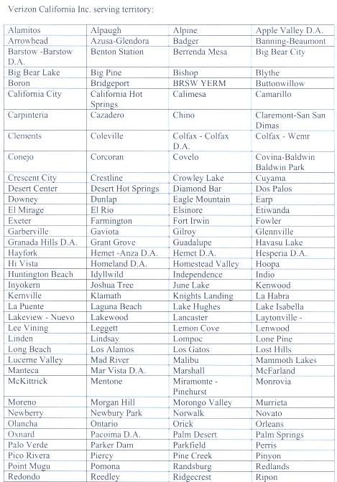
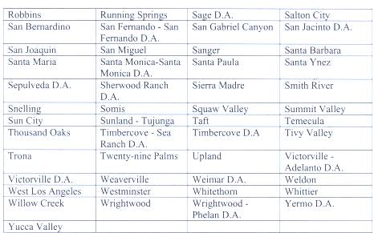
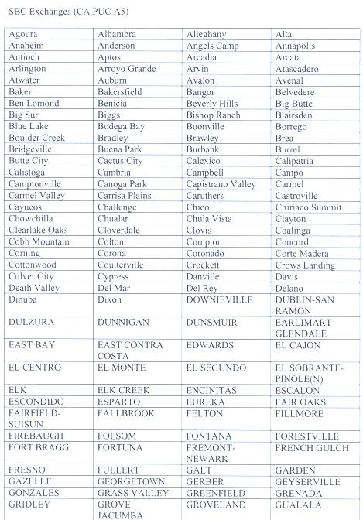
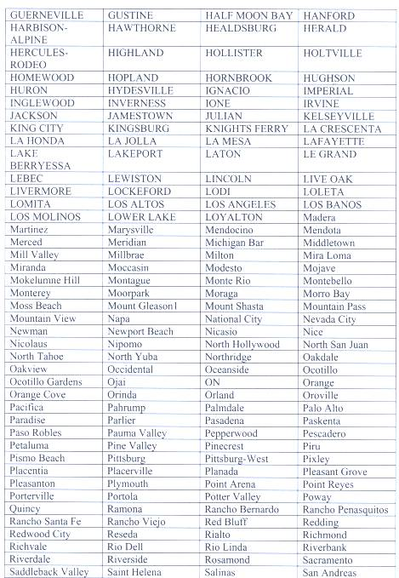
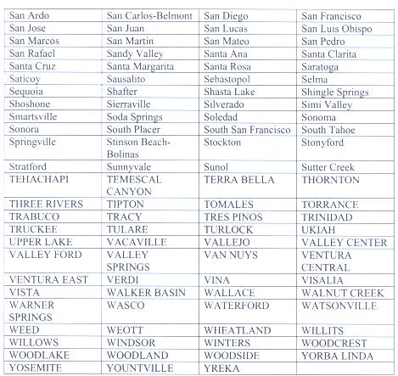

APPENDIX B

SERVICE MAP
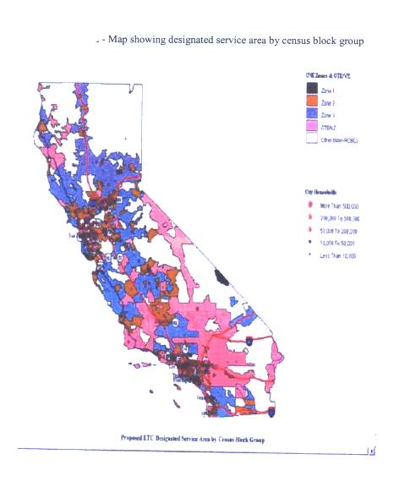

47 C.F.R. §54.201 (a) (1).
Id., O. P. 3.
Resolution T-16086, O. P. 1 & 2.

