PUBLIC UTILITIES COMMISSION OF THE STATE OF CALIFORNIA

ENERGY DIVISION RESOLUTION E-4028
October 19, 2006

RESOLUTION

Resolution E-4028. This Resolution denies in part Southern California Edison Company’s (SCE) request of an additional $37.03 Million to accelerate and expand an additional 300 MW of AC Cycling from August 2006 to July 2007, giving SCE a total of 675 MW by summer 2007. As an alternative, the Resolution approves an acceleration of an additional 225 MW from August 2006 to July 2007 at a cost of $18.4 Million, giving SCE a total of 600 MW by summer 2007. SCE’s request to modify its AC Cycling program design is partially approved.

By Advice Letter 2034-E Filed on August 29, 2006.
__________________________________________________________

Summary
This Resolution denies in part SCE’s request of an additional $37.03 Million to accelerate and expand an additional 300 MW of AC Cycling from August 2006 to July 2007, giving SCE a total of 675 MW by summer 2007. As an alternative, the Resolution approves an acceleration of an additional 225 MW from August 2006 to July 2007 at a cost of $18.4 Million, giving SCE a total of 600 MW by summer 2007. Energy Division believes a total of 600 MW of AC Cycling by summer 2007 will address Southern California’s critical near-term reliability needs.

To reach an additional 225 MW by summer 2007, SCE is authorized to implement the acceleration plan as describe below:
- Significantly increase marketing and outreach activities for AC Cycling.
- Expand the installation of devices to evenings and weekends.
- Offer incentives to recapture dormant devices.

This Resolution partially approves SCE’s request to modify its AC Cycling program design as follows:
- Denies SCE’s proposal to close its Base option to new enrollment and instead, orders SCE to revise its mail-in enrollment form to include the same language and format as its online enrollment form.
- Denies SCE’s proposal to close its Residential 67 % cycling option to new enrollment.
- Approves SCE’s proposal to close its Commercial 40% cycling strategy to new enrollment.
- Approves SCE’s proposal to allow for the removal of customers prior to one year of service due to serious health problems.
- Partially denies SCE’s proposal to include two 1-hour test events and instead, allows SCE to hold one 30-minute test event and if warranted, a second 30-minute test event.
- Approves SCE’s proposal to remove language from the applicability sections of tariff: schedules D-APS and D-APS-E.

This Resolution also orders Southern California Edison to provide a monthly progress report on its effort toward reaching the MW goal to the service list of A.05-06-006 et. al. on the 15th of each month commencing December 15, 2006 until October 2007.

Background
SCE’s Air Conditioning Cycling Program (also known as the Summer Discount Plan) is part of SCE’s three-year (2006-2008) demand response budget application which the Commission approved recently in D.06-03-024 in A. 05-06-008.

The Air Conditioner Cycling Program (AC Cycling Program) is available for individually-metered residential, commercial and industrial customers with central air conditioning, where the air conditioner’s electrical load is subject to temporary disconnection through automatic load control devices. Currently, there are two AC Cycling Program options in which customers may enroll: the Base program and the Enhanced program. The Base program is limited to 15 events during the summer months, with a maximum duration of six hours per event, for a total of 90 hours of interruption. The Enhanced program has an unlimited number of events, for a maximum of 720 hours of interruption during the summer months. An event may be called when the CAISO requests load reductions during the summer or when SCE calls a local event. The incentive credits are based on the installed air conditioner tonnage and the participating customer’s elected cycling strategy, which currently includes 50%, 67%, and 100% for residential customers and 30%, 40%, 50%, and 100% for commercial and industrial customers. Customers enrolled in the Base program receive an average of $100 per summer, and those enrolled in the Enhanced program received an average of $200 per summer.

Cycling Strategy
Comfort Choice | Cooling Cycle
100% | Off continuously for duration of event
67% | Off 20 minutes out of every 30 minutes
50% | Off 15 minutes out of every 30 minutes
40% | Off 12 minutes out of every 30 minutes
30% | Off 9 minutes out of every 30 minutes

In the August 15, 2006 Assigned Commissioner’s Ruling Addressing Electric Reliability Needs in Southern California for Summer 2007 (“Electric Reliability ACR”), Commissioner President Peevey directed SCE to target an additional 300 megawatts (MW) of AC Cycling program capacity for summer 2007. This ruling is in response to the growth in electricity demand throughout the state and the July 2006 heat storm which had exposed certain vulnerabilities in the electric generation and transmission infrastructure. To expand the AC Cycling program, the Electric Reliability ACR directed SCE to determine if shifting the existing demand response funds can cover the costs of the additional 300 MWs or if additional funds (incremental to those previously approved in D.06-03-024) are necessary, and to provide this information to the Commission via the process outlined in ACR issued August 9, 2006.

Under the existing AC Cycling program, SCE is authorized to install 60,000 devices each year in order to enroll 84 MW annually over the 2006-2008 program cycle. SCE is currently authorized to spend $51.4 million on AC Cycling during the 2006-2008 program cycle between the amount authorized in D.06-03-024 and in the SCE’s 2006 General Rate Case. The $54.1 million funding was expected to be spent over the three year period for a total of 180,000 devices.

Accordingly, SCE filed advice letter 2034-E on August 29, 2006 to request an additional $37.03 million to accelerate and expand AC Cycling program by an additional 300 MW by summer 2007. SCE’s strategy to reach the 300 MW by summer 2007 is to accelerate the planned installation of devices by more than one year to July 2007. SCE states it has already installed 16,000 devices (~25MW) in August 2006. In addition, SCE proposes to accelerate the installation of the remaining 136,000 approved devices (equivalent to about 190 MW) by July 2007, which brings the total added MW since July 2006 to 215 MW. To reach the 300 MW goal by summer 2007, SCE needs to install 62,000 more devices that would add another 85 MW.

SCE states that this acceleration and expansion effort will require the following:
- Significantly increase marketing and outreach activities to enroll new customers during 2006 and early 2007, particularly during the winter months when it will be more difficult to focus customers’ attention on summer peak electricity usage.
- Purchase and install additional devices beyond what was planned to achieve 300 MW by summer 2007. Devices will need to be manufactured on an accelerated schedule, which will increase the cost of the devices.
- Expand installation to evenings and Sundays. This may require SCE to hire and pay contractors at overtime rates for evening and Sunday installations.
- Offer incentives to recapture 90,000 dormant devices. There are approximately 90,000 installed devices in SCE’s service territory that are not active because the participating customers moved and the new residents have not yet enrolled in AC Cycling program. SCE proposes to offer the new residents an “activation” incentive to encourage them to enroll in the AC Cycling program.

In addition, SCE proposes to streamline its program implementation and simplify customers’ choices for enrollment by making the following modifications to its AC Cycling program design:

- Close the Base option to new enrollment: SCE proposes to close the Base option to new enrollment, and instead offer only the unlimited Enhanced program for new enrollment. The vast majority of new enrollments have been in the Enhanced program.
- Close Residential 67 % cycling option to new enrollment: This option creates unnecessary confusion for customers when deciding which option to choose and is more complicated to implement.
- Close Commercial 40% cycling option to new enrollment: This option has the lowest level of participation.
- Allow for the removal of customers prior to one year of service due to serious health problems: The recent heat storm revealed the need for SCE to be able to move a residential customer’s account off of the AC Cycling program prior to one year of service if a member of the customer’s household develops a serious medical condition that is substantiated by a medical provider subsequent to program enrollment that, in SCE’s discretion, would have disqualified the customer from enrolling in AC Cycling program in the first place.
- Include two 1-hour test events: SCE requests to switch from one 15-minute test event to two 1-hour test events. A single 15-minute window for testing the communication systems is not sufficient given the various cycling strategies; a test should be one-hour in length.
- Remove language from the applicability section of tariff schedule D-APS and D-APS-E: Tariff schedules D-APS and D-APS-E currently exclude TOU-D-1 and TOU-D-2 customers from participating in the AC Cycling program. SCE proposes to remove this restriction.

Notice
Notice of AL 2034-E was made by publication in the Commission’s Daily Calendar. SCE states that a copy of the Advice Letter was mailed and distributed in accordance with Section III-G of General Order 96-A as well to the parties in A.05-06-006 et al.

Protests
SCE’s Advice Letter 2034-E was timely protested by The Utility Reform Network (TURN) and the Division of Ratepayer Advocates (DRA) on September 11, 2006.

SCE addressed both protests on September 18, 2006.

Discussion
In light of the ACR and the time frame that it sets, and given the language of the D.06-03-024 authorizing the use of an advice letter, Energy Division believes that an AL is an appropriate process in this case, despite the amount of funds requested. Both TURN and DRA objected to SCE’s request for $37 million by advice letter format and request that this proposal be addressed along with SCE’s other augmentation proposals, written in response to Commissioner Peevey’s August 9, 2006 ACR (“DR Augmentation ACR”), which reopens the record of A.05-06-006 et al. and directs the utilities to propose program augmentations and improvements in its DR program for 2007 and 2008.

DRA believes that the record is insufficient to ascertain either the need for the entire $37 million SCE requested, or that the program expansion goal cannot be met by using the unspent demand response dollars currently included in SCE’s currently authorized budget.

TURN argues that by addressing the $37 million AC Cycling budget increase in the same application with the DR Augmentation ACR, it would allow a more comprehensive comparison of all of SCE’s proposal and the ability to shift funds between all existing demand response programs. Both argue that a filing for incremental funding through an advice letter does not significantly expedite the approval process in comparison to the DR Augmentation ACR schedule.

In a reply comment, SCE argued that General Order 96-A provides that a request to revise tariffs is properly made through an advice letter filing. SCE believes that delaying the AL 2034-E will jeopardize SCE’s ability to provide the additional MWs by summer 2007. SCE believes that the final decision on the proposal filed in A.05-06-006 et al. may not be issued until November 30, 2006, and thus too late to ramp up fully to the expanded 300 MW goal.

Energy Division believes addressing the AC Cycling in an AL format is appropriate. A settlement that was adopted in D.06-02-024 states, "The utilities shall file any proposals or requests for incremental funding for new or existing programs by advice letter or application." Thus, SCE may request additional funding through an AL filing. The settlement also requires the IOUs to collaborate with intervenors on their proposals, and in this case, SCE held a teleconference meeting to inform parties of this proposal. Both TURN and DRA were included as among the settling parties.

If SCE’s request for incremental funding is reviewed under this advice letter format, both TURN and DRA argue that SCE’s request for $37 million be rejected as an unnecessary increase in funding.

TURN suggests that SCE should exhaust its existing DR funds before requesting additional funds. According to the utility monthly report, by the end of July, SCE had only spent $7.5 million of its $37.1 million total demand response budget. In addition, TURN recommends that SCE terminate its PEAK program and shift those unused $2.8 million funds towards the AC Cycling proposed program modifications.

DRA questions whether SCE really needs the entire $37 million requested, or that this additional funding need cannot be meet by using the unspent demand response dollars already included in SCE’s currently authorized revenue requirements. DRA believes under SCE’s current budget, SCE has enough money to start its aggressive effort. DRA recommends that SCE focus on recapturing the 90,000 devices that are currently dormant and if activated, could add as much as 126 MW of potential demand response reduction without much additional cost.

In its reply comment, SCE explained that accelerating the installation of the authorized devices will require significant incremental marketing and outreach activities to successfully compress 30 months’ of activity into less than one year. To increase marketing to the level required to target an additional 300 MW by July 2007 means that SCE could run out of funding to complete even the installation of the authorized devices. SCE claimed that the incremental funding is required because it is much more costly to undertake this effort at such a rapid pace.

Both TURN and DRA also raised the issue of whether the 300 MW is an achievable or necessary goal for SCE AC Cycling program. TURN points out the SCE already has close to 1000 MW in I-6 interruptible and AC cycling reliability and that it is unlikely that the utility will be able to increase customer participation at the expedited rate. TURN believes that the incremental cost of $37 million to achieve an additional 85 MW by 2007 is nothing more than a “panic premium” rate for ratepayers.

DRA points out that the large portion of the $37 million funding request will be spent on marketing and outreach, but reaching the 300 MW goal is by no means assured. SCE’s current marketing efforts have already captured the “low-hanging fruit” and have seen a gradual decline in customer response from SCE’s promotions: from 4% in 2004 to about 1.2% in 2006. DRA believes this strongly suggests the likelihood that SCE will encounter ever increasing expenses for each additional customer enrolled. In response to Commissioner Chong’s inquiry at the September 6, 2006 workshop, SCE admitted it would probably not meet this goal by summer 2007. DRA urges the Commission to carefully examine the cost-effectiveness of additional spending by SCE.

Energy Division evaluated SCE’s proposal and is deeply concerned with the cost of the proposal and achievability of the additional 300 MW goal from August 2006 to July 2007.
Energy Division did consider shifting funds from other DR programs, but given the scope of the AC Cycling expansion, there is not enough “untapped” money available to cover such expenses through fund shifting alone. Through a data request, Energy Division found that SCE’s other programs are well underway and does not believe it is advisable to shift additional funds from those programs beyond what SCE is already planning to do. In response to an Energy Division data request, SCE states that there is some potential available funding under the TA/TI program. However, SCE believes that such funding would be the source of its water agency and load management (thermal energy storage) proposals that it intends to file in October 2006. With the exception of the PEAK program, Energy Division could not find any “untapped” money available to shift into the AC Cycling expansion.

The PEAK program is an educational program intended to teach school children the value of smart energy management. By providing students with demand response information, the program hoped it would have a two-fold impact: 1) it would begin to instill a smart energy management ethic in youth; and 2) it would affect the purchasing and energy management behavior of the students’ parents. The Commission believes it is important to continue increasing consumer awareness and knowledge of demand response.

Energy Division investigated other options to see what would be possible if the CPUC did not authorize any incremental funding for the AC Cycling program acceleration or expansion. In a response to an Energy Division data response, SCE states it would continue on the pace of adding 84 MW annually over the 2006-2008 program cycles, which would amount to an additional 224 MW by end of 2008. SCE would not recommend accelerating the installations in such a way that it would run out of money by 2007 and be forced to shut down the program.

Energy Division sent SCE numerous data requests in search of alternative options. Through a data response, SCE did consider another alternative scenario of accelerating the planned 2006-2008 installations without any expansion of the AC Cycling program. In this case, SCE estimated installing the 160,000 remaining devices (224 MW) by summer 2007, which would still require a significant increase in marketing activities. Under this scenario, SCE assumed continuous enrollment from August 2007 to December 2008 at a normal pace (for an additional 60,000 devices or 84 MW). The total estimated incremental cost for this alternative scenario is approximately $23.4 Million.

Based upon the analysis it could complete under a compressed timeframe, Energy Division considered the following three options for SCE AC Cycling program:

Option A: Existing AC Cycling Program - $51.4 million
Under the existing AC Cycling program, SCE would continue on the pace of adding 84 MW annually over the 2006-2008 program cycle, which would amount to an additional 115 MW by July 2007, giving SCE a total of 481 MW by summer 2007. SCE is currently authorized to spend $51.4 million on AC Cycling during the 2006-2008 program cycle between the amount authorized in D.06-03-024 and in the SCE’s 2006 General Rate Case.

Existing AC Cycling Program
Date | Devices | New MW | Total MW
01/06 – 7/31/06 | 17,500 | 24 | 376
08/06 – 12/06 | 42,500 | 60 | 426
By 07/07 | 39,000 | 55 | 481
By 12/07 | 21,000 | 29 | 510
By 07/08 | 39,000 | 55 | 565
By 12/08 | 21,000 | 29 | 594
Total by 2008 | 180,000 | 252 | 594

Option B: 225 MW Accelerated for additional $23.4 Million, giving a total overall budget of $74.8 Million
Under the 225 MW Accelerated option, SCE would install up to 164,000 devices from August 2006 to July 2007, which would amount to an additional 225 MW by July 2007, giving SCE a total of 600 MW by summer 2007. The total estimated incremental cost for this Option B is approximately $23.4 million.

225 MW Accelerated
Date | Devices | New MW | Total MW
01/06 – 7/31/06 | 17,500 | 24 | 376
By 07/07 | 164,000 | 225 | 600
By 07/08 | 28,000 | 39 | 645
By 12/08 | 20,000 | 28 | 673
Total by 2008 | 229,500 | 316 | 673

Option C: 300 MW Accelerated and expanded for additional $37 Million, giving a total of $88.3 Million
Under the 300 MW Accelerated and expanded option, SCE would install up to 214,000 devices from August 2006 to July 2007, which would amount to an additional 300 MW by July 2007, giving SCE a total of 675 MW by summer 2007. The total estimated incremental cost for this Option C is approximately $37 Million.

300 MW Accelerated and Expanded
Date | Devices | New MW | Total MW
01/06 – 7/31/06 | 17,500 | 24 | 376
By 07/07 | 214,000 | 300 | 675
By 07/08 | 32,000 | 45 | 720
By 12/08 | 20,000 | 28 | 748
Total by 2008 | 283,500 | 397 MW | 748

Energy Division believes that accelerating AC cycling installation to achieve an additional 225 MW for a total of 600 MW by July 2007, will enhance reliability for summer 2007. The heat storm that hit California in July 2006 and the growth in electricity demand throughout the state have exposed certain vulnerabilities in the electric generation and transmission infrastructure that require immediate attention to assure reliability in 2007, particularly in parts of southern California. Looking ahead to next summer, it is prudent to go forward with the expectation that a repeat of this summer’s experience, and/or a continuation of the unexpectedly high growth in overall demand, is possible in 2007. Energy Division is faced with difficult options because we have to balance reliability needs with cost. Energy Division is persuaded that targeting an additional 300 MW for summer 2007 is an extremely aggressive goal, and as SCE stated, “by no means assured.” However, we cannot “bury our heads in the sand”, waiting for a repeat of the recent heat storm that exposed us to certain vulnerabilities in the electric generation and transmission infrastructure. Energy Division believes we need to take action now to enhance reliability needs for next summer. To address critical short-term reliability needs in Southern California, we believe SCE needs at least a total of 600 MW of AC Cycling by the summer of 2007. Therefore, Energy Division believes that accelerating the installation of 225 MW by July 2007, giving SCE a total of 600 MW by summer 2007, is a realistic goal. SCE states that the total estimated incremental cost for this is approximately $23.4 Million.

In its comment to the draft resolution, DRA recommends that the Commission should reduce the proposed $23.4 Million incremental cost by $5 to $7.5 Million based on reasonable participation of customers with dormant devices (see comment section). DRA believes SCE’s estimation of the 5% penetration rate for customers with the dormant device should be higher from 20% to 30%. Energy Division agrees with DRA’s recommendation to reduce the proposed $23.4 Million incremental cost by $5 Million based on reasonable participation of customers with dormant devices. This gives SCE a total of $18.4 Million to accelerate the installation of 225 MW by July 2007.

The $18.4 million funding is based on the estimated cost to (1) significantly increase marketing and outreach activities to continue enrolling customers during 2006 and early 2007, particularly during the winter months when it will be more difficult to focus customers’ attention on summer peak electricity usage, (2) hire and pay contractors to install the devices and to procure additional cycling devices that will need to be manufactured on an accelerated schedule, (3) expand the call center, and, (4) process more enrollment applications.

Given the tight timeframe, Energy Division believes that marketing and outreach activities are important part of capturing new customers for AC Cycling program. DRA recommends that SCE should not spend money in the fall and winter of 2006 if SCE does not think it will obtain good results. DRA asks that SCE provide monthly progress reports on its effort toward reaching the MW goal. In its response, SCE believes that if marketing is delayed until spring 2007, the MW goal will not be met, as it would be impossible to install so many devices for customers over just a few short months. To accelerate the effort by more than a year without additional budget for the increase in marketing and outreach as DRA suggests seems to be unreasonable. Even though it is more difficult to persuade customers to participate in the program during the fall and winter (off-season), Energy Division believes that greater customer awareness of the program will result in increased participation. Marketing and outreach activities during the off-season are not entirely a lost cause. Focused marketing such as providing referral incentives to heater repair contractors may result in additional enrollment during the off-season. We agree with SCE that there should be some cost to marketing during the off-season. To ensure that SCE is spending the money wisely, we agree with DRA that SCE should provide a monthly progress reports on its effort toward reaching the MW goal. On the 15th of each month until October 2007, SCE shall provide a monthly progress report to the service list of A.05-06-006 et. al. The report should include the cost breakdown of each media type, the additional enrollment by number of customers and by MWs, the cost and number of new devices installed, and the number of dormant devices activated and associated cost of direct mailing and incentive paid.

Energy Division agrees with DRA’s proposal to immediately focus on recapturing the 90,000 devices that are currently dormant. DRA points out that recapturing the 90,000 devices, if activated, could add as much as 126 MW of potential demand response reduction without much additional cost. In the reply comment, SCE estimates that 5% of customer will enroll based on historical experience. In a response to Energy Division’s data response, SCE is planning to create two direct mailings to customers with dormant devices in the fall and winter. To maximize the response rate among this key group of customers, SCE is proposing to offer a $50 incentive to participate, as SCE would not incur installation fees for these customers. Energy Division agrees with DRA’s proposal to immediately focus on recapturing the 90,000 devices.

Developing a preliminary measurement protocols and cost-effectiveness test is complex and time consuming. In its protest, DRA urges the Commission to speed up the process for determining the MW impact and cost-effectiveness tests for demand response programs. At some point, it may become apparent that any additional spending on AC Cycling program may not yield enough additional MWs to justify the continuation of additional spending on the program. DRA believes if some interim protocols were developed, it would help ensure that the 2007 programs meet some minimum cost-effectiveness requirements, and that the programs selected will provide the most MW reductions for the available budget dollars.

In its response, SCE states it has provided a cost effectiveness of the AC Cycling program using the Standard Practice Manual, which was used to evaluate the 2006-2008 demand response programs.

Energy Division understands the need to develop measurement protocols and cost-effectiveness test, however the heat storm that hit California in late July caused unprecedented demand that strained the state’s electrical grid for several days. Because prolonged hot weather might occur in summer 2007, Energy Division’s chief concern is ensuring that demand response programs are available if needed.

In SCE’s advice letter filing, SCE proposes to modify its AC Cycling program by streamlining its program implementation and simplifying customers’ choices. Energy Division has reviewed the modification and has decided on the following:

- SCE’s proposal to close Base option (limited to 15 events per summer) to new enrollment is denied. SCE proposes to close the Base option to new enrollment, and instead offer only the unlimited Enhanced program for new enrollment. SCE claims that the vast majority of new enrollments have been on the Enhanced program. In response to an Energy Division data request, we found out that ~36% of residential customers are enrolled in the Base option. In fact, there are even more Commercial customers enrolled in the Base option than in the Enhanced option. Energy Division believes that by providing customers with a Base option, it will attract more enrollments.

- SCE’s proposal to close Residential 67% cycling option to new enrollment is denied: SCE claims this option creates unnecessary confusion for customers when deciding which option to choose and is more complicated to implement. In response to an Energy Division data request, we found out that there were more customers enrolled in the 67% cycling option than in the 50% cycling option. Energy Division does not see a need to close Residential 67% cycling option and believes that providing customer additional options would attract more enrollments.

- SCE’s proposal to close Commercial 40% cycling strategy to new enrollment is approved. Given that this 40% strategy has the lowest level of participation and Commercial customers have three other cycling strategies (30%, 50%, and 100%) to choose from, Energy Division does not see a need to continue with this strategy.

- SCE’s proposal to allow for the removal of customers prior to one year of service due to serious health problems is approved. The recent heat storm revealed the need for SCE to be able to move a residential customer’s account off of the AC Cycling program prior to one year of service if a member of the customer’s household develops a serious medical condition that is substantiated by a medical provider subsequent to program enrollment that, in SCE’s reasonable discretion, would have disqualified the customer from enrolling in AC Cycling program in the first place.

- SCE’s proposal to include two 1-hour test events is partially denied. SCE is allowed to hold one 30-minute test event and if warranted, a second 30-minute test event. SCE requests approval to switch from one 15-minute test event to two 1-hour test events. SCE claims that a single 15-minute window for testing the communication systems is not sufficient given the various cycling strategies; a test should be one hour in length. Energy Division believes that a one 30-minute test event is sufficient, but only if the system does not perform correctly after the first test event, then a second 30-minute test is warranted. Energy Division believes that two 1-hour test events may discourage potential enrollment.

- SCE’s proposal to remove language from the applicability section of tariff: schedule D-APS and D-APS-E is approved. Tariff schedule D-APS and D-APS-E currently exclude TOU-D-1 and TOU-D-2 customers from participating in the AC Cycling program. SCE proposes to remove this restriction. Energy Division believes a domestic Time-Of-Use customer who participates in the AC Cycling program has the potential to provide the same air conditioner load reduction as a domestic non Time-Of-Use customer.

Comments
Public Utilities Code section 311(g)(1) provides that this resolution must be served on all parties and subject to at least 30 days public review and comment prior to a vote of the Commission. Section 311(g)(2) provides that this 30-day period may be reduced or waived upon the stipulation of all parties in the proceeding.

Accordingly, on September 19, 2006 the draft resolution was served on the Service List for SCE Advice Letter 2034-E and A.05-06-006 et al., released for public comment, and placed on the Commission’s agenda for October 19, 2006. DRA filed comment on October 6 and both TURN and SCE filed comments on October 10, 2006. SCE filed reply comments on October 13, 2006.

In its comments, DRA recommends that the Commission should reduce the proposed $23.4 Million incremental cost by $5 to $7.5 Million based on reasonable participation of customers with dormant devices. DRA believes SCE’s historical rate of 5% for customers with dormant devices should be at lease the same or higher compare to customers without the dormant devices. Based on SCE’s estimated level of 20% participation rate for new customers without the dormant device over the next 10 month period (October 1, 2006 through July 31, 2007) and the $50/device incentives to customers with dormant devices, DRA believes a 20% to 30% participation rate among customers with dormant devices is a reasonable goal for SCE. DRA believes there is no reason why customer response with dormant devices will be any less than other customers who do not yet have the technology installed on their AC units.

Under Option B which is the total budget of $74.8 million for the three year cycle (2006-2008) for installing a total of 229,500 devices, this translates into a cost of approximately $326 per device installed. Based on the differential between the $326/device cost of enrolling a new customer and the $50/device incentive cost of activating 90,000 dormant devices, DRA calculates a net reduction in budget by about $5 million for 20% enrollment rate and about $7.5 million for a 30% enrollment rate:

Saving at 20% enrollment rate = 90,000*0.2*($326-$50) = $4.97 million
Saving at 30% enrollment rate = 90,000*0.3*($326-$50) = $7.45 million

Accordingly, DRA recommends the Commission reduce the $23.4 Million increase proposed in the draft resolution by $5 to $7.5 million. DRA believes that the reduction in the program budget will not harm the Commission’s goal of 600 MW by July 2007.

In its reply comments, SCE believes DRA’s assumption of 20%-30% returns on dormant devices is flawed, and will only work to under-fund the effort, and risk the achievement of the MW goal. SCE believes its estimates of 5% penetration rate is reasonable based on past experience and should be the basis for funding decisions.

Energy Division agrees with DRA’s recommendation to reduce the proposed $23.4 million incremental cost by $5 million based on reasonable participation of customers with dormant devices. Energy Division is not convinced that the penetration rate for customers with dormant devices (5%) is less compared to customers without the dormant devices (20%). Energy Division agrees with DRA that the penetration rate for customers with dormant devices should be higher because of the $50/device incentive for those customers. With the increase in marketing and outreach in the next 10 month period, the penetration rate should be approximately 20% of eligible customers, which is the same percentage as SCE’s estimation for its new customers without the dormant device. The draft resolution has been modified to reflect this change.

In addition, DRA recommends that the Commission clarify the information SCE is required to provide in its monthly progress report to include the cost breakdown of each media type with the associated number of additional enrollment by number of customers and by MWs, cost and number of new devices installed, and cost for direct mailing and incentives paid. In its reply comment, SCE recommends that it work with the Energy Division to create a monthly progress report format. SCE advises that the information requested may not automatically correlate with the actual results due to lag time. Energy Division understands the lag time, but see no problem with DRA’s proposal. The draft resolution has been modified to reflect this change.

TURN opposes the incremental cost associated with marketing because those cost may or may not be fruitful. In response to TURN’s data request, 23 percent of the original $37 million was slated for marketing and outreach. TURN estimates that 23 percent of the $23.4 million, giving a total of $5.4 million would be used for marketing activities. In its reply comments, SCE opposes TURN’s objections to any additional funds for marketing and outreach. SCE believes that without marketing and outreach, customers will not sign up for the program. Energy Division agrees with SCE that marketing and outreach activities are a key to a successful implementation and maintenance of any demand response programs and thus TURN’s recommendation should be rejected.

As an alternative to denying the incremental funding, TURN also believes that SCE can obtain the $5.4 million for marketing from either fund shift from other programs, or funds slated for 2008 can be used on an accelerated basis. TURN believes that the Commission should scrutinize the potential fund shifting from other demand response program such as TA/TI programs. If SCE exhausts its authorized marketing budget, then it can file an advice letter at a later time. SCE opposes to TURN’s recommendation and states that it does not have sufficient funds to shift to cover the incremental marketing and outreach costs. In addition, SCE states that shifting funds away from the 2006-2008 programs early in the program cycle may place other programs in jeopardy. SCE acknowledge that there is funding available in the Technical Assistance and Technology Incentive (TA/TI), but those monies are intended for the water program and load management proposals to be filed later in October. SCE opposes TURN’s recommendation to wait until the AC Cycling budget runs out to file an advice letter for incremental funding. SCE believes the “wait and see” approach is not necessary and any funding not used for the2006-2008 DR portfolio will be returned to ratepayers.

As noted in the discussion section, Energy Division finds that there is not enough “untapped” money available to cover AC Cycling expense alone. TURN’s recommendation is not persuasive, and thus Energy Division recommends that it be rejected.

In its comments, SCE continues to recommend that the Residential Base option and the Residential 67% cycling option be closed to new enrollment in order to streamline the enrollment process. SCE believes that the closure will diminish customer confusion over the multiple enrollment options, which often leads to incomplete applications and delays in enrollment. SCE states that almost 94% of new enrollments have been for the Enhanced option to date in 2006, and 89% of new residential enrollments were for the Enhanced option in 2005. In addition, SCE believes the 67% cycling option is more complicated to implement.

Energy Division did some further research on SCE’s application process in order have a better understanding of why there are incomplete applications. Energy Division discovered from SCE’s website that only property owners are allowed to enroll online, while renters are required to mail their printed application form with their property manager’s approval. The printed application form can be confusing especially under the Plan options (see attachment A: SCE’s Summer Discount Plan form).

Under the Plan options there is a check box next to the Maximum Savings-Unlimited Enhance option of up to $200, which is marked in bold text. Then there is the “or” option which requires that the customer circle one of the following: Maximum Saving-Limited $100, Good Value-Unlimited $100, Maximum Comfort-Unlimited $50, Good Value-Limited $50, and Maximum Comfort-Limited $25. None of the “or” options are marked in bold text.
Plan Options:

- I would like the Maximum Savings-Unlimited option of up to $200*, where my central air conditioner can be turned off for up to 6 hours a day during any emergency period in the summer season.

OR I would like one of the following options (please circle):
Maximum Savings – Limited ($100*) Good Value-Unlimited ($100) Maximum Comfort – Unlimited ($50*)
Good Value-Limited ($50*) Maximum Comfort – Limited ($25*)

The format of the mail-in application form may help explain why the forms are incomplete since the options are not uniformly presented nor are they well-described. Energy Division disagrees with SCE’s analysis that the closure of the Residential Base option will diminish customer confusion over the multiple enrollment options, which often leads to incomplete applications and delays in enrollment. Rather, it appears that the mail-in application form itself is confusing, especially when selecting the plan options. Energy Division recommends that SCE be ordered to revise its printed form to include the same language and format for the plan options as its online enrollment form (see attachment B) which is clearly understandable. SCE should be directed to use the format as listed in the text box below:

Plan Options:

I would like one of the following options (please mark one):
Up to $200 saving per summer season…(Unlimited interruptions during the summer season)
Up to $100 saving per summer season…(Up to 15 Interruptions during the summer season)
Up to $100 saving per summer season…(Unlimited interruptions during the summer season)
Up to $50 saving per summer season…(Up to 15 Interruptions during the summer season)
Up to $50 saving per summer season…(Unlimited interruptions during the summer season)
Up to $25 saving per summer season…(Up to 15 Interruptions during the summer season)

Energy Division does not see a need to close the Residential Base option and the Residential 67% cycling option and believes that providing customer additional options would attract more enrollments. SCE’s request to close the Residential Base option and the Residential 67% cycling option are denied.

In its comments, SCE requests a total of 90 minutes testing allowance per year. Because the AC Cycling program receives occasional upgrades on its system, SCE believes a total of 90 minutes testing each year will provide the ability to re-test should the system not perform correctly after the upgrades are complete. Energy Division is concerned that an unlimited number of test events with a total of 90 minutes testing each year will be inconvenient to SCE’s customers. We believe one 30-mintues test event is reasonable and if the system does not perform correctly after the first test event, then a second 30-mintues test is warranted. The draft resolution has been modified to reflect this change.

Upon issuance of a final resolution, SCE requests three business days to file a compliance advice letter. SCE’s request is approved.

Findings

- The AC Cycling Program is available for individually-metered residential, commercial and industrial customers with central air conditioning, where the air conditioner’s electrical load is subject to temporary disconnection through automatic load control devices.
- Customers enrolled in the Base program receive on average of $100 per summer, and those enrolled in the Enhanced program received on average of $200 per summer.
- Addressing AC Cycling expansion and acceleration in an Advice Letter format is an appropriate route.
- There is not enough “untapped” money available from other Demand Response programs to cover the additional AC Cycling expense through fund shifting alone.
- Targeting an additional 300 MW for summer 2007 is an extremely aggressive goal, and “by no means assured.”
- Energy Division believes a total of 600 MW of AC Cycling by summer 2007 will address Southern California’s critical near-term reliability needs.
- Targeting 225 MW would give SCE a total of 600 MW by summer 2007.
- Marketing and outreach activities are important in capturing new customers for AC Cycling program.
- Penetration rate for customer with dormant devices should be approximately 20% of the eligible customers.
- SCE printed mail-in enrollment form is confusing and the other AC Cycling options are not clearly marked. SCE shall revise its printed enrollment form to include the same language and format as its online enrollment form.
- Commencing on December 15, 2006, SCE shall provide a monthly progress reports on its effort toward reaching the MW goal to the service list of A.05-06-006 et. al. on the 15th of each month until October 2007. The report should include the cost breakdown of each media type, the additional enrollment by number of customers and by MWs, the cost and number of new devices installed, the number of dormant devices activated and associated cost of direct mailing and incentives paid.

Therefore it is ordered that:

- The request of Southern California Edison to accelerate and expand an additional 300 MW of AC Cycling by summer 2007 for an incremental funding of $37.03 Million is denied.

- Southern California Edison shall accelerate an additional 225 MW from August 2006 to July 2007 for an incremental funding of $18.4 Million.

- Southern California Edison is authorized to implement the accelerated plan which includes (a) significantly increase marketing and outreach activities, (b) expanding the device installation appointment times to evenings and weekends, and (c) offer incentives to reactivate dormant devices.

- Commencing December 15, 2006, Southern California Edison shall provide a monthly progress report on its effort toward reaching the MW goal to the service list of A.05-06-006 et. al. on the 15th of each month until October 2007.

- The request of Southern California Edison for modification of its AC Cycling program to (a) close the Base option to new enrollment is denied; (b) close the Residential 67% cycling option to new enrollment is denied; (c) close Commercial 40% cycling strategy to new enrollment is approved; (d) allow for the removal of customers prior to one year of serve due to serious health programs is approved; (d) include two 1-hour test events is partially denied. SCE is allowed to hold one 30-minute test events and if warranted, a second 30-minute test event; and (e) remove language from the applicability section of tariff: schedule D-APS and D-APS-E is approved.

- Southern California Edison shall file an advice letter with their AC Cycling tariff changes and printed mail-in application form in compliance with this Resolution within 3 business days of this effective date of this Resolution.

This Resolution is effective today.

I certify that the foregoing resolution was duly introduced, passed and adopted at a conference of the Public Utilities Commission of the State of California held on October 19, 2006; the following Commissioners voting favorably thereon:

_______________
STEVE LARSON
Executive Director

MICHAEL R. PEEVEY
PRESIDENT
GEOFFREY F. BROWN
JOHN A. BOHN
RACHELLE B. CHONG
Commissioners

Commissioner Dian M. Grueneich, being necessarily
absent, did not participate.

Attachment A: SCE’s Summer Discount Plan Enrollment Form

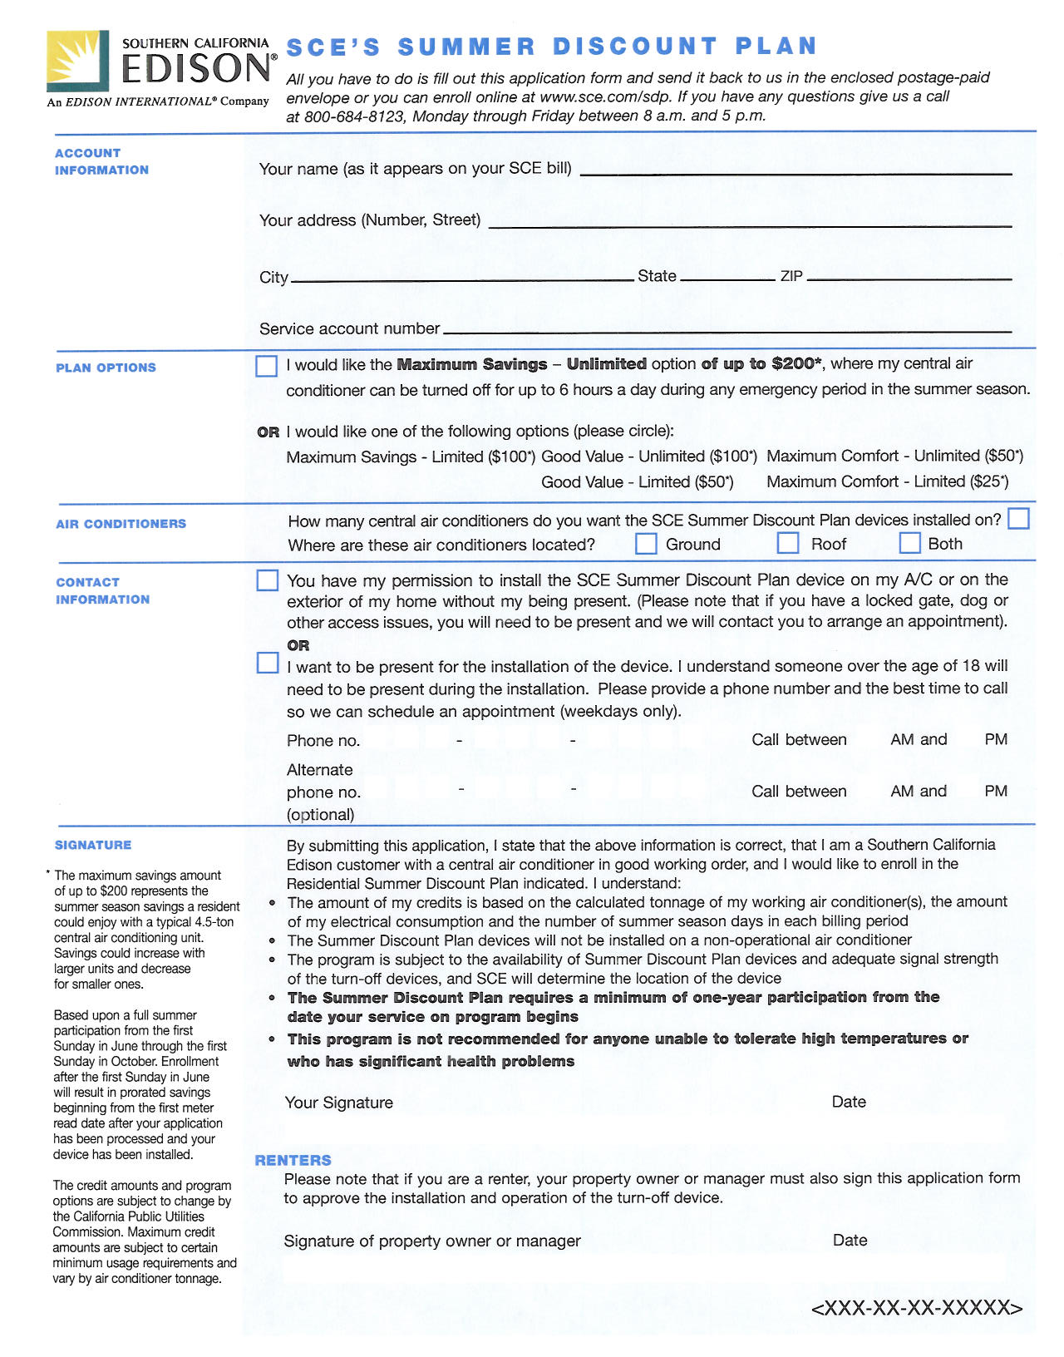

Attachment B: SCE’s Online Summer Discount Enrollment Form

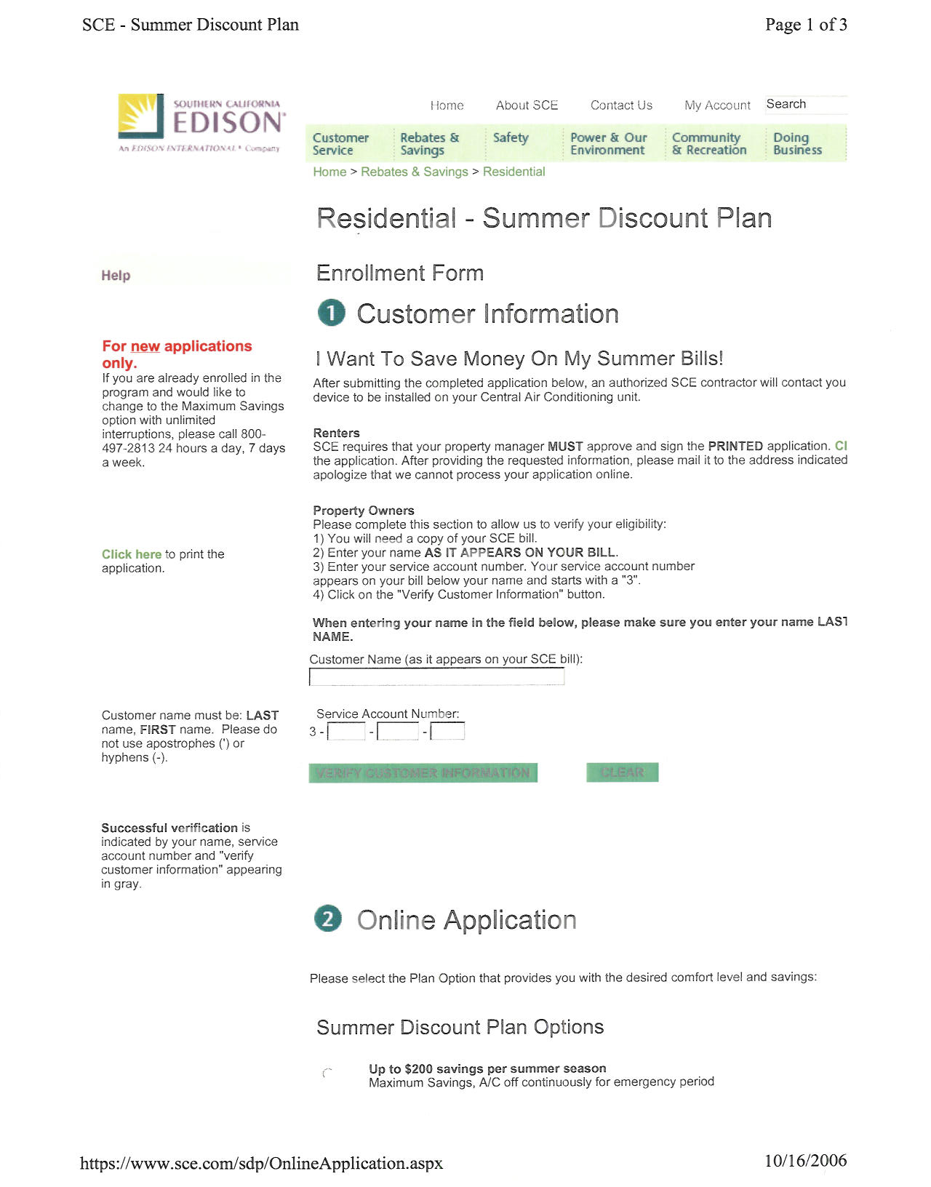
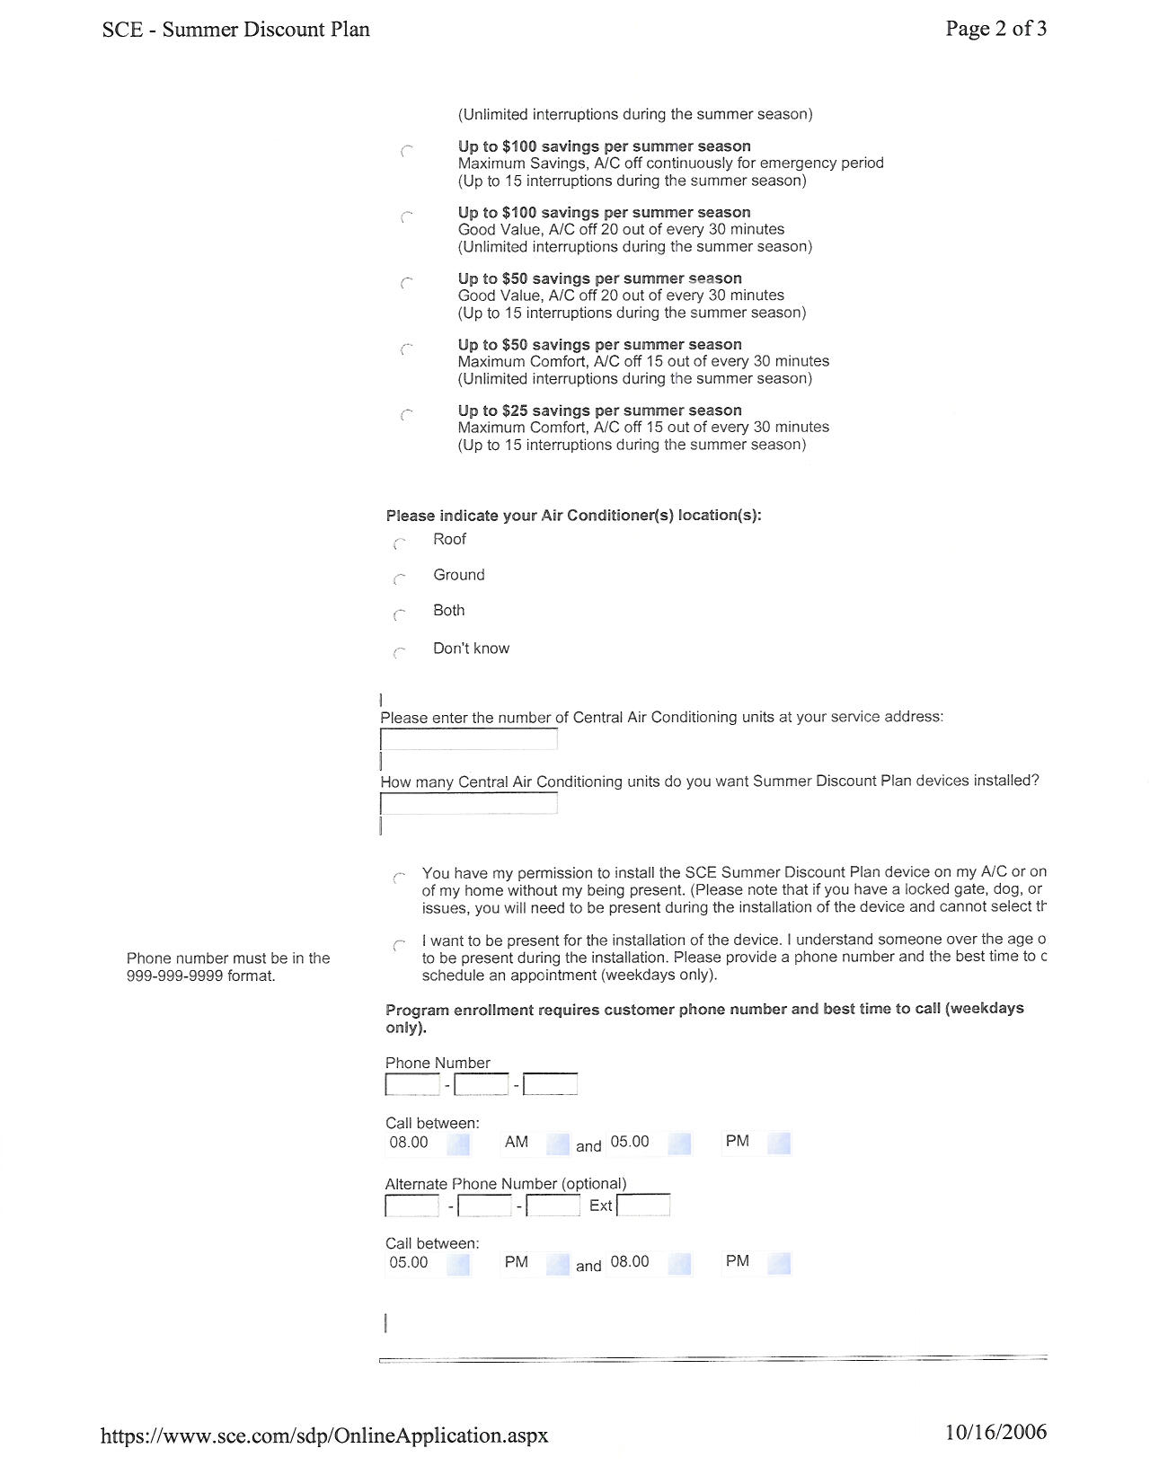
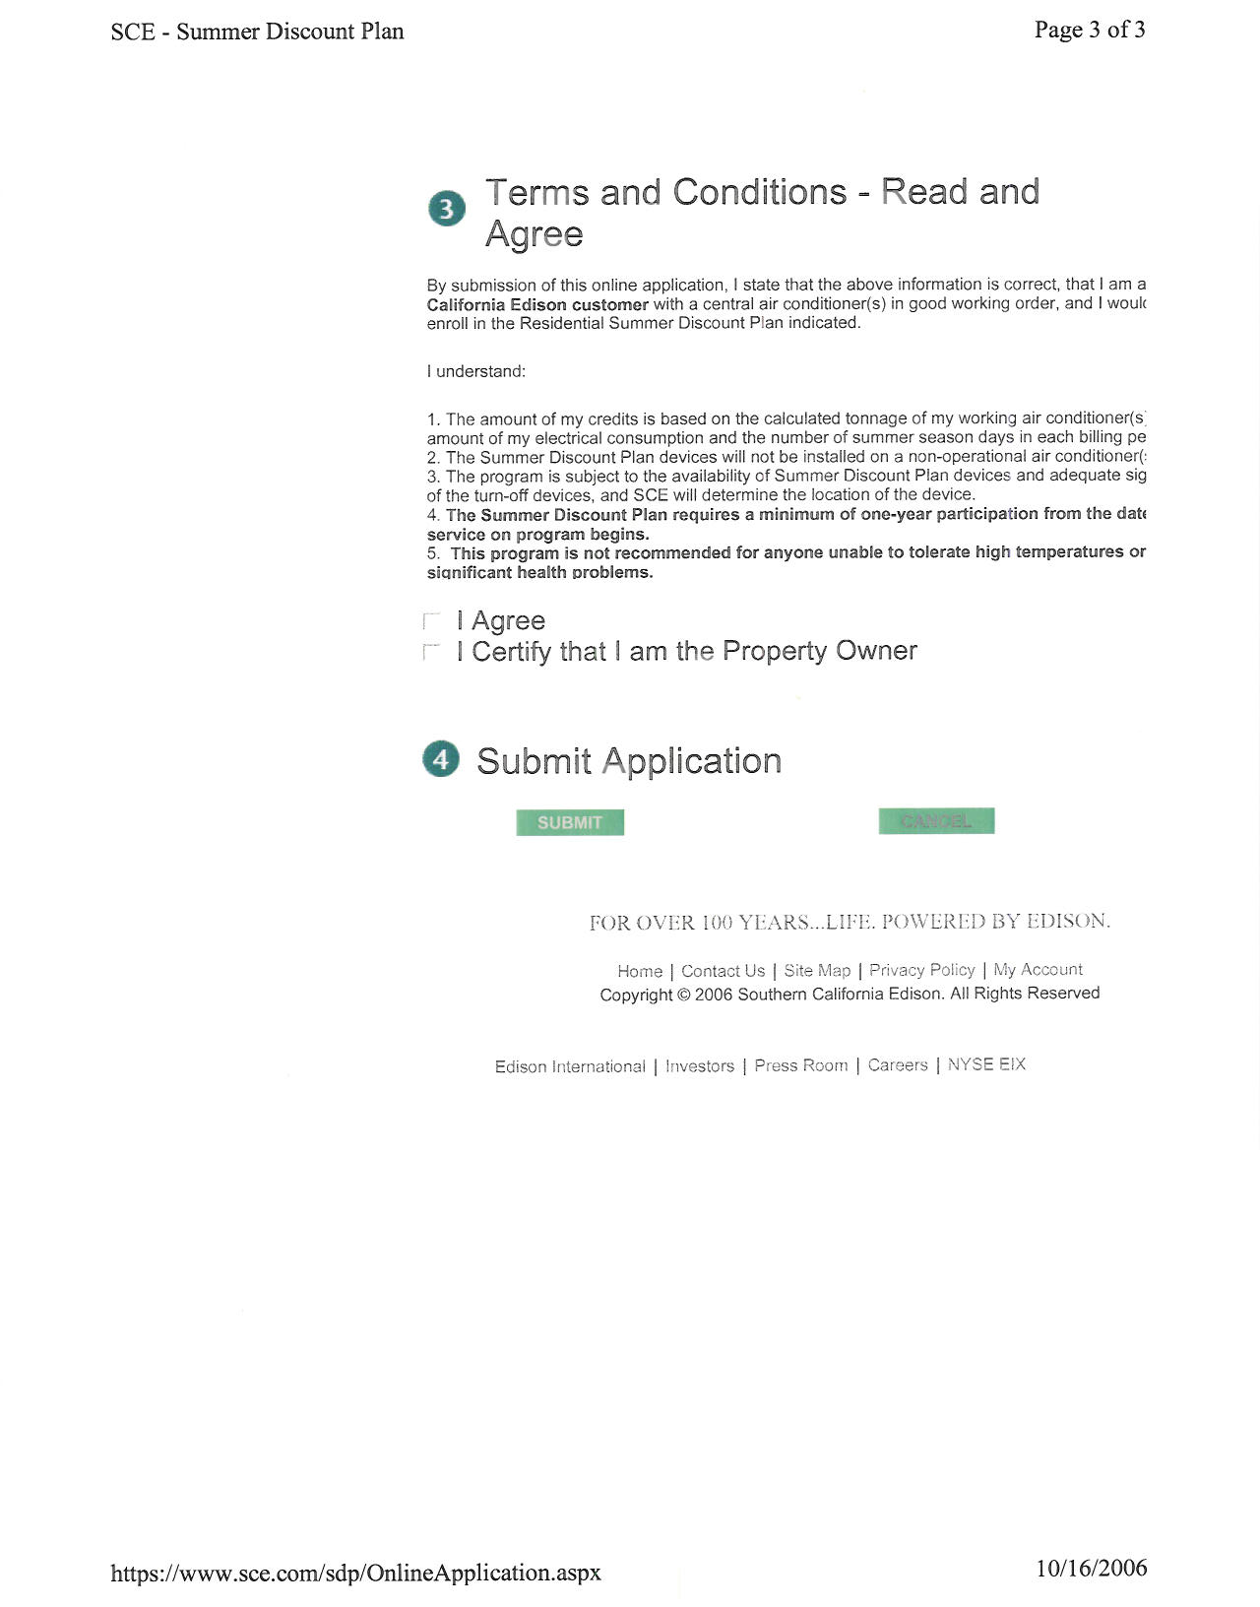

The decision adopted an amended settlement which reduced SCE’s original budget proposal.
The average incentive is based on a customer with a 4.5 ton air conditioner selecting the 100% cycling option.
R.05-12-013 and R.06-02-013.
SCE’s Supplemental Testimony Supporting Southern California Edison Company’s Application (A.05-06-008) for Approval of Demand Response Programs, Goals, and Budgets for 2006-2008, filed August 1, 2005.

