CPSD/RWC/RTSS/JEB/vdl Mailed 11/7/08

PUBLIC UTILITIES COMMISSION OF THE STATE OF CALIFORNIA

Consumer Protection and Safety Division  Rail Transit and Crossing Branch  Rail Transit Safety Section | RESOLUTION ST-98  November 6, 2008

R E S O L U T I O N

RESOLUTION GRANTING NORTH COUNTY TRANSIT DISTRICT A VARIANCE TO GENERAL ORDER 143-B Minimum SIDE clearance requirements ON HIGH LEVEL STATION platform “WING RAILINGS” AND
ORDERING SPECIAL SAFETY PROCEDURES AT
SPRINTER STATIONS WITH RETRACTABLE GANGWAYS

Summary
This resolution grants North County Transit District’s (NCTD’s) request for a variance to General Order (GO) 143-B, Section No. 9.06 c (1) Side Clearance requirements on NCTD’s Sprinter Line high level station platforms. The resolution also imposes special safety procedures on NCTD’s Sprinter Line’s high level station platforms with retractable gangways. These special safety procedures are necessary to ensure safe operations on NCTD’s right-of-way shared by both freight railroad trains operated by the BNSF Railway (BNSF) and light rail transit vehicles as permitted by the Federal Railroad Administration’s (FRA’s) and Federal Transit Administration’s (FTA’s) “temporal separation” provisions.

project description
NCTD constructed a rail fixed-guideway system known as the “Sprinter” carrying passengers between the cities of Oceanside and Escondido on the existing 22-mile Escondido Branch Line, an active freight railroad line, with a new loop extension in San Marcos. The Sprinter utilizes diesel driven, self-propelled, light rail vehicles known as a diesel multiple units (DMUs). Sprinter’s DMUs are manufactured by Siemens AG.

The Escondido Branch Line is also used by BNSF for freight service several nights a week. Freight train operations and light rail passenger train operations are not permitted to occur simultaneously by policy agreement between the FRA and the FTA. Both federal agencies require that these two distinct operations occur separately at different times in a 24-hour period.

NCTD constructed 15 stations with high level platforms for the Sprinter passenger line. Twelve of these high level station platforms are designed with retractable gangways, two are designed with permanent extensions, and one is designed with retractable gangways and permanent extensions. The retractable gangways and permanent extensions serve to bridge the four-inch plus gap between the high level station platforms and the Sprinter DMU vehicles allowing passengers to walk safely from the station platform into the DMU car. The following table lists the high level platform stations with gangways and permanent extensions.

STATION NAME | RETRACTABLE GANGWAY RAILING  CLEARANCE | PERMANENT  EXTENSION RAILING  CLEARANCE
Oceanside Transit Center Station |  | 19 inches
Coast Highway Station | 9 inches
Crouch Street Station | 9 inches
El Camino Real Station | 9 inches
Rancho Del Oro Station | 9 inches
College Boulevard Station | 9 inches
Melrose Station | 9 inches
Vista Transit Center Station | 9 inches
Escondido Avenue Station | 9 inches
Buena Creek Station | 9 inches
Palomar College Station | 9 inches
San Marcos Civic Center Station | 9 inches
California State University San Marcos Station |  | 19 inches
Nordahl Road Station | 9 inches
Escondido Transit Center Station | 9 inches, East Platform | 19 inches, West Platform

The retractable gangways are lowered just prior to Sprinter revenue service. The gangways must be raised prior to freight operations to meet the greater side clearance requirements of GO 26-D applying to freight service. All stations have retractable gangways with side railings except those with no freight operations, i.e., the Oceanside Transit Center Station, the California State University San Marcos Station, and the west high level station platform at the Escondido Transit Center Station. These three stations have railings on the high level station platforms with openings at boarding areas to protect passengers from falling into the trackway below.

BACKGROUND
On February 4, 2008, Commission Staff (staff) inspected the Sprinter high level station platform-mounted railings to ensure adequate dynamic envelope clearances between the outside of the DMU vehicle and the high level station platform. The side clearances between the Sprinter car body and the high level station platform-mounted railings ranged from 17 to 20 inches at the Escondido Transit Center Station eastbound high level station platform, the California State University San Marcos Station eastbound and westbound high level station platforms, and the Oceanside Transit Center Station westbound high level station platform. The railing clearances ranged from 9 to 12 inches at the Escondido Transit Center Station westbound high level platform, the Escondido Avenue Station westbound high level station platform, the Crouch Street Station westbound high level station platform, and the Coast Highway Station westbound high level station platform. On February 4, 2008, staff informed NCTD’s Executive Officer and NCTD’s Project Manager that the railings were not in compliance with the safety requirements of GO 143-B, Section 9.06 c (1).

GO 143-B Section 9.06 (b), (c), (1), Clearances, states:

b. All clearances shall be measured from the dynamic envelope of the outermost surface of the largest vehicle on tangent track. The spacing of tracks and structures shall be increased proportionately for curved track to provide the minimum clearances specified in this part at all locations. Minimum clearances shall be such that no contact can take place due to any condition of design wear, loading or anticipated failure such as air spring deflation or normal lateral vehicle motion.
c. The minimum side clearance to obstructions higher than eight (8) inches above top-of-rail and the clearances between LRVs and streetcars located on parallel tracks used exclusively for light rail transit operations shall be governed by the following requirements:
(1) on station platforms, in yards and along shop aisles, and other locations, including emergency walkways, where passengers, employees, or other persons are permitted or required to be while trains are in motion, the minimum clearances shall be thirty (30) inches…

By letter dated February 12, 2008, NCTD requested Commission authority for a variance from GO 143-B, Section 9.06 c (1). NCTD contended that large gaps between the high level station platforms and the outside of the DMU cars were necessary to provide the required GO 26-D clearances for train crews during freight operations. Because of the clearance requirements of GO 26-D, NCTD claimed it is forced to use retractable gangways to bridge these large gaps for the safety of passengers. Since both the permanent high level station platform extensions and the retractable gangways extend out beyond the high level station platform edge and over the track bed, NCTD has installed safety “wing railings” on both sides of the permanent high level station platform extensions and the gangways to prevent passengers from accidentally falling into the trackway below. “Wing railings” are installed perpendicular to the railings running parallel the length of the high level station platform. “Wing railings” protect passengers from falling into the trackway and prevent them from entering the vehicle dynamic envelope area protected by railings running parallel to the high level station platform edge.

“Wing railings” protecting permanent high level platform extensions.

The “wing railings” on the permanent high level platform extensions (see Attachment No.1) at the Oceanside Transit Center Station, the California State University San Marcos Station, and the west high level station platform at the Escondido Transit Center Station, encroach 19-inches into the 30-inch clearance (see Attachment No. 2) required in GO 143-B, Section 9.06 c (1). These “wing railings” are necessary to protect passengers from falling into large gaps created by the permanent high level station platform extensions, to the trackway below. Retractable gangways are not necessary for the west high level station platform at the Escondido Transit Center Station, the Oceanside Transit Center Station, and the California State University San Marcos Station since these tracks are not shared with freight operations.

“Wing railings” protecting retractable gangways.

The retractable gangway “wing railings” encroach 21 inches into the 30-inch clearance (see Attachment Nos. 3 and 4) required in GO 143-B, Section 9.06 c (1). However, they provide necessary safety protection to passengers from falling into the large gap between the DMU vehicle and the edge of the station high level station platforms which is set back from the retractable gangways.

NCTD has identified the following measures mitigating potential hazards at all stations:

- The DMUs have several safety features which prevent forward movement of the train if a passenger or an object obstructs the light rail vehicle doorway. A light beam located near the floor level holds the doors open during passenger ingress and egress. Further, if a door is stopped in closing cycle by a passenger or an object, it will automatically re-cycle by reopening, waiting a set period of time, and then attempt to close again. The system relies on resistance-sensing by the door actuator and is designed to prevent the doors from closing on a person’s arm or leg. Finally, the interlock system keeps brakes applied and will not allow forward movement unless the doors are fully closed.

- All of the stations have signage for the train operators which mark the precise “cab spotting” locations to ensure accurate train alignment of the DMU doors with the retractable gangways at high level station platforms. The retractable gangways are 14 feet wide versus DMU door openings of approximately 4 feet. This design feature helps ensure that passengers are far away from the side railings when they board and exit the trains.

- NCTD’s contract operator, Veolia Transportation, adopted stringent operating rules requiring the train operators to use their mirrors to ensure all passengers are clear of the doorway areas prior to departure from the station. This operating rule will be reinforced through on-going train operator efficiency testing.

- During the first 90 days of Sprinter revenue service, NCTD doubled the number of security officers patrolling the stations, trains, and right-of-way. The security officers were tasked to ensure passengers use the system safely. NCTD will have a continued security program in place after the first 90 days of increased coverage, providing security officer patrols at stations and on trains. Further, NCTD has a Security Control Center with closed circuit television (CCTV) staffed 24 hours a day, 7 days a week, which monitors the CCTV security cameras in the stations. Security officers can immediately respond via radio, Public Address System, or request for security response, if any boarding issues arise.

Staff accepted NCTD’s Safety Certification Verification Report which allowed NCTD to begin revenue service on March 9, 2008. Staff’s approval letter to NCTD required the filing of this resolution for a variance and, further, required the following:

  - All incidents associated with railings, both those on the high level station platform and those on the retractable gangways, shall be reported to Commission staff within two hours and such incidents shall be investigated by NCTD. NCTD shall prepare an investigation report and that investigation report shall be provided promptly to Commission staff.
  - Train operators shall be required to “look-back” down the high level station platform to ensure that no passengers are on retractable gangways before any train begins movement. Further, the NCTD rule requiring such “look-back” shall be in effect until further order of the Commission.
  - NCTD staff shall conduct efficiency testing on a regular and frequent basis and the results of these tests shall be made available to Commission staff upon demand.
  - NCTD shall provide security personnel at the stations to advise and assist passengers on safe boarding and disembarking habits and to observe passenger behavior during the first 180 days of operations.
  - NCTD shall provide public education and outreach to further educate the public on the safety hazards associated with the combined operations of railroads and rail transit.

In addition, NCTD’s Safety Certification Plan requires Veolia Transportation to issue approved Operating Rules prior to the start of revenue operations on March 9, 2008. Staff verified The Sprinter Code of Operating Rules (SCOR) has been completed. Further, staff verified that SCOR No. 6.30 contains specific language and instructions for train operators regarding passenger boarding and alighting at high level station platforms.

Discussion

A. The requested variance to GO 143-B, Section 9.06 c (1) reducing the dynamic envelope distance between the outside of the DMU vehicle and the high level station platform from 30 inches to 19 inches for “wing railings” at three NCTD Sprinter stations with permanent high level station platform extensions (Attachment Nos. 1 and 2).

Staff supports NCTD’s proposed variance for “wing railings” on the permanent high level station platform extensions at the passenger operations-only track at the (1) Oceanside Transit Center Station, (2) the California State University San Marcos Station, and (3) the west high level station platform at the Escondido Transit Center Station

On April 4, 2008, staff received a clarification letter from NCTD for the permanent high level station platform extensions wing railings at the Oceanside Transit Center Station, the California State University San Marcos Station, and the west high level station platform at the Escondido Transit Center Station which encroach within the 30-inch side clearance requirement. NCTD proposed to relocate these “wing railings” to encroach no more than 11 inches into the 30-inch GO 143-B, Section 9.06, (1) side clearance requirement. These “wing railings” protect passengers from approaching the drop-off at the edge of the high level station platform extension and also prevent pedestrians from entering the vehicle dynamic envelope protected by the railings running parallel to the high level station platform edge (see Attachment No. 1).

B. The requested variance to GO 143-B, Section 9.06 c (1) reducing the dynamic envelope distance between the outside of the DMU vehicle and the high level station platforms with retractable gangways from 30 inches to 9 inches for “wing railings” at 13 Sprinter stations (Attachment Nos. 3 and 4).

These 13 stations are: the Coast Highway Station; the Crouch Street Station; the El Camino Real Station; the Rancho Del Oro Station; the College Boulevard Station; the Melrose Station; the Vista Transit Center; the Escondido Avenue Station; the Buena Creek Station; the Palomar College Station; the San Marcos Civic Center Station; and the Nordahl Road Station and the west high level station platform at the Escondido Transit Center Station.

NCTD supplemented its request for a variance from GO 143-B, Section 9.06, (1) side clearance requirements for high level station platforms.

- In an April 21, 2008, letter to NCTD, staff agreed in principle to implementation of NCTD’s proposed mitigation measures contained in their April 4, 2008 letter to comply with GO 143-B, Section 9.06, (1) side clearance requirements.

- On May 12, 2008, NCTD provided detailed drawings for the reconstruction of the current railings on the permanent platform extensions at the west high level station platform for the Escondido Transit Center Station, the California State University San Marcos Station, and the Oceanside Transit Center Station. These drawings and staff photographs demonstrate that the set-back distance for wing railings on the non-gangway equipped high level station platforms shall be no closer than 19-inches from the outside of the DMU vehicles. NCTD proposes a variance to reduce the minimum side clearance for wing railings at these high level station permanent platform extensions under GO 143-B, Section 9.06, c (1) from 30 inches to 19 inches at these stations.

- On May 23, 2008, staff advised that it had received NCTD’s revised drawings for high level station platforms with retractable gangways. The “wing railings” encroach 21 inches into the 30-inch side clearance requirement of GO 143-B, Section 9.06, c (1). These “wing railings” are necessary to protect patrons from falling off the retractable gangway and into the trackway below. Staff photographs demonstrate that the set-back distance for wing railings on the high level station permanent platform extensions shall be no closer than 9-inches from the outside of the DMU vehicles. NCTD proposes a variance to reduce the minimum side clearance for wing railings at these permanent high level station platform extensions under GO 143-B, Section 9.06, c (1) from 30 inches to 9 inches at these stations.

- On June 3, 2008 staff verified NCTD is currently relocating the high level station platform railings for the west high level station platform at the Escondido Transit Center Station, the California State University San Marcos Station, and the Oceanside Transit Center Station to provide a minimum 19 inch clearance between the high level platform wing railings and the outside of the DMU body.

NCTD’s supplemented its request for a variance from GO 143-B, Section 9.06, (1) side clearance requirements for Sprinter high level station platforms by agreeing to the following special safety procedures for high level Sprinter station platforms.

- On June 3, 2008, staff rode the Sprinter trains and verified that train operator’s were stopping at the “Cab Spot” marker and that they were performing a “look-back” to ensure the station platform retractable gangways were clear of passengers prior to departing from the high level station platforms as required by SCOR No. 6.30. No exceptions were observed.

- On June 13, 2008 staff verified NCTD is performing operator “efficiency testing” as required by 49 CFR Part 217. The records identify train operators, results of tests, and any necessary corrective action.

C. NCTD’s implementation of special safety features and procedures at its Sprinter stations.

Staff agrees that the Sprinter DMU’s safety feature preventing train movement when DMU car doors are blocked and “spot cab” signage on high level station platforms are necessary to mitigate hazards at Sprinter stations.

- In May 2007, during Sprinter train brake testing, staff verified that the Sprinter train incorporates a safety feature that prevents forward movement of the train when a passenger or an object obstructs the doorway.

- On February 20, 2008, staff performed a mainline inspection and verified that all Sprinter Stations have “Spot Cab” signage installed at the appropriate locations notifying passengers that the train will stop only at identified retractable gangway openings.

Staff has verified that NCTD has its train operators perform the following tasks at stations:
- On February 22, 2008, staff verified that Sprinter Code Operating Rule No. 6.30 includes language that the train operator shall stop the train only at the “Spot Cab” locations at all stations.

- On March 5, 2008, staff performed an on-site inspection of the Sprinter Project including inspections of railings on the high level station platforms.

- On March 10, 2008 and June 3, 2008, staff witnessed NCTD Sprinter Operations Facility staff during revenue service perform their dispatching duties. Staff observed patrons on high level station platform boarding and exiting Sprinter trains and verified that security officers are performing their education and advice duties and that train operators are performing their cab-spotting and “look-back” duties. No exceptions were observed.

- On March 12, 2008, staff witnessed NCTD Sprinter Operations Facility staff during revenue service perform their dispatching duties, including duties to be performed at the end of Sprinter revenue service and before freight train operations begin, to comply with temporal separation requirements. No exceptions were observed.

Consequently, staff agrees with NCTD that the 19-inch side clearances for wing railings on the permanent high level station platform extensions at the west high level station platform for the Escondido Transit Center Station, the California State University San Marcos Station, and the Oceanside Transit Center Station, and the nine-inch side clearance for “wing railings” at the stations with retractable gangways will not significantly impact public safety under these special circumstances if NCTD complies with the previously discussed conditions.

For all the above reasons, staff recommends NCTD’s request for variance be granted subject to the conditions set forth above and reiterated in the ORDERING PARAGRAPHS below.

PROTESTS
On July 9, 2008, NCTD’s variance request was noticed in the Commission’s Daily Calendar. No protests or objections have been filed with the Commission.

Comments
This is an uncontested matter in which the resolution grants the relief requested. Accordingly, pursuant to Section 311 (g) (2) of the Public Utilities Code and Rule 14.6 (c) (2) of the Commission’s Rules of Practice and Procedure, the otherwise applicable 30-day period for public review and comment is waived.

Findings
- By letter dated February 12, 2008, NCTD requested Commission authority for a variance from GO 143-B, Section 9.06 c (1), which requires minimum side clearances on fixed rail guideway system high level station platforms of not less than 30 inches.

- NCTD’s request for variance is reasonable and should be granted.

- Passenger safety requires that NCTD comply with the conditions set forth for the variance and, also, with the special safety procedures identified for retractable gangways required for shared use operations.

THEREFORE, IT IS ORDERED that:
- A variance to General Order (GO) 143-B, Section 9.06 c (1) is granted to North County Transit District’s (NCTD) as set forth below:

A variance from the 30-inch minimum side clearance required by GO 143-B, Section 9.06 c (1) shall be granted to NCTD reducing side clearance requirements to a minimum of 19-inches for “wing railings” at high level permanent platform extensions at the three transit stations identified below:
  - Oceanside Transit Center Station at Michigan & Tremont Streets, Oceanside, California;
  - California State University San Marcos Station at La Moree Road near Barham Drive, San Marcos, California;
  - Escondido Transit Center Station west high level station platform, at W. Valley parkway (west of Quince Street), Escondido, California.

A variance to General Order (GO) 143-B, Section 9.06 c (1) is granted to North County Transit District’s (NCTD) as set forth below:
A variance from the 30-inch minimum side clearance required by GO 143-B, Section 9.06 c. (1) shall be granted to NCTD reducing side clearance requirements to a minimum of 9 inches for “wing railings” on retractable gangways at the 13 transit stations identified below:

  - Coast Highway Station at Tremont & Godfrey Streets, near Coast Highway, Oceanside, California;
  - Crouch Street Station at Oceanside Boulevard & Crouch Street, Oceanside, California;
  - El Camino Real Station at S. El Camino Real & Industry Street, Oceanside, California;
  - Rancho Del Oro Station at Oceanside Boulevard & Rancho Del Oro Road, Oceanside, California;
  - College Boulevard Station at College Boulevard & Oceanside Boulevard, Oceanside, California;
  - Melrose Station at Oceanside Boulevard & Melrose Drive, Oceanside, California;
  - Vista Transit Center at N. Santa Fe Avenue & Vista Village Drive, Vista, California;
  - Escondido Avenue Station at Escondido Avenue & Phillips Street, Vista, California;
  - Buena Creek Station at S. Santa Fe Avenue & Buena Creek Road, Vista, California;
  - Palomar College Station at Mission Road & Armorlite Drive, San Carlos, California;
  - San Marcos Civic Center Station at Mission Road & San Marcos Boulevard, San Marcos, California; and
  - Nordahl Road Station at Mission Road & Citracado Parkway/Nordahl Road, Escondido, California.
  - Escondido Transit Center Station east high level station platform, at W. Valley parkway (west of Quince Street), Escondido, California.

- The variances to GO 143-B, Section 9.06 c (1), above in ORDERING PARAGRAPH 1, are conditioned on NCTD complying with the following rules:

a. All incidents associated with the railings, both those on the high level station platform and those on the retractable gangways, will be reported to Commission staff within two hours and an investigation will be conducted by NCTD and the investigation report provided to Commission staff.
b. Train operators shall be required to comply with NCTD’s “look-back” procedure at each station before the train departs.
c. Efficiency test will be conducted by NCTD staff frequently and the results of those tests will be made available to Commission staff.

- NCTD also shall comply with the following special rules for combined railroad and transit operations, i.e., at stations with retractable gangways set forth in ORDERING PARAGRAPH 2 above:

a. NCTD shall continue public education and outreach efforts to further educate the public on the safety hazards associated with combined railroad and rail transit operations.
b. NCTD shall have “Spot Cab” signage installed at the appropriate locations all Sprinter Stations notifying passengers that the train will stop only at identified retractable gangway openings.
c. NCTD shall require that Sprinter Operating Rules include language that the train operator shall stop the train only at the “Spot Cab” locations at all stations.
d. NCTD shall comply with all “temporal separation” requirements.
e. NCTD shall require all train operators to perform a “look-back” down the high level station platform to ensure the station retractable gangways and permanent platform extensions are clear of passengers prior to departing from the high level station platforms as required by SCOR No. 6.30.

- NCTD shall provide staff with documentation showing how each of the conditions in ORDERING PARAGRAPH 3 have been met when requested by Commission staff.

- If at any time staff determines the high level station platforms on the Sprinter line pose a significant safety hazard, NCTD shall immediately consult with staff and make emergency safety modifications to the high level station
platform retractable gangways and permanent extensions that are agreeable to Commission staff.

- This resolution is effective today.

I certify that the foregoing resolution was duly introduced, passed, and adopted by the Commission at its regularly scheduled meeting on November 6, 2008. The following Commissioners voted favorably thereon:

/s/ PAUL CLANON
PAUL CLANON
Executive Director

MICHAEL R. PEEVEY
President
DIAN M. GRUENEICH
JOHN A. BOHN
RACHELLE B. CHONG
TIMOTHY ALAN SIMON
Commissioners

ATTACHMENT No. 1

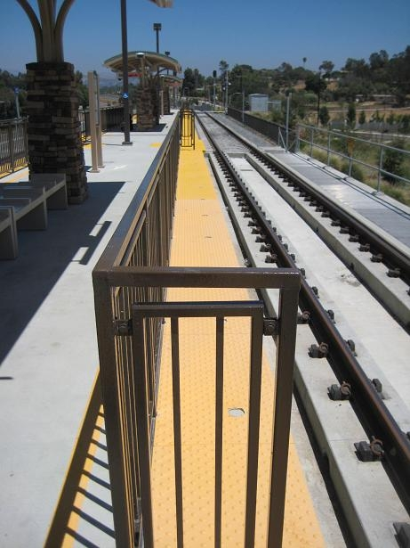
“Wing railings” at High Level Station Platforms
With Permanent High Level Station Platform Extensions
(Oceanside Transit Center Station, California State University San Marcos Station, and the west high level station platform at the Escondido Transit Center Station)
ATTACHMENT No. 2

“Wing railings” at High Level Station Platforms
With Permanent High Level Station Platform Extensions
(Oceanside Transit Center Station, California State University San Marcos Station, and the west high level station platform at the Escondido Transit Center Station)

ATTACHMENT No. 3

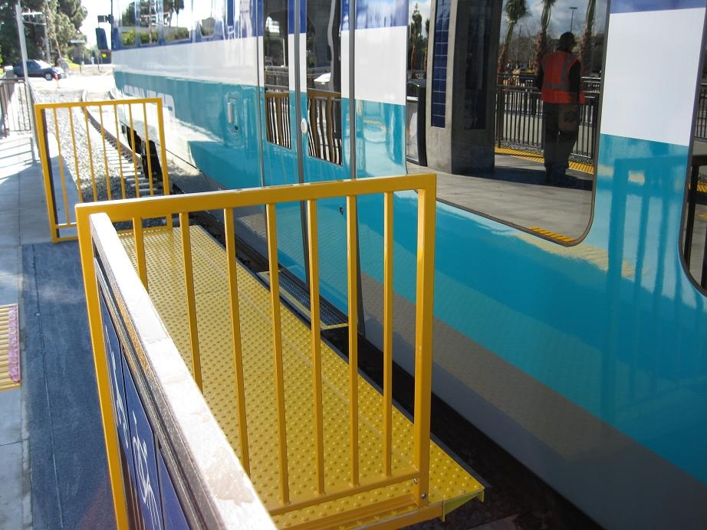

“Wing railings” at High Level Station Platforms
With Retractable Gangways
(Coast Highway Station; Crouch Street Station; El Camino Real Station; Rancho Del Oro Station; College Boulevard Station; Melrose Station; Vista Transit Center; Escondido Avenue Station; Buena Creek Station; Palomar College Station; San Marcos Civic Center Station; Nordahl Road Station; and the Escondido Avenue Station)

ATTACHMENT No. 4


“Wing railings” at High Level Station Platforms
With Retractable Gangways
(Coast Highway Station; Crouch Street Station; El Camino Real Station; Rancho Del Oro Station; College Boulevard Station; Melrose Station; Vista Transit Center; Escondido Avenue Station; Buena Creek Station; Palomar College Station; San Marcos Civic Center Station; Nordahl Road Station; and the Escondido Avenue Station.)

See the October 3, 2006 letter from Grady C. Cothen, Jr., Deputy Associate Administrator for Safety Standards and Program Development, Federal Railroad Administration, to Mr. Edward Fishman, Kirkpatrick & Lockhart, Nicholson, Graham, LLP, Washington, DC; and “Joint Statement of Agency Policy Concerning Shared Use of the track of the General Railroad System by Conventional Railroads and Light Rail Transit Systems” 65 Fed. Reg. 42525, July 10, 2000.
Unless otherwise noted, the term DMU as used in this resolution is in specific reference to the Siemens Model VT-642 selected for service by NCTD on the Sprinter project.
Eighteen of 24 hours each day is reserved for the exclusive use of the Sprinter’s passenger service; six hours of each 24-hour period is reserved for the exclusive use of BNSF for its freight service. The Sprinter’s commuter service is never conducted simultaneously with BNSF’s freight operations.
Veolia Transportation is NCTD’s contracted light rail operator of the Sprinter DMU vehicles and is responsible for vehicle operations.
The platforms at the Oceanside Transit Center Station, the California State University San Marcos Station, and the west high level station platform at the Escondido Transit Center Station, do not have retractable gangways because freight operations are not conducted on the tracks adjacent to the platforms at these stations.

