STATE OF CALIFORNIA ARNOLD SCHWARZENEGGER, Governor
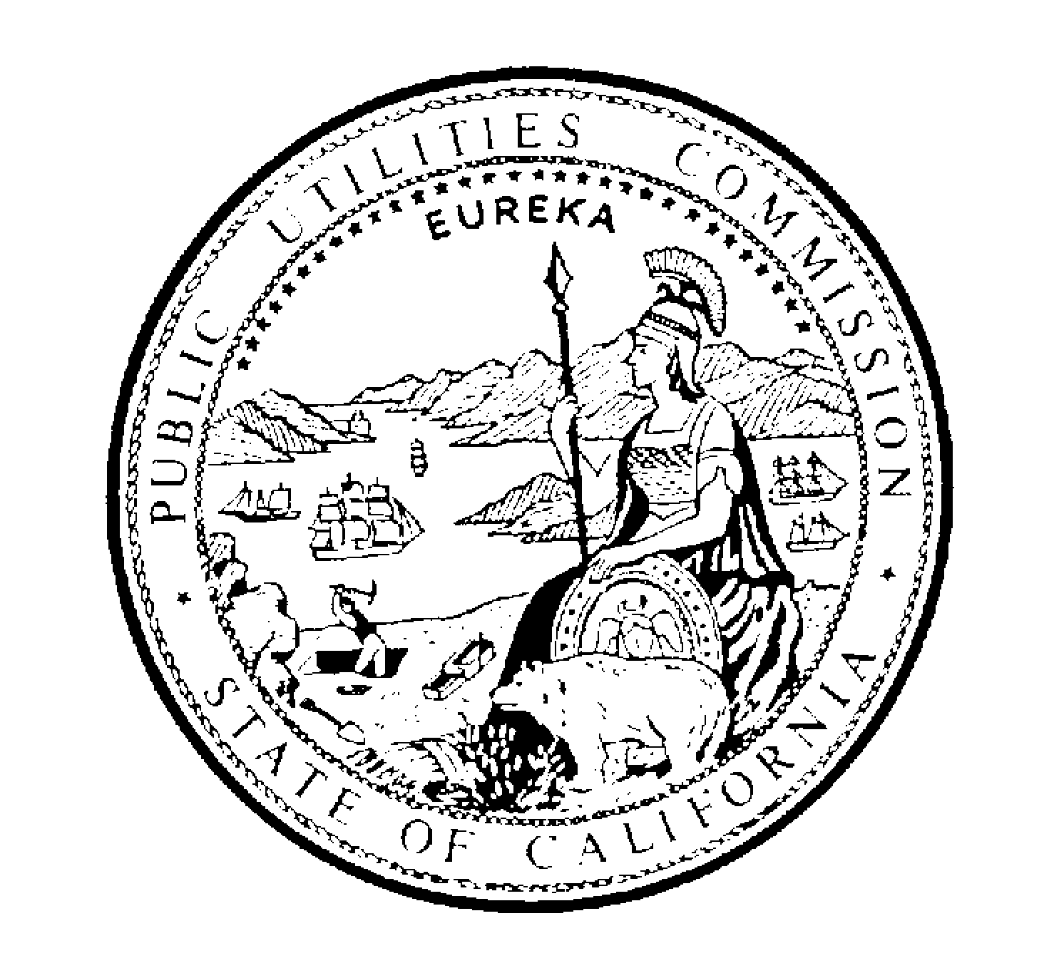PUBLIC UTILITIES COMMISSION
505 VAN NESS AVENUE
SAN FRANCISCO, CA 94102-3298

November 21, 2003

To Persons Interested in the Commission’s Intervenor Program
Pursuant to the invitation we extended on October 29, 2003, eight comments were submitted regarding the process by which the Commission should update the hourly rates used in calculating awards for its intervenor compensation program. The commenters were: Pacific Gas and Electric; SBC Pacific Bell; AT&T Communications of California; Aglet Consumer Alliance; Greenlining Institute; Southern California Edison; TURN; and Grueneich Resource Advocates.
As we indicated earlier, persons may respond to these comments. The replies should be submitted by Internet, on or before Wednesday, December 3. Address replies to the Revised Distribution List (attached) and to the following persons at the Commission:
 | Harriett Burt | hjb@cpuc.ca.gov
 | Michelle Cooke | mlc@cpuc.ca.gov
 | Steven Kotz | kot@cpuc.ca.gov
After analyzing the comments and responses, we will propose an updating process for possible adoption by the Commission. We plan to publish the proposal in a draft resolution before the end of this year. The draft resolution would be subject to further public review and comment.

/s/ WILLIAM AHERN /s/ ANGELA K. MINKIN
William Ahern  Executive Director |  | Angela K. Minkin, Chief  Administrative Law Judge

cc: Commissioners
Revised Distribution List

************ APPEARANCES ************  Robert Munoz  WORLDCOM  201 SPEAR STREET, 9TH FLOOR  SAN FRANCISCO CA 94105  (415) 228-1135  robert.munoz@mci.com  James Weil  AGLET CONSUMER ALLIANCE  PO BOX 1599  FORESTHILL CA 95631  (530) 367-3300  jweil@aglet.org  Dan Geis  AGRICULTURAL ENERGY CONSUMERS ASSO.  925 L STREET, SUITE 800  SACRAMENTO CA 95814  (916) 441-6206  dgeis@dolphingroup.org  Darlene Clark  Attorney At Law  AT&T COMMUNICATIONS OF CALIFORNIA, INC.  795 FOLSOM STREET  SAN FRANCISCO CA 94107  (415) 442-2143  darleneclark@att.com  Julian C. Chang  AT&T COMMUNICATIONS OF CALIFORNIA, INC.  795 FOLSOM STREET, ROOM 2164  SAN FRANCISCO CA 94107  (415) 442-3449  julianchang@att.com  Glenn Semow  CALIFORNIA CABLE & TELECOMM. ASSOC.  4341 PIEDMONT AVENUE  OAKLAND CA 94611  (510) 428-2225  grs@calcable.org  J. Kendrick Kresse  CALIFORNIA CENTER FOR LAW AND THE DEAF  14895 EAST 14TH STREET, SUITE 220  SAN LEANDRO CA 94578  (510) 483-0922  ken.kresse@deaflaw.org | Francis S. Ferraro  CALIFORNIA WATER SERVICE COMPANY  1720 NORTH FIRST STREET  SAN JOSE CA 95112  (408) 367-8225  sferraro@calwater.com  Nikayla K. Nail  Attorney At Law  CALTEL  PO BOX 190427  SAN FRANCISCO CA 94119  (415) 225-9948  nnail@caltel.org  Charles E. Born  Manager-State Government Affairs  CITIZENS TELECOMMUNICATIONS CO. OF CA  PO BOX 340  ELK GROVE CA 95759  cborn@czn.com  Dave Hennessy  CMRAA  3381 STEVENS CREEK BLVD.  SAN JOSE CA 95117  (408) 244-8134  cmraa@aol.com  Sean P. Beatty  Attorney At Law  COOPER, WHITE & COOPER  201 CALIFORNIA ST., 17TH FLOOR  SAN FRANCISCO CA 94111  (415) 433-1900  sbeatty@cwclaw.com  Phil Ceguera  COVAD COMMUNICATIONS  3420 CENTRAL EXPRESSWAY  SANTA CLARA CA 95051  (408) 616-6609  pceguera@covad.com  Doug Garrett  COX CALIFORNIA TELCOM, LLC, DBA COX COMM  2200 POWELL STREET, SUITE 1035  EMERYVILLE CA 94608-2618  (510) 923-6220  douglas.garrett@cox.com
Betty Jo Toccoli  CSBRT/CSBA  6101 WEST CENTENALIA AVENUE,342  CULVER CITY CA 90230  (800) 350-2722  csba@pacbell.net  David J. Marchant  Attorney At Law  DAVIS WRIGHT TREMAINE LLP  ONE EMBARCADERO CENTER, STE. 600  SAN FRANCISCO CA 94111-3834  (415) 276-6500  davidmarchant@dwt.com  Daniel Kirshner  ENVIRONMENTAL DEFENSE FUND  5655 COLLEGE AVENUE, SUITE 304  OAKLAND CA 94618  (510) 658-8008  dkirshner@environmentaldefense.org  Lee Burdick  Attorney At Law  FERRIS & BRITTON  401 WEST A STREET, SUITE 1600  SAN DIEGO CA 92101  (619) 233-3131  lburdick@ferrisbritton.com  Jody London  DIAN M. GRUENEICH  GRUENEICH RESOURCE ADVOCATES  582 MARKET STREET, 10TH FLOOR  SAN FRANCISCO CA 94104  (415) 834-2300  jlondon@gralegal.com  Susan E. Brown  Attorney At Law  LATINO ISSUES FORUM  785 MARKET STREET, 3RD FLOOR  SAN FRANCISCO CA 94103-2003  (415) 284-7220  lifcentral@lif.org  Thomas R. Dill  President  LODI GAS STORAGE, LLC  23265 N. STATE RT. 99 W. FRONTAGE RD  ACAMPO CA 95220  (209) 368-9277  trdill@westernhubs.com | Peter Miller  NATURAL RESOURCES DEFENSE COUNCIL  1834 DELAWARE STREET  BERKELEY CA 94703  (415) 777-0220  pmiller@nrdc.org  Deborah Shefler  Attorney At Law  PACIFIC GAS AND ELECTRIC COMPANY  PO BOX 7442  SAN FRANCISCO CA 94120  (415) 973-7467  dss8@pge.com  Leigh K. Jordan  PARK WATER COMPANY/APPLE VALLEY RANCHOS  9750 WASHBURN ROAD  PO BOX 7002  DOWNEY CA 90241-7002  (562) 923-0711  leigh@parkwater.com  Shawna Parks  Attorney At Law  449 - 15TH STREET, SUITE 303  OAKLAND CA 94612  (510) 451-8644  sparks@dralegal.org  Mark Savage  Attorney At Law  PUBLIC ADVOCATES, INC.  1535 MISSION STREET  SAN FRANCISCO CA 94103-2500  (415) 431-7430  savama@consumer.org  Greg R. Gierczak  Executive Director-Regulatory  ROSEVILLE TELEPHONE COMPANY  PO BOX 969  ROSEVILLE CA 95678  g.gierczak@surewest.com  Linda S Vandeloop  Regulatory Director  SBC PACIFIC BELL  140 NEW MONTGOMERY ST., SUITE 1718  SAN FRANCISCO CA 94105-2228  (415) 542-7556  LV8571@sbc.com

Vicki L. Thompson  Attorney At Law  SEMPRA ENERGY  101 ASH STREET HQ13  SAN DIEGO CA 92101  (619) 699-5130  vthompson@sempra.com  Marc Mihaly  Attorney At Law  SHUTE MIHALY & WEINBERGER LLP  396 HAYES STREET  SAN FRANCISCO CA 94102  (415) 552-7272  armi@smwlaw.com  Mary O. Simmons  Vice President  SIERRA PACIFIC POWER COMPANY  RATES & REGULATORY AFFAIRS  6100 NEIL ROAD, P.O. BOX 10100  RENO NV 89520  (775) 834-5870  msimmons@sierrapacific.com  David R. Garcia  Attorney At Law  SOUTHERN CALIFORNIA EDISON COMPANY  2244 WALNUT GROVE AVENUE  ROSEMEAD CA 91770-7740  (626) 302-2336  david.garcia@sce.com  Andrew W. Bettwy  Attorney At Law  SOUTHWEST GAS CORPORATION  5241 SPRING MOUNTAIN ROAD  LAS VEGAS NV 89102  (702) 876-7107  andy.bettwy@swgas.com  Keith Mccrea  Attorney At Law  SUTHERLAND, ASBILL & BRENNAN  1275 PENNSYLVANIA AVENUE, NW  WASHINGTON DC 20004-2415  (202) 383-0705  keith.mccrea@sablaw.com  ********** STATE EMPLOYEE ***********  Itzel Berrio  Attorney At Law  THE GREENLINING INSTITUTE  785 MARKET STREET, 3RD FLOOR  SAN FRANCISCO CA 94103-2003  (415) 284-7202  iberrio@greenlining.org | Robert Finkelstein  Attorney At Law  THE UTILITY REFORM NETWORK  711 VAN NESS AVE., SUITE 350  SAN FRANCISCO CA 94102  (415) 929-8876 X310  bfinkelstein@turn.org  Michael Shames  Attorney At Law  UTILITY CONSUMERS' ACTION NETWORK  3100 FIFTH AVENUE, SUITE B  SAN DIEGO CA 92103  (619) 696-6966  mshames@ucan.org  Elaine Duncan  Attorney At Law  VERIZON CALIFORNIA INC.  711 VAN NESS AVENUE, SUITE 300  SAN FRANCISCO CA 94102  (415) 474-0468  elaine.duncan@verizon.com  Raymond J. Czahar  Chief Financial Officer  WEST COAST GAS CO., INC.  9203 BEATTY DR.  SACRAMENTO CA 95826-9702  (916) 364-4100  westgas@aol.com  Barbara George  Executive Director  WOMEN'S ENERGY MATTERS  PO BOX 162008  SACRAMENTO CA 95816-9998  (916) 739-1898  wem@igc.org  Karen M. Potkul  Vice President-Legal & Regulatory Affair  XO CALIFORNIA INC.  1924 DEERE AVENUE  SANTA ANA CA 92705  (949) 417-7766  karen.potkul@xo.com
********* INFORMATION ONLY **********

