FOR IMMEDIATE RELEASE

Media Contact: PUC Press Office, 415.703.1366, news@cpuc.ca.gov
PUC INVESTIGATIONS RESULT IN ENFORCEMENT ACTIONS AND FINES IMPOSED ON VARIOUS MOVING COMPANIES

SAN FRANCISCO, July 20, 2007 – During the second quarter of 2007, the California Public Utilities Commission’s (PUC) Consumer Protection and Safety Division, Transportation Enforcement Section, took the following enforcement actions against moving companies for violations of the Public Utilities Code, and PUC rules and regulations including Maximum Rate Tariff 4 (MAX 4).

Administrative Citation
Three companies were cited and fined (totaling $12,250) for violations ranging from:
- Operating and advertising without a permit
- Engaging employees without evidence of workers’ compensation insurance coverage
- Failing to comply to consumer protection rules in MAX 4 such as not showing a Not To Exceed Price on shipping documents
- Operating as a sub-carrier without a permit
- Failing to provide the “Important Information for Persons Moving Household Goods” booklet
- Failing to issue the “Important Notice About Your Move” document

Companies cited are:

- Carlos Rodriquez, Woodland Hills (MTR189360-Active)
- Chipman Corporation dba Chipman Relocations, Sacramento (MTR-114272-Active)
- Hamilton Solis, Gretna, LA (MTR190146-Denied)
- Hu Jie and Hang Alexander Baoshan dba U S Trucking and Moving Inc La Puente, (MTR-189075-Revoked)
- Jaime Calderon dba JC Moving, Covina (MTR-190352-Pending)
- Jaime Gonzales dba A & J Moving and Delivery, Cathedral City (MTR-190349-Active)
- Joshua Ryan Tracy, Rio Oso (MTR-189819-Active)
- Linda Livesay dba Churchill Transportation Company, Hemet (MTR-22115-Revoked)
- Oscar Hernandez, Bellflower (MTR-189971-Denied)
- Robert Lusk and Kelli J. Rodriquez, Chino (MTR 189976-Active)

Official Notice
Four companies were issued Official Notice for one of these violations: advertised or operated prior to issuance of a permit, failed to include a Cal-T # in advertisement, failed to issue a Change Order or a Not To Exceed Price. Companies cited are:
- Rani Ullman dba All American Moving & Storage, San Jose (MTR-189335)
- Redondo Van and Storage, Redondo Beach (MTR-168486)
- Robert H Watson dba Barrett Moving and Storage of California, Oxnard (MTR-189958)
- Tok Kim dba Kim’s Express, Oakland (MTR-None)

Cease and Desist Notice
PUC staff issued 17 cease and desist notices to moving companies for operating and advertising without a valid permit. These companies are:
- Aldo Di Sorbo dba AAA Nationwide Relocation Services, Fort Lauderdale, FL (MTR-None)
- All Safe Move, Inc. Santa Clara (MTR-190181)
- Alvaron Morrow dba Small Moves R Us, Alhambra (MTR-None)
- Angel’s Delivery & Moving, San Rafael (MTR-None)
- Bayardo Aleman-Castro dba Timex Express, Petaluma (MTR-None)
- Brendan Keane, CEO, CaliMovers, Inc., Los Angeles (MTR-Pending)
- Carrie Beets Dba Move Now Moving Systems, Los Angeles (MTR-None)
- Dave Huggon Dba Smart Move, Los Angeles (MTR-None)
- First Choice Moving and Storage, Sherman Oaks (MTR-None)
- Gabriel Ortega dba Heaven Sent Moving, Van Nuys (MTR-None)
- Hong Zhang dba Northern Moving, San Jose (MTR-190130-Denied)
- Joseph Berns Dba Loadstar Moving and Anthony Aira, Santa Barbara (MTR-None)
- Richard S. Youngs Jr., dba Help U Move, Laguna Hills (MTR-None)
- Serhiy Lohvynenko dba SmoothRelocation.com, Los Angeles (MTR-None)
- Shlomi Shalom dba All Safe Move, Inc. Santa Clara (MTR-190181)
- Steve Murray dba Murray’s Moving, Paradise (MTR-None)

Other

American Eagle Moving Co., Inc. (MTR-190112-Revoked): In March 2006, the PUC fined this moving company for operating without a permit and ordered carrier to pay $4,300 in consumer restitution for overcharges. The company obtained a permit; however, it was subsequently revoked for various reasons including failing to pay the PUC fine. Subsequently, the PUC received two consumer complaints that the company alleging that the company took consumer goods and did not deliver them as promised. PUC staff was able to locate one consumer’s goods and arranged for its release. In the other case, PUC staff obtained documentation on the mover from a consumer and also suggested that the consumer file a police report. Subsequently, PUC staff learned that the Los Angeles Police Department (LAPD) had located the moving truck parked on a street. The truck had expired plates and therefore was impounded by the police, and subsequently sold as a lien sale. PUC staff provided the consumer with the new provision of the Public Utilities Code that authorizes peace officers to take possession of goods being held hostage. This helped to secure release of the goods to the consumer. The carrier has five vans, all of which have expired plates. In the course of the investigation, staff located two of these five vans parked on the street and informed the LAPD. These vehicles were also impounded for expired DMV registration. The company was also evicted from its office/storage facility and is now out of business.

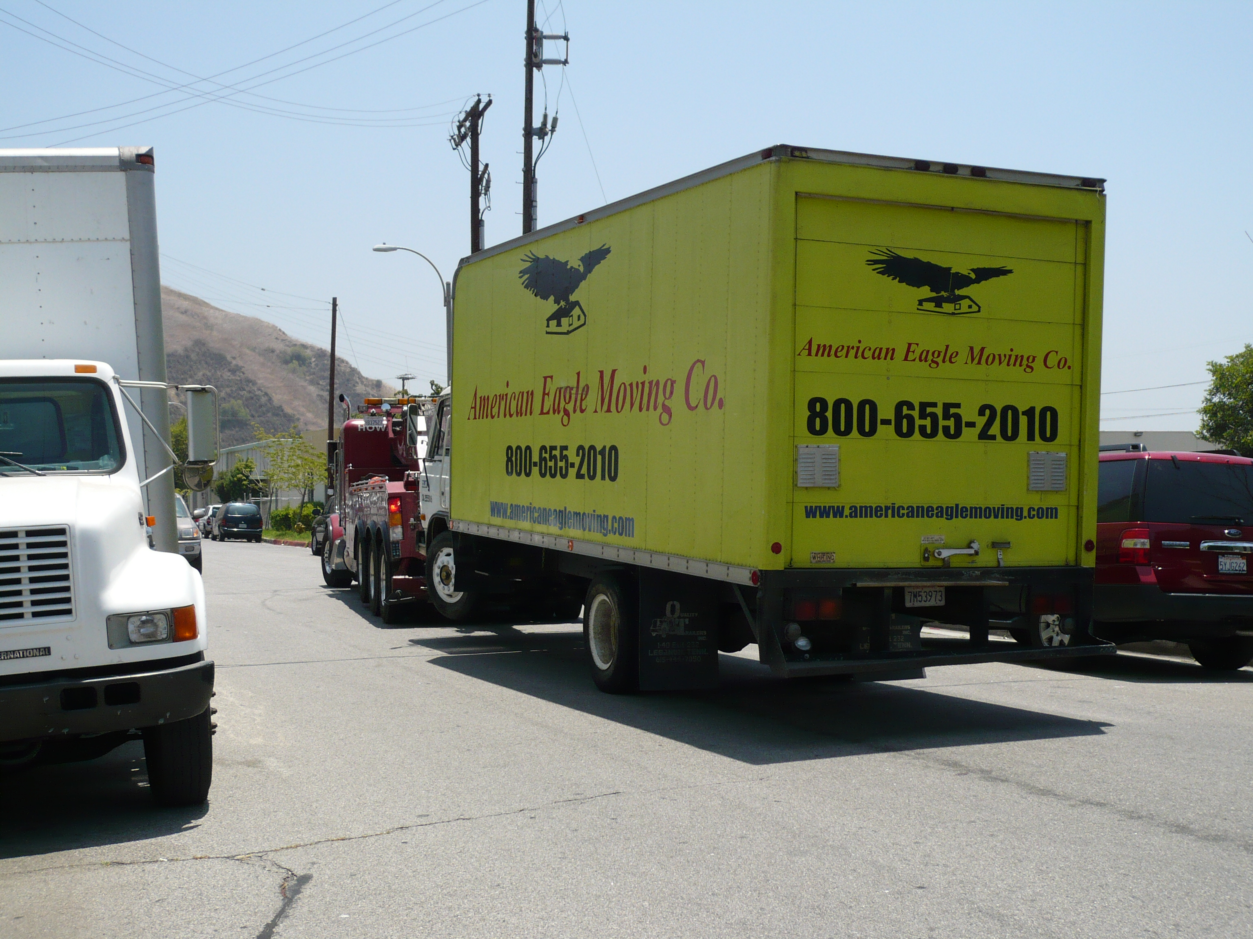
American Eagle Moving Company Truck

For more information, please visit the PUC’s website at www.cpuc.ca.gov.
###

