ULTS Administrative Committee
Orientation

February 19, 2003
10:00 am – 12:00 pm

1. ULTS Program (PP 2 – 5)
- Discounted Telephone Service Hassan Mirza
- Marketing Program (D.96-10-066) Mateo Camarillo
    - Phase I (99-00)
    - Phase II (Pending)
      - Outreach
      - Call Center
2. ULTS Administration (PP 6 – 8)
- Pre SB 669 - ULTS-AC, ULTS-MB and CPUC Oversight Ken McEldowney
- Post SB 669 - Telecommunications Division Hassan Mirza
    - Claims and Review Process (GO 153)
    - Payments (D.01-09-059)
3. ULTS Program Budget (P 9) Hassan Mirza
- CPUC’s Resolution Process (September Year 1)
- Governor’s Budget Proposal (Jan 10 Year 2)
- Budget Act (June Year 2)
4. New ULTS-AC (PP 10 – 14) Linda Gustafson
- Budget Recommendation (Charter § 4.1a)
- Annual Report (Charter § 4.1.b)
- Program Development/Implementation/Administration (Charter § 4.1.c)
- Permanent Marketing Plan (Charter § 2.3)
- Liaisons (Charter § 4.2)
5. Conflict of Interest / Insurance (PP 15 – 16) Lionel Wilson
6. Per Diem and Travel Expenses (PP 17 – 20) Hassan Mirza
- Eligibility
- Air Travel Arrangement
- Claim Process
- Justification Letter/Payee Data Record
7. Teleconference
Universal Lifeline Telephone Service (ULTS) Program

- PU Code § 871 was codified in by the enactment of AB 1348 (1983), known as the Moore Universal Service Telephone Act, requiring the Commission to establish a program to provide low-income households with access to affordable basic residential telephone service.
- D.84-11-028 established General Order (GO) 153 for the implementation, funding, and administration of the Moore Universal Telephone Service Act. The Universal Service Telephone Program (ULTS) was created to provide a 50% discount on residential telephone service to low-income families. This program was funded by a tax administered by the State Board of Equalization.
- D.87-07-090, in response to AB 386 (1987), repealed the ULTS tax and implemented a 4% all end user surcharge accessed on intrastate interLATA services.
- D.87-10-088 established a ULTS trust for the deposits of the surcharge monies, and an administrative committee for the administration of the ULTS program. The administrative committee, ULTS-AC, was comprised of five members including 1 large LEC, 1 small LEC, 1 IEC, and 2 public interest groups.
- Annual Budgets for the ULTS program are adopted by the Commission through the resolution process. Budget resolutions can be found at: http://www.cpuc.ca.gov/static/industry/telco/consumer+information/surcharges+and+taxes/index.htm.
- D.94-09-065 standardized the ULTS rates to the lower of 50% of the LEC’s tariffed rate or 50% of Pacific Bell’s basic service rate and revised the assessment of the surcharge from intrastate interLATA services to all intrastate telecommunications services. This decision also required the large LECs to perform ULTS outreach to undersubscribed communities, and established a 95% subscribership goal for low-income and non-English speaking households.
- D.96-10-066 required all competitive local exchange carriers (CLEC) to provide ULTS, extended the 95% subscribership goal for all customer groups, removed the large LECs’ outreach requirement, established a marketing working group to perform ULTS outreach in a competitively neutral manner, and set the budget for the marketing working group to the annual total average ULTS marketing expenses reimbursed to the large LECs over the last 3 years (1993 to 1995).
- D.97-12-105 established a nine-member ULTS Marketing Board (ULTS-MB), and ordered the board to use 80% of its marketing budget to bring basic telephone service to qualifying households currently without telephone service and the remaining 20% to close the gap between the total number of residential customers eligible for the ULTS program and total number of customers who actually use the ULTS program.
- Annual Outreach Budgets are included in the ULTS annual budgets. Resolution T-16176, the first annual budget for the outreach, set the marketing budget at $5 million a year.
- D.98-10-050 increased the ULTS-MB annual budget from $5 million to $7 million.
- Resolution T-16353 (1999) approved a 12-month marketing program and the operation of a call center for the ULTS program. These marketing and outreach efforts were conducted from November 1999 through October 2000.
- D.00-10-028 revised GO 153 to reflect changes to the ULTS program that occurred subsequent to 1984, set standards for carriers service representatives in informing subscribers on the availability of ULTS program, etc.
- PU Code § 270-281 et seq. were codified by the enactment of SB 669 (1999) requiring a ULTS Trust Administrative Committee Fund be created in the State Treasury, limiting moneys in this fund to only be expended for the purpose of the program and upon appropriation in the annual Budget Act, changing the role of the ULTS-AC from administrative to advisory, and requiring the Commission to submit a transition plan on or before July 1, 2000.
- SB 742 (2001) mandated that the remaining funds of the ULTS Trust be transferred to the State Treasury on October 1, 2001.
- Resolution T-16561 (2001) approved a proposed contract with Richard Heath & Associates (RHA) in the amount of $4,983,241 for a 12-month marketing program submitted by the ULTS-MB.
- Resolution T-16606 (2001) approved a proposed contract with RHA in the amount of $1,481,990 for a 36-month operation of a call center submitted by the ULTS-MB.
- D.01-09-064 revised the charters of ULTS-AC and the ULTS-MB to conform to SB 669, and directed the Information and Management Services Division (IMSD) and the Telecommunications Division (TD) to take over the administration of the ULTS program starting October 1, 2001.
- D.02-04-059 merged the ULTS-MB (disappearing committee) and the ULTS-AC (surviving committee) into one committee, and established a nine-member board for the merged committee. On September 13, 2002, the Commission issued a letter on the advisory committee application process. This letter was sent to over 4,000 groups and organizations. Interested parties should submit their resumes to the Commission on or before October 31, 2002.
- D.02-07-033 directed the Low Income Oversight Board (LIOB) to solicit public input and develop recommendations for coordinated customer outreach between the ULTS and CARE programs.
Period |  | # of ULTS Subscribers | # of Carriers
11/02 |  | 3,279,647 | 20
10/02 |  | 3,328,029 | 25
09/02 |  | 3,363,699 | 28
08/02 |  | 3,394,844 | 27
07/02 |  | 3,364,374 | 29
06/02 |  | 3,363,225 | 29
05/02 |  | 3,386,332 | 30
04/02 |  | 3,391,639 | 31
03/02 |  | 3,354,688 | 30
02/02 |  | 3,345,187 | 28
01/02 |  | 3,367,465 | 30
12/01 |  | 3,362,501 | 28
11/01 |  | 3,342,466 | 27
10/01 |  | 3,466,671 | 29
09/01 |  | 3,439,667 | 26
08/01 |  | 3,379,005 | 28
07/01 |  | 3,348,870 | 29
06/01 |  | 3,300,282 | 27
05/01 |  | 3,298,529 | 28
04/01 |  | 3,300,150 | 28
03/01 |  | 3,260,844 | 26
02/01 |  | 3,246,076 | 28
01/01 |  | 3,225,303 | 29
ULTS-Fund
Receipt and Disbursement Summary

Date | Receipts | Disbursements | Balance
10/1/2001 |  |  | $108,736,244.20
10/31/2001 | $25,105,624.78 | ($32,543,216.91) | $101,298,652.07
11/30/2001 | $25,080,657.18 | ($1,045,930.14) | $125,333,379.11
12/1/2001 | $28,138,978.08 | ($27,195,613.15) | $126,276,744.04
1/5/2002 | $1,213,782.05 |  | $127,490,526.09
1/31/2002 | $23,753,344.95 | ($17,024,272.70) | $134,219,598.34
2/28/2002 | $24,210,114.43 | ($11,712,008.52) | $146,717,704.25
3/31/2002 | $23,254,960.11 | ($17,106,924.09) | $152,865,740.27
4/30/2002 | $22,001,997.16 | ($18,768,549.69) | $156,099,187.74
5/31/2002 | $22,058,826.88 | ($23,643,373.48) | $154,514,641.14
6/30/2002 | $16,126,611.39 | ($17,895,846.47) | $152,745,406.06
Total | $210,944,897.01 | ($166,935,735.15) | $152,745,406.06
Fiscal Year 2002-2003
7/1/2002 |  |  | $152,745,406.06
7/5/2002 | $2,214,354.00 |  | $154,959,760.06
7/31/2002 | $24,224,723.56 | ($18,668.17) | $179,165,815.45
8/31/2002 | $28,519,849.94 | ($20,198.26) | $207,665,467.13
9/30/2002 | $19,984,366.38 | ($24,223,082.15) | $203,426,751.36
10/4/2002 | $7,907,508.90 |  | $211,334,260.26
10/31/2002 | $20,238,000.73 | ($18,304,833.65) | $213,267,427.34
11/29/2002 | $20,607,738.50 | ($27,176,982.46) | $206,698,183.38
Total | $123,696,542.01 | ($69,743,764.69) | $206,698,183.38

Payment Process Established in D.01-09-064

EVENT | CARRIER PAYMENTS  (DAY/MONTH) | OTHER PAYMENT REQUESTS  (DAY/MONTH)
Payment letter posted in daily calendar | 8 ^{th} (Month 1) | 23 ^{rd} (Month 1)
End of comment period on payment letter | 15 ^{th} (Month 1) | 30 ^{th} (Month 1)
Payment letter submitted to IMSD for payment processing | 15 ^{th} (Month 1) | 30 ^{th} (Month 1)
Payment mailed to payee by Controller or CPUC | 20 ^{th} (Month 1) | 5 ^{th} (Month 2)

If any date in a payment timeline falls on a weekend or holiday, that date will be advanced to the next business day but the remaining dates in the payment timeline will remain unchanged.

MISCELLANEOUS TELECOMMUNICATION MATTERS

Date Filed | Subject
January 23, 2003 | California High-Cost Fund-A Administrative Committee Fund: Notice of filing of payment letter(s) for payments to be made on February 5, 2003. Protests or comments may be submitted. All protests and comments must be filed by 12:00 PM on or before January 30, 2003 with John M. Leutza, Director of the Telecommunications Division, California Public Utilities Commission, 505 Van Ness Avenue, San Francisco, CA 94102. These payment letters are available at: http://www.cpuc.ca.gov/static/industry/telco/public+programs/index.htm or contact Hassan Mirza at (415) 703-1638.
January 23, 2003 | The California High-Cost Fund-B Administrative Committee Fund: Notice of filing of payment letter(s) for payments to be made on February 5, 2003. Protests or comments may be submitted. All protests and comments must be filed by 12:00 PM on or before January 30, 2003 with John M. Leutza, Director of the Telecommunications Division, California Public Utilities Commission, 505 Van Ness Avenue, San Francisco, CA 94102. These payment letters are available at:  http://www.cpuc.ca.gov/static/industry/telco/public+programs/index.htm or contact Hassan Mirza at (415) 703-1638.
January 23, 2003 | The California Teleconnect Fund Administrative Committee Fund: Notice of filing of payment letter(s) for payments to be made on February 5, 2003. Protests or comments may be submitted. All protests and comments must be filed by 12:00 PM on or before January 30, 2003 with John M. Leutza, Director of the Telecommunications Division, California Public Utilities Commission, 505 Van Ness Avenue, San Francisco, CA 94102. These payment letters are available at:  http://www.cpuc.ca.gov/static/industry/telco/public+programs/index.htm, or you may contact Robert Weissman at (415) 703-1989.
January 23, 2003 | The Universal Lifeline Telephone Service (ULTS) Trust Administrative Committee Fund: Notice of filing of payment letter(s) for payments to be made on February 5, 2003. Protests or comments may be submitted. All protests and comments must be filed by 12:00 PM on or before January 30, 2003 with John M. Leutza, Director of the Telecommunications Division, California Public Utilities Commission, 505 Van Ness Avenue, San Francisco, CA 94102. These payment letters are available at: http://www.cpuc.ca.gov/static/industry/telco/public+programs/index.htm or contact Hassan Mirza at (415) 703-1638.

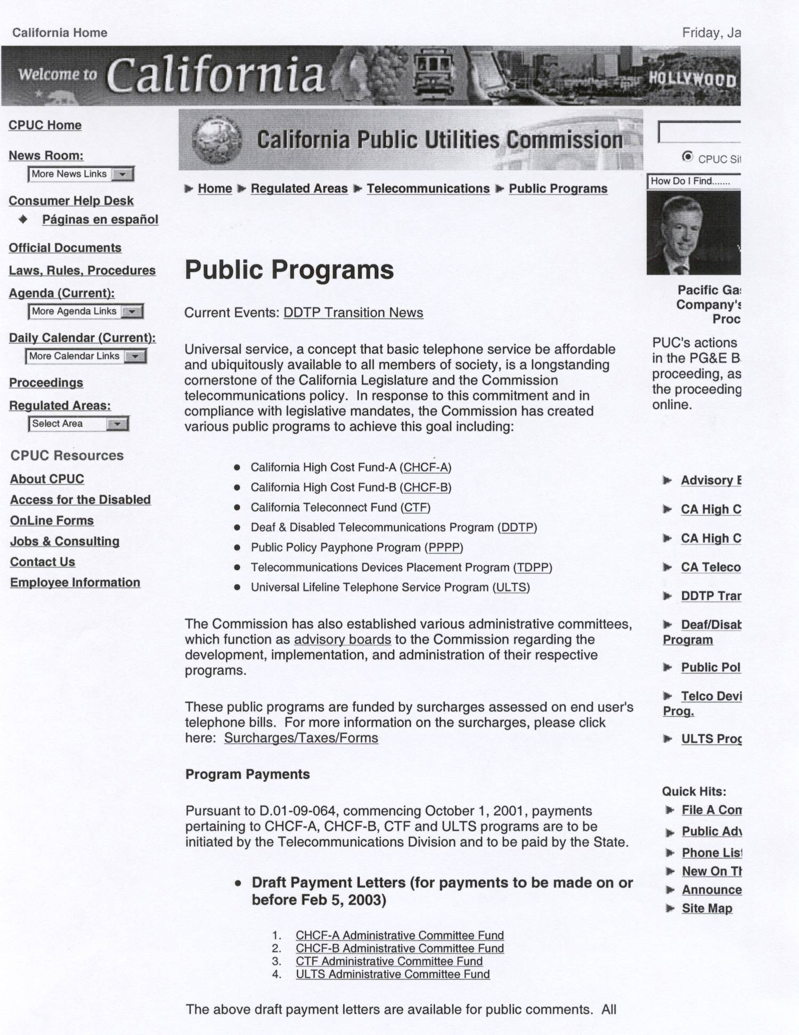

http://resserver/CPUC/static/Industry/Telco/Public+Programs/_index.htm

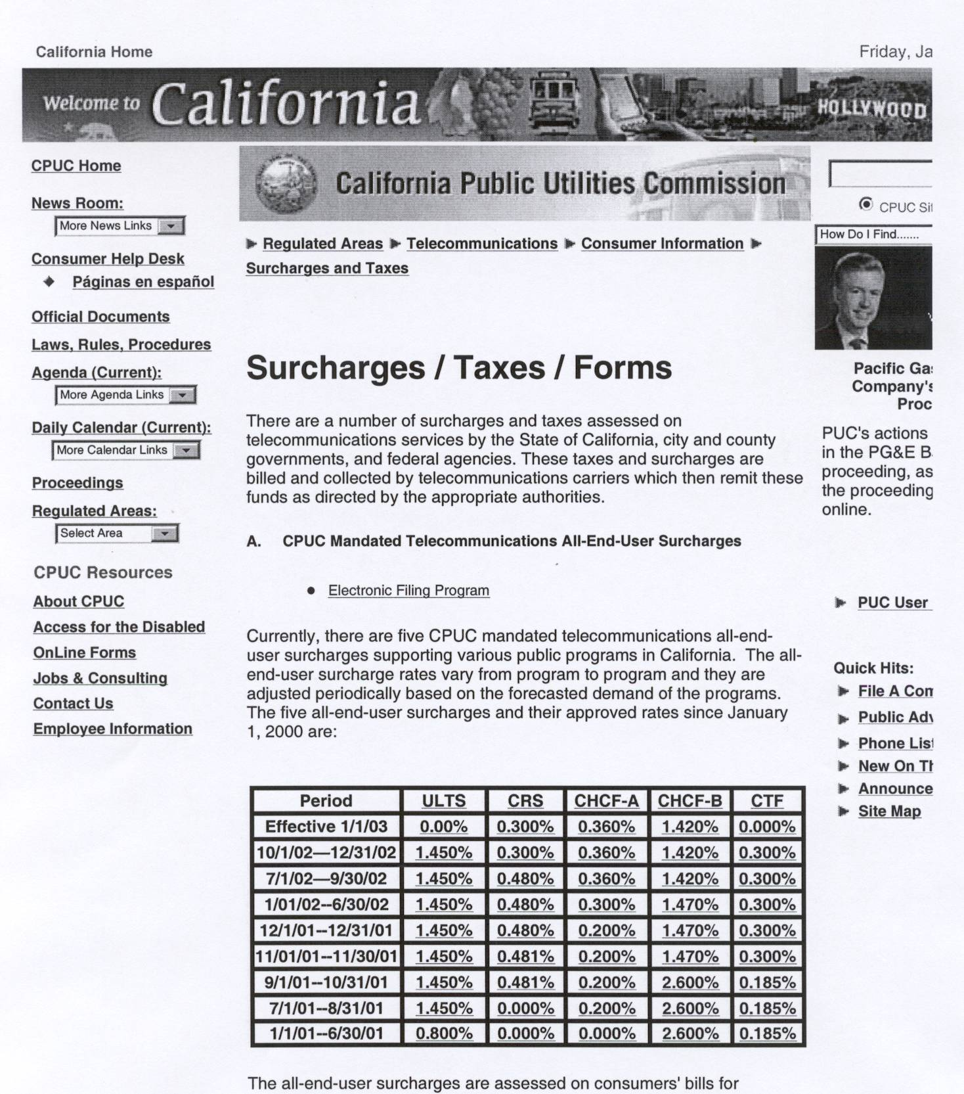

http://resserver/CPUC/static/Industry/Telco/Consumer+Information/Surcharges+and+Taxes/_index.htm

Primary: | Alternate:
Ana Montes  Director of Technology  Latino Issues Forum  785 Market St, Ste 300  San Francisco, CA 94103  E-Mail: anamontes@lif.org  Telephone: 415-284-7208 | Jeff Nelder  Deputy Executive Director  Charity Cultural Services Center  827 Stockton St  San Francisco, CA 94108  E-Mail: ccscgrantwriter@yahoo.com  Telephone: 415-989-8224
Fred Hesse  Verizon  Regulatory Advocacy  One Verizon Way, MC: CA500GC  Thousand Oaks, CA 91362  E-Mail: fred.hesse@verizon.com  Telephone: 805-372-7233 | Colin Petheram  Regulatory & Constituency Relations  140 New Montgomery, Room 1325  San Francisco, CA 94105  E-Mail: colin.petheram@sbc.com  Telephone: 415-542-7471
Ken McEldowney  Consumer Action  717 Market Street, Room 310  San Francisco, CA 94103  E-Mail: ken.mceldowney@consumer-action.org  Telephone: 415-777-9648 | Annie Chung  Executive Director  Self Help for the Elderly  407 Sansome St, Ste 300  San Francisco, CA 94111-3104  E-Mail: Anni2pacbell.net  Telephone: 415-823-0331
Linda Burton  Sierra Telephone  PO Box 219  Oakhurst, CA 93644  E-Mail: lindab@stcg.net  Telephone: | Rhonda Armstrong  Regulatory Manager  Kerman Telephone Co.  811 S Madera Ave  Kerman, CA 93630  E-Mail: rhondaa@kermantel.net  Telephone: 559-846-7780
Linda L. Gustafson  CPUC  ORA  505 Van Ness Ave 4th FL  San Francisco, CA 94102  E-Mail: llg@cpuc.ca.gov  Telephone: 415-703-2385 | Joel Tolbert  CPUC  ORA  505 Van Ness Ave 4th FL  San Francisco, CA 94102  E-Mail: jjt@cpuc.ca.gov  Telephone: 415-703-1742

Primary: | Alternate:
Marlene Hebert
AT&T
Law & Government Affairs Dept
795 Folsom Street, Room 2158D
San Francisco, CA 94107
E-Mail: mrhebert@att.com
Telephone: 415-442-2688

Mateo Camarillo  4067 Ohio Street  San Diego, CA 92104  E-Mail: Mateorc1@aol.com  Telephone: 619-282-0217 | Tony Fletcher  Rose Resnick Light House For the Blind  214 Van Ness Ave  San Francisco, CA 94102  E-Mail: afletcher@lighthouse-sf.org  Telephone: 415-431-1481 ext. 219
Mike A. Gipson  County of LA Community Action Board  17503 Sudbury Ct.  Carson, CA 90745  E-Mail: mgipson@utla.net  Telephone: 213-368-6235 | Rev. John O. Hopkins  Truevine Community Outreach, Inc.  5238 Clark St  Lynwood, CA 90262  E-Mail: jhopk78341@aol.com  Telephone: 310-635-4300
Richard Elbrecht  Supervising Attorney  Dept of Consumer Affairs  400 R Street, Suite 3090  Sacramento, CA 95814  E-Mail: richard_elbrecht@dca.ca.gov  Telephone: 916-445-5126 | Lyle Millage  Beaumont Chamber of Commerce  790 Beaumont Ave Ste 114  Beaumont, CA 92223  E-Mail: nodust@pe.net  Telephone: 909-845-4726

ULTS-AC Charter
Section 4.1:
a) Pursuant to Pub. Util. Code § 273(a), on or before June 1 of each year the ULTSAC shall submit a proposed budget to the Commission’s Telecommunications Division. The proposed budget shall include estimated program expenditures and the Committee’s projected expenses for the fiscal year (July 1 to June 30) that will commence thirteen (13) months thereafter.
- Pursuant to Pub. Util. Code § 273(b), on or before October 1 of each year the ULTSAC shall submit a report to the Commission describing Committee activities during the prior fiscal year.
- Pursuant to Pub. Util. Code § 277(a), the ULTSAC shall advise the Commission regarding the development, implementation and administration of the ULTS program, within the context of the Committee’s purpose, as described in Paragraph 2.1

Section 2.3
Component Program: Universal Lifeline Telephone Service Marketing Program (ULTSMP). The ULTSAC includes the ULTSMP, which is a component program under Pub. Util. Code § 277. The focus of the ULTSMP is the marketing of the ULTS program in a competitive environment.
The ULTSAC’s advice and recommendations to the Commission about the ULTSMP shall focus on achieving the ULTS program goal of providing basic telephone service to all qualifying low-income households. Since the funds available for marketing initiatives are limited, the recommendations shall be prioritized to reflect the most pressing needs of the ULTS program, including proposals for expenditure of 80% of the marking budget on campaigns designed to bring basic telephone service to qualifying households currently without telephone service.
The proposals for expenditure of the remaining 20% of the marketing budget shall be aimed at closing the gap between the total number of households with phone service who qualify for the ULTS program and the number of such households that actually use the program, consistent with the mandate of Pub. Util. Code § 871.5(c).
The ULTSAC may also make recommendations in its Annual Report to the Commission on the following ULTSMP issues: (1) how to use existing funding levels for the ULTS marketing program to reduce the total number of households that qualify for ULTS that are without phone service and (2) how to narrow the gap between the total number of households with phone service who qualify for the ULTS program and the total number of such customers who actually use the program.
Section 4.2:
a) One liaison, from the Commission’s Telecommunications Division, or its successor, who shall be appointed by the Director of that division, shall facilitate advisory board meetings by scheduling the room for such meetings, preparing agendas and meeting information packages, and taking and preparing minutes of the meetings. The liaison shall also assist the Committee in the development of each proposed fiscal year program budget and in the preparation and filing of the annual report.
b) One liaison, from the Commission’s Information and Management Services Division, or its successor, who shall be appointed by the Director of that division, shall provide the Committee with monthly reports on the financial status of the program.
- One liaison, from the Commission’s Legal Division, or its successor, who shall be appointed by the Commission’s General Counsel, shall provide the Committee with legal advice, upon request.
- d) One liaison, from the Commission’s Public Advisor's Office, or its successor, who shall be appointed by the Public Advisor, shall facilitate communication between the board and the public, generally, including any necessary or useful public outreach consistent with the board's purpose. The liaison shall ensure that the board is aware of any specific, program-related concerns or proposals, including those regarding the effectiveness of the programs, which have come to the Commission's attention and shall undertake any other tasks to assist the board in fulfilling its purpose as the Commission may formally or informally direct.

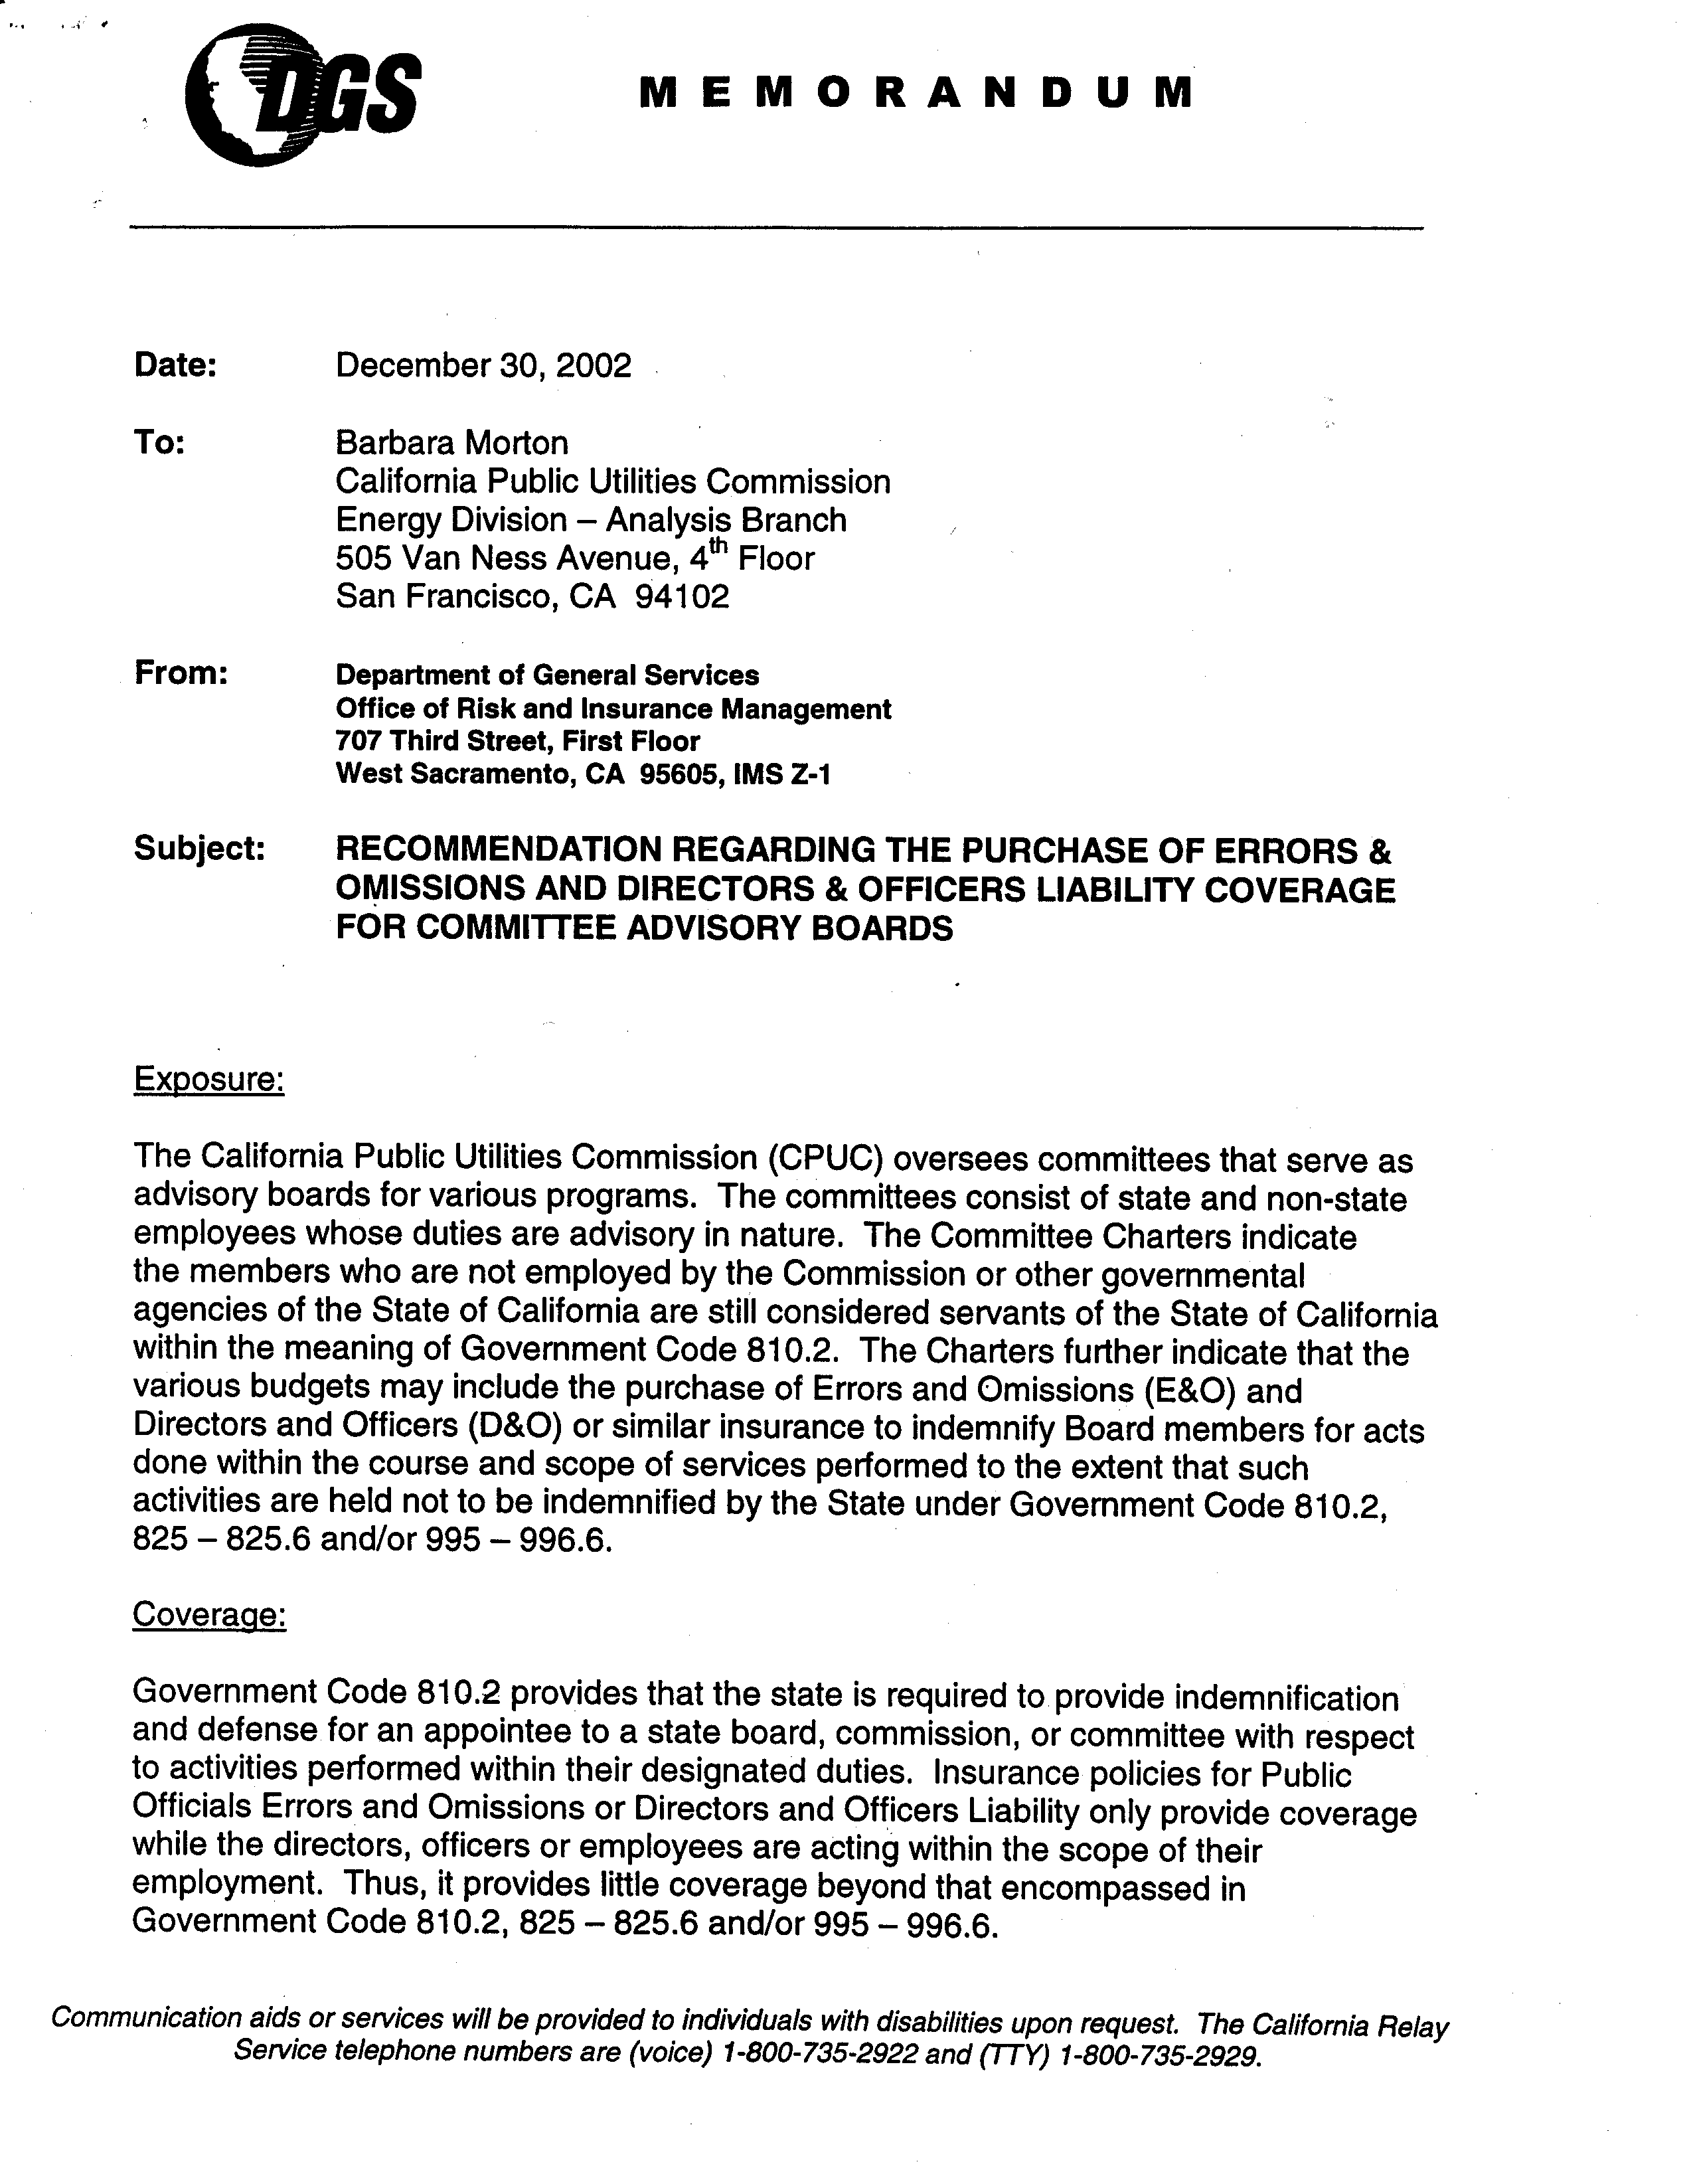
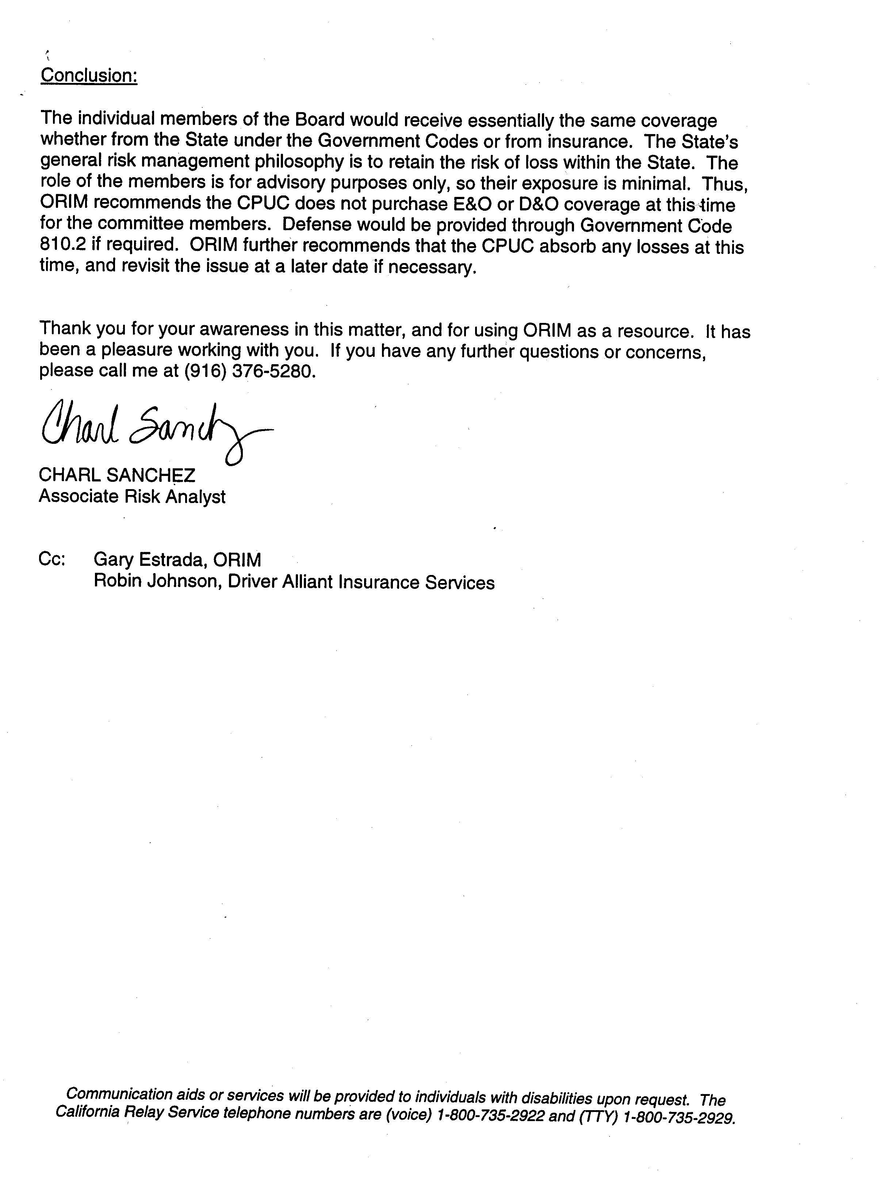

John M. Leutza, Director
Telecommunications Division, CPUC
505 Van Ness Avenue, 3rd FL
San Francisco, CA 94102
Subject: Eligibility for Per Diem Payment
Individual is an appointed primary/alternate committee member of the CHCF-A/CHCF-B/CTF/ULTS Advisory Committee representing Company, a consumer/community-based organization. Individual is not an employee of a public utility, the California Public Utilities Commission, or other governmental agencies of the State of California, therefore is eligible for per diem payment in accordance with Section 3.8 of the Charter.
Additional Language for Justification for Payment directly paid to individual:
Individual is an unpaid volunteer of the Company / The Company does not have the financial resources to support Individual’s participation of the above-identified Advisory Committee, therefore all per diem payments should be paid directly to Individual.

Executive or Officer of the Company
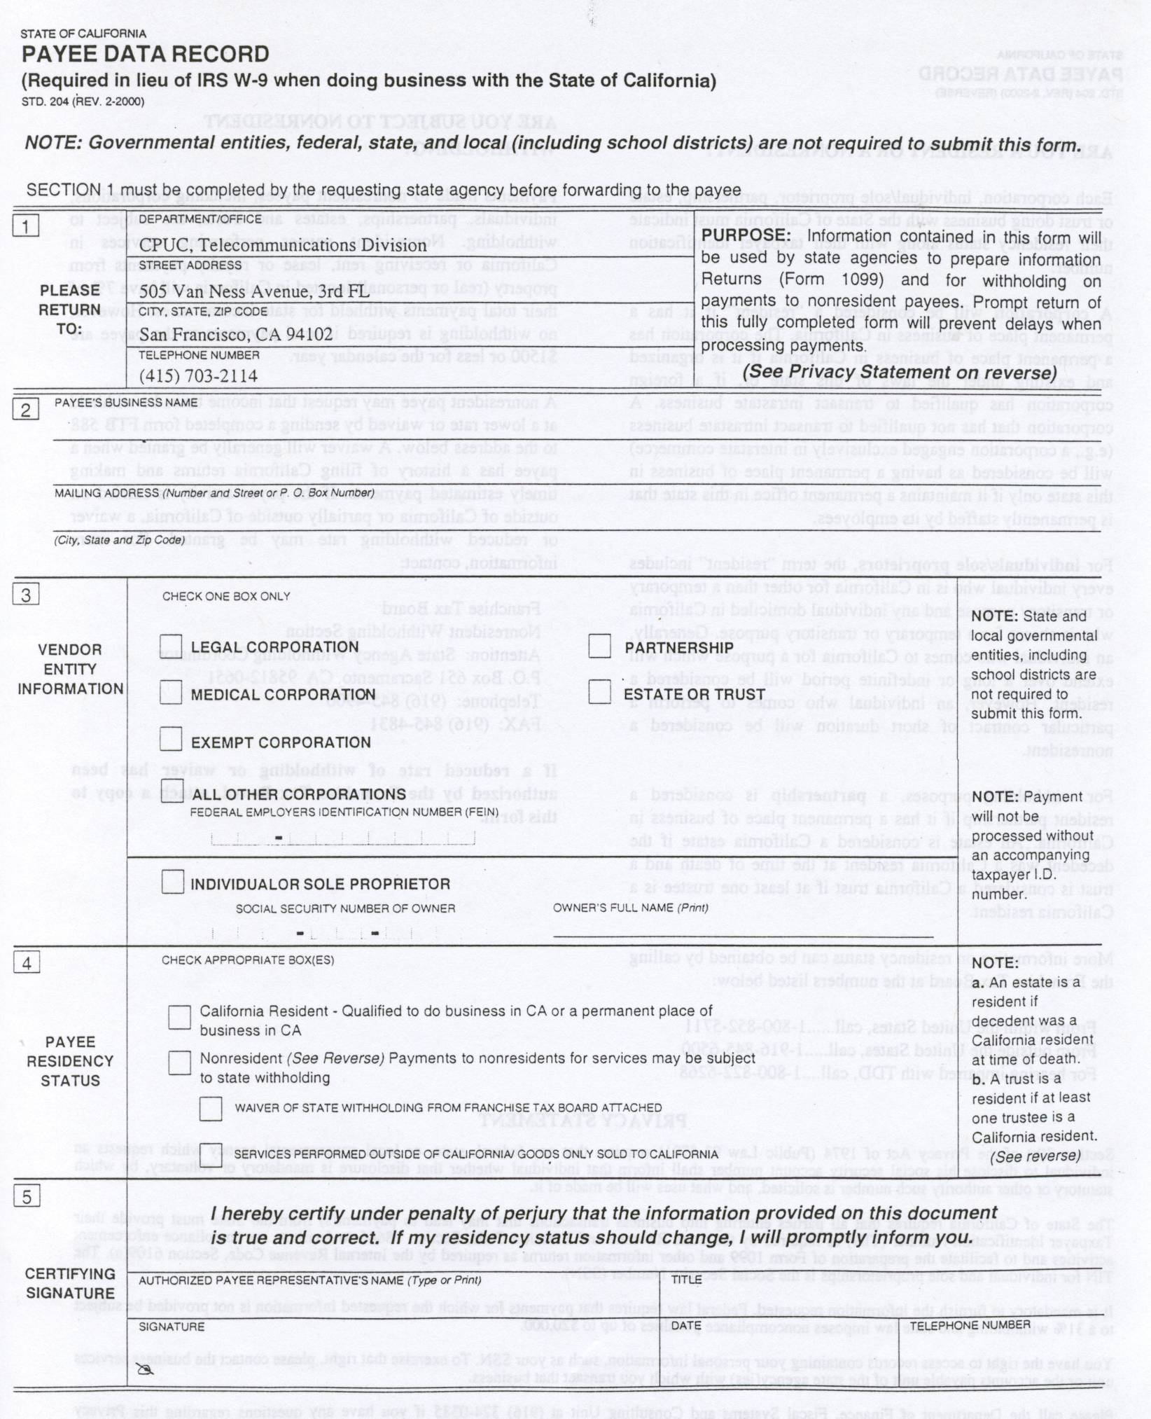
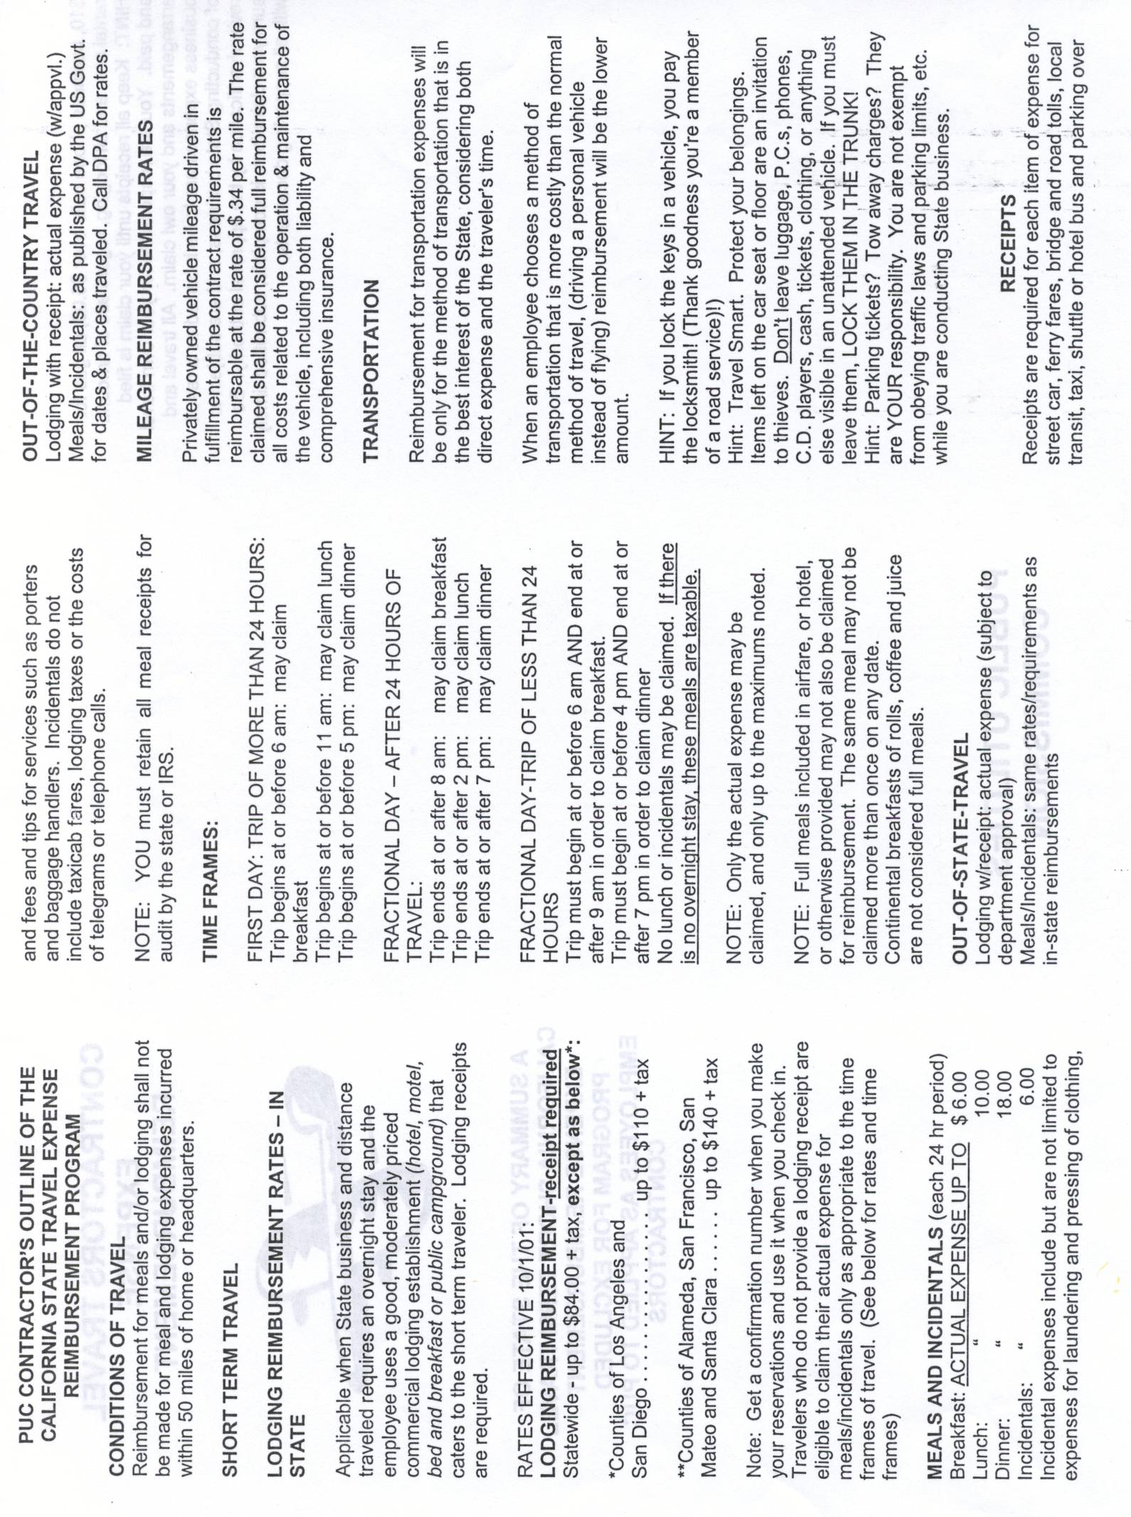

Payment of all other requests and invoices, such as TECs, etc.

