STATE OF CALIFORNIA |  | Public Utilities Commission  San Francisco

M e m o r a n d u m

Date: | April 5, 2006
To: | The Commission  (Meeting of April 13, 2006)
From: | Delaney Hunter, Director  Office of Governmental Affairs (OGA) — Sacramento
Subject: | AB 2993 (Leno) - Electricity: net energy metering.  As Introduced February 24, 2006

Legislative Subcommittee Recommendation: Support

SUMMARY OF BILL: The bill will revise net-metering rules to establish a separate net-metering limit of 200 megawatts (MW) for Pacific Gas and Electric (PG&E).

DIVISION ANALYSIS (Energy Division):

Under existing law, net-metering caps are calculated as 0.5% of the utility’s highest record of peak demand. SDG&E has a 50 MW cap. Using the 0.5% of peak demand calculation, PG&E’s current net metering cap is 95 MW. The proposed legislation will revise PG&E’s net-metering cap to 200 MW instead of a percentage of peak demand, in effect doubling PG&E’s current cap. The other utility’s net-metering cap calculation will remain the same. AB 2993 is beneficial in that it will allow the continuance of net-metering options for eligible renewable distributed generation customers of the State’s largest utility helping the State meet its goal of 3,000 MW of solar generation by 2017.

PG&E is close to their net-metering cap of 0.5% of peak demand and is expected to reach it by September of 2006. San Diego Gas and Electric (SDG&E) has a 50 MW cap of which 37% has been met. If all the new solar projects in SDG&E’s area that have applied for SGIP incentives in 2006 are approved and participate in SDG&E’s net metering program, SDG&E could reach 83% of its revised cap beginning in 2007. Energy Division recommends that similar legislation be introduced to increase SDG&E’s net metering cap in the near future. Attachment 1 includes a summary of the utilities' net-metering status.

Increasing PG&E’s net-metering cap to 200 MW, as AB 2993 allows, is equivalent to increasing the cap to just under 1% of PG&E’s current peak demand. Increasing the cap would ensure that net-metering continue to be a coordinated incentive for State solar program participation in the near future, helping the State pursue the goal of reaching 3,000 MW of solar generation or displacement by 2017 as identified in D.06-01-024.

There will be a negative effect on eligible renewable distributed generation projects if PG&E reaches its net-metering cap; net metering is an important incentive for installing eligible renewable distributed generation units. Currently over 90% of PG&E’s SGIP applicants participate in the net metering program. PG&E’s net metering program has been in effect since 1996 and is anticipated to reach its cap (the equivalent of 95 MW) in September of 2006. The proposed legislation would double PG&E’s current net metering cap and ensure the cap will not be met in the near future.

“PG&E anticipates that it will likely reach the 0.5 percent cap on retail net metering prior to January 1, 2007 for two reasons. First, PG&E has interconnected approximately 70 MW of solar and is installing approximately 2 MW each month. Second, the increased funding for the 2006 self-Generation Incentive Program will likely accelerate installation rates. PG&E estimates that the 0.5 percent cap on retail net metering may be reach by September 2006.”

Legislation is required to revise PG&E’s net metering cap. The Commission cannot revise the cap without corresponding legislative authority to do so.

PROGRAM BACKGROUND:

In 1995, California was one of the first states to formally adopt net metering for solar and wind systems with a capacity size of 10 KW or less. Net metering was expanded in 2001 to include systems up to 1 MW, and again in 2003 to introduce a pilot net billing program for biogas and fuel cell systems through 2005. From 2002 to 2003 net metered customers in California grew by 74%, for a total of 5,242 customers participating in the program. This was the same period the California Self-Generation Incentive Program began accepting applications for state rebates from distributed generation customers, the majority of them being solar systems eligible for net metering participation. The implementation of the California Solar Initiative will fuel similar growth in net metering programs once it begins accepting applications in 2007 (see below).

California created the California Solar Initiative through the adoption of D.06-01-024 by the CPUC on January 12, 2006. The decision committed $2.8 billion dollars to the development of solar in California and established a program goal to bring on line or displace 3,000 MW of power. In addition, the CPUC adopted D.05-12-044 infusing $300 million into the existing SGIP. The SGIP provides incentives to distributed generation technologies, primarily solar systems. For both the SGIP and CSI programs net metering options are critical to encourage customer participation in the State’s solar program.

LEGISLATIVE HISTORY:

California’s net-metering law took effect in 1995 and was applied to all investor owned utilities to allow net-metering for solar and wind energy systems up to 1 MW.

AB 2228 was adopted in September of 2002 allowing biogas-electric facilities up to 1 MW to net meter until December of 2005 under a pilot program.

AB 58 amended the net-metering law in 2002 and included provisions that:
- limited the total amount of net-metering to 0.5% of utilities peak demand;
- exempted net-metered customers from exit fees or departing load fees;
- prohibited inter-class cost shifting resulting from net-metering;
- allowed municipal utilities to permit time-of-use net-metering based on generation value of the systems;
- advised the State Treasurer to consider net-metering projects sustainable for purposes of evaluating low-income housing projects; and
- permitted wind energy projects up to 50 KW to net-meter, allowing wind energy projects from 50 KW to 1 MW to utilize time-of-use net-metering.

AB 1214 made fuel cells eligible for net-metering until the cumulative generating capacity of net-metered fuel cells reaches 45 MW within the utility’s service territory with a peak demand of at least 10,000 MW or until capacity reaches 22.5 MW within a service territory of a utility with a peak demand of less than 10,000 MW. Maximum total capacity of all net-metered fuel cells in all service territories is limited to 112.4 MW.

AB 67, adopted in 2005, removed the January 1, 2006 repeal date of AB 1214 (above) and allowed fuel cells that begin operation before January 1, 2010 to participate in net-metering.

OTHER STATES’ OR FEDERAL INFORMATION (if known):

Currently 40 states offer net-metering options for their customers including the District of Columbia. 45% of these states offer programs that have no net metering cap. Attachment 2 to this analysis summarizes the state programs as of October 2005. From 2002 to 2003 the number of U.S. electric customers participating in net metering programs grew by 52% (see Attachment 3). In California the growth rate for this same period was 74% (see Attachment 4). California’s Self-Generation Incentive Program began accepting applications for distributed generation in 2002 and may have contributed to the increase in net metering participation for the state during this time. The implementation of the California Solar Initiative will fuel similar growth in net metering programs once it begins accepting applications in 2007. This legislation would ensure net metering options are still available to PG&E customers in the near future, encouraging customer participation in the State’s solar program.

FISCAL IMPACT:

None

STATUS:

AB 2993 was introduced on February 24, 2006 and has yet to be assigned to a policy committee.

SUPPORT/OPPOSITION:
Support
PV Manufacturer’s Association
Oppose
None on file

STAFF CONTACTS:

Delaney Hunter dlh@cpuc.ca.gov
OGA 916-327-3788

Lisa Paulo lp1@cpuc.ca.gov
Staff – Energy Division (415) 355-5495

ATTACHMENT 1

Utility | Net Metering Cap | Current Net Metering Participation | % of Net Metering Cap | Potential New Net Metering Participation (2006) | % of Cap (Existing and New)*
SDG&E | 50 MW | 19 MW | 37% | 23 MW | 83%
PG&E | 95 MW | 72 MW | 76% | 108 MW** | 189%
SCE | 110 MW | 36 MW | 33% | 44 MW | 73%
*Note: This figure represents what the percentage of net metering participation would be if all active renewable net metering eligible SGIP applications participated in the utility’s net metering program. There are various reasons why an applicant would not participate in the net metering program, such as the applicant is served by an electric service provider that does not offer net metering, the system does not use an inverter or exceeds 1 MW.
**This figure includes 2006 waitlisted PG&E SGIP applications (35 MW) most of which will not be funded in 2006. Excluding the waitlisted data, PG&E has a total net metering potential, including current net metered projects, of 145 MW (152% of current cap).

ATTACHMENT 2

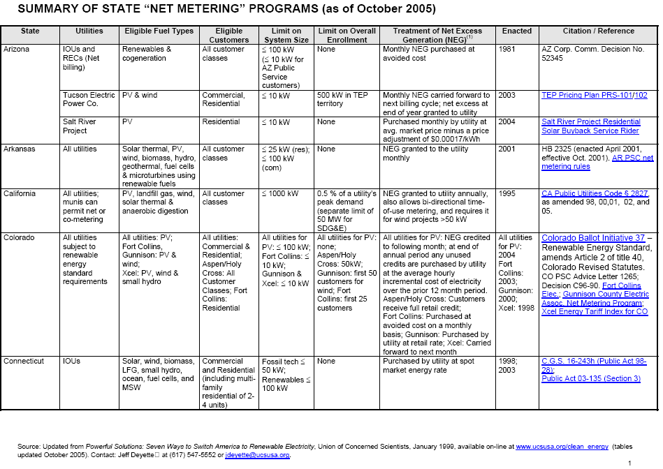

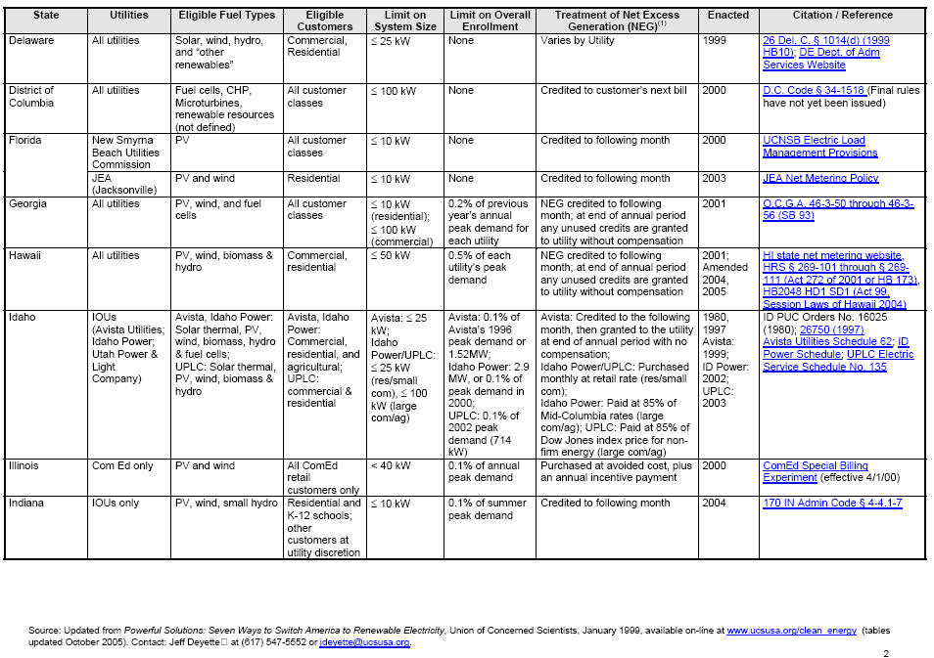

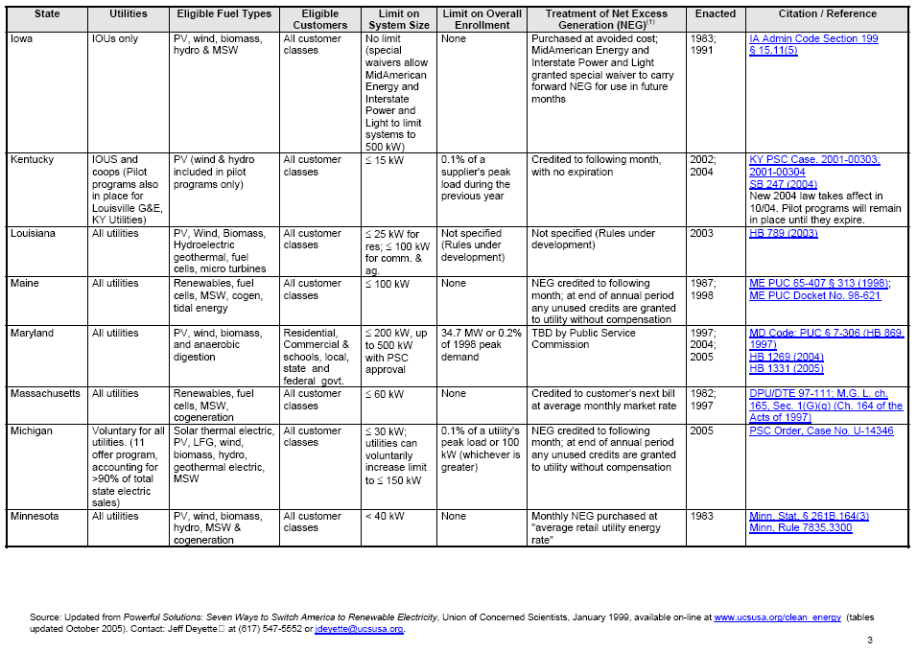

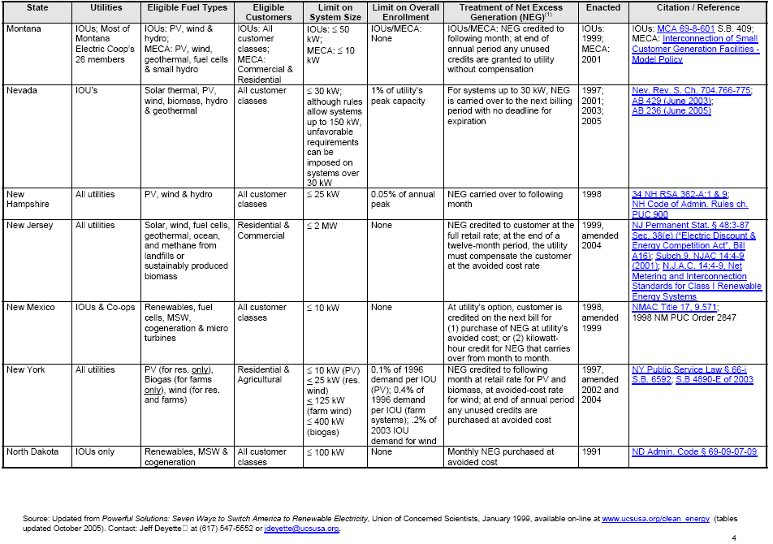

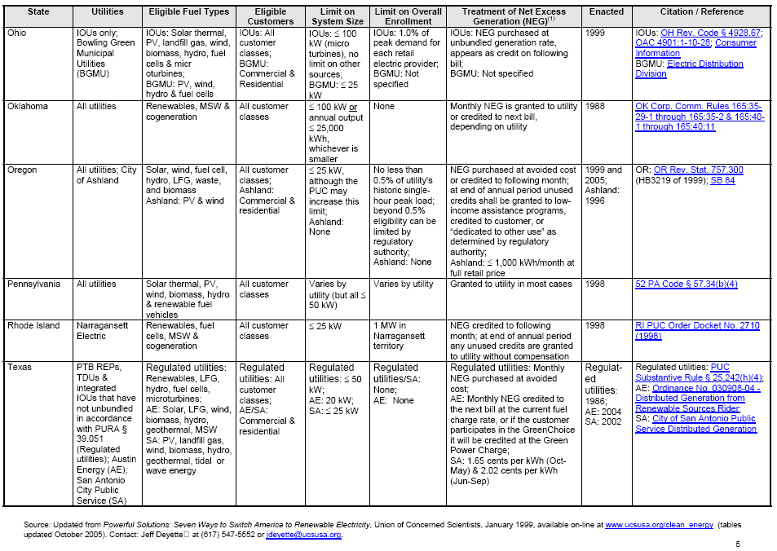

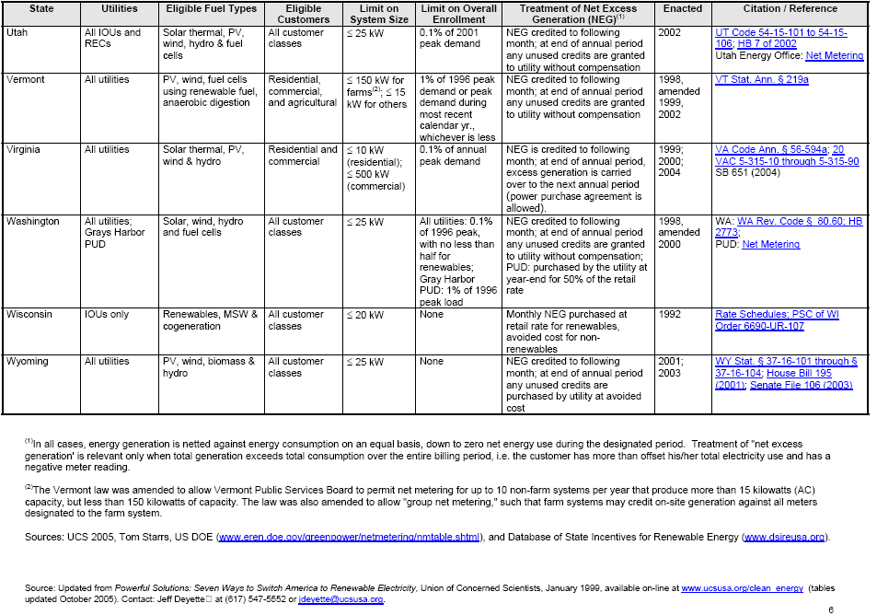

ATTACHMENT 3

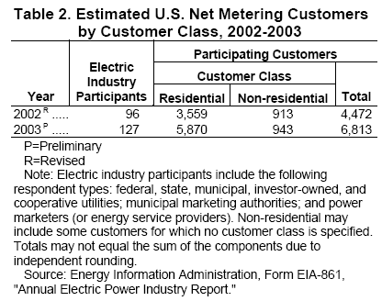

ATTACHMENT 4

Release Date: December 2004
Next Release Date: November 2005
Table 44. Estimated Net Metering Customers by State and Customer Class, 2002 and 2003
State | Electric Industry  Participants  2003 P | Participating Customers
State | Electric Industry  Participants  2003 P | 2003 P |  |  | 2002  Total
State | Electric Industry  Participants  2003 P | Residential | Non-residential | Total | 2002  Total
Alabama
Alaska | 2 | 1 | 1 | 2
Arizona | 2 | 29 | 301 | 330 | 320
Arkansas
California | 14 | 4,869 | 373 | 5,242 | 3,016
Colorado | 9 | 128 | 35 | 163 | 149
Connecticut | 2 | 20 | 8 | 28 | 25
Delaware | 1 | 7 | 3 | 10 | 11
District of Columbia
Florida | 2 | 7 | 3 | 10 | 9
Georgia | 1 | 1 |  | 1
Hawaii | 3 | 28 | 3 | 31 | 14
Idaho | 3 | 15 | 3 | 18 | 11
Illinois | 1 |  | 1 | 1 | 12
Indiana | 1 | 3 |  | 3 | 3
Iowa | 1 | 2 |  | 2 | 2
Kansas | 2 | 2 | 3 | 5 | 4
Kentucky | 2 |  | 14 | 14 | 1
Louisiana
Maine
Maryland | 2 | 5 |  | 5 | 6
Massachusetts | 3 | 90 | 1 | 91 | 85
Michigan | 1 | 2 | 1 | 3 | 4
Minnesota | 17 | 129 | 11 | 140 | 97
Mississippi
Missouri | 2 | 1 | 1 | 2 | 2
Montana | 2 | 3 |  | 3 | 3
Nebraska |  |  |  |  | 11
Nevada | 2 | 54 | 2 | 56 | 39
New Hampshire | 3 | 48 | 25 | 73 | 69
New Jersey
New Mexico | 3 | 9 | 1 | 10 | 8
New York | 1 | 43 | 3 | 46 | 22
North Carolina
North Dakota | 2 | 1 | 1 | 2 | 5
Ohio | 4 | 5 | 6 | 11 | 5
Oklahoma | 2 | 1 | 35 | 36 | 36
Oregon | 6 | 23 | 14 | 37 | 22
Pennsylvania | 2 | 42 | 18 | 60 | 35
Rhode Island | 2 | 12 | 4 | 16 | 5
South Carolina |  |  |  |  | R 0
South Dakota |  |  |  |  | R 0
Tennessee
Texas | 4 | 7 | 6 | 13 | 197
Utah | 1 |  | 1 | 1
Vermont | 2 | 46 | 6 | 52 | 43
Virginia | 6 | 12 | 0 | 12 | 5
Washington | 10 | 44 | 4 | 48 | 34
West Virginia | 2 | 1 | 1 | 2
Wisconsin | 6 | 178 | 54 | 232 | 161
Wyoming | 2 | 2 |  | 2 | 1
Total | 127 | 5,870 | 943 | 6,813 | R 4,472
P=Preliminary.
R=Revised.
Note: Electric industry participants include the following respondent types: federal, state, municipal, investor-owned, and cooperative utilities; municipal marketing authorities; and power marketers (or energy service providers). Non-residential may include some customers for which no customer class is specified. Blank cells indicate no data was reported for the state or the number of customers in a class was zero. Totals may not equal the sum of the components due to independent rounding.
Source: Energy Information Administration, Form EIA-861, "Annual Electric Power Industry Report"

BILL LANGUAGE:

BILL NUMBER: AB 2993 INTRODUCED
BILL TEXT

INTRODUCED BY Assembly Member Leno

FEBRUARY 24, 2006

An act to amend Section 2827 of the Public Utilities Code,
relating to electricity, and declaring the urgency thereof, to take
effect immediately.

LEGISLATIVE COUNSEL'S DIGEST

AB 2993, as introduced, Leno Electricity: net energy metering.
Existing law requires every electric service provider, as defined,
except the San Diego Gas and Electric Company, to develop a standard
contract or tariff providing for net energy metering, and to make
this contract or tariff available to eligible customer generators,
upon request, on a first-come-first-served basis until the total
rated generating capacity used by eligible customer generators
exceeds 0.5% of the electric service provider's aggregate customer
peak demand.
This bill would establish for the Pacific Gas and Electric Company
a separate limit of 200 megawatts.
The bill would make a finding and declaration of the Legislature
regarding the inapplicability of a general statute within the meaning
of Section 16 of Article IV of the California Constitution.
The bill would declare that it is to take effect immediately as an
urgency statute.
Vote: 2/3. Appropriation: no. Fiscal committee: no. State-mandated
local program: no.

THE PEOPLE OF THE STATE OF CALIFORNIA DO ENACT AS FOLLOWS:

SECTION 1. Section 2827 of the Public Utilities Code is amended to
read:
2827. (a) The Legislature finds and declares that a program to
provide net energy metering for eligible customer-generators is one
way to encourage substantial private investment in renewable energy
resources, stimulate in-state economic growth, reduce demand for
electricity during peak consumption periods, help stabilize
California's energy supply infrastructure, enhance the continued
diversification of California's energy resource mix, and reduce
interconnection and administrative costs for electricity suppliers.
(b) As used in this section, the following definitions apply:
(1) "Electric service provider" means an electrical corporation,
as defined in Section 218, a local publicly owned electric utility,
as defined in Section 9604, or an electrical cooperative, as defined
in Section 2776, or any other entity that offers electrical service.
This section shall does not apply to a
local publicly owned electric utility, as defined in Section 9604 of
the Public Utilities Code, that serves more than 750,000 customers
and that also conveys water to its customers.
(2) "Eligible customer-generator" means a residential, small
commercial customer as defined in subdivision (h) of Section 331,
commercial, industrial, or agricultural customer of an electric
service provider, who uses a solar or a wind turbine electrical
generating facility, or a hybrid system of both, with a capacity of
not more than one megawatt that is located on the customer's owned,
leased, or rented premises, is interconnected and operates in
parallel with the electric grid, and is intended primarily to offset
part or all of the customer's own electrical requirements.
(3) "Net energy metering" means measuring the difference between
the electricity supplied through the electric grid and the
electricity generated by an eligible customer-generator and fed back
to the electric grid over a 12-month period as described in
subdivision (h). Net energy metering shall be accomplished using a
single meter capable of registering the flow of electricity in two
directions. An additional meter or meters to monitor the flow of
electricity in each direction may be installed with the consent of
the customer-generator, at the expense of the electric service
provider, and the additional metering shall be used only to provide
the information necessary to accurately bill or credit the
customer-generator pursuant to subdivision (h), or to collect solar
or wind electric generating system performance information for
research purposes. If the existing electrical meter of an eligible
customer-generator is not capable of measuring the flow of
electricity in two directions, the customer-generator shall be
responsible for all expenses involved in purchasing and installing a
meter that is able to measure electricity flow in two directions. If
an additional meter or meters are installed, the net energy metering
calculation shall yield a result identical to that of a single meter.
An eligible customer-generator who already owns an existing solar or
wind turbine electrical generating facility, or a hybrid system of
both, is eligible to receive net energy metering service in
accordance with this section.
(4) "Wind energy co-metering" means any wind energy project
greater than 50 kilowatts, but not exceeding one megawatt, where the
difference between the electricity supplied through the electric grid
and the electricity generated by an eligible customer-generator and
fed back to the electric grid over a 12-month period is as described
in subdivision (h). Wind energy co-metering shall be accomplished
pursuant to Section 2827.8.
(5) "Co-energy metering" means a program that is the same in all
other respects as a net energy metering program, except that the
local publicly owned electric utility, as defined in Section 9604,
has elected to apply a generation-to-generation energy and
time-of-use credit formula as provided in subdivision (i).
(6) "Ratemaking authority" means, for an electrical corporation as
defined in Section 218, or an electrical cooperative as defined in
Section 2776, the commission, and for a local publicly owned electric
utility as defined in Section 9604, the local elected body
responsible for regulating the rates of the local publicly owned
utility.
(c) (1) (A) Every electric service provider shall develop a
standard tariff providing for net energy metering, and shall make
this tariff available to eligible customer-generators, upon request,
on a first-come-first-served basis until, except as provided in
subparagraph (B) subparagraphs (B) and (C)
, the total rated generating capacity used by eligible
customer-generators exceeds one-half of 1 percent of the electric
service provider's aggregate customer peak demand.
(B) Notwithstanding subparagraph (A), the San Diego Gas and
Electric Company shall make its standard net energy metering tariff
available to eligible customer-generators until the total rated
generating capacity used by eligible customer-generators within its
service territory exceeds 50 megawatts.
(C) Notwithstanding subparagraph (A), the Pacific Gas and Electric
Company shall make its standard net energy metering tariff available
to eligible customer-generators until the total rated generating
capacity used by eligible customer-generators within its service
territory exceeds 200 megawatts.
(2) On an annual basis, beginning in 2003, every electric service
provider shall make available to the ratemaking authority information
on the total rated generating capacity used by eligible
customer-generators that are customers of that provider in the
provider's service area. For those electric service providers who are
operating pursuant to Section 394, they shall make available to the
ratemaking authority the information required by this paragraph for
each eligible customer-generator that is their customer for each
service area of an electric corporation, local publicly owned
electric utility, or electrical cooperative, in which the customer
has net energy metering. The ratemaking authority shall develop a
process for making the information required by this paragraph
available to energy service providers, and for using that information
to determine when, pursuant to paragraph (3), a service provider is
not obligated to provide net energy metering to additional
customer-generators in its service area.
(3) Notwithstanding Except as provided in
subparagraphs (B) and (C) of paragraph (1), an electric service
provider is not obligated to provide net energy metering to
additional customer-generators in its service area when the combined
total peak demand of all customer-generators served by all the
electric service providers in that service area furnishing net energy
metering to eligible customer-generators exceeds one-half of 1
percent of the aggregate customer peak demand of those electric
service providers.
(d) Electric service providers shall make all necessary forms and
contracts for net metering service available for download from the
Internet.
(e) (1) Every electric service provider shall ensure that requests
for establishment of net energy metering are processed in a time
period not exceeding that for similarly situated customers requesting
new electric service, but not to exceed 30 working days from the
date the electric service provider receives a completed application
form for net metering service, including a signed interconnection
agreement from an eligible customer-generator and the electric
inspection clearance from the governmental authority having
jurisdiction. If an electric service provider is unable to process
the request within the allowable timeframe, the electric service
provider shall notify both the customer-generator and the ratemaking
authority of the reason for its inability to process the request and
the expected completion date.
(2) Electric service providers shall ensure that requests for an
interconnection agreement from an eligible customer-generator are
processed in a time period not to exceed 30 working days from the
date the electric service provider receives a completed application
form from the eligible customer-generator for an interconnection
agreement. If an electric service provider is unable to process the
request within the allowable timeframe, the electric service provider
shall notify the customer-generator and the ratemaking authority of
the reason for its inability to process the request and the expected
completion date.
(f) (1) If a customer participates in direct transactions pursuant
to paragraph (1) of subdivision (b) of Section 365 with an electric
supplier that does not provide distribution service for the direct
transactions, the service provider that provides distribution service
for an eligible customer-generator is not obligated to provide net
energy metering to the customer.
(2) If a customer participates in direct transactions pursuant to
paragraph (1) of subdivision (b) of Section 365 with an electric
supplier, and the customer is an eligible customer-generator, the
service provider that provides distribution service for the direct
transactions may recover from the customer's electric service
provider the incremental costs of metering and billing service
related to net energy metering in an amount set by the ratemaking
authority.
(g) Each net energy metering contract or tariff shall be
identical, with respect to rate structure, all retail rate
components, and any monthly charges, to the contract or tariff to
which the same customer would be assigned if the customer did not use
an eligible solar or wind electrical generating facility, except
that eligible customer-generators shall not be assessed standby
charges on the electrical generating capacity or the kilowatthour
production of an eligible solar or wind electrical generating
facility. The charges for all retail rate components for eligible
customer-generators shall be based exclusively on the
customer-generator's net kilowatthour consumption over a 12-month
period, without regard to the customer-generator's choice of electric
service provider. Any new or additional demand charge, standby
charge, customer charge, minimum monthly charge, interconnection
charge, or any other charge that would increase an eligible
customer-generator's costs beyond those of other customers who are
not customer-generators in the rate class to which the eligible
customer-generator would otherwise be assigned if the customer did
not own, lease, rent, or otherwise operate an eligible solar or wind
electrical generating facility are contrary to the intent of this
section, and shall not form a part of net energy metering contracts
or tariffs.
(h) For eligible residential and small commercial
customer-generators, the net energy metering calculation shall be
made by measuring the difference between the electricity supplied to
the eligible customer-generator and the electricity generated by the
eligible customer-generator and fed back to the electric grid over a
12-month period. The following rules shall apply to the annualized
net metering calculation:
(1) The eligible residential or small commercial
customer-generator shall, at the end of each 12-month period
following the date of final interconnection of the eligible
customer-generator's system with an electric service provider, and at
each anniversary date thereafter, be billed for electricity used
during that period. The electric service provider shall determine if
the eligible residential or small commercial customer-generator was a
net consumer or a net producer of electricity during that period.
(2) At the end of each 12-month period, where the electricity
supplied during the period by the electric service provider exceeds
the electricity generated by the eligible residential or small
commercial customer-generator during that same period, the eligible
residential or small commercial customer-generator is a net
electricity consumer and the electric service provider shall be owed
compensation for the eligible customer-generator's net kilowatthour
consumption over that same period. The compensation owed for the
eligible residential or small commercial customer-generator's
consumption shall be calculated as follows:
(A) For all eligible customer-generators taking service under
tariffs employing "baseline" and "over baseline" rates, any net
monthly consumption of electricity shall be calculated according to
the terms of the contract or tariff to which the same customer would
be assigned to or be eligible for if the customer was not an eligible
customer-generator. If those same customer-generators are net
generators over a billing period, the net kilowatthours generated
shall be valued at the same price per kilowatthour as the electric
service provider would charge for the baseline quantity of
electricity during that billing period, and if the number of
kilowatthours generated exceeds the baseline quantity, the excess
shall be valued at the same price per kilowatthour as the electric
service provider would charge for electricity over the baseline
quantity during that billing period.
(B) For all eligible customer-generators taking service under
tariffs employing "time-of-use" rates, any net monthly consumption of
electricity shall be calculated according to the terms of the
contract or tariff to which the same customer would be assigned to or
be eligible for if the customer was not an eligible
customer-generator. When those same customer-generators are net
generators during any discrete time-of-use period, the net
kilowatthours produced shall be valued at the same price per
kilowatthour as the electric service provider would charge for retail
kilowatthour sales during that same time-of-use period. If the
eligible customer-generator's time-of-use electrical meter is unable
to measure the flow of electricity in two directions, paragraph (3)
of subdivision (b) shall apply.
(C) For all residential and small commercial customer-generators
and for each billing period, the net balance of moneys owed to the
electric service provider for net consumption of electricity or
credits owed to the customer-generator for net generation of
electricity shall be carried forward as a monetary value until the
end of each 12-month period. For all commercial, industrial, and
agricultural customer-generators the net balance of moneys owed shall
be paid in accordance with the electric service provider's normal
billing cycle, except that if the commercial, industrial, or
agricultural customer-generator is a net electricity producer over a
normal billing cycle, any excess kilowatthours generated during the
billing cycle shall be carried over to the following billing period
as a monetary value, calculated according to the procedures set forth
in this section, and appear as a credit on the customer-generator's
account, until the end of the annual period when paragraph (3) shall
apply.
(3) At the end of each 12-month period, where the electricity
generated by the eligible customer-generator during the 12-month
period exceeds the electricity supplied by the electric service
provider during that same period, the eligible customer-generator is
a net electricity producer and the electric service provider shall
retain any excess kilowatthours generated during the prior 12-month
period. The eligible customer-generator shall not be owed any
compensation for those excess kilowatthours unless the electric
service provider enters into a purchase agreement with the eligible
customer-generator for those excess kilowatthours.
(4) The electric service provider shall provide every eligible
residential or small commercial customer-generator with net
electricity consumption information with each regular bill. That
information shall include the current monetary balance owed the
electric service provider for net electricity consumed since the last
12-month period ended. Notwithstanding this subdivision, an
electric service provider shall permit that customer to pay monthly
for net energy consumed.
(5) If an eligible residential or small commercial
customer-generator terminates the customer relationship with the
electric service provider, the electric service provider shall
reconcile the eligible customer-generator's consumption and
production of electricity during any part of a 12-month period
following the last reconciliation, according to the requirements set
forth in this subdivision, except that those requirements shall apply
only to the months since the most recent 12-month bill.
(6) If an electric service provider providing net metering to a
residential or small commercial customer-generator ceases providing
that electrical service to that customer during any 12-month period,
and the customer-generator enters into a new net metering contract or
tariff with a new electric service provider, the 12-month period,
with respect to that new electric service provider, shall commence on
the date on which the new electric service provider first supplies
electric service to the customer-generator.
(i) Notwithstanding any other provisions of this section, the
following provisions shall apply to an eligible customer-generator
with a capacity of more than 10 kilowatts, but not exceeding one
megawatt, that receives electrical service from a local publicly
owned electric utility, as defined in Section 9604, that has elected
to utilize a co-energy metering program unless the electric service
provider chooses to provide service for eligible customer-generators
with a capacity of more than 10 kilowatts in accordance with
subdivisions (g) and (h):
(1) The eligible customer-generator shall be required to utilize a
meter, or multiple meters, capable of separately measuring
electricity flow in both directions. All meters shall provide
"time-of-use" measurements of electricity flow, and the customer
shall take service on a time-of-use rate schedule. If the existing
meter of the eligible customer-generator is not a time-of-use meter
or is not capable of measuring total flow of energy in both
directions, the eligible customer-generator shall be responsible for
all expenses involved in purchasing and installing a meter that is
both time-of-use and able to measure total electricity flow in both
directions. This subdivision shall not restrict the ability of an
eligible customer-generator to utilize any economic incentives
provided by a government agency or the electric service provider to
reduce its costs for purchasing and installing a time-of-use meter.
(2) The consumption of electricity from the electric service
provider shall result in a cost to the eligible customer-generator to
be priced in accordance with the standard rate charged to the
eligible customer-generator in accordance with the rate structure to
which the customer would be assigned if the customer did not use an
eligible solar or wind electrical generating facility. The generation
of electricity provided to the electric service provider shall
result in a credit to the eligible customer-generator and shall be
priced in accordance with the generation component, established under
the applicable structure to which the customer would be assigned if
the customer did not use an eligible solar or wind electrical
generating facility.
(3) All costs and credits shall be shown on the eligible
customer-generator's bill for each billing period. In any months in
which the eligible customer-generator has been a net consumer of
electricity calculated on the basis of value determined pursuant to
paragraph (2), the customer-generator shall owe to the electric
service provider the balance of electricity costs and credits during
that billing period. In any billing period in which the eligible
customer-generator has been a net producer of electricity calculated
on the basis of value determined pursuant to paragraph (2), the
electric service provider shall owe to the eligible
customer-generator the balance of electricity costs and credits
during that billing period. Any net credit to the eligible
customer-generator of electricity costs may be carried forward to
subsequent billing periods, provided that an electric service
provider may choose to carry the credit over as a kilowatt hour
credit consistent with the provisions of any applicable tariff,
including any differences attributable to the time of generation of
the electricity. At the end of each 12-month period, the electric
service provider may reduce any net credit due to the eligible
customer-generator to zero.
(j) A solar or wind turbine electrical generating system, or a
hybrid system of both, used by an eligible customer-generator shall
meet all applicable safety and performance standards established by
the National Electrical Code, the Institute of Electrical and
Electronics Engineers, and accredited testing laboratories such as
Underwriters Laboratories and, where applicable, rules of the Public
Utilities Commission regarding safety and reliability. A
customer-generator whose solar or wind turbine electrical generating
system, or a hybrid system of both, meets those standards and rules
shall not be required to install additional controls, perform or pay
for additional tests, or purchase additional liability insurance.
(k) If the commission determines that there are cost or revenue
obligations for an electric corporation, as defined in Section 218,
that may not be recovered from customer-generators acting pursuant to
this section, those obligations shall remain within the customer
class from which any shortfall occurred and may not be shifted to any
other customer class. Net metering and co-metering customers shall
not be exempt from the public benefits charge. In its report to the
Legislature, the commission shall examine different methods to ensure
that the public benefits charge remains a nonbypassable charge.
(l) A net metering customer shall reimburse the Department of
Water Resources for all charges that would otherwise be imposed on
the customer by the commission to recover bond-related costs pursuant
to an agreement between the commission and the Department of Water
Resources pursuant to Section 80110 of the Water Code, as well as the
costs of the department equal to the share of the department's
estimated net unavoidable power purchase contract costs attributable
to the customer. The commission shall incorporate the determination
into an existing proceeding before the commission, and shall ensure
that the charges are nonbypassable. Until the commission has made a
determination regarding the nonbypassable charges, net metering shall
continue under the same rules, procedures, terms, and conditions as
were applicable on December 31, 2002.
(m) In implementing the requirements of subdivisions (k) and (l),
a customer-generator shall not be required to replace its existing
meter except as set forth in paragraph (3) of subdivision (b), nor
shall the electric service provider require additional measurement of
usage beyond that which is necessary for customers in the same rate
class as the eligible customer-generator.
(n) On or before January 1, 2005, the commission shall submit a
report to the Governor and the Legislature that assesses the economic
and environmental costs and benefits of net metering to
customer-generators, ratepayers, and utilities, including any
beneficial and adverse effects on public benefit programs and special
purpose surcharges. The report shall be prepared by an independent
party under contract with the commission.
(o) It is the intent of the Legislature that the Treasurer
incorporate net energy metering and co-energy metering projects
undertaken pursuant to this section as sustainable building methods
or distributive energy technologies for purposes of evaluating
low-income housing projects.
SEC. 2. The Legislature finds and declares that, because of the
unique circumstances applicable only to the territory of the Pacific
Gas and Electric Company, a statute of general applicability cannot
be enacted within the meaning of subdivision (b) of Section 16 of
Article IV of the California Constitution. Therefore, this special
statute is necessary.
SEC. 3. This act is an urgency statute necessary for the immediate
preservation of the public peace, health, or safety within the
meaning of Article IV of the Constitution and shall go into immediate
effect. The facts constituting the necessity are:
Existing law requires that electric service providers, including
electrical corporations, to develop a standard contract or tariff
providing for net energy metering, and to make this contract or
tariff available to eligible customer generators until the total
rated generating capacity used by eligible customer generators
exceeds one-half of 1 percent of the electric service provider's
aggregate customer peak demand. At some point during the second
quarter of 2006, the Pacific Gas and Electric Company will reach the
one-half of 1 percent cap and will cease offering the net energy
metering tariff or contract to eligible customer-generators. Unless
the net energy metering cap is increased, installation of solar and
wind generation equipment by eligible customer-generators in the
service territory of the Pacific Gas and Electric Company will end
and the public resources protected by those installations will be
threatened.

PG&E Advice Letter Filing 2796-E, filed March 1, 2006.

